
GROUP - 28
System Testing - Support
Testers: Kirtan and Ruchir

Introduction
This document presents the system testing approach for the Support modules of the application. The objective is to validate user-facing functionality using Black-Box Testing, focusing on input–output behaviour without inspecting the internal code.
Both Equivalence Class Partitioning (ECP) and Boundary Value Analysis (BVA) techniques are applied to systematically identify valid and invalid input categories.
Additionally, Acceptance Testing is conducted to verify that the system meets user requirements by executing real inputs on the interface and observing the actual application response.

BlackBox Testing — Support

Constraints
A. FAQ Search Bar Constraints
- Input can be any string (letters, numbers, partial words).
- Search must return FAQs where question OR answer contains the query text.
- Case-insensitive matching.
- Empty search must show all FAQ categories.
- If no FAQ matches → show “No results found”.
B. Accordion (FAQ Dropdown) Constraints
- Clicking a question should expand its answer.
- Only the clicked question should open (single accordion).
- Clicking again collapses it.
- All FAQ answers must remain read-only text.
C. Email Support Modal Constraints
- Clicking “Contact via Email” must open the modal.
- Clicking outside modal or close button (X) closes it.
- Clicking an email must copy the email to clipboard.
- Visual feedback (✔ icon) should appear after copying.

Equivalence Class Partitioning (ECP)
EC Class | Search Input | FAQ Result | Email Modal | Clipboard Copy | Result
E1 | valid text matching FAQ | FAQs displayed | N/A | N/A | success
E2 | valid text not matching any FAQ | “No results found” displayed | N/A | N/A | success
E3 | empty input | all FAQs visible | N/A | N/A | success
E4 | click “Contact via Email” | modal opens | modal visible | N/A | success
E5 | clicking email inside modal | N/A | modal open | email copied | success
E6 | clicking outside modal / X | N/A | modal closes | N/A | success

Boundary Value Analysis (BVA)
Input / Action | Expected Output | Actual Output | Reason
Search = "" (empty) | Show all FAQs | — | Default state
Search = "a" (1 char) | Show FAQs containing “a” | — | Minimum non-empty input
Search = very long string (“xxxxxxxx…”) | No results found | — | Exceeds typical match length
Search = special chars (“@#$%”) | No results found | — | Should not crash, simply no match
Click “Contact via Email” | Modal opens | — | Modal visibility
Click outside modal | Modal closes | — | UI behavior
Click email inside modal | Email copied (✔ icon) | — | Clipboard functionality

Acceptance Testing — Support Page

Test 1 — Search Working with Matching Keyword
Input: group
Expected Output:
All the FAQs related / containing the word group should be shown
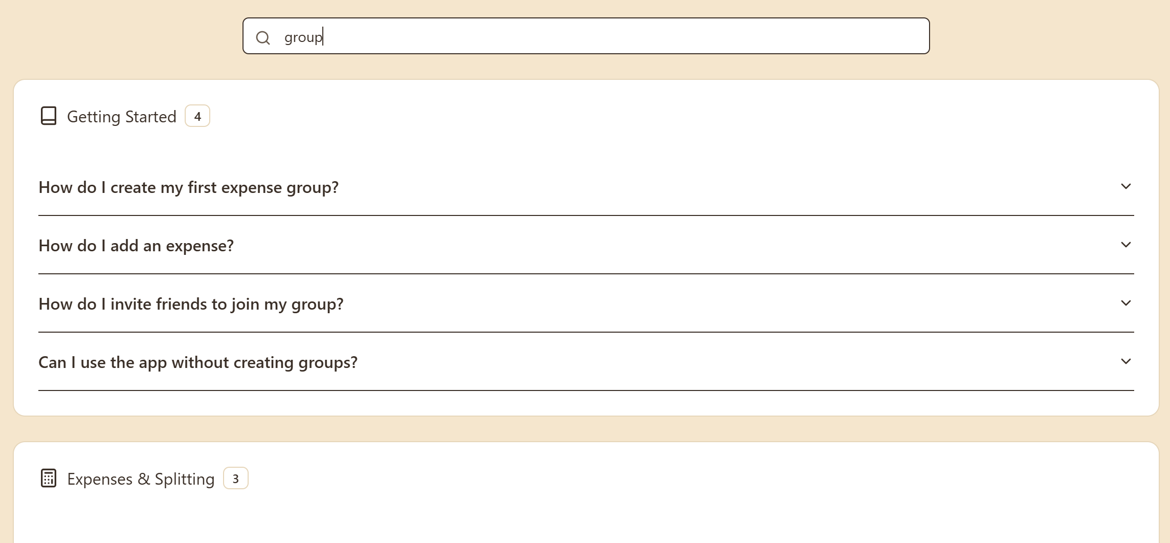

Test 2 — Search With No Matching Results
Input: xyz123
Expected Output: “No results found” card should appear.
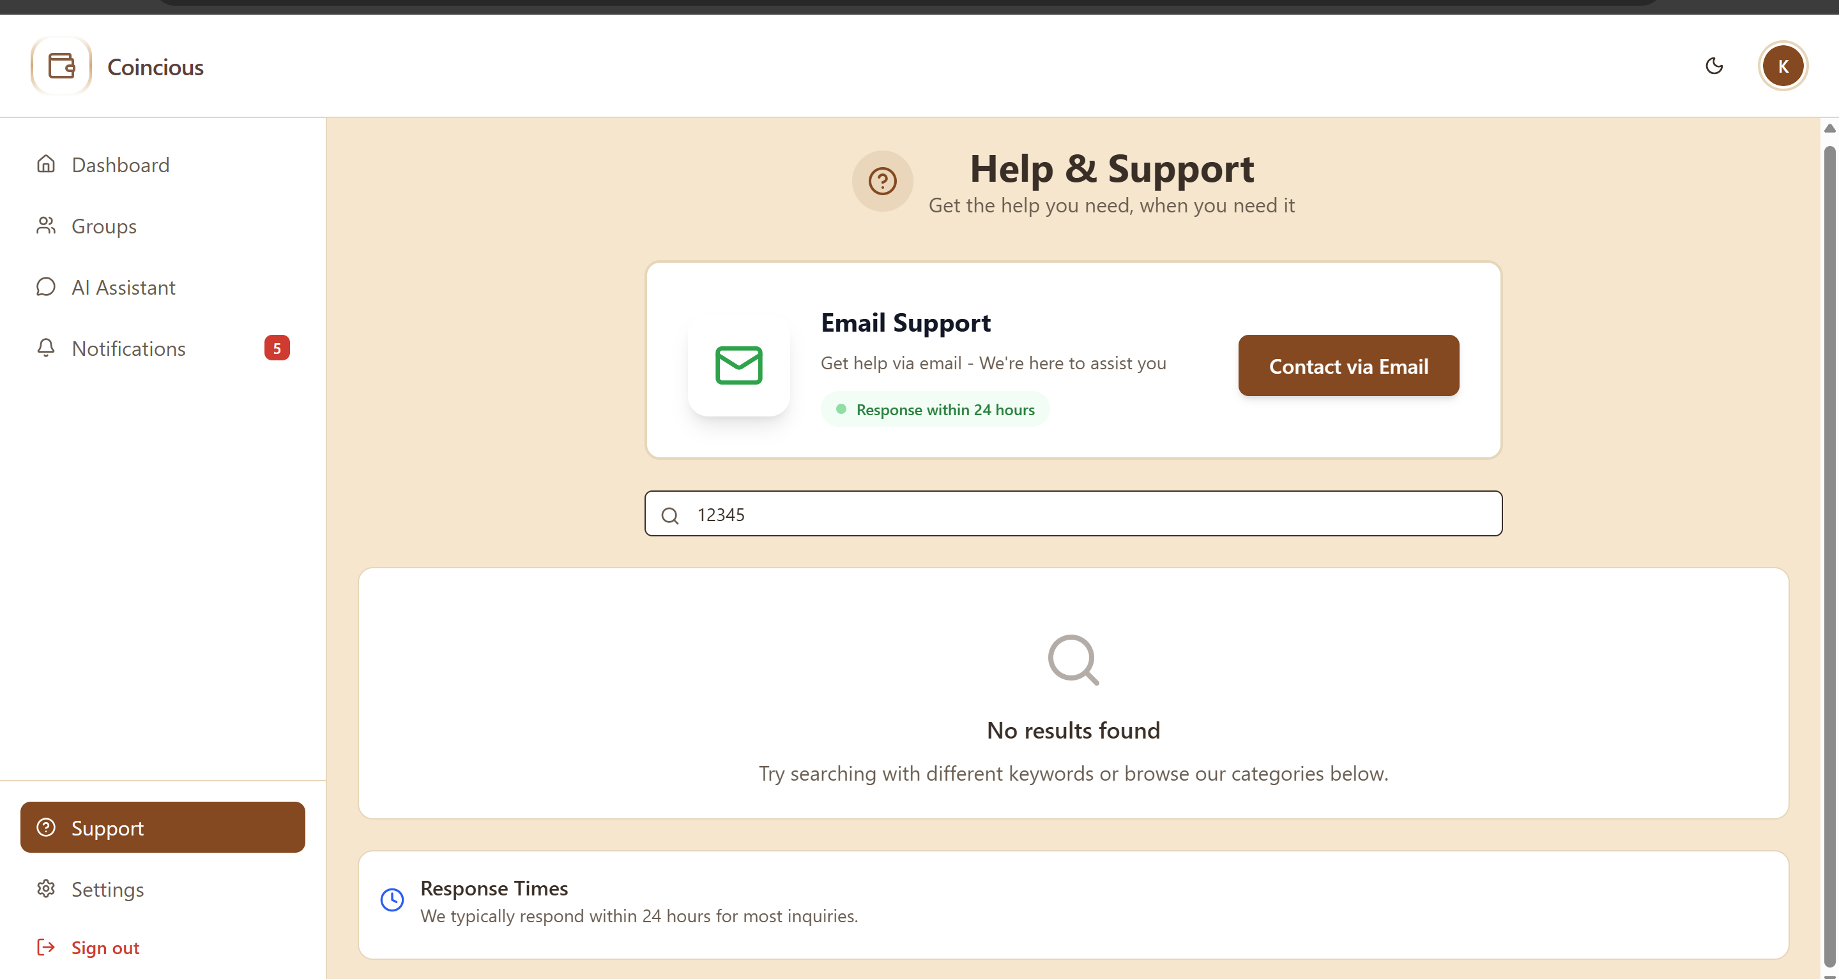

Test 3 — Expand/Collapse FAQ Accordion
Action: Click on any FAQ question → then click again
Expected Output:
- First click: Answer should expand
- Second click: Answer collapses
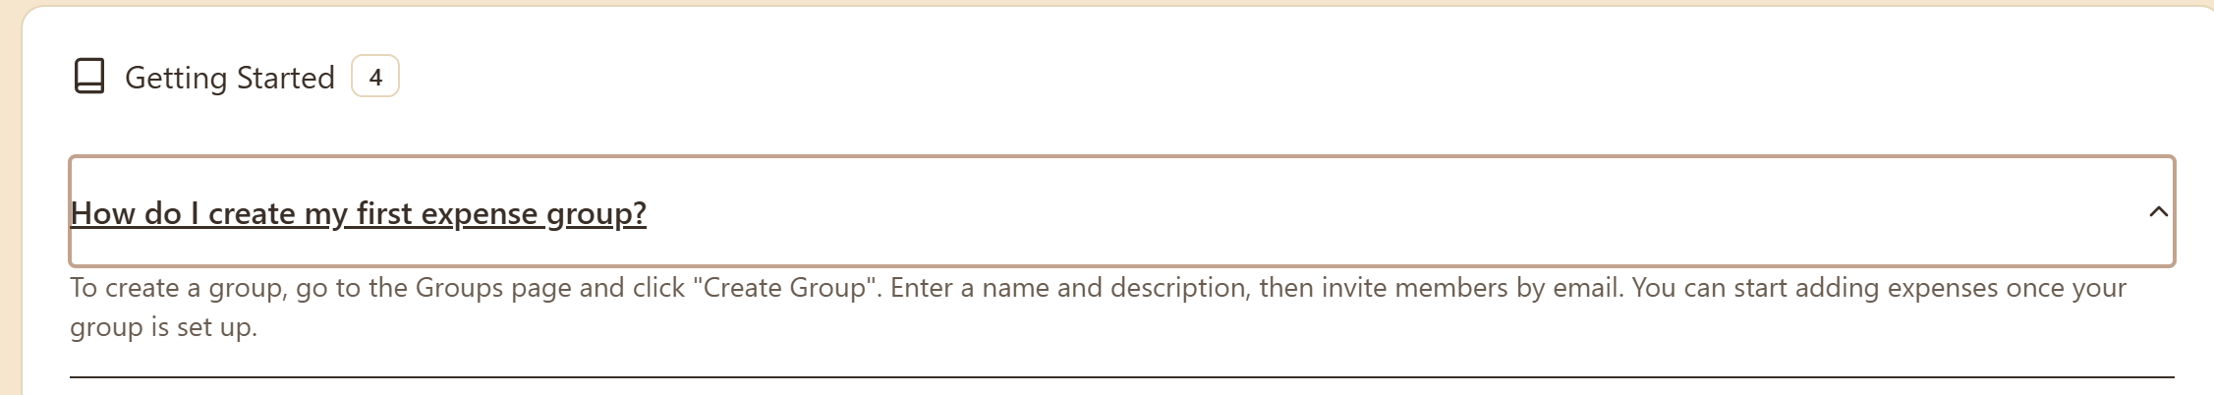
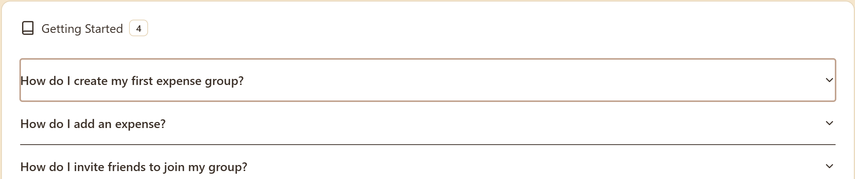

Test 4 — Open Email Support Modal
Action: Click onto the contact via email button
Expected Output: Email Support modal should appear with two email options.
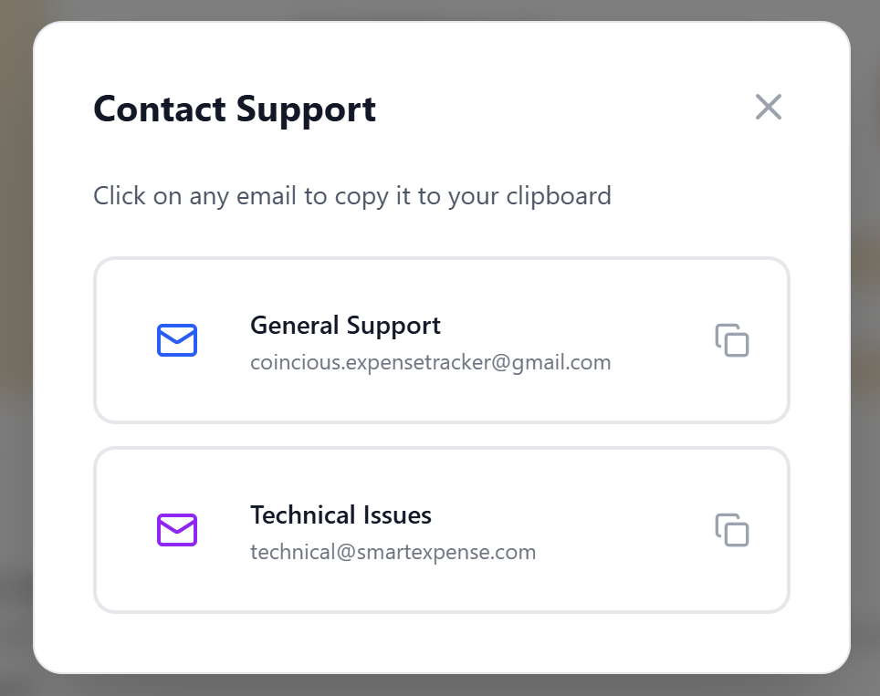

Test 5 — Copy Email to Clipboard
Action: Click on General Support email
Expected Output:
- ✔ (tick icon) should appear
- Email copied to clipboard
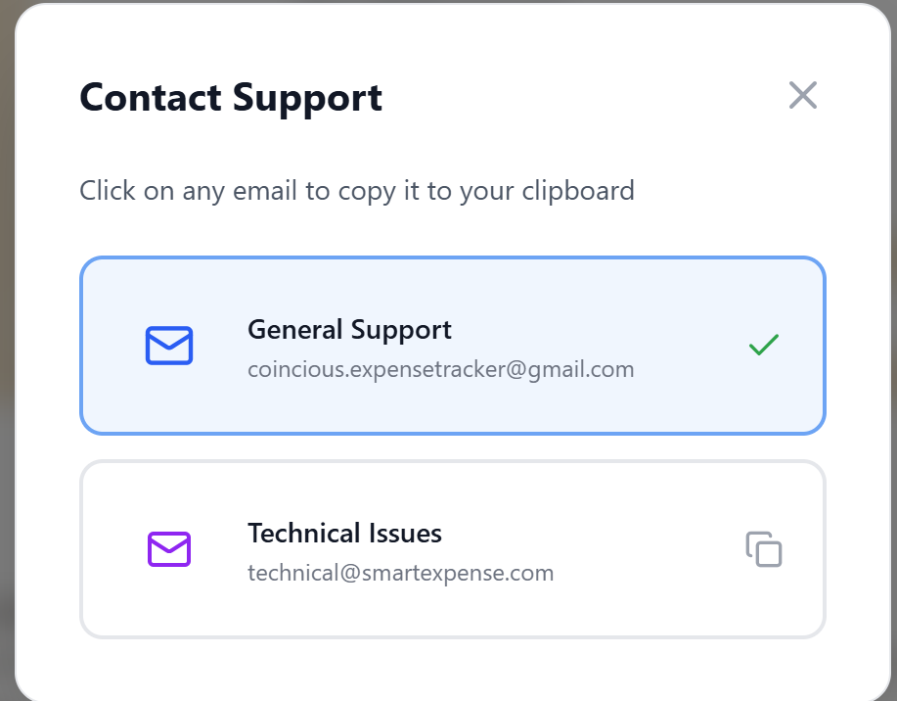

Test 6 — Close Modal
Action: Click outside modal OR press “X”
Expected Output: Modal closes.
