
GROUP - 28
System Testing – Addexpense (Personal + Group)
Testers: Kirtan, Ruchir

1. Add Expense (Personal) – Field Constraints
Title (Required)
- Cannot be empty
- Must have at least 1 character which is not a space.
Amount (Required)
- Cannot be empty
- Must be a valid number
- Must be greater than 0
- Will allow decimals values
Date (Required)
- Cannot be empty
- Data format must be valid.
- Invalid date strings are not allowed.
- Future dates are not allowed.
Category (Required)
- Cannot be empty
- Must be selected from the dropdown options or auto categorize with AI
Description (Optional)
- Can be empty
- Can contain any characters
Receipt Upload (Optional)
- Can be left empty
- If uploaded, must be JPG, PNG, or PDF

2. Equivalence Class Partitioning (ECP)
EC Class | Title | Amount | Date | Category | Receipt | Expected Result
E1 | valid | valid (>0) | valid | valid | optional | success
E2 | invalid (empty) | valid | valid | valid | optional | error
E3 | valid | invalid (empty) | Valid | valid | optional | error
E4 | valid | valid | invalid ( wrong format) | valid | optional | error
E5 | valid | valid | valid | invalid (not selected) | optional | error
E6 | valid | valid | valid | valid | invalid file type | error
E7 | invalid | invalid | valid | valid | optional | error
E8 | valid | invalid | invalid | valid | optional | error
E9 | valid | valid | invalid | invalid | optional | error
E10 | invalid | invalid | invalid | invalid | invalid | error

3. Boundary Value Analysis (BVA)
Covers limits of numeric, date, and input formats.

Title | Amount | Date | Category | Receipt | Expected Output | Actual Output | Reason
"" | 100 | 20/11/2025 | Food | none | fail | fail | Title must be non-empty
"Lunch" | 0 | 20/11/2025 | Travel | none | fail | fail | Amount must be > 0
"Lunch" | -10 | 20/11/2025 | Health | none | fail | fail | Negative amount invalid
"Lunch" | abc | 20/11/2025 | Food | none | fail | fail | Amount must be numeric
"Lunch" | 100 | "" | Food | none | fail | fail | Date cannot be empty
"Lunch" | 100 | 20/11/2025 | (not selected) | none | fail | fail | Category required
"Lunch" | 100 | 20/11/2025 | Food | file.exe | fail | fail | Invalid file type
"Lunch" | 100 | 20/11/2025 | Travel | receipt.png | success | success | Valid input with receipt

Acceptance Testing — Add Expense (Personal)

Test 1 — Missing Required Field (Empty Title)
Title: (empty)
Amount: 150
Date: 20/11/2025
Category: Food
Receipt: None
Expected Output: Invalid , popup indicating to fill the title field
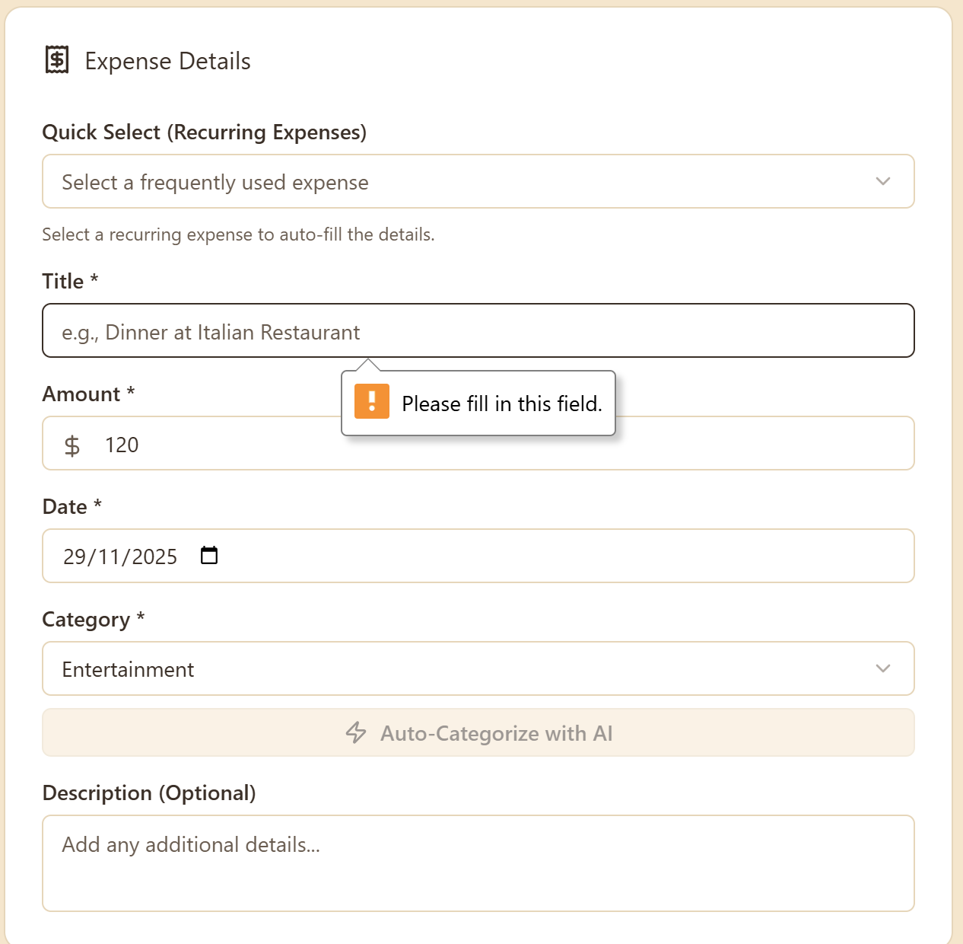

Test 2 — Invalid Amount (Zero or Negative)
Title: Grocery Shoppings
Amount: 0
Date: 20/11/2025
Category: Grocerie
Receipt: None
Expected Output: Invalid (Amount must be greater than 0)
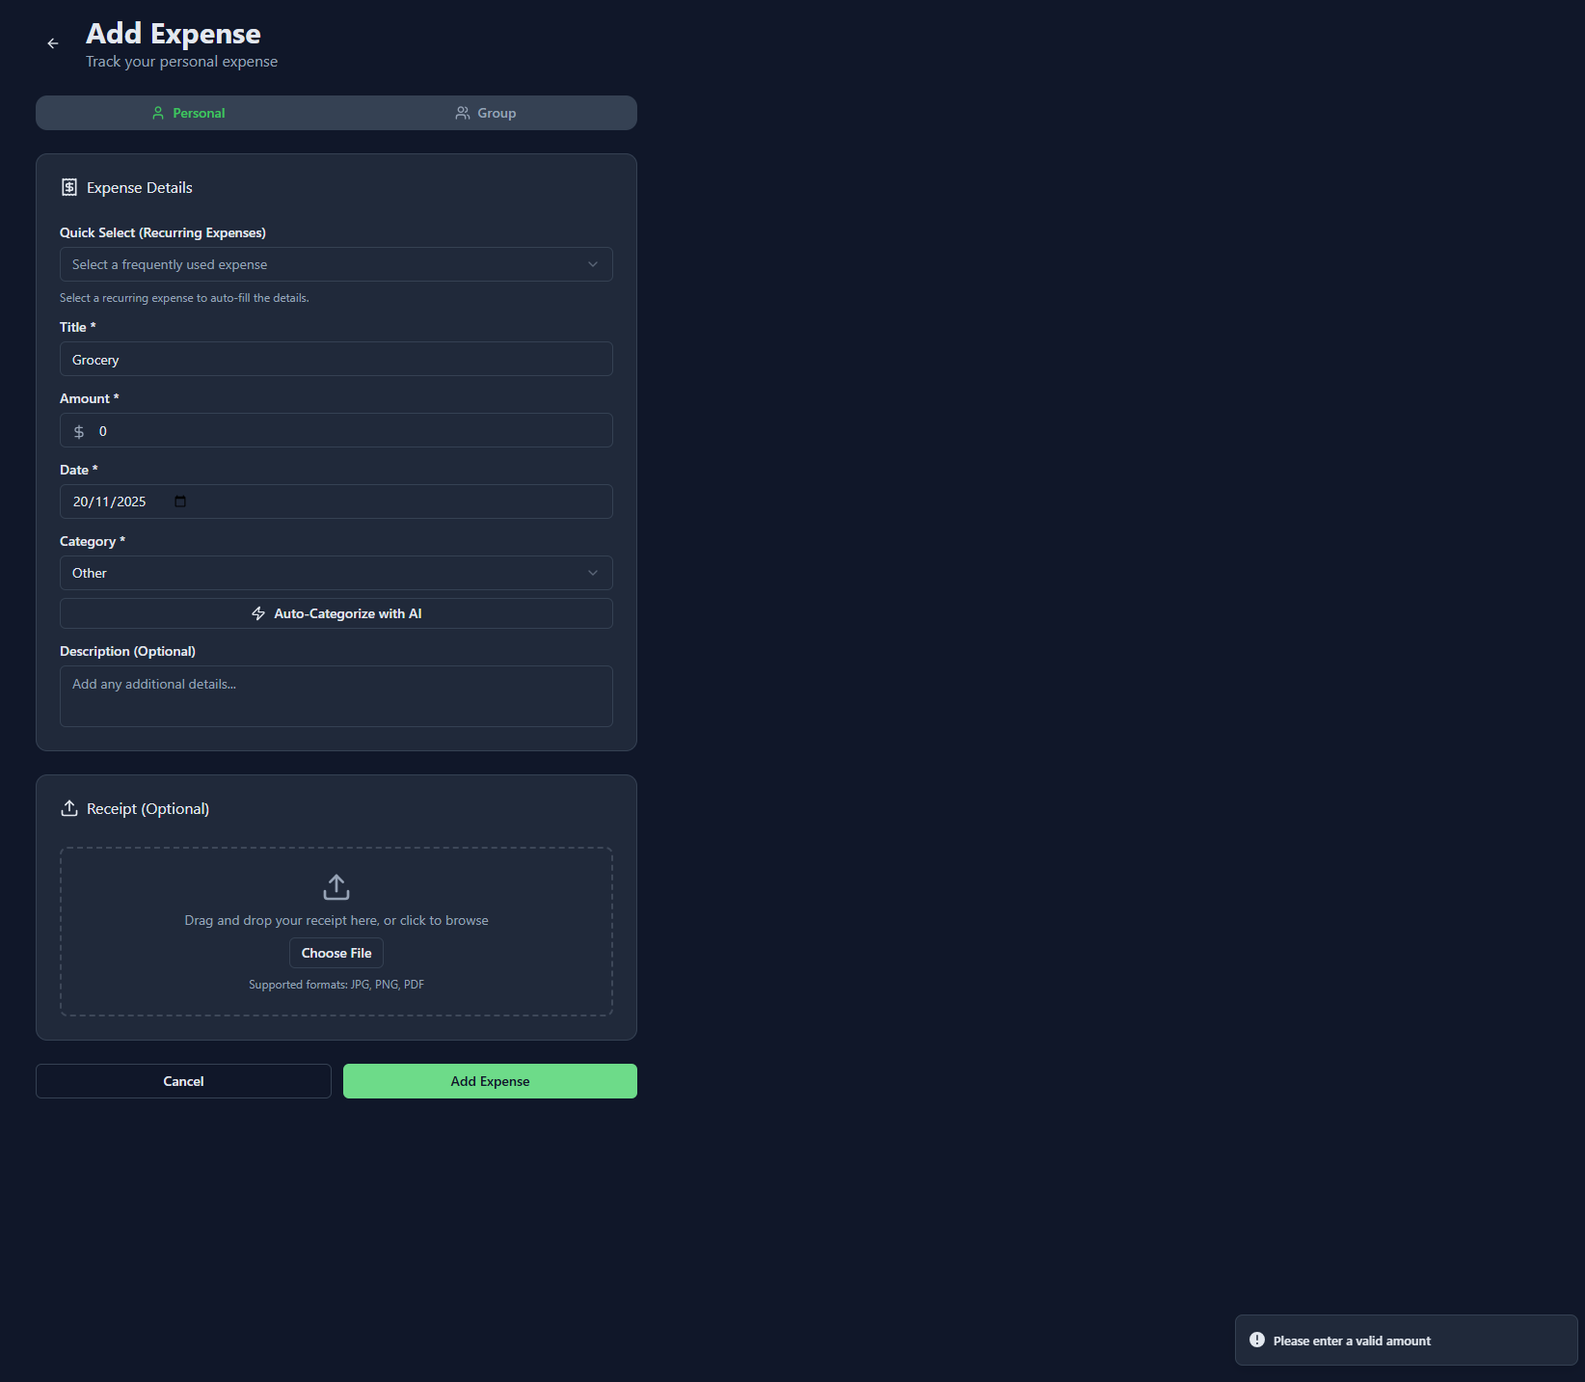
Test 3 — Invalid Amount (Non-numeric)
Title: Grocery
Amount: 0
Date: 20/11/2025
Category: Travel
Receipt: None
Expected Output: Invalid (Amount must be numeric)
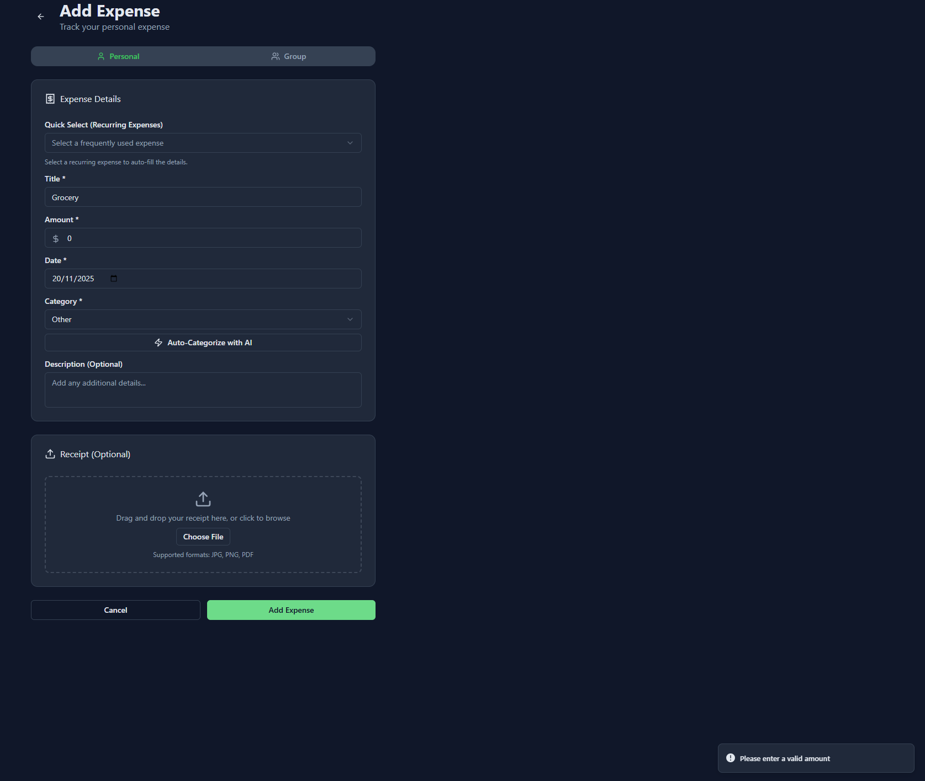
Test 4 — Category Not Selected
Title: poker
Amount: 120
Date: 20/11/2025
Category: (not selected)
Receipt: None
Expected Output: Invalid (Category required)
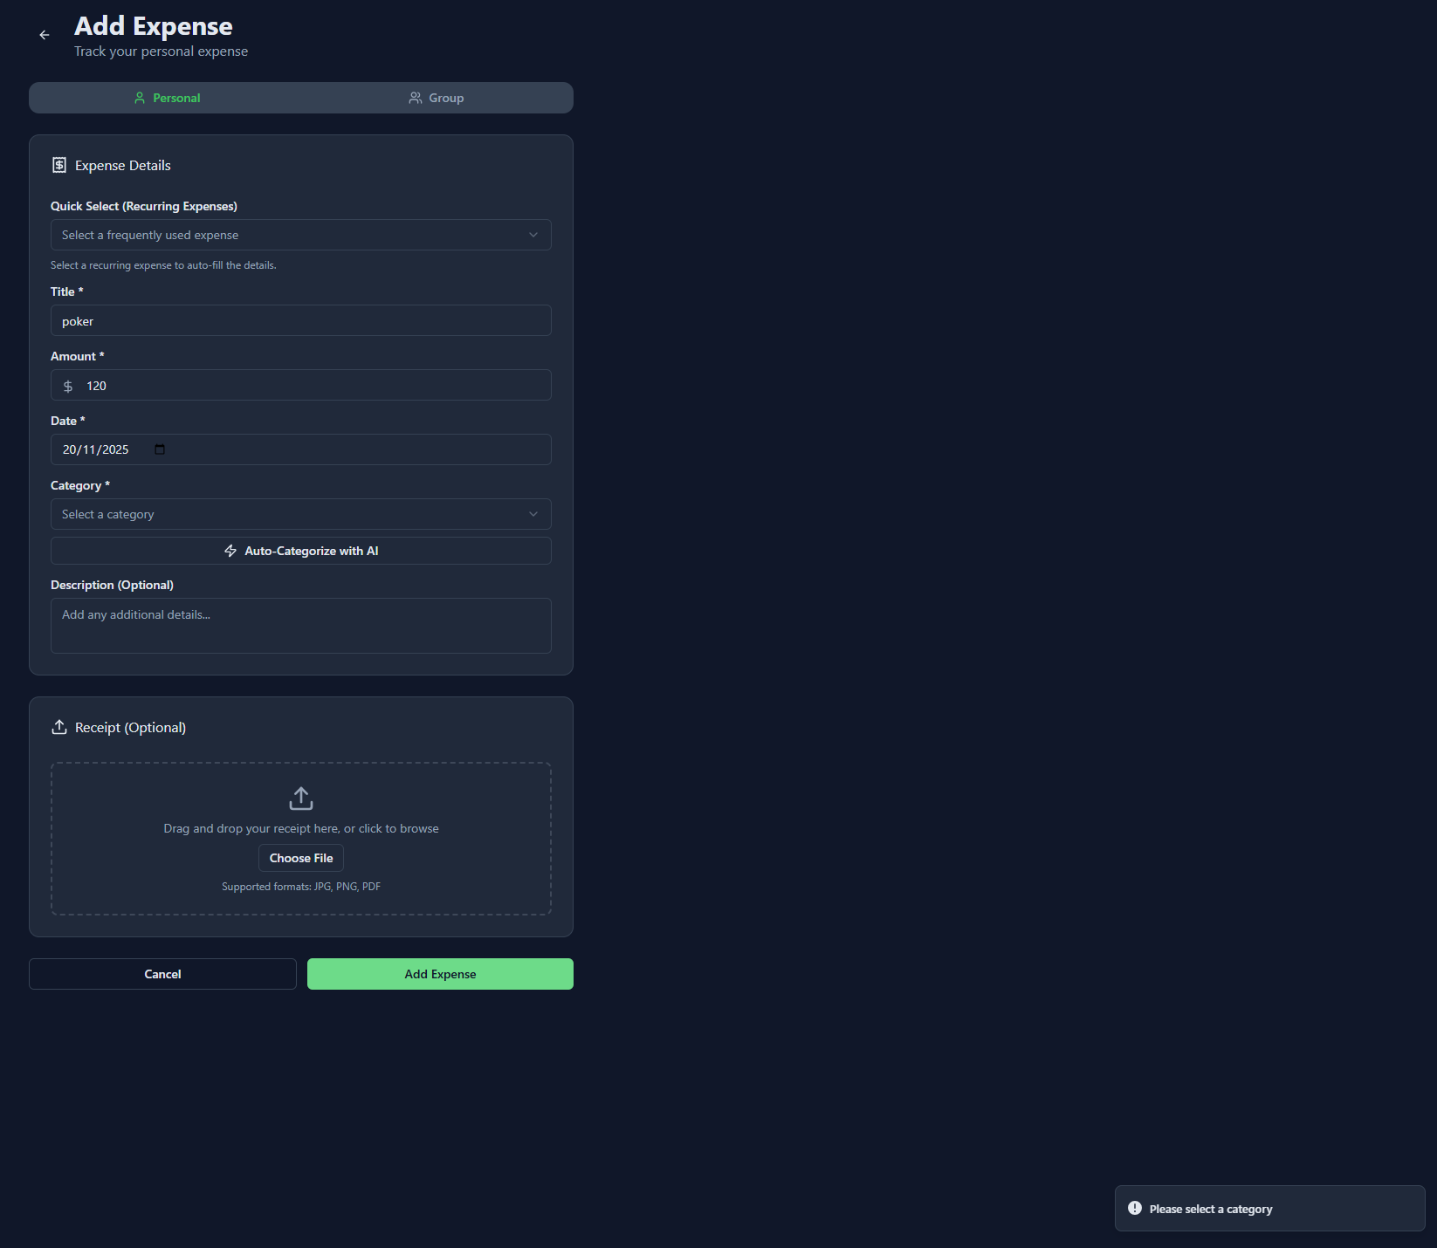
Test 5 — Invalid Receipt File Type
Title: Bill
Amount: 50
Date: 20/11/2025
Category: Utilities
Receipt: file.exe
Expected Output: Invalid (Only JPG, PNG, PDF allowed)
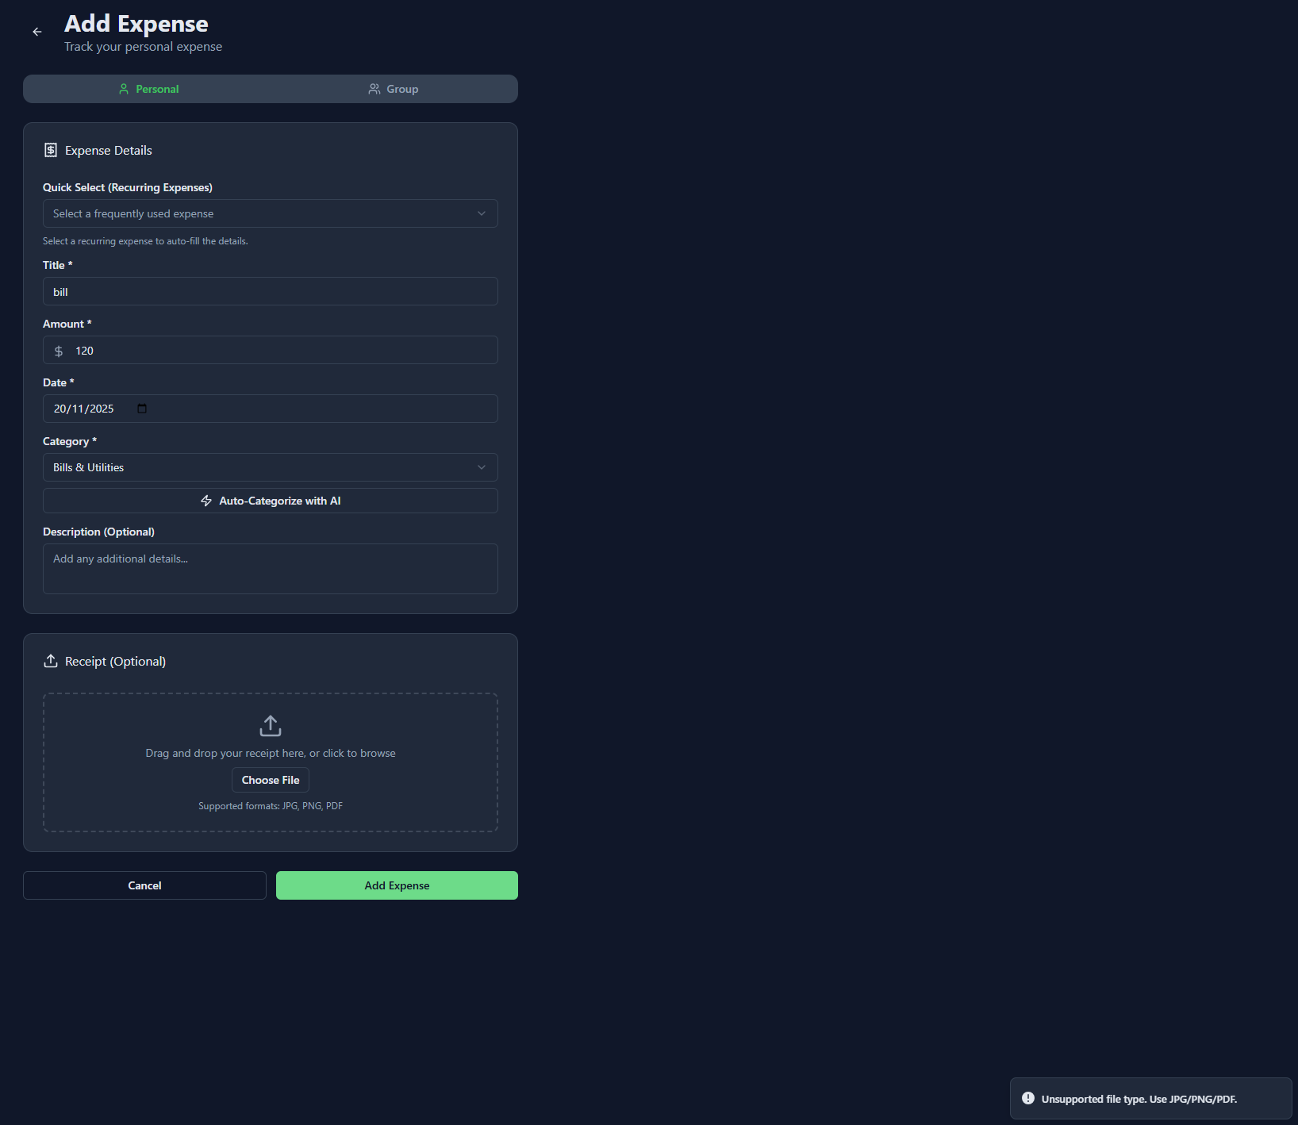

Test 6 — Invalid Date Format
Title: Parking
Amount: 10
Date: 20-02-3000
Category: Transport
Receipt: None
Expected Output: valid must be less than {current date}.
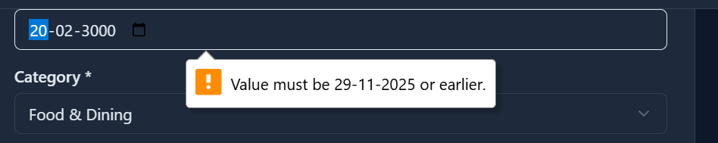
Test 7 — Successful Expense Creation
Title: Dinner at Italian Restaurant
Amount: 75.50
Date: 20/11/2025
Category: Food
Receipt: receipt.png
Expected Output: Success (Expense added successfully)

Test 8 – Future Dates Not Allowed
Date Selected: 01/01/2030
Expected Output:
User should not be able to select a future date from the calendar.
Disable future dates (click option will be disabled).

Screenshot:
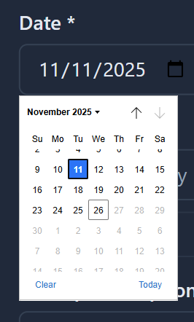
BlackBox Testing — Add Expense (Group Section)
*Note = Since the initial part of the group section is completely same to the personal expense section , hence we are not reapting the testing required for those particular fields (expenmse detail)
1. Group & Payment – Field Constraints

Select Group (Required)
- Cannot be empty
- Only options in dropdown allowed
Paid By (Required)
- At least one member should be selected.
- Submit disabled without selecting payer
Split Method
Two modes:

A. Equal Division Mode
- Must select at least one member to split with
- All selected members will be included in equal calculation
- System automatically divides total amount by the number of members.
- If no members are selected, then it is invalid

B. Unequal Division Mode
- User will input the amount split between every member.
- All member fields must be filled
- Each amount must be ≥ 0
- Sum of all split amounts MUST equal to the Total Expense Amount
- Otherwise, it will show error

General Split Constraints
- If split validation fails than the expense cannot be added
- No negative values
- No empty fields (for Unequal division)
- This unequal splitting total should be equal to the total amount

2. Equivalence Class Partitioning (ECP)

EC Class | Group Selected | Paid By | Split Method | Split Values | Expected Result
E1 | valid | valid | Equal | valid members selected | success
E2 | valid | valid | Unequal | values sum = total | success
E3 | invalid (none) | - | - | - | error
E4 | valid | invalid (none) | - | any | error
E5 | valid | valid | Equal | no members selected | error
E6 | valid | valid | Unequal | missing values | error
E7 | valid | valid | Unequal | non-numeric value | error
E8 | valid | valid | Unequal | negative value | error
E9 | valid | valid | Unequal | sum ≠ total amount | error
E10 | valid | valid | Equal | selecting members not allowed (UI blocked) | error / invalid state
E11 | valid | valid | Unequal | extra members beyond group | error (not possible in UI)
3. Boundary Value Analysis (BVA)

Group | Paid By | Split Method | Split Inputs | Total Amount | Expected Output | Reason
none | — | Equal | — | 100 | fail | Group must be selected
demoGroup32 | ruchir | Equal | none selected | 100 | fail | Must choose members
demoGroup32 | ruchir | Unequal | 50, "" | 100 | fail | Missing input field
demoGroup32 | ruchir | Unequal | 50, abc | 100 | fail | Non-numeric
demoGroup32 | ruchir | Unequal | 50, -10 | 100 | fail | Negative value
demoGroup32 | ruchir | Unequal | 40, 40 | 100 | fail | 40+40 ≠ 100
demoGroup32 | ruchir | Unequal | 50, 50 | 100 | success | Valid split
demoGroup32 | ruchir | Equal | dame3e, ruchir | 100 | success | Valid: 100/2 split

Acceptance Testing : ADD EXPENSE(Groups)

Test 1 — No Group Selected (Required field)
Action / Inputs
- Group: (none selected)
- Paid By: —
- Total Amount: 100
Expected Output: Invalid — popup indicating to select a group
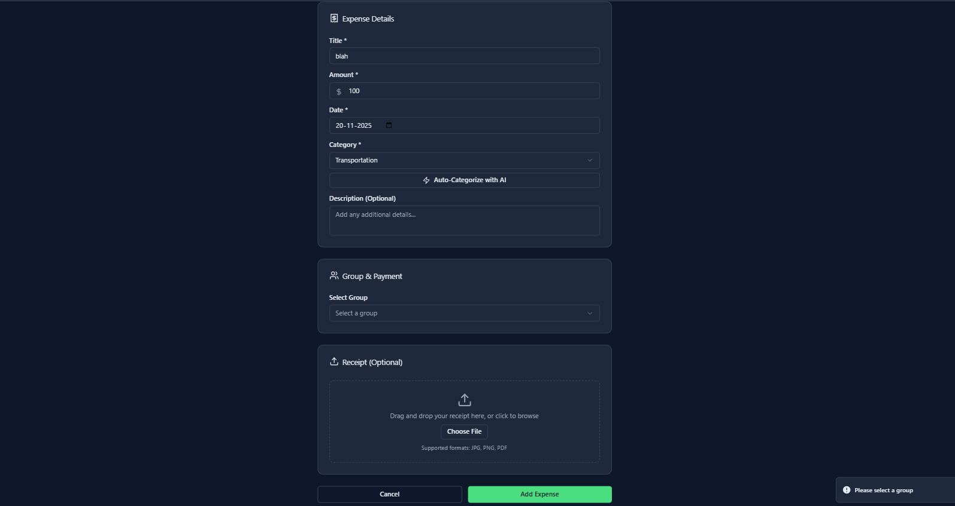

Test Case 2 — Valid Equal Split
Precondition: A group with at least 2 members exists.
Steps:
- Open Add Expense → Group Expense.
- Enter a valid amount (e.g., ₹100).
- Select a valid group.
- Select a valid payer.
- Choose Equal Split.
- Select at least two members for splitting.
- Click Add Expense.
Expected Output:
- Expense is successfully added.
- Confirmation message will be shown.
- Expense will be appeared in Group Expense list.
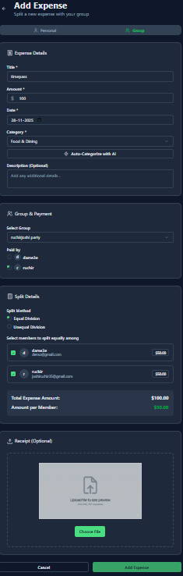
Test Case 3 — Valid Unequal Split
Precondition: Same as above.
Steps:
- Enter amount ₹100.
- Select group and payer.
- Select Unequal Split method.
- Enter valid values for each member, e.g., 60 & 40.
- Click Add Expense.
Expected Result:
- Expense added successfully.
- Confirmation message visible.
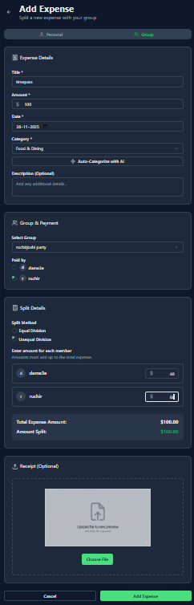
Test Case 4 — Invalid Unequal Split (Sum mismatch)
Steps:
- Enter amount ₹100.
- Select group and payer.
- Choose Unequal Split.
- Enter 50 & 20 (does not total 100).
- Click Add Expense.
Expected Result:
Expense is not saved.
- Error message / validation occurs: “Remaining to allocate.”
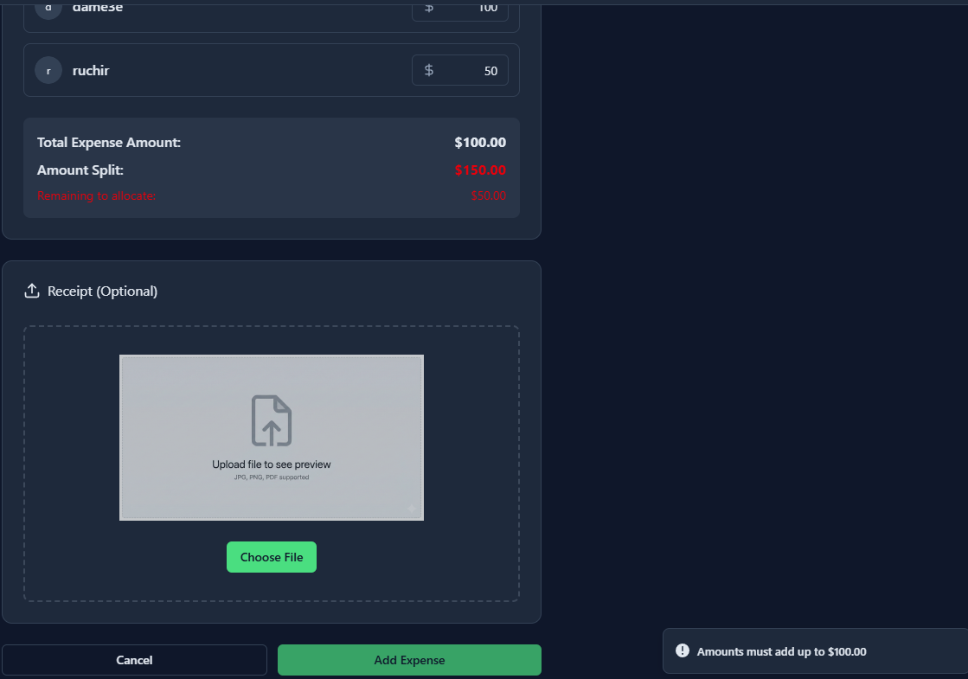
Test Case 5 — No Members Selected in Equal Split
Steps:
- Enter valid amount.
- Select valid group + payer.
- Choose Equal Split.
- Do not select any members.
- Click Add Expense.
Expected Result:
- Expense is not added.
- System asks to select members.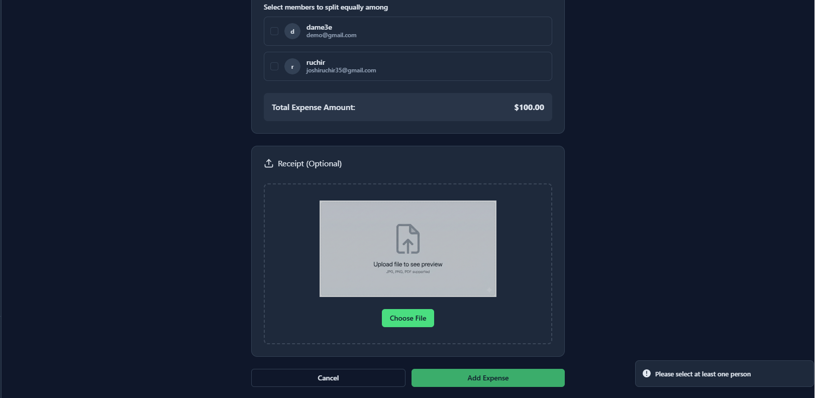
Test Case 6 — Negative or Non-numeric Values of amount in unequal split.
Steps:
- Enter amount ₹100.
- Select group & payer.
- Choose Unequal Split.
- Enter -20 or abc as one member’s amount.
- Click Add Expense.
Expected Result:
- Invalid Number.
