
GROUP – 28
SYSTEM TESTING Landing , Signup and Login
Testers : Kirtan Chauhan and Ruchir Joshi

Introduction
This document explains the system testing done for the Signup, Login, and Landing Page of the Smart Expense app. We used Black-Box Testing methods such as Equivalence Class Partitioning (ECP) and Boundary Value Analysis (BVA) to check how the system behaves with different types of inputs. Acceptance Testing was also performed to verify real user actions like submitting forms and navigating through the app.
Along with validation testing for Signup and Login, the Landing Page was tested for overall usability, navigation, and support form functionality to ensure a smooth and responsive user experience.

BlackBox Testing - Landing Page

1] Landing Page – System Constraints
- Support Form: All fields must be filled; email must be valid; empty form cannot be submitted; after submitting, show success message and close the popup.
- Theme Switch: On Clicking the sun/moon icon theme should change from Light to Dark (or vice versa) instantly.
- Page Display: Page should open without login; text and images should look correct in both themes.
- Watch Demo: Button should play or open a demo video showing how the app works.
- Create Account Button: Should open the signup page when clicked.

2] Equivalence Class Partitioning (ECP) – Landing Page

Class | Support Form Fields (Name, Subject, Message) | Email Format | Support Button Click | Expected Result
E1 | valid | valid | clicked | Success (form submits + success toast)
E2 | invalid (any empty field) | valid | clicked | Error, cannot submit
E3 | valid | invalid (wrong format) | clicked | Error, invalid email
E4 | — (form not opened yet) | — | clicked | Support popup opens
E5 | — | — | not clicked | No action / stays on page

3] Boundary Value Analysis (BVA) – Landing Page

Field | Boundary Value | Expected Result
Name / Subject / Message | Empty | Error shown
Name / Subject / Message | 1 character | Accepted
Email | Empty / invalid (abc@) | Error
Email | First valid (a@gmail.com) | Accepted
Submit | All fields valid | Success message & close popup
Theme Toggle | 1 click | Switches theme

Acceptance Testing – Landing Page

Test Case 1 – Create Account Button Navigation
- Action: User clicks the Create Account button.
- Expected Output: The system should navigate to the Signup Page.

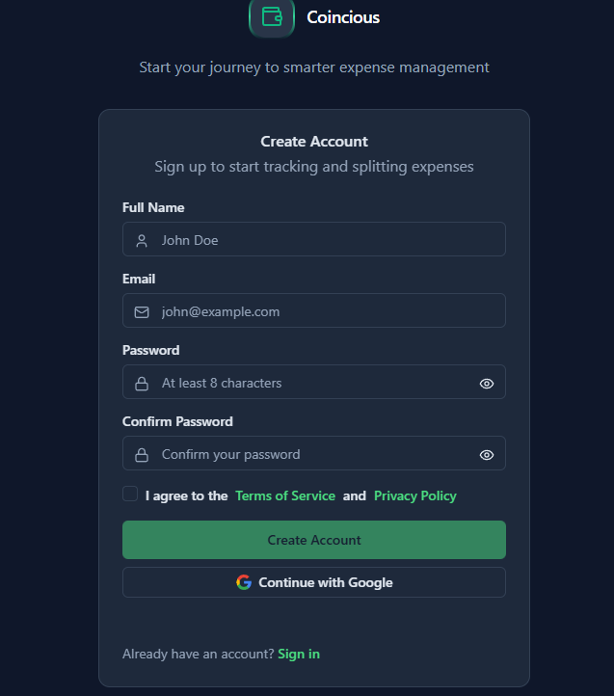

Test Case 2 – Watch Demo Button Functionality
- Action: User clicks Watch Demo button.
- Expected Output: Demo video should play .

Test Case 3 – Support Form Valid Submission
- Action: Enter valid Name, valid Email, Subject, and Message and click Submit.
- Expected Output: Form should submit and success message will appear.



Test Case 4 – Support Form Invalid Submission
- Input: Leave one or more fields blank and click Submit.
- Expected Output: Error message should display and form should not submit.
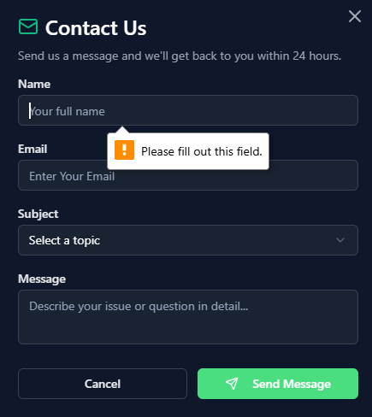

Test Case 5 – Theme Toggle Behaviour
- Input: Click the Theme Toggle icon.
- Expected Output: Page should switch between Light Mode ↔ Dark Mode immediately.
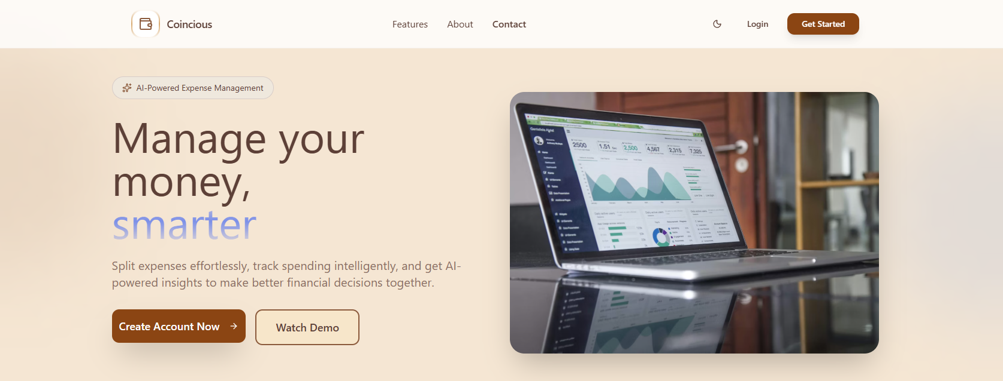
BlackBox Testing — Signup Page

1. Signup Test
Field Constraints:
Full Name Constraints:
- Cannot be empty.
- Must contain at least one alphabetic character.
Email Constraints:
- Cannot be empty.
- Must follow proper email format (example@ex.com )
- Must not already be registered, new Entries only.
Password Constraints:
- Cannot be empty.
- Must contain at least 8 characters.
- At least one Uppercase letter.
- At least one Numerical value from 0 to 9 .
- Atleast one lowercase letter.
- At least one Special character example: !,@,#
Confirm Password Constraints:
- Must match the above password field exactly.
Terms & Conditions Checkbox Constraint:
- Should be ticked for further process
Equivalence Class Partitioning (ECP)

Equivalence Class | Full Name | Email | Password | Confirm Password | T&C Checkbox | Result
E1 | valid | valid | valid (meets all 5 rules) | valid | checked | success
E2 | valid | invalid | valid | valid | checked | error
E3 | valid | valid | invalid (fails ≥1 rule) | valid | checked | error
E4 | valid | valid | valid | invalid | checked | error
E5 | valid | valid | valid | valid | unchecked | error
E6 | invalid | valid | valid | valid | checked | error
E7 | invalid | valid | invalid | valid | checked | error
E8 | invalid | invalid | invalid | invalid | unchecked | error

Boundary Value Analysis (BVA)

Full Name | Email | Password | Confirm Password | T&C | Expected | Actual | Reason
John | john@example.com | Ab1@ (4 chars) | Ab1@ | ✔ | fail | fail | Length < 8
John | john@example.com | abcdefgh | abcdefgh | ✔ | fail | fail | Missing uppercase, number, special
John | john@example.com | Abcdefgh | Abcdefgh | ✔ | fail | fail | Missing number + special
John | john@example.com | Abcd1234 | Abcd1234 | ✔ | fail | fail | Missing special character
John | john@example.com | Abcd@123 | Abcd@12 | ✔ | fail | fail | Confirm password mismatch
John | john@example.com | Abcd@123 | Abcd@123 | ✘ | fail | fail | T&C not accepted
John | existing@gmail.com | Abcd@123 | Abcd@123 | ✔ | fail | fail | Email already registered
John | newuser@gmail.com | Abcd@123 | Abcd@123 | ✔ | success | success | Fully valid input

BlackBox Testing — Login Page

1. Login Test
Field Constraints
Email Constraints:
- Cannot be empty.
- Must follow valid email pattern.
- Must be a registered ID.
Password Constraints:
- Cannot be empty.
- Must match the password stored for the given registered email.
Forgot Password Constraints
In the “Reset Password” modal:
Email Constraints (Reset Password):
- Cannot be empty.
- Must follow valid email pattern.
- Must be registered — reset link only worked for registered user
Button Behaviour:
- “Send Reset Email” must trigger an error if:
  - Email invalid
  - Email unregistered
  - Email empty

Equivalence Class Partitioning (ECP)

Equivalence Class | Email | Password | Result
E1 | valid | valid | success
E2 | invalid | valid | error
E3 | valid | invalid | error
E4 | invalid | invalid | error
E5 | valid but not registered | valid | error
E6 | valid | valid but incorrect | error

Forgot Password — Equivalence Class Partitioning (ECP)
Equivalence Class | Email | Result
F1 | valid & registered | success
F2 | invalid format | error
F3 | empty email | error
F4 | valid format but not registered | error

Boundary Value Analysis (BVA)
Email | Password | Expected Output | Actual Output | Reason
"" (empty) | Abcd@123 | fail | fail | Email cannot be empty
"a@" | Abcd@123 | fail | fail | Invalid email format
admin@gmail.com | "" (empty) | fail | fail | Password cannot be empty
user@demo.com | "abc" | fail | fail | Incorrect password
unregistered@gmail.com | Abcd@123 | fail | fail | Email not registered
user@demo.com | password | success | success | Valid login with correct credentials

Forgot Password — Boundary Value Analysis (BVA)
Email | Expected Output | Actual Output | Reason
"" (empty) | fail | fail | Email cannot be empty
"a@" | fail | fail | Invalid email format
unregistered@gmail.com | fail | fail | Email not found in database
admin@demo.com | success | success | Valid email — reset link sent

Acceptance Testing — Signup Page

Sign-Up Page

Test 1 — Invalid Email Format
Full Name: John Doe
Email: john@
Password: Abcd@123
Confirm Password: Abcd@123
T&C Checkbox: ✔ Checked
Expected Output: Invalid (Email format error)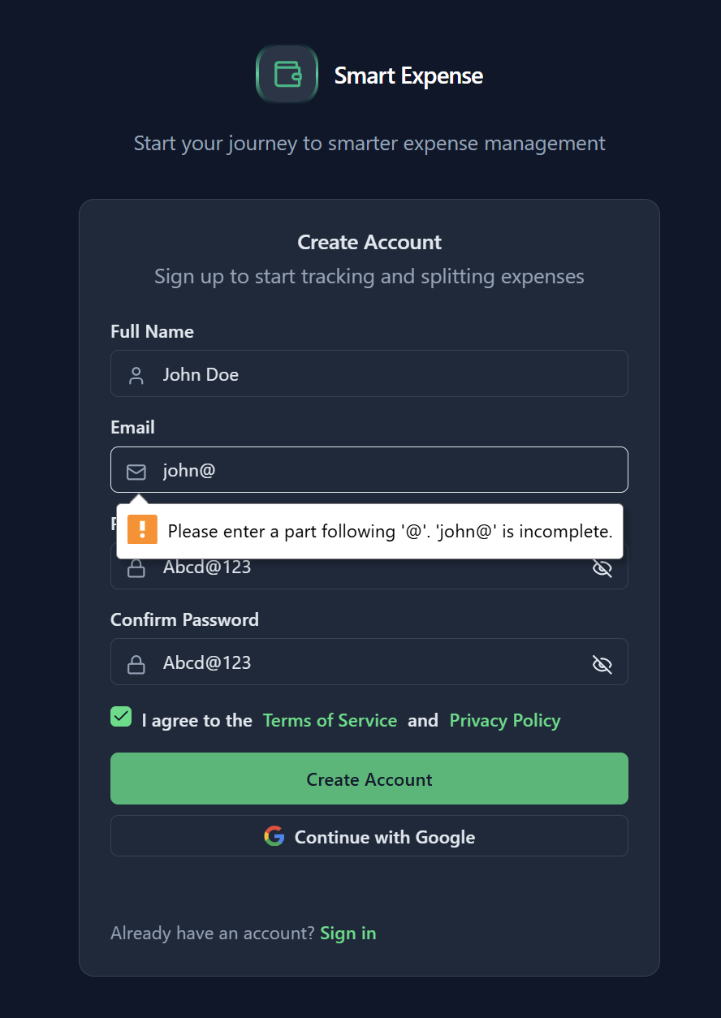

Test 2 — Password constraints not fulfilled.
Full Name: TImepass
Email: you@gmail.com
Password: 1234567
Confirm Password: 1234567
T&C Checkbox: ✔ Checked
Expected Output: Invalid (Password must be ≥ 8 characters)
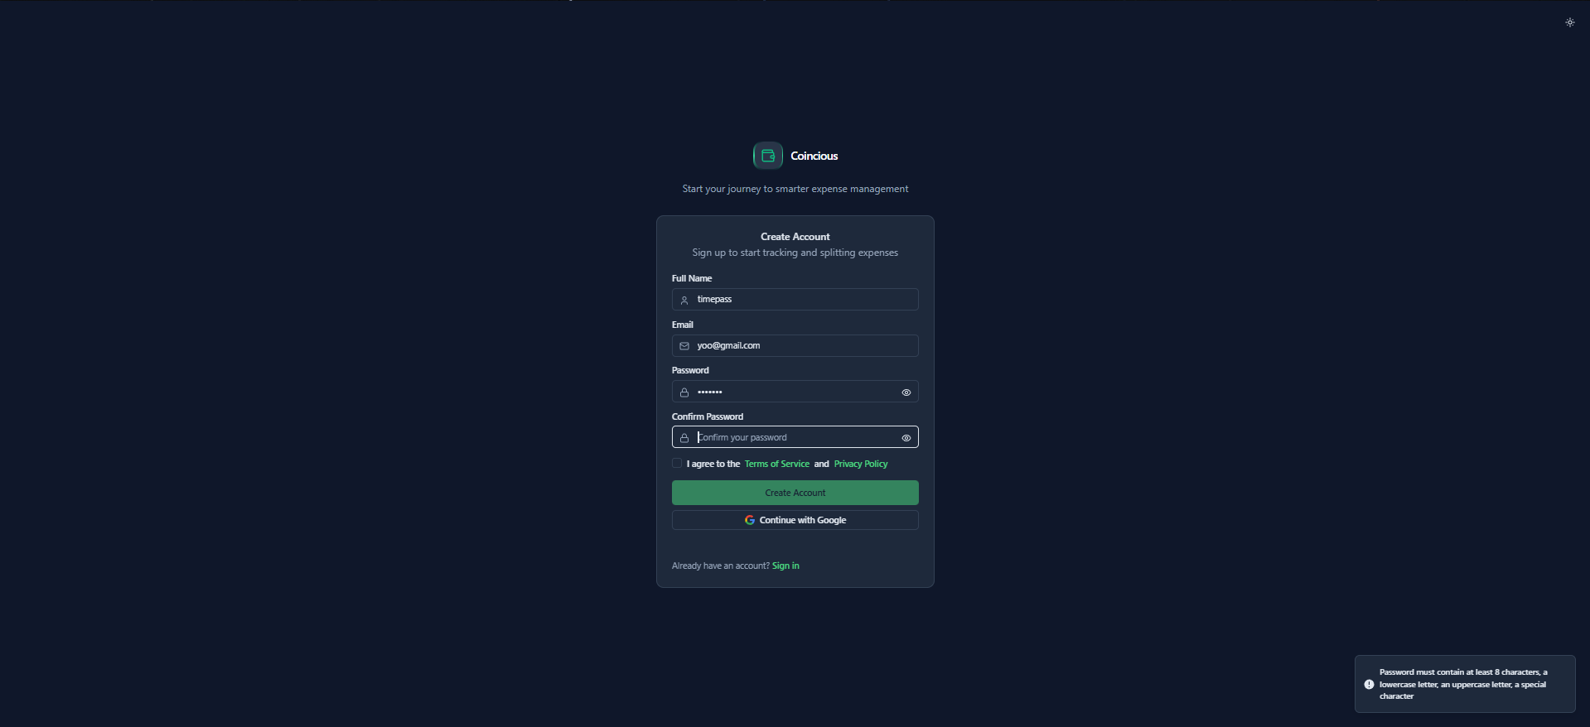
Test 3 — Confirm Password Does Not Match
Full Name: Neel Patel
Email: neel.patel@gmail.com
Password: Abcd@123
Confirm Password: Abcd@12
T&C Checkbox: ✔ CheckedExpected Output: Invalid (Passwords do not match)
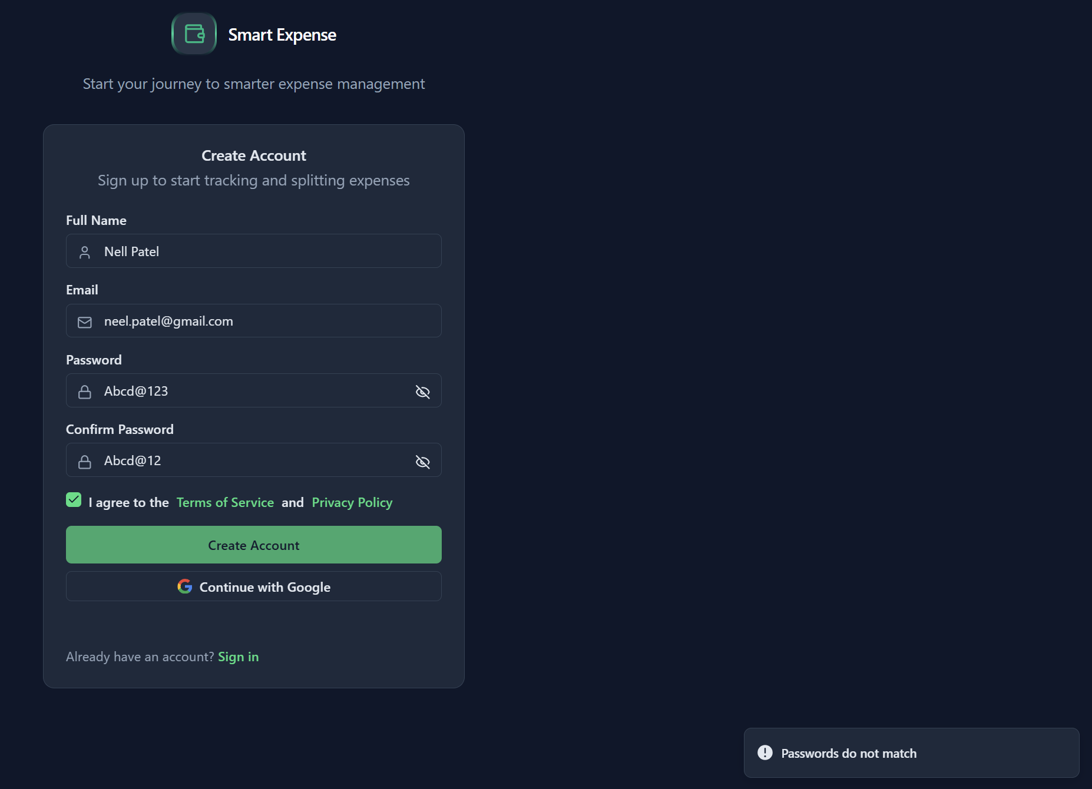

Test 3.1- Toggle button functionality
Full Name: Neel Pa
Email: neel.patel@gmail.com
Password: Abcd@123 toggle button clicked
Confirm Password: Abcd@123toggle button clicked
T&C Checkbox: Checked
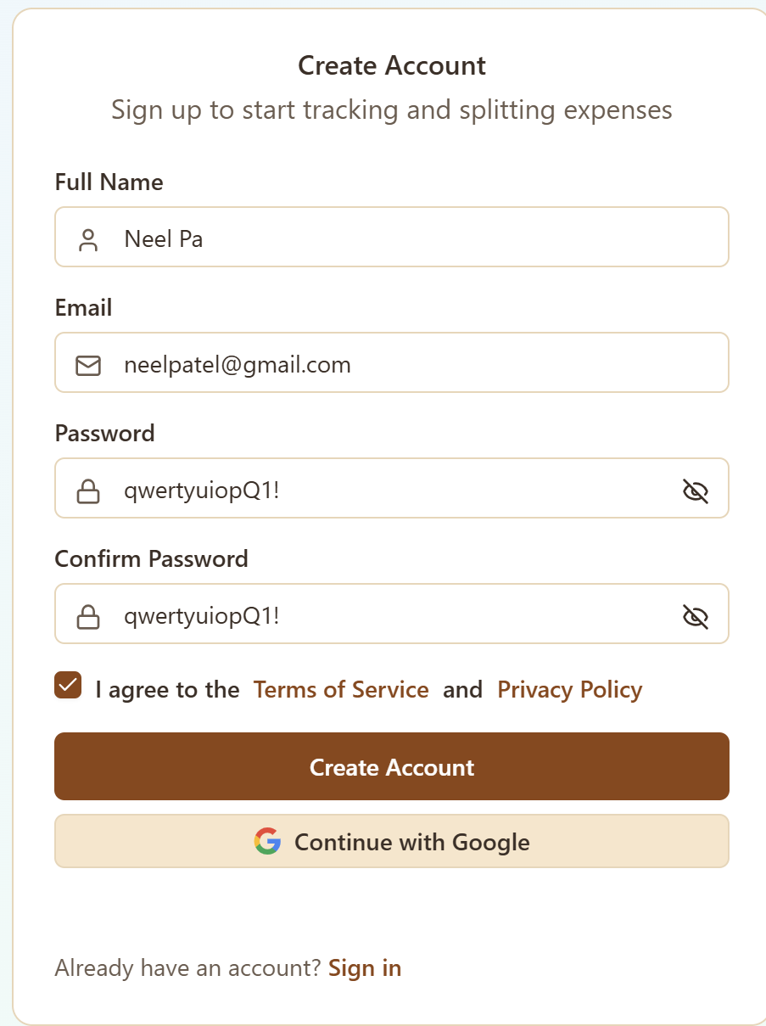

Test 4 — Terms of service and privacy policy Checkbox Not Selected
Full Name: Nell Patel
Email: neel.patel@gmail.com
Password: Abcd@123
Confirm Password: Abcd@123
T&C Checkbox: ✘ Not checked
Expected Output: Invalid (User must accept Terms)
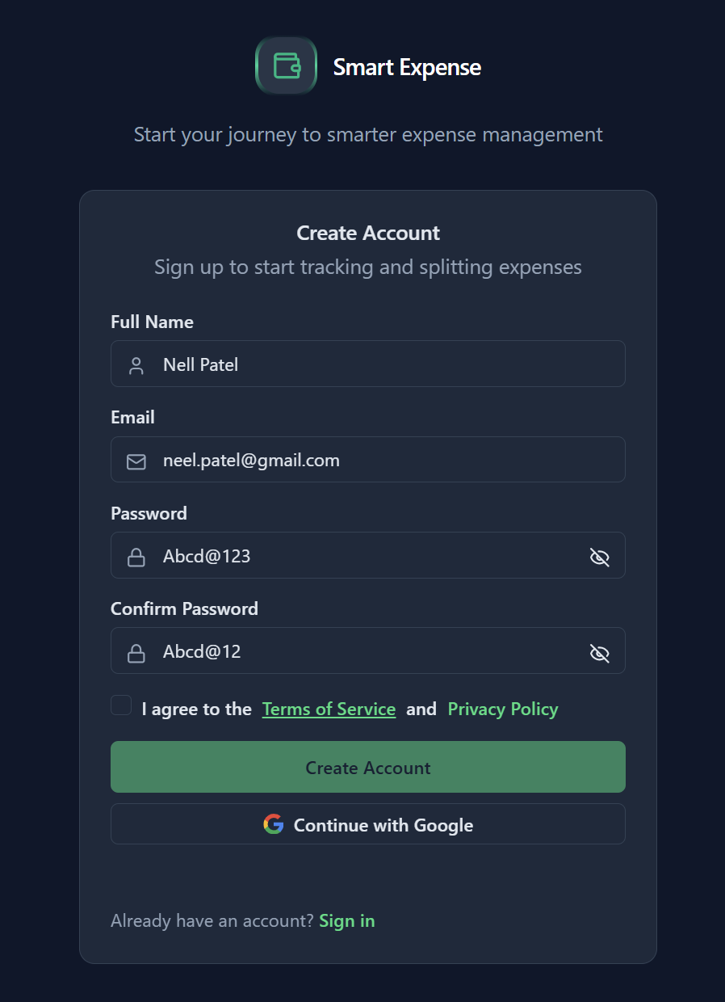
Create Account Button is not Clickable

Test 5 — Email Already Registered
Full Name: Kirtan
Email: 202301409@dau.ac.in
Password: qwertyuiop
Confirm Password:qwertyuiop
T&C Checkbox: ✔ Checked
Expected Output: Invalid (Email already in use)
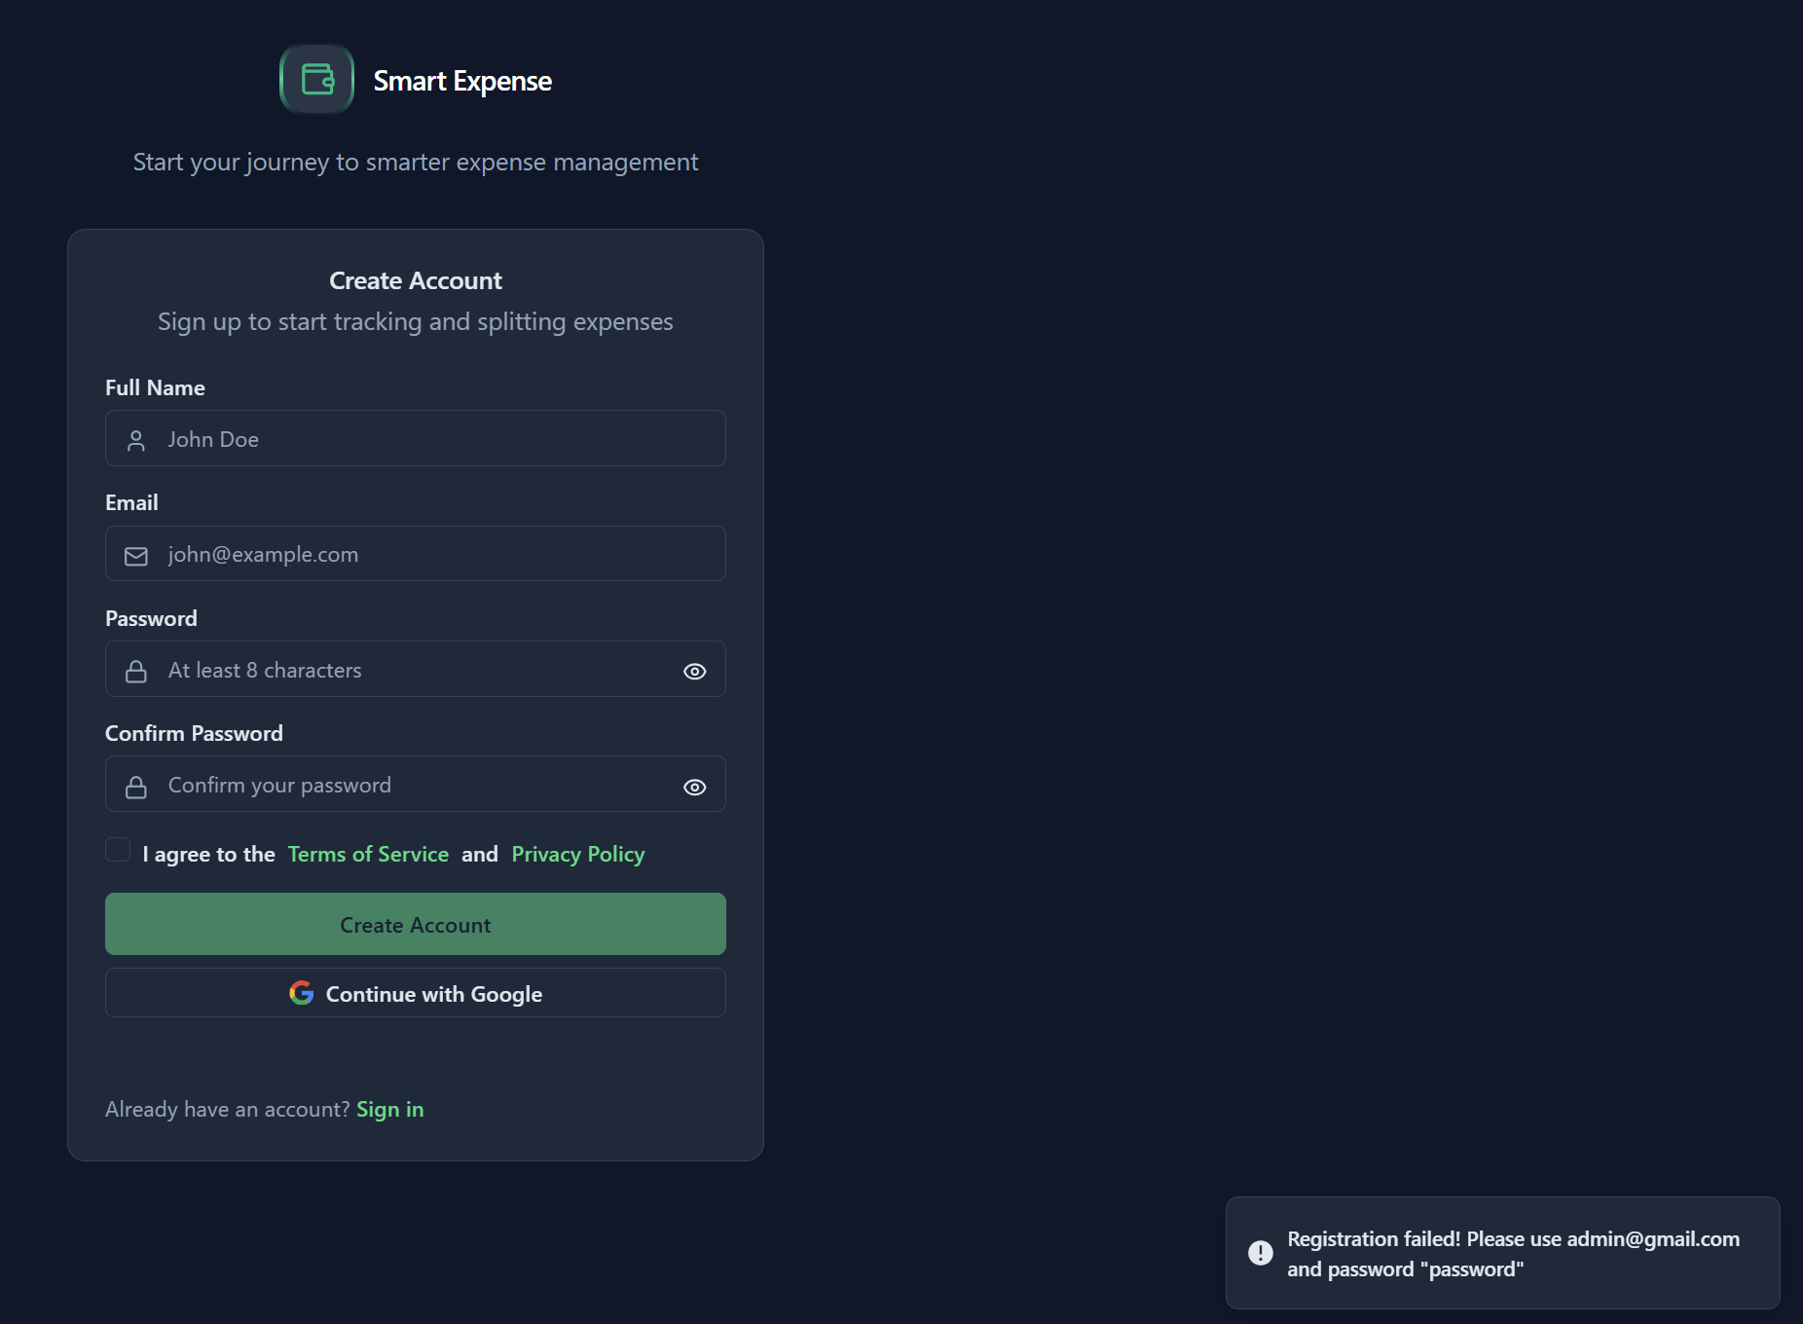
Shows Error signing up , but unclear message.
Message should be User is already registered, try login.

Error solved:
New output:
Will redirect to the login page after this. With proper message popping up

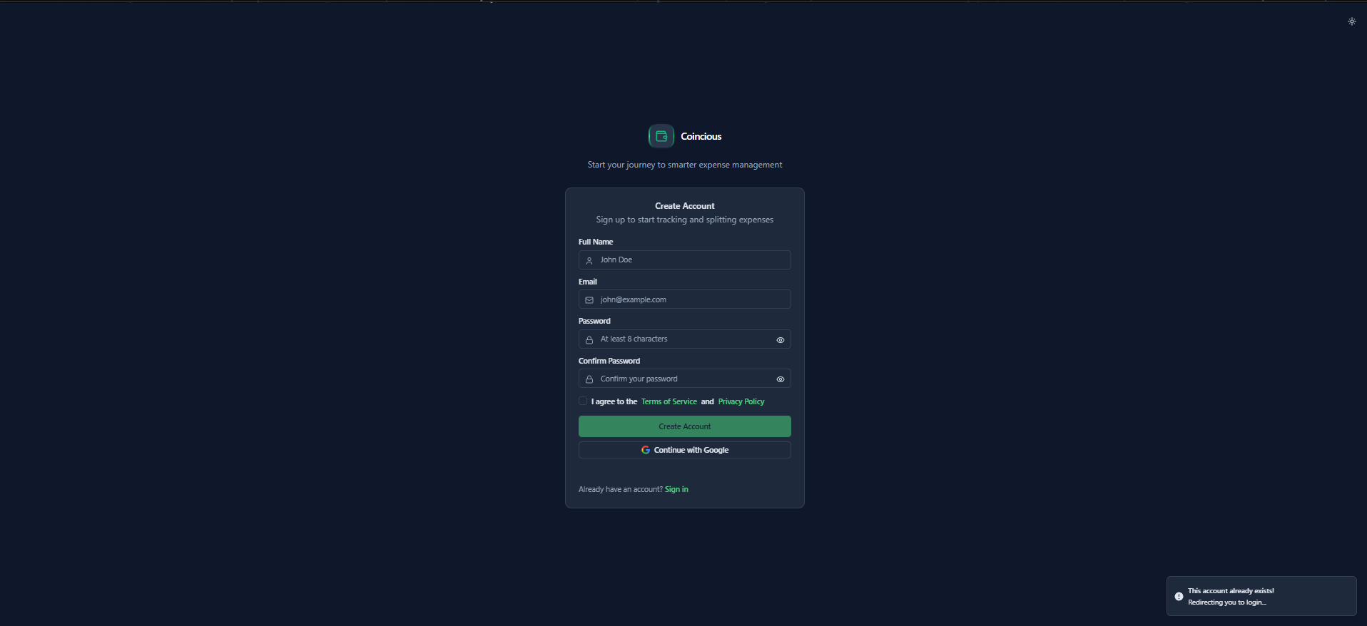
Test 6 — Email Validation
Full Name: random
Email: random@gmail.com
Password: qwertyuiopQ1!
Confirm Password:qwertyuiopQ1!
T&C Checkbox: Checked
Expected Output: Feedback informing a Email sent to the Email address indicating registration of account .
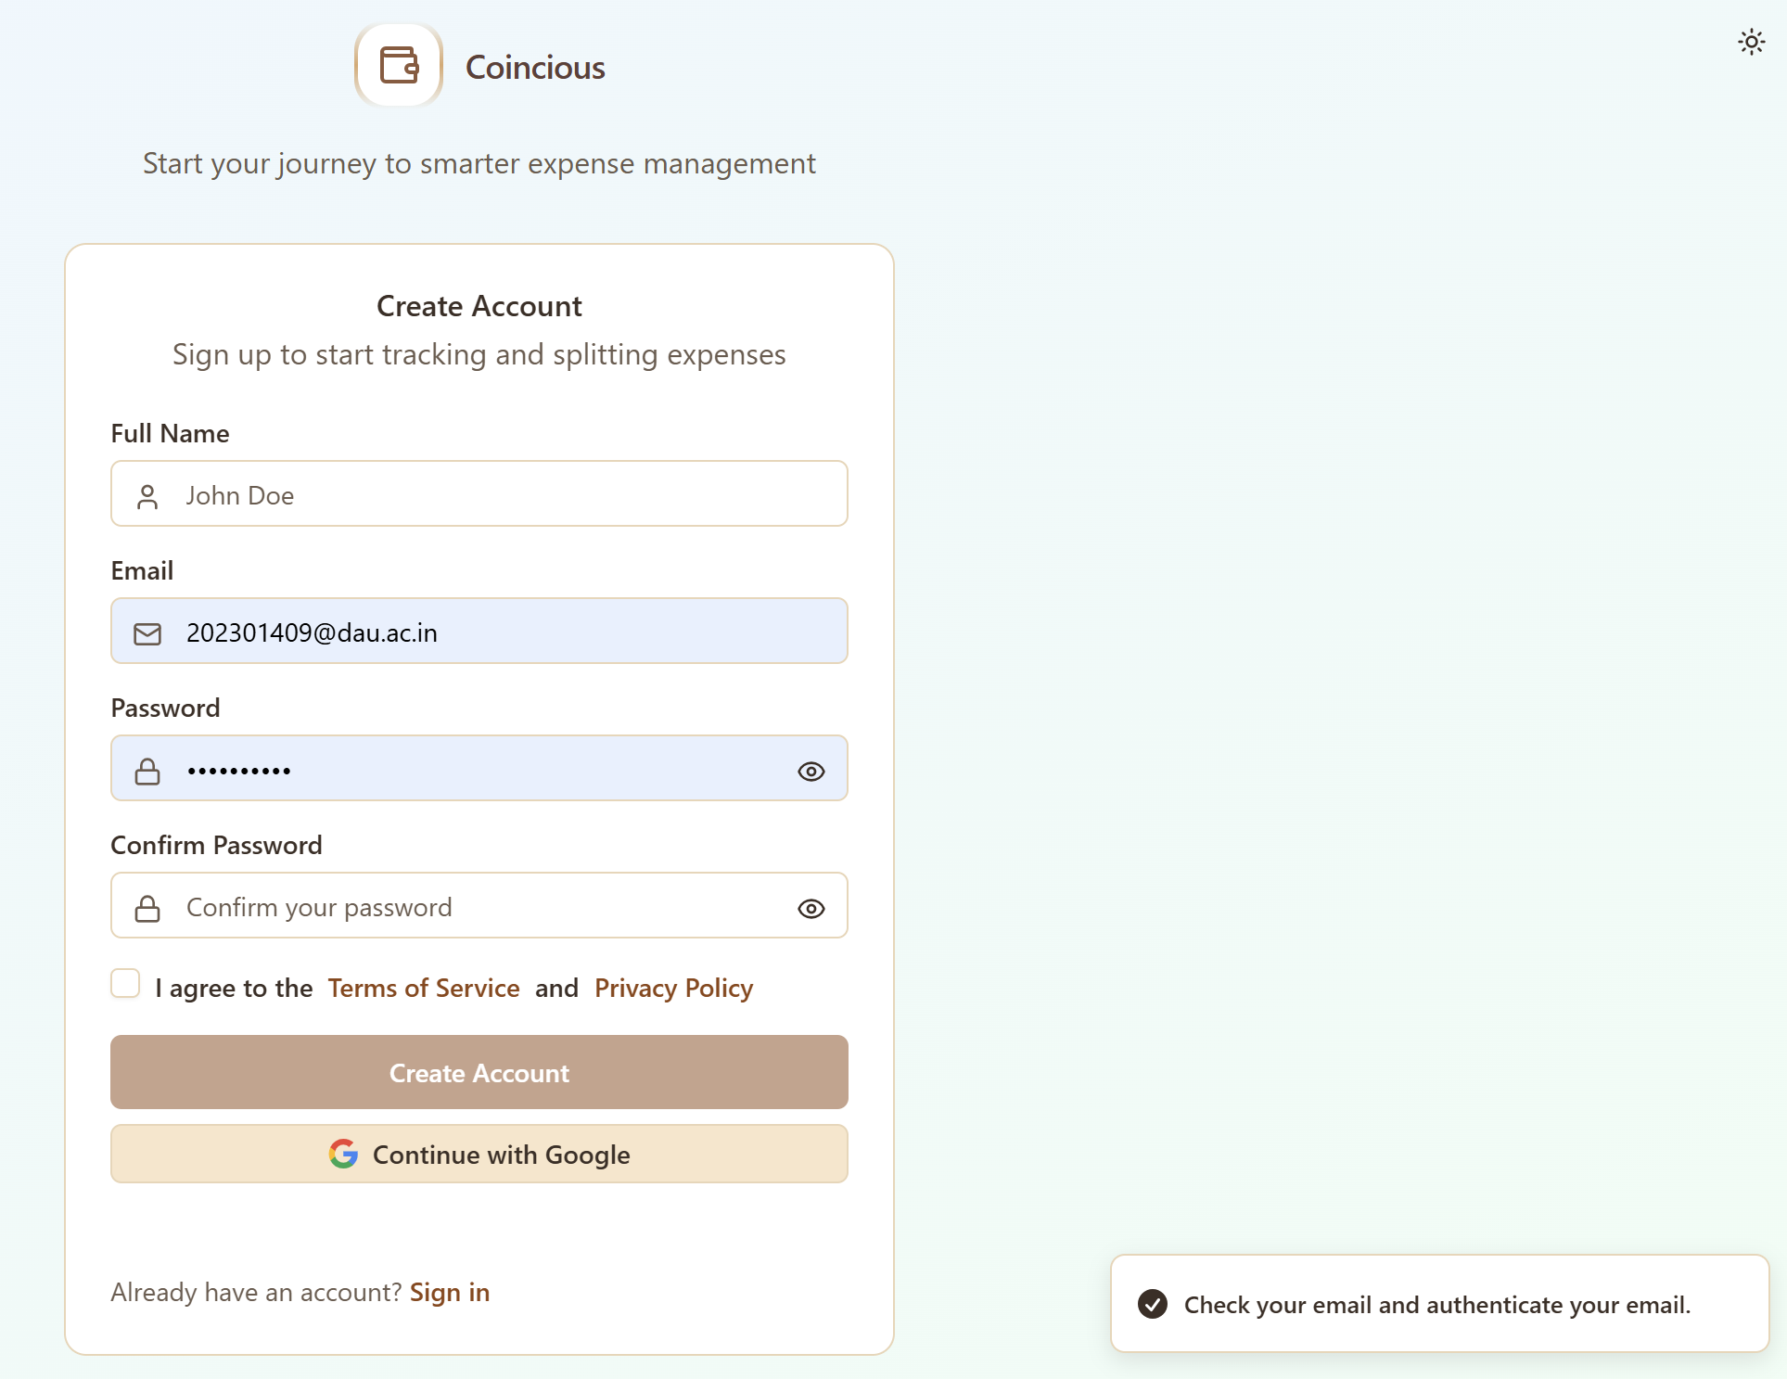

Test 7 – Redirecting to login page from signup
Action : Click “Sign-in” text
expected output : redirects to login page
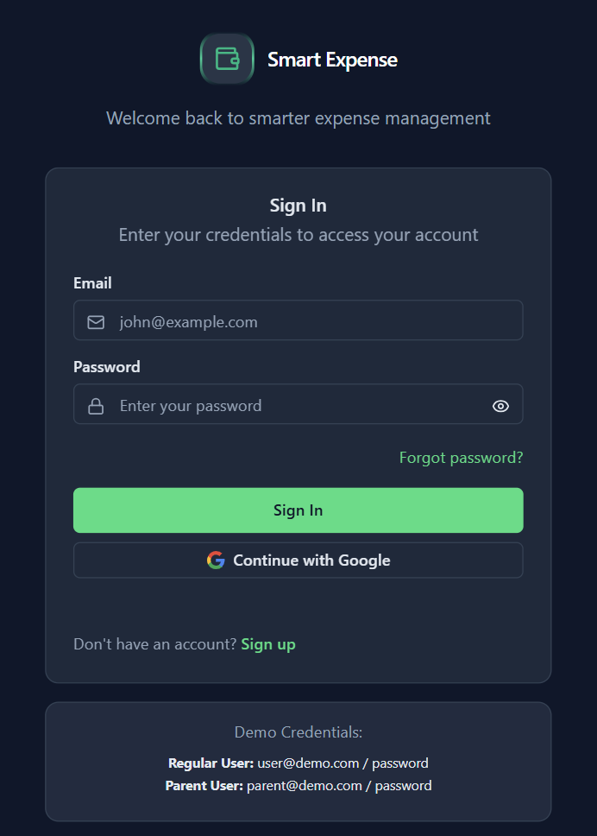

Acceptance Level Testing
Login-In Page
Test 1 — Invalid Email Format
Email: admin@
Password: Abcd@123
Expected Output: Invalid (Invalid email format)
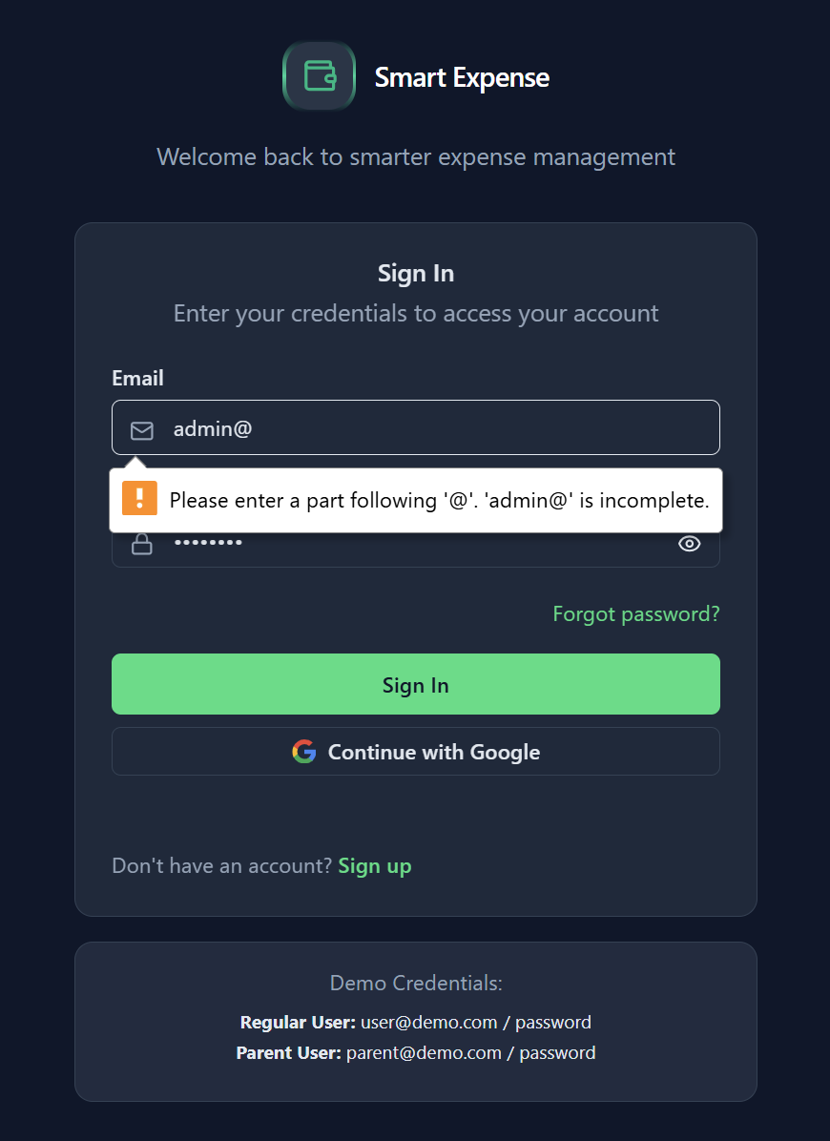
Test 2 — Empty Password Field
Email: user@demo.com
Password: (empty)
Expected Output: Invalid (Password cannot be empty)
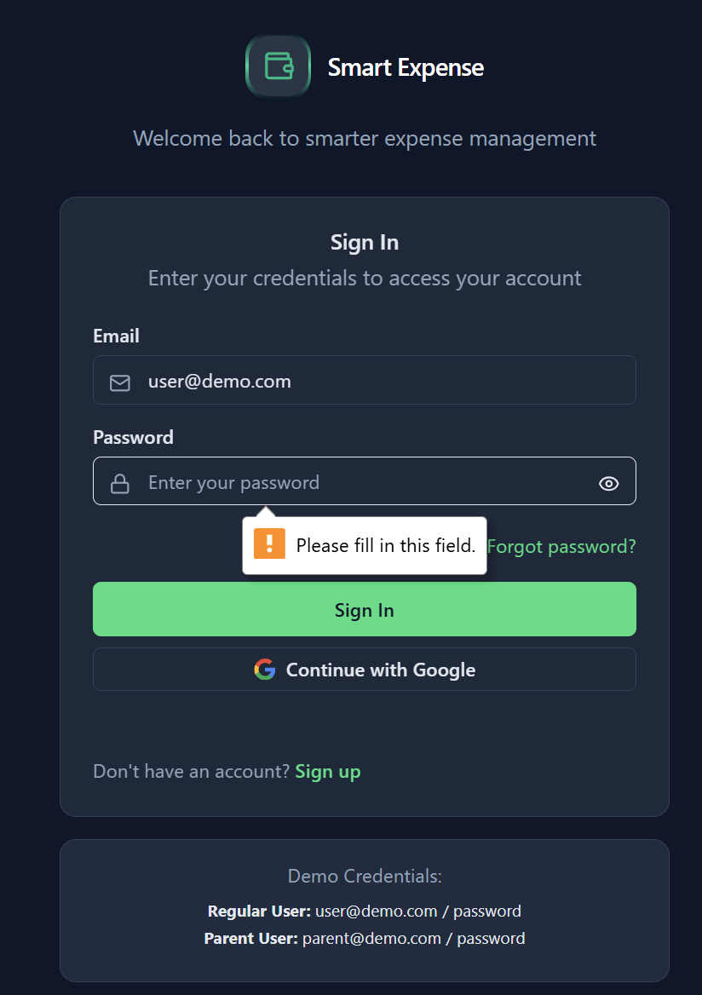
Test 3 — Unregistered Email
Email: randomuser999@gmail.com
Password: Abcd@123
Expected output : Invalid Credentials
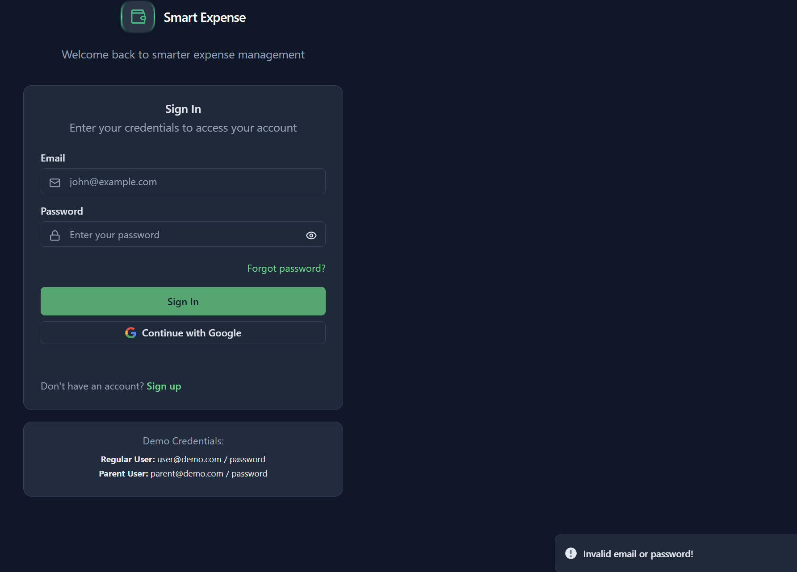
Test 4 — Incorrect Password for Registered Email
Email: user@demo.com
Password: wrongpass
Expected Output: Invalid (Incorrect password)
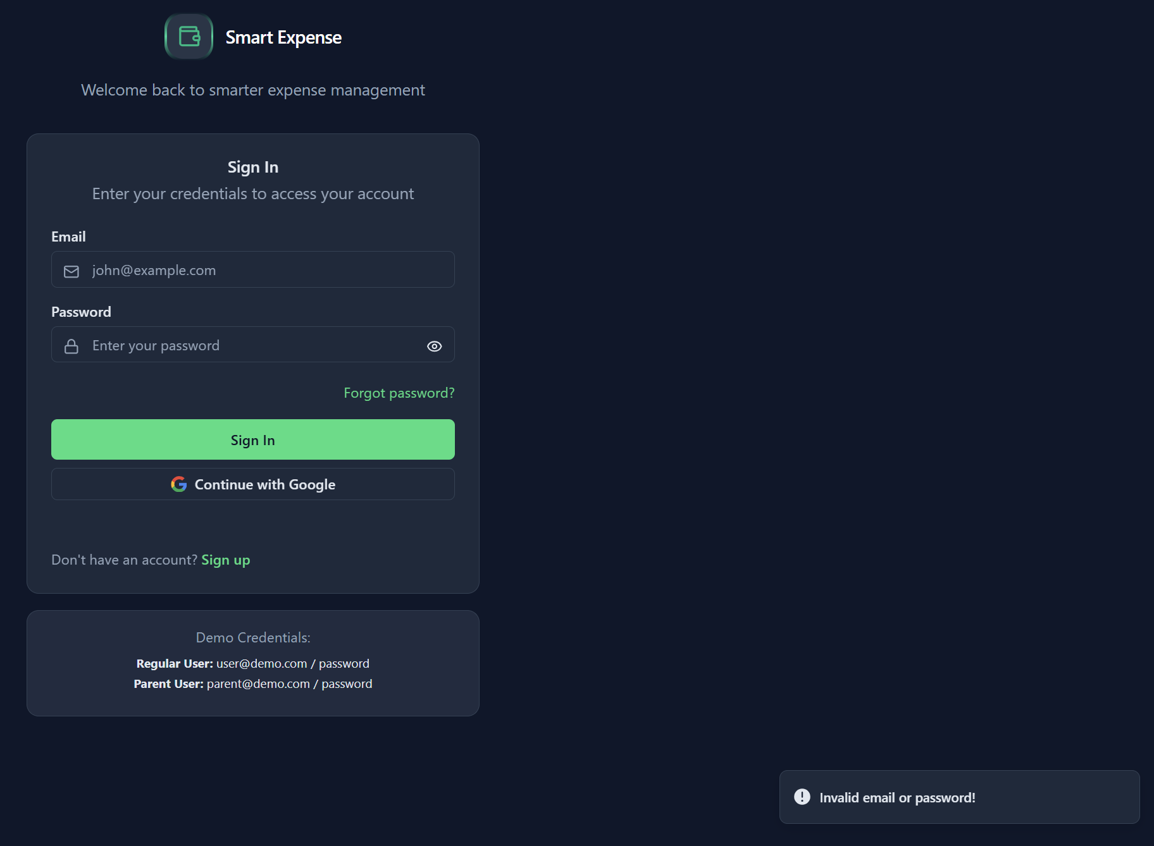
Test 5 — Valid Login Credentials
Email: user@demo.com
Password: password
Expected Output: Success (User logged in successfully)

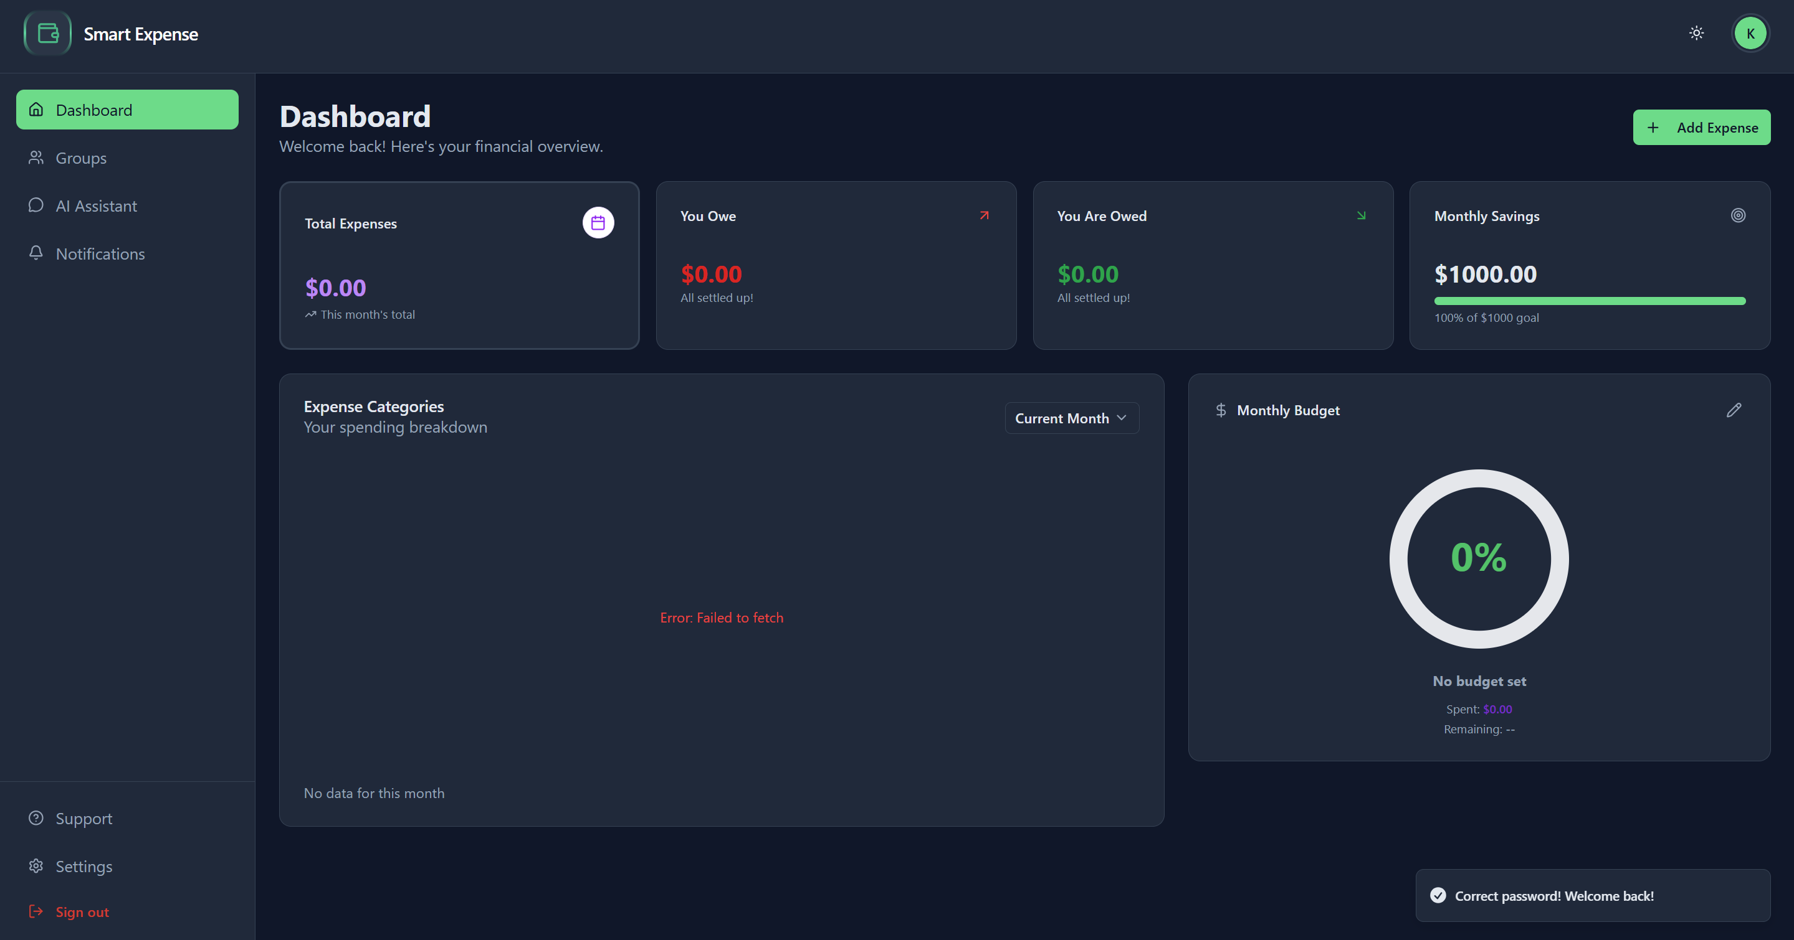
Dashboard shows up with user feedback of correct creds entered .
Test 6 — Google Login Button (UI Acceptance)
Action: Click Continue with Google Button
Expected Output: Google OAuth popup opens
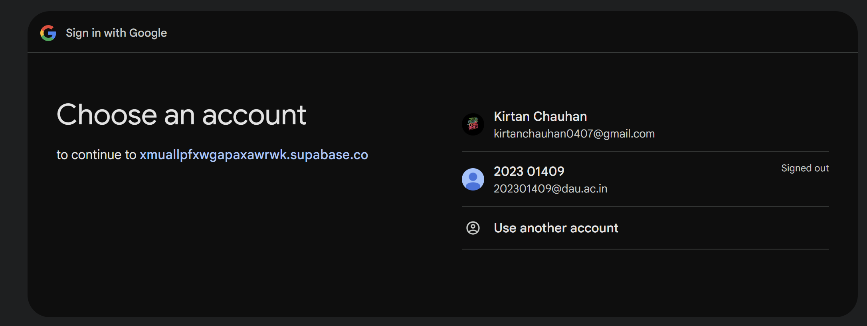
Test 7 – Redirect to Sign-up from login page
Action : Click “Signup” text on login page
Expected output : Redirects to signup page
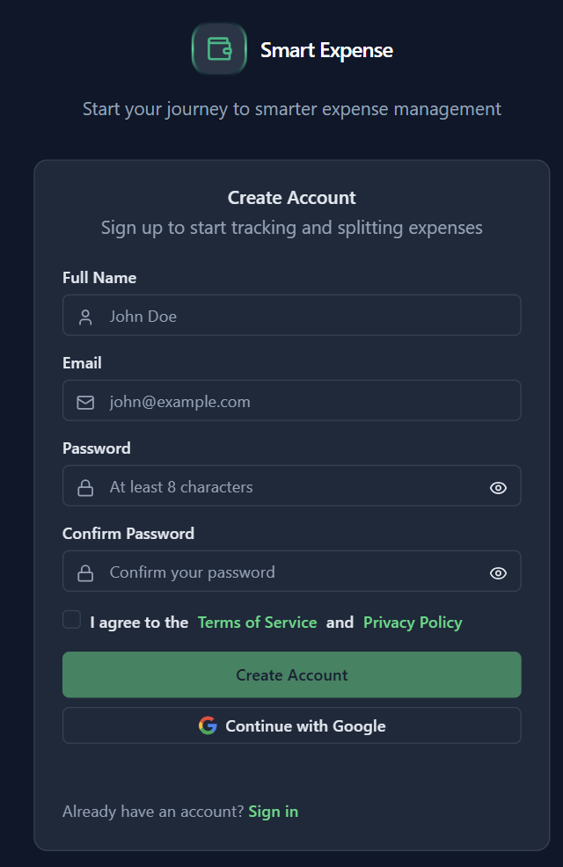

Acceptance Testing — Forgot Password

Test FP-1 — Empty Email Field
Email: Empty
Expected Output: Invalid — Unclickable Button
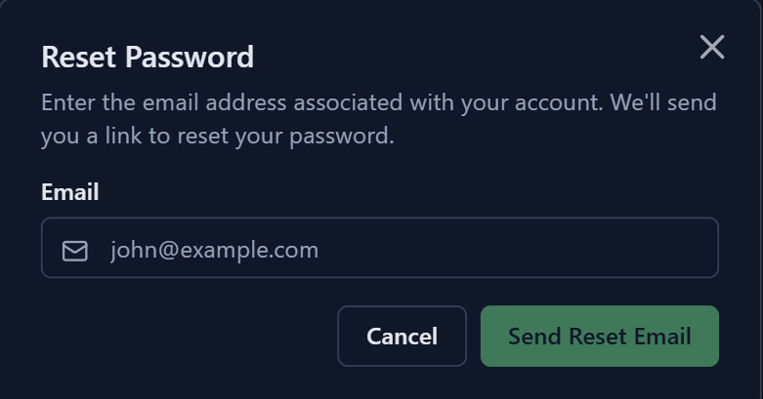

Test FP-2 — Invalid Email Format
Email: john@
Expected Output: Invalid — incorrect email format


Test FP-3 — Unregistered Email
Email: notarealuser123@gmail.com
Expected Output: Invalid — account does not exist
Output: if account is invalid link will not be sent anywhere. But it will just show this message.
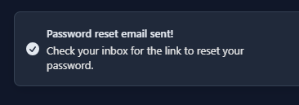

Test FP-4 — Valid Registered Email
Email: joshiruchir35@gmail.com
Expected Output: Success — reset email sent

