

GROUP - 28

SYSTEM TESTING – ChatBot and Profile

Testers : Kirtan Chauhan and Ruchir Joshi

Introduction
This document presents the System Testing approach for the AI-Assistant (CHATBOT) and Profile modules of the Smart Expense application. The objective is to validate user-facing functionality using Black-Box Testing, focusing on input–output behaviour without inspecting the internal code.
Both Equivalence Class Partitioning (ECP) and Boundary Value Analysis (BVA) techniques are applied to systematically identify valid and invalid input categories.
Additionally, Acceptance Testing is conducted to verify that the system meets user requirements by executing real inputs on the interface and observing the actual application response.

BlackBox Testing — AI-Assistant

User-Visible Constraints
1. Message Input Field
- Cannot be empty
- Cannot contain only spaces
- Accepts any text characters
2. Send Button
- Disabled when input is empty
- Disabled when bot is typing
- Enabled only when input has valid non-whitespace text
3. Quick Actions
- Clicking sends predefined messages automatically
- Should work even when input box is empty
- Should be disabled when bot is typing
4. Suggestions
- Only appear after bot messages
- Are clickable
- Auto-send the suggestion text
5. Typing Indicator
- Appears when bot is "thinking"
- During this time:
  - Input box is disabled
  - Send button is disabled
6. Chat Flow
- User messages appear on the right
- Bot messages appear on the left
- Chat auto-scrolls to the newest message
7. Authentication
- If user is not logged in → they cannot send messages (UI prevents interaction)
8. Markdown Rendering
- Bot messages may include bullet points or formatted text
- The UI must properly render markdown

2. Equivalence Class Partitioning (ECP)
EC | Input | Chat State | Expected Outcome
E1 | Valid text | bot not typing | Message sent + bot response
E2 | Empty input | bot not typing | Cannot send
E3 | Spaces only | bot not typing | Cannot send
E4 | Valid text | bot typing | Cannot send
E5 | Quick Action | bot not typing | Auto-send + bot response
E6 | Suggestion click | bot not typing | Auto-send + bot response
E7 | Quick Action | bot typing | Blocked (no send)
E8 | User not logged in | any | Cannot send message
E9 | Valid text | bot not typing | Bot returns markdown content

3. Boundary Value Analysis (BVA)

Test | Input | Expected Output | Reason
BVA1 | "" | fail | Input cannot be empty
BVA2 | " " | fail | Whitespace-only invalid
BVA3 | "a" (minimum valid input) | success | Minimum valid
BVA4 | Very long message (300+ chars) | success | Stress test
BVA5 | Quick Action click | success | Should auto-send
BVA6 | Suggestion click | success | Should auto-send
BVA7 | Message typed while bot typing | fail | Send blocked
BVA8 | Bot returns markdown | success | UI must render markdown
BVA9 | User logged out | fail | System blocks sending

Acceptance Testing — AI Assistant Chatbot
Test 1 — Sending a Valid Message
Input:
"How much did I spend on food this month?"
Action:
Type the message and press Send.
Expected Output:
Bot responds with a spending breakdown message related to food.
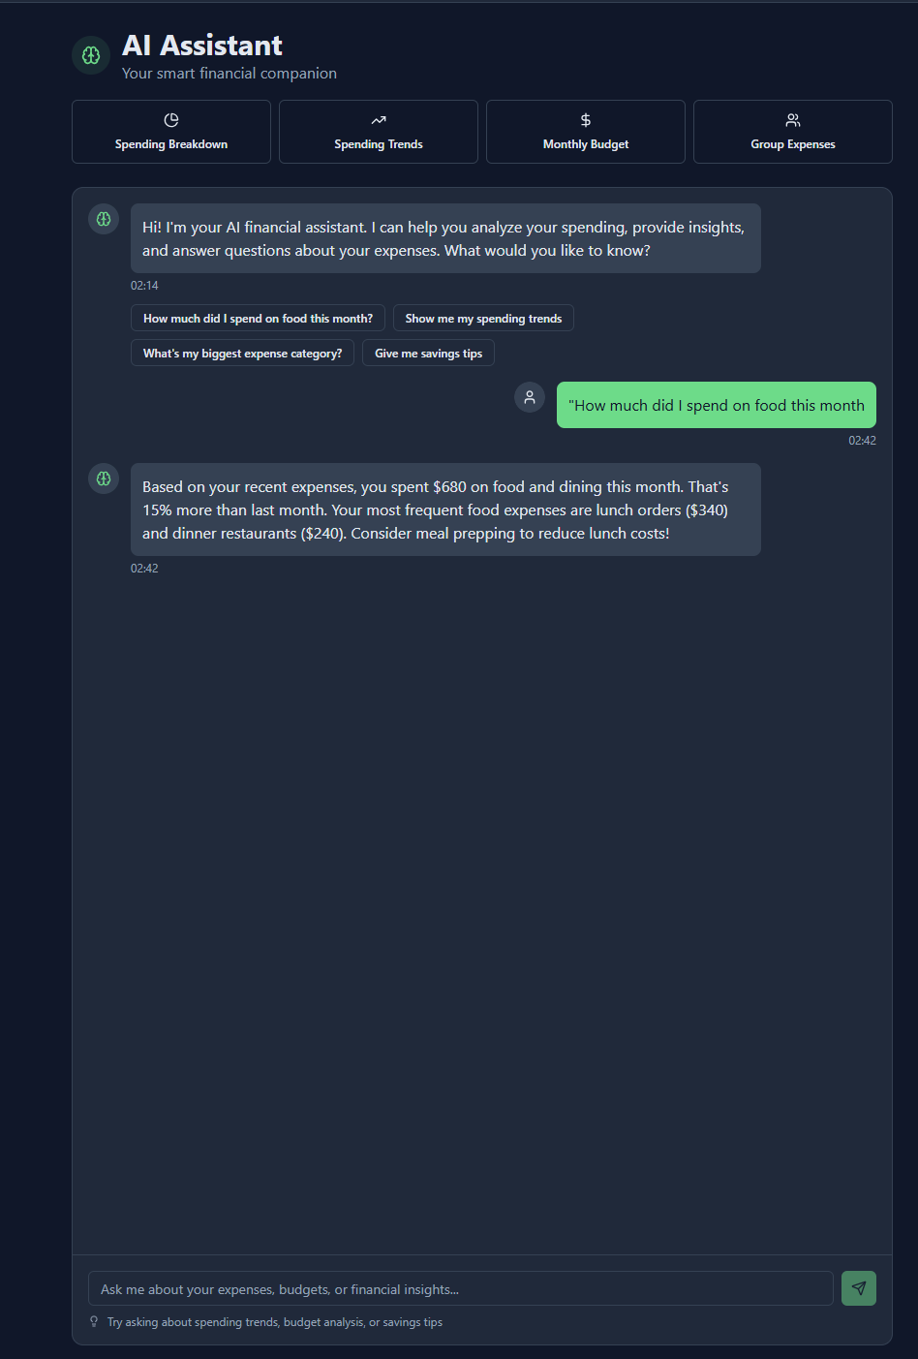

Test 2 — Sending an Empty Message
Input:
"" (no text)
Action:
Attempt to press Send.
Expected Output:
Message is NOT sent.
Send button remains disabled.
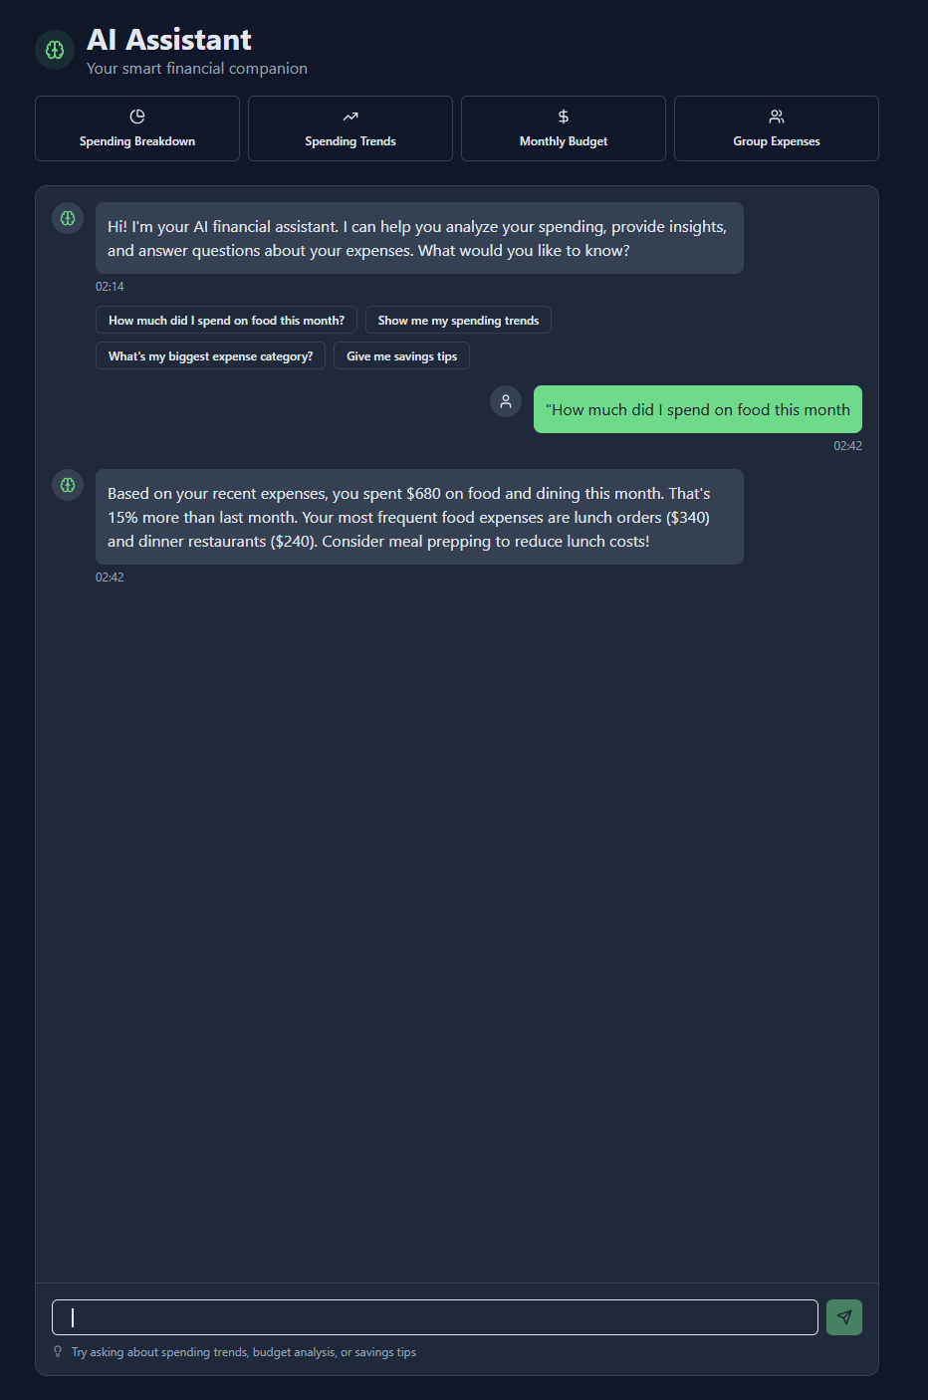
Test 3 — Quick Action Button
Input:
Click “Spending Trends” quick action card.
Action:
User does not type anything; clicks the Quick Action button.
Expected Output:
The Quick Action query auto-sends, and a bot response appears with trend analysis.
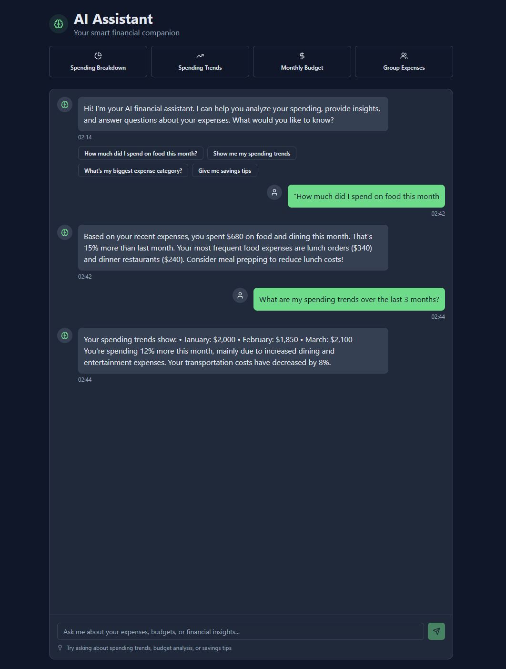

Test 4 — Suggestion Chip Click
Input:
Click bot suggestion:
“Show me my spending trends”
Action:
Click the suggested chip under the bot message.
Expected Output:
Message is auto-sent, bot responds with formatted markdown text.

Test 5 — User Tries Sending While Bot is Typing
Input:
Type “Hello” while bot is typing.
Action:
Try clicking Send during the typing indicator.
Expected Output:
Send button is disabled.
Message cannot be sent until bot reply finishes.
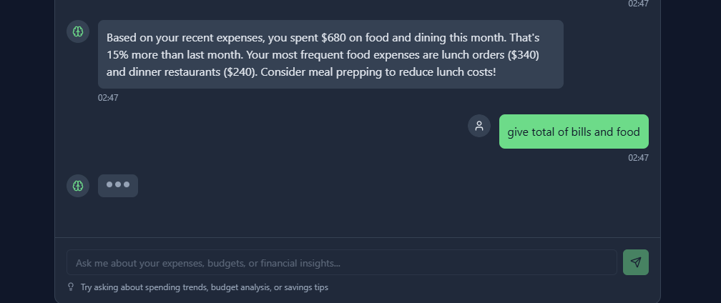
Black-Box Testing — Profile Page
1. Field Constraints (User-Visible Only)
A. Name Field
- Cannot be empty
- Must contain alphabetic characters
- Should allow alphanumeric (kirtan123) — UI doesn’t restrict
- No minimum or maximum shown, but assume:
  - Should not exceed 50 characters (standard usability assumption)
B. Phone Number Field
- Optional
- If entered:
  - Must be valid phone format (digits only)
  - Should typically be 10–15 digits
  - No alphabetic characters allowed
C. Profile Picture Upload
- Optional
- If uploaded:
  - Must be an image (JPG, PNG) — inferred from typical systems
  - Invalid files should be rejected
D. Save Changes Button
Allowed only when:
- At least one editable field changes
- Inputs meet constraints
E. Cancel Button
- Discards all changes
- Returns fields to previous values

2. Equivalence Class Partitioning (ECP)
EC | Name | Phone | Profile Pic | Expected Result
E1 | valid | valid | valid/none | success
E2 | valid | valid | invalid file | error
E3 | valid | invalid | valid/none | error
E4 | invalid (empty) | valid | valid/none | error
E5 | invalid (symbols only) | valid | valid/none | error
E6 | valid | empty (allowed) | valid/none | success
E7 | valid | invalid format (alphabets) | valid/none | error
E8 | no changes | — | — | Save disabled
E9 | valid | excessive digits (>15) | valid/none | error
E10 | valid | valid | none | success

3. Boundary Value Analysis (BVA)
Field | Test Input | Expected Output | Reason
Name | "" (empty) | fail | Name cannot be empty
Name | "a" (1 char) | pass | Minimum valid
Name | Very long (51+ chars) | fail | Exceeds typical UI constraints
Name | "!!!" | fail | No alphabetic characters
Phone | "" | pass | Optional field
Phone | "1234567890" (10 digits) | pass | Valid
Phone | "12345" (too short) | fail | Invalid phone format
Phone | "1234567890123456" (>15 digits) | fail | Exceeds phone length
Phone | "abcd1234" | fail | Alphabets not allowed
Profile Pic | No file | pass | Optional
Profile Pic | JPG/PNG | pass | Valid format
Profile Pic | PDF/EXE | fail | Invalid type
Save Changes | No edits made | fail (button disabled) | Must change something

Acceptance Testing — Profile Page
Test 1 — Update Name Successfully
Action:
Click Edit Profile, change Name → “kirtan47”, then click Save Changes.
Expected Output:
Name is updated and reflected on the Profile page.
Success message
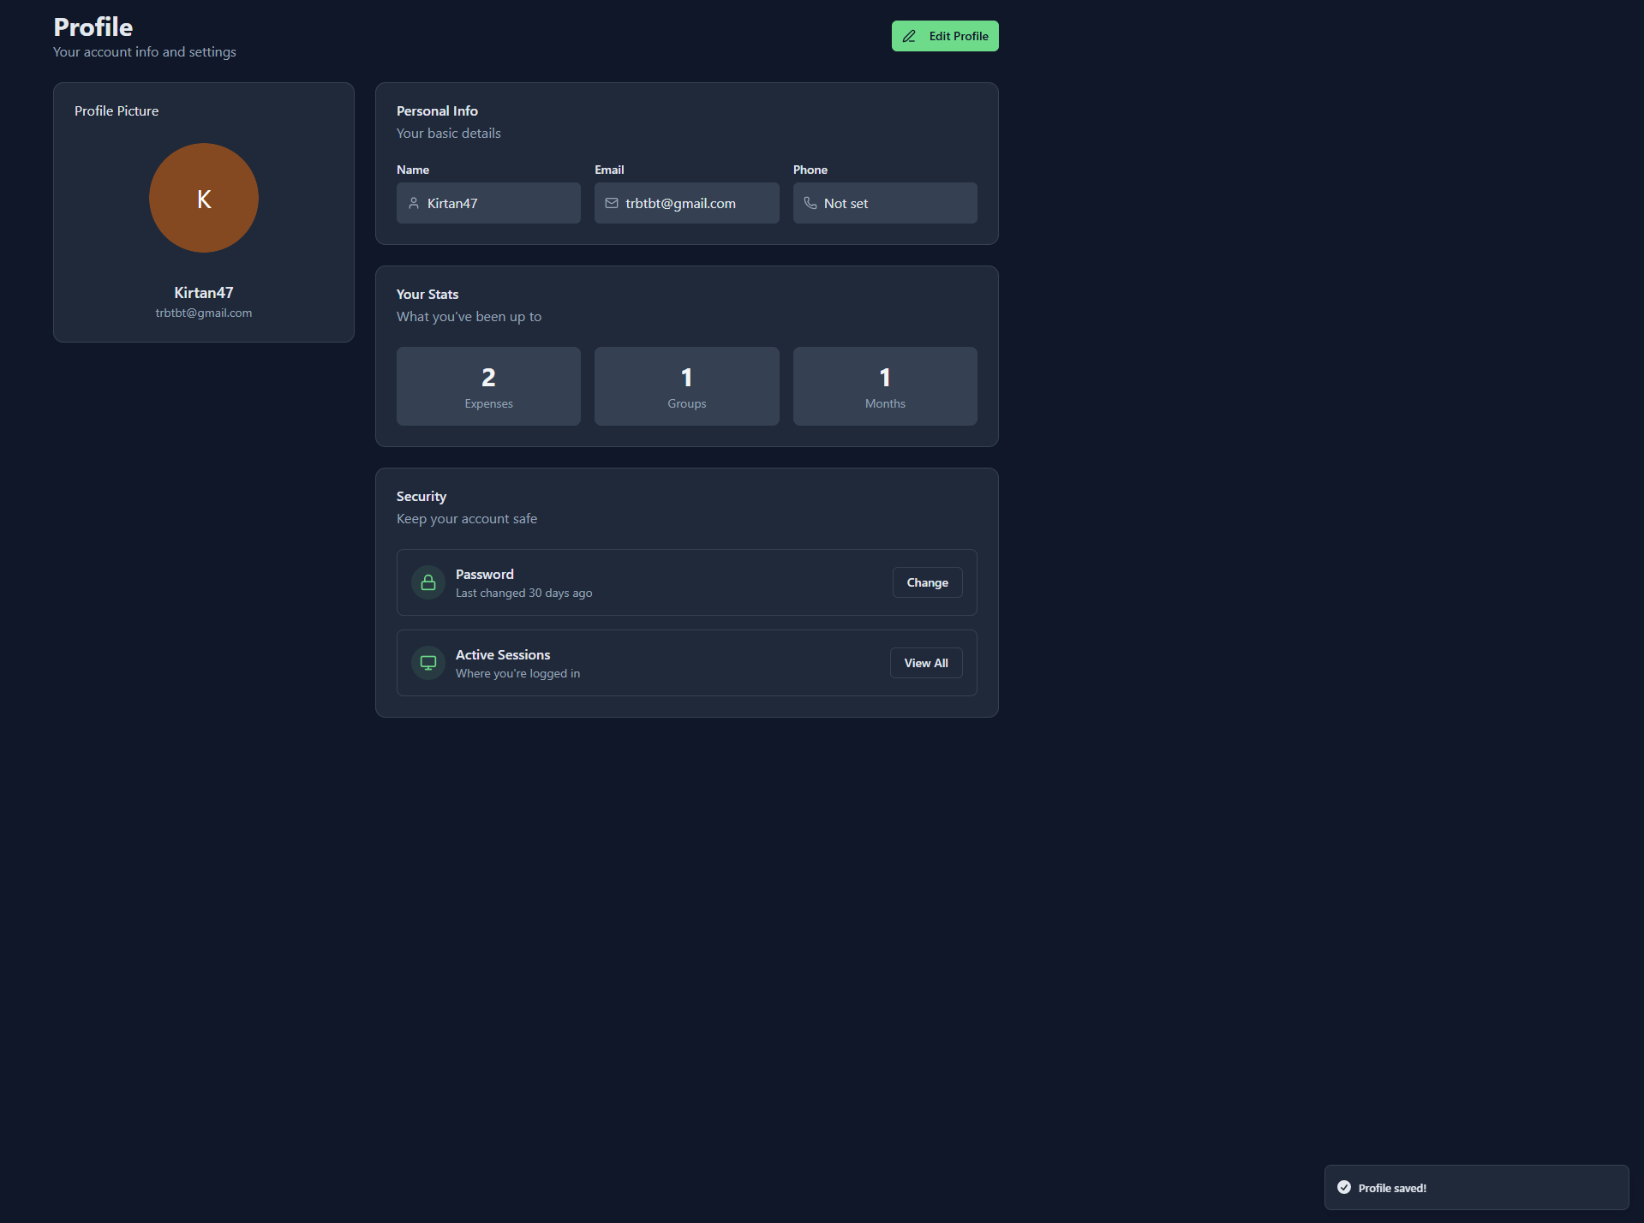
Test 2 — Attempt to Save Empty Name
Action:
Click Edit Profile, clear Name field completely, click Save Changes.
Expected Output:
Save should fail.
Error message or Save button disabled (depending on implementation).
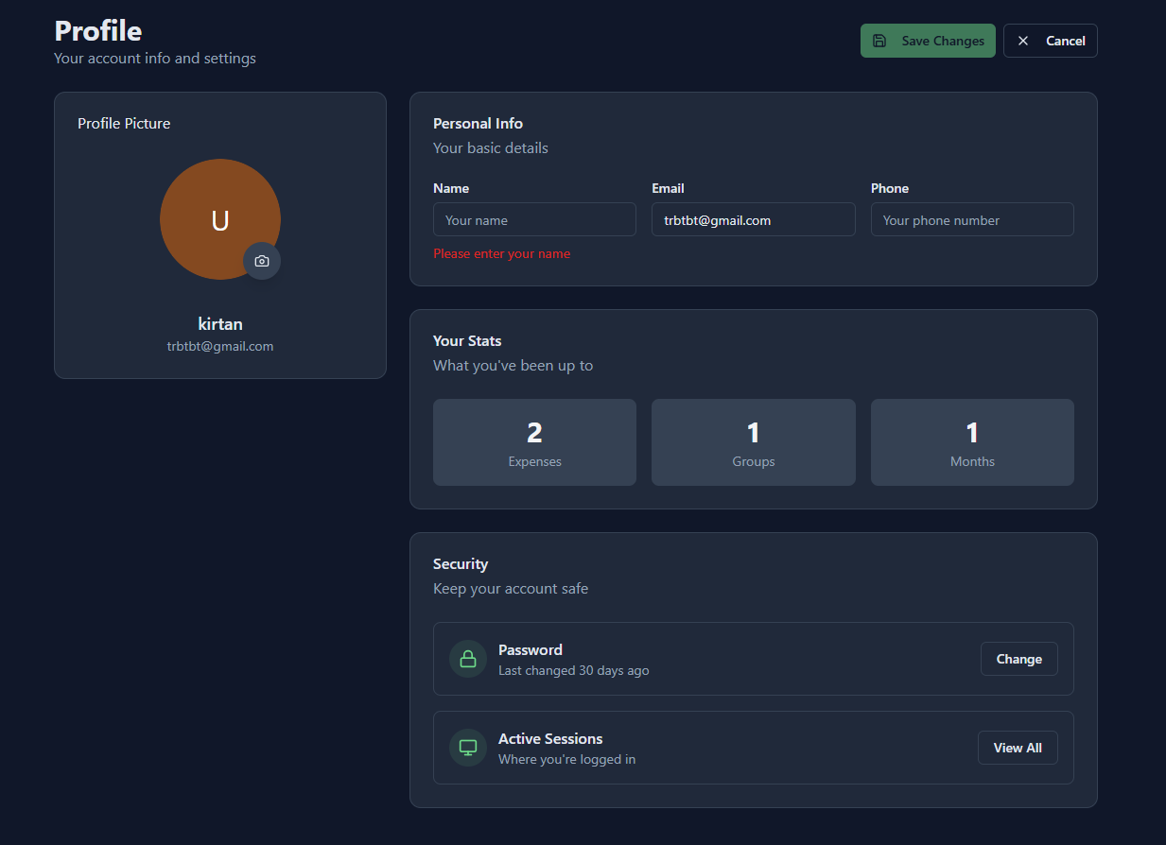
Test 3 — Enter Invalid Phone Number (Alphabetic Characters)
Action:
Click Edit Profile, enter phone: “abcd123”, click Save Changes.
Expected Output:
Save should fail.
Phone field should show validation error or Save should be blocked.
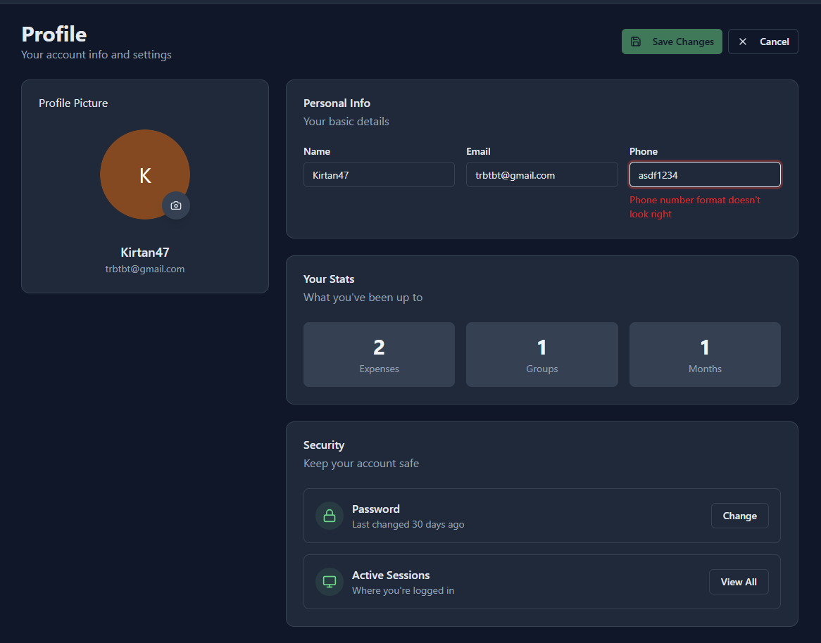
Test 4 — Upload Invalid Profile Picture Format
Action:
Click the camera icon on Profile Picture → upload file.pdf or file.exe.
Expected Output:
Image upload should fail.
Error shown OR file not accepted.

Test 5 — Upload Valid Profile Picture
Action:
Click profile pic → upload a valid JPG/PNG image.
Expected Output:
Profile picture updates instantly or after Save.

Test 6 — Save Without Making Any Changes
Action:
Open Profile → click Edit Profile → do not change anything → click Save Changes.
Expected Output:
Save should be blocked (button disabled) or no update made.

Test 7 — Update Phone Number Successfully
Action:
Click Edit Profile, set Phone → “9876543210”, click Save Changes.
Expected Output:
Phone number updates and displays on Profile page.
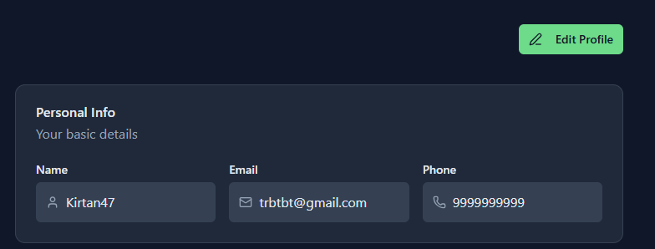
For Create new password :
Test 1 — Empty Fields (All Blank)
Current Password: (empty)
New Password: (empty)
Confirm Password: (empty)
Action:
Click Update.
Expected Output:
Form should not submit.
Validation errors should appear OR Update butt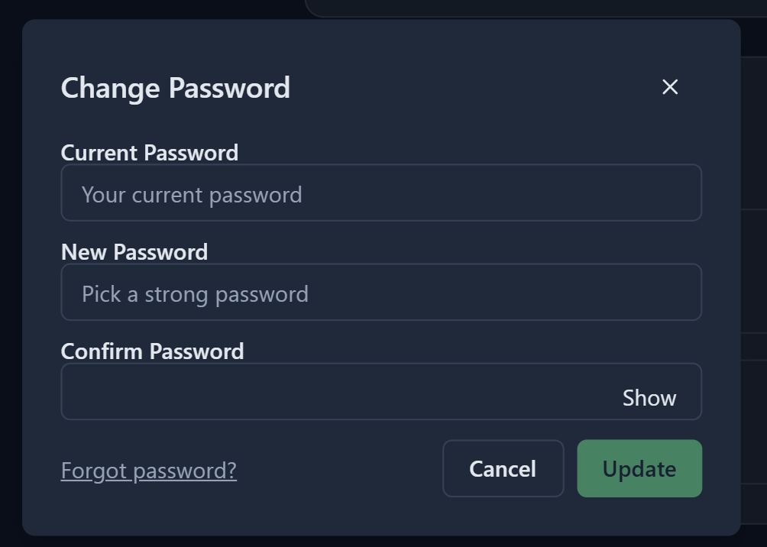on stays disabled.

Test 2 — Incorrect Current Password
Current Password: wrongOldPass1
New Password: Abcd@123
Confirm Password: Abcd@123
Action:
Click Update.
Expected Output:
Password update fails.
Error message appears: “Incorrect current password” (or your app’s variation).

Test 3 — New Password Too Weak (Less Than 8 Characters)
Current Password: correctOldPass
New Password: 12345
Confirm Password: 12345
Action:
Click Update.
Expected Output:
Update prevented.
Validation message: “Password must be at least 8 characters” (or similar).
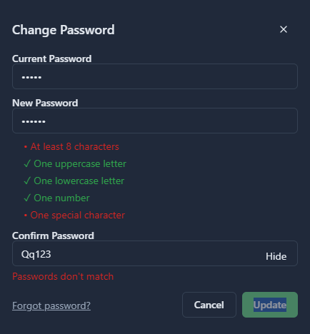
Test 4 — New Password and Confirm Password Do Not Match
Current Password: correctOldPass
New Password: Abcd@123
Confirm Password: Abcd@12
Action:
Click Update.
Expected Output:
Update fails.
Error message: “Passwords do not match.”
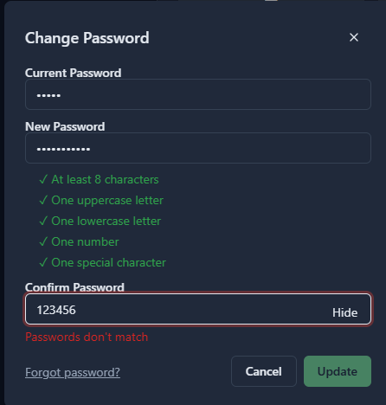
Test 5 — Using the Same Password as Old Password
Current Password: correctOldPass
New Password: correctOldPass
Confirm Password: correctOldPass
Action:
Click Update.
Expected Output:
Update is rejected.
Error message: “”

Test 6 — Successful Password Change
Current Password: correctOldPass
New Password: StrongPass@123
Confirm Password: StrongPass@123
Action:
Click Update.
Expected Output:
Password updated successfully.
Modal closes OR success toast appears.
📸 Screenshot: (Insert screenshot of success message)

Test 7 – Forgot password
Action : Click on Forgot password
Expected output :
