**Computer Network Lab**



Computer Network Lab,

Department of Computer Science,

School of Technology,

Pandit Deendayal Energy University

By:

Tirth Shah,

22BCP230

Under the guidance of:

Dr. Shantanu Roy, Department of Computer Science, School of Technology, Pandit Deendayal Energy University

**Certificate**



This is to certify that **Tirth Shah,** student of **G6-Div3 CSE’26** with

enrolment number **22BCP230** has satisfactorily completed his work

in **Information Security Lab** under the guidance of **Dr. Shantanu Roy.**

**______________ _____________**

Lab Instructor Head of the department

Practical-1

Q1. Simulation of Various Networking Topologies.

**A1.**

Network topology refers to the arrangement of nodes, links, and devices in a computer network, defining their connections and interactions.

Understanding different topologies aids in designing efficient networks. Common types include bus, star, ring, mesh, tree, and hybrid topologies, each with unique pros and cons.

**Types of Network Topologies:**

* **Point-to-Point**
* **Mesh**
* **Star**
* **Bus**
* **Ring**
* **Tree**
* **Hybrid**

**Point-to-Point Topology:**

This topology connects two nodes directly, with one serving as the sender and the other as the receiver. It's the simplest form of communication, offering high bandwidth between the two nodes.

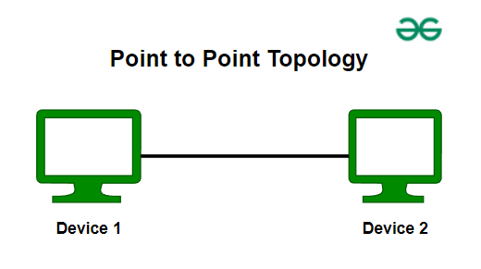

*Point to Point Topology*

## **Mesh Topology**

In a mesh topology, every device is connected to another device via a particular channel.

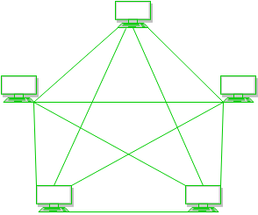

*Mesh Topology*

**Figure 1**: Every device is connected to another via dedicated channels. These channels are known as links.

* Suppose, the N number of devices are connected with each other in a mesh topology, the total number of ports that are required by each device is N-1. In Figure 1, there are 5 devices connected to each other, hence the total number of ports required by each device is 4. The total number of ports required = N * (N-1).
* Suppose, N number of devices are connected with each other in a mesh topology, then the total number of dedicated links required to connect them is NC2 i.e. N(N-1)/2. In Figure 1, there are 5 devices connected to each other, hence the total number of links required is 5*4/2 = 10.

**Advantages of Mesh Topology**

* Communication is very fast between the nodes.
* Mesh Topology is robust.
* The fault is diagnosed easily. Data is reliable because data is transferred among the devices through dedicated channels or links.
* Provides security and privacy.

**Disadvantages of Mesh Topology**

* Installation and configuration are difficult.
* The cost of cables is high as bulk wiring is required, hence suitable for less number of devices.
* The cost of maintenance is high.

A common example of mesh topology is the internet backbone, where various internet service providers are connected to each other via dedicated channels. This topology is also used in military communication systems and aircraft navigation systems.

## **Star Topology**

In Star Topology, all the devices are connected to a single hub through a cable. This hub is the central node and all other nodes are connected to the central node.

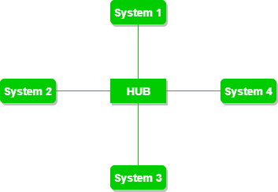

*Star Topology*

**Figure 2**: A star topology having four systems connected to a single point of connection i.e. hub.

**Advantages of Star Topology**

* If N devices are connected to each other in a star topology, then the number of cables required to connect them is N. So, it is easy to set up.
* Each device requires only 1 port i.e. to connect to the hub, therefore the total number of ports required is N.
* It is Robust. If one link fails only that link will affect and not other than that.
* Easy to fault identification and fault isolation.
* Star topology is cost-effective as it uses inexpensive coaxial cable.

**Disadvantages of Star Topology**

* If the concentrator (hub) on which the whole topology relies fails, the whole system will crash down.
* The cost of installation is high.
* Performance is based on the single concentrator i.e. hub.

A common example of star topology is a local area network (LAN) in an office where all computers are connected to a central hub. This topology is also used in wireless networks where all devices are connected to a wireless access point.

## **Bus Topology**

Bus Topology is a network type in which every computer and network device is connected to a single cable. It is bi-directional.

It is a multi-point connection and a non-robust topology because if the backbone fails the topology crashes.

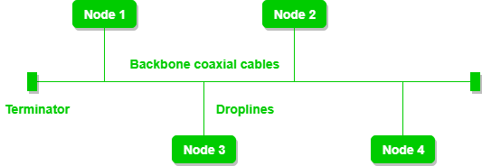

*Bus Topology*

**Figure 3**: A bus topology with shared backbone cable. The nodes are connected to the channel via drop lines.

**Advantages of Bus Topology**

* If N devices are connected to each other in a bus topology, then the number of cables required to connect them is 1, known as backbone cable, and N drop lines are required.
* Coaxial or twisted pair cables are mainly used in bus-based networks that support up to 10 Mbps.
* The cost of the cable is less compared to other topologies, but it is used to build small networks.
* Bus topology is familiar technology as installation and troubleshooting techniques are well known.

**Disadvantages of  Bus Topology**

* A bus topology is quite simpler, but still, it requires a lot of cabling.
* If the common cable fails, then the whole system will crash down.
* Adding new devices to the network would slow down networks.
* Security is very low.

A common example of bus topology is the Ethernet LAN, where all devices are connected to a single coaxial cable or twisted pair cable. This topology is also used in cable television networks.

## **Ring Topology**

In a Ring Topology, it forms a ring connecting devices with exactly two neighboring devices. A number of repeaters are used for Ring topology with a large number of nodes, because if someone wants to send some data to the last node in the ring topology with 100 nodes, then the data will have to pass through 99 nodes to reach the 100th node. Hence to prevent data loss repeaters are used in the network.

The data flows in one direction, i.e. it is unidirectional, but it can be made bidirectional by having 2 connections between each Network Node, it is called Dual Ring Topology

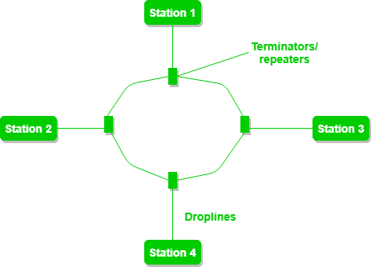

*Ring Topology*

**Figure 4**: A ring topology comprises 4 stations connected with each forming a ring.

**Advantages of Ring Topology**

* The data transmission is high-speed.
* The possibility of collision is minimum in this type of topology.
* Cheap to install and expand.
* It is less costly than a star topology.

**Disadvantages of Ring Topology**

* The failure of a single node in the network can cause the entire network to fail.
* Troubleshooting is difficult in this topology.
* The addition of stations in between or the removal of stations can disturb the whole topology.
* Less secure.

## **Tree Topology**

This topology is the variation of the Star topology.

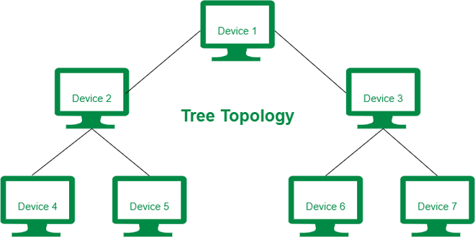

*Tree Topology*

**Figure 5**: In this, the various secondary hubs are connected to the central hub which contains the repeater. This data flow from top to bottom i.e. from the central hub to the secondary and then to the devices or from bottom to top i.e. devices to the secondary hub and then to the central hub. It is a multi-point connection and a non-robust topology because if the backbone fails the topology crashes.

**Advantages of Tree Topology**

* It allows more devices to be attached to a single central hub thus it decreases the distance that is traveled by the signal to come to the devices.
* It allows the network to get isolated and also prioritize from different computers.
* We can add **new devices to the existing network.**
* **Error detection** and **error correction** are very easy in a tree topology.

**Disadvantages of Tree Topology**

* If the central hub gets fails the entire system fails.
* The cost is high because of the cabling.
* If new devices are added, it becomes difficult to reconfigure.

A common example of a tree topology is the hierarchy in a large organization. At the top of the tree is the CEO, who is connected to the different departments or divisions (child nodes) of the company. Each department has its own hierarchy, with managers overseeing different teams (grandchild nodes). The team members (leaf nodes) are at the bottom of the hierarchy, connected to their respective managers and departments.

## **Hybrid Topology**

This topological technology is the combination of all the various types of topologies we have studied above. Hybrid Topology is used when the nodes are free to take any form. It means these can be individuals such as Ring or Star topology or can be a combination of various types of topologies seen above. Each individual topology uses the protocol that has been discussed earlier.

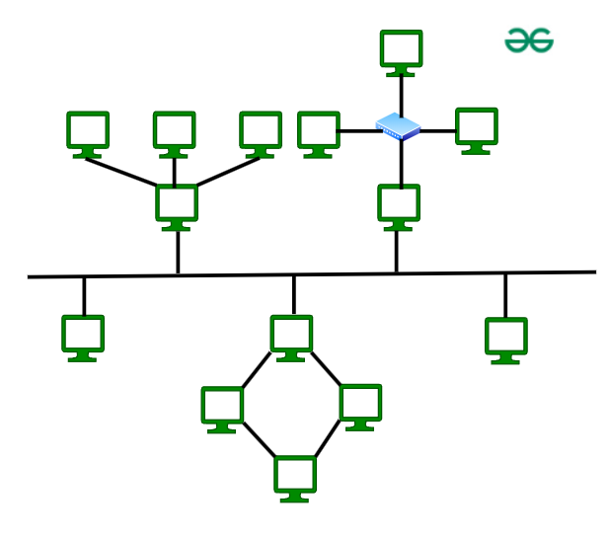

*Hybrid Topology*

The above figure shows the structure of the Hybrid topology. As seen it contains a combination of all different types of networks.

**Advantages of Hybrid Topology**

* This topology is **very flexible**.
* The size of the network can be easily expanded by **adding new devices.**

**Disadvantages of Hybrid Topology**

* It is challenging**to design the architecture** of the Hybrid Network.
* **Hubs**used in this topology are**very expensive.**
* The infrastructure cost is very high as a hybrid network **requires a lot of cabling and network devices**.

A common example of a hybrid topology is a university campus network. The network may have a backbone of a star topology, with each building connected to the backbone through a switch or router. Within each building, there may be a bus or ring topology connecting the different rooms and offices. The wireless access points also create a mesh topology for wireless devices. This hybrid topology allows for efficient communication between different buildings while providing flexibility and redundancy within each building.

## **Conclusion**

In conclusion, network topologies play a crucial role in determining the efficiency and reliability of a computer network. Each topology, whether it’s bus, star, ring, mesh, or tree, offers unique benefits and potential drawbacks. By understanding these different arrangements, network designers can choose the most appropriate topology to meet the specific needs of their systems, ensuring optimal performance and connectivity.

**Cisco Packet Tracer Simulation of Network Topologies:**

**Point to Point:**

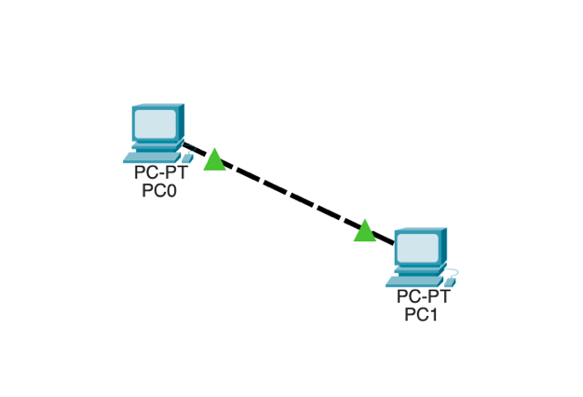

**Bus:**

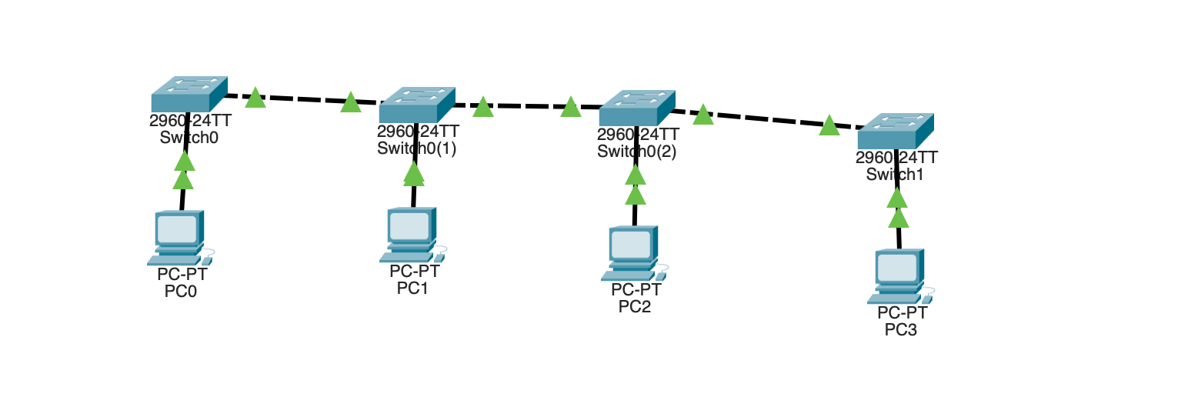

**Mesh:**

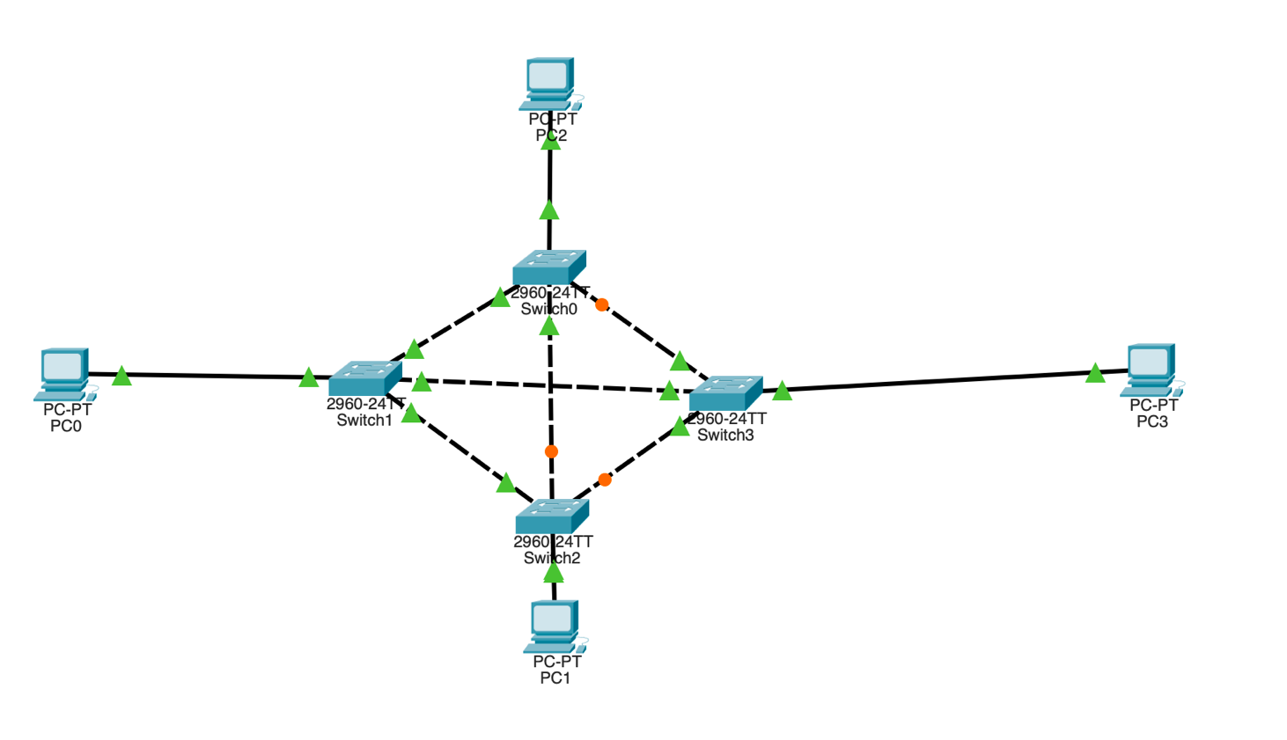

**Ring:**

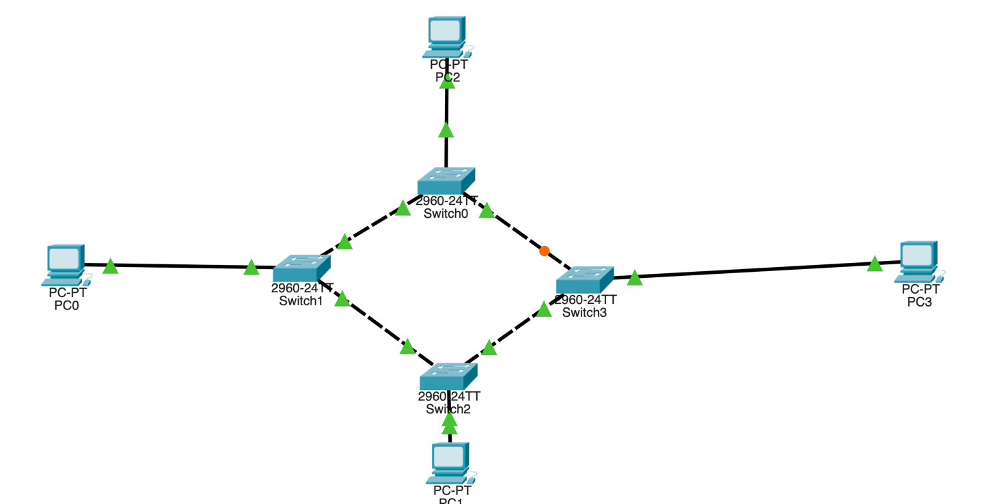

**Star:**

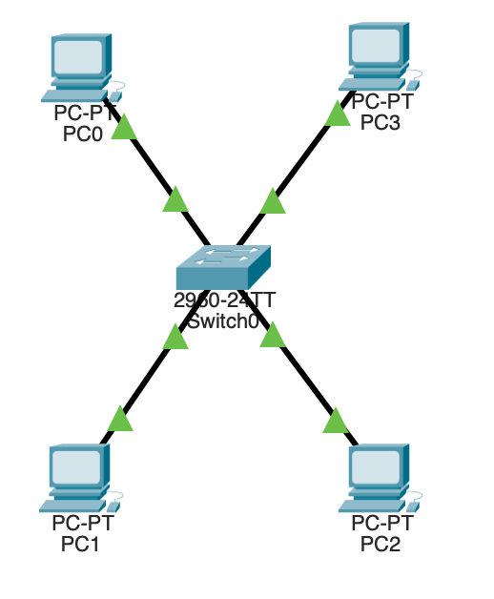

**Tree:**

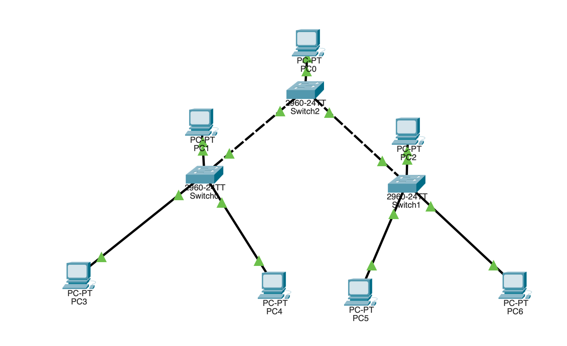

**Hybrid:**

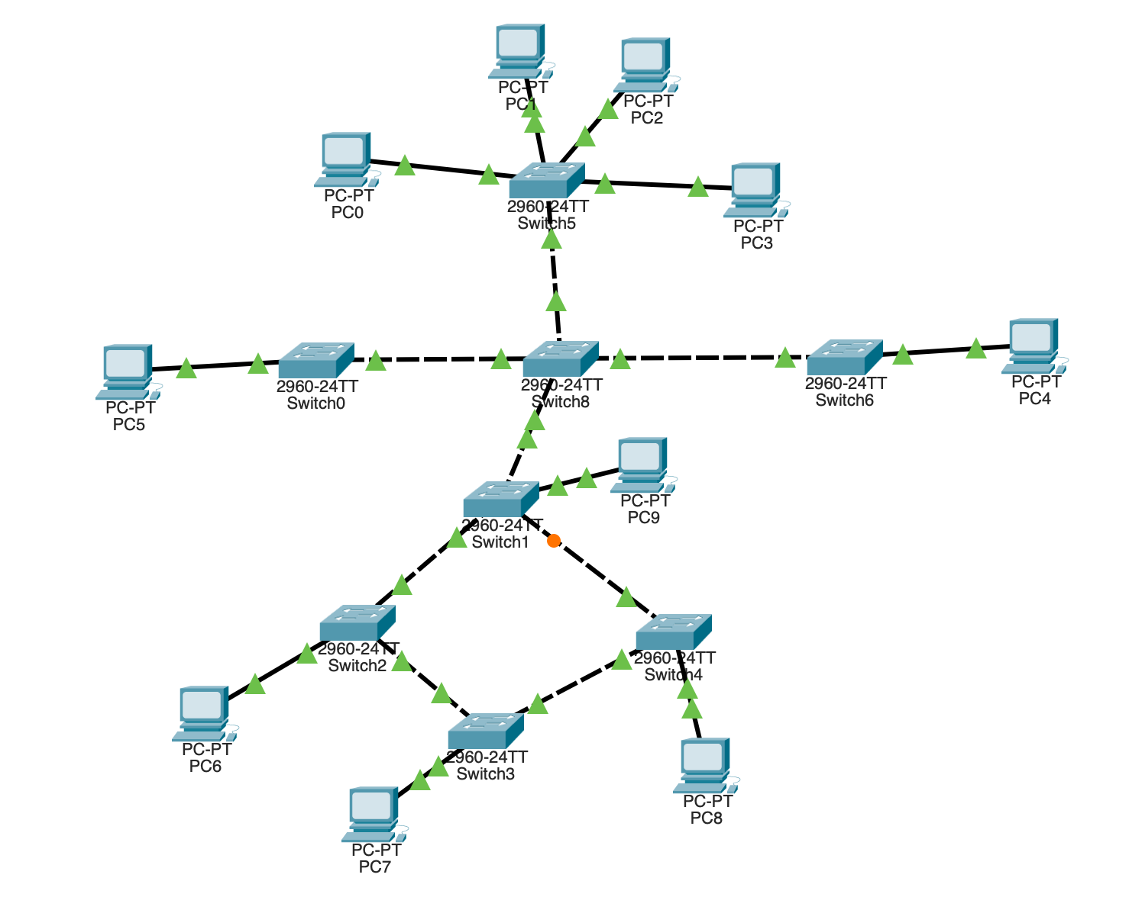

Practical-2

**Q1.** Implement Router In Cisco Packet Tracer

**A1.**

**Theory:**

* **Router's Role:** In a Cisco Packet Tracer simulation, routers are crucial for connecting multiple networks and enabling communication between devices in different subnets.
* **Layer 3 Operation:** Unlike switches, which operate at Layer 2 (Data Link Layer), routers work at Layer 3 (Network Layer). They use IP addresses to route data between different networks.
* **Network Setup:** In Cisco Packet Tracer, PCs in different networks are connected to switches, and these switches are connected to the router.
* **IP Address Configuration:** The router is configured with appropriate IP addresses for each network interface to route data between the connected networks.
* **Data Transmission:** When a PC needs to send a message to another PC in a different network, the packet is sent to the local switch, then to the router.
* **Routing Decision:** The router examines the destination IP address, determines the best route, and forwards the packet to the appropriate network.
* **Inter-Network Communication:** This process allows for seamless communication across different networks, demonstrating the importance of routers in directing data based on IP addressing and routing tables.

**Procedure:**

1. **Create a New Project:** Start a new project in Cisco Packet Tracer.
2. **Add Devices:** Add routers, switches, and PCs to the project.
3. **Connect Devices:** Connect the devices using appropriate cables.
4. **Assign IP Addresses:** Assign IP addresses to each device, ensuring correct subnet masks and default gateways.
5. **Configure Routing:** Configure routing on the routers using static routes (e.g., ip route [destination_network] [subnet_mask] [next_hop_address]) or dynamic routing protocols (e.g., OSPF).
6. **Test Connectivity:** Use the ping command on a PC to test connectivity to another PC in a different network.
7. **Observe Packet Flow:** Observe the packet flow to ensure proper routing.

**Cisco Packet Tracer:**

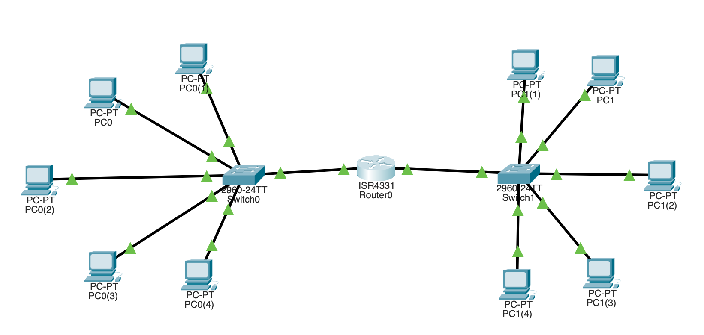

**Conclusion:**

Simulating router connections and message sending in Cisco Packet Tracer provides valuable insights into network management. By configuring routers, PCs, and routing protocols, users can understand how data is routed across networks. This helps in developing practical skills for real-world network management and troubleshooting.

------------------------------------------------------------------------------------------------

**Q2.** Implement Virtual LAN Circuit In Cisco Packet Tracer

**A2.**

**Theory:**

A **Virtual Local Area Network (VLAN)** is a technology that divides a physical network into multiple logical networks. This allows network administrators to group devices together based on their function or location, even if they are physically connected to different network switches. This segmentation improves network management, security, and performance.

**Key Concepts:**

1. **Logical Segmentation:** VLANs create separate broadcast domains within a single physical network. Devices in the same VLAN can communicate as if they were on the same physical network, but they are isolated from devices in other VLANs.
2. **Broadcast Domains:** A broadcast domain is a network segment where a broadcast message sent by one device is received by all other devices within that segment. VLANs help reduce broadcast traffic by creating multiple broadcast domains, improving network performance and efficiency.

**Procedure:**

**Configure the Switch:**

1. Set Up VLAN Connections from Command Line Interface By Programming Them. Select the Switch >> Choose CLI >> Write a similar code to below

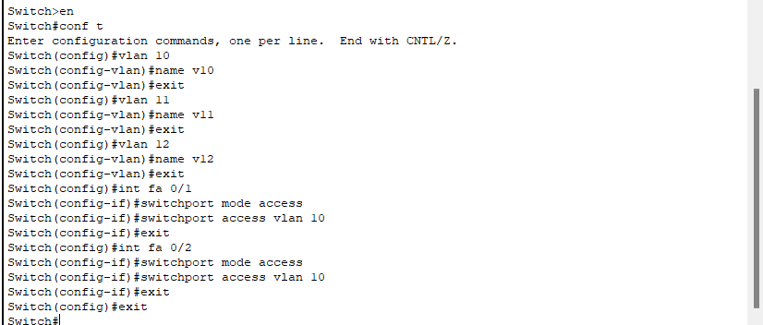

1. Select the Switch >> Choose to Configure the Ports on the switch >> Select the ports where the PCs are connected via VLAN, and make sure they are ON
2. Pass Message to check the reliability of the network and troubleshoot if necessary.

**Cisco Packet Tracer Network:**

