

SENECA COLLEGE NEWHAMN CAMPUS

COURSE WEB422 FALL 2023

ASSIGNMENT1

Using the [Mockaroo service](https://mockaroo.com/) generate 150 rows of realistic data in JSON format.

Below is a screen capture

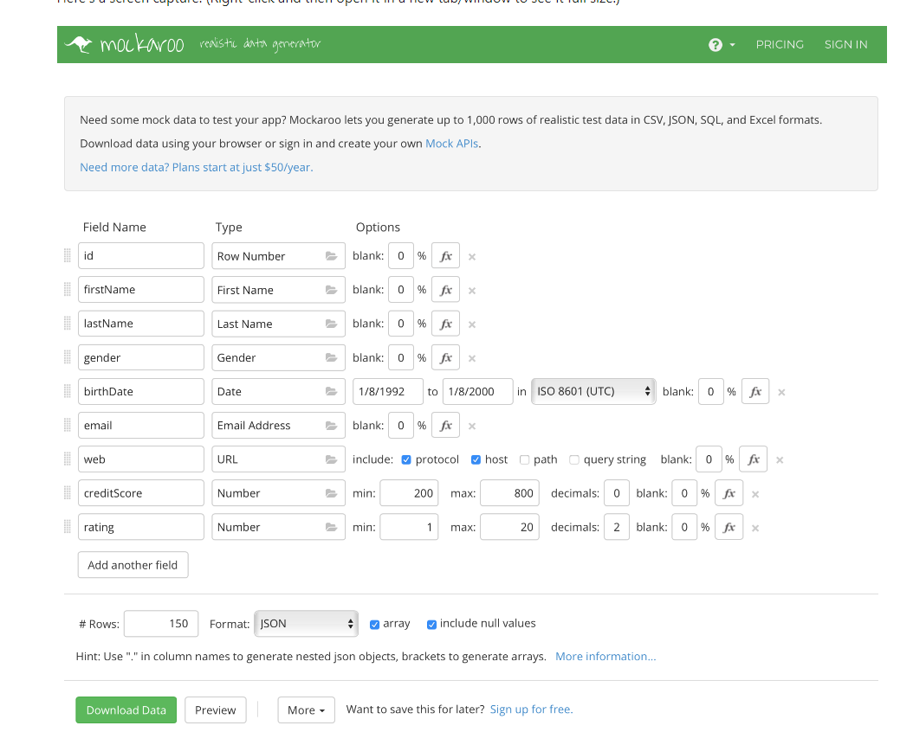

1. Modify the example code used in class, assign the JSON as the value of the new variable.
2. Update the code in the function
3. Compose a GET request to Get all item
4. Compose a GET request to GET one item
5. Compose a POST request to Add a new item
6. Compose a PUT request to Edit existing item
7. Compose a DELETE request to delete item
8. Test the API’s using Thunder client
9. Give a screen snapshot to every API testing

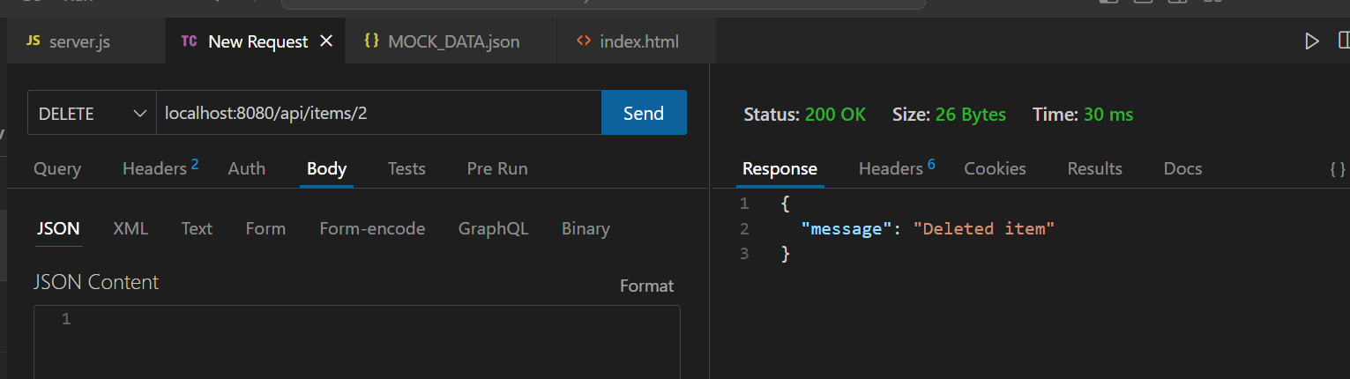

1. Upload the zip folder of the code to Assignment1 drop box, also upload the word document containing the snapshot.

The Assignment is due on Friday September 15th 2023.