Assignment:-1
Q1. Monthly AC Sales (Bar Chart)
A company recorded the number of Air Conditioner (AC) units sold during the first six
months of the year.
Month AC Sales
January 35
February 42
March 50
April 48
May 65
June 72
Write a Python program using Matplotlib to create a Bar Chart representing the monthly AC
sales.

Code:-
import pandas as pd
import matplotlib.pyplot as plt
df=pd.read_csv(r"D:\bscitE2_14\ds\bar.csv")
plt.bar(df["Month"],df["AC Sales"],color="#DF2354")
plt.title("Monthly Sales")
plt.xlabel("Month")
plt.ylabel("Sales")
plt.show()

Output:-
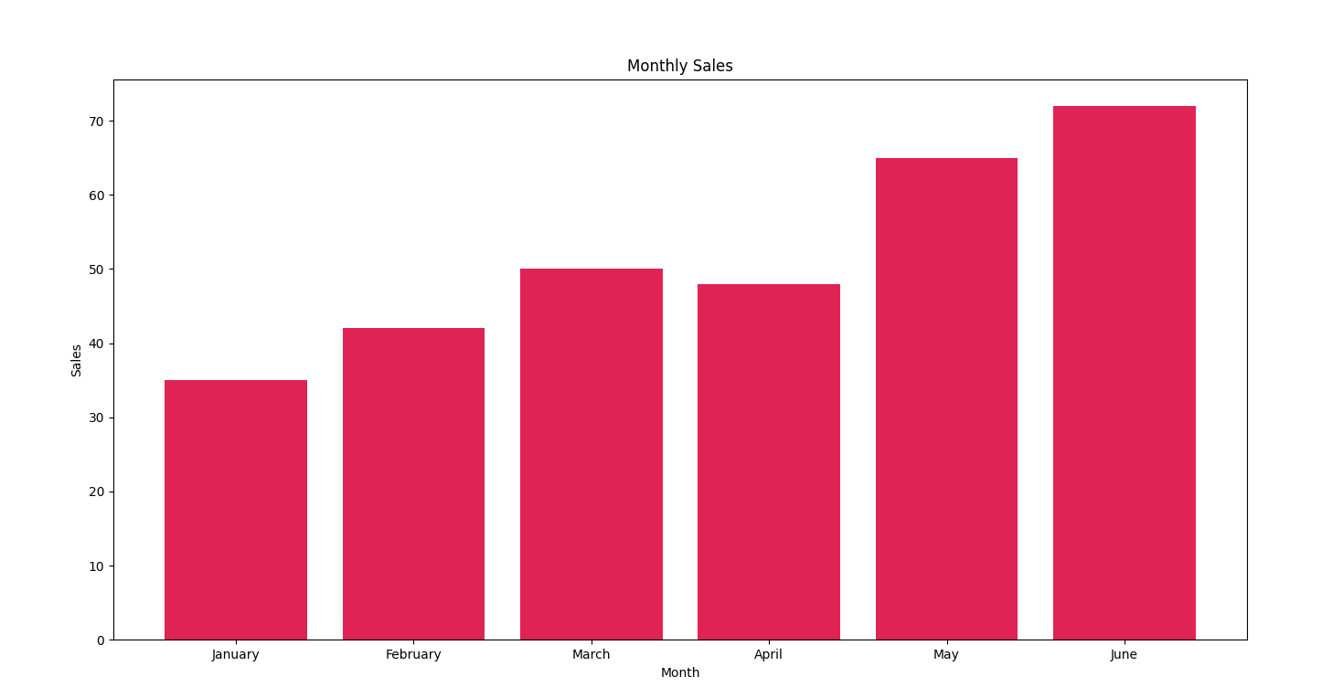
Q2. Monthly Laptop Sales (Line Chart)
An electronics store recorded the number of laptops sold during six months.
Month Laptop Sales
January 20
February 28
March 35
April 45
May 52
June 60
Write a Python program using Matplotlib to create a Line Chart showing the monthly laptop
sales trend.

Code:-
import pandas as pd
import matplotlib.pyplot as plt
df=pd.read_csv(r"D:\bscitE2_14\ds\line.csv")
plt.plot(df["Month"],df["Laptop Sales"],marker='o')
plt.title("Monthly Sales")
plt.xlabel("Month")
plt.ylabel("Sales")
plt.show()

output:-
