**Created two separate branches:**

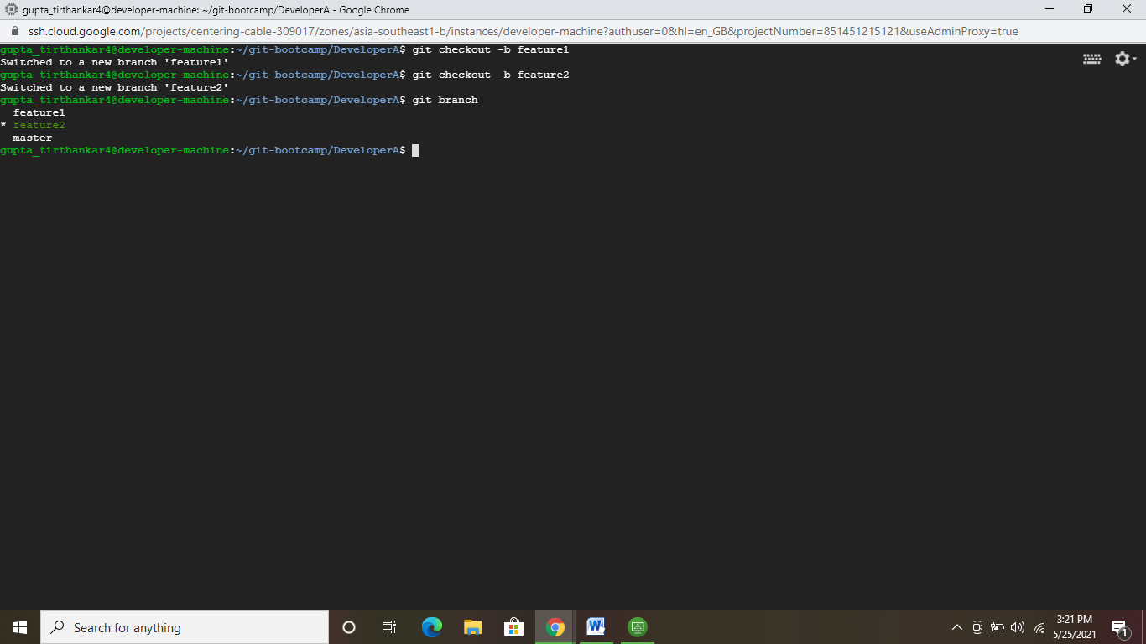

**Changes committed from feature1 branch:**

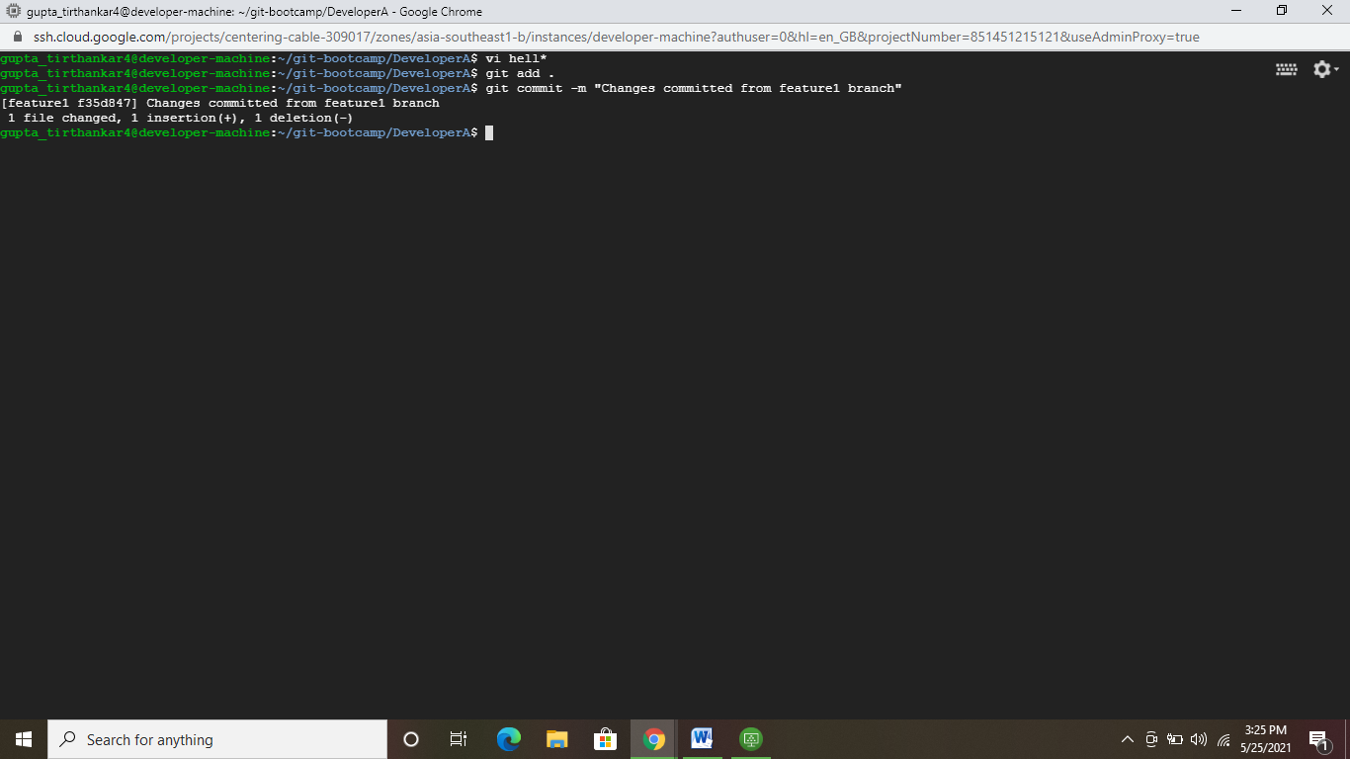

**Changes made in feature2 branch. Switched to master branch and merged changes from feature1 branch.**

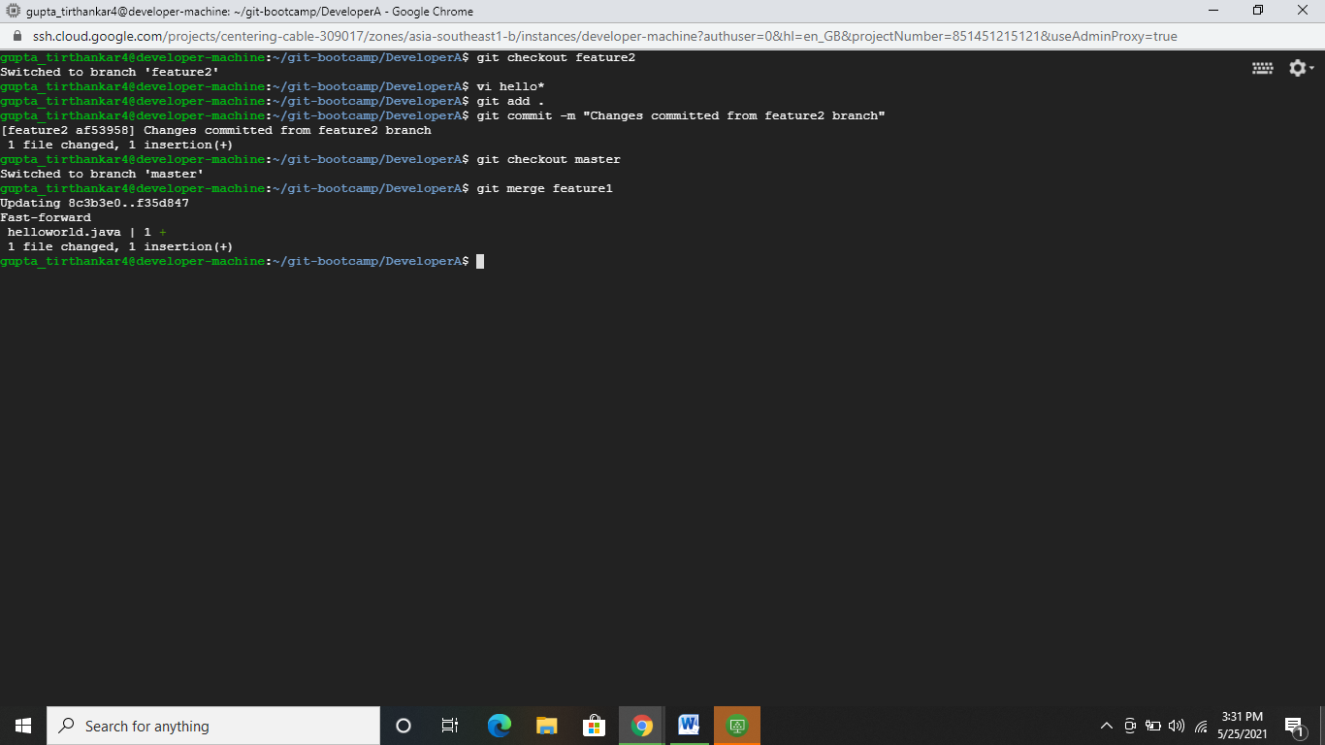

**Attempting to merge changes from feature2 branch, conflict arises:**

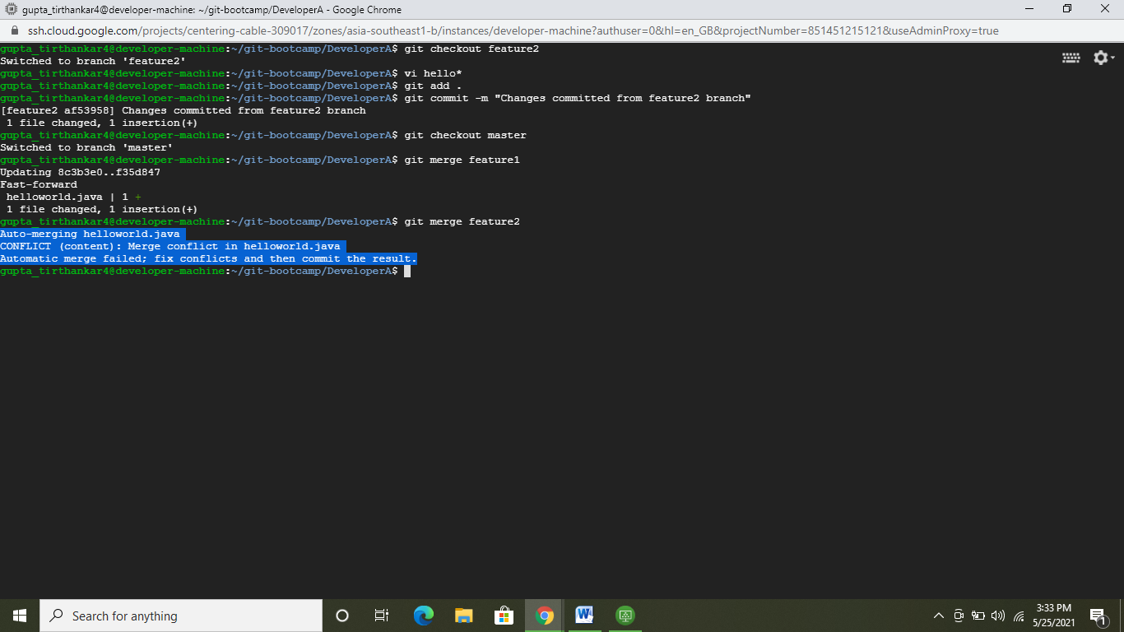

**Using Vimdiff to merge conflicts:**

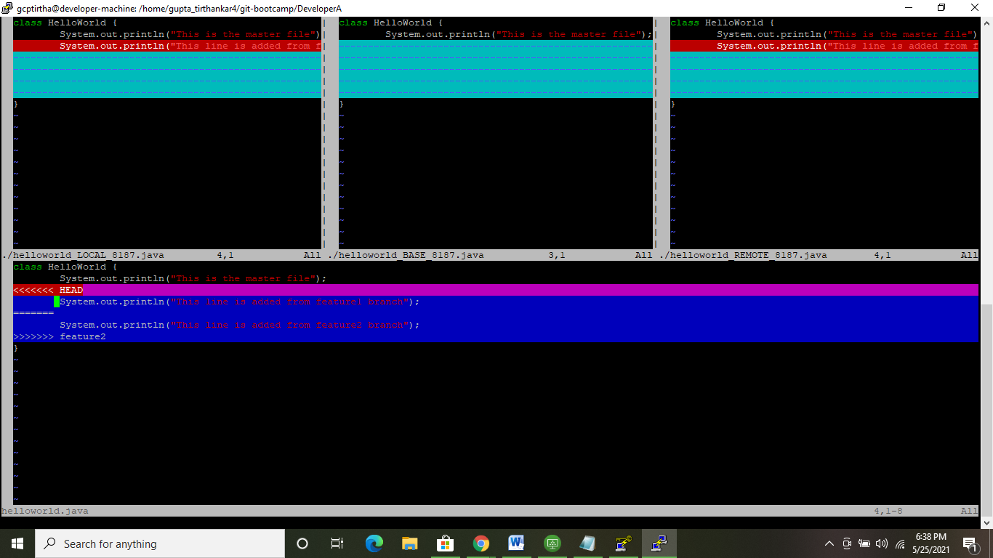

**Code pushed to remote after merging conflicts:**

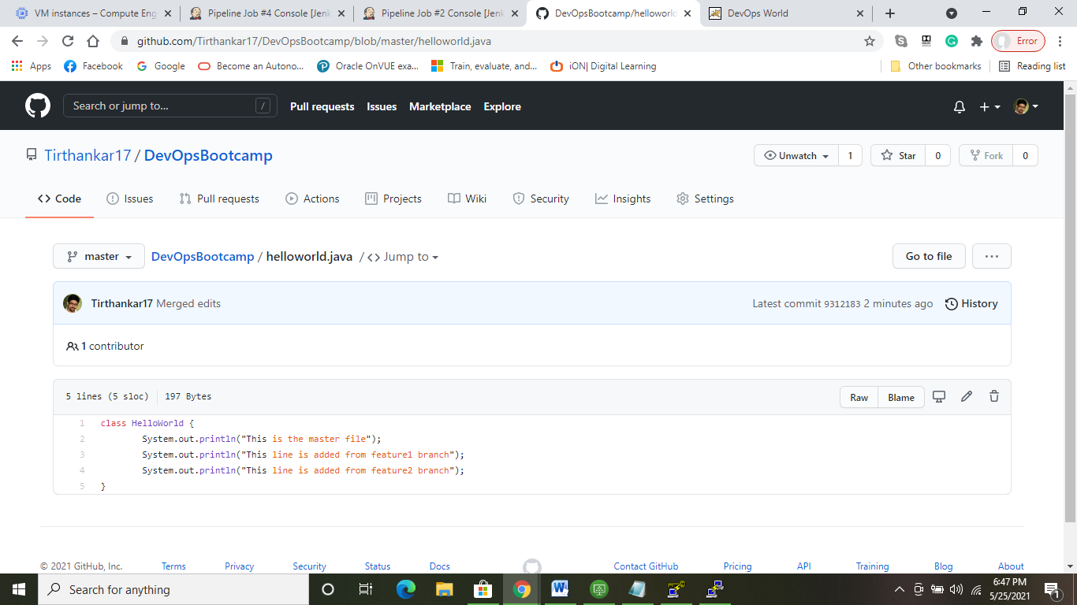

**Established a Build Pipeline View in Jenkins with Three Jobs , Checkout and compile, Build Test Package and Deploy job. Pipeline is executing successfully:**

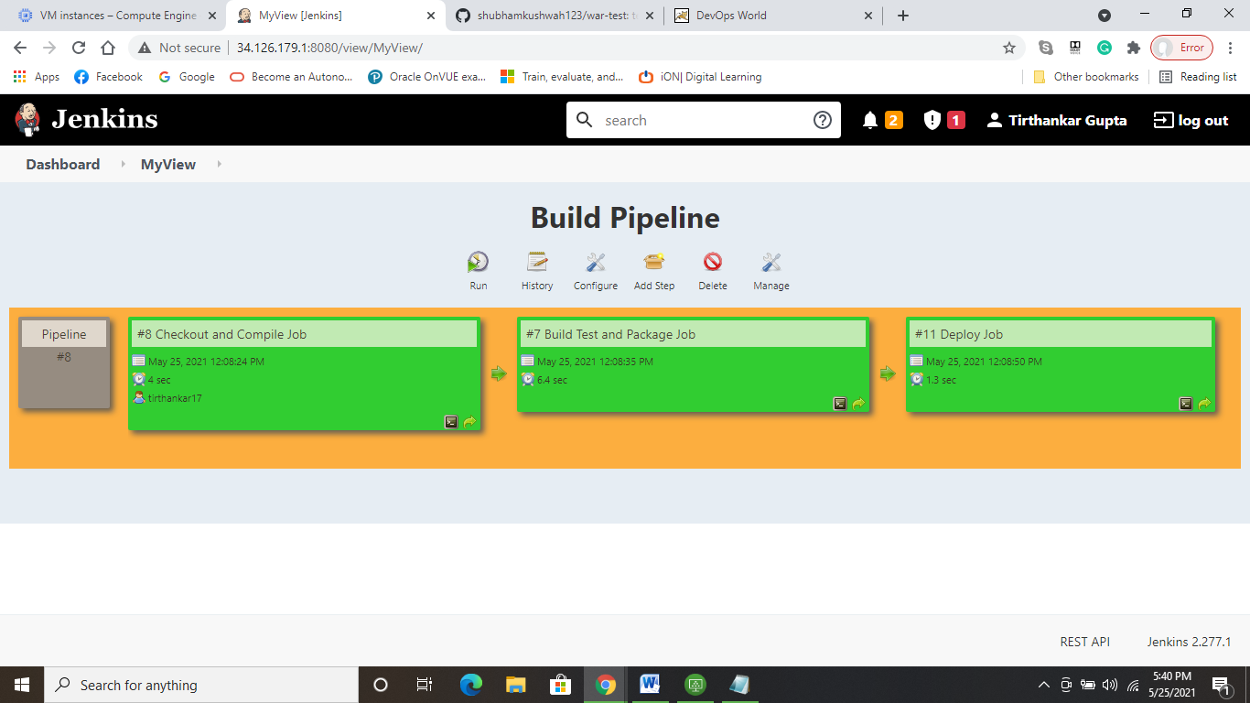

**Console output of “Checkout and Compile Job”:**

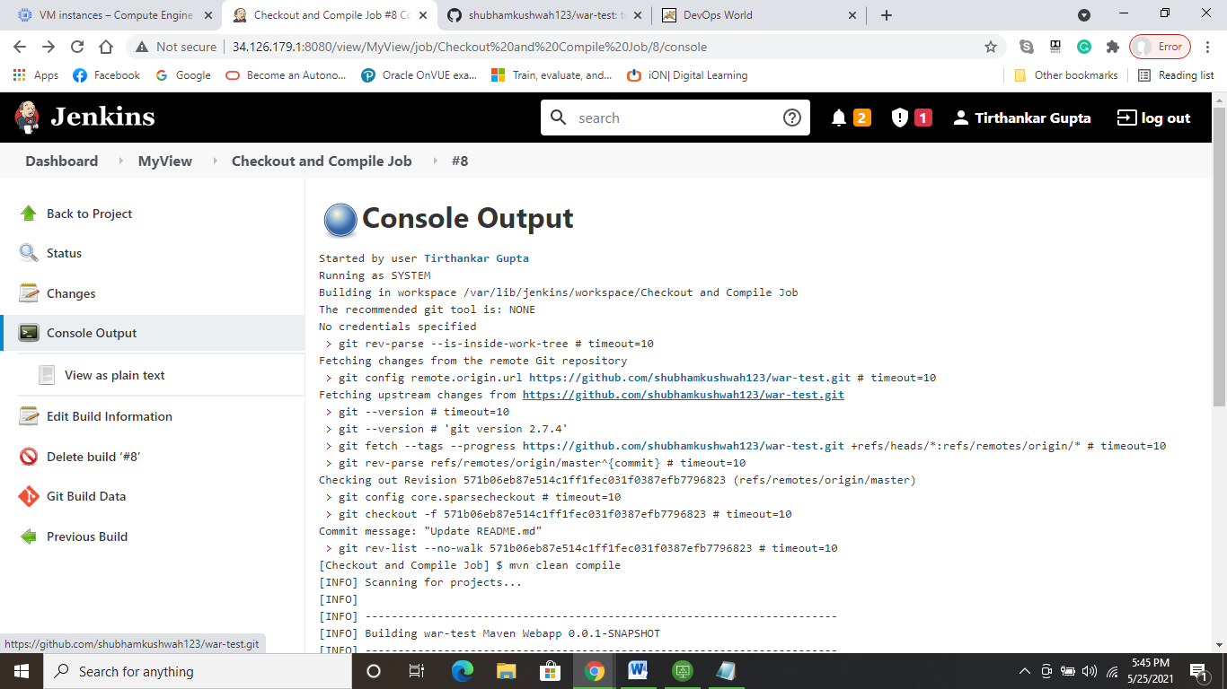

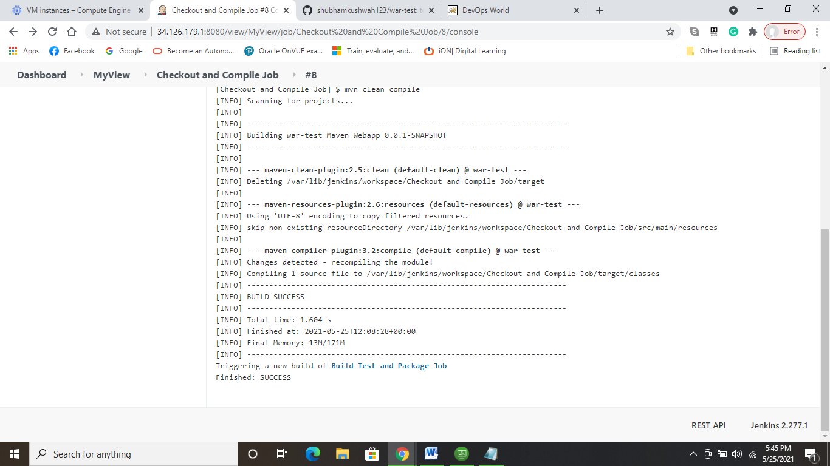

**Console output of “Build Test and Package Job”**

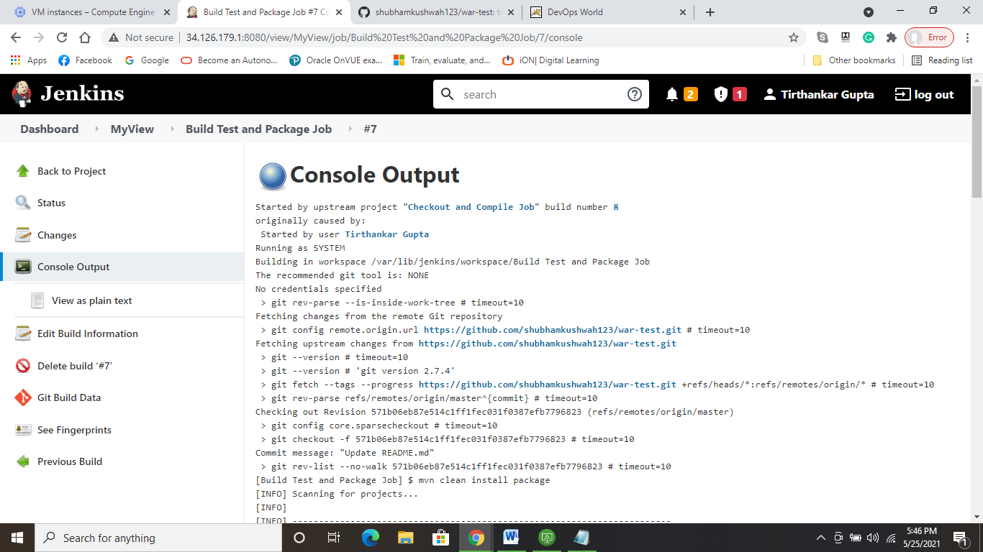

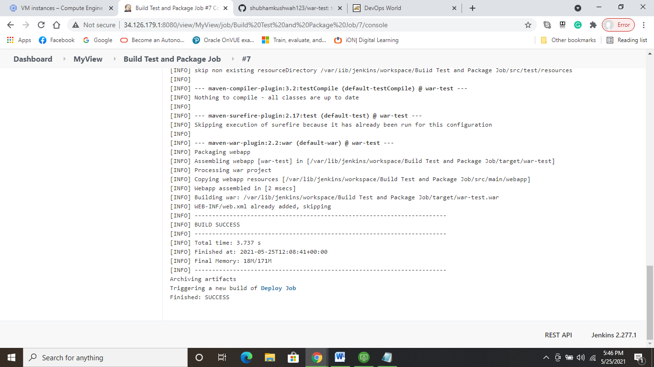

**Console output of “Deploy Job”:**

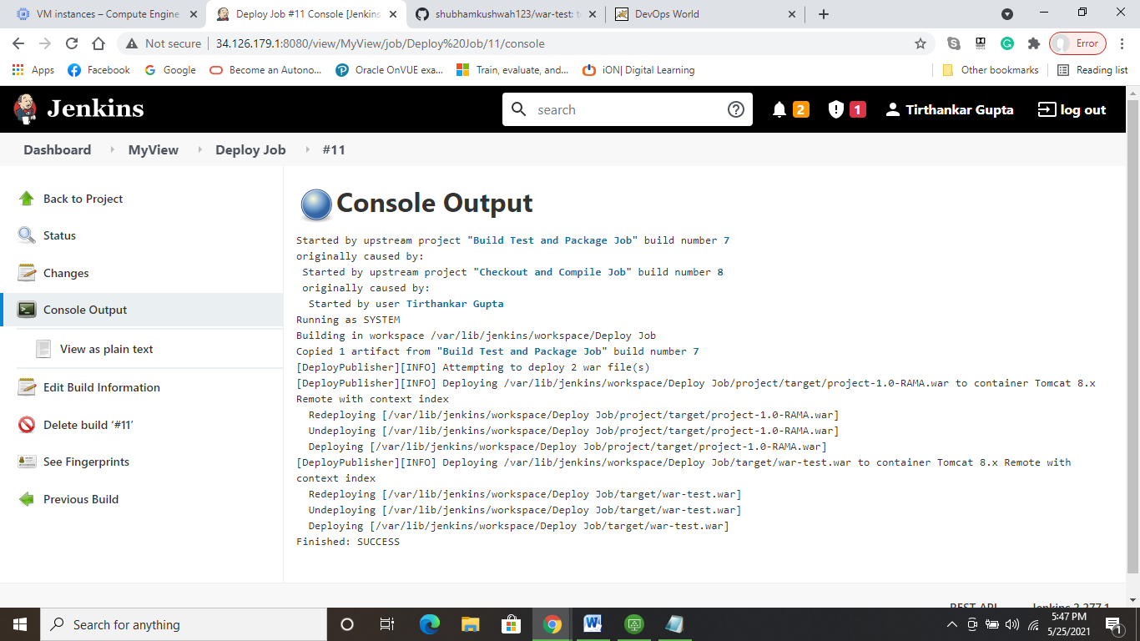

**App Launched successfully from Tomcat Manager Portal:**

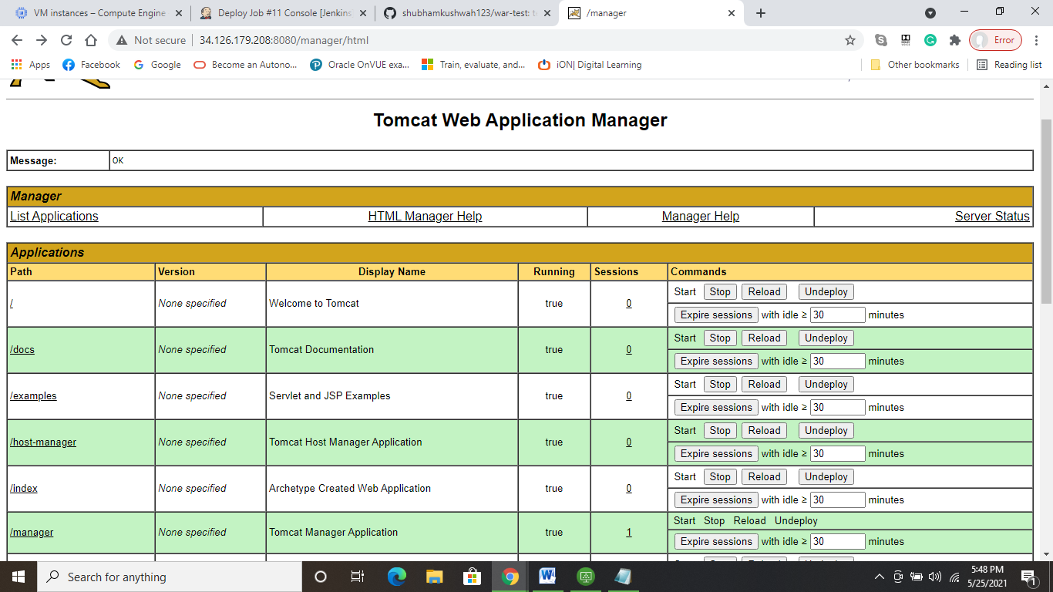

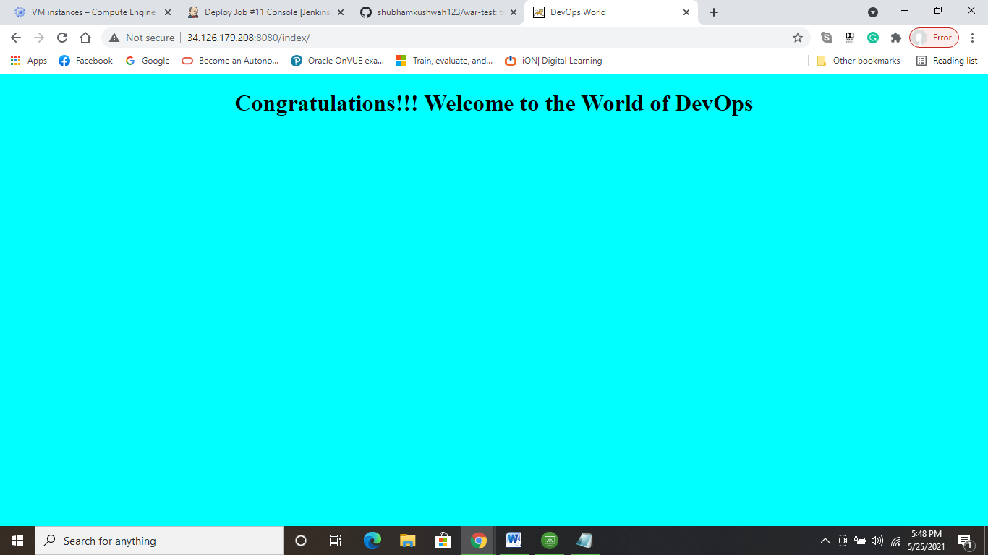

**Created a Pipeline Project using script, successfully running:**

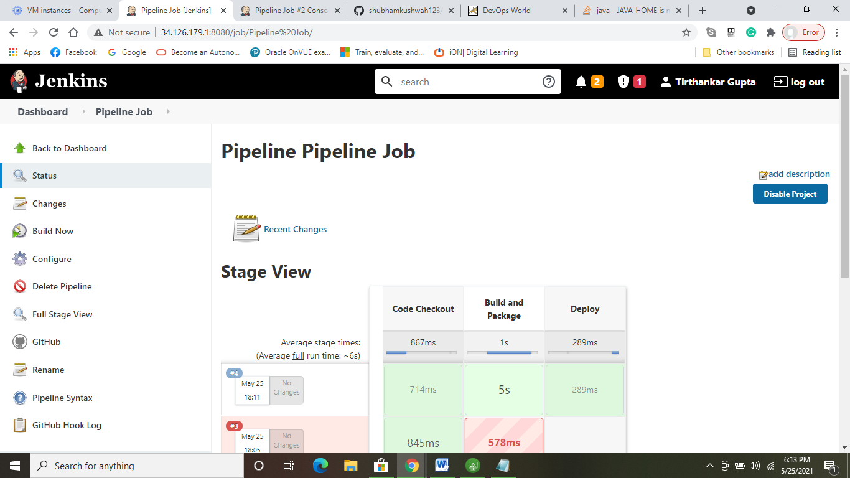

**Pipeline Script Snippet:**

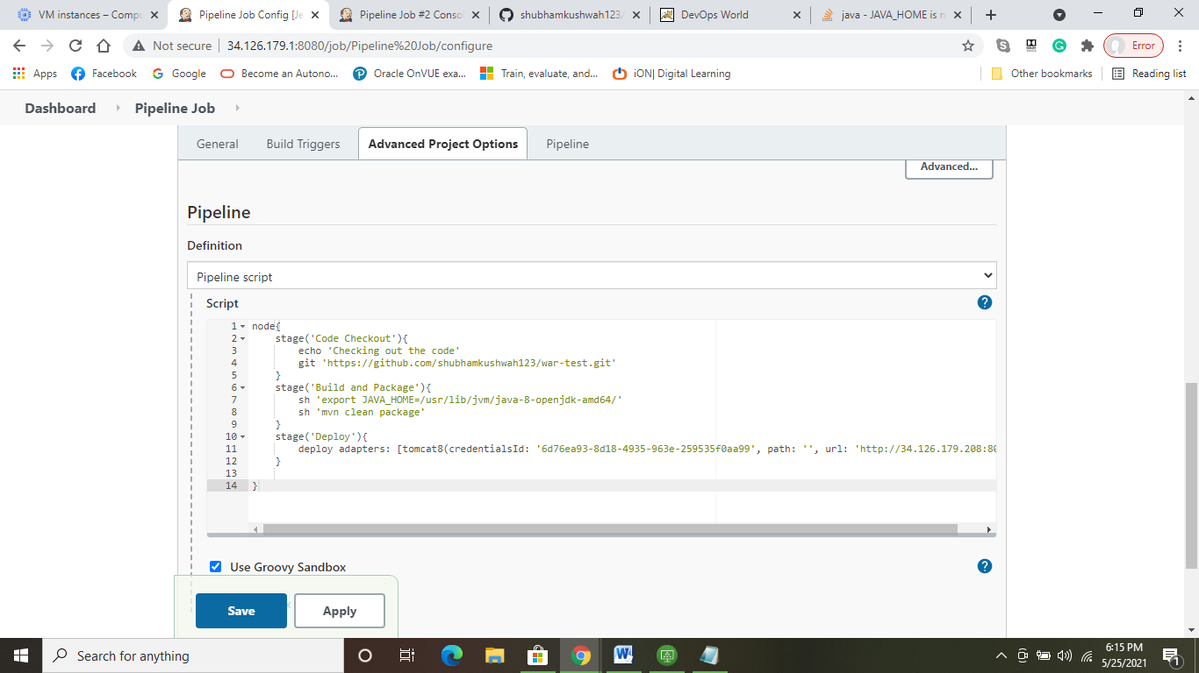

**Pipeline Job Console Output:**

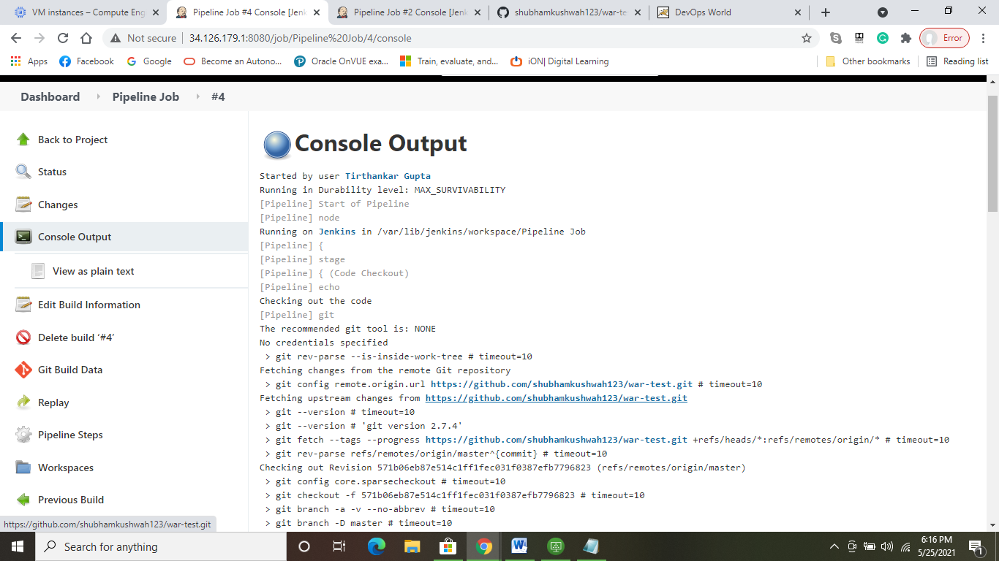

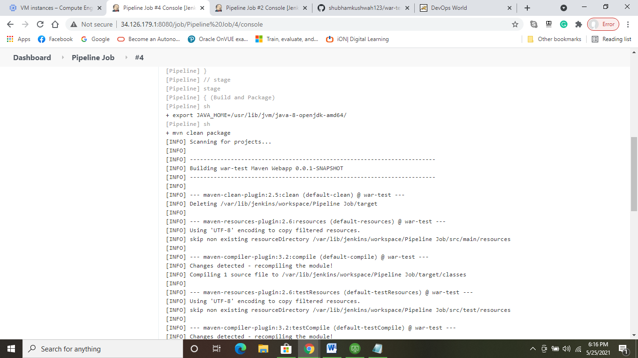

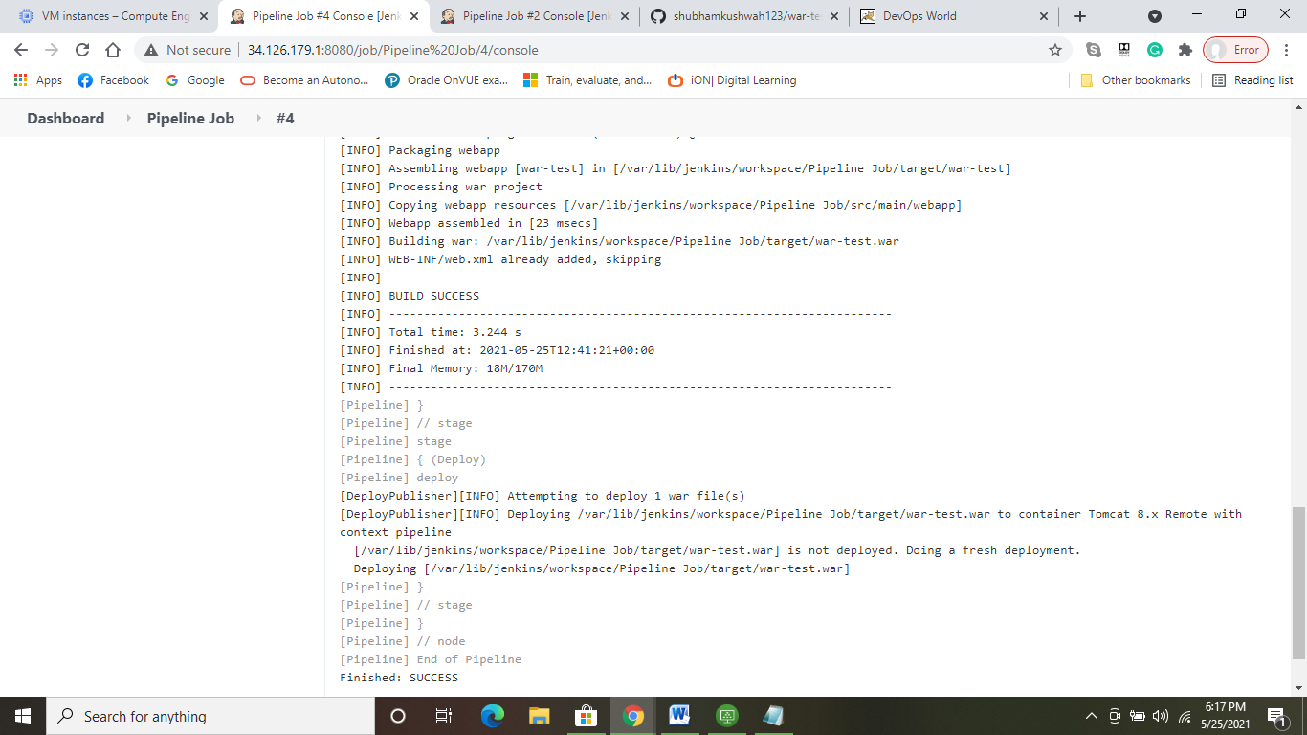

**Pipeline job successfully deployed the war to Tomcat(index=Pipeline):**

