**Created a new GCP instance and installed Docker in it:**

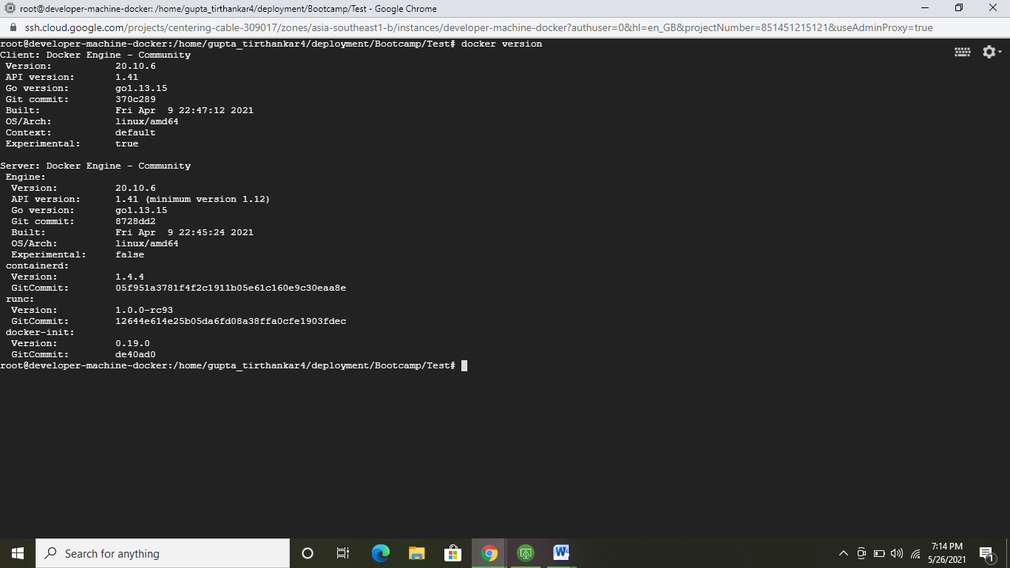

**Copied the index.html from Git repo and also created Dockerfile:**

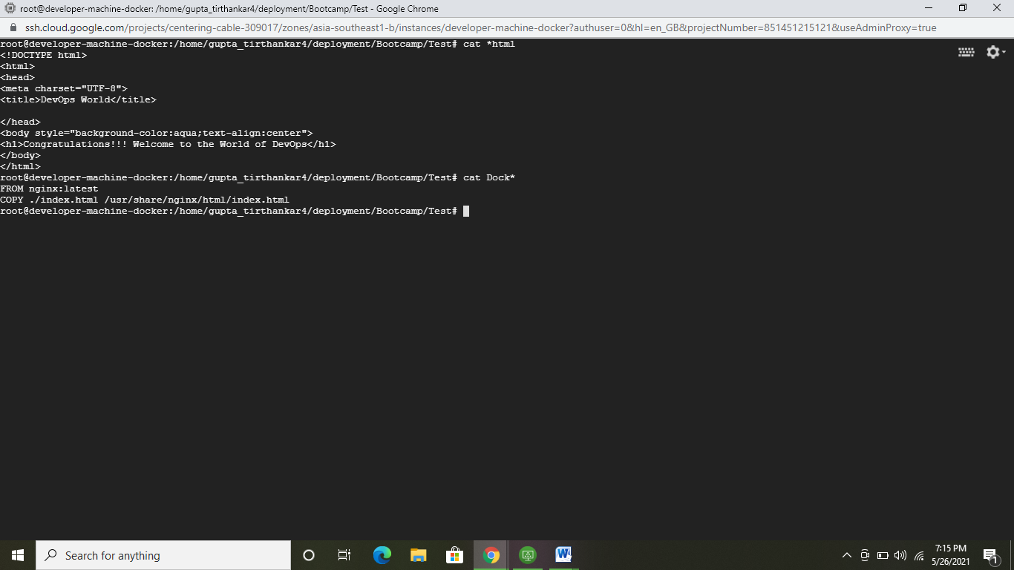

**Prepared the docker image and pushed it to Docker Hub. Also launched the container opening the appropriate port:**

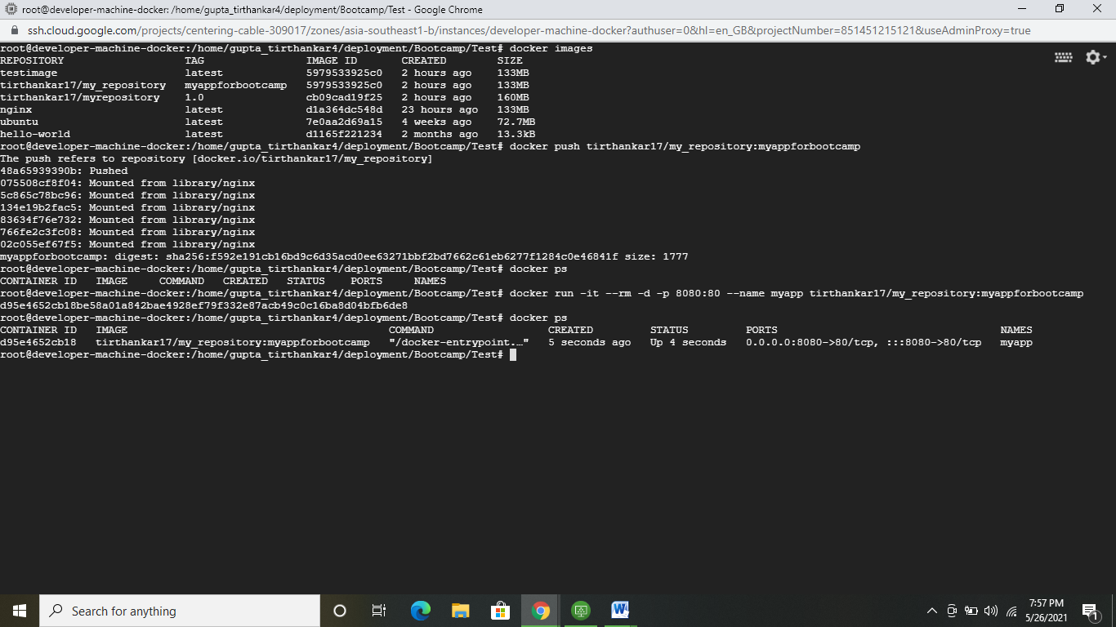

**Successfully launched container:**

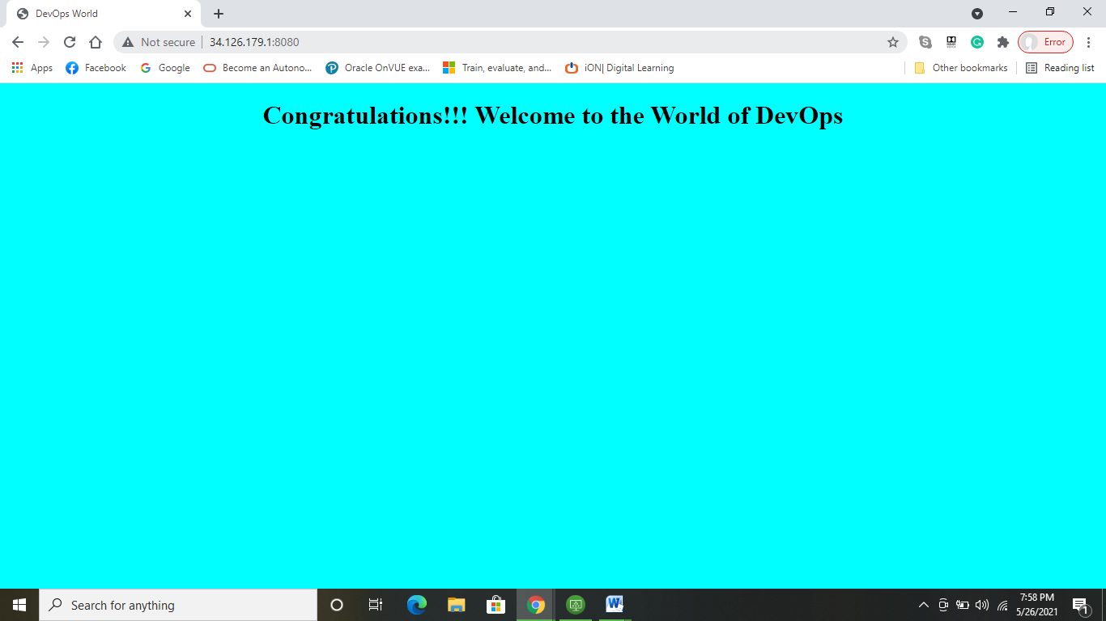

**Image pushed to my docker hub repository:**

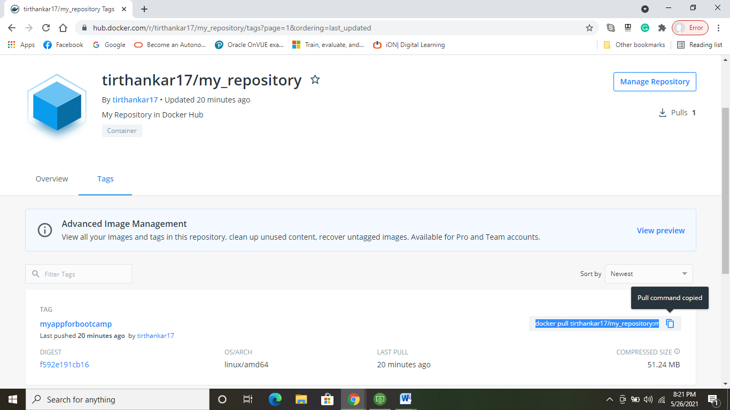

**Pulling the image from docker hub in another separate VM:**

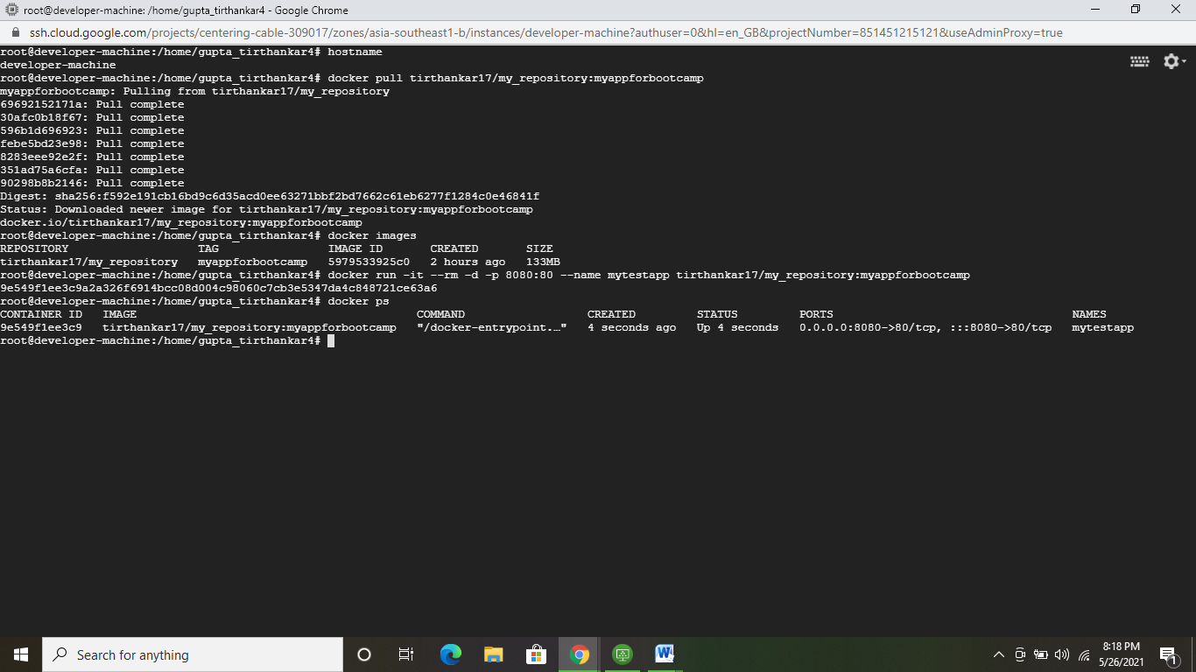

**Running container:**

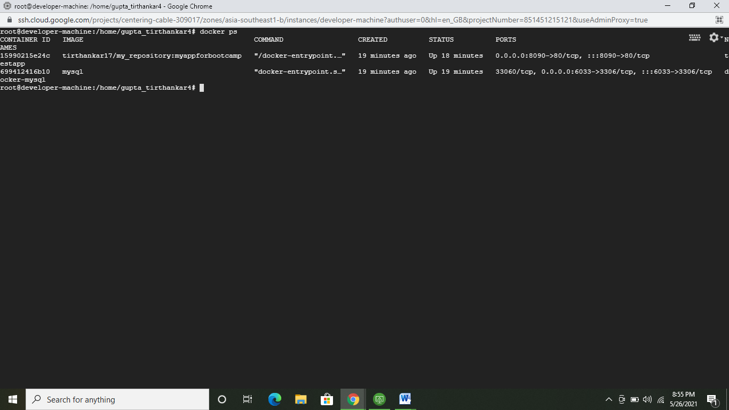

**Written the docker-compose and created image with it:**

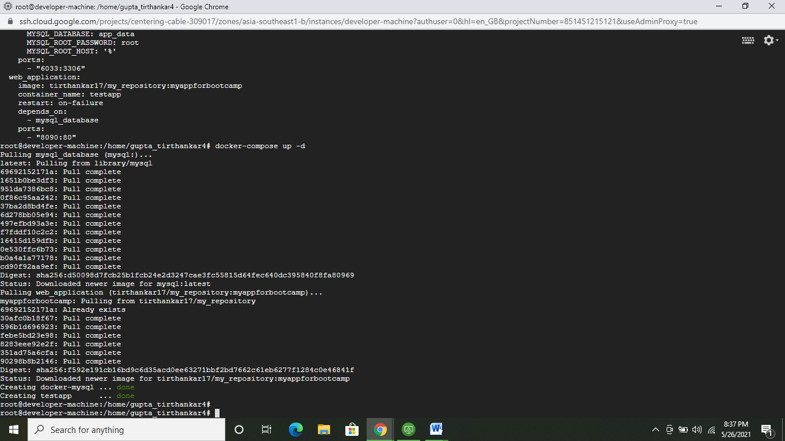



**Created table in the mysql database container in interactive mode:**