**Created one master node and slave node VM instance in GCP:**

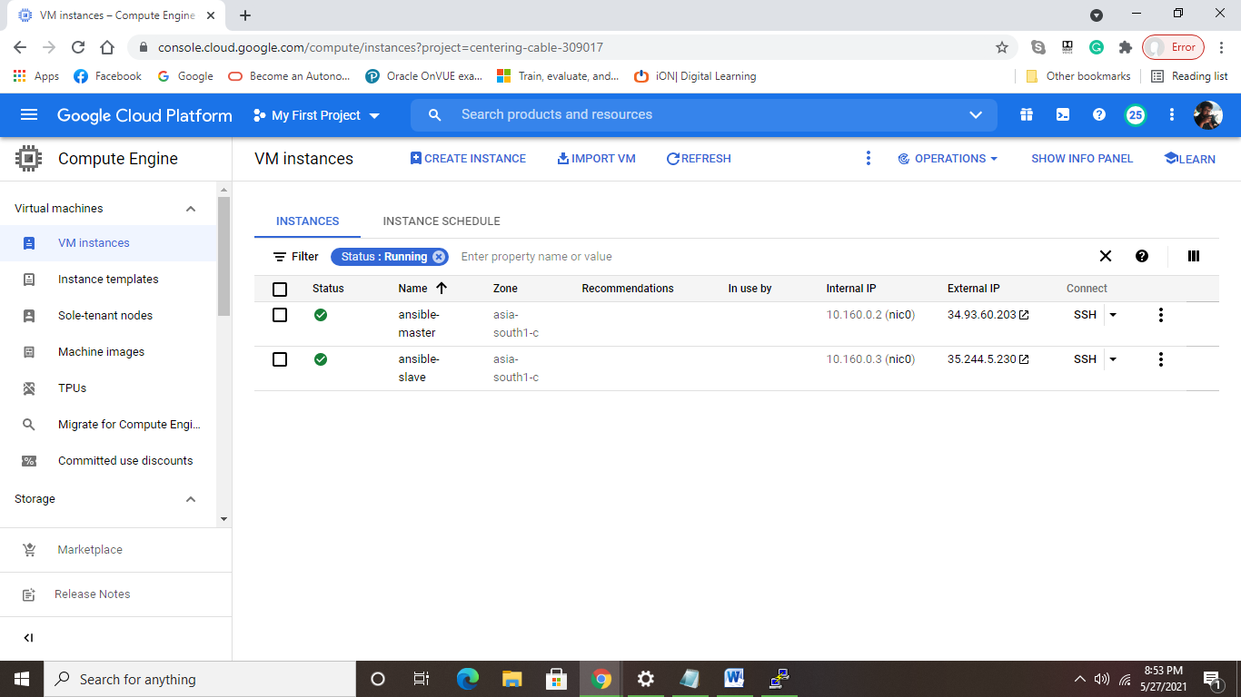

**Installed Ansible on master node, on slave node Ansible is not present:**

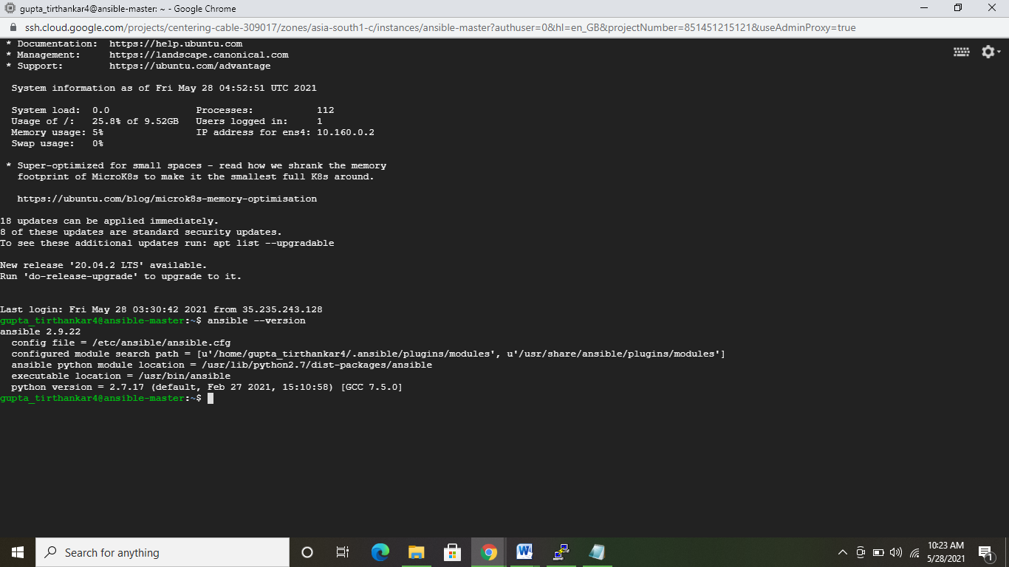

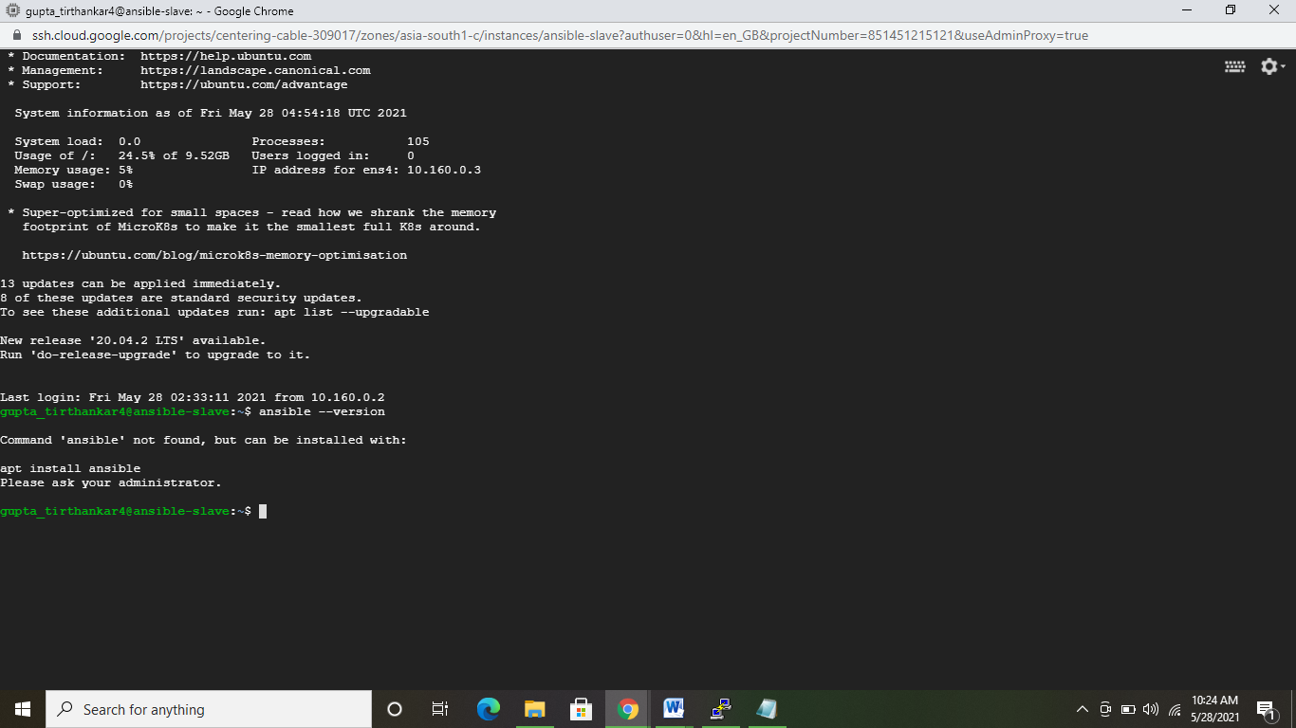

**I have created a user named “gcptirtha” with root priviledges in the master node and I have generated a keygen pair for this id, private key permission is set to 400:**

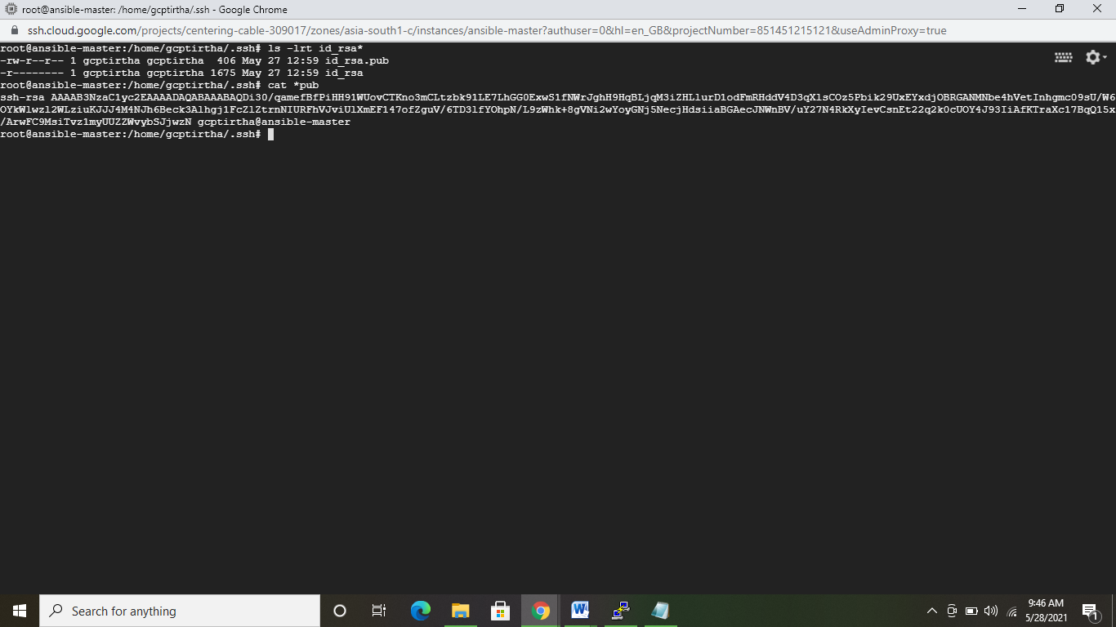

**Added the newly generated public key to my project metadata, so that all GCP instances inherit it. In this case it is ansible-slave gcp instance which inherits it.**

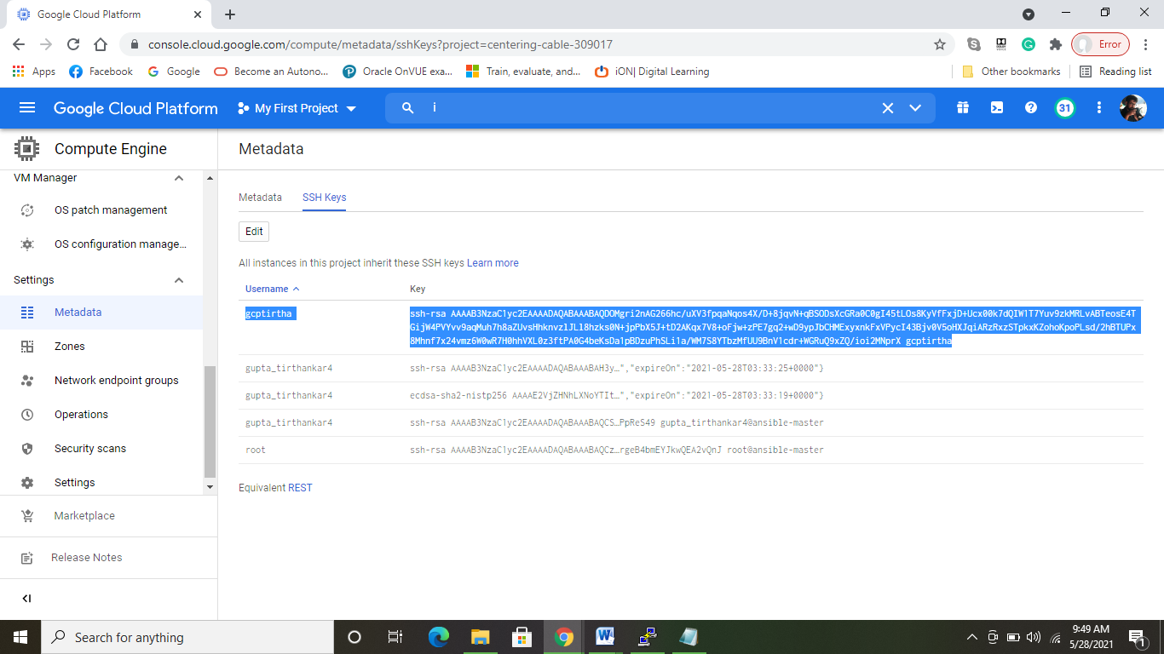

**Modified the ansible.cfg file to use this ID to communicate with slave nodes and provided the secret key to it.**

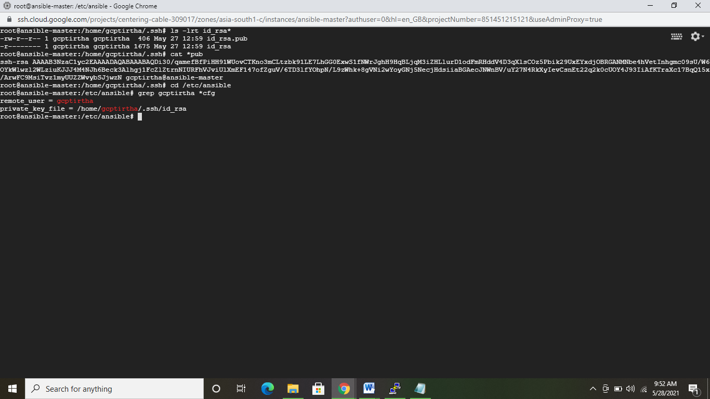

**Added slave node in ansible hosts file**

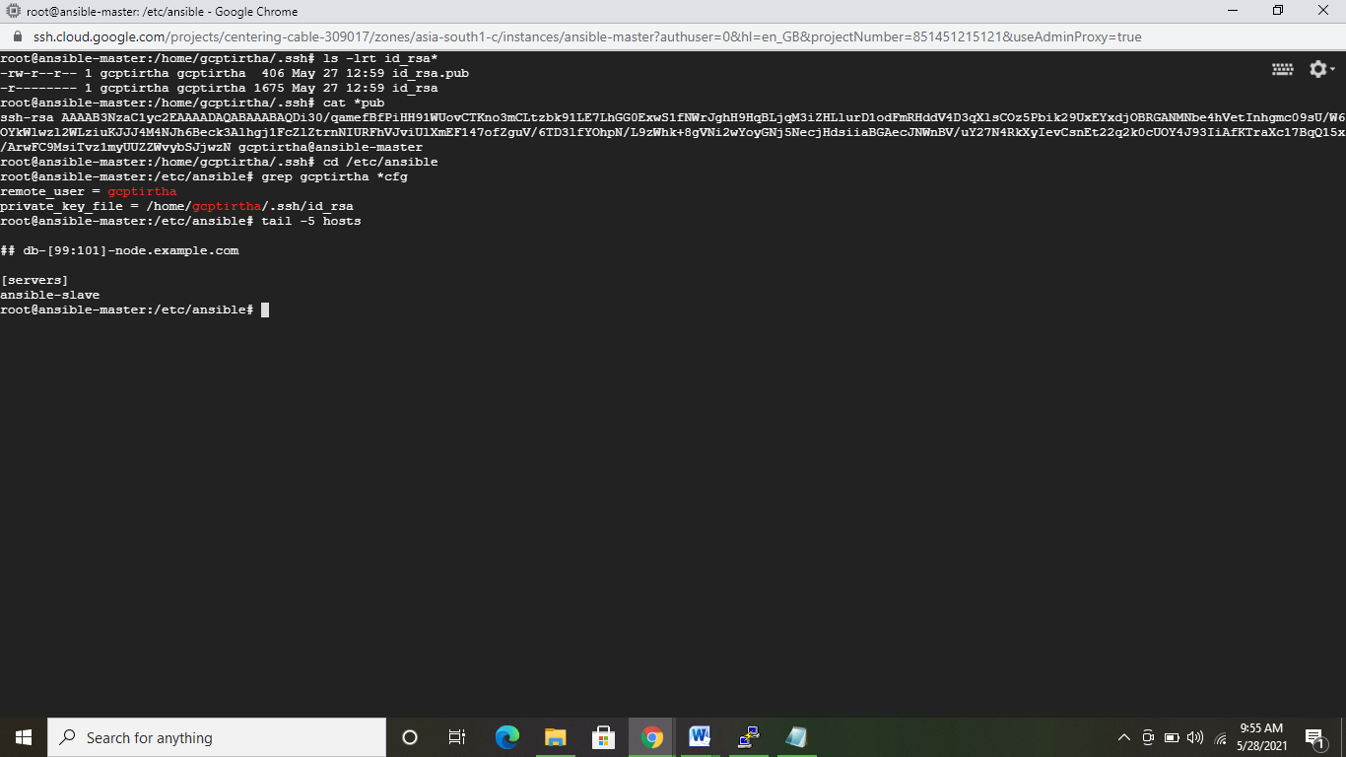

**Successfully able to ping Slave node from master:**

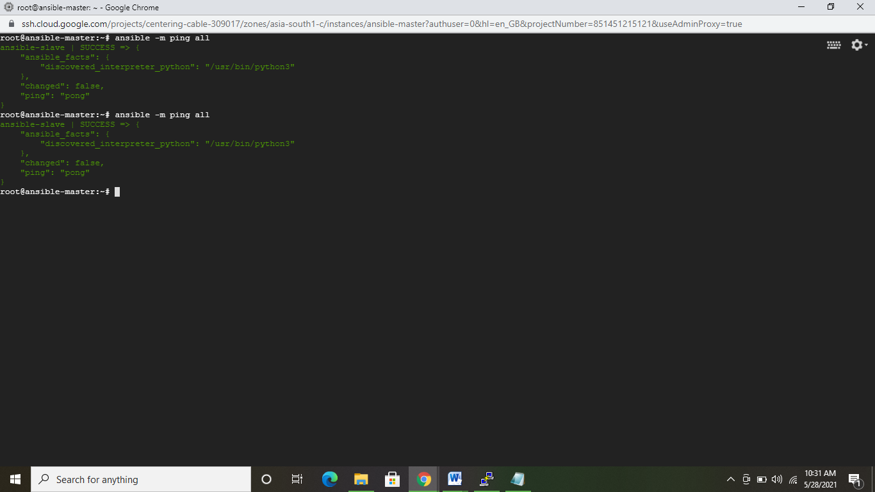

**Prepared a Dockerfile to pull the app from git and build an image to run the app on tomcat:**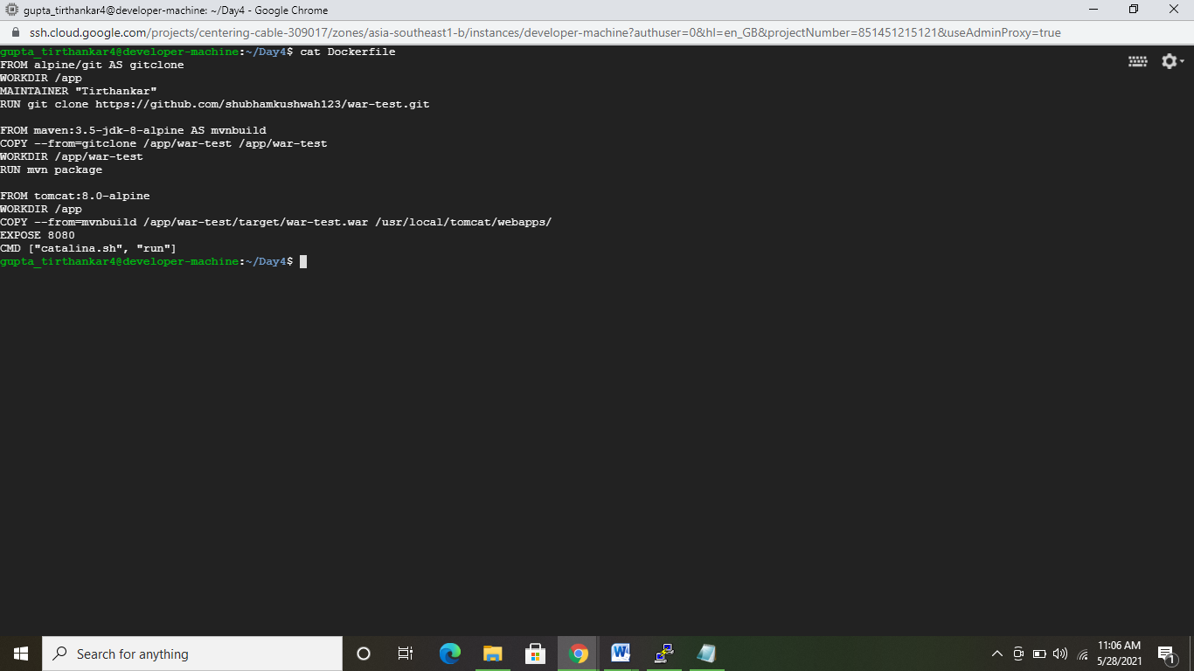

**Image built from Dockerfile successfully:**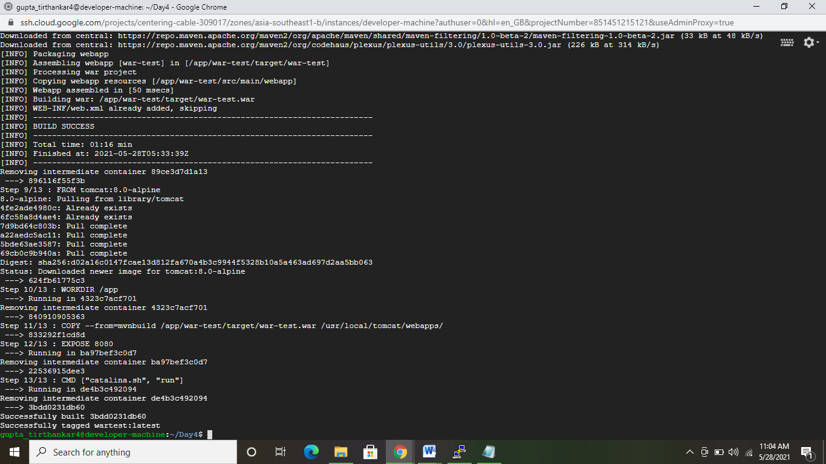

**Pushed the built image to dockerhub:**

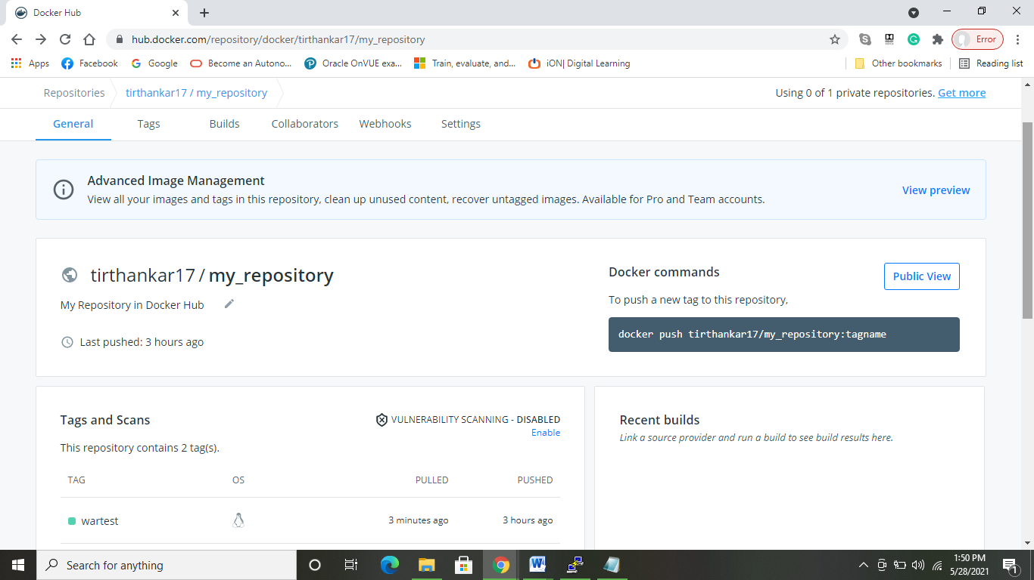

**Written the playbook to install softwares and deploy war in slave node:**

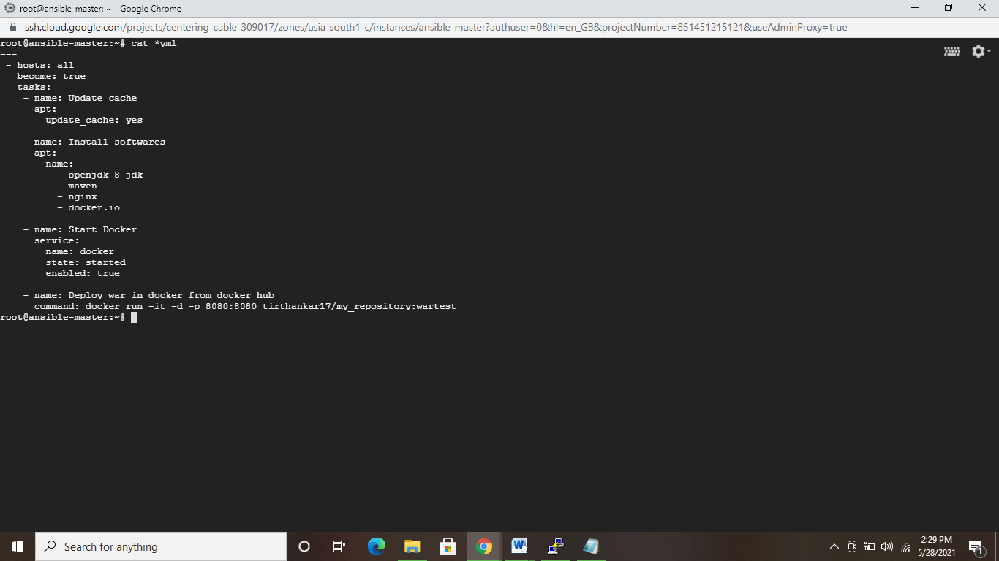

**Running playbook:**

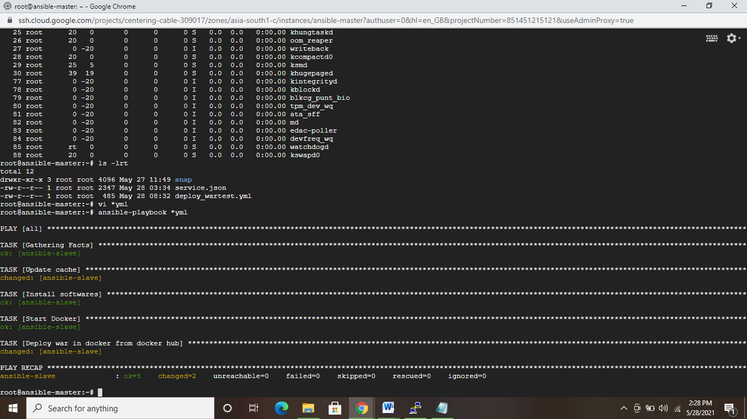

**Logged in Slave node to validate software installations:**

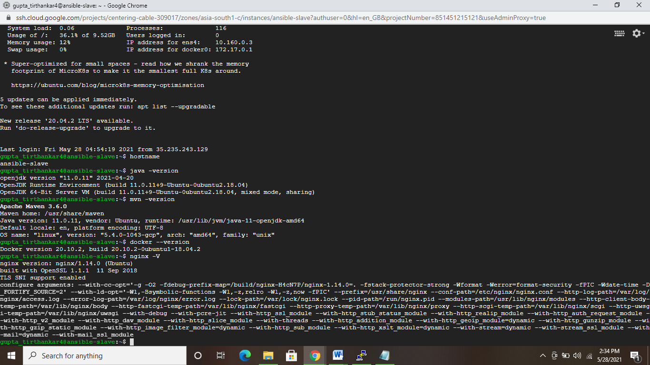

**App running as a container:**

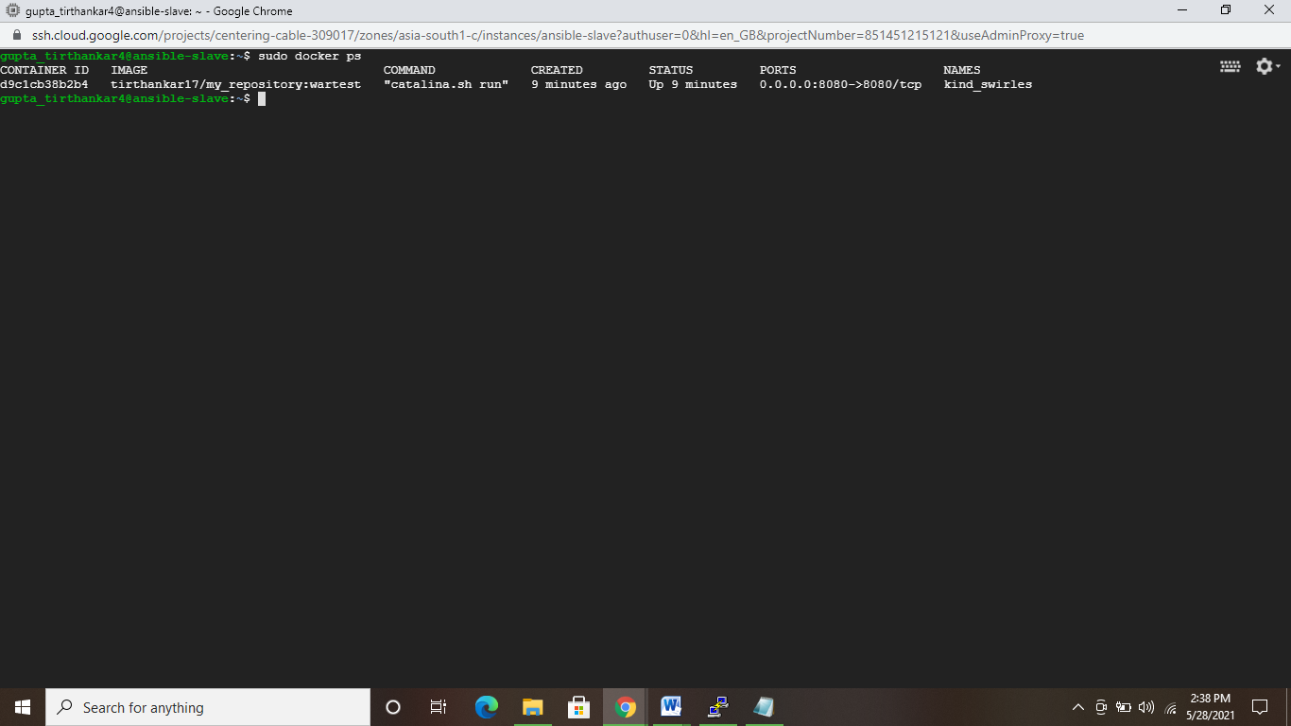

**App accessible from browser:**

