Golden Gate Bridge DevOps Bootcamp –Day 1 Assignment

**Name:** Tirthankar Gupta

**EmpID:** 758489

**Git Repository URL**: <https://github.com/Tirthankar17/DevOpsBootcamp.git>

**Created and committed 3 demo files by Developer A:**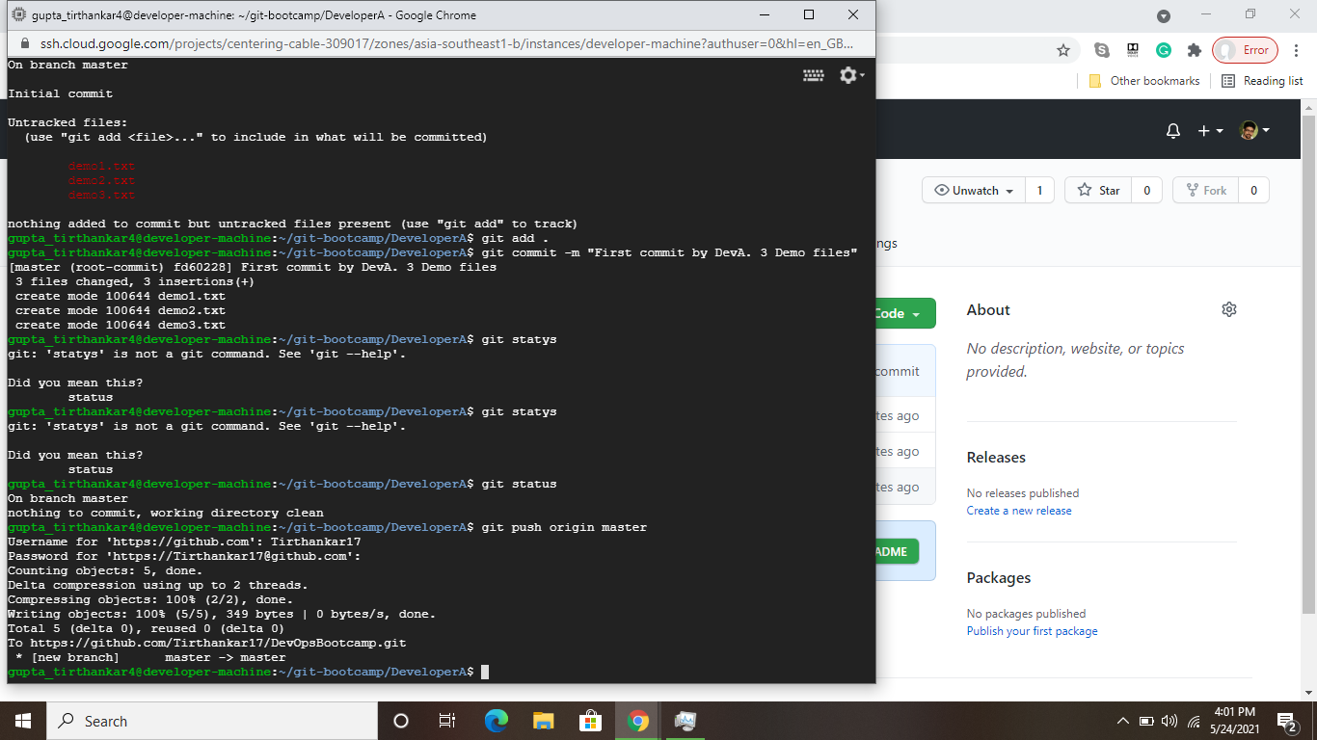

**Commit changes made by Developer B:**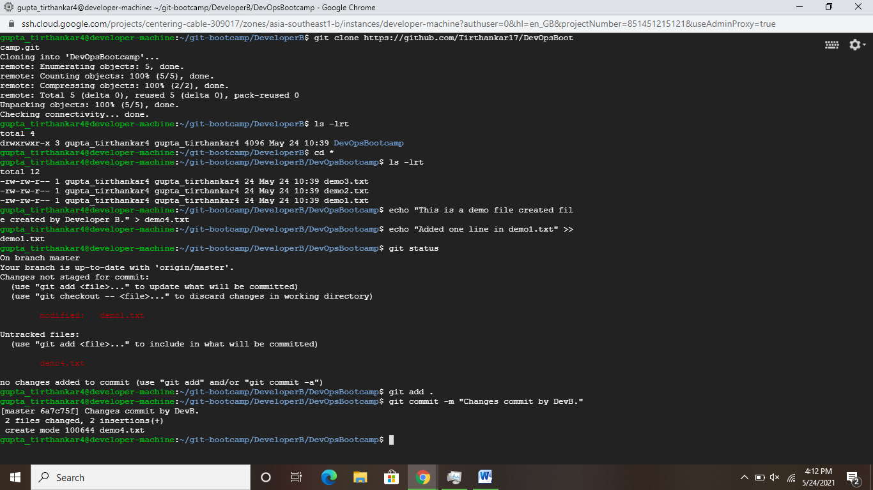

**Pulled the changes in DeveloperA Working directory from remote:**

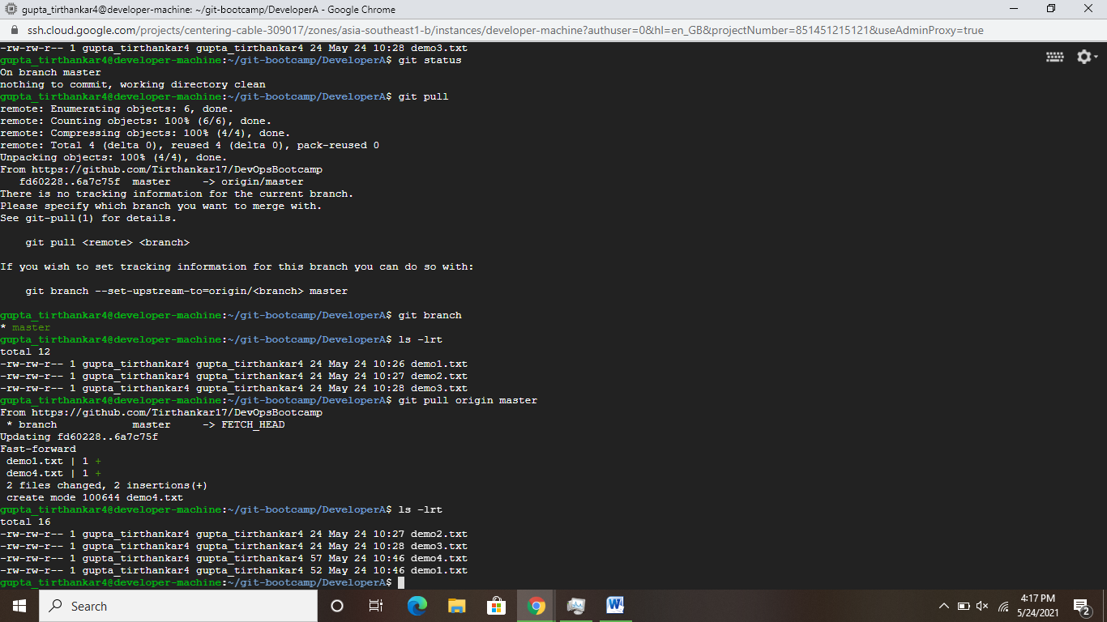

**Created a feature branch named “feature1” , merged it with the master branch after making changes:**

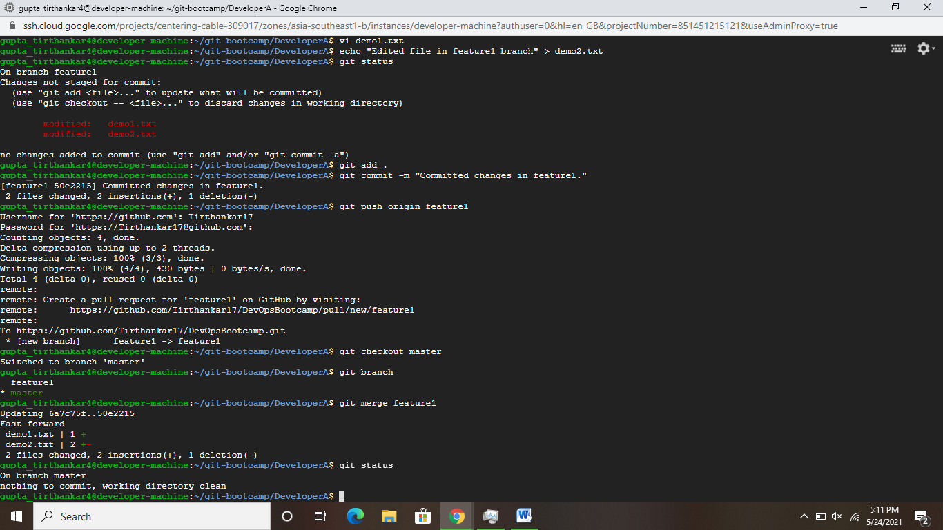

**Deleted feature1 branch after merging with master:**

