**Agile and Scrum**

* Scrum is a process framework used to manage complex product development
* Scrum delivers products of highest possible values, creatively and productively
* Scrum is the most popular agile process framework, over 70% of all agile teams use it

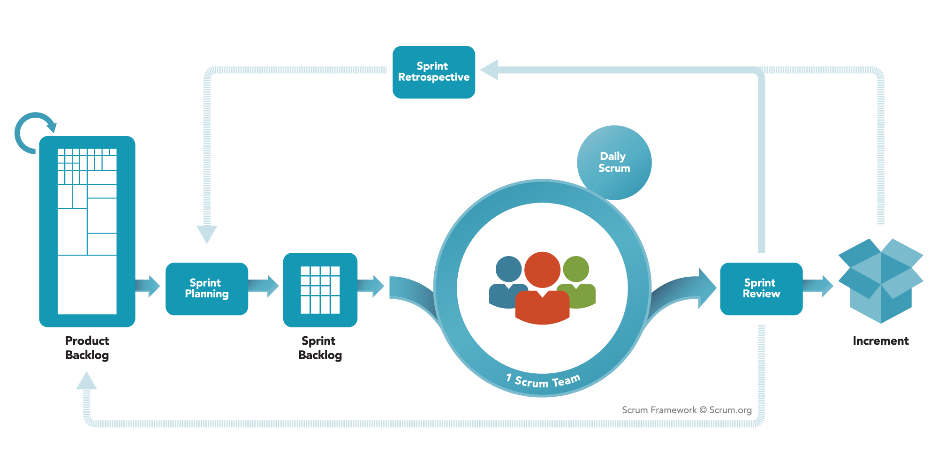

**Scrum Values and Roles**

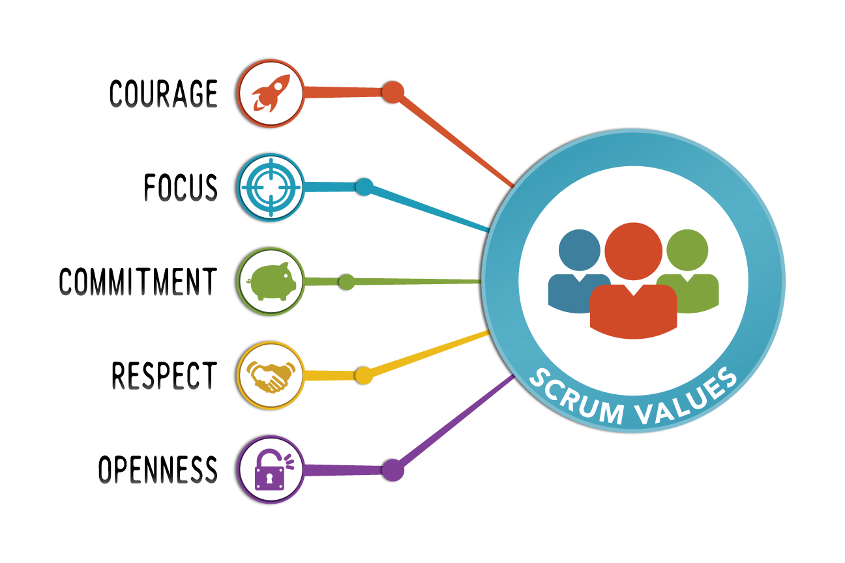

* Following are the defined roles in a scrum team
  + Product Owner : Responsible for maximizing the value of the product. Sole person for managing the product backlog
  + Scrum Master : Ensures that scrum team adheres to Scrum theory, practices and rules
  + The Development Team : Optimal team size is small enough to remain nimble and large enough to complete significant work

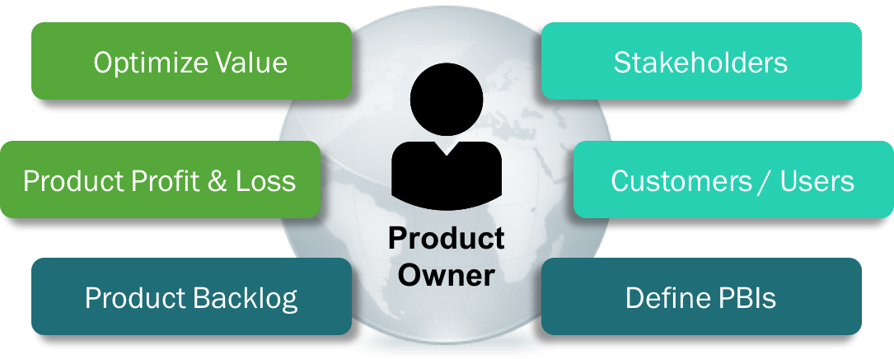

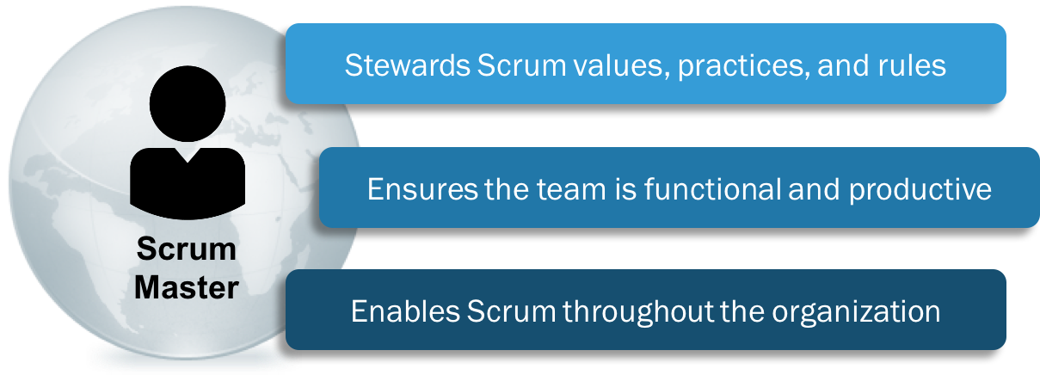

**Scrum Events**

* The heart of scrum is Sprint, a time-box of one month or less during which a usable and potentially releasable product increment is created. A sprint starts immediately after the conclusion of previous sprint. A sprint typically consists of the following

1. Sprint planning
2. Daily scrums
3. The development work
4. Sprit review
5. Sprint retrospective

* Sprint goal is
* An objective set for the sprint that can be met through the implementation of product backlog items
* It is created during sprint planning meeting
* The selected product backlog items (Sprint backlog) deliver one coherent function, which can be the Sprint goal

**Sprint Planning**

* The work to be performed in the sprint is planned at the sprint planning
* The plan is created by the collaborative work of the entire scrum team
* Sprint planning is time-boxed to a maximum of 8 hours for a one month (4 weeks) sprint
* Sprint planning answers the following:
  + What can be delivered in the increment resulting from the upcoming sprint
  + How will the work needed to deliver the increment be achieved

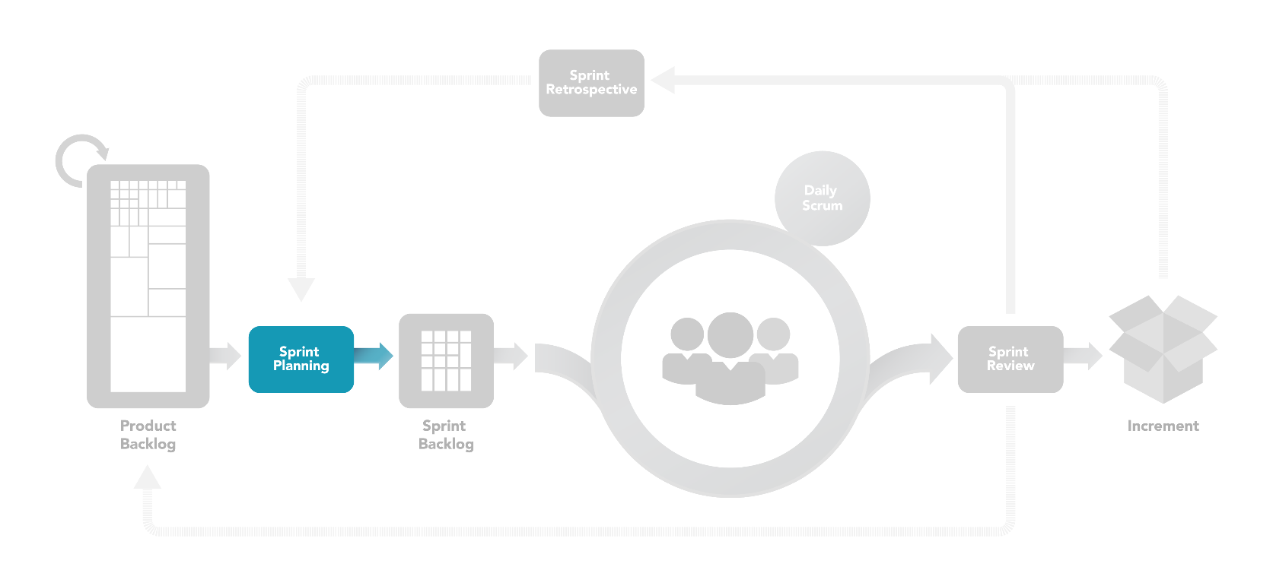

**Daily Scrum**

* A 15 minute time-boxed event, used by the development team to synchronize activities and create a plan for the next 24 hours
* Held at the same time and place to reduce complexity
* The scrum master ensures that the development team has the meeting but the Dev team is responsible for conducting the daily scrum
* Daily scrums help to
  + Eliminate other meetings
  + Improve communications amongst team members
  + Promote quick decision making
  + Identify impediments to development
  + Increase dev teams level of knowledge

**Sprint Review meeting**

* A 4-hr time-boxed meeting for one month sprint, held at end of sprint to inspect increments added and adapt product backlog if needed
* This is an informal meeting used to elicit feedback and foster collaboration
* Result of this is a revised product backlog that defines the probable product backlog items for the next sprint
* The product backlog may also be adjusted overall to meet new opportunities

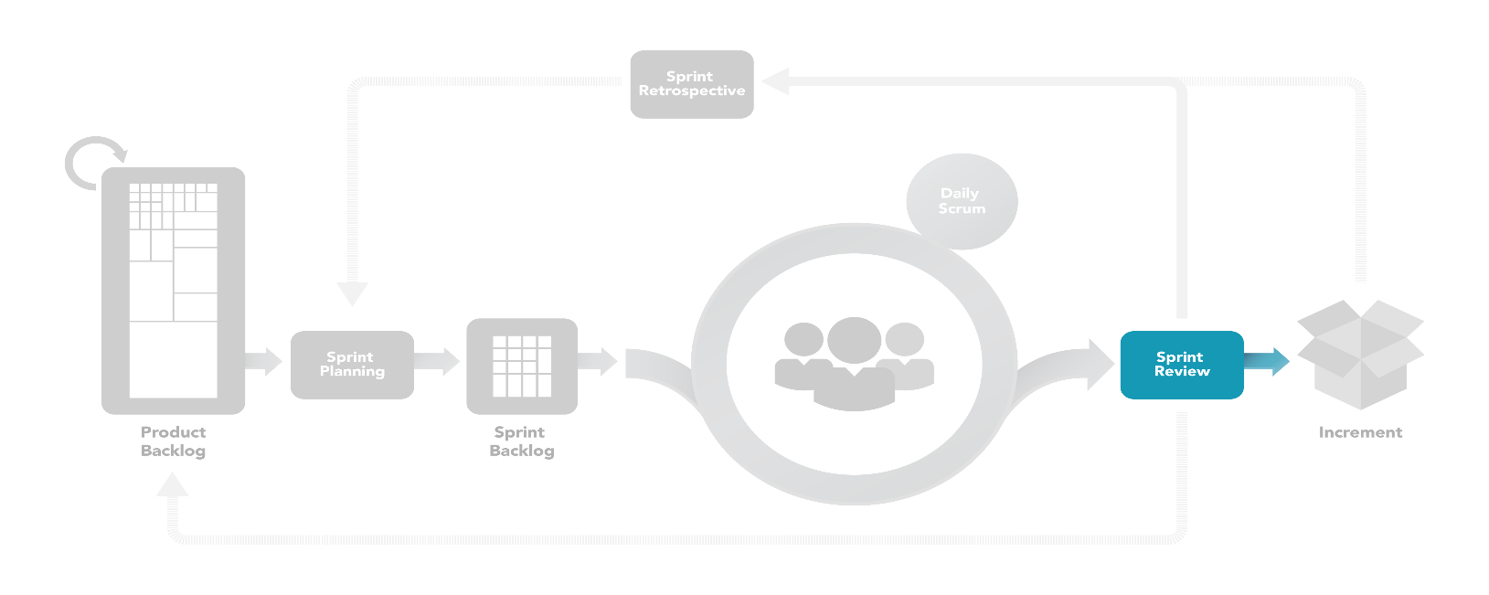

**Sprint Retrospective**

* An opportunity for the scrum team to inspect itself and create a plan for improvements to be enacted during the next sprint
* Occurs after the Sprint Review and prior to the next Sprint planning. It’s a 3 hour time-boxed meeting for a one month sprint
* The purpose of Sprint retrospective is to:
  + Inspect how last sprint went with regards to people, relationships, process and tools
  + Identify and order ‘what went well’ and ‘what needed improvements’
  + Create a plan for implementing improvements
* For the scrum team, Sprint Retrospective provides a formal opportunity to focus on inspection and adaptation

**Sprint artifacts**

* Product Backlog
  + An ordered list of everything that might be needed in the product
  + Is the single source of requirements for any changes to be made to the product
  + Product owner is responsible for maintaining it

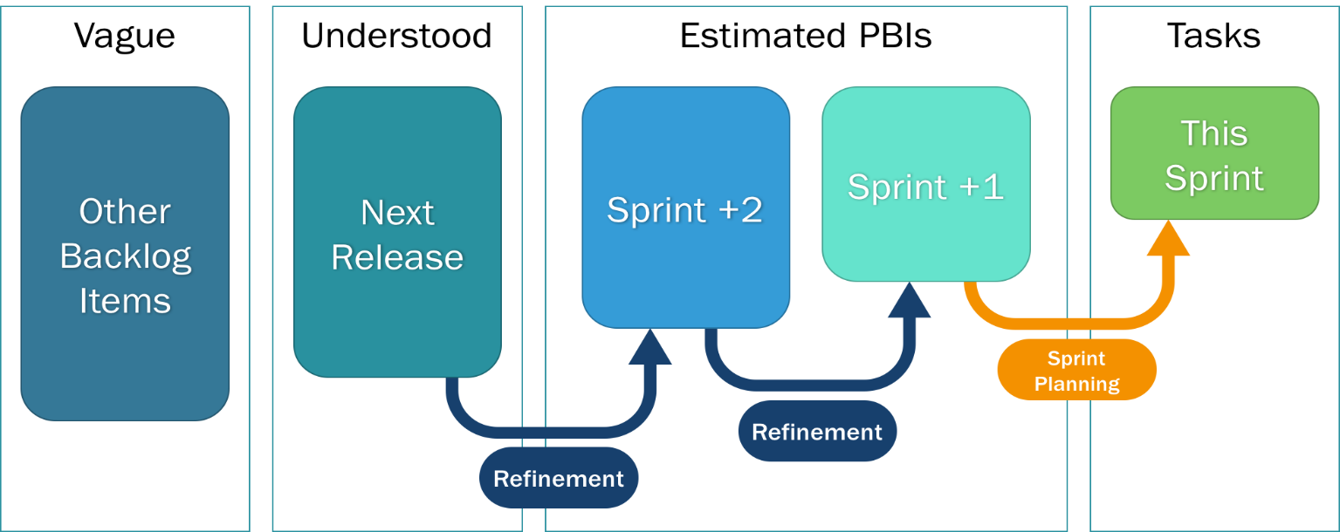

* + It is never complete; it evolves as the product evolves. As long as the product exists its Product Backlog also exists
  + Lists all features, functions, requirements, enhancements and fixes that constitute the changes to be made to the product in future releases
  + Product backlog items have the attributes of a description, order, estimate and value
  + Higher ordered product backlog items are usually clearer and more detailed than lower order ones
  + Ordering is defined by Clarity and Priority
  + Requirements never stop changing so the product backlog is a living artifact
* Backlog refinement
  + Is the act of adding detail, estimates and order to items in the product backlog
  + An ongoing process in which the Product Owner and the Development team collaborate on the details of product backlog items
  + Refinement usually consumes no more than 10% of the capacity of development team
  + Change in product backlog is at Product Owner’s discretion
  + The development team is responsible for all estimates
* Sprint Backlog
  + Set of product backlog items selected for the sprint in support of the sprint goal
  + Sprint backlog is a forecast by the development team about what functionality will be in the next increment
  + It is a plan with enough detail that changes in progress can be understood in the Daily scrum
  + The development team modifies the sprint backlog throughout the sprint and the sprint backlog emerges during the sprint
  + Only the development team can change its sprint backlog during the sprint. It belongs solely to the development team
  + Sprint backlog is a highly visible, real time picture of the work that the development team plans to accomplish during the sprint