**Spring**

* A powerful, open-source, application framework to reduce the complexity of enterprise application development
* It has layered architecture and loosely coupled
* Enables POJO programming that aids in continuous integration and testability
* Supports AOP
* Spring container – creates and manages the life cycle of application objects (components)
* Spring modules:

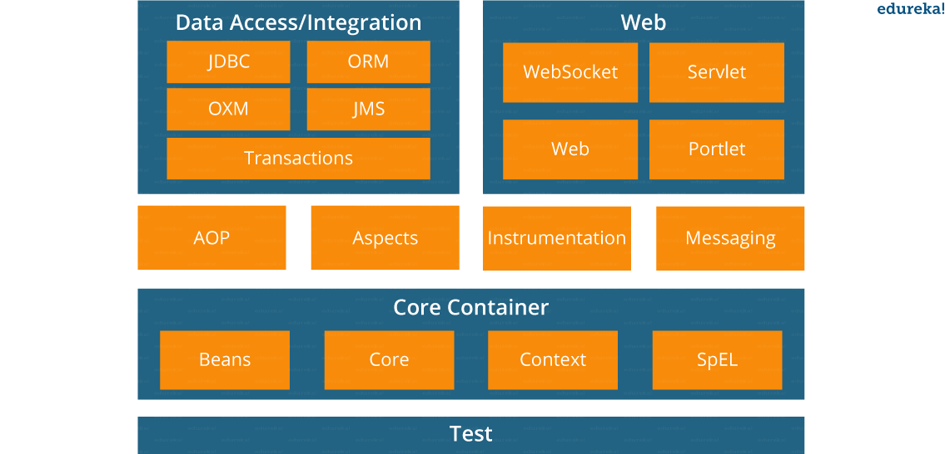

* Spring container creates objects, wires them together, configures them and manages their complete life cycle
* Spring configuration information configures the spring container. These metadata are provided in form of:
  + XML
  + Java Annotations
  + Java code
* DI in spring is done in two ways:
  + Constructor injection
  + Setter injection
* IoC containers in Spring
  + BeanFactory
  + ApplicationContext (built over bean factory plus some other features)
* How configuration metadata is provided to container
  + XML based configuration
  + Annotation based configuration
  + Java based configuration
* Bean property values can be

* + value (in case of simple primitive values or String)
  + ref (in case it is an object)
  + Spring configurations can be split into several XMLs using import tag
    - <import resource=”service-layer-config.xml” />
* Five bean scopes are supported by Spring
  + Singleton
  + Prototype
  + Request
  + Session
  + Global-session
* Bean life cycle

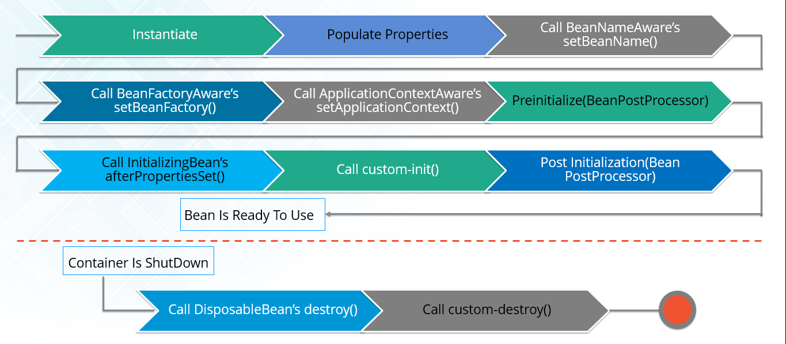

* Autowiring has the following modes
  + no (the default)
  + byName
  + byType
  + constructor
  + autodetect

* To turn on annotation based wiring , you must add the following line in beans definition XML as
  + <context: annotation-config />

* Bean initialization types
  + If lazy-init is false (default) bean is loaded when application comes up
  + If true, bean is loaded when first explicit call is made to it
* Main annotations for spring beans

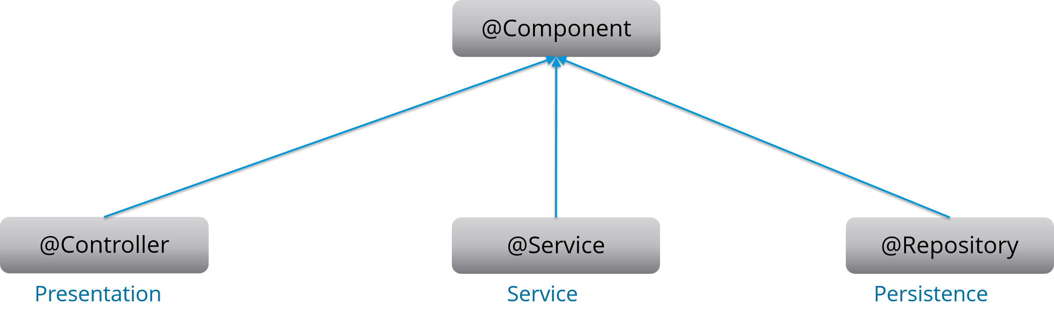

* @Required annotation

* + Is applied to bean property setter methods
  + Should be populated at configuration time with an explicit property value
* @Qualifier

* + To remove ambiguity between beans of same types to be used

* @RequestMapping
  + Class level
  + Method level

* Spring DAO layer allows you to switch between persistence technologies easily
* Ways by which Hibernate can be accessed using Spring
  + IoC with a hibernate template and callback
  + Extending Hibernate DAO support and applying an AOP interceptor node

* Transaction management types supported by Spring
  + Programmatic TM (extreme flexibility but difficult to maintain)
  + Declarative TM (TM separated from business code)

* Spring AOP

* + Joinpoints
  + Advice (5 types)
  + Aspects
  + Cross-cutting concerns

* Spring web MVC framework

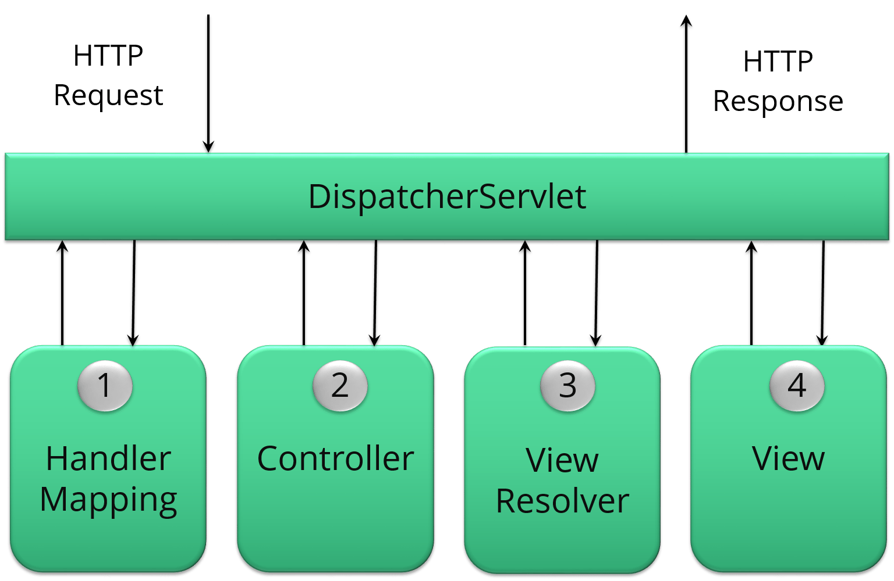

**JPA and Hibernate**

* Hibernate is one of the most widely used ORM tools for Java applications. It is a reference implementation of Java Persistence API
* Map POJOs to traditional DB tables using JPA annotations or XML-based configurations
* Hibernate implicitly provides transaction management
* Important interfaces of Hibernate
  + SessionFactory (initialized by hibernate configuration file – single per application)
  + Session (core interface between Java application layer and hibernate)
  + Transaction (one session can have multiple transactions)
* Three states of an entity beans
  + Transient
  + Persistent
  + Detached