Sidebar menu
Write
Notifications
1

Get unlimited access to the best of Medium for less than $1/week.
Become a member

Agno — The Agentic OS for Building Production-Grade AI Agents

Harshalsant
Follow
4 min read
·
Nov 21, 2025
1
1
AI Agents are moving from simple chatbots to autonomous workflows, multi-agent systems, and LLM-powered automation across DevOps, Data, Cloud, Customer Support, and Engineering. But building these systems end-to-end is still hard. Developers must manage prompts, tools, memory, workflows, RAG pipelines, and observability on their own.
Agno (Agentic OS) solves this by providing a programmable framework and runtime to build, deploy, and scale real-world AI agents. Think of Agno as the operating system for AI agents, offering capabilities such as multi-agent orchestration, tool execution, memory, RAG, and production-grade deployment.
In this article, we’ll explore Agno in depth — from architecture to implementation — so you can build your own enterprise-ready agentic systems.
What Exactly Is Agno?
Agno is an Agent Operating System that abstracts away the complexity of building agents. It handles:
- LLM interaction
- Tool calling
- RAG workflows
- Multi-agent pipelines
- Memory & state
- Agent-to-agent communication
- Human-in-the-loop
- Observability
- Deployment
Instead of building all of this manually, Agno gives you a clean framework and runtime.

Agno Architecture: The Agentic OS Stack
Agno provides a layered architecture that makes building complex LLM apps predictable and modular:
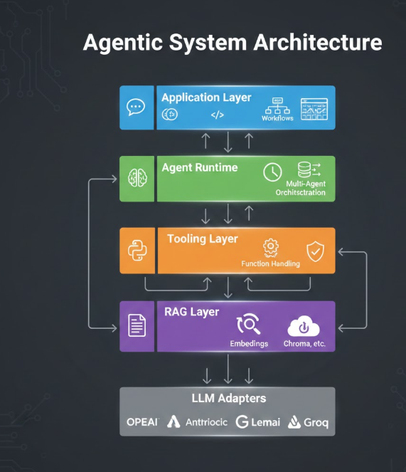
Agno brings together everything needed to run autonomous agents in production.

Building an Agent in Agno
An agent in Agno is a combination of:
- Model
- Instructions
- Tools
- Memory
- State
- Execution policy
Below is a minimal yet powerful example:
from agno.agent import Agent
from agno.models.openai import OpenAIChat
agent = Agent(
name="DevOpsFixer",
model=OpenAIChat("gpt-4o"),
instructions="You are a senior DevOps engineer...",
tools=[shell_tool, kubectl_tool, jira_api],
memory=True,
state=True
)
When invoked, Agno’s runtime:
- Builds a contextual prompt
- Evaluates memory & state
- Selects tools automatically
- Executes tool calls
- Streams or returns final output
This frees you from writing a custom agent loop.

Building Tools in Agno
Tools are Python functions that the agent can call autonomously.
from agno.tools import tool
@tool
def check_pod_status(namespace: str):
return kube.check_status(namespace)
Agno automatically:
- Generates tool schema
- Allows LLM to decide when to use it
- Handles arguments
- Applies retries
- Logs execution
Tools can connect to:
- Kubernetes
- Databases
- REST APIs
- Vector DBs
- Cloud systems
- Internal SDKs
- External apps

Multi-Agent Workflows
Agno makes multi-agent pipelines first-class citizens.
from agno.workflows import Workflow, Step
workflow = Workflow(
steps=[
Step(agent=planner_agent),
Step(agent=research_agent),
Step(agent=writer_agent),
]
)
Agents can:
- Decompose tasks
- Share memory/state
- Handoff tasks
- Call tools collaboratively
This is ideal for:
- Research workflows
- Analyst automation
- DevOps troubleshooting
- RAG processing pipelines

RAG Implementation with Agno
Agno includes built-in components for Retrieval-Augmented Generation.

1. Load documents
from agno.rag.loader import PDFLoader
docs = PDFLoader("build_logs.pdf").load()

2. Index them
from agno.rag import Indexer
indexer = Indexer(embed_model="text-embedding-3-large")
index = indexer.index(docs)

3. Use as a tool for the agent
rag_agent = Agent(
model=OpenAIChat("gpt-4o"),
tools=[index.as_tool("search_docs")]
)
Your agent can now search knowledge bases autonomously.

Deploying Agno Agents in Production
Agno supports multiple deployment strategies:

1. Local Development
Perfect for prototyping.

2. Docker Deployment
/app
/agents
/tools
/rag
server.py
Dockerfile

3. Cloud Deployment
You can deploy Agno on:
- Kubernetes
- AWS ECS
- Azure Container Apps
- Google Cloud Run
- Vercel /Netlify for UI
Use:
- Redis → memory/state
- Pinecone → vector DB
- S3/GCS → file storage
- OpenTelemetry → tracing
Agno exposes agents as REST APIs via:
from agno.server import create_app
app = create_app(agents=[devops_agent])

Enterprise-Grade Features
Agno includes the production essentials:

Safety
- Guardrails
- Restricted tools
- Output filtering
- Role-based execution

Observability
- Tracing for tool calls
- Session logs
- Token usage analytics
- Failure analysis

🧠Memory
- Short-term
- Long-term
- Episodic

Recovery
- Error retries
- Circuit-breaking
- Human approval loops

Real-World Use Cases
Enterprises are using Agno to build:

1. DevOps Autonomous Agent
- Read build logs
- Predict root cause
- Generate fixes
- Run kubectl safely
- Open Jira tickets

2. Data Engineering Agent
- Run SQL
- Diagnose pipeline failures
- Auto-fix DAG issues
- Document database changes

3. FinOps Agent
- Analyze cloud costs
- Predict spikes
- Suggest optimization steps

4. Enterprise RAG Agent
- Auto-index documents
- Maintain embeddings
- Answer employee queries

5. Multi-Agent Research Assistant
- Planner agent
- Research agent
- Writer agent

Why Agno Matters
Agno simplifies and accelerates the hardest parts of building AI agent systems:
- Tool orchestration
- Multi-agent logic
- RAG indexing
- Observability
- Deployment
- Safety & governance
Instead of reinventing infrastructure, you focus on what the agent should do, not how it should work.

🏁 Final Thoughts
As AI systems move from chatbots to autonomous digital workers, frameworks like Agno will become foundational. Agno makes agent development faster, structured, and enterprise-ready.
If you’re building anything involving:
- DevOps automation
- Data engineering assistance
- RAG-backed knowledge agents
- Enterprise workflows
- Large-scale AI systems
Then Agno is one of the most powerful, developer-friendly Agent OS platforms available today.
1
1


Written by Harshalsant
50 followers
·
5 following
Principal Architect driving Cloud, Data, AI/ML, and DevOps innovation with LLMs, GenAI, MLOps, and multi-cloud platforms.
Follow
Help
Status
About
Careers
Press
Blog
Store
Privacy
Rules
Terms
Text to speech

