PROJECT SPECIFICATION
Natural Language to SQL
Query Assistant
An on-premises, open-source AI use case for conversational data access

Version 1.0
July 2026
Prepared for internal review

Table of Contents

1. Executive Summary
This document specifies a Natural Language to SQL Query Assistant: an internal tool that lets non-technical staff ask questions about company data in plain English and receive accurate results without writing SQL. The assistant uses an open-source large language model to translate a question into a SQL query, executes that query against a database, and returns results alongside the generated SQL for transparency.
The solution is built entirely on open-source components and is designed to run on-premises, so no data or query content leaves the organization's network. It doubles as a practical demonstration of the organization's broader open-source AI capability, alongside the existing OpenTranslate AI initiative.
Why this use case: it is one of the fastest ways to demonstrate real LLM capability alongside genuine engineering — a working backend, a live database, and a polished frontend — while remaining scoped enough to build and demo within a short timeline.

2. Objectives
- Reduce the time non-technical stakeholders spend waiting on ad-hoc SQL requests from engineering or analytics teams.
- Demonstrate a production-style pattern for applying open-source LLMs to internal data access.
- Keep all data, queries, and model inference on-premises for security and compliance.
- Establish a reusable architecture (model serving, backend, caching, auth) that other internal AI use cases can build on.

3. Use Case Description
A user opens the assistant and types a question such as “Top 5 customers by revenue” or “Which orders were placed last month?” The system:
- Interprets the question using the live database schema as context.
- Generates a corresponding SQL query using an open-source language model.
- Validates the query is read-only and safely bounded (e.g. row limits).
- Executes it against the target database.
- Returns the results in a table, with the generated SQL shown alongside for transparency and trust.
The same interaction pattern extends naturally to follow-up questions, multilingual input, and role-based data access, as detailed in Section 7.

4. User Workflow Example
The steps below walk through a single interaction end to end, from the moment a user types a question to the moment they see results.
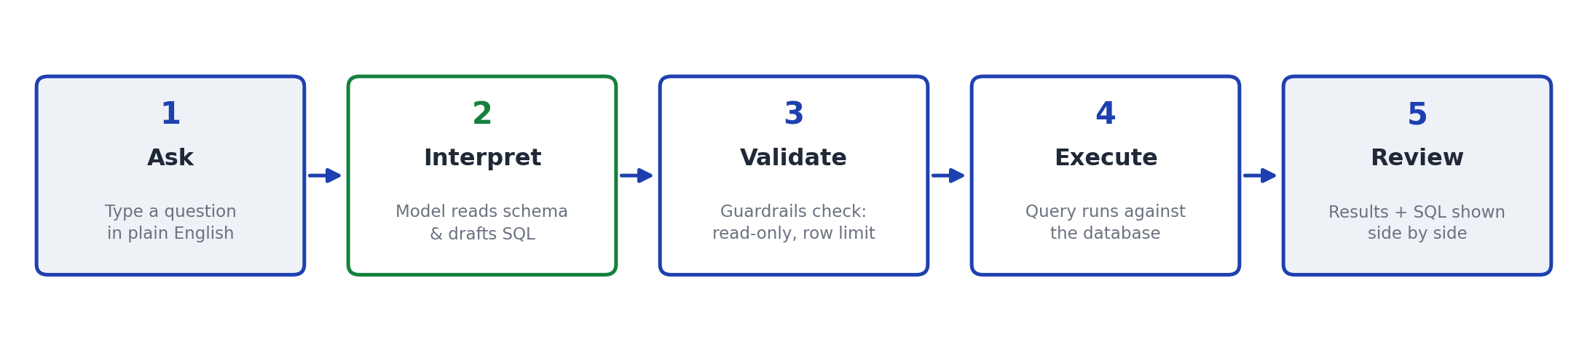

Worked Example
Scenario: a sales operations manager wants to know which customers to prioritize for renewal outreach this quarter.
Step | What Happens
1. Ask | The user types: “Top 5 customers by revenue.” No SQL knowledge required.
2. Interpret | The backend sends the question to the model along with the live schema (customers, orders, order_items, products). The model drafts a SQL query joining all four tables and aggregating revenue per customer.
3. Validate | The guardrail layer confirms the query is a single read-only SELECT statement and adds a row limit, since none was specified.
4. Execute | The query runs against the database and returns five rows in under a second.
5. Review | The results table displays customer names and total revenue, ranked highest to lowest. The generated SQL is shown alongside so the user (or a reviewing analyst) can verify exactly what was run.
Generated SQL for this example:
SELECT c.name, SUM(oi.quantity * p.price) AS revenue
FROM customers c
JOIN orders o ON o.customer_id = c.id
JOIN order_items oi ON oi.order_id = o.id
JOIN products p ON p.id = oi.product_id
GROUP BY c.name
ORDER BY revenue DESC
LIMIT 5;
Customer | Revenue
Fatima Khan | $48,220
Priya Nair | $41,860
Lucas Martin | $37,510
Wei Zhang | $29,940
Arjun Rao | $22,115
The manager now has a ranked list to act on, without filing a request to the data team or writing a single line of SQL.

5. System Architecture
The system follows a standard three-tier architecture with a model-serving layer added for LLM inference. The diagram below shows how a question flows from the frontend through the backend to the model and data layers, and how platform services support the request.
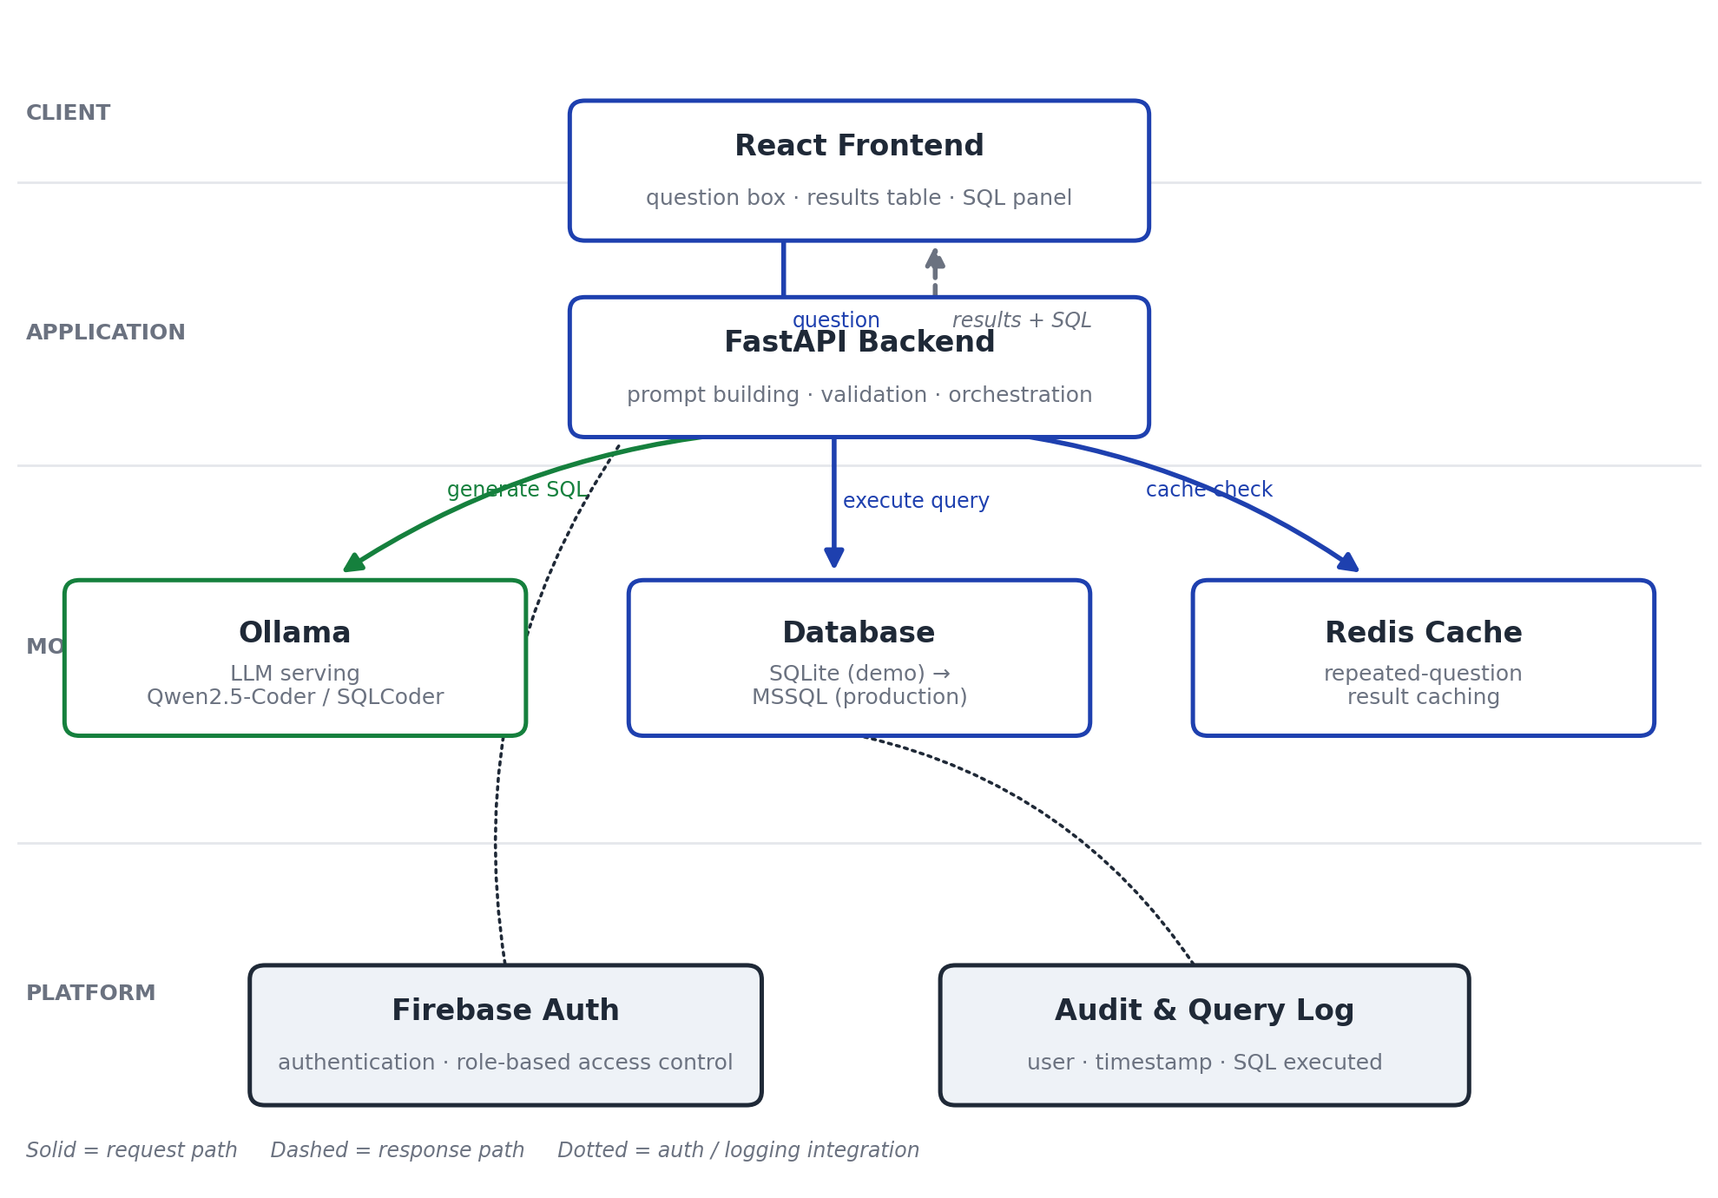
Layer | Component | Responsibility
Frontend | React | Question input, results table, SQL display, schema explorer, history
Backend | FastAPI (Python) | Prompt construction, orchestration, query validation, auth, caching
Model serving | Ollama | Hosts and serves the open-source LLM for local inference
Database | SQLite → MSSQL | Stores business data (dummy dataset for demo; production-ready path to Microsoft SQL Server)
Cache | Redis | Caches repeated questions to reduce redundant model calls
Identity | Firebase Authentication | Authentication and role-based access control
Request flow: the frontend sends the user's question to the backend, which builds a schema-aware prompt, calls the LLM via Ollama, validates and executes the resulting SQL against the database, and returns results plus the SQL text to the frontend for display.

6. Technology Stack
Category | Choice | Rationale
Language model | Qwen2.5-Coder (7B / 14B) | Strong reasoning and code/SQL generation; Apache 2.0 licensed
Alternative model | SQLCoder (Defog) | Purpose-built for text-to-SQL; strong choice if scope stays SQL-only
Fallback model | Mistral-7B-Instruct | General-purpose, permissively licensed backup option
Backend framework | FastAPI | Lightweight, async-friendly, strong typing via Pydantic
Frontend framework | React | Component-based UI, wide team familiarity
Database | SQLite (demo) / MSSQL (production) | Easy local demo path with a clear production upgrade
Model serving | Ollama / vLLM | Ollama for simplicity; vLLM if throughput becomes a priority
All components are open-source, avoiding proprietary licensing costs and keeping the entire stack deployable within the organization's own infrastructure.

7. Feature Set
Features are grouped into delivery tiers so the core experience is functional early, with additional capability layered in as time allows.

Tier 1 — Core (demo-critical)
- Natural language input and SQL generation
- Query execution against the database
- Results table with generated SQL shown for transparency

Tier 2 — Supporting functionality
- Schema-aware prompting and error self-correction
- Query history log
- Follow-up / conversational context
- Read-only guardrails, CSV export, loading states

Tier 3 – 4 — Data handling, trust & safety
- Multi-table join support and a schema explorer panel
- Sample/suggested questions for new users
- Row-limit guards, SQL sanitization, and user feedback capture (👍/👎)

Tier 5 – 6 — UX polish and enterprise readiness
- Dark/light mode, editable SQL, voice input, sortable/paginated results
- Role-based access control via Firebase Authentication, audit logging, Redis caching

Tier 7 – 8 — Multilingual and stretch goals
- Question input and response translation across Hindi, Telugu, Tamil, and French
- Auto-suggested charts, multi-turn report building, plain-English SQL explanations

8. Requirements

8.1 Functional Requirements
ID | Requirement
FR-1 | The system shall accept a natural-language question from the user through a web interface.
FR-2 | The system shall generate a corresponding SQL query using an open-source language model, informed by the live database schema.
FR-3 | The system shall reject or strip any generated statement that is not a single read-only SELECT.
FR-4 | The system shall automatically apply a row limit to any query that does not specify one.
FR-5 | The system shall execute the validated query against the configured database and return results.
FR-6 | The system shall display the generated SQL alongside the results for transparency.
FR-7 | The system shall log each question, the generated SQL, and the result count to a query history.
FR-8 | The system shall support follow-up questions that reference the previous turn's context.
FR-9 | The system shall allow authenticated users to export results as CSV.
FR-10 | The system shall restrict access to specific tables or columns based on the authenticated user's role.
FR-11 | The system shall accept questions in Hindi, Telugu, Tamil, or French and translate internally before SQL generation.
FR-12 | The system shall capture user feedback (positive/negative) on individual generated queries.

8.2 Non-Functional Requirements
ID | Requirement
NFR-1 | All model inference and data storage shall remain on-premises; no query content shall be transmitted to external, third-party services.
NFR-2 | Typical queries shall return results within 3 seconds under normal load, excluding first-time model load.
NFR-3 | Every executed query shall be recorded in an audit log with user identity and timestamp.
NFR-4 | The model-serving layer shall be swappable (e.g. Qwen2.5-Coder to SQLCoder) via configuration, without code changes.
NFR-5 | The database layer shall support a documented upgrade path from SQLite to MSSQL with no application-layer rework.
NFR-6 | The system shall self-correct at most once per query on execution failure before returning an error to the user.
NFR-7 | The application shall be deployable within the organization's existing on-premises infrastructure without new external dependencies.

8.3 Environment & Infrastructure Prerequisites
Component | Minimum Requirement
Model host | GPU with ≥16GB VRAM recommended for 7B–14B models (CPU-only viable for demo at reduced speed)
App server | 4 vCPU / 16GB RAM for backend, frontend, Redis, and dummy database
Software | Python 3.10+, Node.js 18+, Docker, Ollama, Redis, Microsoft SQL Server (production) or SQLite (demo)
Identity provider | Firebase Authentication project (existing or newly provisioned) for authentication and RBAC
Network | Internal network access only; no outbound calls required at runtime

9. Demo Data Model
The demonstration uses a small relational dataset representative of common business data, allowing multi-table join questions to be tested meaningfully.
Table | Key Columns
customers | id, name, city, signup_date, segment
products | id, name, category, price
orders | id, customer_id, order_date, status
order_items | id, order_id, product_id, quantity

10. Security & Governance
- All inference and data storage remain on-premises; no query content is sent to external APIs.
- Only SELECT statements are permitted; all generated SQL is validated before execution.
- Row limits are automatically enforced to prevent unbounded result sets.
- Role-based access via Firebase Authentication restricts which tables and columns a given user can query.
- Every query is logged with user identity, timestamp, and executed SQL for audit purposes.

11. Project Timeline
The project is scoped as a six-week effort from kickoff to stakeholder review, structured so a working demo exists early and enterprise-readiness and polish are layered in afterward.
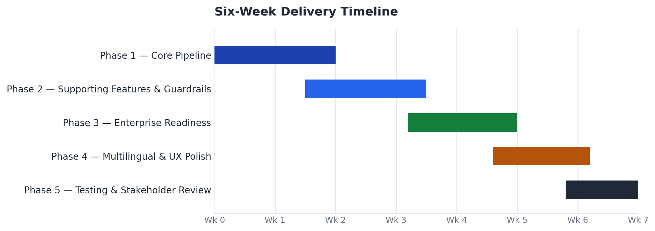
Phase | Duration | Scope | Outcome
Phase 1 | Weeks 1–2 | Core pipeline: input → LLM → SQL → execution → results table | Working end-to-end demo
Phase 2 | Weeks 2–3 | History, guardrails, error handling, schema explorer | Reliable, presentable tool
Phase 3 | Weeks 4–5 | Auth, caching, audit logging | Enterprise-ready deployment
Phase 4 | Weeks 5–6 | Multilingual support, chart suggestions, UX polish | Differentiated, polished product
Phase 5 | Weeks 6–7 | End-to-end testing and stakeholder walkthrough | Sign-off and rollout decision
Phases overlap slightly by design: supporting features begin before the core pipeline is fully hardened, and testing runs alongside the final polish work rather than strictly after it.

12. Success Metrics
- Percentage of natural-language questions that produce a correct, executable SQL query on first attempt.
- Average response time from question submission to results display.
- Reduction in ad-hoc SQL requests directed at engineering/analytics teams.
- User satisfaction, measured via the built-in feedback mechanism.

13. Next Steps
- Confirm model choice (Qwen2.5-Coder vs. SQLCoder) based on a short bake-off against sample questions.
- Provision the dummy dataset and stand up the Phase 1 pipeline.
- Review the working demo with stakeholders before proceeding to enterprise-readiness features.

