PROJECT SPECIFICATION
Natural Language to SQL
Query Assistant
An on-premises, open-source AI use case for conversational data access
Version 1.0
July 2026
Prepared for internal review

Table of Contents
1. Executive Summary 3
2. Objectives 3
3. Use Case Description 4
4. User Workflow Example 4
5. System Architecture 6
5.1 Component Architecture 6
5.2 End-to-End Query Sequence 7
6. Technology Stack 8
7. Requirements 9
7.1 Functional Requirements 9
7.2 Non-Functional Requirements 10
7.3 Infrastructure Prerequisites 11
8. Security & Governance 11
9. Features 12
9.1 Admin Dashboard Features 12
9.2 User Features 12
10. Project Timeline 13
11. Success Metrics 13
12. Limitations & Mitigations 14
13. Key Terms & Glossary 15

1. Executive Summary
This document specifies a Natural Language to SQL Query Assistant: an enterprise-ready internal tool that empowers non-technical staff to query company data using plain English, eliminating the need for manual SQL coding. The assistant uses an open-source large language model (LLM) to translate natural language questions into precise SQL queries, executes them against the database, and returns both the results and the generated SQL to ensure complete transparency.
The solution is architected entirely on open-source components and designed for secure, on-premises deployment, ensuring that all data, queries, and model inference remain within the organization's network. Beyond its primary function, the tool incorporates advanced features, including AI-driven data visualization, role-based access control (RBAC) via a custom JWT authentication system, and administrative CRUD operational capabilities.
This project serves as a scalable demonstration of the organization's broader open-source AI capability, acting as a foundational architecture for future initiatives such as the OpenTranslate AI project. It is designed for rapid delivery, balancing high-impact engineering — a robust backend, live database, and polished frontend — with an efficient development timeline.

Why This Use Case
This use case was selected because it offers an accelerated way to showcase both high-level LLM capability and robust, full-stack engineering. It provides a comprehensive, working architecture — a secure backend, a live database, and a polished frontend — that demonstrates technical proficiency in a tangible way. The project is also strategically scoped for rapid development and demonstration within a constrained timeframe, making it an ideal candidate for highlighting the organization's broader open-source AI capabilities.

2. Objectives
- Reduce the time non-technical stakeholders spend waiting on ad-hoc SQL requests from engineering or analytics teams.
- Implement a robust, production-style pattern for applying open-source LLMs to internal data access, featuring advanced visualization and administrative management.
- Keep all data, queries, and model inference on-premises, ensuring strictly isolated and compliant operations.
- Build a reusable, modular architecture (model serving, backend, custom JWT-based authentication, and caching) that serves as a foundational platform for future internal AI initiatives, such as OpenTranslate AI.
- Enable administrative users to securely perform CRUD operations (INSERT, UPDATE, and DELETE) via natural language while maintaining a complete audit trail for governance.

3. Use Case Description
A user opens the assistant and types a question such as "Top 5 customers by revenue" or "Which orders were placed last month?" The system:
- Interprets the question using the live database schema as context.
- Generates a corresponding SQL query using an open-source language model.
- Validates the query for security: standard users are restricted to read-only SELECT statements, while authenticated administrators may perform INSERT, UPDATE, and DELETE operations via natural language.
- Enforces safety guardrails, including automatic row limits, to prevent unbounded result sets.
- Executes the query against the target database.
- Returns the results in a structured table, accompanied by AI-generated insights and auto-generated charts for enhanced visual clarity, with the raw SQL displayed for full transparency and trust.
This interaction pattern scales to support follow-up conversational questions, multilingual input (Hindi, Telugu, Tamil, French), and granular, role-based data access control via the custom JWT-based authentication system.

4. User Workflow Example
The steps below walk through a single interaction end to end, from the moment a user types a question to the moment they see results.
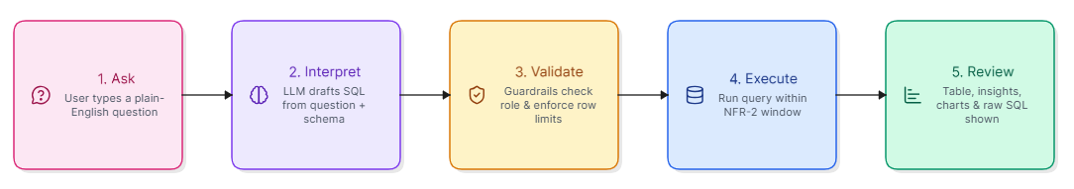

Worked Example
Scenario: a sales operations manager wants to know which customers to prioritize for renewal outreach this quarter.
Step | What Happens
1. Ask | The user types a question in plain English (e.g., "Show me the top 5 customers by revenue"). No SQL knowledge is required.
2. Interpret | The backend transmits the question and live database schema to the LLM, which drafts the corresponding SQL query.
3. Validate | The guardrail layer validates the query against user roles; standard users are restricted to SELECT, while admins may perform INSERT, UPDATE, or DELETE. Row limits are automatically enforced.
4. Execute | The validated query is executed against the database, with results returned within the NFR-2 target response window.
5. Review | The frontend displays the results in a table, supplemented by AI-generated insights and auto-generated charts. The raw SQL is provided alongside for transparency.
Generated SQL for this example:
SELECT c.name, SUM(oi.quantity * p.price) AS revenue
FROM customers c
JOIN orders o ON o.customer_id = c.id
JOIN order_items oi ON oi.order_id = o.id
JOIN products p ON p.id = oi.product_id
GROUP BY c.name
ORDER BY revenue DESC
LIMIT 5;
Customer | Revenue
Fatima Khan | 48,220
Priya Nair | 41,860
Lucas Martin | 37,510
Wei Zhang | 29,940
Arjun Rao | 22,115
The manager now has a ranked list to act on, without filing a request to the data team or writing a single line of SQL.

5. System Architecture

5.1 Component Architecture
The system follows a standard three-tier architecture with a model-serving layer added for LLM inference. The diagram below shows how a question flows from the frontend through the backend to the model and data layers, and how platform services support the request.
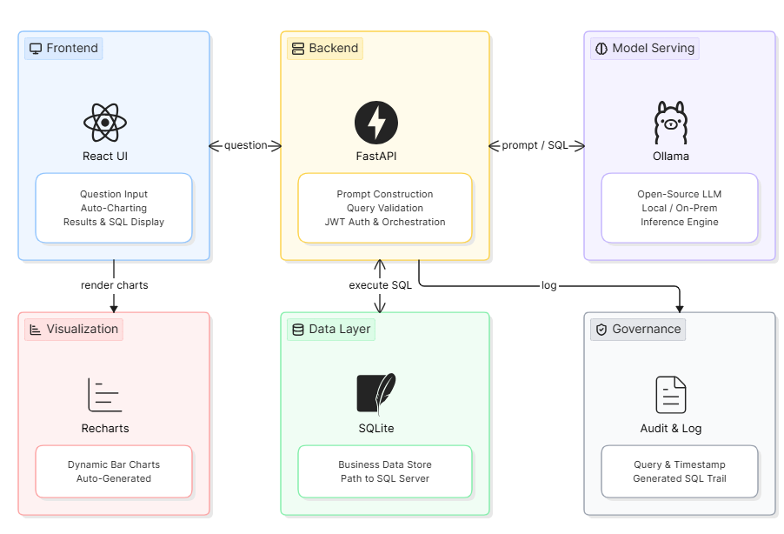
Layer | Component | Responsibility
Frontend | React | Question input, dynamic auto-charting, results table, and SQL display
Backend | FastAPI (Python) | Prompt construction, orchestration, query validation, and JWT-based auth
Model serving | Ollama | Hosts and serves the open-source LLM for local, on-premises inference
Database | SQLite / MSSQL | Stores business data with a clear path to production MSSQL Server
Visualization | Recharts | Provides seamless integration for dynamic, auto-generated bar charts
Governance | Audit & Log | Tracks every user query, timestamp, and generated SQL for audit purposes
Request Flow: The frontend sends the user's question to the backend, which builds a schema-aware prompt, calls the LLM via Ollama, validates and executes the resulting SQL against the database, and returns the formatted results, AI-generated insights, and SQL text to the frontend for display.

5.2 End-to-End Query Sequence
The following sequence describes the chronological lifecycle of a non-English user query, showcasing the custom authentication check, the two-step local LLM pipeline, database execution, and dynamic frontend rendering.
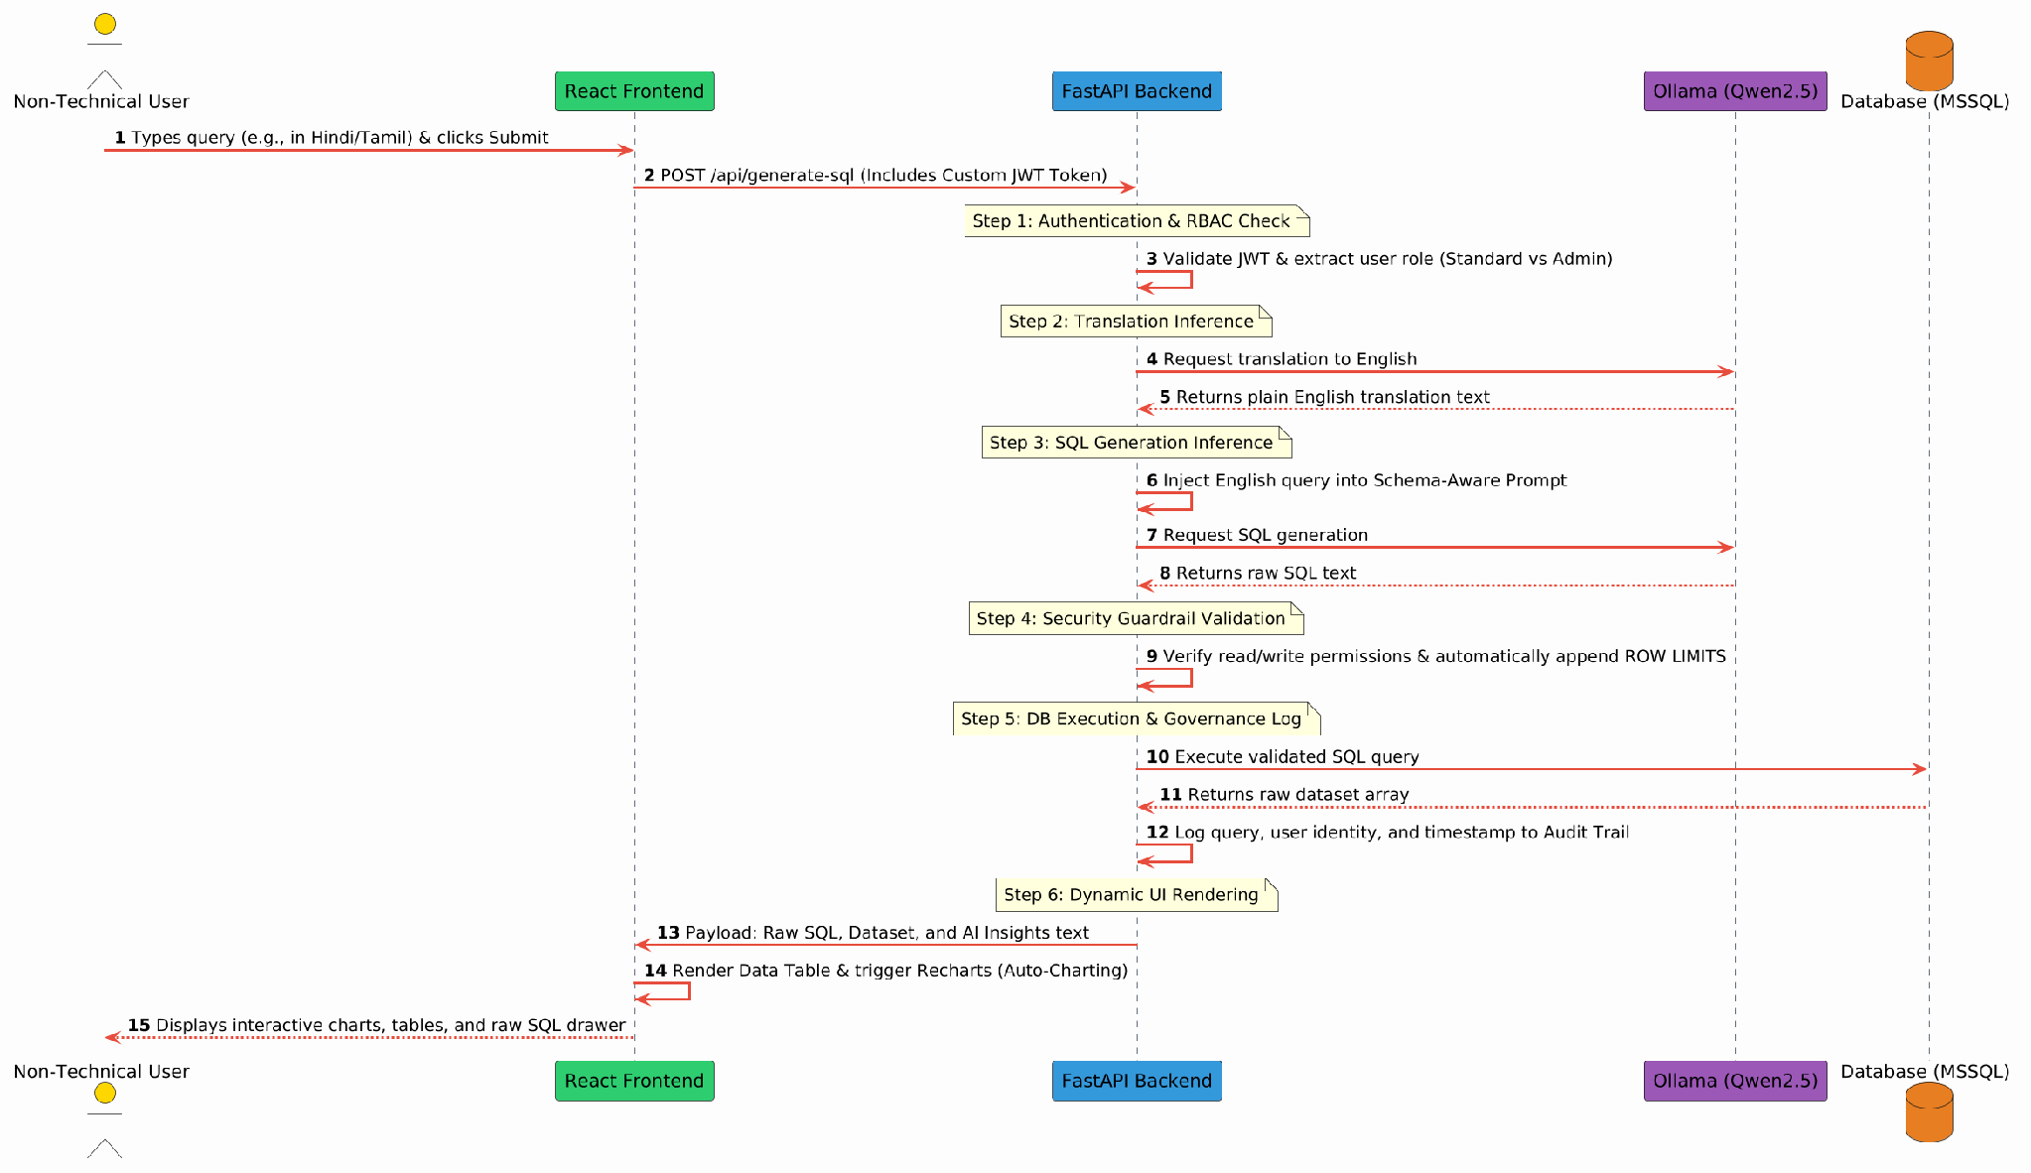

6. Technology Stack
Category | Choice | Rationale
Language model | Qwen2.5-Coder (7B / 14B) | Strong reasoning and SQL generation; Apache 2.0 licensed
Backend framework | FastAPI | Lightweight, async-friendly, strong typing via Pydantic
Frontend framework | React | Component-based UI, wide team familiarity
Visualization | Recharts | Seamless integration for dynamic, auto-generated charts
Authentication | Custom JWT implementation | Secure, stateless session management and role-based access control
Database | SQLite | Easy local demo path with a clear production upgrade path
Model serving | Ollama | Simplifies local inference for on-premises deployment
All components are open-source, avoiding proprietary licensing costs and keeping the entire stack deployable within the organization's own infrastructure.

7. Requirements

7.1 Functional Requirements
ID | Requirement
FR-1 | The system shall accept a natural-language question from the user through a web interface.
FR-2 | The system shall generate a corresponding SQL query using an open-source language model, informed by the live database schema.
FR-3 | The system shall restrict standard users to read-only SELECT statements while allowing administrative CRUD operations.
FR-4 | The system shall automatically apply a row limit to any SELECT query that does not specify one.
FR-5 | The system shall execute the validated query against the configured database and return results.
FR-6 | The system shall display the generated SQL alongside the results for transparency.
FR-7 | The system shall log each question, the generated SQL, and the result count to a query history.
FR-8 | The system shall provide AI-generated data insights and auto-charting for query results.
FR-9 | The system shall allow authenticated users to export results as CSV.
FR-10 | The system shall implement RBAC to distinguish between standard users and administrators.
FR-11 | The system shall support multilingual input (Hindi, Telugu, Tamil, French) via internal translation.
FR-12 | The system shall provide an Admin Dashboard for monitoring system logs and activity.
FR-13 | The system shall provide an Admin UI to dynamically configure the global SQL LIMIT guardrail.
FR-14 | The system shall allow administrators to toggle table visibility (schema governance) within the LLM prompt context.
FR-15 | The system shall provide User Management forms for creating, editing, promoting, and suspending user accounts.
FR-16 | The system shall include a 'Prompt Studio' for real-time editing of the LLM system prompt.
FR-17 | The dashboard shall visualize system health via query volume, error rates, and user activity leaderboards using Recharts.

7.2 Non-Functional Requirements
ID | Requirement
NFR-1 | All model inference and data storage shall remain on-premises.
NFR-2 | Typical queries shall return results within 3 seconds under normal load.
NFR-3 | Every executed query shall be recorded in an audit log with user identity and timestamp.
NFR-4 | The model-serving layer shall be swappable via configuration without code changes.
NFR-5 | The system shall self-correct at most once per query on execution failure.
NFR-6 | The application shall use custom JWT-based authentication for secure session management.

7.3 Environment & Infrastructure Prerequisites
Component | Minimum Requirement
Model host | GPU with ≥16 GB VRAM recommended for 7B–14B models (CPU-only viable for demo at reduced speed)
App server | 4 vCPU / 16 GB RAM for backend, frontend, and demo database
Software | Python 3.10+, Node.js 18+, Ollama, SQLite (demo)
Identity provider | Custom JWT-based authentication system for secure RBAC
Network | Internal network access only; no outbound calls required at runtime

8. Security & Governance
- All model inference and data storage remain on-premises; no query content is transmitted to external third-party APIs.
- Standard users are restricted to SELECT statements, while authenticated administrative users are permitted to perform INSERT, UPDATE, and DELETE operations via validated natural language inputs.
- Row limits are automatically enforced on all SELECT queries to prevent unbounded result sets and protect system resources.
- Role-Based Access Control (RBAC) is implemented via a custom JWT-based authentication system to manage user sessions and restrict data access.
- To ensure operational flexibility, the system includes an Admin Dashboard for dynamic governance. Administrators can modify global row limits (e.g., overriding the default 500-limit) and define the visible database schema for the LLM without requiring backend redeployment
- Mitigated by the read-only guardrails and schema-aware prompting
- Every query is logged with user identity, timestamp, and the exact SQL executed to maintain a full audit trail for governance purposes.

9. Features

9.1 Admin Dashboard Features
- Database & Schema Governance: Enables administrators to dynamically whitelist or blacklist tables for LLM access and modify global result set constraints.
- User & Access Management: Provides a centralized interface for full CRUD operations on user accounts, role-based promotion (Standard to Admin), and account suspension toggles to ensure security without losing audit trails.
- Prompt Engineering Studio: A configuration interface that allows administrators to update the System Prompt (e.g., regional currency formatting) directly, ensuring the model's behavior aligns with business needs without code changes.
- System Analytics Dashboard: Utilizes the existing Recharts integration to provide real-time insights into system health, including query volume, success/failure ratios, and user engagement metrics.
- Request Management Console:An administrative view to review pending user requests, view attached notes, and execute decisions (Accept/Reject) accompanied by mandatory feedback notes.

9.2 User Features
- Natural Language Querying: Allows non-technical staff to interact with the database using plain English.
- Multilingual Support: Enables input in languages including Hindi, Telugu, Tamil, and French.
- Dynamic Visualization: Automatically generates charts and data insights for query results using Recharts.
- Data Export: Provides functionality for authenticated users to export query results as CSV.
- Transparency: Displays raw SQL alongside the query results to ensure trust and governance.
- Request & Approval Workflow: Enables standard users to submit data access or operation requests to administrators with context notes, allowing admins to accept or reject these requests with explanatory feedback.

10. Project Timeline
The project is scoped as a six-week effort from kickoff to stakeholder review, structured so a working demo exists early and enterprise-readiness and polish are layered in afterward.
Phase | Duration | Effort | Scope | Outcome
Phase 1 | Days 1–2 | 16 hrs | Core pipeline: input, LLM integration, SQL generation, and results display | Working end-to-end demo
Phase 2 | Days 3–4 | 16 hrs | Query history, read-only guardrails, error handling, and schema explorer | Reliable, presentable tool
Phase 3 | Days 5–6 | 16 hrs | JWT-based authentication, audit logging, and CRUD operational control | Enterprise-ready
Phase 4 | Days 7–8 | 16 hrs | Multilingual support, auto-charting, AI-driven insights, and UX polish | Differentiated, polished product
Phase 5 | Days 9–10 | 16 hrs | End-to-end testing, admin dashboard finalization, and walkthrough | End-to-end testing, Admin Dashboard finalization and final walkthrough.
Phases overlap slightly by design: supporting features begin before the core pipeline is fully hardened, and testing runs alongside the final polish work rather than strictly after it.

11. Success Metrics
Success is measured across accuracy, performance, adoption, and governance dimensions. Targets below are proposed baselines for stakeholder review and can be tuned once production usage data is available.
Metric | Definition | Target | Measurement Method
First-attempt SQL accuracy | Share of natural-language questions that produce a correct, executable SQL query on the first attempt | ≥ 85% | Automated regression suite of representative questions, logged pass/fail per run
Average response time | Time from question submission to display of results and AI-generated insights | ≤ 3 seconds (per NFR-2) | Backend timing instrumentation on production traffic
Ad-hoc SQL request reduction | Decrease in manual SQL requests directed at engineering or analytics teams | ≥ 50% within first quarter post-launch | Comparison of support/ticket volume before and after rollout
Admin CRUD success rate | Share of natural-language administrative CRUD operations executed correctly without manual intervention | ≥ 95% | Audit log review of admin-issued CRUD operations
User adoption | Active weekly usage among the target non-technical staff population | ≥ 70% of target group | Login and query activity from the audit log
System availability | Uptime of the on-premises service during business hours | ≥ 99% | Infrastructure and application monitoring

12. Limitations & Mitigations
While the Natural Language to SQL Query Assistant is highly capable of handling standard business intelligence queries, stakeholders should be aware of the following architectural boundaries and their respective mitigations:
- Schema Size Constraints: The local LLM has a fixed text limit (context window).
- Query Complexity Limits: The model excels at standard aggregations and joins but may struggle to generate highly complex analytical queries, such as multi-level nested subqueries or recursive CTEs. To mitigate this, the UI encourages targeted, single-topic questions and prompts the user to break down complex requests if a query fails validation.
- Multilingual Nuance & Slang: The two-step pipeline translates regional languages to English before generating SQL. While accurate for formal language, heavy dialects, slang, or internal business jargon may be mistranslated. To mitigate this, the system includes a built-in user feedback loop (thumbs up/down) to identify common translation failures for future model fine-tuning.
- Hardware-Bound Latency: Because the system runs strictly on-premises for security, inference speed depends entirely on the host hardware. Concurrent requests could create processing bottlenecks. To mitigate this, the backend is fully asynchronous, and the UI implements non-blocking loading states to properly manage user expectations during periods of high utilization.

13. Key Terms & Glossary
Term | Definition
LLM | Large Language Model — the AI model that interprets natural-language questions and drafts SQL.
NL-to-SQL | Natural Language to SQL — the task of translating a plain-English question into an executable SQL query.
RBAC | Role-Based Access Control — restricts what a user can do based on their assigned role (standard user vs. administrator).
JWT | JSON Web Token — a signed token format used here for stateless, custom session authentication.
CRUD | Create, Read, Update, Delete — the four basic database operations; INSERT/UPDATE/DELETE are restricted to administrators.
FR / NFR | Functional Requirement / Non-Functional Requirement — numbered requirement identifiers used in Section 8.
Guardrail | An automated safety check (e.g., row limits, SELECT-only restriction) that constrains what a generated query can do.
Schema-aware prompting | Including the live database schema in the prompt sent to the LLM so generated SQL matches real tables and columns.
Audit trail | A chronological log of every query, user identity, and timestamp, retained for governance and compliance review.
Ollama | An open-source runtime used to host and serve the LLM locally for on-premises inference.
FastAPI | A Python web framework used for the backend API, prompt orchestration, and query validation.
Recharts | A React charting library used to auto-generate visualizations from query results.
Qwen2.5-Coder | The primary open-source, Apache 2.0-licensed language model used for SQL generation.
VRAM | Video RAM — GPU memory capacity; relevant to sizing the model-hosting hardware.

