Assignment-1: Toal, Mukherjee, & Visaria (2012).

# REPLICATION NOTES:

## DOWNLOAD INPUT FILES (PROWESS)

* Downloaded prowess data in text files and a DRT csv file (which indicates state names, drt date, for state names and the clusters)
  + Companydata.csv – This file from Prowess has the company names and states for all eligible firms
  + tangible assets2.txt – used to calculate tangible asset (1990) for all eligible firms
  + Borrowings.txt – Prowess download which has the borrowing information from CASH FLOW repository for 1988-2003 for all the firms. Used to calculate change in Long term Borrowing of the firms
  + BorrowingsBS.txt – Prowess download which has the borrowing information from LIABILITIES repository for 1988-2003 for all the firms. Used to calculate change in Long term Borrowing of the firms, when the same is not available from the previous step.
  + DRTdata.csv – Manually created file which contains the state names, state codes, DRT date and DRT day for each state. This information is used to add DRT variables in the final panel data.
  + predictdata_drtge.dta – A file which provides the drt adoption related data of states, their firm characteristics and other factors that may affect the decision to adopt DRT early or late.

## RUN R-CODE

Run the R file (R_code) , each STEP sequentially, to generate the panel data that will be fed to STATA. While running the code it is advisable to run each line of code sequentially and simultaneously refer to the comments in the code. If running in bulk, than it should be done sequentially for each step as show below.

|  |  |  |  |
| --- | --- | --- | --- |
| **Step No** | **Input File** | **Step Description** | **Output Table** |
| STEP 1:  Retrieve Company Name and State | Companydata.csv | Retrieves the list of companies which are non-financial and non-govt entities, with state and CIN information. | company_state (11536 firms) |
| STEP2:  Calculate Tangible Assets | tangible assets2.txt | Calculate Tangible Asset as Total asset less intangible asset for firms where asset information is available (1528 firms) | tang  (1528 firms) |
| STEP3:  Calculate change in LTB |  | Calculate change in Long term borrowing using both Balance-Sheet (Liabilities section) and Cash-Flow data from Prowess. |  |
| STEP 3.1:  Calculate change in LTB using CF data | Borrowings.txt | Calculate change in LTB from CF data from prowess. Change in LTB is calculated as  (i) "Cash inflow due to proceeds from long term borrowings"  (ii) OR {"cash inflow due to proceeds from total borrowings" - "cash inflow due to proceeds from short term borrowings"} | Borrowings_CF  (Panel data of change in LTB for 1528 firms) |
| STEP 3.2:  Calculate change in LTB using BS data | BorrowingsBS.txt | Calculate change in LTB from BS (Liabilities) data from Prowess.  (i) Level of LTB = (Total Liabilities - Total capital - Reserves & funds - share appln money - Deposits - Current liabilities)  (ii) Change in LTB for a firm-year is calculated as difference of LTB for the firm for consecutive years | Borrowings_BS  (Panel data of change in LTB for 1528 firms) |
| STEP 3.3:  Combine Change in LTB calculated from step 3.1 & 3.2 | Borrowings_CF  Borrowings_BS | Merge results of step 3.1 & 3.2 to create a single variable denoting change in LTB. Results from CF data is preferred over results from BS data, if both are available.  Split the output panel data into two tables:  (i) Panel data for 1991-2003 for replicating Table V  (ii) Panel data for 1989-1993 for replicating pre trends (Table VII) | Borrowing,  Table5_Borrowing,  Table7_Borrowing |
| STEP 4:  Merge State, Tangibles & Borrowings data | company_state  tang  Table5_Borrowing  Table7_Borrowing | Merge results of steps 1, 2, and 3.  Remove any record where Tangible Asset, or state, or change in LTB is missing.  Make the negative change in LTB as 0 (indicating no new LTB) | merge_table_5  merge_table_7 |
| STEP 5:  Add DRT dummy to the panel data | merge_table_5  merge_table_7  DRTdata.csv | Merge the DRT data with the panel data, to add columns for bdrtdts (drt date), drtyear.  Calculate the drt dummy | merge_table_5  (17,736 obs)  merge_table_7  (7,390 obs) |
| STEP 6:  Graph of DRT effect | merge_table_5  PanelData2.csv | Plot the following graphs:  Avg change in borrowings vs year  Avg level of Borrowing vs year  Borrowing vs Initial size (for big firms & small firms separately) | graph1  graph2_smallfirms  graph2_bigfirms |

Note:

* CF data is not available in the new Prowess for 1988 for more than 90% of the firms. Hence 1989-2003 has been used as the study period. Old version of Prowess is not accessible which the paper has used.
* From BS (Liabilities) section, Long term liability is not available. Hence it is calculated indirectly as (Total Liabilities - Total capital - Reserves & funds - share appln money - Deposits - Current liabilities).
* The Final output from step is exported as csv files (PanelData_table5.csv and PanelData_table7.csv). These files will be used in STAT to run the desired specifications for replications.
* The R code should be run step-by-step. The code has adequate comments and discussions to help the reader understand each step.

## STATA REGRESSIONS & GRAPHS

* The CSV outputs from R file are used to run the regressions.
* Before running the do-file, please edit the following inside the do-file
  + Ensure that the input file is present in the import location command (line 2)
  + Ensure that the cd command , save command and imports points to the proper location

|  |  |  |
| --- | --- | --- |
| **Input file** | **Stata do-file** | **Output** |
| predictdata_drtge.dta | DRTsurvival_LPM | Model of DRT survival using LPM |
| predictdata_drtge.csv | DRTsurvival_CoxModel | Model of DRT survival using Cox Hazard |
| PanelData_table5.csv | Table5 | Regressions for Table V |
| PanelData_table7.csv | Table7 | Regressions for table VII |
| PanelData_table5.csv | Pretrend_graph1 | Pretrend graph for |
| PanelData_table5.csv | Pretrend_graph2 | Pretrend graph with state-trend effect |

# REPLICATION OF TABLE II

## Regression Results: Cox Hazard model

Survival Analysis of DRT Adoption (non-time varying regressors)

--------------------------------------------------------------------

(1) (2) (3)

analysis t~s analysis t~s analysis t~s

--------------------------------------------------------------------

Bank credit (1990-~) -0.000

(-0.604)

Firm assets (1990-~) -0.384

(-0.392)

Firm profits (1990~) -0.261

(-0.942)

--------------------------------------------------------------------

Observations 80 56 56

--------------------------------------------------------------------

t statistics in parentheses

* p<0.05, ** p<0.01, *** p<0.001

Survival Analysis of DRT Adoption (time & non-time varying regressors)

--------------------------------------------------------------------

(1) (2) (3)

analysis t~s analysis t~s analysis t~s

--------------------------------------------------------------------

main

Bank credit (1990-~) -0.000

(-0.939)

Firm assets (1990-~) 0.848

(0.649)

Firm profits (1990~) -0.403

(-0.612)

--------------------------------------------------------------------

tvc

Growth rate of sta~P -0.009 -0.027 -0.022

(-0.167) (-0.512) (-0.441)

Per capita credit 0.009 0.002 0.002

(0.864) (0.109) (0.138)

SSI share in total~t 2.331 8.824 3.942

(0.485) (0.647) (0.300)

Growthrate of SSI ~ -0.094 -6.407 -5.273

(-0.103) (-0.928) (-0.851)

Pending High court~p -0.009 -0.054 -0.072

(-0.077) (-0.400) (-0.544)

Sitting High court~a -7.621 2000.640 1539.482

(-0.087) (1.418) (1.264)

Congress Party \& ~s 0.048 -0.219 0.305

(0.049) (-0.212) (0.231)

Janata Party \& al~s 0.806 0.334 -0.079

(0.650) (0.274) (-0.053)

Communist Party \&~s 0.860 1.251 1.153

(0.701) (1.042) (0.971)

Regional Parties 0.942 1.146 0.976

(0.805) (1.037) (0.909)

Centre's ally 0.424 -0.530 -0.795

(0.502) (-0.479) (-0.579)

--------------------------------------------------------------------

Observations 76 56 56

--------------------------------------------------------------------

t statistics in parentheses

* p<0.05, ** p<0.01, *** p<0.001

The cox hazard regression is used to find the rate of decay or the time for an event to occur. Here the coz hazard regression is used to find whether the time taken by states to adopt DRT is dependent on any of the characteristics of the firms of other factors. The determinants include both time invariant factors and time variant factors. As shown in the replicated results, the coefficients of these factors are insignificant, suggesting that the DRT was adopted by states in a random and exogenous manner. This is important to establish, because if DRT adoption is dependent on any factor which differs across states, then it can lead to endogeneity problems in determining the effect of DRT on Borrowings.

## Regression Results: Linear Probability Model

DRT adoption using LPM – non-time varying variables

--------------------------------------------------------------------

(1) (2) (3)

early early early

--------------------------------------------------------------------

meanatbc -0.000

(-1.489)

assetspretrend 0.613***

(4.546)

profitspretrend 0.125**

(3.221)

Constant 0.648*** 0.167* 0.411***

(15.350) (2.199) (9.902)

--------------------------------------------------------------------

Observations 234 174 174

--------------------------------------------------------------------

t statistics in parentheses

* p<0.05, ** p<0.01, *** p<0.001

DRT adoption using LPM - time varying variables

--------------------------------------------------------------------

(1) (2) (3)

early early early

--------------------------------------------------------------------

meanatbc 0.000*

(2.440)

gr -0.011 -0.010 -0.012

(-1.666) (-1.471) (-1.679)

pccredit -0.003** -0.001 -0.001

(-2.663) (-0.812) (-0.619)

share -1.199 -1.429 -1.100

(-1.521) (-0.927) (-0.661)

sharegrowth 0.095 0.441 0.416

(0.596) (1.165) (1.057)

casespc 0.004 0.064** 0.065**

(0.233) (3.198) (3.164)

judgepc 44.029*** -572.417*** -615.415***

(3.727) (-4.530) (-4.779)

congress 0.170 0.145 0.148

(1.519) (1.384) (1.345)

janata 0.135 0.075 0.120

(0.921) (0.557) (0.817)

communist 0.112 -0.285 -0.302

(0.792) (-1.823) (-1.883)

regional 0.108 0.107 0.050

(0.875) (0.895) (0.412)

assetspretrend 0.402**

(2.687)

profitspretrend 0.051

(0.982)

Constant 0.562** 0.671** 0.842***

(3.231) (3.007) (3.683)

--------------------------------------------------------------------

Observations 157 119 119

--------------------------------------------------------------------

t statistics in parentheses

* p<0.05, ** p<0.01, *** p<0.001

The survival adoption of firms in their respective states is analysed using an LPM model. In this model, the dependent variable is an indicator variable ‘Early’. It carries a value of 1 if the state adopts DRT on or after 1995, i.e. if the state is a late adopter. And it has a value of 0, if the state adopts DRT early (i.e. before 1995). This variable is regressed against all the non-time and time varying parameters.

Unlike the Cox Hazard model, I find that the coefficients are significantly positive for non-time varying variables average firm assets in the state, and average firm profits in the state, which indicates that a state may prefer to voluntarily adopt DRT earlier than other states, if the firms in the states have higher profits and assets. The adoption of DRT is also positively dependent on the number of high court judges per capita in the state. Thus, although Cox Hazard model suggests that DRT adoption is an exogenous event, the LPM model provides some evidence that the decision to adopt DRT by states might be an endogenous factor.

## Use of Hazard rate model vs Linear Probability model

The authors use hazard rate model, which predict the time to event (or survival time) based on the predictors. The predictors in the hazard rate model have a multiplicative effect on the survival time and usually assume an exponential or Weibull parametric distribution, as compared to linear probability model.

# REPLICATION OF TABLE V

## Regression Results: Effect of DRT on Borrowings

--------------------------------------------------------------------------------------------

(1) (2) (3) (4) (3 + state trend)

borrowing borrowing borrowing borrowing borrowing

--------------------------------------------------------------------------------------------

drtown 131.5* 103.3 -54.97* -37.30 -82.63***

(2.58) (2.07) (-2.36) (-1.75) (-4.61)

drtsize 0.0680*** 0.0526*** 0.0677***

(19.14) (16.11) (19.38)

y1 64.99 0 -212.1 0 0

(0.57) (.) (-1.50) (.) (.)

y2 139.8 75.30* -125.2 73.03 68.91

(1.19) (2.58) (-1.98) (0.85) (0.81)

y11 89.17 57.01 -25.91 29.99 34.11

(1.53) (0.79) (-0.47) (0.33) (0.37)

y12 31.69 0 -42.04 0 0

(0.67) (.) (-0.47) (.) (.)

st1 -2.914 13.66*** 14.64**

(-0.41) (10.49) (3.49)

st2 -73.24*** 15.94*** -54.97

(-10.33) (12.25) (-0.72)

st19 -12.34 0 5.183*

(-1.74) (.) (2.81)

st20 -5.573 13.29*** 6.855

(-0.67) (7.69) (0.23)

ys1 0.130* 0 0.128*

(2.41) (.) (2.33)

ys2 0.126*** 0.00145 0.124***

(4.40) (0.07) (4.20)

ys11 0.0697 0.00782 0.0701

(2.04) (0.16) (2.04)

ys12 0.0566*** 0 0.0572***

(5.09) (.) (5.28)

sts1 -0.00871***

(-6.45)

sts2 -0.0103***

(-7.64)

sts19 -0.0000704

(-0.02)

sts20 -0.00679***

(-4.83)

_cons 329.1*** 394.6*** 195.6*** 396.9*** -27.69

(5.16) (12.90) (4.19) (14.98) (-0.14)

--------------------------------------------------------------------------------------------

N 11472 11472 11472 11472 11472

--------------------------------------------------------------------------------------------

t statistics in parentheses

* p<0.05, ** p<0.01, *** p<0.001

## Variables used:

1. ‘drtown’ indicates the dummy variable which specifies whether a firm is treated
2. ‘drtsize’ is an interaction variable of size (in 1990) and drt
3. ‘y1-y12’ are the year fixed effects
4. ‘st1-st20’ are the statetrends
5. ‘ys1-ys20’ are the interaction of year Dummy and size
6. ‘sts1-sts20’ are the state-trend-size interactions
7. The coefficients for intermittent values y4-y10, st3-st18, ys3-ys18 and sts3-sts18 are intentionally left out for space constraints.

## Data issues and differences in results:

1. CF data is not available in the new Prowess for 1988 for more than 90% of the firms. Hence 1989-2003 has been used as the study period. Old version of Prowess is not accessible, which the paper has used.
2. CF data from prowess is inadequate for other years as well, hence I use change in BS item of Long term borrowing as a proxy. I use the former whenever available. The values imputed from CF do not always match with the values imputed from BS items in prowess.
3. I have used values directly from prowess and have not converted them into millions like the paper does.
4. Due to the above reasons the coefficients are different from the original paper, but the direction are the same and economic effects are significant and similar.
5. I also replicated the results using only BS derived borrowings, and the results confirm with the above results (although the coefficients differ)

## Comparison of estimates of (3) & (4)

After inclusion of the interaction term of DRT with size (in 1990), the coefficient for DRT is negative and significant. Column 4 also controls for state specific time trends by using multiplicative interaction terms of state dummies with time trends. This additional control ensures that estimated DRT effect is not confounded by secular changes in borrowing at the state level that may have coincided with DRT establishment. Additionally, column 4 specification also controls for state-trend-size by using interaction of state trend with size of the firm in 1990. This captures if there is any heterogenous effect of the changing state trend on the firms due to the different initial sizes of the firm. Adding the control on top of specification 3, still results in negative and significant coefficient for DRT (intercept), and positive and significant coefficient for Year Dummy*size, although the magnitudes of the coefficients have decreased marginally. So specification (4) confirms the negative effect of DRT which was shown in (3)

## Specification (3): with & without state trends

The regression results show the coefficients for specification (3), with and without state trends. The coefficients for drtown increase further (in absolute value) after including state trends, which suggests that after controlling for state trends, drt has a more negative effect on borrowings of firms. However, the coefficient for drt*size still remains the same (positive and significant at 0.185). Hence it can be argued that the decrease in magnitude of the coefficients in specification 4 is mostly driven by the interaction of state-trend and size of the firms.

## Graphical Evidences of effects of DRT

### Graph1: Avg of change in borrowings vs Year w.r.t DRT event

The first graph does not show a clear relation of how change in LTB was effected after DRT. This could be due to difference in Borrowings determined from BS and CF. Hence I also plot BS derived borrowing levels against event years as shown in the second graph, which predicts that on an average borrowings increased at a faster rate after DRT.

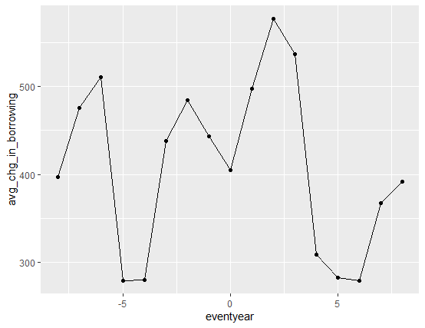

.

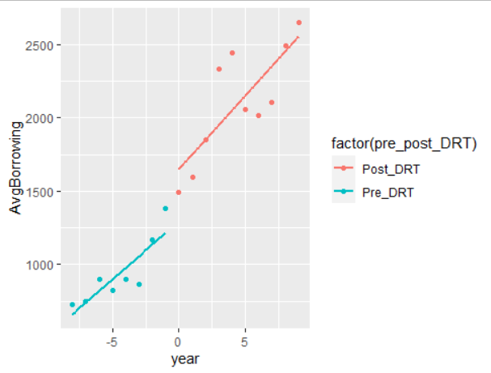

### Graph2: Post DRT period: Change in Avg Borrowings vs Initial Size of firm

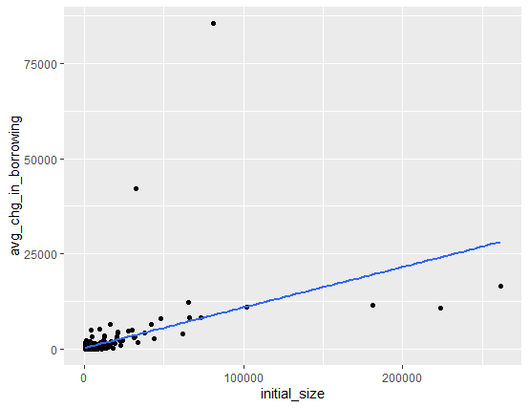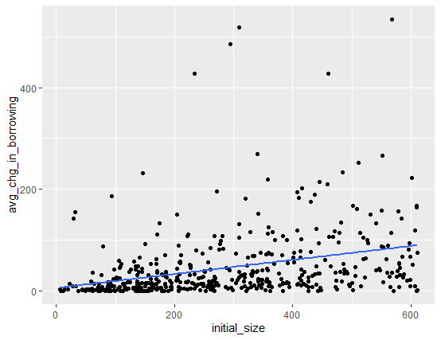

In the post DRT period, I have segregated the data into big firms and small firms based on the initial size of the firm as compared to the median size. If a firm has size more than the median size, it is classified as big firm, else it falls under the category of small firms. Then, I plot the average change in borrowings vis-à-vis size of the firm to find whether the change in borrowings is impacted w.r.t. the size of the firms. As observed, change in borrowings is mostly higher for larger firms. However, it is also evident that this change is higher for the group of big firms as compared to the group of small firms. This is line with the negative coefficient in the regression results for DRT, but a positive coefficient for DRT*Size. Thus, for small firms, the net increase in change in borrowings is lower than that of large firms.

# REPLICATION OF TABLE VII

## Regression Results: PRE-TRENDS

----------------------------------------------------------------------------

(1) (2) (3) (4)

borrowing borrowing borrowing borrowing

----------------------------------------------------------------------------

earlytrend -20.48 25.73**

(-1.02) (3.43)

earlyasset~d -0.0185**

(-3.36)

tdrtyear -6.383 5.602**

(-1.75) (3.60)

tdrtyearass -0.00370**

(-3.40)

----------------------------------------------------------------------------

N 1390 1390 1390 1390

----------------------------------------------------------------------------

t statistics in parentheses

* p<0.05, ** p<0.01, *** p<0.001

Note: Although the coefficients are different from the paper, due to the reasons stated previously, but the signs and economic effects are still in line with the results in the paper.

## Variables used:

1. ‘earlytrend’ is the interaction of variable Early and time trend. Here Early is a dummy which is 1 if DRT was introduced in 1st wave of DRT i.e. before 1995
2. ‘earlyassettrend’ is an interaction variable of earlytrend and size
3. ‘tdrtyear’ interaction of DRT years and time. Here DRT years is the number of years during 1993-2002, when the state had a DRT.
4. ‘tdrtyearass’ is interaction of tdrtyear and asset size

## Empirical Analysis of spec (3) & (4)

The coefficient of tdrtyear shows the differential time trend in Borrowings from 1989-1993 for *early states* (which have higher number of DRT years in the period of study from 1991-2003) as compared to *late states* (which have lower number of DRT years in 1991-2003). Specification (3) results show that the pre trends are different for firms in early states as compared to firms in late states. The early adopters have a negative pre-trend in borrowings (coefficient of -6.38). Specification (4) further interacts the tdrtyear with asset size. It tries to capture how the pre trend of borrowing varies for firms, given their initial size, and whether the state was early adopter or late adopter. The positive coefficient for tdrtyear and negative coefficient of tdrtyearass, suggests that borrowings decreased for firms which had a larger size, and borrowings increased for small size firms during the 1989-1993 period. Thus parallel trend assumption does not hold, because in the prior years, the trends of both large and small firms were opposite. Compared with results from table 5, we can infer that although the trend of borrowing was opposite for large firms (negative trend) as compared to small firms (positive trend) in the 1988-1993 period, these trends were reversed after the DRT came into effect (i.e. bigger firms credit increased, but smaller firms credit decreased).

## Pretrend Graph

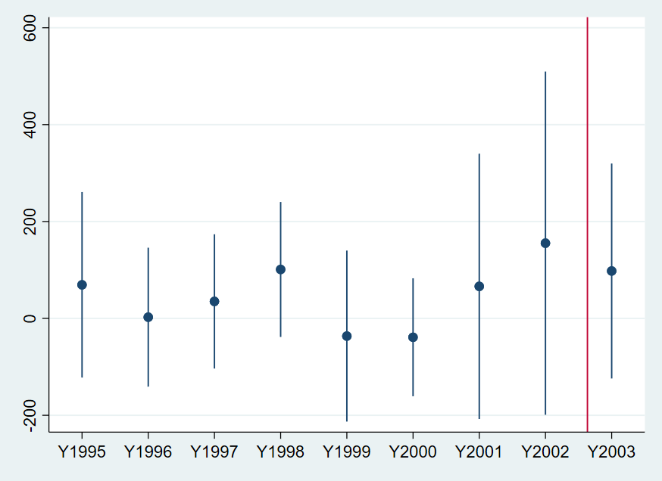

## Pretrend Graph (with state-trend effects)

