Change History
Version | Description
2.0 | Initial Release
3.0 | Added 3rd party applications in Table 1 that are used for Rest of the World devices, which resulted in adding test cases for Web.  Added Maintenance Plan in the Internal Reference Table  Modified Table 1 to compare the app versions from previous month to current month.  Modified Table 2 to add Wireless ENS to Protocol  Combined Activa and Percept PC test tables in Section 7.6 as they communicate with A610
4.0 | Updated to add Zoom Feature Check section
5.0 | Updated to add Teams Feature Check section

Contents
1. Purpose 3
2. Equipment Used 3
3. Zoom Feature Check 9
4. Microsoft Teams Feature Check 10
5. Internal References 11
6. External References 11
7. Acronyms and Abbreviations 11
8. Testing Steps 12
9. Verification Results 14
9.1. Verification Results: Model A810 (SynchroMed II) & (SynchroMed III) 15
9.2. Verification Results: Model A71300 (Stim Trialing) 19
9.3. Verification Results: Model A71200 (Vanta) 21
9.4. Verification Results: Model A71100 (Restore) 24
9.5. Verification Results: Model A710 (Intellis) 26
9.6. Verification Results: Model A610 (DBS) – Percept PC. 29
9.7. Verification Results: Model A610 (DBS) – Percept RC 32
9.8. Verification Results: Model A90400 ( SureTune 4 Connector) 37
9.9. Verification Results: Model A620 (DBS Patient Demo App) 39
10. Conclusion 41
11. Issue Tracking 41
Appendix A - Pairing Tablet to CTM to device 42

Purpose
This periodic test protocol documents the functional impact of 3rd party applications on Medtronic therapy applications (Refer Table 3), communication manager (Model A901), patient data services (Model A902), and recharge application software (Model A90300). The scope of this testing is restricted to fielded devices (INS, pumps, clinician / patient communicators). This testing and resulting documentation are developed to determine the impact of the Mobile Platform 3rd Party Applications to the regulated device (therapy application).

Equipment Used
Table 1: List of 3rd Party applications
Note: 3rd party application used for testing (if not used in any tablet, put N/A), add additional rows if other 3rd party apps are to be added before test execution.
S.No | Product (3rd Party Apps) | Identification (P/N or current month January 2025 version – Tested for all geographies) |  |  |  | Identification (P/N or current month Feb 2025 version – Tested for all geographies) |  |  | Remarks (Identify version changes Yes / No)
 |  | S2- SOCTS2JPNALLid | S2-SOCTS2EUAllid | S5e | A4p | S2 | S5e | A4p | S2 | S5e | A4p
1 | Adobe Acrobat PDF Reader | 24.8.1.34717 | 24.8.1.34717 | 25.1.0.37036 | 25.1.0.37036 | 24.8.1.34717 | 25.2.0.37438 | 25.2.0.37438 | NO | Yes | Yes
2 | Brother Print Service Plugin | 1.15.1 | 1.15.1 | 1.15.1 | 1.15.1 | 1.15.1 | 1.15.1 | 1.15.1 | NO | NO | NO
3 | Calculator | 6.0.60.6 | 6.0.63.9 | 6.0.63.9 | 12.3.05.8 | 6.0.63.9 | 6.0.63.9 | 12.3.05.8 | NO | NO | NO
4 | Camera | 6.6.24 | 6.6.24 | 9.0.06.25 | 14.1.00.67 | 6.6.24 | 9.0.06.25 | 14.1.00.67 | NO | NO | NO
5 | Canon Print Service | 2.12.0 | 2.12.0 | 2.12.0 | 2.12.0 | 2.12.0 | 2.12.0 | 2.12.0 | NO | NO | NO
6 | Chrome | 119.0.6045.193 | 119.0.6045.193 | Disabled in S5e Tablets | Disabled in A4p Tablets | 119.0.6045.193 | Disabled in S5e Tablets | Disabled in A4p Tablets | NO | NO | NO
7 | Clock | 7.0.83.9 | 7.0.74.5 | 10.0.10.15 | 12.3.21.3 | 7.0.83.9 | 10.0.10.15 | 12.3.21.3 | Yes | NO | NO
8 | Epson iPrint | 7.8.0 | 7.8.0 | 7.12.7 | 7.12.7 | 7.8.0 | 7.12.7 | 7.12.7 | NO | NO | NO
9 | Epson iProjection | Version not available for S2. | Version not available for S2. | 4.0.5 | 4.1.0 | Version not available for S2. | 4.0.5 | 4.1.1 | NO | NO | Yes
10 | Gallery | 5.4.03.2 | 5.4.03.2 | 10.2.00.21 | 15.1.03.14 | 5.4.03.2 | 10.2.00.21 | 15.1.03.14 | NO | NO | NO
11 | Google Play Store | 44.6.25-23 | 44.6.25-23 | 44.5.23-23 | 44.5.23-31 | 45.0.21-23 | 45.0.21-23 | 45.0.21-31 | Yes | Yes | Yes
12 | HP Print Service Plugin | 23.2.5.3169 | 23.2.5.3169 | 23.2.5.3169 | 23.2.5.3169 | 23.2.5.3169 | 23.2.5.3169 | 23.2.5.3169 | NO | NO | NO
13 | VMWare Workspace ONE Intelligent Hub | 24.09.1.648 | 22.01.0.6 | 24.11.1.837 | 24.11.1.837 | 24.09.1.648 | 25.01.0.904 | 25.01.0.904 | NO | Yes | Yes
14 | Mopria Print Service App | 2.15.5 | 2.15.5 | 2.18.7 | 2.18.7 | 2.15.5 | 2.18.7 | 2.18.7 | NO | NO | NO
15 | My Files | 4.1.92.111 | 4.1.92.111 | 10.1.00.171 | 15.0.05.47 | 4.1.92.111 | 10.1.00.171 | 15.0.05.47 | NO | NO | NO
16 | Ricoh Printer | Version not available for S2. | Version not available for S2. | 1.0.4 | N/A | Version not available for S2. | 1.0.4 | N/A | NO | NO | NO
17 | Samsung Print Service Plugin | 3.09.230727 | 3.09.230727 | N/A | N/A | 3.09.230727 | N/A | N/A | NO | NO | NO
18 | VMWare Workspace ONE Content | 22.10.8 | 22.10.8 | 24.11.2.43 | 24.11.2.43 | 22.10.8 | 25.02.0.53 | 25.02.0.53 | NO | Yes | Yes
19 | VMWare Workspace ONE Web | 23.09.0.4 | 23.09.0.4 | 24.11.1.837 | 24.11.1.837 | 23.09.0.4 | 24.11.1.837 | 24.11.1.837 | NO | NO | NO
20 | Xerox Print Service Plugin | 2.6.02.6 | 2.6.02.6 | 2.6.02.6 | 2.6.02.6 | 2.6.02.6 | 2.6.02.6 | 2.6.02.6 | NO | NO | NO
21 | YouTube | Removed from the field | Removed from the field | Removed from the field | Not released to the field | Removed from the field | Removed from the field | Not released to the field | NO | NO | NO
22 | Zoom Cloud Meetings | 6.2.11.25892 | 6.2.11.25892 | Removed | Removed | 6.2.11.25892 | Removed | Removed | NO | NO | NO
23 | Microsoft Teams | NA | NA | 1416/1.0.0.2024234502 | 1416/1.0.0.2024234502 | NA | 1416/1.0.0.2025032402 | 1416/1.0.0.2025032402 | NO | Yes | Yes
24 | Knox E-FoTA | NA | NA | NA | 2.0.70.3 | NA | NA | 2.0.70.3 | NO | NO | NO

Note:
- “Knox E-FoTA” App is present in A4p but not configured, however opened in the background.
- The latest version of zoom application is no longer compatible for S2(OS7) devices. Zoom version 6.0.10.21967 was locked as an internal application via MDM.
- Zoom application has been removed from S5e and A4p tablets refer to KDD NDHF1563-230498
- In S2 Tablets Web application was last updated in September 2023. Ater that there was no update available in S2 Tablets due to unsupported OS version.
- YouTube application has been removed from all the Tablets, refer to NDHF1563-216266. Chrome Application has been disabled in S5e Tablets, refer to NDHF1563-219442
- SynChromed is tested on S2 tablet both SOCTS2JPNAllid and SOCTS2EUAllid group because clock version is not updating to 7.0.83.9 in SOCTS2EUAllid group S2 tablet.
Table 2: Other Test Equipment and Therapy applications
Note: Equipment / Component / Settings used for testing (if not used, put N/A), add additional rows if other equipment is added.
Test Equipment and Therapy Applications | Identification (P/N or current version)  (To be filled in the report)
CT900D: Samsung Galaxy Tab S2 | Model: SM-T813  SN Number: R52M10M43NV  UAT Server: ds874  Group ID: SOCTS2JPNAllid  Android Security Patch Level:  July 1,2019.  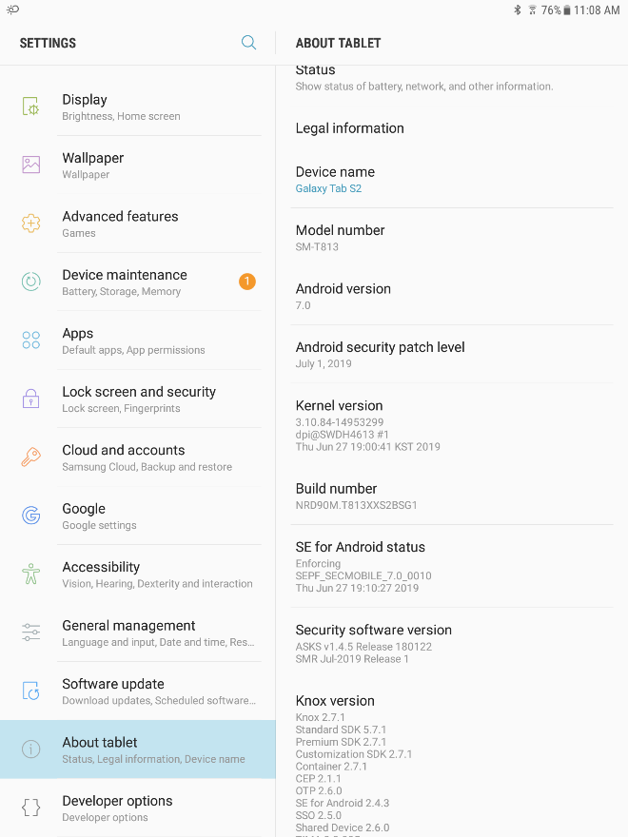  Model: SM-T813  SN Number: R52M10JX84H  UAT Server: ds874  Group ID: SOCTS2EUAllid  Android Security Patch Level:  Aug 1,2018  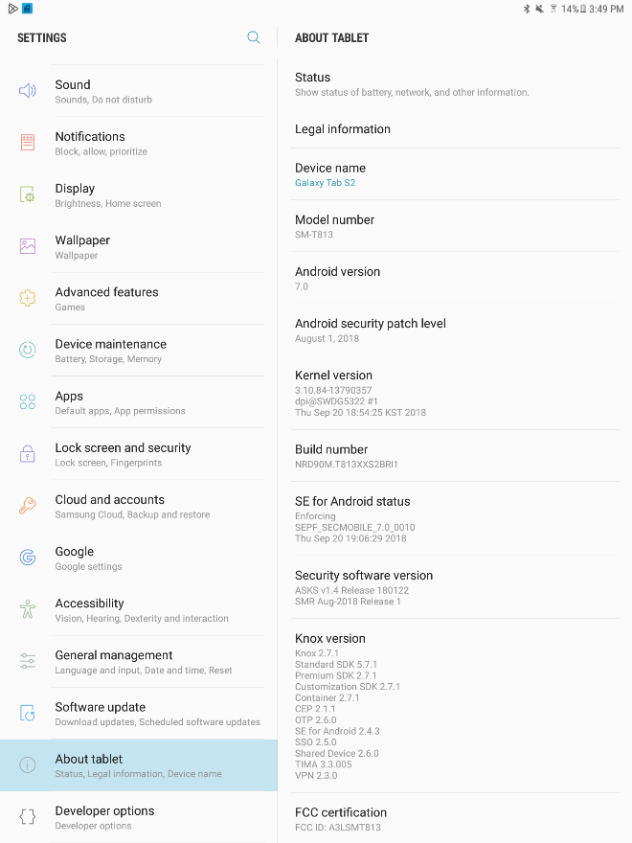
CT900E: Samsung Galaxy Tab S5e | Model: SM-T720  SN Number: R52N70BLQPR  UAT server: ds874  Group ID: SOCTS5USAllid  Android Security Patch Level:  April 1,2020  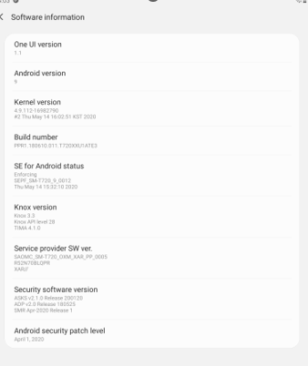
CT900F: Samsung Galaxy Tab A4p | Model: SM-T630  SN Number: R52TA0EKS2Y  UAT server: ds874  Group ID: SOCTA4PUSAllid  Android Security Patch Level:  November 01,2024.  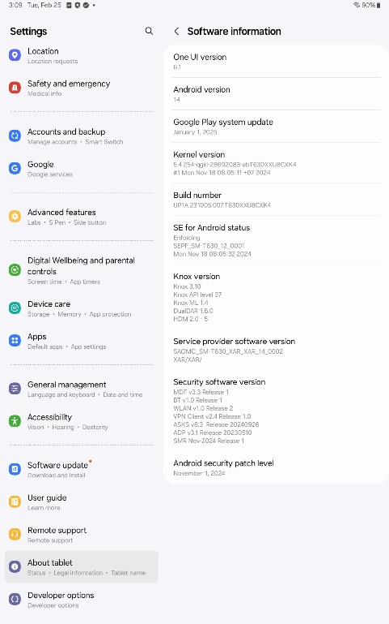
A4P With Feb
Google Play System Update  (Only for CT900F Tablet model)  - Navigate to Settings -> About Tablet -> Software Information.  - Click on Google Play System Update.  - The latest version will be downloaded. Note the date and time in Table 2. | Google play system update:  January 1, 2025  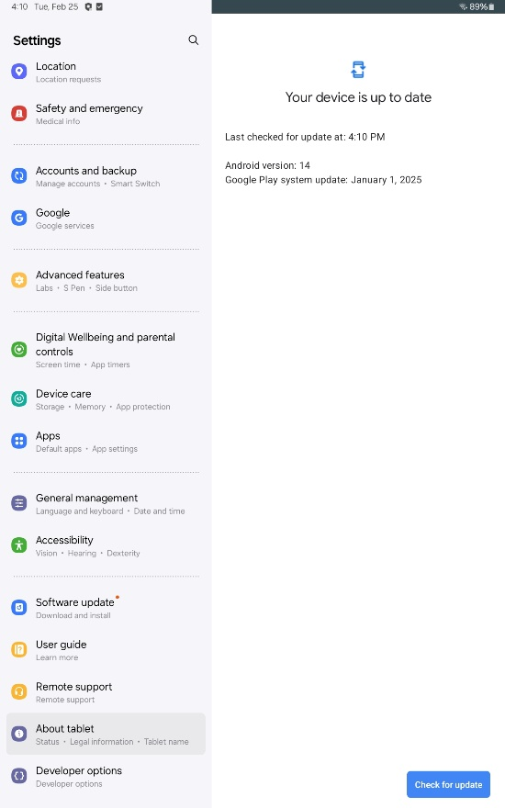
Communicator Model (8880T2) | SN Number: NKW011719N
Percept PC / Activa PC /RC / SC  Select any one of the device as all the Percept PC and Activa devices connect with A610 | Percept PC  SN Number: NPI705951H  Percept RC:  SN: NND500395H
Vanta/Pain PC INS | SN Number: NMS505519H
Inceptiv/Pain RC INS | SN Number: NNC500298H
Intellis INS | SN Number: NME741732H
Restore INS | SN Number: NMB709025H
Wireless ENS | SN Number: NLJ202360N, NLJ387366N
SynchroMed II Pump | SN Number: NGP005083H
SynchroMed III Pump | SN Number: NFY001793H
Wireless Recharger (WR9200/WR9220/WR9230) | WR9200 / WR9220 SN Number: NPW014376N, NPP018964N.  WR9230 SN Number: NRA011534N

Table 3: List of Tablets and compatible therapy applications
Note: Before executing the protocol, add the appropriate application version and handset compatibility with therapy app used for testing in the test report.
If the device is moved into different AirWatch groups for testing in other geographies, mention in the AW group column of Table 3 in the test report.
Therapy | Therapy Application | Supporting Tablets |  |  | AW Group
 |  | S2 Tablet | S5e Tablet | A4p Tablet
DBS | DBS Clinician Application (A610) | 4.0.1052 | 4.0.1052 | 4.0.1166 | S2: SOCTS2EUAllid  S5e: SOCTS5USALLid,  A4p: SOCTA4PUSAllid.
 | DBS Patient Demo | 3.0.25 | 3.0.25 | 3.0.38 | S2: SOCTS2EUAllid  S5e: SOCTS5USALLid,  A4p: SOCTA4PUSAllid.
 | SureTune 4 Connector | 1.0.91 | 1.0.91 | 1.0.211 | S2: SOCTS2EUAllid  S5e: SOCTS5USALLid,  A4p: SOCTA4PUSAllid.
TDD | SynchroMed Clinician Application (A810) | SOCTS2EUAllid  2.0.3283  SOCTS2JPNALLid  2.0.1460 | 2.0.3283 | 2.0.3283 | S2: SOCTS2JPNALLid & SOCTS2EUAllid  S5e: SOCTS5USALLid,  A4p: SOCTA4PUSAllid.
SCS | Restore Clinician Application (A71100) | 1.0.4488 | 1.0.4488 | 1.0.4488 | S2: SOCTS2EUAllid  S5e: SOCTS5USALLid,  A4p: SOCTA4PUSAllid.
 | Pain PC CP App (A71200) | 2.0.2683 | 2.0.2683 | 2.0.2683 | S2: SOCTS2EUAllid  S5e: SOCTS5USALLid,  A4p: SOCTA4PUSAllid.
 | SCS CP Trialing (A71300) | 2.0.767 | 2.0.767 | 2.0.767 | S2: SOCTS2EUAllid  S5e: SOCTS5USALLid,  A4p: SOCTA4PUSAllid.
 | Intellis Clinician Application (A710) | 2.0.247 | 2.0.247 | 2.0.247 | S2: SOCTS2EUAllid  S5e: SOCTS5USALLid,  A4p: SOCTA4PUSAllid.
 | Inceptiv Clinician Application (A71400) | 1.0.2969 | 1.0.2969 | 1.0.2969 | S2: SOCTS2EUAllid  S5e: SOCTS5USALLid,  A4p: SOCTA4PUSAllid.
Common | Recharger Application (A90300) | 2.0.679 | 2.0.679 | 2.0.679 | S2: SOCTS2EUAllid  S5e: SOCTS5USALLid,  A4p: SOCTA4PUSAllid.
 | Communication Manager (A901) | SOCTS2EUAllid  1.0.1325  SOCTS2JPNALLid  1.0.1308 | 1.0.1325 | 2.0.1367 | S2: SOCTS2JPNALLid & SOCTS2EUAllid,  S5e: SOCTS5USALLid,  A4p: SOCTA4PUSAllid.
 | PDS (A902) | SOCTS2EUAllid  1.0.947  SOCTS2JPNALLid  1.0.828 | 1.0.947 | 1.0.947 | S2: SOCTS2JPNALLid & SOCTS2EUAllid  S5e: SOCTS5USALLid,  A4p: SOCTA4PUSAllid.

Zoom Feature Check
S No | Feature | Change (Yes/No)
1 | Compatability with OS 7 Tablet. | No Change
2 | Start, end and leave a meeting. | No Change
3 | Screen Sharing | No Change
4 | Prevent additional attendees from joining a meeting (Lock a meeting). | No Change
5 | Record Session | No Change
6 | Connect to a meeting via Meeting ID and Password. | No Change
7 | Allow Cellular while in a meeting. | No Change
8 | New Feature Addition: 6.2.11.25892 | 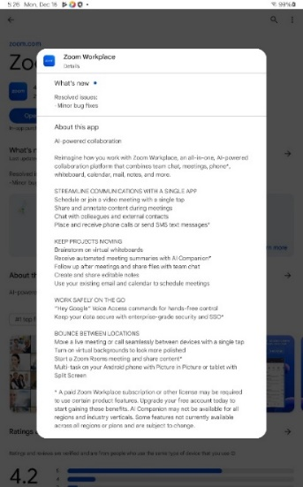

Microsoft Teams Feature Check
S No | Feature | Change (Yes/No)
1 | Compatibility with OS 9 & OS 14 Tablets. | No Change
2 | Start, end and leave a meeting. | No Change
3 | Screen Sharing | No Change
4 | Prevent additional attendees from joining a meeting ( Lock a meeting). | No Change
5 | Record Session | No Change
6 | Connect to a meeting via Meeting ID and Password. | No Change
7 | Screen Recording | No Change
8 | New Feature Addition: 1416/1.0.0.2025032402 | 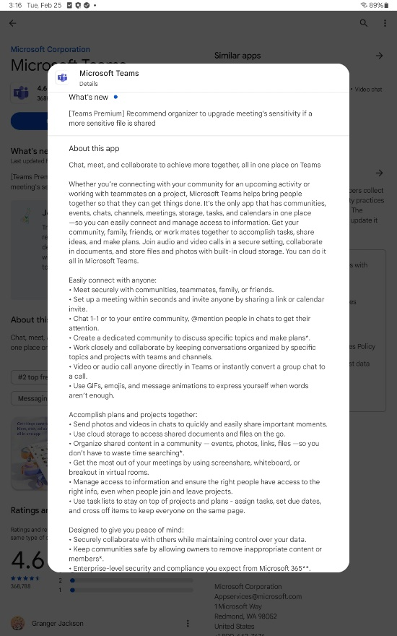

Internal References
Document Number | Document Name | Document Version
PCPWI33003 | Design Capability Assessment | E
NSP1149-35381 | Risk Assessment for Non-Medical Software– Intelligent Hub | 4.0
NSP1149-34893 | (Handset/Tablet) Intelligent Hub Security Impact Assessment | 29.0
NSP1149-35378 | 3rd Party Application Risk Assessment- Brother Print Service, Canon Print Service, Epson iPrint, HP Print Service, Mopria Print Service, Ricoh Printer, Samsung Print Service and Xerox Print Service | 2.0
NSP1149-35376 | 3rd Party Application Risk Assessment- Calculator, Camera, Clock, and Samsung My Files | 3.2
NSP1149-35374 | Risk Assessment for Non-Medical Software Products - Chrome Browser, Web - Workspace ONE and YouTube | 5.0
NSP1149-35373 | Risk Assessment for Non-Medical Software - Cisco Webex Meetings, Epson iProjection, Zoom Cloud and Microsoft Teams | 7.1
NSP1149-35379 | 3rd Party Application Risk Assessment- Gallery | 3.0
NDHF1500-221443 | 3rd Party Non Medical Software Maintenance Plan | 2.0
NSP1177-34605 | NPSW Validation Report for Zoom Version 6.0.10.21967 with DBS/SCS/TDD | 7.0
NSP1177-36421 | NPSW Validation Report for Microsoft Teams v1416/1.0.0.2024 with DBS/SCS/TDD | 2.0
NDHF1563-230498 | Key Decision Document for Removing Zoom from Clinician Tablets | 2.0
NDHF1563-230498 | Key Decision Document for Removing Zoom from Clinician Tablets | 2.0

External References
Document Name | Document Version
Off-The-Shelf Software Use in Medical Devices Guidance for Industry and Food and Drug Administration Staff | Document issued on September 27, 2019.

Acronyms and Abbreviations
Term | Definition
Airwatch (AW) | VMWare’s Workspace ONE
COTS | Commercial Off-the-shelf
CTM | Clinician telemetry module
MDM | Mobile Device Management
INS | Internal Neurostimulator
ENS | External Neurostimulator
CP | Clinician Programmer
DBS | Deep Brain Stimulation
SCS | Spinal Cord Stimulation
TDD | Targeted Drug Delivery

Testing Steps
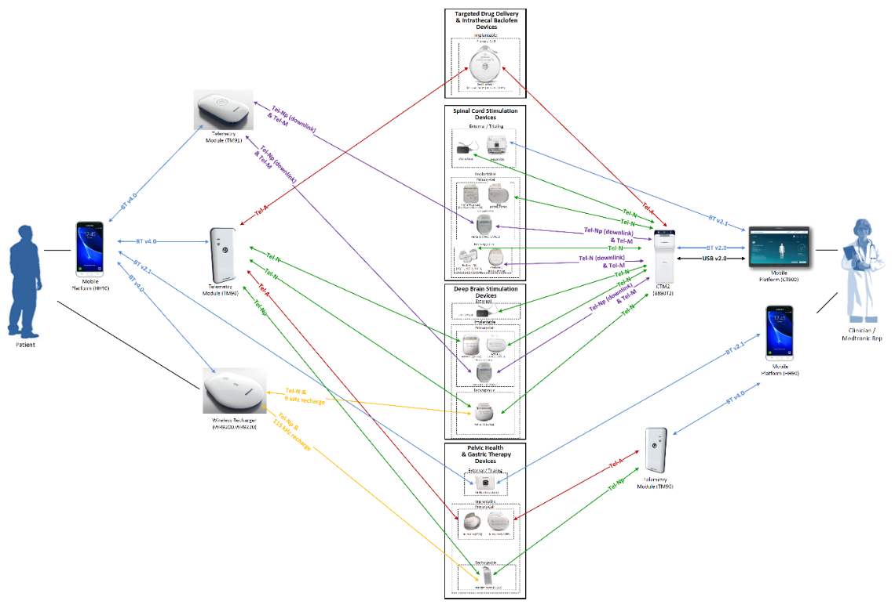
Figure 1: Overview of Communication between Therapies Implantable and External Devices
Test Setup
- Apps Pushed Through AirWatch (AW)
Step | Instructions
 | Enroll tablet into specified UAT AirWatch (AW) group
 | Deploy the updated versions of Therapy Apps, along with the applicable platform Apps (Communication Manager and PDS mentioned in Table 2) and 3rd party apps as mentioned in the Table 1.
 | Turn on Wi-Fi, and logon to a Wi-Fi network
 | Launch AW Intelligent hub Application on the handset
 | Navigate to “Managed Apps” under AW Intelligent hub Application to see if apps have downloaded, otherwise navigate ton the App Catalog, which is on the bottom lower right corner of AW Agent Application, then install (or update) applications
 | Verify apps and versions downloaded under “Managed Apps”

Test Case 1: Connectivity
- Open all the third-party apps mentioned in Table 1
- Connect CTM with tablet using a cable (Note: Refer Appendix A for pairing tablet to handset)
- Launch Clinician therapy Application with CTM powered ON and INS on top of CTM
- Ensure CTM is turned on. Select CONNECT on the Clinician Application (Note: In Intellis application A710, select Internal Device)
- During the device interrogation session, the Communication in Progress window appears.
- Wait for the interrogation session to be completed by observing that both the Communication in Progress is at 100 and the Communication in Progress window is closed (Do NOT select CANCEL). Note: In A610, Select SKIP if asked to perform an IMPEDANCE MEASUREMENT.
- Verify the interrogation is completed with no interruption.
- Setup the patient information, device information as prompted by the app and start stimulation.
- From the About screen, Verify the serial number matches CTM serial number and INS device serial number. Record test results in the Actual results cell of the Test Case 1, Step 6.
- Provide evidence of the about screen
- Provide the evidence of the screen with stimulation (or drug infusion) turned ON
- Close the About window and End session on the Clinician Application

Test case 2: Open logs (Session reports) with Acrobat PDF
- Complete Test case 1 before executing Test case 2.
- Connect CTM with tablet with cable.
- Launch Clinician Application with CTM powered ON and INS on top of CTM.
- In the initial screen select “Reports” button
- Select Sessions report from the drop down and download the log with latest timestamp.
- Check for the logs stored in /storage/emulated/0/Reports
- Open the report with Adobe pdf reader.
- Provide evidence that the logs are opened in the Adobe pdf reader.
Test Case 3: Test Intelligent Hub
- Perform the test using AirWatch UAT enrolled device.
- Open the therapy application.
- Execute Test Case 1 to check the connectivity.
- Attempt to uninstall the therapy application.
(Note: Uninstalling the app in the production environment is not allowed by the Intelligent Hub)
- Open google play store.
- Install any app from google play store (Result: if not allowed in the Hub, show evidence of installation not allowed / successful)
Test case 4: Read serial number using recharger application – camera utility check (Note: Execute only while testing rechargeable devices)
- In clinician tablet open the recharger application A90300
- Click on “Connect” from the app screen.
- Click on “Scan Code” button.
- Check for the 2D QR code on the wireless recharger (WR9200 / WR9220/WR9230)
Note: Use WR9200 for Activa RC, WR9220 for Intellis and WR9230 for Inceptiv.
- Select continue on recharger application.
- Focus the camera window on the wireless recharger QR code.
- Scan the code.
- “Connecting to Recharger” screen appears. Serial number is displayed.
- Provide evidence if the serial number matches the serial number mentioned on the wireless recharger.
Test case 5: Open logs with VMWare Content
- Complete Test case 1 before executing Test case 5
- Connect CTM with tablet with cable.
- Launch Clinician Application with CTM powered ON and INS on top of CTM.
- In the initial screen select “Reports” button
- Select Sessions report from the drop down and download the log with latest timestamp.
- Check for the logs stored in /storage/emulated/0/Reports.
- Open the report with VMWare content.
- Check that the logs are opened in the VMWare content.
Test case 6: Check VMWare Web
- Connect the tablet to Wi-Fi or hotspot.
- Open the VMWare Web app from the tablet home screen.
- Check if the VMWare Web app is opening as intended.
- Open Medtronic home page (https://www.medtronic.com/us-en/index.html)
- Check if the Medtronic home page is opening.

Verification Results
“Pass” indicates that the therapy application functioned as intended in the Test Case scenario.
Note: Add the results table if any additional devices are tested in the report.

Verification Results: Model A810 (SynchroMed II) & (SynchroMed III)
Test cases | Expected result* | Observed result | Result Pass / Fail* (CT900D; S2) SOCTS2JPNALLid | Result  Pass / Fail* (CT900E; S5e) | Result Pass / Fail* (CT900F; A4p)
Test Case 1: Connectivity | No interruptions (progress bar should complete 100 and move to therapy screen) in the connectivity will be observed when all the 3rd party apps are OPEN.  Capture About screen  Capture home screen and therapy & refill screen after the connection is established  Therapy application should not experience any crash or malfunction. | AirWatch groups: SOCTS2JPNALLid, SOCTS2EUAllid SOCTA4PUSAllid & SOCTS5USALLid  No interruptions in the connectivity are observed.  About Screen:  S2_SynchroMed II_TestCase1_About_Screen.  S2_SynchroMed III_TestCase1_About_Screen  S5e_SynchroMed II_TestCase1_About_Screen  S5e_SynchroMed III_TestCase1_About_Screen  A4P_SynchroMed II_TestCase1_About_Screen  A4P_SynchroMed III_TestCase1_About_Screen  Home Screen:  S2_SynchroMed II_TestCase1_Home_Screen  S2_SynchroMed III_TestCase1_Home_Screen  S5e_SynchroMed II_TestCase1_Home_Screen  S5e_SynchroMed III_TestCase1_Home_Screen  A4p_SynchroMed II_TestCase1_Home_Screen  A4p_SynchroMed III_TestCase1_Home_Screen  Stimulation Screen:  S2_SynchroMed II_TestCase1_Refill_Screen  S2_SynchroMed III_TestCase1_Refill_Screen  S5e_SynchroMed II_TestCase1_Refill_Screen  S5e_SynchroMed III_TestCase1_Refill_Screen  A4p_SynchroMed II_TestCase1_Refill_Screen  A4p_SynchroMed III_TestCase1_Refill_Screen | SM2  Pass  Fail  Electronically Signed in MRCS 617206 26 Feb 2025  SM3  Pass  Fail  Electronically Signed in MRCS 617206 26 Feb 2025 | SM2  Pass  Fail  Electronically Signed in MRCS 617206 27 Feb 2025  SM3  Pass  Fail  Electronically Signed in MRCS 617206 27 Feb 2025 | SM2  Pass  Fail  Electronically Signed in MRCS 617206 28 Feb 2025  SM3  Pass  Fail  Electronically Signed in MRCS 617206 28 Feb 2025
Test case 2: Open logs with Acrobat PDF | Check that the logs can be opened in the Adobe pdf reader | AirWatch groups:  SOCTS2JPNALLid, SOCTS2EUAllid SOCTA4PUSAllid & SOCTS5USALLid.  logs opened in Adobe pdf reader.  Adobe Screen:  S2_SynchroMed II_TestCase2_Adobe_Screen  S5e_SynchroMed II_TestCase2_Adobe_Screen  A4p_SynchroMed II_TestCase2_Adobe_Screen  S2_SynchroMed III_TestCase2_Adobe_Screen  S5e_SynchroMed III_TestCase2_Adobe_Screen  A4p_SynchroMed III_TestCase2_Adobe_Screen | SM2  Pass  Fail  Electronically Signed in MRCS 617206 26 Feb 2025  SM3  Pass  Fail  Electronically Signed in MRCS 617206 26 Feb 2025 | SM2  Pass  Fail  Electronically Signed in MRCS 617206 27 Feb 2025  SM3  Pass  Fail  Electronically Signed in MRCS 617206 27 Feb 2025 | SM2  Pass  Fail  Electronically Signed in MRCS 617206 28 Feb 2025  SM3  Pass  Fail  Electronically Signed in MRCS 617206 28 Feb 2025
Test Case 3: Test Intelligence Hub | 3A. Therapy application should not be uninstalled.  Capture error screen that shows that the uninstallation is not allowed.  3B. Random app does not get installed in the tablet  Capture the screenshot that shows the app from google play store is prevented from installation | 3A. Therapy application is not uninstalled.  AirWatch groups:  SOCTS2JPNALLid, SOCTS2EUAllid SOCTA4PUSAllid & SOCTS5USALLid.  Notification Screen:  TestCase3A_Notification_Screen  S2_SynchroMed II_TestCase3A_Notification_Screen  S5e_SynchroMed II_TestCase3A_Notification_Screen  A4P_SynchroMed II_TestCase3A_Notification_Screen  S2_SynchroMed III_TestCase3A_Notification_Screen  S5e_SynchroMed III_TestCase3A_Notification_Screen  A4P_SynchroMed III_TestCase3A_Notification_Screen  3B. Random app is not installed  Play Store Screen:  TestCase3B_Play_Store_Screen | SM2  Pass  Fail  Electronically Signed in MRCS 617206 26 Feb 2025  SM3  Pass  Fail  Electronically Signed in MRCS 617206 26 Feb 2025 | SM2  Pass  Fail  Electronically Signed in MRCS 617206 27 Feb 2025  SM3  Pass  Fail  Electronically Signed in MRCS 617206 27 Feb 2025 | SM2  Pass  Fail  Electronically Signed in MRCS 617206 28 Feb 2025  SM3  Pass  Fail  Electronically Signed in MRCS 617206 28 Feb 2025
Test case 5: Open logs with VMWare Content | Logs should be opened in the VMWare content | Logs are opened in the VMWare content  AirWatch groups:  SOCTS2JPNALLid, SOCTS2EUAllid SOCTA4PUSAllid & SOCTS5USALLid.  VMWare Content Screen:  S2_SynchroMed II_TestCase5_VMWare_Content_Screen  S5E_SynchroMed II_TestCase5_VMWare_Content_Screen  A4P_SynchroMed II_TestCase5_VMWare_Content_Screen  S2_SynchroMed III_TestCase5_VMWare_Content_Screen  S5E_SynchroMed III_TestCase5_VMWare_Content_Screen  A4P_SynchroMed III_TestCase5_VMWare_Content_Screen | SM2  Pass  Fail  Electronically Signed in MRCS 617206 26 Feb 2025  SM3  Pass  Fail  Electronically Signed in MRCS 617206 26 Feb 2025 | SM2  Pass  Fail  Electronically Signed in MRCS 617206 27 Feb 2025  SM3  Pass  Fail  Electronically Signed in MRCS 617206 27 Feb 2025 | SM2  Pass  Fail  Electronically Signed in MRCS 617206 28 Feb 2025  SM3  Pass  Fail  Electronically Signed in MRCS 617206 28 Feb 2025
Test Case 6: Open VMWare Web | VMWare Web should open Medtronic Home Page (https://www.medtronic.com/us-en/index.html) by default | Medtronic Home Page is opened in VMWare Web as intended  AirWatch groups:  SOCTS2JPNALLid, SOCTS2EUAllid SOCTA4PUSAllid & SOCTS5USALLid.  VMWare Web Screen  TestCase6_VMWare_Web_Screen | SM2  Pass  Fail  Electronically Signed in MRCS 617206 26 Feb 2025  SM3  Pass  Fail  Electronically Signed in MRCS 617206 26 Feb 2025 | SM2  Pass  Fail  Electronically Signed in MRCS 617206 27 Feb 2025  SM3  Pass  Fail  Electronically Signed in MRCS 617206 27 Feb 2025 | SM2  Pass  Fail  Electronically Signed in MRCS 617206 28 Feb 2025  SM3  Pass  Fail  Electronically Signed in MRCS 617206 28 Feb 2025

Verification Results: Model A71300 (Stim Trialing)
Test cases | Expected result* | Observed result | Result Pass / Fail* (CT900D; S2) | Result  Pass / Fail* (CT900E; S5e) | Result Pass / Fail* (CT900F; A4p)
Test Case 1: Connectivity | No interruptions (progress bar should complete 100 and move to therapy screen) in the connectivity will be observed when all the 3rd party apps are OPEN.  Capture About screen  Capture home screen and stimulation screen after the connection is established.  Therapy application should not experience any crash or malfunction. | No interruptions in the connectivity are observed.  SOCTS2EUAllid, SOCTA4PUSAllid & SOCTS5USALLid  AirWatch groups:  About Screen:  S2_Stim Trialing_TestCase1_About_Screen  S5e_Stim Trialing_TestCase1_About_Screen  A4p_Stim Trialing_TestCase1_About_Screen  Home Screen:  S2_Stim Trialing_TestCase1_Home_Screen  S5e_Stim Trialing_TestCase1_Home_Screen  A4p_Stim Trialing_TestCase1_Home_Screen  Stimulation Screen:  S2_Stim Trialing_TestCase1_Stimulation_Screen  S5e_Stim Trialing_TestCase1_Stimulation_Screen  A4p_Stim Trialing_TestCase1_Stimulation_Screen | Pass  Fail  Electronically Signed in MRCS 617206 26 Feb 2025 | Pass  Fail  Electronically Signed in MRCS 617206 27 Feb 2025 | Pass  Fail  Electronically Signed in MRCS 617206 28 Feb 2025
Test case 2: Open logs with Acrobat PDF | Check that the logs can be opened in the Adobe pdf reader | AirWatch groups:  SOCTS2EUAllid, SOCTA4PUSAllid & SOCTS5USALLid.  Logs opened in Adobe pdf reader.  Adobe Screen:  S2_Stim Trialing_TestCase2_Adobe_Screen  S5e_Stim Trialing_TestCase2_Adobe_Screen  A4p_Stim Trialing_TestCase2_Adobe_Screen | Pass  Fail  Electronically Signed in MRCS 617206 26 Feb 2025 | Pass  Fail  Electronically Signed in MRCS 617206 27 Feb 2025 | Pass  Fail  Electronically Signed in MRCS 617206 28 Feb 2025
Test Case 3: Test Intelligence Hub | 3A. Therapy application should not be uninstalled.  Capture error screen that shows that the uninstallation is not allowed.  3B. Random app does not get installed in the tablet  Capture the screenshot that shows the app from google play store is prevented from installation | AirWatch groups:  SOCTS2EUAllid, SOCTA4PUSAllid & SOCTS5USALLid.  3A. Therapy application is not uninstalled.  Notification Screen:  S2_Stim Trialing_TestCase3A_Notification_Screen  S5e_Stim Trialing_TestCase3A_Notification_Screen  A4p_Stim Trialing_TestCase3A_Notification_Screen  3B. Random app is not installed.  Play Store Screen:  TestCase3B_Play_Store_Screen | Pass  Fail  Electronically Signed in MRCS 617206 26 Feb 2025 | Pass  Fail  Electronically Signed in MRCS 617206 27 Feb 2025 | Pass  Fail  Electronically Signed in MRCS 617206 28 Feb 2025
Test case 5: Open logs with VMWare Content | Logs should be opened in the VMWare content | AirWatch groups:  SOCTS2EUAllid, SOCTA4PUSAllid & SOCTS5USALLid  Logs are opened in the VMWare content.  VMWare Content Screen:  S2_Stim Trialing_TestCase5_VMWare_Content_Screen  S5e_Stim Trialing_TestCase5_VMWare_Content_Screen  A4p_Stim Trialing_TestCase5_VMWare_Content_Screen | Pass  Fail  Electronically Signed in MRCS 617206 26 Feb 2025 | Pass  Fail  Electronically Signed in MRCS 617206 27 Feb 2025 | Pass  Fail  Electronically Signed in MRCS 617206 28 Feb 2025
Test Case 6: Open VMWare Web | VMWare Web should open Medtronic Home Page (https://www.medtronic.com/us-en/index.html) by default | AirWatch groups:  SOCTS2EUAllid, SOCTA4PUSAllid & SOCTS5USALLid  Medtronic Home Page is opened in VMWare Web as intended.  VMWare Web Screen:  TestCase6_VMWare_Web_Screen | Pass  Fail  Electronically Signed in MRCS 617206 26 Feb 2025 | Pass  Fail  Electronically Signed in MRCS 617206 27 Feb 2025 | Pass  Fail  Electronically Signed in MRCS 617206 28 Feb 2025

Verification Results: Model A71200 (Vanta)
Test cases | Expected result* | Observed result | Result Pass / Fail* (CT900D; S2) | Result  Pass / Fail* (CT900E; S5e) | Result Pass / Fail* (CT900F; A4p)
Test Case 1: Connectivity | No interruptions (progress bar should complete 100 and move to therapy screen) in the connectivity will be observed when all the 3rd party apps are OPEN.  Capture About screen  Capture home screen and stimulation screen after the connection is established.  Therapy application should not experience any crash or malfunction. | AirWatch groups:  SOCTS2EUAllid, SOCTA4PUSAllid & SOCTS5USALLid.  No interruptions in the connectivity are observed.  About Screen:  S2_Vanta_TestCase1_About_Screen  S5e_Vanta_TestCase1_About_Screen  A4p_Vanta_TestCase1_About_Screen  Home Screen:  S2_Vanta_TestCase1_Home_Screen  S5e_Vanta_TestCase1_Home_Screen  A4p_Vanta_TestCase1_Home_Screen  Stimulation Screen:  S2_Vanta_TestCase1_Stimulation_Screen  S5e_Vanta_TestCase1_Stimulation_Screen  A4p_Vanta_TestCase1_Stimulation_Screen  Therapy application did not experience any crash or malfunction. | Pass  Fail  Electronically Signed in MRCS 617206 26 Feb 2025 | Pass  Fail  Electronically Signed in MRCS 617206 27 Feb 2025 | NA  Pass  Fail
Test case 2: Open logs with Acrobat PDF | Check that the logs can be opened in the Adobe pdf reader | AirWatch groups:  SOCTS2EUAllid, SOCTA4PUSAllid & SOCTS5USALLid.  Logs opened in Adobe pdf reader.  Adobe Screen:  S2_Vanta_TestCase2_Adobe_Screen  S5e_Vanta_TestCase2_Adobe_Screen  A4p_Vanta_TestCase2_Adobe_Screen | Pass  Fail  Electronically Signed in MRCS 617206 26 Feb 2025 | Pass  Fail  Electronically Signed in MRCS 617206 27 Feb 2025 | NA  Pass  Fail
Test Case 3: Test Intelligence Hub | 3A. Therapy application should not be uninstalled.  Capture error screen that shows that the uninstallation is not allowed.  3B. Random app does not get installed in the tablet  Capture the screenshot that shows the app from google play store is prevented from installation | AirWatch groups:  SOCTS2EUAllid, SOCTA4PUSAllid & SOCTS5USALLid.  3A. Therapy application is not uninstalled.  Notification Screen:  S2_Vanta_TestCase3A_Notification_Screen  S5e_Vanta_TestCase3A_Notification_Screen  A4p_Vanta_TestCase3A_Notification_Screen  3B. Random app is not installed.  Play Store Screen:  TestCase3B_Play_Store_Screen | Pass  Fail  Electronically Signed in MRCS 617206 26 Feb 2025 | Pass  Fail  Electronically Signed in MRCS 617206 27 Feb 2025 | NA  Pass  Fail
Test case 5: Open logs with VMWare Content | Logs should be opened in the VMWare content | AirWatch groups:  SOCTS2EUAllid, SOCTA4PUSAllid & SOCTS5USALLid.  Logs are opened in the VMWare content.  VMWare Content Screen:  S2_Vanta_TestCase5_VMWare_Content_Screen.  S5e_Vanta_TestCase5_VMWare_Content_Screen  A4p_Vanta_TestCase5_VMWare_Content_Screen | Pass  Fail  Electronically Signed in MRCS 617206 26 Feb 2025 | Pass  Fail  Electronically Signed in MRCS 617206 27 Feb 2025 | NA  Pass  Fail
Test Case 6: Open VMWare Web | VMWare Web should open Medtronic Home Page (https://www.medtronic.com/us-en/index.html) by default | AirWatch groups:  SOCTS2EUAllid, SOCTA4PUSAllid & SOCTS5USALLid.  Medtronic Home Page is opened in VMWare Web as intended  VMWare Web Screen:  TestCase6_VMWare_Web_Screen | Pass  Fail  Electronically Signed in MRCS 617206 26 Feb 2025 | Pass  Fail  Electronically Signed in MRCS 617206 27 Feb 2025 | NA  Pass  Fail

Verification Results: Model A71100 (Restore)
Test cases | Expected result* | Observed result | Result Pass / Fail* (CT900D; S2) | Result  Pass / Fail* (CT900E; S5e) | Result Pass / Fail* (CT900F; A4p)
Test Case 1: Connectivity | No interruptions (progress bar should complete 100 and move to therapy screen) in the connectivity will be observed when all the 3rd party apps are OPEN.  Capture About screen  Capture home screen and stimulation screen after the connection is established.  Therapy application should not experience any crash or malfunction. | AirWatch groups:  SOCTS2EUAllid, SOCTA4PUSAllid & SOCTS5USALLid.  No interruptions in the connectivity are observed.  About Screen:  S2_Restore_TestCase1_About_Screen  S5e_Restore_TestCase1_About_Screen  A4p_Restore_TestCase1_About_Screen  Home Screen:  S2_Restore_TestCase1_Home_Screen  S5e_Restore_TestCase1_Home_Screen  A4p_Restore_TestCase1_Home_Screen  Stimulation Screen:  S2_Restore_TestCase1_Stimulation_Screen  S5e_Restore_TestCase1_Stimulation_Screen  A4p_Restore_TestCase1_Stimulation_Screen  Therapy application did not experience any crash or malfunction. | Pass  Fail  Electronically Signed in MRCS 617206 26 Feb 2025 | Pass  Fail  Electronically Signed in MRCS 617206 27 Feb 2025 | NA  Pass  Fail
Test case 2: Open logs with Acrobat PDF | Check that the logs can be opened in the Adobe pdf reader | AirWatch groups:  SOCTS2EUAllid, SOCTA4PUSAllid & SOCTS5USALLid.  Logs opened in Adobe pdf reader.  S2_Restore_TestCase2_Adobe_Screen  S2_Restore_TestCase2_Adobe_Screen  S2_Restore_TestCase2_Adobe_Screen | Pass  Fail  Electronically Signed in MRCS 617206 26 Feb 2025 | Pass  Fail  Electronically Signed in MRCS 617206 27 Feb 2025 | NA  Pass  Fail
Test Case 3: Test Intelligence Hub | 3A. Therapy application should not be uninstalled.  Capture error screen that shows that the uninstallation is not allowed.  3B. Random app does not get installed in the tablet  Capture the screenshot that shows the app from google play store is prevented from installation | AirWatch groups:  SOCTS2EUAllid, SOCTA4PUSAllid & SOCTS5USALLid.  3A. Therapy application is not uninstalled.  Notification Screen:  S2_Restore_TestCase3A_Notification_Screen  S5e_Restore_TestCase3A_Notification_Screen  A4p_Restore_TestCase3A_Notification_Screen  3B. Random app is not installed  Play Store Screen:  TestCase3B_Play_Store_Screen | Pass  Fail  Electronically Signed in MRCS 617206 26 Feb 2025 | Pass  Fail  Electronically Signed in MRCS 617206 27 Feb 2025 | NA  Pass  Fail
Test case 5: Open logs with VMWare Content | Logs should be opened in the VMWare content | AirWatch groups:  SOCTS2EUAllid, SOCTA4PUSAllid & SOCTS5USALLid.  Logs are opened in the VMWare content.  VMWare Content Screen:  S2_Restore_TestCase5_VMWare_Content_Screen  S5e_Restore_TestCase5_VMWare_Content_Screen  A4p_Restore_TestCase5_VMWare_Content_Screen | Pass  Fail  Electronically Signed in MRCS 617206 26 Feb 2025 | Pass  Fail  Electronically Signed in MRCS 617206 27 Feb 2025 | NA  Pass  Fail
Test Case 6: Open VMWare Web | VMWare Web should open Medtronic Home Page (https://www.medtronic.com/us-en/index.html) by default | AirWatch groups:  SOCTS2EUAllid, SOCTA4PUSAllid & SOCTS5USALLid.  Medtronic Home Page is opened in VMWare Web as intended.  VMWare Web Screen:  TestCase6_VMWare_Web_Screen | Pass  Fail  Electronically Signed in MRCS 617206 26 Feb 2025 | Pass  Fail  Electronically Signed in MRCS 617206 27 Feb 2025 | NA  Pass  Fail

Verification Results: Model A710 (Intellis)
Test cases | Expected result* | Observed result | Result Pass / Fail* (CT900D; S2) | Result  Pass / Fail* (CT900E; S5e) | Result Pass / Fail* (CT900F; A4p)
Test Case 1: Connectivity | No interruptions (progress bar should complete 100 and move to therapy screen) in the connectivity will be observed when all the 3rd party apps are OPEN.  Capture About screen  Capture home screen and stimulation screen after the connection is established.  Therapy application should not experience any crash or malfunction. | AirWatch groups:  SOCTS2EUAllid, SOCTA4PUSAllid & SOCTS5USALLid.  No interruptions in the connectivity are observed.  About Screen:  S2_Intellis_TestCase1_About_Screen  S5e_Intellis_TestCase1_About_Screen  A4p_Intellis_TestCase1_About_Screen  Home Screen:  S2_Intellis_TestCase1_Home_Screen  S5e_Intellis_TestCase1_Home_Screen  A4p_Intellis_TestCase1_Home_Screen  Stimulation Screen:  S2_Intellis_TestCase1_Stimulation_Screen  S5e_Intellis_TestCase1_Stimulation_Screen  A4p_Intellis_TestCase1_Stimulation_Screen  Therapy application did not experience any crash or malfunction. | Pass  Fail  Electronically Signed in MRCS 617206 26 Feb 2025 | Pass  Fail  Electronically Signed in MRCS 617206 27 Feb 2025 | Pass  Fail  Electronically Signed in MRCS 617206 28 Feb 2025
Test case 2: Open logs with Acrobat PDF | Check that the logs can be opened in the Adobe pdf reader | AirWatch groups:  SOCTS2EUAllid, SOCTA4PUSAllid & SOCTS5USALLid.  Logs opened in Adobe pdf reader.  Adobe Screen:  S2_Intellis_TestCase2_Adobe_Screen  S5e_Intellis_TestCase2_Adobe_Screen  A4p_Intellis_TestCase2_Adobe_Screen | Pass  Fail  Electronically Signed in MRCS 617206 26 Feb 2025 | Pass  Fail  Electronically Signed in MRCS 617206 27 Feb 2025 | Pass  Fail  Electronically Signed in MRCS 617206 28 Feb 2025
Test Case 3: Test Intelligence Hub | 3A. Therapy application should not be uninstalled.  Capture error screen that shows that the uninstallation is not allowed.  3B. Random app does not get installed in the tablet  Capture the screenshot that shows the app from google play store is prevented from installation | AirWatch groups:  SOCTS2EUAllid, SOCTA4PUSAllid & SOCTS5USALLid.  3A. Therapy application is not uninstalled.  Notification Screen:  S2_Intellis_TestCase3A_Notification_Screen  S5e_Intellis_TestCase3A_Notification_Screen  A4p_Intellis_TestCase3A_Notification_Screen  3B. Random app is not installed.  Play Store Screen:  TestCase3B_Play_Store_Screen | Pass  Fail  Electronically Signed in MRCS 617206 26 Feb 2025 | Pass  Fail  Electronically Signed in MRCS 617206 27 Feb 2025 | Pass  Fail  Electronically Signed in MRCS 617206 28 Feb 2025
Test case 4: Read serial number using wireless app – camera app check (applicable for when wireless recharger is part of system) | Check if the serial number of scanned wireless recharger is accurately displayed on the wireless recharger application | AirWatch groups:  SOCTS2EUAllid, SOCTA4PUSAllid & SOCTS5USALLid.  Serial number of scanned wireless recharger app is accurately displayed on the wireless recharger app  Recharger About Screen:  S2_Intellis_TestCase4_Recharger_Screen1  S2_Intellis_TestCase4_Recharger_Screen2  S5e_Intellis_TestCase4_Recharger_Screen1  S5e_Intellis_TestCase4_Recharger_Screen  A4p_Intellis_TestCase4_Recharger_Screen1  A4p_Intellis_TestCase4_Recharger_Screen2 | Pass  Fail  Electronically Signed in MRCS 617206 26 Feb 2025 | Pass  Fail  Electronically Signed in MRCS 617206 27 Feb 2025 | Pass  Fail  Electronically Signed in MRCS 617206 28 Feb 2025
Test case 5: Open logs with VMWare Content | Logs should be opened in the VMWare content | AirWatch groups:  SOCTS2EUAllid, SOCTA4PUSAllid & SOCTS5USALLid.  Logs are opened in the VMWare content  VMWare Content Screen:  S2_Intellis_TestCase5_VMWare_Content_Screen  S5e_Intellis_TestCase5_VMWare_Content_Screen  A4p_Intellis_TestCase5_VMWare_Content_Screen | Pass  Fail  Electronically Signed in MRCS 617206 26 Feb 2025 | Pass  Fail  Electronically Signed in MRCS 617206 27 Feb 2025 | Pass  Fail  Electronically Signed in MRCS 617206 28 Feb 2025
Test Case 6: Open VMWare Web | VMWare Web should open Medtronic Home Page (https://www.medtronic.com/us-en/index.html) by default | AirWatch groups:  SOCTS2EUAllid, SOCTA4PUSAllid & SOCTS5USALLid.  Medtronic Home Page is opened in VMWare Web as intended  VMWare Web Screen  TestCase6_VMWare_Web_Screen | Pass  Fail  Electronically Signed in MRCS 617206 26 Feb 2025 | Pass  Fail  Electronically Signed in MRCS 617206 27 Feb 2025 | Pass  Fail  Electronically Signed in MRCS 617206 28 Feb 2025

Verification Results: Model A610 (DBS) – Percept PC.
Test cases | Expected result* | Observed result | Result Pass / Fail* (CT900D; S2) | Result  Pass / Fail* (CT900E; S5e) | Result Pass / Fail* (CT900F; A4p)
Test Case 1: Connectivity | No interruptions (progress bar should complete 100 and move to therapy screen) in the connectivity will be observed when all the 3rd party apps are OPEN.  Capture About screen  Capture home screen and stimulation screen after the connection is established.  Therapy application should not experience any crash or malfunction. | AirWatch groups:  SOCTS2EUAllid, SOCTA4PUSAllid & SOCTS5USALLid.  No interruptions in the connectivity are observed.  About Screen:  S2_Percept PC_DBS_TestCase1_About_Screen  S5e_Percept PC_DBS_TestCase1_About_Screen  A4p_Percept PC_DBS_TestCase1_About_Screen  Home Screen:  S2_Percept PC_DBS_TestCase1_Home_Screen  S5e_Percept PC_DBS_TestCase1_Home_Screen  A4p_Percept PC_DBS_TestCase1_Home_Screen  Stimulation Screen:  S2_Percept PC_DBS_TestCase1_Stimulation_Screen  S5e_Percept PC_DBS_TestCase1_Stimulation_Screen  A4p_Percept PC_DBS_TestCase1_Stimulation_Screen  Therapy application did not experience any crash or malfunction. | Pass  Fail  Electronically Signed in MRCS 617206 26 Feb 2025 | Pass  Fail  Electronically Signed in MRCS 617206 27 Feb 2025 | NA  Pass  Fail
Test case 2: Open logs with Acrobat PDF | Check that the logs can be opened in the Adobe pdf reader | AirWatch groups:  SOCTS2EUAllid, SOCTA4PUSAllid & SOCTS5USALLid.  Logs opened in Adobe pdf reader  Adobe Screen:  S2_Percept PC_DBS_TestCase2_Adobe_Screen  S5e_Percept PC_DBS_TestCase2_Adobe_Screen  A4p_Percept PC_DBS_TestCase2_Adobe_Screen | Pass  Fail  Electronically Signed in MRCS 617206 26 Feb 2025 | Pass  Fail  Electronically Signed in MRCS 617206 27 Feb 2025 | NA  Pass  Fail
Test Case 3: Test Intelligence Hub | 3A. Therapy application should not be uninstalled.  Capture error screen that shows that the uninstallation is not allowed.  3B. Random app does not get installed in the tablet  Capture the screenshot that shows the app from google play store is prevented from installation | AirWatch groups:  SOCTS2EUAllid, SOCTA4PUSAllid & SOCTS5USALLid.  3A. Therapy application is not uninstalled  Notification Screen:  S2_Percept PC_DBS_TestCase3A_Notification_Screen  S5e_Percept PC_DBS_TestCase3A_Notification_Screen  A4p_Percept PC_DBS_TestCase3A_Notification_Screen  3B. Random app is not installed  Play Store Screen:  TestCase3B_Play_Store_Screen | Pass  Fail  Electronically Signed in MRCS 617206 26 Feb 2025 | Pass  Fail  Electronically Signed in MRCS 617206 27 Feb 2025 | NA  Pass  Fail
Test case 5: Open logs with VMWare Content | Logs should be opened in the VMWare content | AirWatch groups:  SOCTS2EUAllid, SOCTA4PUSAllid & SOCTS5USALLid.  Logs are opened in the VMWare content  VMWare Content Screen:  S2_Percept PC_DBS_TestCase5_VMWare_Content_Screen  S5e_Percept PC_DBS_TestCase5_VMWare_Content_Screen  A4p_Percept PC_DBS_TestCase5_VMWare_Content_Screen | Pass  Fail  Electronically Signed in MRCS 617206 26 Feb 2025 | Pass  Fail  Electronically Signed in MRCS 617206 27 Feb 2025 | NA  Pass  Fail
Test Case 6: Open VMWare Web | VMWare Web should open Medtronic Home Page (https://www.medtronic.com/us-en/index.html) by default | AirWatch groups:  SOCTS2EUAllid, SOCTA4PUSAllid & SOCTS5USALLid.  Medtronic Home Page is opened in VMWare Web as intended  TestCase6_VMWare_Web_Screen | Pass  Fail  Electronically Signed in MRCS 617206 26 Feb 2025 | Pass  Fail  Electronically Signed in MRCS 617206 27 Feb 2025 | NA  Pass  Fail

Verification Results: Model A610 (DBS) – Percept RC
Test cases | Expected result* | Observed result | Result Pass / Fail* (CT900D; S2) | Result  Pass / Fail* (CT900E; S5e) | Result Pass / Fail* (CT900F; A4p)
Test Case 1: Connectivity | No interruptions (progress bar should complete 100 and move to therapy screen) in the connectivity will be observed when all the 3rd party apps are OPEN.  Capture About screen  Capture home screen and stimulation screen after the connection is established.  Therapy application should not experience any crash or malfunction. | AirWatch groups:  SOCTS2EUAlli, SOCTA4PUSAllid & SOCTS5USALLid.  No interruptions in the connectivity are observed.  About Screen:  S2_Percept RC_DBS_TestCase1_About_Screen  S5e_Percept RC_DBS_TestCase1_About_Screen  A4p_Percept RC_DBS_TestCase1_About_Screen  Home Screen:  S2_PerceptRC_DBS_TestCase1_Home_Screen  S5e_PerceptRC_DBS_TestCase1_Home_Screen  A4p_PerceptRC_DBS_TestCase1_Home_Screen  Stimulation Screen:  S2_Percept RC_DBS_TestCase1_Stimulation_Screen  S5e_Percept RC_DBS_TestCase1_Stimulation_Screen  A4p_Percept RC_DBS_TestCase1_Stimulation_Screen  Therapy application did not experience any crash or malfunction. | Pass  Fail  Electronically Signed in MRCS 617206 26 Feb 2025 | Pass  Fail  Electronically Signed in MRCS 617206 27 Feb 2025 | Pass  Fail  Electronically Signed in MRCS 617206 28 Feb 2025
Test case 2: Open logs with Acrobat PDF | Check that the logs can be opened in the Adobe pdf reader | AirWatch groups:  SOCTS2EUAlli, SOCTA4PUSAllid & SOCTS5USALLid.  Logs opened in Adobe pdf reader  Adobe Screen:  S2_Percept RC_DBS_TestCase2_Adobe_Screen  S5e_Percept RC_DBS_TestCase2_Adobe_Screen  A4p_Percept RC_DBS_TestCase2_Adobe_Screen | Pass  Fail  Electronically Signed in MRCS 617206 26 Feb 2025 | Pass  Fail  Electronically Signed in MRCS 617206 27 Feb 2025 | Pass  Fail  Electronically Signed in MRCS 617206 28 Feb 2025
Test Case 3: Test Intelligence Hub | 3A. Therapy application should not be uninstalled.  Capture error screen that shows that the uninstallation is not allowed.  3B. Random app does not get installed in the tablet  Capture the screenshot that shows the app from google play store is prevented from installation | AirWatch groups:  SOCTS2EUAlli, SOCTA4PUSAllid & SOCTS5USALLid.  3A. Therapy application is not uninstalled  Notification Screen:  S2_Percept RC_DBS_TestCase3A_Notification_Screen  S5e_Percept RC_DBS_TestCase3A_Notification_Screen  A4p_Percept RC_DBS_TestCase3A_Notification_Screen  3B. Random app is not installed  Play Store Screen:  TestCase3B_Play_Store_Screen | Pass  Fail  Electronically Signed in MRCS 617206 26 Feb 2025 | Pass  Fail  Electronically Signed in MRCS 617206 27 Feb 2025 | Pass  Fail  Electronically Signed in MRCS 617206 28 Feb 2025
Test case 4: Read serial number using wireless app – camera app check (applicable for when wireless recharger is part of system) | Check if the serial number of scanned wireless recharger is accurately displayed on the wireless recharger application | AirWatch groups:  SOCTS2EUAlli, SOCTA4PUSAllid & SOCTS5USALLid.  Serial number of scanned wireless recharger app is accurately displayed on the wireless recharger app  Recharger About Screen:  S2_PerceptRC_DBS_TestCase4_Recharger_Screen1  S2_PerceptRC_DBS_TestCase4_Recharger_Screen2  S5e_PerceptRC_DBS_TestCase4_Recharger_Screen1  S5e_PerceptRC_DBS_TestCase4_Recharger_Screen2  A4p_PerceptRC_DBS_TestCase4_Recharger_Screen1  A4p_PerceptRC_DBS_TestCase4_Recharger_Screen2 | Pass  Fail  Electronically Signed in MRCS 617206 26 Feb 2025 | Pass  Fail  Electronically Signed in MRCS 617206 27 Feb 2025 | Pass  Fail  Electronically Signed in MRCS 617206 28 Feb 2025
Test case 5: Open logs with VMWare Content | Logs should be opened in the VMWare content | AirWatch groups:  SOCTS2EUAlli, SOCTA4PUSAllid & SOCTS5USALLid.  Logs are opened in the VMWare content  VMWare Content Screen:  S2_Percept RC_DBS_TestCase5_VMWare_Content_Screen  S5e_Percept RC_DBS_TestCase5_VMWare_Content_Screen  A4p_Percept RC_DBS_TestCase5_VMWare_Content_Screen | Pass  Fail  Electronically Signed in MRCS 617206 26 Feb 2025 | Pass  Fail  Electronically Signed in MRCS 617206 27 Feb 2025 | Pass  Fail  Electronically Signed in MRCS 617206 28 Feb 2025
Test Case 6: Open VMWare Web | VMWare Web should open Medtronic Home Page (https://www.medtronic.com/us-en/index.html) by default | AirWatch groups:  SOCTS2EUAlli, SOCTA4PUSAllid & SOCTS5USALLid.  Medtronic Home Page is opened in VMWare Web as intended  TestCase6_VMWare_Web_Screen | Pass  Fail  Electronically Signed in MRCS 617206 26 Feb 2025 | Pass  Fail  Electronically Signed in MRCS 617206 27 Feb 2025 | Pass  Fail  Electronically Signed in MRCS 617206 28 Feb 2025

Verification Results: Model A90400 ( SureTune 4 Connector)
Test cases | Expected result* | Observed result | Result Pass / Fail* (CT900D; S2) | Result  Pass / Fail* (CT900E; S5e) | Result Pass / Fail* (CT900F; A4p)
Test Case 1: Connectivity | No interruptions (progress bar should complete 100 and move to therapy screen) in the connectivity will be observed when all the 3rd party apps are OPEN.  Capture About screen  Capture home screen and stimulation screen after the connection is established.  Therapy application should not experience any crash or malfunction. | AirWatch groups:  SOCTS2EUAlli, SOCTA4PUSAllid & SOCTS5USALLid.  No interruptions in the connectivity are observed.  About Screen:  S2_SureTune_TestCase1_About_Screen  S2_DBS_TestCase1_About_Screen  S5e_SureTune_TestCase1_About_Screen  S5e_DBS_TestCase1_About_Screen  A4p_SureTune_TestCase1_About_Screen  A4p_DBS_TestCase1_About_Screen  Home Screen:  S2_SureTune_TestCase1_Home_Screen  S5e_SureTune_TestCase1_Home_Screen  A4p_SureTune_TestCase1_Home_Screen | Pass  Fail  Electronically Signed in MRCS 617206 26 Feb 2025 | Pass  Fail  Electronically Signed in MRCS 617206 27 Feb 2025 | Pass  Fail  Electronically Signed in MRCS 617206 28 Feb 2025
Test Case 3: Test Intelligence Hub | 3A. Therapy application should not be uninstalled.  Capture error screen that shows that the uninstallation is not allowed.  3B. Random app does not get installed in the tablet  Capture the screenshot that shows the app from google play store is prevented from installation | AirWatch groups:  SOCTS2EUAlli, SOCTA4PUSAllid & SOCTS5USALLid.  3A. Therapy application is not uninstalled  3B. Random app is not installed  Play Store Screen:  TestCase3B_Play_Store_Screen | Pass  Fail  Electronically Signed in MRCS 617206 26 Feb 2025 | Pass  Fail  Electronically Signed in MRCS 617206 27 Feb 2025 | Pass  Fail  Electronically Signed in MRCS 617206 28 Feb 2025
Test Case 6: Open VMWare Web | VMWare Web should open Medtronic Home Page (https://www.medtronic.com/us-en/index.html) by default | AirWatch groups:  SOCTS2EUAlli, SOCTA4PUSAllid & SOCTS5USALLid.  Medtronic Home Page is opened in VMWare Web as intended  TestCase6_VMWare_Web_Screen | Pass  Fail  Electronically Signed in MRCS 617206 26 Feb 2025 | Pass  Fail  Electronically Signed in MRCS 617206 27 Feb 2025 | Pass  Fail  Electronically Signed in MRCS 617206 28 Feb 2025

Verification Results: Model A620 (DBS Patient Demo App)
Test cases | Expected result* | Observed result | Result Pass / Fail* (CT900D; S2) | Result  Pass / Fail* (CT900E; S5e) | Result Pass / Fail* (CT900F; A4p)
Test Case 1: Connectivity | No interruptions (progress bar should complete 100 and move to therapy screen) in the connectivity will be observed when all the 3rd party apps are OPEN.  Capture About screen  Capture home screen and stimulation screen after the connection is established.  Therapy application should not experience any crash or malfunction. | AirWatch groups:  SOCTS2EUAlli, SOCTA4PUSAllid & SOCTS5USALLid.  No interruptions in the connectivity are observed.  About Screen:  S2_DBSPatientDemo_TestCase1_About_Screen  S5e_DBSPatientDemo_TestCase1_About_Screen  A4p_DBSPatientDemo_TestCase1_About_Screen  Home Screen:  S2_DBSPatientDemo_TestCase1_Home_Screen  S5e_DBSPatientDemo_TestCase1_Home_Screen  A4p_DBSPatientDemo_TestCase1_Home_Screen | Pass  Fail  Electronically Signed in MRCS 617206 26 Feb 2025 | Pass  Fail  Electronically Signed in MRCS 617206 27 Feb 2025 | Pass  Fail  Electronically Signed in MRCS 617206 28 Feb 2025
Test Case 3: Test Intelligence Hub | 3A. Therapy application should not be uninstalled.  Capture error screen that shows that the uninstallation is not allowed.  3B. Random app does not get installed in the tablet  Capture the screenshot that shows the app from google play store is prevented from installation | AirWatch groups: SOCTS2EUAlli, SOCTA4PUSAllid & SOCTS5USALLid.  3A. Therapy application is not uninstalled  3B. Random app is not installed  Play Store Screen:  DBSPatientDemo_TestCase3B_Play_Store_Screen | Pass  Fail  Electronically Signed in MRCS 617206 26 Feb 2025 | Pass  Fail  Electronically Signed in MRCS 617206 27 Feb 2025 | Pass  Fail  Electronically Signed in MRCS 617206 28 Feb 2025
Test Case 6: Open VMWare Web | VMWare Web should open Medtronic Home Page (https://www.medtronic.com/us-en/index.html) by default | AirWatch groups: SOCTS2EUAlli, SOCTA4PUSAllid & SOCTS5USALLid.  Medtronic Home Page is opened in VMWare Web as intended  TestCase6_VMWare_Web_Screen | Pass  Fail  Electronically Signed in MRCS 617206 26 Feb 2025 | Pass  Fail  Electronically Signed in MRCS 617206 27 Feb 2025 | Pass  Fail  Electronically Signed in MRCS 617206 28 Feb 2025

Conclusion
<The conclusion will be determined in the report. Reference last month’s word choice.>

Issue Tracking
S.No | Issue Description | Issue reference number
<Note: Fill the table if issues are observed during the execution of the protocol. The issues should be logged in Track wise following and the reference number to be provided for each issue identified. Remove this text before routing the report.
Field Issue Monitoring and Resolution: The procedures for receiving, documenting, evaluating, resolving, and tracking feedback arising after release of the OTS software item. This includes application of software risk management (per D00202364), security risk management (per D00582601), and 3rd party application removal (per PCPWI53612) in the maintenance process.

Appendix A - Pairing Tablet to CTM to device
Perform the following actions to pair a Tablet to a CTM to a device:
- On the Tablet, open the DBS Clinician Application (Follow same steps for other therapy applications)
- Connect the Micro-USB end of the pairing cable to the Tablet, and connect the other end of the pairing cable to the CTM as detailed in the figure below:
Note: S5e has Type C USB port. Use the Micro USB to Type C converter to connect with CTM
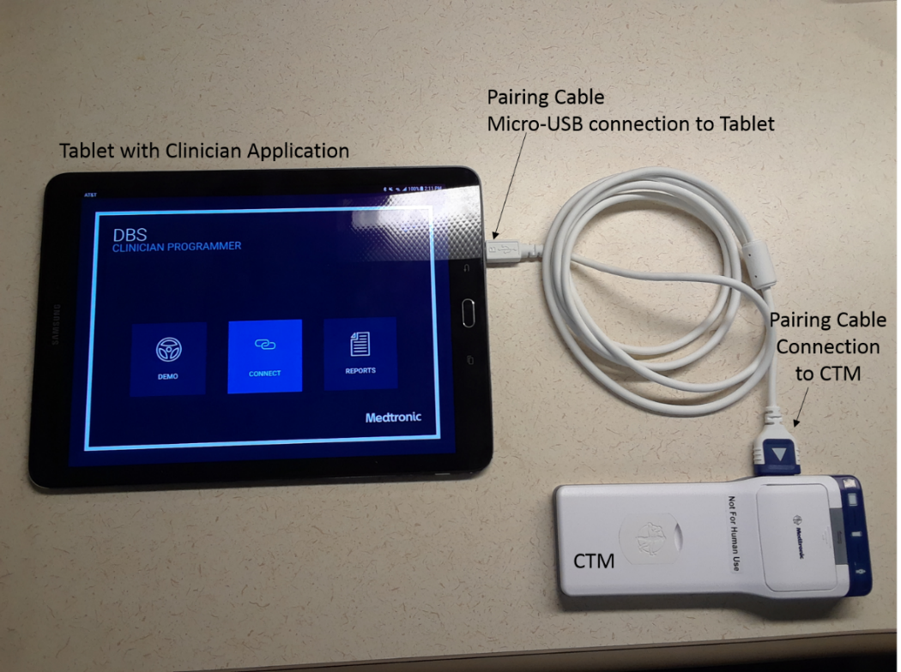
- If, the following message appears, select the “Use by default for this USB device” radio button and then press [OK].
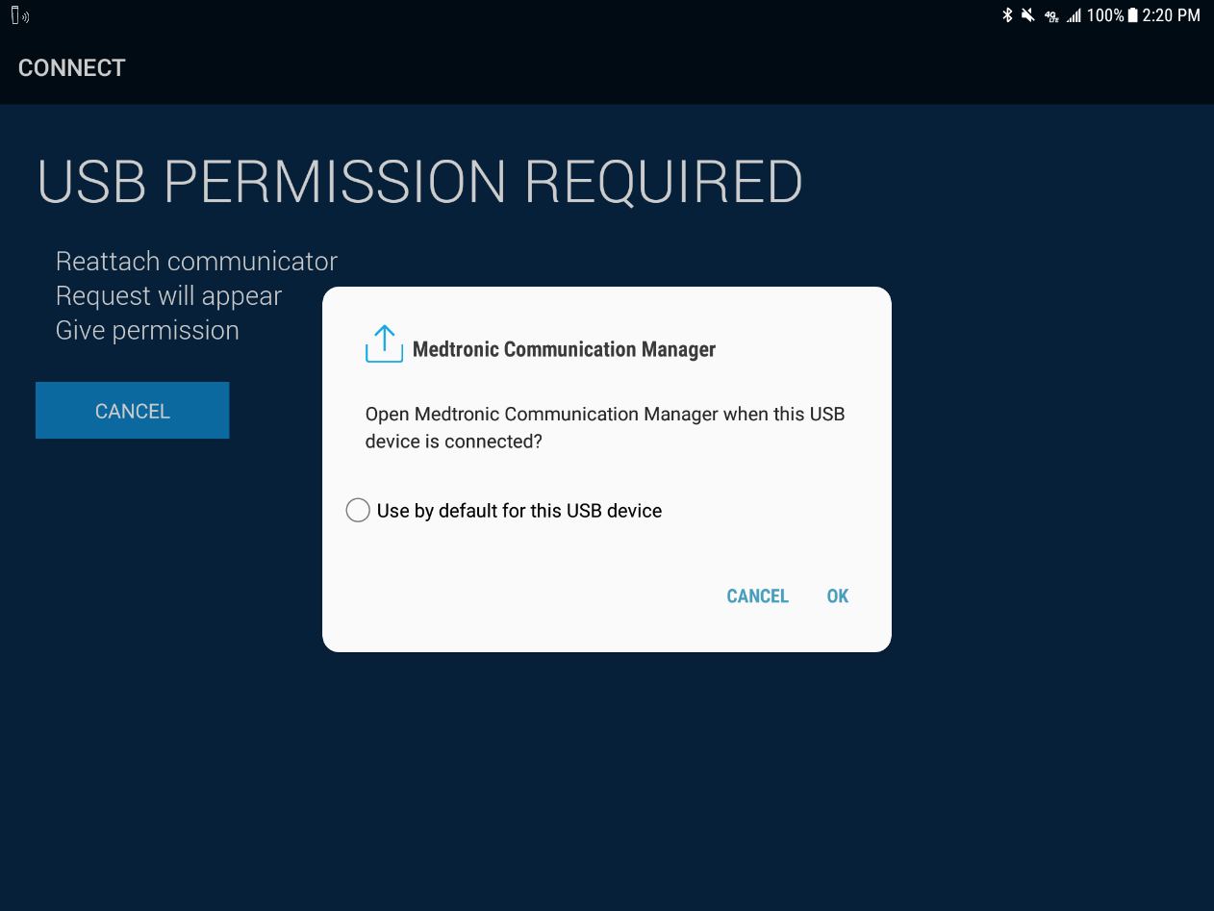
- Place the device (i.e., INS/ENS) on top of the CTM.
- On the Clinician Application, press [CONNECT].
- Upon completion of the device interrogation, unplug the pairing cable from the Tablet and the CTM.
Note: The CTM will automatically switch to a Bluetooth connection. A Bluetooth keycode pairing window may appear and can be disregarded.

