Heart Disease Risk Prediction - End-to-End MLOps Pipeline
Machine Learning Operations (AIMLCZG523) - Assignment 1
Table of Contents

Student name
BITS ID
Code repository | https://github.com/Tirumala-devi-damarla/heart-disease-mlops
Demo video
API access | Local Kubernetes (minikube) - see Section 9.3

1. Introduction
The goal of this assignment is to build a machine learning classifier that predicts whether a patient has heart disease from routine clinical measurements, and to take it all the way to a monitored API running on Kubernetes using MLOps practices: reproducible data processing, experiment tracking, automated testing, CI/CD, containerisation, deployment and monitoring.
The dataset is the UCI Heart Disease (Cleveland) dataset with 303 patients and 13 input features (age, sex, chest pain type, resting blood pressure, cholesterol, fasting blood sugar, resting ECG, maximum heart rate, exercise-induced angina, ST depression, ST slope, number of major vessels and thalassemia). The original target num (0-4) is converted into a binary label: 0 = no disease, 1 = disease present.
Tools used: Python 3.12, pandas, scikit-learn 1.5, MLflow 2.17, FastAPI, pytest, flake8, GitHub Actions, Docker, minikube (Kubernetes v1.37), NGINX Ingress, Prometheus and Grafana.

2. Setup and installation
git clone https://github.com/Tirumala-devi-damarla/heart-disease-mlops.git && cd heart-disease-mlops
python3.12 -m venv .venv && source .venv/bin/activate
pip install -r requirements.txt
bash scripts/download_data.sh # data
PYTHONPATH=src python -m heart.eda # EDA figures
PYTHONPATH=src python -m heart.train # training + MLflow
pytest -v # unit tests
docker build -t heart-api:1.0.0 . # serving image
Two requirement files are used: requirements.txt (everything for development, training and tests, all versions pinned) and requirements-serve.txt (only what the API needs), which keeps the Docker image smaller. The full command list for Docker, Kubernetes and monitoring is in RUN_INSTRUCTIONS.md.

3. Data acquisition and preprocessing
scripts/download_data.sh calls src/heart/data.py, which:
- downloads processed.cleveland.data from the UCI repository (skipped if already present),
- reads it with the documented column names and treats ? as missing,
- removes duplicate rows (none in this file, but the check is there for future data),
- fills missing values - only ca (4 rows) and thal (2 rows) are missing, so they are filled with the column mode instead of dropping 2% of an already small dataset,
- converts num to the binary target and casts the code-like columns to integers,
- validates the result (all columns present, no NaN, binary target, positive age/cholesterol) and saves data/processed/heart_clean.csv.
Validation raises an error instead of silently continuing, so bad data stops the CI pipeline. The model pipeline also contains its own imputers, so the API accepts requests where ca / thal are unknown.

4. Exploratory data analysis
All plots are produced by src/heart/eda.py (and shown in notebooks/01_eda.ipynb) using a consistent colour scheme: teal = no disease, coral = disease.
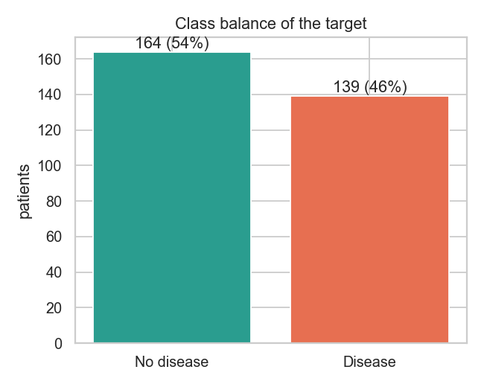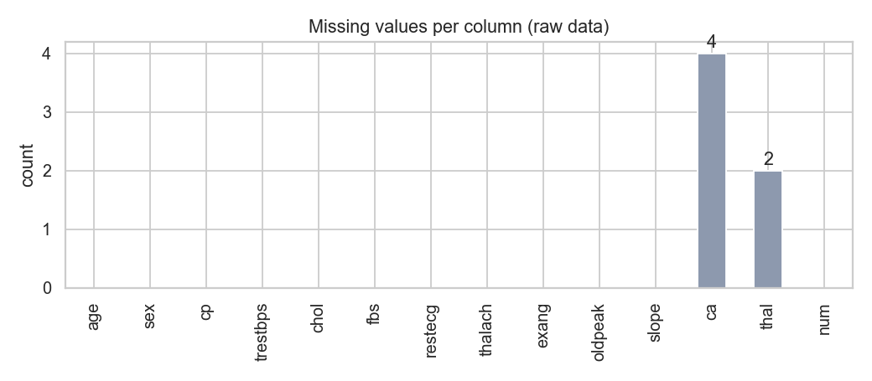
The classes are reasonably balanced (164 / 139, i.e. 54% / 46%), so no resampling was needed; a stratified train/test split and stratified cross-validation keep the ratio in every fold.
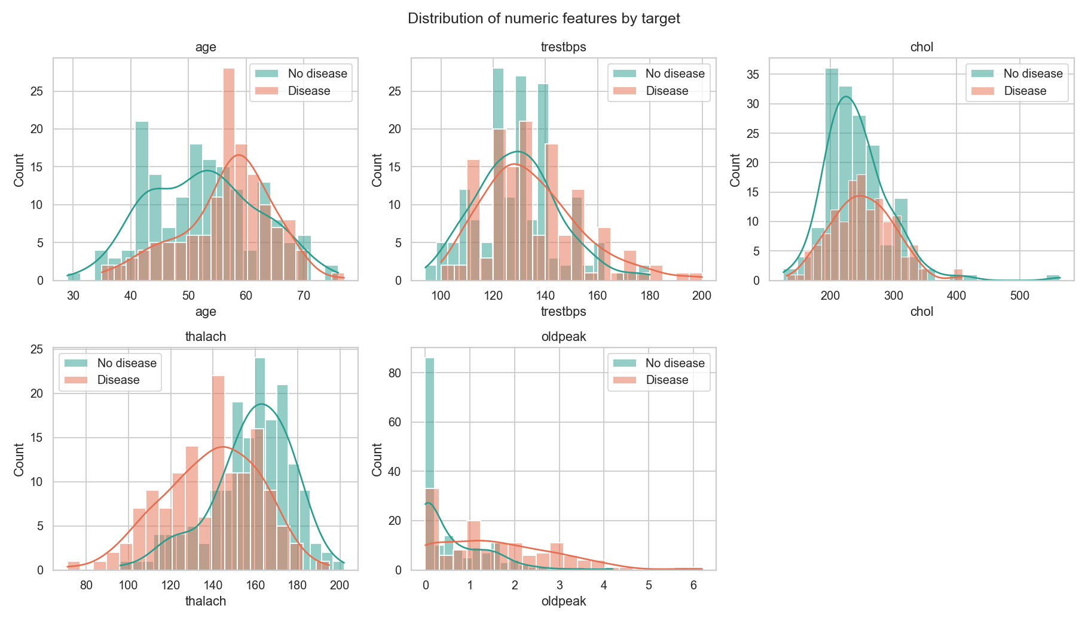
Numeric features by target
Patients with disease reach a lower maximum heart rate (thalach) and have a higher ST depression (oldpeak); they are also slightly older. Cholesterol and resting blood pressure look very similar for both groups.
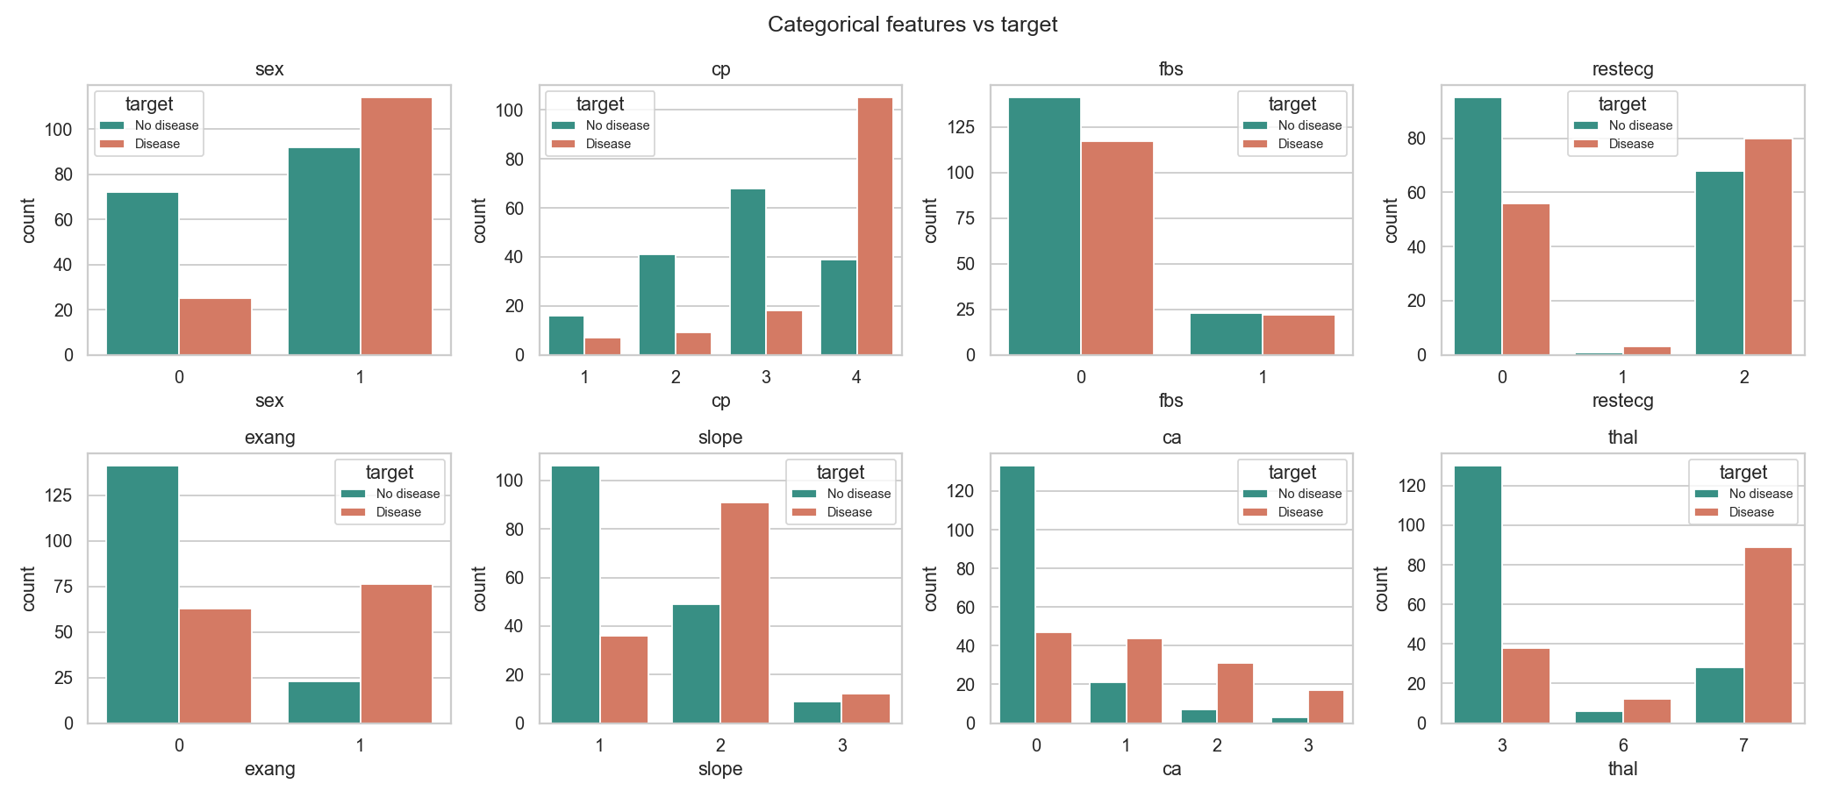
Categorical features vs target
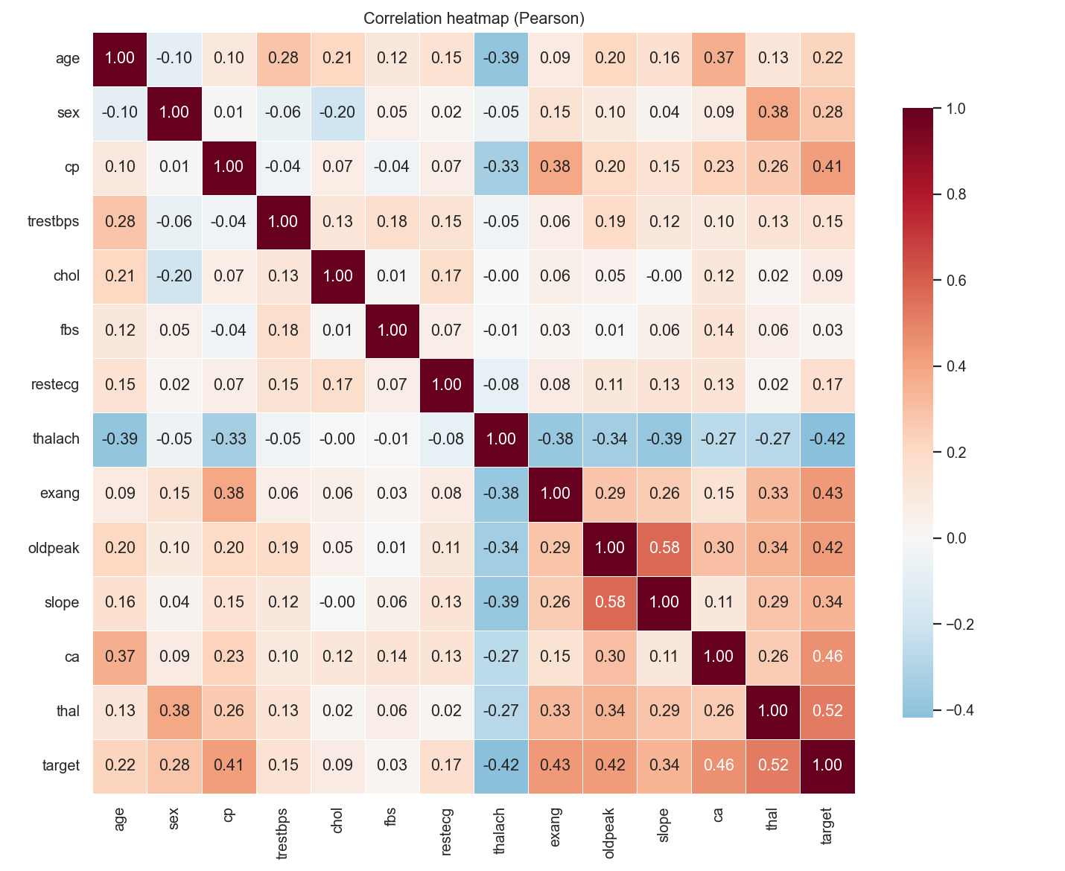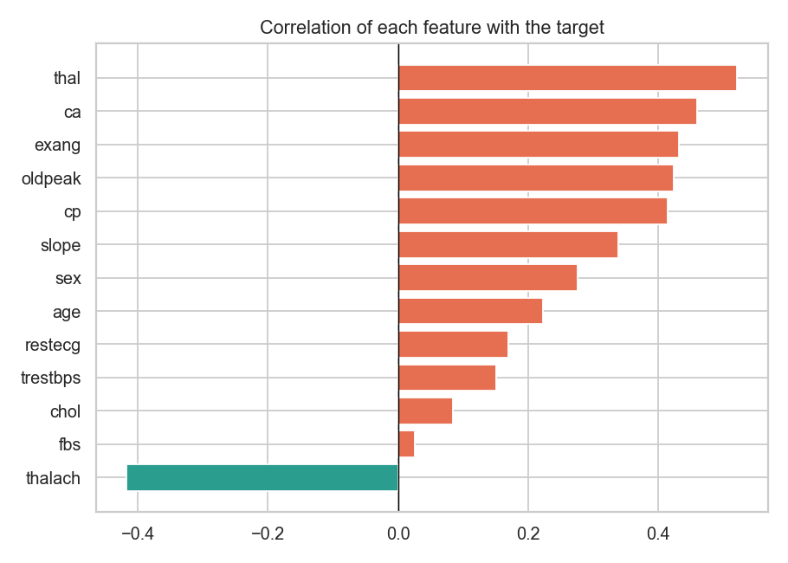
Key findings
- cp = 4 (asymptomatic chest pain), exang = 1, thal = 7 (reversible defect) and ca > 0 are the strongest indicators of disease.
- chol and fbs are almost uncorrelated with the target.
- No pair of features is so strongly correlated (|r| > 0.6) that one has to be removed.
- Some outliers exist (e.g. cholesterol 564), but they are clinically possible, so they were kept.

5. Feature engineering and model development

5.1 Preprocessing pipeline
Everything that transforms the input is inside one scikit-learn Pipeline (src/heart/features.py), which is saved together with the model. This means the training code, the tests, the notebook and the API container all run exactly the same transformations, so there is no train/serve skew.
Step | Columns | Transformation
Feature engineering | age, thalach | new feature hr_pct_max = thalach / (220 - age)
Numeric | age, trestbps, chol, thalach, oldpeak, ca, hr_pct_max | median imputation + StandardScaler
Binary | sex, fbs, exang | most-frequent imputation
Categorical | cp, restecg, slope, thal | most-frequent imputation + One-Hot (unknown categories ignored)
The engineered feature hr_pct_max is the share of the age-predicted maximum heart rate that the patient reached in the exercise test. EDA showed that both age and thalach matter, and this ratio combines them into one clinically meaningful value. ca is kept as numeric because it is an ordered count (0-3).

5.2 Models and hyper-parameter tuning
Data is split 80/20 (stratified, random_state=42): 242 rows for training and 61 for a final hold-out test. Three model families were tuned with GridSearchCV using 5-fold stratified cross-validation and ROC-AUC as the selection metric. ROC-AUC was used because it measures how well the model ranks patients by risk independently of a single threshold.
Model | Grid searched | Best parameters
Logistic Regression | C in {0.01, 0.1, 0.5, 1, 5}, penalty in {l1, l2} (10 candidates) | C = 0.5, l2
Random Forest | n_estimators {100, 300}, max_depth {3, 5, None}, min_samples_leaf {1, 4} (12) | 100 trees, depth 5, leaf 4
Gradient Boosting | n_estimators {100, 200}, learning_rate {0.05, 0.1}, max_depth {2, 3} (8) | 100, 0.05, depth 2
The grids are deliberately small: with only 242 training rows, a large search would mostly fit the noise of the CV folds.

5.3 Results
The best estimator from each search was re-evaluated with 5-fold CV on the training set (accuracy, precision, recall, F1, ROC-AUC) and once on the hold-out test set.
Metric | Logistic Regression | Random Forest | Gradient Boosting
CV accuracy | 0.851 | 0.818 | 0.818
CV precision | 0.887 | 0.844 | 0.827
CV recall | 0.783 | 0.755 | 0.774
CV F1 | 0.828 | 0.789 | 0.796
CV ROC-AUC | 0.907 ± 0.020 | 0.897 ± 0.028 | 0.874 ± 0.025
Test accuracy | 0.869 | 0.869 | 0.902
Test recall | 0.929 | 0.929 | 0.929
Test ROC-AUC | 0.960 | 0.958 | 0.959
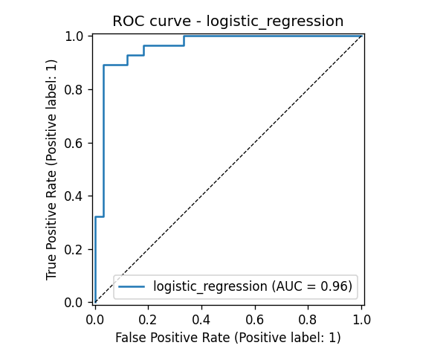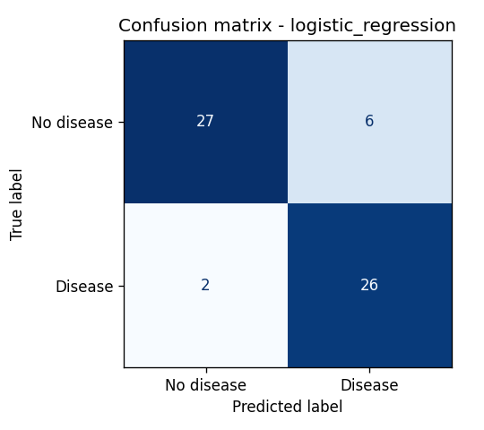
Model selection. The model is chosen on mean CV ROC-AUC, not on the test score, so the test set stays an unbiased final check. Logistic Regression wins on every CV metric and also has the lowest variance across folds. Gradient Boosting has a slightly higher test accuracy, but the test set has only 61 patients (one patient = 1.6%), so this difference is not meaningful compared to the CV results. Logistic Regression also gives well-behaved probabilities and coefficients that a clinician can interpret, which matters for a medical use case. On the test set it finds 26 of 28 disease cases (recall 0.93), which is the most important error type to minimise in screening.
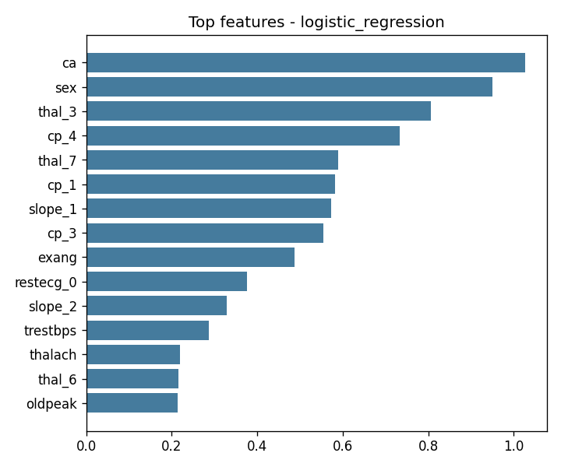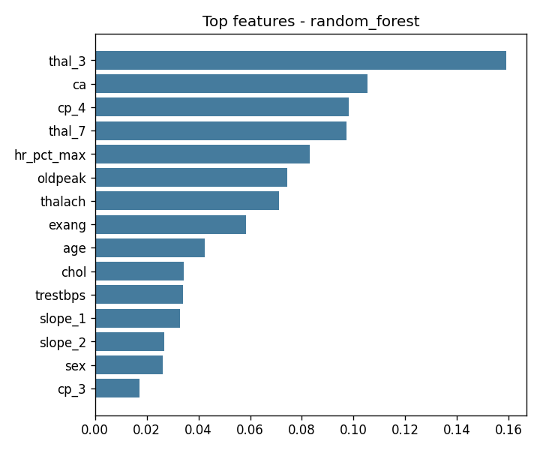
Both models agree with the EDA: ca, thal, cp and oldpeak are the most important inputs, and the engineered hr_pct_max ranks among the top features for the Random Forest.

6. Experiment tracking (MLflow)
src/heart/train.py logs everything to a local MLflow tracking store (./mlruns):
- one parent run per model family with the best parameters, dataset sizes, all CV metrics (mean and std), all test metrics and the tuning time,
- one nested child run for every grid candidate (30 in total) with its parameters and CV ROC-AUC, so the whole tuning process can be compared in the UI,
- artifacts: confusion matrix, ROC curve, precision-recall curve, feature importance plot and the full CV results table (CSV),
- the model in MLflow format with an input example and signature,
- tags model_family, stage, and selected_for_serving=true on the winning run.
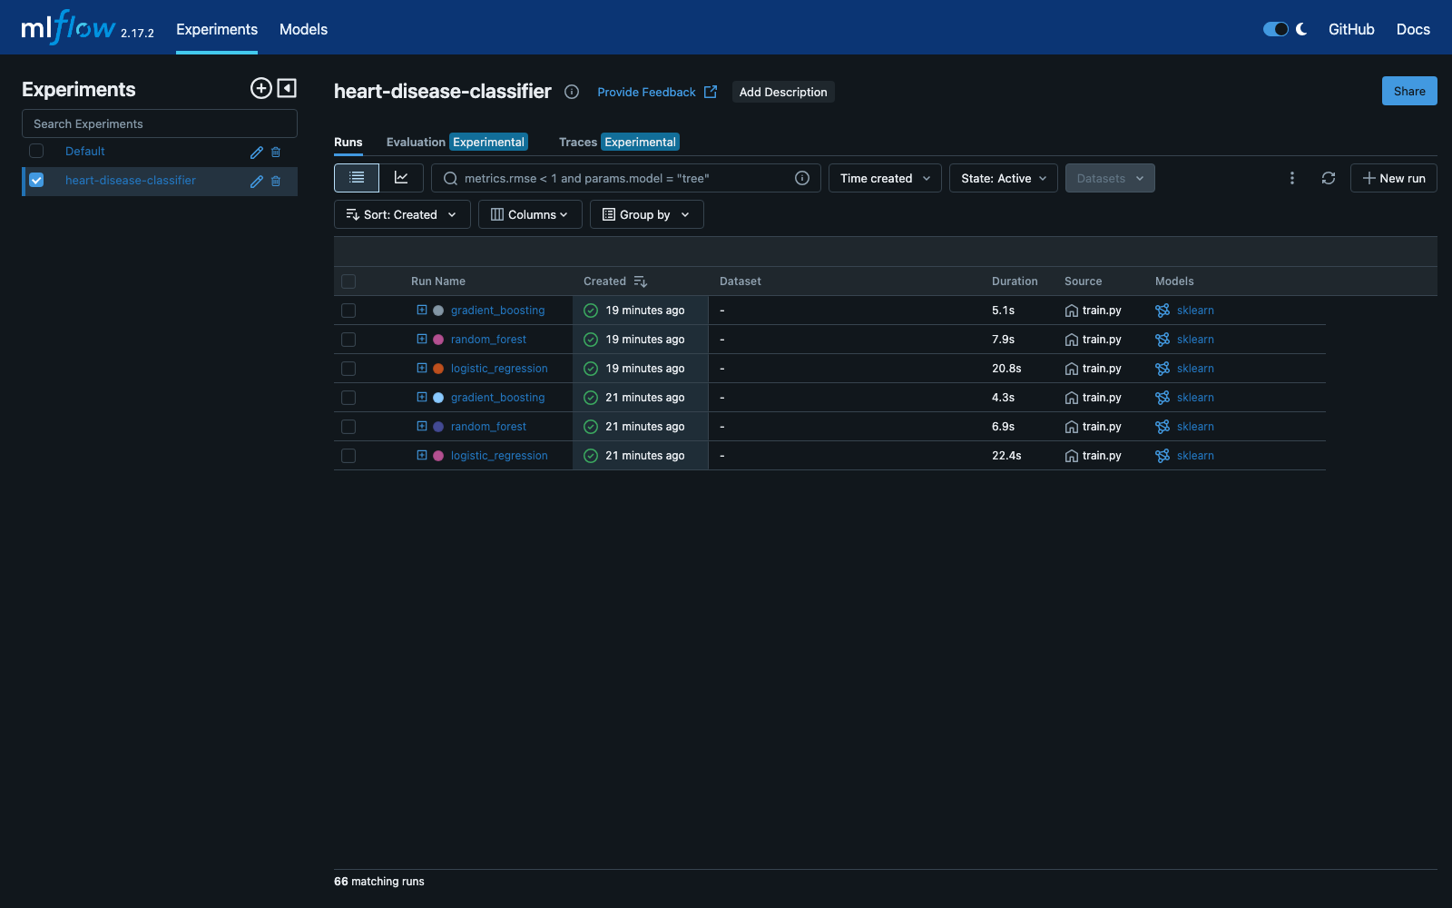
MLflow experiment with the parent runs (expandable to nested candidates)
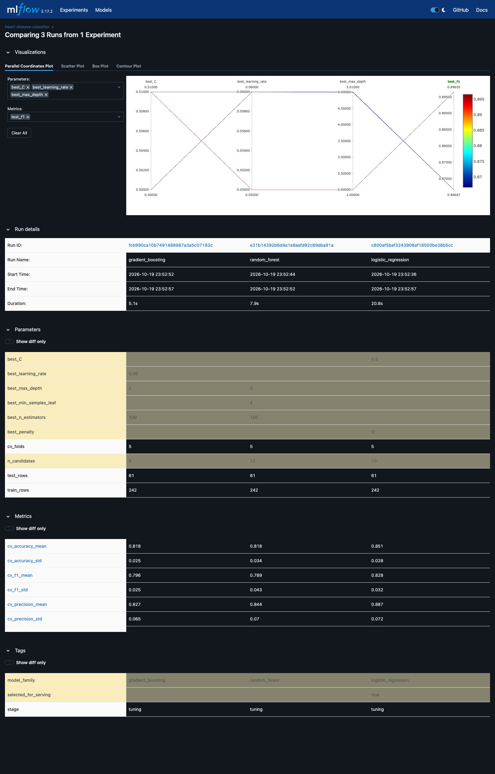
MLflow comparison of the three model families
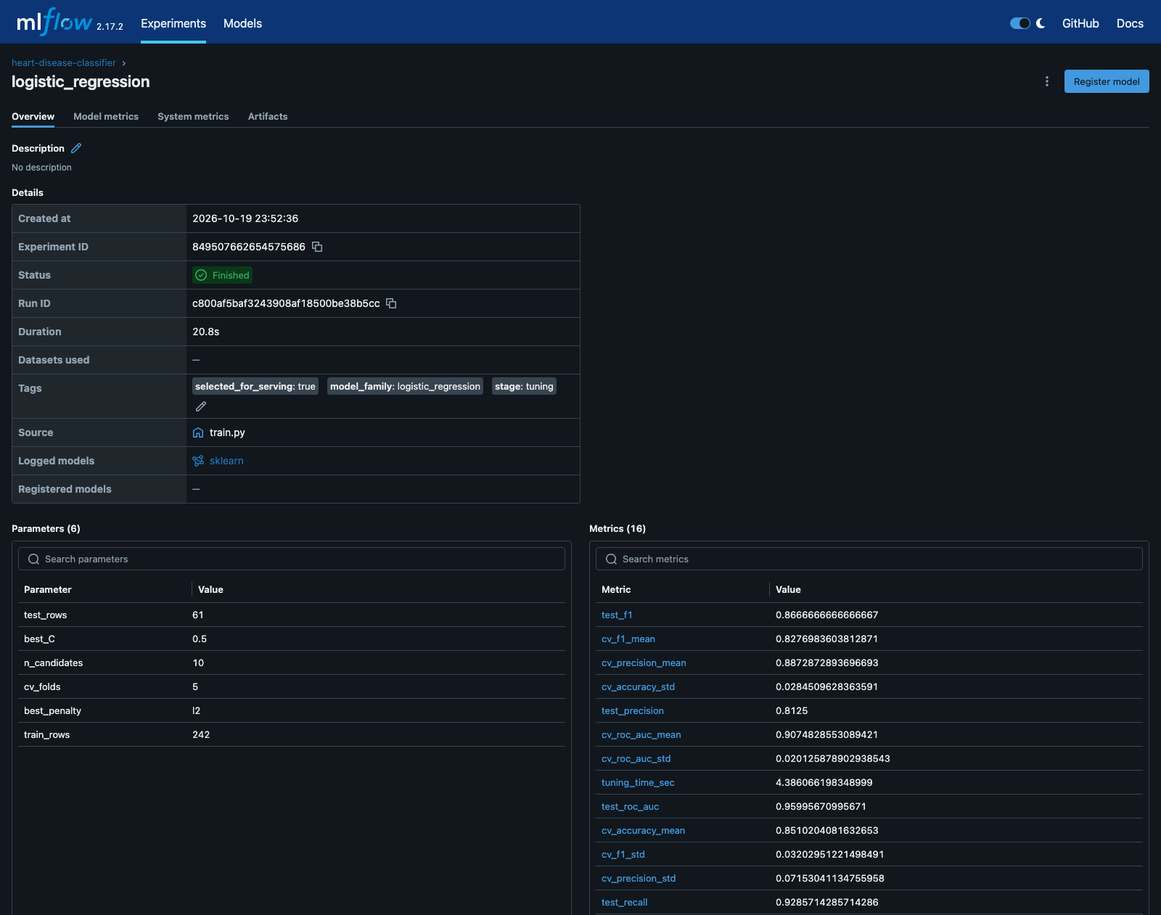
Selected run: parameters, metrics and tags
Summary: 2 complete training sessions were run (66 runs including nested ones). The results were identical in both, which confirms that the pipeline is reproducible (fixed random seeds, pinned library versions).

7. Model packaging and reproducibility
- Model formats: the winning pipeline is saved as models/model.joblib (used by the API) and as an MLflow model in models/mlflow_model/ (contains MLmodel, conda.yaml, requirements.txt, input example and signature). models/metadata.json stores the model name, MLflow run id, best parameters, metrics and the feature list.
- Preprocessing is part of the model, so a client only sends raw patient values.
- Pinned dependencies in requirements.txt / requirements-serve.txt.
- Fixed seeds (RANDOM_STATE = 42) for the split, CV folds and models.
- Single source of configuration (src/heart/config.py) for paths and column lists.
- scripts/predict.py and notebooks/03_inference.ipynb show inference from the saved file.

8. CI/CD pipeline and automated testing

8.1 Unit tests
The tests/ folder has 30 pytest tests:
File | What is tested
test_data.py (9) | duplicate removal, missing value filling, binary target, dtypes, validation errors, ? parsing
test_features.py (5) | hr_pct_max values, no NaN after preprocessing, output width, unseen categories, feature names
test_model.py (5) | both model types train and predict valid probabilities, metrics, joblib round-trip, the full train.main() with MLflow in a temp folder
test_api.py (11) | /health, /predict (incl. optional fields), invalid inputs return 422, batch endpoint, /metrics, 503 when no model is loaded
The tests use a small synthetic dataset, so they run in about 15 seconds and do not touch the real model files.
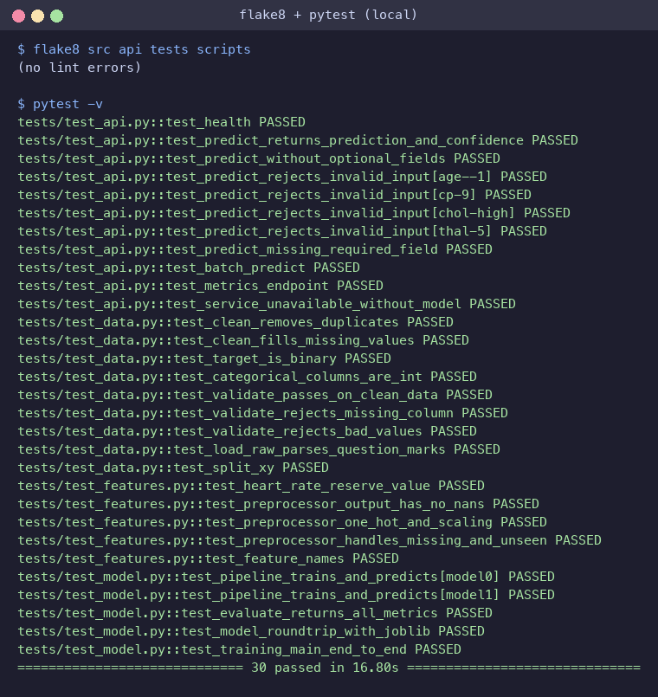
flake8 and pytest results

8.2 GitHub Actions workflow
.github/workflows/ci.yml runs on every push and pull request with four dependent jobs:
- Lint - flake8 over src, api, tests, scripts; report uploaded as an artifact.
- Unit tests - pytest -v --junitxml; JUnit XML and log uploaded.
- Data + training - downloads the dataset, trains all models, applies a quality gate (job fails if CV ROC-AUC < 0.80) and uploads the model, plots, training log and mlruns/.
- Docker - builds the image with the freshly trained model, starts the container, waits for /health, calls /predict and checks the response; container logs are uploaded.
Because every job needs the previous one, a lint error, a failing test or a bad model stops the pipeline with a red build and clear logs (tee + exit ${PIPESTATUS[0]} keeps the real exit code while still saving the log).
The run on GitHub (run #1, triggered by a push to main) passed all four jobs in under 4 minutes and produced 5 artifacts. On the fresh Ubuntu runner the selected model reached exactly the same CV ROC-AUC (0.9075) as locally, which is another check that the pipeline is reproducible.
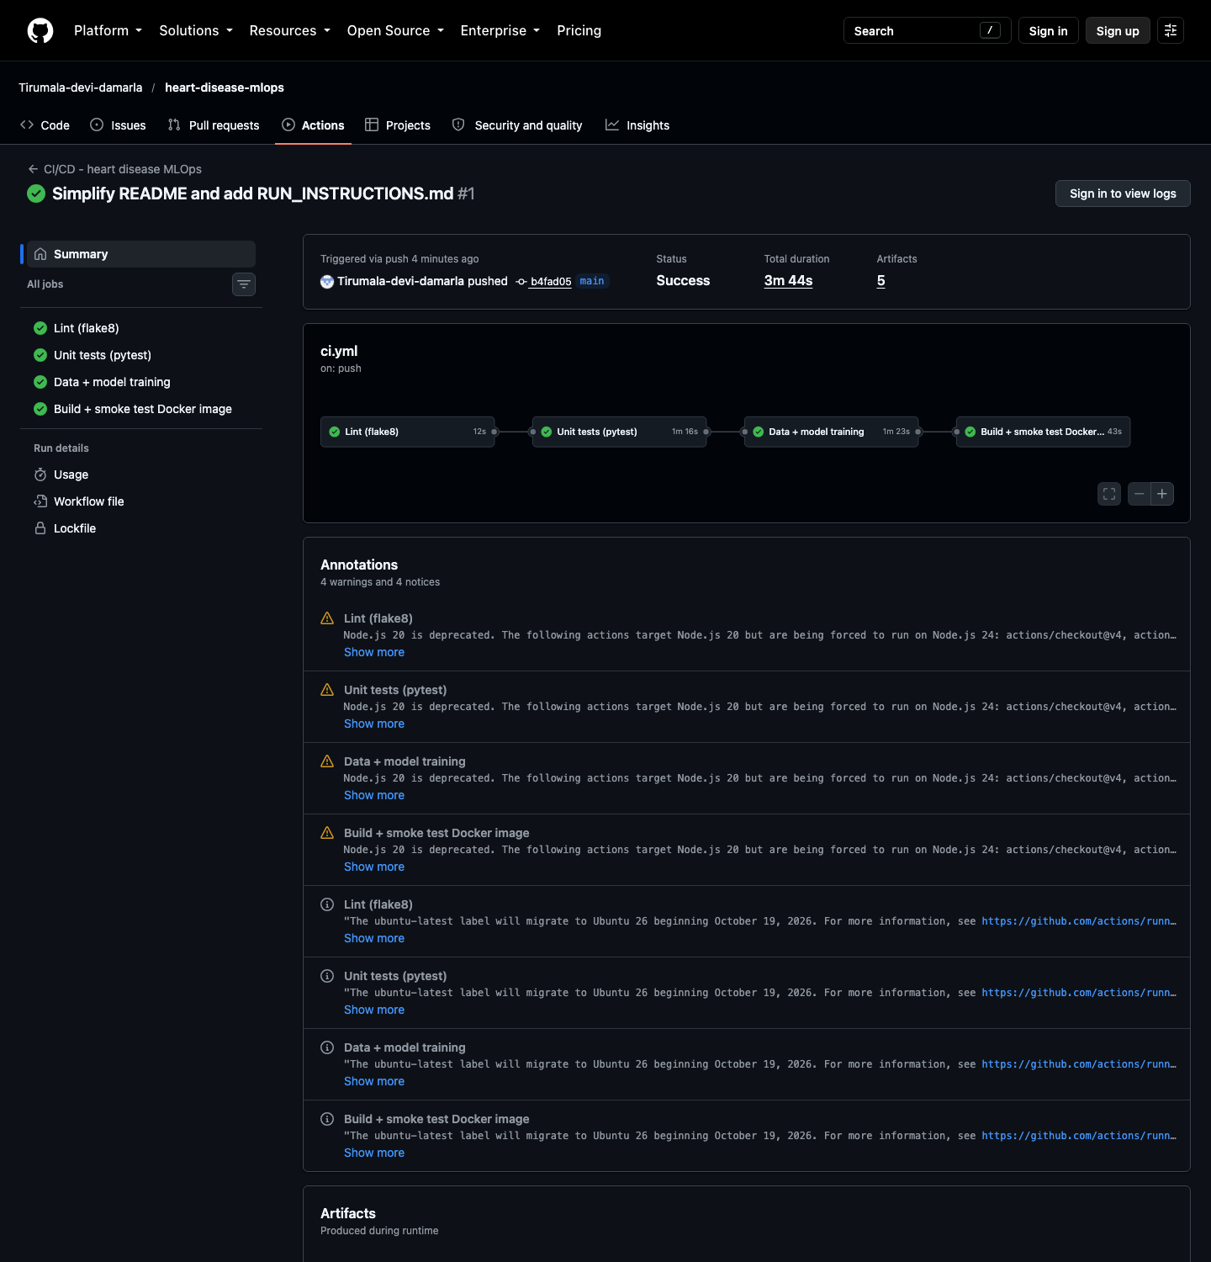
GitHub Actions run #1 - all four jobs passed
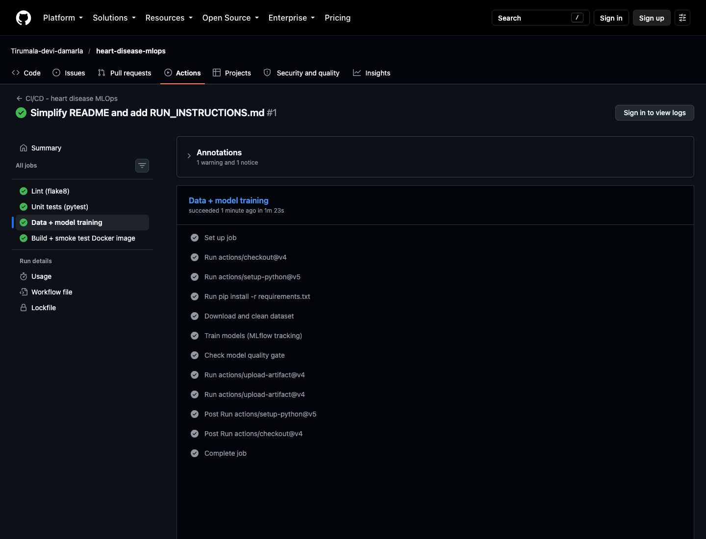
Steps of the training job
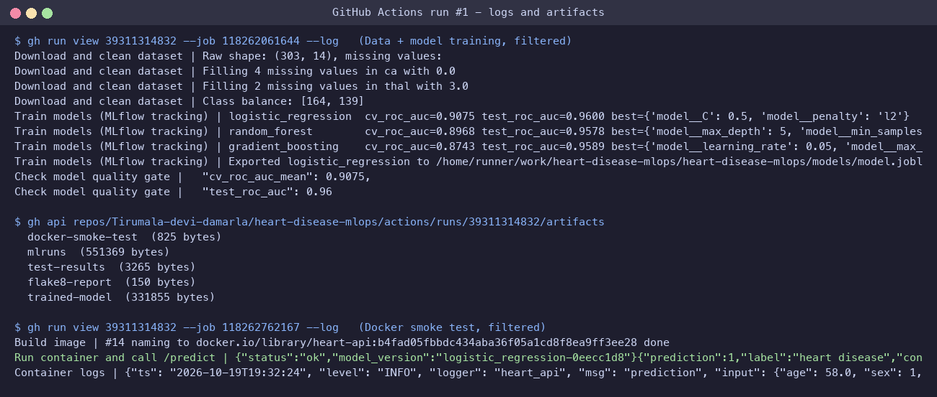
CI logs (training, quality gate, Docker smoke test) and the uploaded artifacts

9. Containerisation and deployment

9.1 Docker
The Dockerfile uses python:3.12-slim, installs only requirements-serve.txt, copies src/, api/ and the model, runs as a non-root user (UID 1000), has a HEALTHCHECK on /health and starts uvicorn on port 8000.
The FastAPI service (api/main.py) exposes:
Endpoint | Purpose
POST /predict | JSON patient record -> prediction, label, confidence, probability_disease, risk_level, model_version
POST /predict/batch | up to 100 patients
GET /health | liveness/readiness probe (503 if the model is not loaded)
GET /model-info | contents of metadata.json
GET /metrics | Prometheus metrics
GET /docs | Swagger UI
Input validation is done with Pydantic (value ranges and allowed category codes from the UCI documentation), so invalid requests get a clear HTTP 422 error. confidence is the probability of the predicted class.
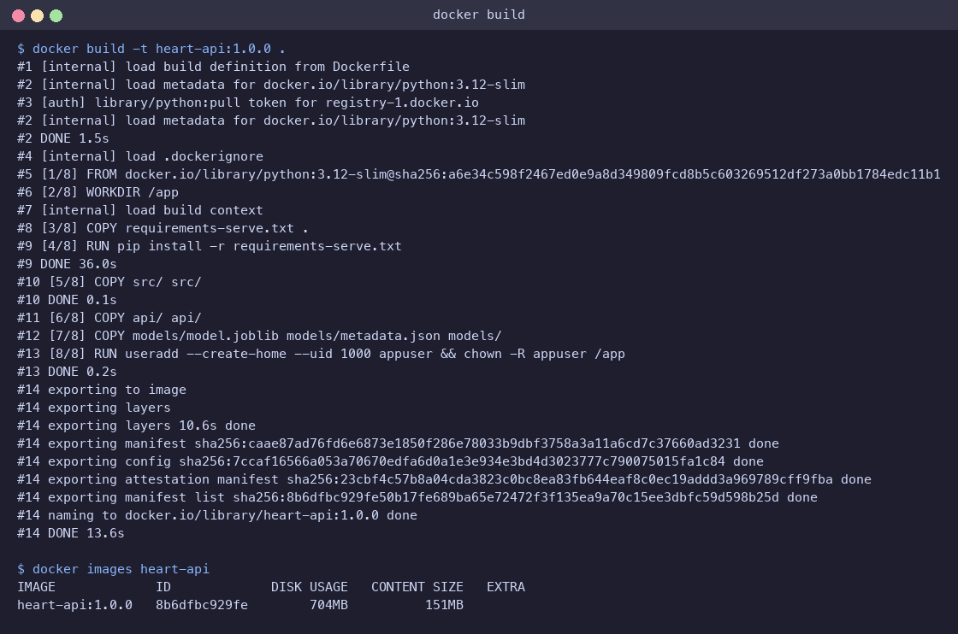
Docker image build
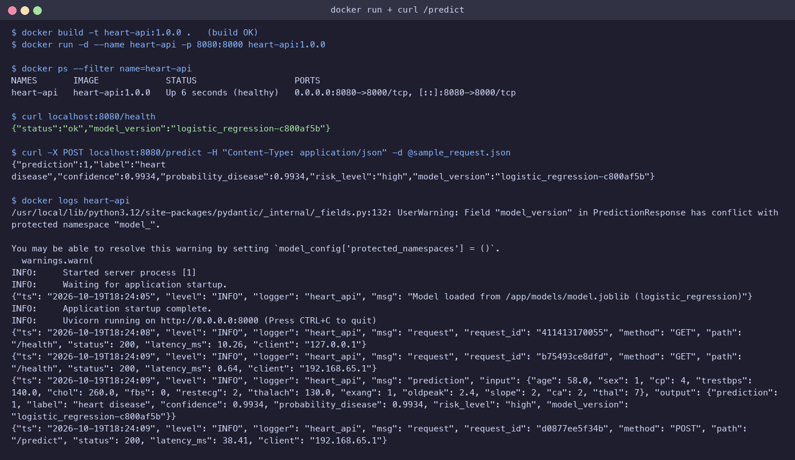
Container running locally and answering /predict
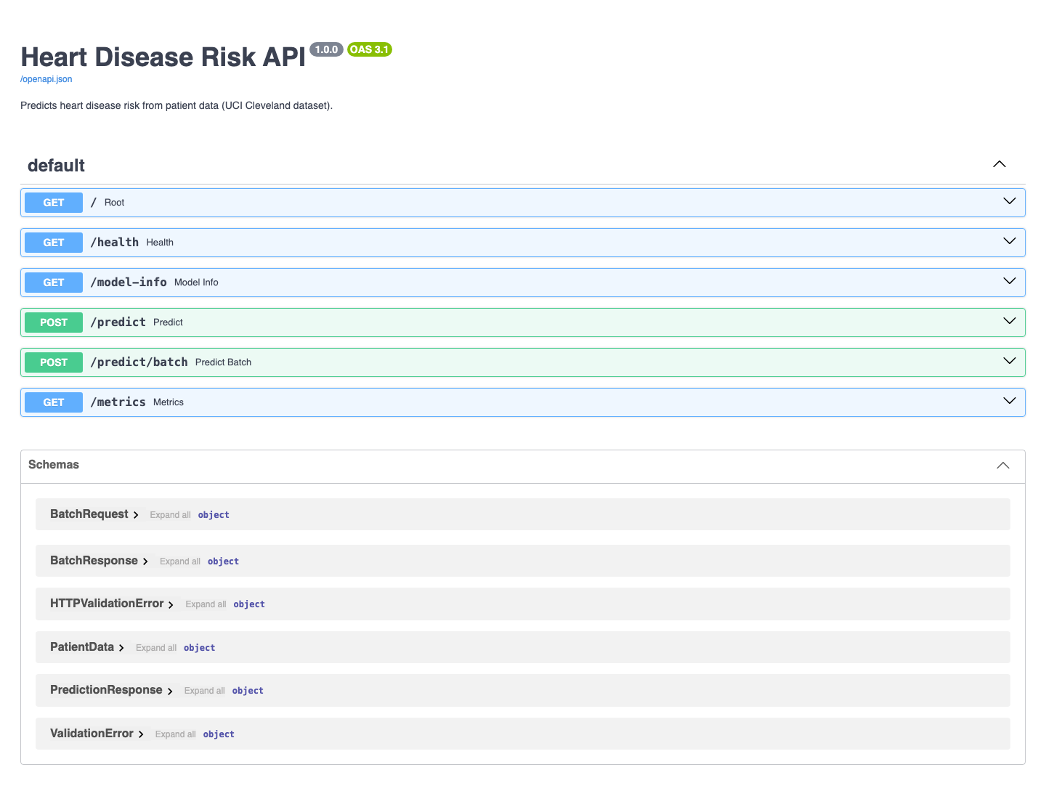
Swagger UI of the API

9.2 Kubernetes manifests (k8s/)
File | Resource
00-namespace.yaml | namespace heart-mlops
01-configmap.yaml | LOG_LEVEL, MODEL_PATH
02-deployment.yaml | 2 replicas, rolling update (maxUnavailable 0), readiness + liveness probes on /health, CPU/memory requests and limits, runAsNonRoot, Prometheus scrape annotations
03-service.yaml | LoadBalancer service on port 80
04-ingress.yaml | NGINX Ingress, host heart-api.local
05-hpa.yaml | HorizontalPodAutoscaler, 2-4 replicas at 70% CPU

9.3 Deployment on minikube and verification
The image is loaded into the cluster with minikube image load and deployed with kubectl apply -f k8s/. The endpoints were verified through both the LoadBalancer service (minikube service ... --url) and the NGINX Ingress (port-forward of the ingress controller with Host: heart-api.local):
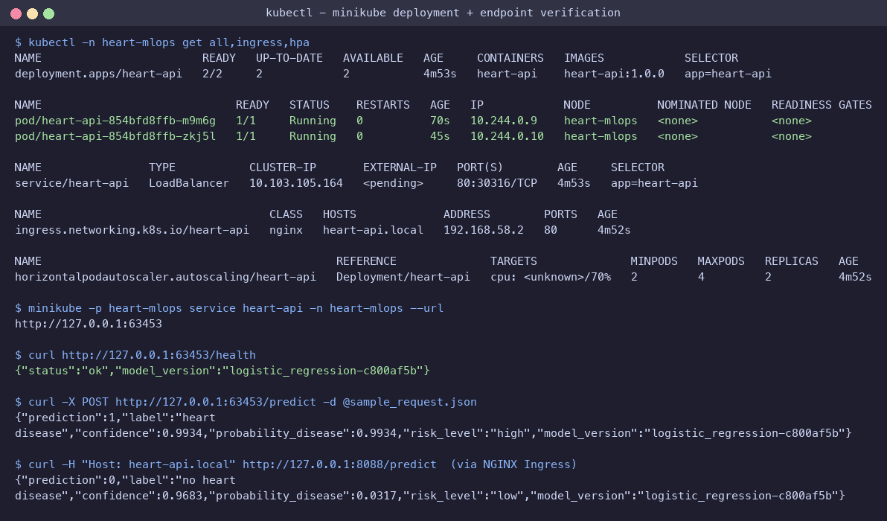
Deployment and endpoint verification
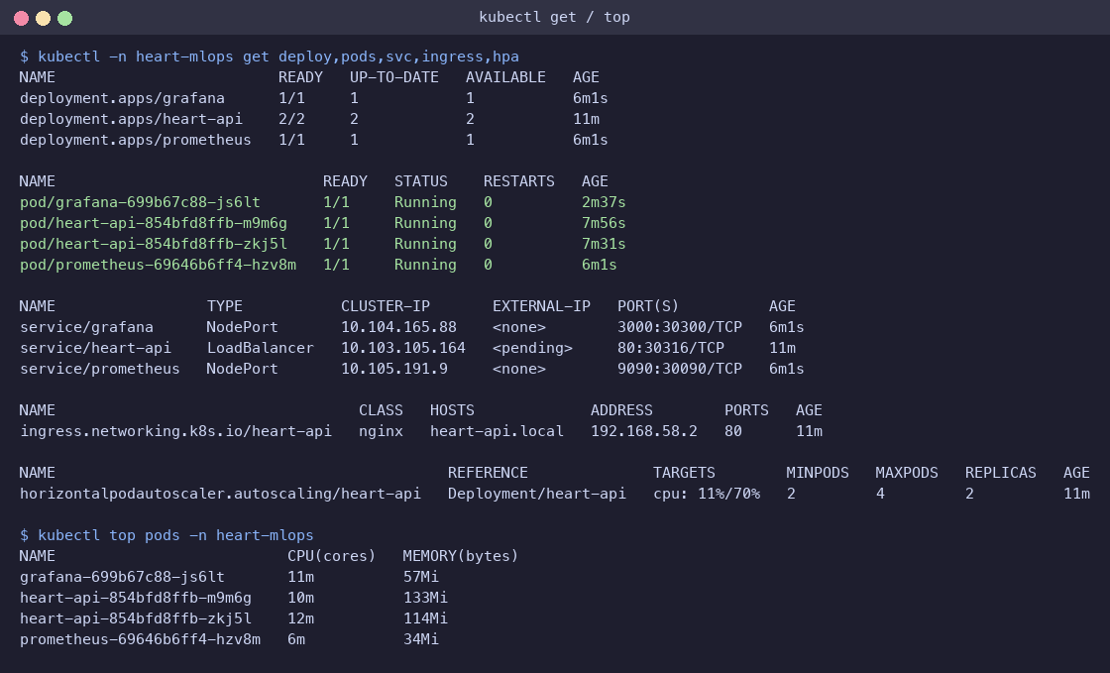
Running resources, HPA reading CPU, pod resource usage
Access instructions (local): run minikube -p heart-mlops tunnel in a separate terminal; the LoadBalancer then gets 127.0.0.1 as external IP and the API is reachable at http://127.0.0.1/predict. Without the tunnel, use minikube -p heart-mlops service heart-api -n heart-mlops --url.

10. Monitoring and logging
Logging. A FastAPI middleware writes one JSON line per request (request id, method, path, status, latency in ms, client IP) and the /predict handler logs the input and output of every prediction. A request id is returned in the x-request-id header, so a client error can be matched to the log line. Logs are written to stdout and read with kubectl logs.
Metrics. prometheus-client exposes:
- api_requests_total{method, endpoint, status} - request counter,
- api_request_latency_seconds - latency histogram per endpoint,
- model_predictions_total{label} - predictions per class,
- model_probability_disease - histogram of predicted probabilities (useful to spot drift),
- model_loaded - 1 when the model is loaded.
Prometheus runs inside the cluster and discovers the API pods automatically through the Kubernetes API (role-based access limited to the namespace) using the prometheus.io/* pod annotations, so new replicas created by the HPA are scraped without changing the config. Grafana is provisioned from code with the Prometheus datasource and a dashboard JSON (monitoring/grafana/dashboards/heart-api.json). Traffic was generated with scripts/generate_traffic.py (≈5% deliberately invalid requests to show errors).
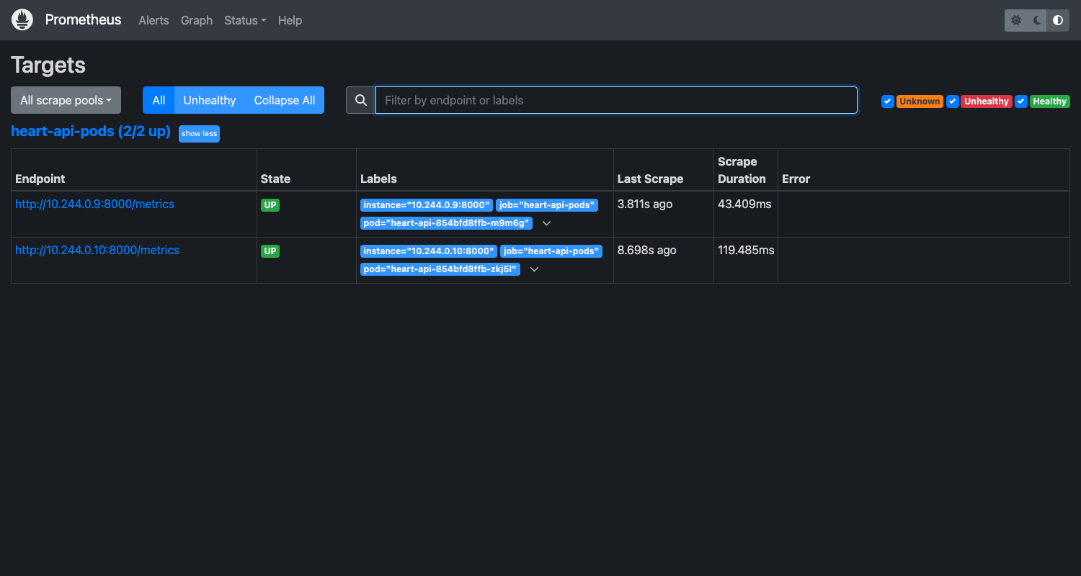
Prometheus discovered both API pods
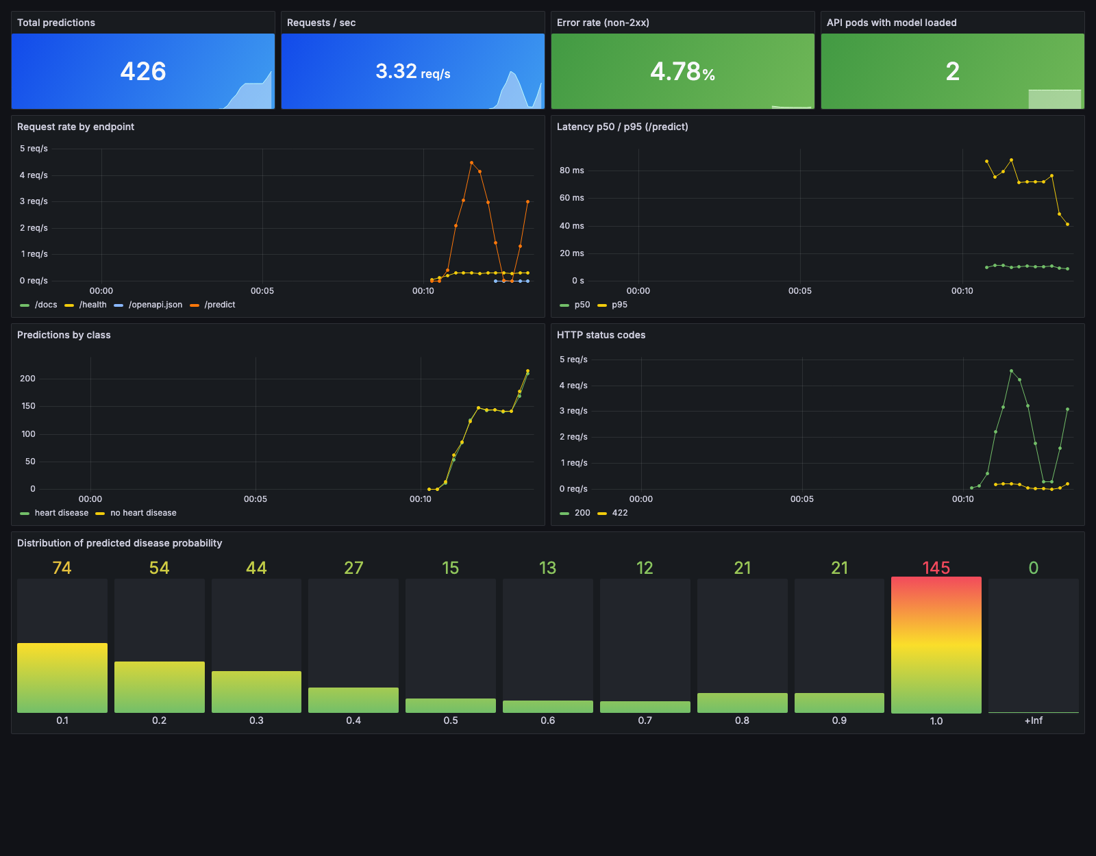
Grafana dashboard: totals, request rate, latency p50/p95, predictions by class, status codes and probability distribution

11. Architecture
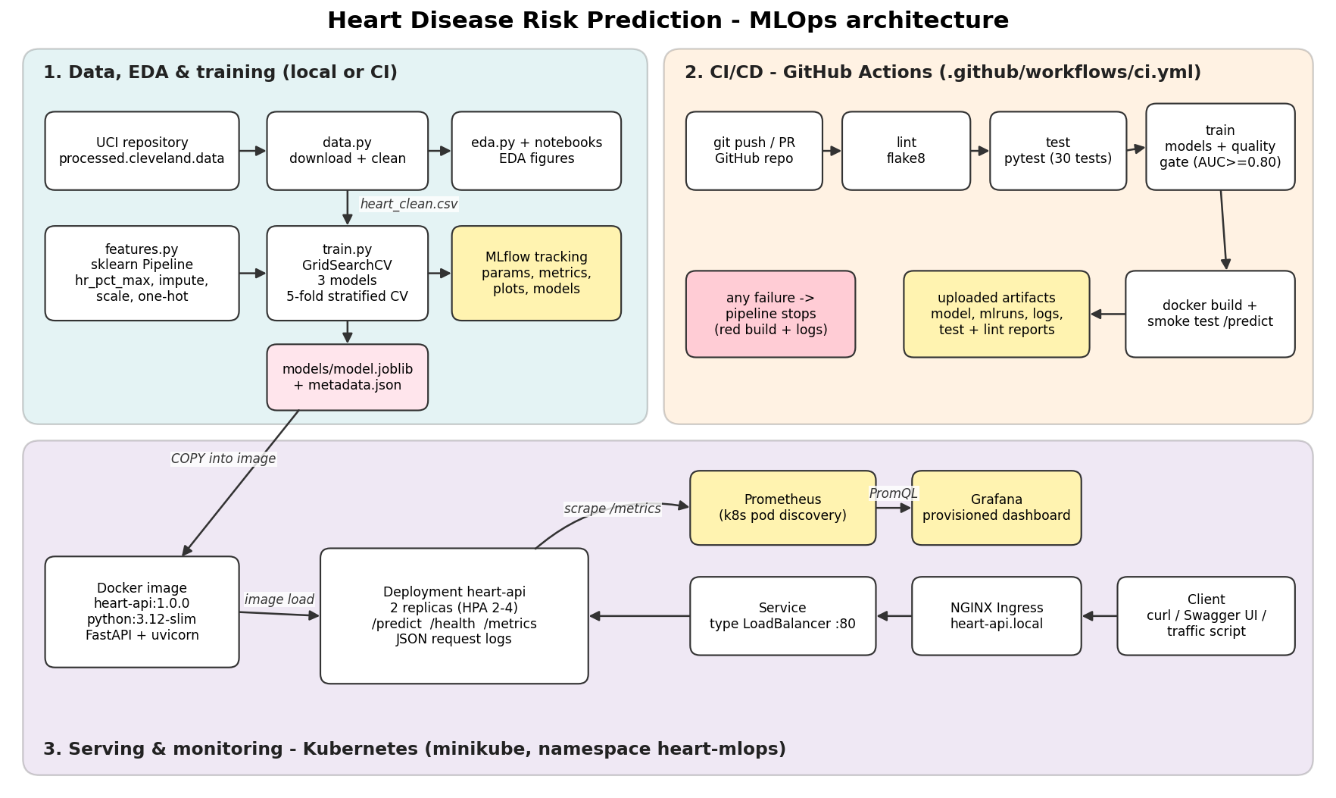
End-to-end architecture
The system has three parts: (1) data processing, EDA and training with MLflow tracking, (2) a GitHub Actions pipeline that lints, tests, retrains with a quality gate and builds/tests the Docker image, and (3) serving on Kubernetes: Ingress -> Service -> 2-4 API pods, scraped by Prometheus and visualised in Grafana.

12. Challenges and lessons learned
- SSL error when downloading the data - the python.org build of Python on macOS has no CA certificates. Fixed by using the certifi bundle in the download code instead of changing system settings.
- Pods stuck in CreateContainerConfigError - the deployment requires runAsNonRoot, but the image used a named user (appuser), which Kubernetes cannot verify. Fixed by giving the user a fixed UID (1000) in the Dockerfile and setting runAsUser: 1000.
- Existing minikube cluster would not start (API server never came up) and ports 8000/9090 were already in use - a separate minikube profile (heart-mlops) and different host ports were used instead.
- Re-running training from a notebook re-exported the model with a new run id, which no longer matched the deployed image. The training notebook now reads results from MLflow, and training only runs through the script / CI. Lesson: there should be exactly one place that produces the served model.
- HPA showed <unknown> CPU until the metrics-server addon was enabled.

13. Conclusion and future work
A complete, reproducible pipeline was built: the selected Logistic Regression model reaches 0.907 CV ROC-AUC (0.960 on the hold-out set) and is served by a validated, monitored FastAPI service on Kubernetes, with every change checked by a four-stage CI pipeline.
Possible improvements: use the MLflow Model Registry with a database backend for model stage transitions; push images to a container registry and add a CD job that deploys to a cloud cluster (GKE/EKS); add data-drift detection on the logged inputs (e.g. Evidently); calibrate the decision threshold for higher recall; and train on the other UCI sites (Hungary, Switzerland, VA) to test generalisation.

References
- Janosi, A., Steinbrunn, W., Pfisterer, M., Detrano, R. (1989). Heart Disease [Dataset]. UCI Machine Learning Repository. https://doi.org/10.24432/C52P4X
- scikit-learn documentation - https://scikit-learn.org
- MLflow documentation - https://mlflow.org/docs/latest
- FastAPI documentation - https://fastapi.tiangolo.com
- Kubernetes documentation - https://kubernetes.io/docs
- Prometheus and Grafana documentation - https://prometheus.io/docs, https://grafana.com/docs

