**A Mini Project On**

“Student Database Management System”

*Submitted by*

Batch No: 14

G.Tirumala 17121A1240

Jayaram.S.V 17121A1241

K.Bhavitha Reddy 17121A1242



Department of Information Technology

SREE VIDYANIKETHAN ENGINEERING COLLEGE

(AUTONOMOUS)

(Affliated by JNTUA, Ananthapuramu, Approved by AICTE, Accredited by NBA & NAAC)

Sree Sainath Nagar, Tirupati – 517 102, A.P., INDIA

2017 - 2021

**CONTENTS**

**S.No TOPIC PAGE No**

ABSTRACT 1

1. INTRODUCTION 2

2. MODULE 3

3. CODE 5

4. RESULT 15

5. CONCLUSION AND FUTURE WORKS 22

REFERENCES 23

**ABSTRACT**

An organized and systematic office solution is essential for all universities and organizations. There are many departments of administration for the maintenance of college information and student database in any institution. All these departments provide various records regarding students. Most of these track records need to maintain information about the students. This information could be the general details like student name, address, performance, attendance etc or specific information related to departments like collection of data.

All the modules in college administration are interdependent. They are maintained manually. So they need to be maintained and centralized as, information from one module will be needed by other modules. For example when a student needs his course completion certificate it needs to check many details about the student like his name, register number, year of study, exams he attended and many other details. So it needs to contact all the modules that the office, department and examination and results of students. With that in mind, we overhauled the existing Student Database Management System and made necessary improvement to streamline the process of recording and retrieving student’s information and managing their classes, including marking of attendance, is now a breeze.

In general, this project aims to enhance efficiency and at the same time maintain information accurateness. Later in this report, features and improvement that allow achievement to this goal will be demonstrated and highlighted.

Our work is useful for easy user interface. We are planning to utilize the powerful database management, data retrieval and data manipulation. We will provide more ease for managing the data than manually maintaining in the documents. Our work is useful for saving valuable time and reduces the huge paper work.

**INTRODUCTION**

Right from the olden day’s people used to store important information in the written form. But many of the records are gone because of the paper quality and some of records cannot be understood by everyone because of the change in handwriting. So nowadays people started using applications like niva etc to store important information like student’s records. This project can be used by the users in similar way. All a user need is a basic computer and some basic knowledge on computer. The duty/role of the administrator is to create records of a student and update the details in the record i.e. exam marks, deletion of a student record if student left the institution etc.

Student can only view students record and verify whether all the details are correct or not and can view the marks obtained and the average of the marks

**MODULES**

**2.1 ADMIN MODULE:**

In this module the admin able to create the student record, modify the record, search the record and delete the record.

* Insert Record
* Search Record
* Delete Record
* Modify Record
* Display Record

**2.1.1 INSERT RECORD**

A Record can be created by opening a file using the touch or cat command in which all the records can be stored. By using this first a file is created so that records can be added. The users can add details of a student like name of the student, student roll number, exam marks.

**2.1.2 SEARCH RECORD**

In this record the user may search the record of any student by entering the roll number of that particular student. The grep command is used so that the searched roll number can be found. Then records of that student alone can be displayed.

**2.1.3 DELETE RECORD**

The user may be deleting any student’s data from the record list. For deleting a record first the roll number is read from the user. The grep command is used to match with that roll number. By using mv command the details of that student are moved to a temporary file. So the record is deleted.

.

**2.1.4 MODIFY RECORD**

The user may modify the records of any student (if it exists); in this module the grep command is used to search a roll number. Then by using cut command the records of that student are moved to a temporary file.

The necessary changes can be done on the record (modifications). Then again the data on this temporary file is copied and is updated to the main file containing records of all students.

**2.1.5 DISPLAY RECORD**

In this module sort command with -g option is used to display the records of students with name of the student, student’s roll number, marks obtained in respective subjects and the average marks are displayed. By using the option the administrator can view and analyze the performance of students and can take necessary steps to help students.

**2.2 STUDENT MODULE**

* Search Record
* View Record

**2.2.1 SEARCH RECORD**

In this module the user may search the record of any student by entering the roll number of that particular student. The grep command is used so that searched roll number can be found. The records of that student alone can be displayed.

**2.2.2 VIEW RECORD**

In this module sort command with -g option is used to display records of students with name, roll number, marks and the average marks are displayed. By using this option students can view and analyze their performance and can take necessary steps to improve themselves.

**SOURCE CODE**

echo " Mini Project "

echo " on "

echo " Student Database Management System”

create ()

{

echo "Enter the filename which you want to create"

read db

touch $db

echo "File created"

}

insert()

{

if [ -z $db ];then

echo "Database doesnt exist. Create a new database."

else

echo "Enter the number of records to be added."

read no

while [ $no -gt 0 ]

do

echo "Enter roll no: "

read rno

srno=`grep "^$rno" "$db"`

if [ -z $srno ]

then

echo "Enter Name: "

read name

echo enter $name marks in three subjects

echo "Linux Programming: "

read sub1

echo "Operating System: "

read sub2

echo "Data structures: "

read sub3

avg=$((($sub1+$sub2+$sub3)/3))

echo "Average : $avg"

record=$rno":"$name":"$sub1":"$sub2":"$sub3":"$avg

echo $record >> "$db"

no=$(($no-1))

else

echo "Record already exists."

fi

done

fi

}

search()

{

echo " Enter roll no: "

read rno

record=`grep "^$rno" "$db"`

if [ $? -ne 0 ]; then

echo "Record doesnt exist. "

else

echo "Record found"

echo $record

fi

}

modify()

{

echo " Enter roll no to modify: "

read rno

grep "^$rno" $db > temp1.txt

grep -v "^$rno" $db > temp2.txt

mv temp2.txt $db

if [ $? -ne 0 ]; then

echo "Record doesnt exist. "

else

name=`cut -d ";" -f2 "temp1.txt"`

sub1=`cut -d ";" -f3 "temp1.txt"`

sub2=`cut -d ";" -f4 "temp1.txt"`

sub3=`cut -d ";" -f5 "temp1.txt"`

echo "Enter the value you want to modify"

MENU=" Values

1)Name

2)Linux programming

3)Operating System

4)Data Structures

5) Exit

"

while [ true ]

do

echo "$MENU"

echo "Enter your choice"

read n1

case $n1 in

1)echo "Enter the new name"

read name

;;

2)echo "Enter the new marks for Linux Programming:"

read sub1

;;

3)echo "Enter the new marks for Operating System:"

read sub2

;;

4)echo "Enter the new marks for Data Structures:"

read sub3

;;

*)

echo "Student record modified"

break

;;

esac

done

avg=$((($sub1+$sub2+$sub3)/3))

record=$rno":"$name":"$sub1":"$sub2":"$sub3":"$avg

echo $record >> "$db"

fi

}

delete()

{

echo " Enter roll no: "

read rno

record=`grep "^$rno" "$db"`

if [ $? -ne 0 ]; then

echo "Record doesnt exist. "

else

echo "Record found"

echo $record

record=`grep -v "^$rno" "$db" > tmp.txt`

mv tmp.txt $db

echo "Record deleted."

fi

}

display()

{

echo " Complete database..."

sort -g $db

}

admin()

{

MENU1="***********Admin Menu***********\n

1)Create\n

2)Insert\n

3)Search\n

4)Modify\n

5)Delete\n

6)Display\n

7)Exit\n

"

while true

do

echo $MENU1

echo "Enter your choice: "

read n

case $n in

1) create

;;

2)insert

;;

3) search

;;

4) modify

;;

5) delete

;;

6) display

;;

7) exit

;;

esac

done

}

student()

{

create

while true

do

echo "*******Student MENU*******"

echo "1.search record\n2.view all records\n3.Exit"

read n

case $n in

1)search

;;

2)display

;;

3)exit

;;

*)echo "Invalid choice"

;;

esac

done

}

menu1="*******MAIN MENU******\n

1.Admin\n

2.student\n

3.Exit

"

while true

do

echo $menu1

echo Enter your choice:

read n

case $n in

1)admin

;;

2)student

;;

3)exit

;;

esac

done

**RESULT**

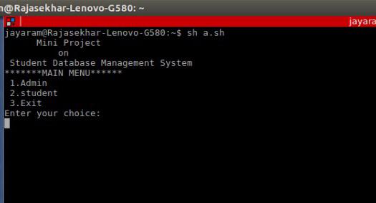

4.1 Entering the option either admin or student

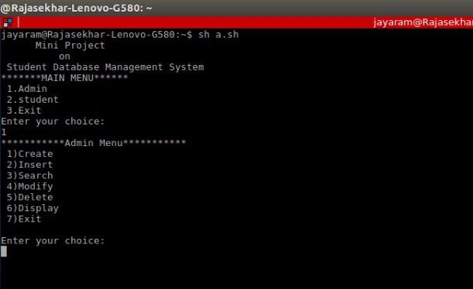

4.2 Entering the option in admin menu

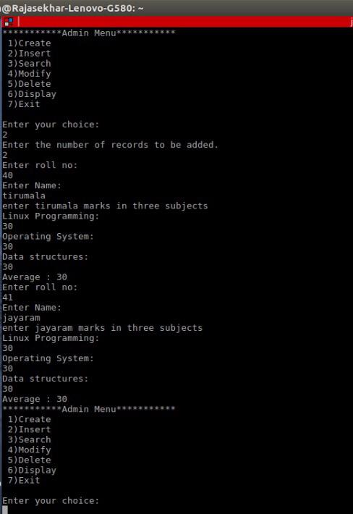

4.3 Inserting two student’s records

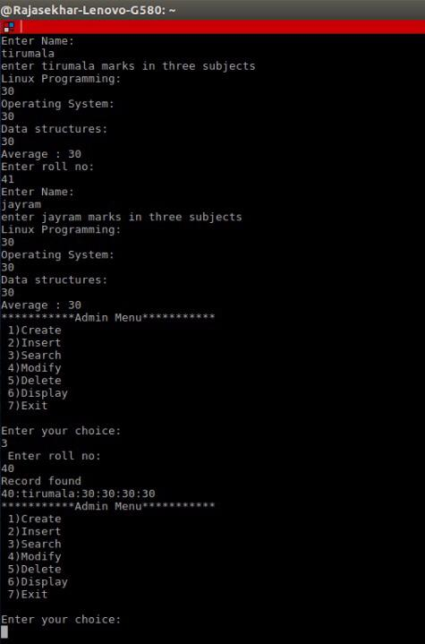

4.4 Searching a record by student’s roll number

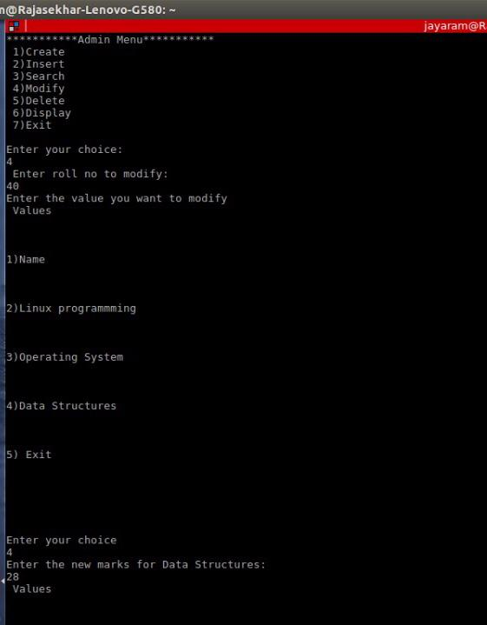

4.5 Modifying subject marks in a student’s record

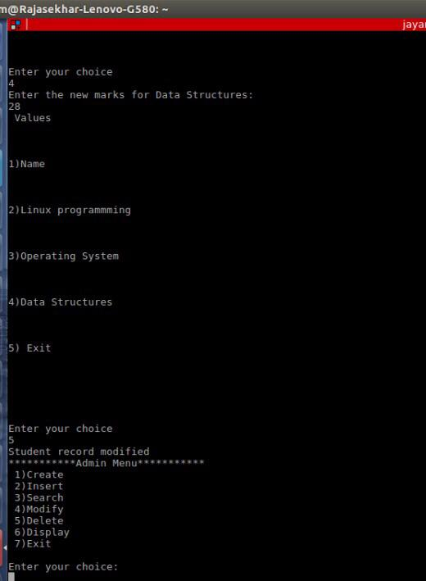

4.6 Student’s record is modified

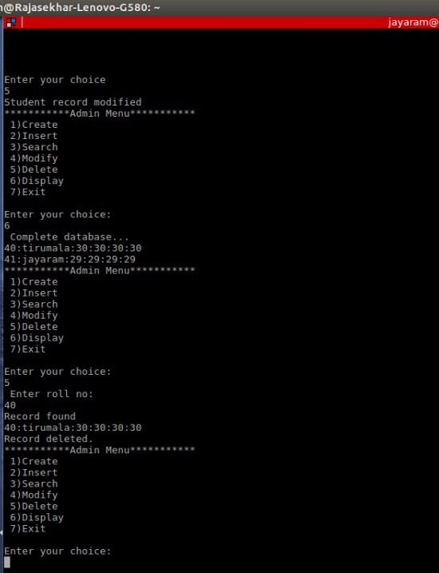

4.7 Displaying complete database & Deleting a record by entering student’s roll number

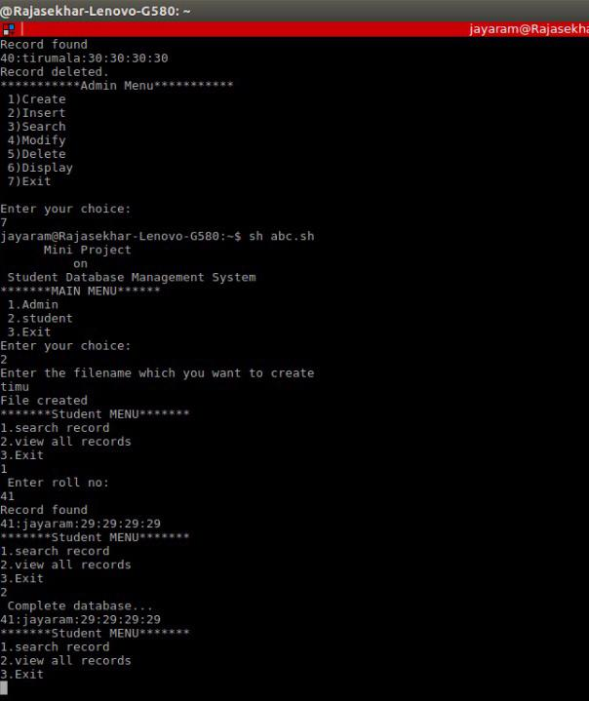

4.8 Exiting from Admin menu, selecting Student menu, performing search & view options in student menu

**CONCLUSION AND FUTURE WORK**

Simplicity is never simple. As we have seen in this project, the process of creating a user friendly and straight forward platform that facilitates the administrator’s job is one filled with complexity. From understanding user requirements to system design and finally system prototype and finalization, every stem requires the understand and commitment towards achieving the objectives of the project.

Although the student database management module is not fully integrated to the system used on real time, the system prototype demonstrate easy navigation and data are stored in a systematic way.

Overall, efficiency has improved and work process simplified. Although all the objectives have been met, the system still has room for improvement. The system is robust and flexible enough for future upgrade using advanced technology and devices.

**REFERENCES**

REFERENCE BOOK:

* Neil Matthew and Richard Stones, **“Beginning Linux Programming,”** Wiley Dreamtech, Fourth Edition, 2008.
* Richard Petersen**, “Linux: The Complete Reference,”** Tata McGraw-Hill, Sixth Edition, 2007.
* Sumitabha Das, **“Your UNIX: The Ultimate Guide,”** Tata McGraw-Hill, 2007.
* Neil Matthew and Richard Stones, Beginning Linux Programming, Wiley Dreamtech, Fourth Edition, 2008.

SOFTWARE DOWNLOAD WEBSITE :

* <https://www.ubuntu.com/download> Drafted on 02/10/2018 at 10.00 AM