AUTOMATIC ANSWER EVALUATION USING MACHINE LEARNING

TABLE OF CONTENTS
CHAPTER | TITLE | PAGE NO
 | ABSTRACT
 | INTRODUCTION
 | - General Introduction
 | - Project Objectives
 | SYSTEMPROPOSAL
 | - Existing System
 | - Disadvantages
 | - Proposed System
 | 2.2.1 Advantages
 | - Literature Survey
 | SYSTEM DIAGRAMS
 | - Architecture Diagram
 | - Flow Diagram
 | - UML Diagrams
 | IMPLEMENTATION
 | - Modules
 | - Modules Description
 | SYSTEMREQUIREMENTS
 | - Hardware Requirements
 | - Software Requirements
 | - Software Description
 | - Testing of Products
 | CONCLUSION
7. | FUTUREENHANCEMENT
8. | SAMPLECODING
9. | SAMPLESCREENSHOT
10. | REFERENCES

ABSTRACT

Nowadays, as we are moving towards automation there is a need for an automatic descriptive answer evaluation system. Manual evaluation is a time and energy-consuming task. Presently, we have automated systems for objective type, single sentence answers and descriptive answers with less accuracy level. Automatic evaluation of answer scripts has been found very useful from our experiments, and often the assigned marks is the same as manually scored marks. In this paper, our goal is to develop an automated answer evaluation system using machine learning. The system will evaluate the answer based upon the number of words and number of letters from extracted text from the pre-processed data. After that, we have to implement the Natural Language Processing (NLP) for cleaning the extracted text. The text summarization is a process of creating a short, accurate summary of the longer text. Then, we have to implement the deep learning algorithm such as Artificial Neural Network (ANN). The experimental results will be shown like accuracy and marks based on number of words and number of letters from 0 to 10.

CHAPTER 1
INTRODUCTION

  - General Introduction:

Optical character Recognition, conversion of images of text into a character. We can segment the each characters in one wordUsing classification algorithm, to recognize the text .The process of Recognition a text using classification algorithm. Result is compared with the text that should appear in that specific part of the image.Optical character recognition or optical character reader (OCR) is the electronic or mechanical conversion of images of typed, handwritten or printed text into machine-encoded text, whether from a scanned document, a photo of a document, a scene-photo (for example the text on signs and billboards in a landscape photo) or from subtitle text superimposed on an image (for example: from a television broadcast). Widely used as a form of data entry from printed paper data records – whether passport documents, invoices, bank statements, computerized receipts, business cards, mail, printouts of static-data, or any suitable documentation – it is a common method of digitizing printed texts so that they can be electronically edited, searched, stored more compactly, displayed on-line, and used in machine processes such as cognitive computing, machine translation, (extracted) text-to-speech, key data and text mining. OCR is a field of research in pattern recognition, artificial intelligence and vision. Early versions needed to be trained with images of each character, and worked on one font at a time. Advanced systems capable of producing a high degree of recognition accuracy for most fonts are now common, and with support for a variety of digital image file format inputs.^{[2]} Some systems are capable of reproducing formatted output that closely approximates the original page including images, columns, and other non-textual components.Optical character recognition (OCR) technology is a business solution for automating data extraction from printed or written text from a scanned document or image file and then converting the text into a machine-readable form to be used for data processing like editing or searching. Optical character Recognition (OCR) is a conversion of scanned or printed text images, handwritten text into editable text for further processing. This technology allows machine to recognize the text automatically. It is like combination of eye and mind of human body. An eye can view the text from the images but actually the brain processes as well as interprets that extracted text read by eye. In development of computerized OCR system, few problems can occur. First: there is very little visible difference between some letters and digits for computers to understand. For example it might be difficult for the computer to differentiate between digit “0” and letter “o”. Second: It might be very difficult to extract text, which is embedded in very dark background or printed on other words or graphics. In 1955, the first commercial system was installed at the reader’s digest, which used OCR to input sales report into a computer and then after OCR method has become very helpful in computerizing the physical office documents. Today many types of OCR software available in the markets like: Desktop OCR, Server OCR, Web OCR etc. Accuracy rate of any OCR tool varies from 71% to 98%. Many OCR tools are available as of now but only few of them are open source and free. Tesseract is the one of the open source and free OCR software. It is written in the C++, so it is platform independent. It can be used in other applications in the form of Dynamic Link Library (DLL). So it can be easily added as the reference in the form of DLL in other application to use the functionality provided by Tesseract. The following section contains history and functionality of Tesseract. Normally educational or non-educational organizations evaluate a student's performance on the basis of examination either in the form of the subjective or objective pattern. Nowadays during this pandemic, everyone is working in a virtual manner. In the present scenario, manual evaluation of subjective answers is a hectic task. Now, we have many systems which can evaluate objective type or MCQ questions. These techniques are evaluated in machines itself after providing a data-set of answers. But it helps only in competitive or objective type exam evaluation. The descriptive examination is the backbone of all the universities. On the basis of the descriptive answer, the moderator will know how much knowledge the student has gained. Manual evaluation of subjective answers is a very tedious, time-consuming task and requires lots of manpower. It also requires a high level of concentration. Answer evaluation varies from person to person according to their way of evaluation and interrelation between student and moderator. This affects the result of the student.
  - Objectives:
The main objective of our project is,
- To recognize or to extract the text from the input image.
- To implement the deep learning algorithms and NLP techniques.
- To enhance the overall performance for classification algorithms.
- To recognize the text effectively by using the pytesseract.
- To evaluate the extracted text based on number of words and number of letters.

CHAPTER 2
SYSTEM PROPOSAL

2.1 EXISTING SYSTEM:
In existing system, nowadays, as we are moving towards automation there is a need for an automatic descriptive answer evaluation system. Manual evaluation is a time and energy-consuming task. Presently, we have automated systems for objective type, single sentence answers and descriptive answers with less accuracy level. In this paper, our goal is to develop an automated answer evaluation system using machine learning. The system will evaluate the answer based upon the matched keywords and the minimum length of the answer provided by the moderator. The scanned handwritten answer sheet will be given as input to the proposed system. The system will use an artificial neural network with back-propagation algorithm.
2.1.1 DISADVANTAGES:
- The results is low when compared with proposed.
- The prediction of text is poor
- It doesn’t implement the pytesseract.

  - PROPOSED SYSTEM:

In proposed system, the imagedataset was taken as input. Then, we have to implement the pre-processingstep. In this step, we have to resize the original image and convert the image into gray scale.After that, we have to extract the text from the pre-processed image by using mean standard deviation. After that, we have to extract the text from input image by using the pytesseract and the extracted text will be stored in text format. Then, we have to implement the Natural Language Processing for cleaning the extracted text. Then, we can calculate the number of words and number of letters from extracted text. After that, we have to implement the deep learning algorithm such as Artificial Neural Network (ANN). The experimental results shows that some performance metrics such as accuracy and evaluate marks based on number of words and number of letters.
2.2.1 ADVANTAGES:
- It displays the text format
- It will recognize easy
- The accuracy is high.
- To evaluate the answers.

2.3LITERATURE SURVEY:

2.3.1Answer Evaluation Using Machine Learning, 2019
Author: Prince Sinha, SharadBharadia, AyushKaul, Dr.SheetalRathi
Methodology:
In this modern age, where the world moves towards automation so, there is a need for automation in answer evaluation system. Currently, the online answer evaluation is available for mcq based question, hence evaluation of the theory answer is hectic for the checker. Teacher manually checks the answer and allot the marks. The current system takes more manpower and time to evaluate the answer. In this journal an application based on the evaluation of answers using machine learning. The objective of the journal is to specially reduce the manpower and time consumption. Since in manual answer evaluation, the manpower and the time consumption is much more. Also, in the manual system, it may be possible that the marks given to two same answers are different. This application system provides an automatic evaluation of answer based on the keyword provided to the application in form of the input by the moderator which will provide equal distribution of marks and will reduce time and manpower.
Advantage:
- As, online system has much more advantages over the offline examination. Online exams saves time to evaluate the answers.
- As, there were no provision for offline paper evaluation, he designed an algorithm that automatically evaluate the single sentence descriptive answer.
Disadvantage:
- Less Effective

2.3.2Optical Character Recognition (OCR)System for Roman Script & EnglishLanguage using Artificial Neural Network(ANN) Classifier, 2016

Author: Honey Mehta, Sanjay Singla, Aarti Mahajan

Methodology:
Character recognition from scanned images is a very complex task. But as for record keeping we require all the data in digital format to perform various manipulation operations. The main issue in case of character recognition is the different styles and fonts in which the text is written. We proposed a new approach by using the concept of Artificial Neural Network and Nearest Neighbour approach for character recognition from scanned images. Three layers are used for classification purpose. First is the input layer consist the input given by the segmented characters, then hidden layer consist the neurons trained by the training network and the output layer consist output neurons to generate unicode. Character recognition is a process of identification of printed, typewritten or handwritten characters. The characters are optically scanned and converted into machine editable form. It is an important field of image processing and artificial Intelligence. It is widely used as a form of data entry from books, research articles, bank forms, office papers or any other form of printed records.
Advantage:
- High performance and accuracy.
Disadvantage:
- It is having some scalability problem.

2.3.3High accuracy Optical Character Recognitionalgorithms using learning array of ANN, 2014

Author: Mrs.B.Vani,Ms. M. ShyniBeaulah, Mrs. R. Deepalakshmi

Methodology:
Optical Character recognition refers to the process of translating the handwritten or printed text into a format that is understood by the machines for the purpose of editing, searching and indexing. The Performance of the current OCR illustrates and explains the actual errors and imaging defects in recognition with illustrated examples. This paper aims to create an application interface for OCR using artificial neural network as a back end to achieve high accurate rate in recognition. The proposed algorithm using neural network concept provides a high accuracy rate in recognition of characters. The proposed approach is implemented and tested on isolated character database consisting of English characters, digits and keyboard special characters. The recognition of characters from scanned images of documents has been a problem that has received much attention in the field of image processing, pattern recognition and artificial intelligence. Classical methods in pattern recognition do not suffice for the recognition due to the size, shape and style.
Advantage:
- Despite the computational Complexity involved, artificial neural networks offer several advantages in pattern recognition with high accuracy in recognition rate with the sense of emulating adaptive human intelligence to a small extent.
Disadvantage:
- It is less in efficiency and not give perfect result.

2.3.4 Optical Character Recognition using Artificial Neural Networks, 2020

Author: Anirudh Sanjay Patil1, Jashneet Singh Monga2

Methodology:
With no doubt keyboarding the most time consuming and labour-intensive operation is the most familiar method of data input into the computer. Optical Character Recognition is that the machine carbon of human reading and has been the subject of intensive research for three decades. OCR can be described as Mechanical or Electronic conversion of scanned images where images are often handwritten, typewritten or printed text. It is a way of digitizing printed texts in order that they will be electronically searched and utilized in machine processes. It converts the images into machine-encoded text that can be utilized in machine translation, text-to-speech and text mining. This paper presents a simple, efficient, and low-cost approach to construct OCR for reading any document that has fix font size and style or handwritten style. To achieve effectiveness and less computational cost, OCR in this paper uses database to recognize English characters which makes this OCR very simple to manage.
Advantage:
- A close match between analytical results and the available results shows the correctness of derived model.
- High Efficiency.
Disadvantage:
- Low in accuracy performance.

2.3.5Neural Network based Handwritten CharacterRecognition system without feature extraction, 2011
Author:J. Pradeep, E. Srinivasan S. Himavathi
Methodology:
Handwriting recognition has been one of the active and challenging research areas in the field of image processing and pattern recognition. It has numerous applications which include, reading aid for blind, bank cheques and conversion of any hand written document into structural text form. In this paper an attempt is made to recognize handwritten characters for English alphabets without feature extraction using multilayer Feed Forward neural network. Each character data set contains 26 alphabets. Fifty different character data sets are used for training the neural network. The trained network is used for classification and recognition. In the proposed system, each character is resized into 30x20 pixels, which is directly subjected to training. That is, each resized character has 600 pixels and these pixels are taken as features for training the neural network. The results show that the proposed system yields good recognition rates which are comparable to that of feature extraction based schemes for handwritten character recognition.
Advantage:
- Good in Performance
Disadvantage:
- Not Reliable
- The problem is framed by defining it, outlining identifying strategies and resources.

CHAPTER 3
SYSTEM DIAGRAMS

3.1 SYSTEM ARCHITECTURE:

Dataset
Input image
Preprocessing
Image Resize
Gray scale conversion
Feature Extraction
Text Recognition
Length of words
Length of letters
Calculate length
Classification
Accuracy
ANN
Mean Standard Deviation
Pytesseract
Answer Evaluation

LR

FIGURE 3.1: SYSTEM ARCHITECTURE

3.2 FLOW DIAGRAM
Start
Input image
Preprocessing
Feature Extraction
Text Recognition
Calculate length
Classification
Mark Evaluation

FIGURE 3.2: FLOW DIAGRAM

3.3 UML DIAGRAMS:
3.3.1 USE CASE DIAGRAM:

Input Image
Preprocessing
Feature Extraction
Text recognition
System
User
Evaluate answer
Calculate length
Classification

FIGURE 3.3.1: USE CASE DIAGRAM

3.3.2ACTIVITY DIAGRAM:
Input image
Preprocessing
Feature extraction
Text recognition

Calculate length
Classification
Classification

FIGURE 3.3.2: ACTIVITY DIAGRAM
3.3.3SEQUENCE DIAGRAM:
Input Image
Text recognition
Classification
Evaluate answer
Select image
Pytesseract
ANN
Image resize
Calculate length
Evaluate marks

FIGURE 3.3.3: SEQUENCE DIAGRAM

3.3.4ER DIAGRAM:
Image selection
Feature extraction
Read image
Image resize
Gray scale
Mean std deviation vaues
Text extraction
Data splitting
Classification
Test
Train
Evaluate answer
Pytessaract
ANN

FIGURE 3.3.4: ER DIAGRAM

3.3.5CLASS DIAGRAM:
Select image ()
Image resize ()
Gray scale ()
Input
Pytesseract ()

Text recognition

ANN ()

Evaluate marks ( )

Classification
Feature extraction
Mean ()
Standard ()
Normalize ()
Find number of words
Find number of letters

Calculate length

Recognize text ()

FIGURE 3.3.5: CLASS DIAGRAM

CHAPTER 4
IMPLEMENTATION

4.1 MODULES:
- Input
- Preprocessing
- Feature extraction
- Text recognition
- NLP techniques
- Data splitting
- Classification
- Evaluate answer
- Performance metrics
4.2 MODULES DESCRIPTION:
4.2.1:INPUT:
- The dataset contains the images in the form of ‘.jpg’ or ‘.png’
- In this step, we have to read or load the input image by using the imread () function.
- The input image is used to detect or recognize the text.
- In our process, we are used the tkinter file dialogue box for selecting the input image.
4.2.2: PREPROCESSING:
- In our process, we have to resize the image and convert the image into gray scale.
- To resize an image, you call the resize () method on it, passing in a two-integer tuple argument representing the width and height of the resized image.
- The function doesn't modify the used image; it instead returns another Image with the new dimensions.
- Convert an Image to Grayscale in Python Using the Conversion Formula and the matplotlib Library.
- We can also convert an image to grayscale using the standard RGB to grayscale conversion formula that is imgGray = 0.2989 * R + 0.5870 * G + 0.1140 * B.

    - FEATURE EXTRACTION:
- Variance and Standard Deviation are essentially a measure of the spread of the data in the data set. Variance is the average of the squared differences from the mean.
- mean () function can be used to calculate mean/average of a given list of numbers. It returns mean of the data set passed as parameters. Arithmetic mean is the sum of data divided by the number of data-points.

    - TEXT RECOGNITION:
- In our process, we have to recognize the text by using the pytesseract.
- Python-tesseract is an optical character recognition (OCR) tool for python. That is, it will recognize and “read” the text embedded in images.
- Python-tesseract is a wrapper for Google's Tesseract-OCR Engine.

4.2.5: NLP TECHNIQUES:
- NLP is a field in machine learning with the ability of a computer to understand, analyse, manipulate, and potentially generate human language.
- Cleaning (or pre-processing) the data typically consists of a number of steps:
- Remove punctuation: Punctuation can provide grammatical context to a sentence which supports our understanding.
- Tokenization: Tokenizing separates text into units such as sentences or words. It gives structure to previously unstructured text. eg: Plata o Plomo-> ‘Plata’,’o’,’Plomo’.
- Stemming: Stemming helps reduce a word to its stem form.
- Padding: In any raw text data, naturally there will be sentences of different lengths. However, all neural networks require to have inputs with the same size. For this purpose, padding is done.
4.2.6: DATA SPLITTING:
- During the machine learning process, data are needed so that learning can take place.
- In addition to the data required for training, test data are needed to evaluate the performance of the algorithm in order to see how well it works.
- In our process, we considered 70% of the input dataset to be the training data and the remaining 30% to be the testing data.
- Data splitting is the act of partitioning available data into two portions, usually for cross-validator purposes.
- One Portion of the data is used to develop a predictive model and the other to evaluate the model's performance.
- Separating data into training and testing sets is an important part of evaluating data mining models.
- Typically, when you separate a data set into a training set and testing set, most of the data is used for training, and a smaller portion of the data is used for testing.

4.2.7: CLASSIFICATION:
- In our process, we have to implement the deep learning algorithm such as Artificial Neural Network (ANN).
- Artificial Neural Networks (ANN) are part of supervised machine learning where we will be having input as well as corresponding output present in our dataset.
- Our whole aim is to figure out a way of mapping this input to the respective output.
- ANN can be used for solving both regression and classification problems.
4.2.8: EVALUATE ANSWER:
- In this step, we can evaluate the answers from the extracted text based on length of answers and length of words.
- We can put the marks from o to 10 based on length of answers and length of words.
4.2.7: PERFORMANCE METRICS:
The Final Result will get generated based on the overall classification and prediction. The performance of this proposed approach is evaluated using some measures like,
- Accuracy
Accuracy of classifier refers to the ability of classifier. It predicts the class label correctly and the accuracy of the predictor refers to how well a given predictor can guess the value of predicted attribute for a new data.
AC= (TP+TN)/ (TP+TN+FP+FN)

CHAPTER 5
SYSTEM REQUIREMENTS
5.1 HARDWARE REQUIREMENTS:
- System : Pentium IV 2.4 GHz
- Hard Disk : 200 GB
- Mouse : Logitech.
- Keyboard : 110 keys enhanced
- Ram : 4GB
5.2 SOFTWARE REQUIREMENTS:
- O/S : Windows 7.
- Language : Python
- Front End : Anaconda Navigator –Spyder

5.3 SOFTWARE DESCRIPTION:
5.3.1 Python
Python is one of those rare languages which can claim to be both simple and powerful. You will find yourself pleasantly surprised to see how easy it is to concentrate on the solution to the problem rather than the syntax and structure of the language you are programming in. The official introduction to Python is Python is an easy to learn, powerful programming language. It has efficient high-level data structures and a simple but effective approach to object-oriented programming. Python's elegant syntax and dynamic typing, together with its interpreted nature, make it an ideal language for scripting and rapid application development in many areas on most platforms.I will discuss most of these features in more detail in the next section.

5.3.2 Features of Python

Simple
Python is a simple and minimalistic language. Reading a good Python program feels almost like reading English, although very strict English! This pseudo-code nature of Python is one of its greatest strengths. It allows you to concentrate on the solution to the problem rather than the language itself.

Easy to Learn
As you will see, Python is extremely easy to get started with. Python has an extraordinarily simple syntax, as already mentioned.

Free and Open Source
Python is an example of a FLOSS (Free/Libré and Open Source Software). In simple terms, you can freely distribute copies of this software, read its source code, make changes to it, and use pieces of it in new free programs. FLOSS is based on the concept of a community which shares knowledge. This is one of the reasons why Python is so good - it has been created and is constantly improved by a community who just want to see a better Python.

High-level Language
When you write programs in Python, you never need to bother about the low-level details such as managing the memory used by your program, etc.

Portable
Due to its open-source nature, Python has been ported to (i.e. changed to make it work on) many platforms. All your Python programs can work on any of these platforms without requiring any changes at all if you are careful enough to avoid any system-dependent features.
You can use Python on GNU/Linux, Windows, FreeBSD, Macintosh, Solaris, OS/2, Amiga, AROS, AS/400, BeOS, OS/390, z/OS, Palm OS, QNX, VMS, Psion, Acorn RISC OS, VxWorks, PlayStation, Sharp Zaurus, Windows CE and PocketPC!
You can even use a platform like Kivy to create games for your computer and for iPhone, iPad, and Android.

Interpreted
This requires a bit of explanation.
A program written in a compiled language like C or C++ is converted from the source language i.e. C or C++ into a language that is spoken by your computer (binary code i.e. 0s and 1s) using a compiler with various flags and options. When you run the program, the linker/loader software copies the program from hard disk to memory and starts running it.
Python, on the other hand, does not need compilation to binary. You just run the program directly from the source code. Internally, Python converts the source code into an intermediate form called bytecodes and then translates this into the native language of your computer and then runs it. All this, actually, makes using Python much easier since you don't have to worry about compiling the program, making sure that the proper libraries are linked and loaded, etc. This also makes your Python programs much more portable, since you can just copy your Python program onto another computer and it just works!

Object Oriented
Python supports procedure-oriented programming as well as object-oriented programming. In procedure-oriented languages, the program is built around procedures or functions which are nothing but reusable pieces of programs. In object-oriented languages, the program is built around objects which combine data and functionality. Python has a very powerful but simplistic way of doing OOP, especially when compared to big languages like C++ or Java.

Extensible
If you need a critical piece of code to run very fast or want to have some piece of algorithm not to be open, you can code that part of your program in C or C++ and then use it from your Python program.

Embeddable
You can embed Python within your C/C++ programs to give scripting capabilities for your program's users.

Extensive Libraries
The Python Standard Library is huge indeed. It can help you do various things involving regular expressions, documentation generation, unit testing, threading, databases, web browsers, CGI, FTP, email, XML, XML-RPC, HTML, WAV files, cryptography, GUI (graphical user interfaces), and other system-dependent stuff. Remember, all this is always available wherever Python is installed. This is called the Batteries Included philosophy of Python.
Besides the standard library, there are various other high-quality libraries which you can find at the Python Package Index.
5.4 TESTING PRODUCTS:
Systemtestingisthestageofimplementation, whichaimedatensuringthat systemworksaccuratelyandefficientlybeforethe liveoperationcommence. Testingisthe processofexecutingaprogramwiththeintentoffindinganerror.A goodtestcaseisonethathasahighprobability offindinganerror.Asuccessful testisonethatanswersayetundiscoverederror.

Testingisvitaltothesuccessofthesystem. Systemtestingmakesalogical assumption thatifallpartsofthesystem arecorrect,thegoalwillbesuccessfully achieved.. Aseriesoftestsareperformedbeforethesystemisreadyfortheuser acceptancetesting. Anyengineered productcanbetestedinoneofthefollowing ways. Knowingthespecifiedfunctionthataproducthasbeendesignedtofrom, testcanbeconductedtodemonstrate eachfunctionisfullyoperational. Knowing theinternalworking ofaproduct,testscanbeconductedtoensurethat“algears mesh”,thatistheinternaloperation oftheproductperformsaccordingtothe specificationandallinternalcomponentshavebeenadequatelyexercised.

5.4.1UNITTESTING:

Unittestingisthetestingofeachmoduleandthe integrationofthe overallsystemisdone. Unittestingbecomesverification effortsonthesmallest unitofsoftwaredesigninthemodule. Thisisalsoknownas‘moduletesting’.

Themodules ofthesystemaretestedseparately. Thistestingiscarriedoutduring theprogrammingitself. Inthistesting step,eachmodelisfoundtobeworking satisfactorily asregardtotheexpectedoutputfromthemodule. Therearesome validation checksforthefields. Forexample,thevalidation checkisdonefor verifyingthedatagivenbytheuserwherebothformatandvalidity ofthedata enteredisincluded.Itisveryeasytofinderroranddebugthe system.

5.4.2INTEGRATIONTESTING:

Datacan belostacrossaninterface, onemodulecan havean adverse effect ontheothersubfunction,when combined,maynotproducethedesired majorfunction. Integratedtesting issystematictesting thatcanbedonewith sample data. The need for the integrated test is to find the overallsystem performance.Thereare twotypesofintegrationtesting.Theyare:

i) Top-downintegrationtesting. ii) Bottom-upintegrationtesting.

5.4.3 TESTINGTECHNIQUES/STRATEGIES:

- WHITEBOXTESTING:

White Boxtestingisatestcasedesignmethodthatuses thecontrolstructure oftheproceduraldesigntodrivecases. Usingthewhiteboxtestingmethods,we

Derivedtestcasesthatguaranteethatallindependentpathswithinamodulehave beenexercisedatleastonce.

- BLACKBOXTESTING:

- Blackboxtestingisdonetofindincorrectormissingfunction

- Interfaceerror

- Errorsinexternaldatabaseaccess

- Performanceerrors.

- Initializationandterminationerrors

In‘functional testing’,isperformedtovalidateanapplication conformstoits specificationsofcorrectlyperformsallitsrequiredfunctions.Sothistestingis alsocalled ‘black boxtesting’. Itteststheexternalbehaviourofthesystem. Here theengineeredproductcanbetestedknowingthespecifiedfunctionthataproduct hasbeendesignedtoperform,testscanbeconductedtodemonstrate thateach functionisfullyoperational.

5.4.4SOFTWARETESTINGSTRATEGIES

VALIDATIONTESTING:

Aftertheculminationofblackboxtesting,softwareiscompletedassembly asapackage,interfacingerrorshavebeenuncoveredandcorrectedandfinal seriesofsoftwarevalidationtestsbeginvalidationtestingcanbedefinedasmany,

Butasingledefinition isthatvalidationsucceedswhenthesoftwarefunctionsina mannerthatcanbe reasonablyexpectedbythe customer

USERACCEPTANCETESTING:

Useracceptanceofthe systemis the keyfactor forthe successofthe system. The systemunderconsideration is testedforuseracceptancebyconstantlykeepingintouchwithprospectivesystem atthetimeofdeveloping changeswheneverrequired.

OUTPUTTESTING:

Afterperformingthevalidationtesting,thenextstepisoutputaskingthe userabouttheformatrequiredtestingoftheproposedsystem,sincenosystem couldbeusefulifitdoesnotproducetherequiredoutputinthespecificformat. Theoutputdisplayedorgeneratedbythesystemunderconsideration. Herethe outputformatisconsideredintwoways. Oneisscreenandtheotherisprinted format. Theoutputformatonthescreenisfoundtobecorrectastheformatwas designedinthesystemphaseaccordingtotheuserneeds. Forthehardcopyalso outputcomesoutasthespecifiedrequirementsbytheuser.Hencetheoutput testingdoesnotresult inanyconnectioninthe system.

CHAPTER 6
CONCLUSION
We conclude that, the image dataset was taken from dataset repository. We are implemented the NLP techniques and classification algorithms (i.e.) deep learning algorithm. Then, deep learning algorithms such as artificial neural network (ANN). Finally, the result shows that the accuracy for above mentioned algorithm and evaluate the answer and put marks from 0 to 10 based on length of letters and length of words.

CHAPTER 7
FUTURE ENHANCEMENT
In the future, we should like to hybrid the two different machine learning. In future, it is possible to provide extensions or modifications to the proposed classification algorithms to achieve further increased performance. Apart from the experimented combination of data mining techniques machine algorithms can be used to improve the detection accuracy. Finally, the sentiment analysis detection system can be extended as a prevention system to enhance the performance of the system.

CHAPTER 7
SAMPLE CODE
#==================== IMPORT PACKAGES =======================

fromtkinter.filedialog import askopenfilename
import pandas as pd
importmatplotlib.pyplot as plt
from skimage.io import imread
fromskimage.transform import resize
importnumpy as np
importpytesseract
import re
fromsklearn.model_selection import train_test_split
importos
import cv2
fromkeras.models import Sequential
fromkeras.layers import Dense
fromkeras.utils import to_categorical

#============================= READ A DATA ===============================

filename = askopenfilename()
img = imread(filename)
print()
print("***********************************************")
print()
print(" Original Image ")
print()
print("***********************************************")
plt.imshow(img)
plt.title('ORIGINAL IMAGE')
plt.axis("off")
plt.show()

#=========================== PREPROCESSING ===============================

#=== RESIZE ===

resized_image = resize(img, (150, 200))
print()
print("***********************************************")
print()
print(" Resized Image ")
print()
print("***********************************************")
fig = plt.figure()
plt.title('RESIZED IMAGE')
plt.imshow(resized_image)
plt.axis("off")
plt.show()

#=== GRAY SCALE CONVERSION ===
r, g, b = resized_image[:,:,0], resized_image[:,:,1], resized_image[:,:,2]
gray = 0.2989 * r + 0.5870 * g + 0.1140 * b

print()
print("***********************************************")
print()
print(" Gray scale Image ")
print()
print("***********************************************")
plt.imshow(gray)
plt.title('GRAY IMAGE')
plt.axis("off")
plt.show()

#===================== FEATURE EXTRACTION ==============================

mean_val = np.mean(gray)
median_val = np.median(gray)
var_val = np.var(gray)
Test_features = [mean_val,median_val,var_val]

print("************************************")
print()
print(" Test Features ")
print()
print("************************************")
print()
print(Test_features)

#=================== TEXT RECOGNITION ========================

pytesseract.pytesseract.tesseract_cmd = r'C:\Program Files (x86)\Tesseract-OCR\tesseract.exe'
text = pytesseract.image_to_string(img,lang = 'eng')
print()
print("***********************************************")
print()
print(" Text Extraction ")
print()
print("***********************************************")
print()
print(text)

#=================== CALCULATE LENGHT ========================

#=== No.of.words ===

num_of_words=len(text.split())

print("*******************************************")
print()
print(" Number of words in extracted text ")
print()
print("*******************************************")
print()
print("The number of words:",num_of_words)

num_of_letters=len(text)

print("*******************************************")
print()
print(" Number of letters in extracted text ")
print()
print("*******************************************")
print()
print("The number of words:",num_of_letters)

#========================== NATURAL LANGUAGE PROCESSING ==================================

#=== test cleaning ===

df = pd.Series(text)
cleanup_re = re.compile('[^a-z]+')
defcleanup(sentence):
sentence = str(sentence)
sentence = sentence.lower()
sentence = cleanup_re.sub(' ', sentence).strip()
return sentence

df[0] = df.apply(cleanup)

#========================== MARK EVALUATION ==================================

ifnum_of_letters> 250:
marks=10
elifnum_of_letters>230 and num_of_letters<250:
marks=9
elifnum_of_letters> 200 and num_of_letters<230:
marks=8
elifnum_of_letters>180 and num_of_letters< 200:
marks=7
elifnum_of_letters> 160 and num_of_letters< 180:
marks=6
elifnum_of_letters> 140 and num_of_letters< 160:
marks=5
elifnum_of_letters>110 and num_of_letters<140:
marks=4
elifnum_of_letters> 80 and num_of_letters<110:
marks=3
elifnum_of_letters>40 and num_of_letters<80:
marks=2
else:
marks=1
ifnum_of_words>=15:
m=5
elifnum_of_words>=13 and num_of_words<15:
m=4
elifnum_of_words>=10 and num_of_words<13:
m=3
elifnum_of_words>=5 and num_of_words<10:
m=2
elifnum_of_words>1 and num_of_words<5:
m=1
else:
m=0
total_marks=(marks+m)/2
print("*******************************************")
print()
print(" Total marks ")
print()
print("*******************************************")
print()
print("The total evaluated marks:", total_marks)
print()

#====================== DATA SPLITTING ==========================

#=== test and train ===

test_data = os.listdir('./dataset/test/')

train_data = os.listdir('./dataset/train/')

dot= []
labels = []
forimg in train_data:
try:
img_1 = plt.imread('./dataset/train/' + "/" + img)
img_resize = cv2.resize(img_1,((50, 50)))
dot.append(np.array(img_resize[:,:,0]))
labels.append(1)
except:
None

forimg in test_data:
try:
img_2 = plt.imread('./dataset/test/'+ "/" + img)
img_resize = cv2.resize(img_2,(50, 50))
dot.append(np.array(img_resize[:,:,0]))
labels.append(0)
except:
None

x_train, x_test, y_train, y_test = train_test_split(dot,labels,test_size = 0.2, random_state = 101)

x_train1=np.zeros((len(x_train),50,50))
fori in range(0,len(x_train)):
x_train1[i,:,:]=x_train[i]

x_test1=np.zeros((len(x_test),50,50))
fori in range(0,len(x_test)):
x_test1[i,:,:]=x_test[i]

y_train1=np.array(y_train)
train_Y_one_hot = to_categorical(y_train1)
test_Y_one_hot = to_categorical(y_test)

#====================== CLASSIFICATION ==========================

#=== ARTIFICIAL NEURAL NETWORK ===

print()

#initialize the model
classifier = Sequential()

#defining the layers
classifier.add(Dense(activation = "relu", input_dim = 50, units = 9, kernel_initializer = "uniform"))
classifier.add(Dense(activation = "relu", units = 14,kernel_initializer = "uniform"))
classifier.add(Dense(activation = "sigmoid", units = 1,kernel_initializer = "uniform"))

#compile the model
classifier.compile(optimizer = 'adam' , loss = 'mae', metrics = ['accuracy'] )

#fitting the model
classifier.fit(x_train1,train_Y_one_hot[:,0], batch_size = 2 ,epochs = 10 )

#predict the model
y_pred = classifier.predict(x_train1)
y_pred = (y_pred> 0.5)

accuracy = classifier.evaluate(x_test1, test_Y_one_hot[:,0], verbose=1)

print("*******************************************")
print()
print(" PERFORMANCE ANALYSIS ")
print()
print("*******************************************")
print()
print("1.Accuracy for ANN:",accuracy[0]*100,'%')
print()

CHAPTER 9
SAMPLE SCREENSHOTS
- Data selection:
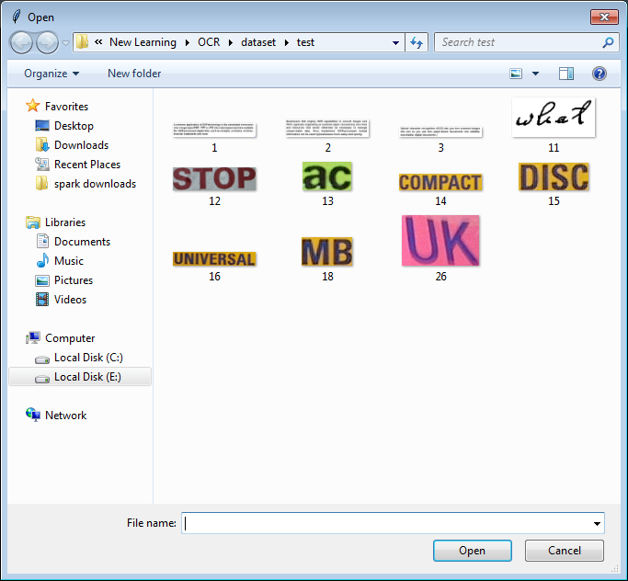
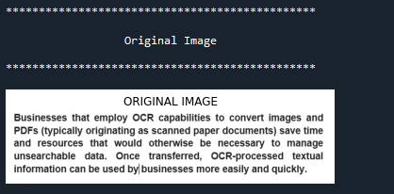

- Preprocessing:
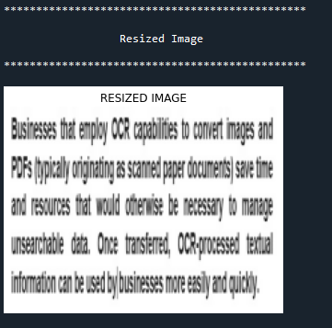
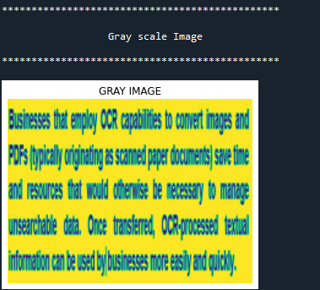

- Feature extraction:
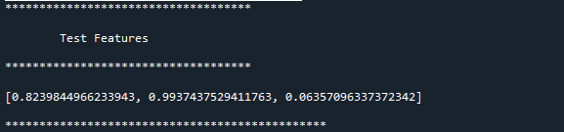
- Text extraction:

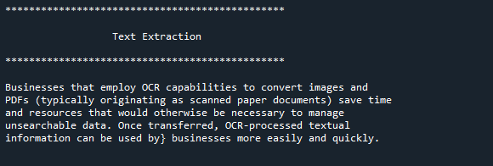
- Calculate length:
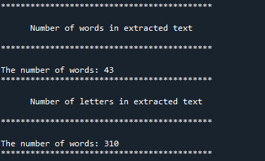

- Evaluate Marks:
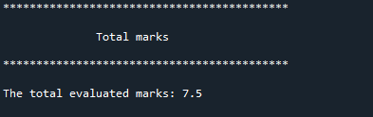

- ANN:
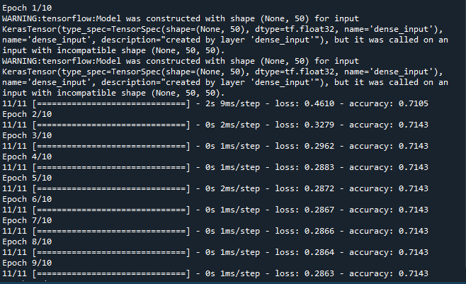

- Performance metrics:
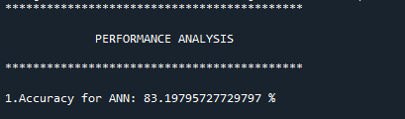

CHAPTER 10
REFERENCES
[1] Prince Sinha, SharadBharadia and AyushKaul, “Answer Evaluation Using Machine Learning”, March 2018. Available: https://www.researchgate.net/ publication/333856264\_Answer\_Evaluation\_Using\_ Machine\_Learning [Accessed: September 19, 2020]
[2] Honey Mehta, Sanjay Singla and Aarti Mahajan, "Optical Character Recognition (OCR) System for Roman Script & English Language using Artificial Neural Network (ANN) Classifier", in International Conference on Research Advances in Integrated Navigation System (RAINS - 2016), April 06 - 07, 2016.
[3]B.Vani and M. ShyniBeaulah, "High accuracy Optical Character Recognition algorithms using learning array of ANN", in International Conference on Circuit, Power and Computing Technologies [ICCPCT] 2014, pp. 1474 - 1479.
[4] SameekshaBarve, "Optical Character Recognition Using Artificial Neural Network", in International Journal of Advanced Research in Computer Engineering \& Technology, Volume 1, Issue 4, June 2012, pp. 131-133.
[5] J. Pradeep, E. Srinivasan and S. Himavathi, "Neural Network-based Handwritten Character Recognition system without feature extraction", in International Conference on Computer, Communication and Electrical Technology (ICCCET) 2011, 18th \& 19th March, 2011, pp. 40-44.
[6] Sk Asif Akram, MousumiSaha and Tamasree Biswas, "Evaluation of descriptive answer sheet using machine learning", in International Journal of Engineering Sciences \& Research Technology (IJESRT), April 2019, pp. 184-186.
[7] V. Lakshmi and Dr V. Ramesh, "Evaluating students descriptive answer using natural language processing and artificial neural networks", in International Journal of Creative Research Thoughts (IJCRT), Volume 5, Issue 4, December 2017, pp. 3168-3173.
[8] S. Impedovo, L. Ottaviano and S.Occhinegro, “Optical character recognition”, International Journal Pattern Recognition and Artificial Intelligence, Vol. 5(1-2), pp. 1- 24, 1991
[9] Sheeba Praveen, “An Approach to Evaluate Subjective Questions for Online Examination System”, Assistant Professor, Dept. CSE,Integral University, Lucknow ,U.P, India.
[10] J.Pradeep ,E.Srinivasan and S.Himavathi, “Diagonal Based Feature Extraction For Handwritten Alphabets Recognition System Using Neural Networks”, International Journal of Computer Science & Information Technology (IJCSIT), Vol 3, No 1, Feb 2011.
[11] B vanni, M. shyni, and R. Deepalakshmi, ”High accuracy optical character recognition algorithms using learning array of ANN” in Proc. 2014 IEEE International Conference on Circuit, Power and Computing Technologies (ICCPCT), 2014 International Conference.
[12] Baoguang Shi, Xiang Bai and Cong Yao, “An End-to-End Trainable Neural Network for Image-based Sequence Recognition and Its Application to Scene Text Recognition”, arXiv: 1507.05717v1 [cs.CV] 21 Jul 2015.
[13] YusufPerwej, Ashish Chaturvedi, “Neural Networks for Handwritten English Alphabet Recognition”, International Journal of Computer Applications (0975 – 8887) Volume 20– No.7, April 2011.
[14] George Nagy, Stephen V. Rice, and Thomas A. Nartker, “Optical Character Recognition: An Illustrated Guide to the Frontier (The Springer International Series in Engineering and Computer Science)”
[15] BatuhanBalci, Dan Saadati, Dan Shiferaw, “Handwritten Text Recognition using Deep Learning”, CS231n: Convolutional Neural Networks for Visual Recognition Spring 2017 project report.

