AUTOMATIC ANSWER EVALUATION USING MACHINE LEARNING
A PROJECT REPORT
Submitted to

Jawaharlal Nehru Technological University Kakinada, Kakinada
in partial fulfillment for the award of the degree of

Bachelor of Technology in
Computer Science and Engineering

Submitted by

T. SAI HAREESHA
Under the esteemed guidance of
S.NAHIDA
Associate Professor, CSE Department


DEPARTMENT OF COMPUTER SCIENCE AND ENGINEERING

NRI INSTITUTE OF TECHNOLOGY
Autonomous
(Approved by AICTE, Permanently Affiliated to JNTUK, Kakinada)
Accredited by NBA (CSE, ECE & EEE), Accredited by NAAC with ‘A’ Grade ISO 9001: 2015 Certified Institution Pothavarappadu (V), (Via) Nunna, Agiripalli (M), Krishna Dist, PIN: sssss521212, A.P, India. 2018-2022


NRI INSTITUTE OF TECHNOLOGY
(An Autonomous Institution, Approved by AICTE, Permanently Affiliated to JNTUK, Kakinada) Accredited by NBA (CSE, ECE & EEE), Accredited by NAAC with ‘A’ Grade ISO 9001: 2015 Certified Institution Pothavarappadu (V), (Via) Nunna, Agiripalli (M), Krishna Dist, PIN: 521212, A.P, India

Certificate
This is to certify that the Project entitled “AUTOMATIC ANSWER EVALUATION USING MACHINE LEARNING” is a bonafide work carried out by T.SAI HAREESHA, in partial fulfillment for the award of degree of Bachelor of Technology in Computer Science and Engineering of Jawaharlal Nehru Technological University Kakinada, Kakinada during the year 2021-2022.

S.NAHIDA Dr. D. SUNEETHA

Project Guide Head of the Department

EXTERNAL EXAMINER

DECLARATION

We here by declare that the project report titled “AUTOMATIC ANSWER EVALUATION USING MACHINE LEARNING ” is a bonafide work carried out in the Department of Computer Science and Engineering, NRI Institute of Technology, Agiripalli, Vijayawada during the academic year 2019-2020, in partial fulfillment for the award of the degree of Bachelor of Technology by JNTU Kakinada.

We further declare that this dissertation has not been submitted elsewhere for any Degree.

ACKNOWLEDGEMENT

We take this opportunity to thank all who have rendered their full support to our work. The pleasure, the achievement, the glory, the satisfaction, the reward, the appreciation and the construction of our project cannot be expressed with a few words for their valuable suggestions.

We are grateful to our Project Guide S.Nahida, Professor for rendering the valuable suggestions and extended his support to complete the project successfully.

We are expressing our heartfelt thanks to Head of the Departmen,Dr.D. Suneetha for her continuous guidance for completion of our Project work.

We are extending our sincere thanks to Dean of the Department, Dr. K. V. Sambasiva Rao for his continuous guidance and support to complete our project successfully.

We are thankful to the Principal, Dr. C. Naga Bhaskar for his encouragement to complete the Project work.

We are extending our sincere and honest thanks to the Chairman, Dr. R. Venkata Rao & Secretary, Sri K. Sridhar for their continuous support in completing the Project work.
Finally, We thank the Administrative Officer, Staff Members, Faculty of Department of CSE, NRI Institute of Technology and our friends, directly or indirectly helped us in the completion of this project.

ABSTRACT

Nowadays, as we are moving towards automation there is a need for an automatic descriptive answer evaluation system. Manual evaluation is a time and energy-consuming task. Presently, we have automated systems for objective type, single sentence answers and descriptive answers with less accuracy level. Automatic evaluation of answer scripts has been found very useful from our experiments, and often the assigned marks is the same as manually scored marks. In this paper, our goal is to develop an automated answer evaluation system using machine learning. The system will evaluate the answer based upon the number of words and number of letters from extracted text from the pre-processed data. After that, we have to implement the Natural Language Processing (NLP) for cleaning the extracted text. The text summarization is a process of creating a short, accurate summary of the longer text. Then, we have to implement the deep learning algorithm such as Artificial Neural Network (ANN). The experimental results will be shown like accuracy and marks based on number of words and number of letters from 0 to 10.

INDEX

- List of Figures i
- List of Abbreviations ii
- Introduction 1
  - Introduction to project 2-3
  - Problem Definition 4
  - Solution for Problem Definition 4
  - Process Diagram 5
- Literature Review 7-11
- System Analysis 12
  - Existing System 13
  - Proposed System 13
  - Analysis Model 14-16
  - Modules 17-21
- Feasibility study 22
  - Technical 23
  - Economical 23
  - Operational 23
- System Requirement Specification 24
  - Introduction 25
  - Functional Requirements 26
  - Non-Functional Requirements 27
  - System Requirements 28
    - Software Requirements 28
    - Hardware Requirements 28
- System Design 29
  - UML Modeling 30
  - Class Diagram 31
  - Use-Case Diagram 32
  - Activity Diagram 33
  - Sequence Diagram 34
  - Component Diagram 35
6.7 System Architecture Diagram 36
- Coding 37
  - Software Description (Technical Description) 38-41
  - Sample Code 41-47
- Testing 49-50
- Results 52-53
- Conclusion 56
- Future Enhancement 56
- References 57-59
- Publication 61

LIST OF FIGURES

- Process Diagram 5
- Analysis Model 15
- Flowchart 30
- Architectural diagram 36
- Activity diagram 33
- Class Diagram 31
- Sequence Diagram 34

LIST OF ABBREVIATIONS

1.OCR: Optical Character Recognition
2.SDD: Software Design Description
3.ANN:Artificial Neural Network
4. SRS: Software Requirements Specification

CHAPTER 1 INTRODUCTION

General Introduction:

Optical character Recognition, conversion of images of text into a character. We can segment the each characters in one wordUsing classification algorithm, to recognize the text .The process of Recognition a text using classification algorithm. Result is compared with the text that should appear in that specific part of the image.Optical character recognition or optical character reader (OCR) is the electronic or mechanical conversion of images of typed, handwritten or printed text into machine-encoded text, whether from a scanned document, a photo of a document, a scene-photo (for example the text on signs and billboards in a landscape photo) or from subtitle text superimposed on an image (for example: from a television broadcast). Widely used as a form of data entry from printed paper data records – whether passport documents, invoices, bank statements, computerized receipts, business cards, mail, printouts of static-data, or any suitable documentation – it is a common method of digitizing printed texts so that they can be electronically edited, searched, stored more compactly, displayed on-line, and used in machine processes such as cognitive computing, machine translation, (extracted) text-to-speech, key data and text mining. OCR is a field of research in pattern recognition, artificial intelligence and vision. Early versions needed to be trained with images of each character, and worked on one font at a time. Advanced systems capable of producing a high degree of recognition accuracy for most fonts are now common, and with support for a variety of digital image file format inputs.^{[2]} Some systems are capable of reproducing formatted output that closely approximates the original page including images, columns, and other non-textual components.Optical character recognition (OCR) technology is a business solution for automating data

extraction from printed or written text from a scanned document or image file and then converting the text into a machine-readable form to be used for data processing like editing or searching. Optical character Recognition (OCR) is a conversion of scanned or printed text images, handwritten text into editable text for further processing. This technology allows machine to recognize the text automatically. It is like combination of eye and mind of human body. An eye can view the text from the images but actually the brain processes as well as interprets that extracted text read by eye. In development of computerized OCR system, few problems can occur. First: there is very little visible difference between some letters and digits for computers to understand. For example it might be difficult for the computer to differentiate between digit “0” and letter “o”. Second: It might be very difficult to extract text, which is embedded in very dark background or printed on other words or graphics. In 1955, the first commercial system was installed at the reader’s digest, which used OCR to input sales report into a computer and then after OCR method has become very helpful in computerizing the physical office documents. Today many types of OCR software available in the markets like: Desktop OCR, Server OCR, Web OCR etc. Accuracy rate of any OCR tool varies from 71% to 98%. Many OCR tools are available as of now but only few of them are open source and free. Tesseract is the one of the open source and free OCR software. It is written in the C++, so it is platform independent. It can be used in other applications in the form of Dynamic Link Library (DLL). So it can be easily added as the reference in the form of DLL in other application to use the functionality provided by Tesseract. The following section contains history and functionality of Tesseract. Normally educational or non-educational organizations evaluate a student's performance on the basis of examination

either in the form of the subjective or objective pattern. Nowadays during this pandemic, everyone is working in a virtual manner. In the present scenario, manual evaluation of subjective answers is a hectic task. Now, we have many systems which can evaluate objective type or MCQ questions. These techniques are evaluated in machines itself after providing a data-set of answers. But it helps only in competitive or objective type exam evaluation. The descriptive examination is the backbone of all the universities. On the basis of the descriptive answer, the moderator will know how much knowledge the student has gained. Manual evaluation of subjective answers is a very tedious, time-consuming task and requires lots of manpower. It also requires a high level of concentration. Answer evaluation varies from person to person according to their way of evaluation and interrelation between student and moderator. This affects the result of the student.
  - PROBLEM DEFINITION:

It takes the huge amount of time and effort if we follow the classical approach for segmentation of customers according to their interests. This decreases the productivity and overall sales. This is labor intensive and often produces incorrect results.One of the biggest issues with customer segmentation is data quality. Inaccurate data in source systems will usually result in poor grouping. For example, customers who are individuals, attributes like age, gender, and marital status are frequently used. If these attributes are not maintained properly, the segments will be inaccurate and as a result, the information will likely be less useful. If the users do not feel comfortable with the quality of the data, they are likely not going to use the segments. Data quality issues also arise from a lack of maintenance and regular cleansing to ensure accuracy.
  - SOLUTION FOR PROBLEM DEFINITION:

In this project we use an effective machine learning algorithm to perform customer segmentation on the data of credit card users. We apply the algorithm on large amount of data considering many factors which would provide successful insights. The process is easier compared to manual approach and provides effective solutions. The fundamental goal is to
obtain accurate results. The existing system is performed by considering less number of factors and on limited number of customers where as the proposed system is performed on more than 9000 records to provide a solution for the problem statement.

  - PROCESS DIAGRAM

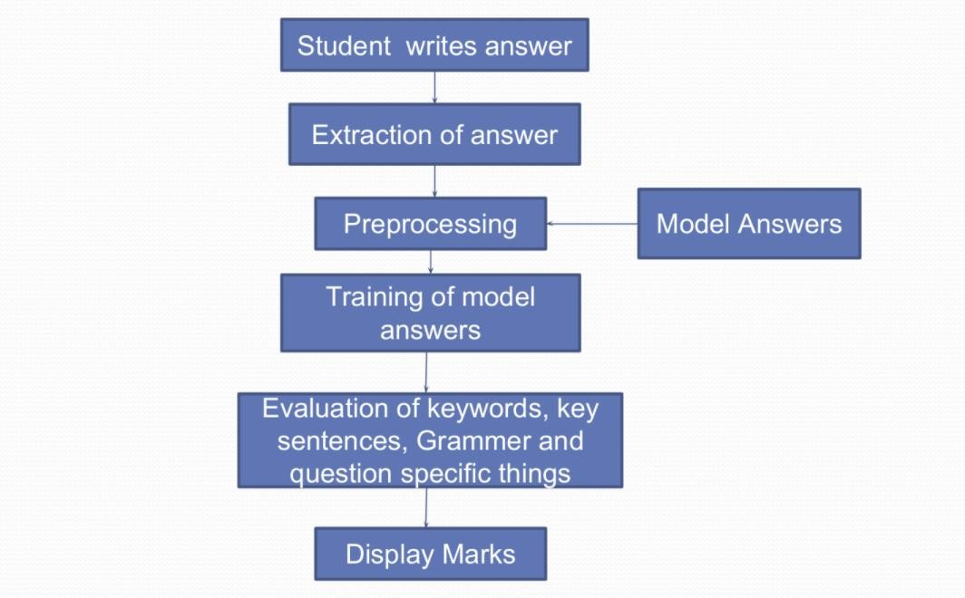

Fig.1

CHAPTER 2 LITERATURE REVIEW

2.LITERATURE REVIEW:
- Answer Evaluation Using Machine Learning, 2019
Author: Prince Sinha, SharadBharadia, AyushKaul, Dr.SheetalRathi

Methodology:

In this modern age, where the world moves towards automation so, there is a need for automation in answer evaluation system. Currently, the online answer evaluation is available for mcq based question, hence evaluation of the theory answer is hectic for the checker. Teacher manually checks the answer and allot the marks. The current system takes more manpower and time to evaluate the answer. In this journal an application based on the evaluation of answers using machine learning. The objective of the journal is to specially reduce the manpower and time consumption. Since in manual answer evaluation, the manpower and the time consumption is much more. Also, in the manual system, it may be possible that the marks given to two same answers are different. This application system provides an automatic evaluation of answer based on the keyword provided to the application in form of the input by the moderator which will provide equal distribution of marks and will reduce time and manpower.

Advantage:

- As, online system has much more advantages over the offline examination. Online exams saves time to evaluate the answers.
- As, there were no provision for offline paper evaluation, he designed an algorithm that automatically evaluate the single sentence descriptive answer.

Disadvantage:

- Less Effective

Optical Character Recognition (OCR)System for Roman Script & EnglishLanguage using Artificial Neural Network(ANN) Classifier

Methodology:
Character recognition from scanned images is a very complex task. But as for record keeping we require all the data in digital format to perform various manipulation operations. The main issue in case of character recognition is the different styles and fonts in which the text is written. We proposed a new approach by using the concept of Artificial Neural Network and Nearest Neighbour approach for character recognition from scanned images. Three layers are used for classification purpose. First is the input layer consist the input given by the segmented characters, then hidden layer consist the neurons trained by the training network and the output layer consist output neurons to generate unicode. Character recognition is a process of identification of printed, typewritten or handwritten characters. The characters are optically scanned and converted into machine editable form. It is an important field of image processing and artificial Intelligence. It is widely used as a form of data entry from books, research articles, bank forms, office papers or any other form of printed records.

Advantage:

  - High performance and accuracy.

Disadvantage:

  - It is having some scalability problem.

High accuracy Optical Character Recognitionalgorithms using learning array of ANN

Methodology:
Optical Character recognition refers to the process of translating the handwritten or printed text into a format that is understood by the machines for the purpose of editing, searching and indexing. The Performance of the current OCR illustrates and explains the actual errors and imaging defects in recognition with illustrated examples. This paper aims to create an application interface for OCR using artificial neural network as a back end to achieve high accurate rate in recognition. The proposed algorithm using neural network concept provides a high accuracy rate in recognition of characters. The proposed approach is implemented and tested on isolated character database consisting of English characters, digits and keyboard special characters. The recognition of characters from scanned images of documents has been a problem that has received much attention in the field of image processing, pattern recognition and artificial intelligence. Classical methods in pattern recognition do not suffice for the recognition due to the size, shape and style.

Advantage:
  - Despite the computational Complexity involved, artificial neural networks offer several advantages in pattern recognition with high accuracy in recognition rate with the sense of emulating adaptive human intelligence to a small extent.

Disadvantage:

  - It is less in efficiency and not give perfect result.

Optical Character Recognition using Artificial Neural Networks, 2020

Methodology:
With no doubt keyboarding the most time consuming and labour-intensive operation is the most familiar method of data input into the computer. Optical Character Recognition is that the machine carbon of human reading and has been the subject of intensive research for three decades. OCR can be described as Mechanical or Electronic conversion of scanned images where images are often handwritten, typewritten or printed text. It is a way of digitizing printed texts in order that they will be electronically searched and utilized in machine processes. It converts the images into machine-encoded text that can be utilized in machine translation, text-to-speech and text mining. This paper presents a simple, efficient, and low-cost approach to construct OCR for reading any document that has fix font size and style or handwritten style. To achieve effectiveness and less computational cost, OCR in this paper uses database to recognize English characters which makes this OCR very simple to manage.

Advantage:

  - A close match between analytical results and the available results shows the correctness of derived model.
  - High Efficiency.

Disadvantage:

  - Low in accuracy performance.

Neural Network based Handwritten CharacterRecognition system without feature extraction,

Methodology:

Handwriting recognition has been one of the active and challenging research areas in the field of image processing and pattern recognition. It has numerous applications which include, reading aid for blind, bank cheques and conversion of any hand written document into structural text form. In this paper an attempt is made to recognize handwritten characters for English alphabets without feature extraction using multilayer Feed Forward neural network. Each character data set contains 26 alphabets. Fifty different character data sets are used for training the neural network. The trained network is used for classification and recognition. In the proposed system, each character is resized into 30x20 pixels, which is directly subjected to training. That is, each resized character has 600 pixels and these pixels are taken as features for training the neural network. The results show that the proposed system yields good recognition rates which are comparable to that of feature extraction based schemes for handwritten character recognition.

Advantage:

  - Good in Performance

Disadvantage:
  - Not Reliable
  - The problem is framed by defining it, outlining identifying strategies and resources.

CHAPTER 3 SYSTEM DIAGRAMS

  - EXISTING SYSTEM:
In existing system, nowadays, as we are moving towards automation there is a need for an automatic descriptive answer evaluation system. Manual evaluation is a time and energy-consuming task. Presently, we have automated systems for objective type, single sentence answers and descriptive answers with less accuracy level. In this paper, our goal is to develop an automated answer evaluation system using machine learning. The system will evaluate the answer based upon the matched keywords and the minimum length of the answer provided by the moderator. The scanned handwritten answer sheet will be given as input to the proposed system. The system will use an artificial neural network with back-propagation algorithm.

DISADVANTAGES:

    - The results is low when compared with proposed.
    - The prediction of text is poor
    - It doesn’t implement the pytesseract.

PROPOSED SYSTEM:
In proposed system, the imagedataset was taken as input. Then, we have to implement the pre-processingstep. In this step, we have to resize the original image and convert the image into gray scale.After that, we have to extract the text from the pre-processed image by using mean standard deviation. After that, we have to extract the text from input image by using the pytesseract and the extracted text will be stored in text format. Then, we have to implement the Natural Language Processing for cleaning the extracted text.

extracted text. After that, we have to implement the deep learning algorithm such as Artificial Neural Network (ANN). The experimental results shows that some performance metrics such as accuracy and evaluate marks based on number of words and number of letters.

ADVANTAGES:

- It displays the text format
- It will recognize easy
- The accuracy is high.

ANALYSIS MODEL:

- Waterfall Model - Design
The waterfall approach was the first SDLC Model to be used widely in Software Engineering to ensure the success of the project. In the "The Waterfall" approach, the whole process of software development is divided into separate phases. In this Waterfall model, typically, the outcome of one phase acts as the input for the next phase sequentially.

The following illustration is a representation of the different phases of the Waterfall Model-

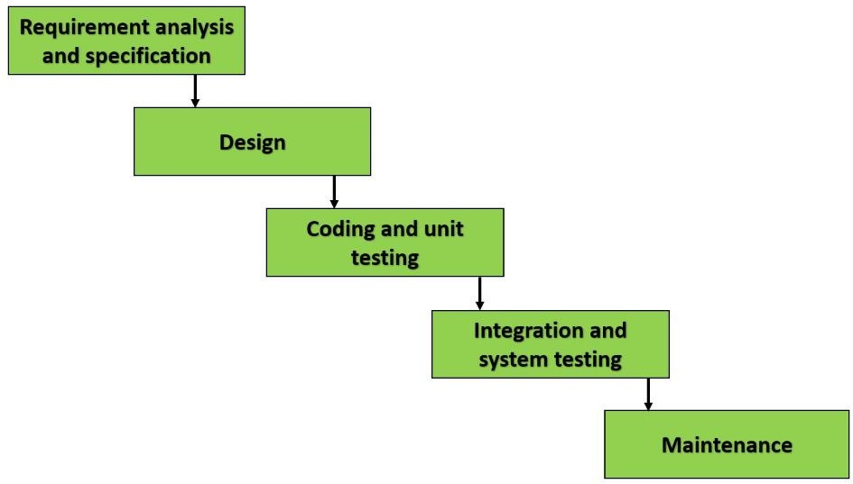

Fig: 2. Waterfall Model diagram

Sequential phases in Waterfall modelare:
Requirements analysis and specification: The aim of the requirement analysis and specification phase is to understand the exact requirements of the customer and document them properly. This phase consists of two different activities.
Requirement gathering and analysis: Firstly, all the requirements regarding the software are gathered from the customer and then the gathered requirements are analysed. The goal of the analysis part is to remove incompleteness (an incomplete requirement is one in which some parts of the actual requirements have been omitted) and inconsistencies (an inconsistent requirement is one in which some part of the requirement contradicts some other part).
Specification Requirement: These analysed requirements are documented in a software requirement specification (SRS) document. SRS document serves as a contract between the development team and customers. Any future dispute between the customers and the developers can be settled by examining the SRS document.

Design: The goal of this phase is to convert the requirements acquired in the SRS into a format that can be coded in a programming language. It includes high-level and detailed design as well as the overall software architecture. A Software Design Document is used to document all of this effort (SDD)

Coding and Unit testing: In the coding phase software design is translated into source code using any suitable programming language. Thus, each designed module is coded. The aim of the unit testing phase is to check whether each module is working properly or not.

Integration and System testing: Integration of different modules are undertaken soon after they have been coded and unit tested. Integration of various modules is carried out incrementally over a number of steps. During each integration step, previously planned modules are added to the partially integrated system and the resultant system is tested. Finally, after all the modules have been successfully integrated and tested, the full working system is obtained and system testing is carried out on this.
System testing consists of three different kinds of testing activities as described below:

Alpha testing: Alpha testing is the system testing performed by the development team.
Beta testing: Beta testing is the system testing performed by a friendly set of customers.
Acceptance testing: After the software has been delivered, the customer performed acceptance testing to determine whether to accept the delivered software or reject it.
Maintenance: Maintenance is the most important phase of a software life cycle. The effort spent on maintenance is 60% of the total effort spent to develop a full software. There are basically three types of maintenance:
- Corrective Maintenance: This type of maintenance is carried out to correct errors that were not discovered during the product development phase.
- Perfective Maintenance: This type of maintenance is carried out to enhance the functionalities of the system based on the customer’s request.

MODULES:
  - Input
  - Preprocessing
  - Feature extraction
  - Text recognition
  - NLP techniques
  - Data splitting
  - Classification
  - Evaluate answer
  - Performance metrics

INPUT:
  - The dataset contains the images in the form of ‘.jpg’ or ‘.png’
  - In this step, we have to read or load the input image by using the imread () function.
  - The input image is used to detect or recognize the text.
  - In our process, we are used the tkinter file dialogue box for selecting the input image.

PREPROCESSING:
  - In our process, we have to resize the image and convert the image into gray scale.
  - To resize an image, you call the resize () method on it, passing in a two- integer tuple argument representing the width and height of the resized image.

  - Convert an Image to Grayscale in Python Using the Conversion Formula and the matplotlib Library.
  - We can also convert an image to grayscale using the standard RGB to grayscale conversion formula that is imgGray = 0.2989 * R + 0.5870 * G + 0.1140 * B.

FEATURE EXTRACTION:
  - Variance and Standard Deviation are essentially a measure of the spread of the data in the data set. Variance is the average of the squared differences from the mean.
  - mean () function can be used to calculate mean/average of a given list of numbers. It returns mean of the data set passed as parameters. Arithmetic mean is the sum of data divided by the number of data-points.

TEXT RECOGNITION:
- In our process, we have to recognize the text by using the pytesseract.
- Python-tesseract is an optical character recognition (OCR) tool for python. That is, it will recognize and “read” the text embedded in images.
- Python-tesseract is a wrapper for Google's Tesseract-OCR Engine.

NLP TECHNIQUES:

- NLP is a field in machine learning with the ability of a computer to understand, analyse, manipulate, and potentially generate human language.
- Cleaning (or pre-processing) the data typically consists of a number of steps:

- Remove punctuation: Punctuation can provide grammatical context to a sentence which supports our understanding.
- Tokenization: Tokenizing separates text into units such as sentences or words. It gives structure to previously unstructured text. eg: Plata o Plomo-
> ‘Plata’,’o’,’Plomo’.

- Stemming: Stemming helps reduce a word to its stem form.

- Padding: In any raw text data, naturally there will be sentences of different lengths. However, all neural networks require to have inputs with the same size. For this purpose, padding is done.

DATA SPLITTING:

  - During the machine learning process, data are needed so that learning can take place.
  - In addition to the data required for training, test data are needed to evaluate the performance of the algorithm in order to see how well it works.
  - In our process, we considered 70% of the input dataset to be the training data and the remaining 30% to be the testing data.
  - Data splitting is the act of partitioning available data into two portions, usually for cross-validator purposes.
  - One Portion of the data is used to develop a predictive model and the other to evaluate the model's performance.
  - Separating data into training and testing sets is an important part of evaluating data mining models.

  - Typically, when you separate a data set into a training set and testing set, most of the data is used for training, and a smaller portion of the data is used for testing.

CLASSIFICATION:
- In our process, we have to implement the deep learning algorithm such as Artificial Neural Network (ANN).
- Artificial Neural Networks (ANN) are part of supervised machine learning where we will be having input as well as corresponding output present in our dataset.
- Our whole aim is to figure out a way of mapping this input to the respective output.
- ANN can be used for solving both regression and classification problems.

EVALUATE ANSWER:
  - In this step, we can evaluate the answers from the extracted text based on length of answers and length of words.
  - We can put the marks from o to 10 based on length of answers and length of words.

PERFORMANCE METRICS:

The Final Result will get generated based on the overall classification and prediction. The performance of this proposed approach is evaluated using some measures like,

Accuracy

Accuracy of classifier refers to the ability of classifier. It predicts the class label correctly and the accuracy of the predictor refers to how well a given predictor can guess the value of predicted attribute for a new data.
AC= (TP+TN)/ (TP+TN+FP+FN)

CHAPTER 4
Feasibility Study

FEASIBILITY STUDY:
The feasibility study is carried out to test whether the proposed system is worth being implemented.
- The feasibility carried out mainly in three sections namely.
  - Technical Feasibility
  - Economic Feasibility
  - Operational Feasibility

4.1 Technical Feasibility:
- This study centre around the system’s department hardware, software and to what extend it can support the proposed system.
- System can give guarantee of accuracy, and easy to use.
- The project is decided to build using python which is readily available. This states that project is technically

4.2 Economic Feasibility:
- Economic analysis is the most frequently used method for evaluating effectiveness of the proposed system.
- Most commonly known as cost benefit analysis.
- Python is an open source so there is no need to consider cost.
- Hence this project is economically feasible.

4.3 Operational Feasibility:
- Operational Feasibility is a measure how people feel about the project.
- Our proposed system can generate marks based on keywords and length of the answer which are given to machine.

CHAPTER 5 SYSTEM REQUIREMENTS

  - INTRODUCTION:

A Software Requirements specification (SRS) – a requirements specification for a software system is a complete description of behavior of a system to be developed. It includes a set of cases that describe all the interactions users will have with the software. In addition to use cases, the SRS also contains non-functional requirements. Nonfunctional requirements are requirements which impose constraints on the design or implementation (such as performance engineering requirements, quality standards, or design constraints). System Requirements Specification It is a collection of information that embodies the requirements of a system. A business analyst, sometimes titled system analyst, is responsible for analyzing the business needs of their clients and stakeholders to help identify business problems and propose solutions. Projects are subject to three sorts of require elements.

    - Business requirements describe in business terms what must be delivered or accomplished to provide value.
    - Product requirements describe properties of a system or product (which could be one of several ways to accomplish a set of business requirements.)
    - Process requirements describe activities performed by the developing organization. For instance, process requirements could specify methodologies that must be followed, and constraints that the organization must obey.

Product and process requirements are closely linked. Process requirements often specify the activities that will be performed to satisfy a product requirement. For example, a maximum development cost requirement (a process requirement) may be imposed to help achieve a maximum sales price requirement (a product requirement) a requirement that the product be maintainable (a product requirement) often is addressed by imposing requirements to follow particular development styles.

A system engineering, a requirement can be a description of what a system must do, referred to
However, implementation constraints on the solution may validly be expressed by the future owner, for example for required interfaces to external systems; for interoperability with other systems; and for commonality with other owned products.

FUNCTIONAL REQUIREMENTS:

In software engineering, a functional requirement defines a function of a software system or its component. A function is described as a set of inputs, the behavior, and outputs (see also software). Functional requirements may be calculations, technical details, data manipulation and processing and other specific functionality that define what a system is supposed to accomplish. Behavioral requirements describing all the cases where the system uses the functional requirements are captured in use cases. Generally, functional requirements are expressed in the form “system shall do <requirement>”. The plan for implementing functional requirements is detailed in the system design. In requirements engineering, functional requirements specify particular results of a system. Functional requirements drive the application architecture of a system. A requirements analyst generates use cases after gathering and validating a set of functional requirements. The hierarchy of functional requirements is: user/stakeholder request -> feature -> use case -> business rule.
Functional requirements drive the application architecture of a system. A requirements analyst generates use cases after gathering and validating a set of functional requirements. Functional requirements may be technical details, data manipulation and other specific functionality of the project is to provide the information to the user.
The following are the Functional requirements of our system:

    - It should meet the functional requirements as mentioned in Objectives.
    - It should be able to find all places those are registered in customer database.

NON-FUNCTIONAL REQUIREMENTS:

    - Error occurrence in the system.
      - Customer requests.
    - Availability:A system’s “availability” or “uptime” is the amount of time that is operational and available for use. It’s related to the server providing the service to the users in displaying images. As our system will be used by thousands of users at any time our system must be available always. If there are any cases of updates they must be performed in a short interval of time without interrupting the normal services made available to the users.

    - Efficiency: Specifies how well the software utilizes scarce resources: CPU cycles, disk space, memory, bandwidth etc. All of the abovementioned resources can be effectively used by performing most of the validations at client side and reducing the workload on server by using JSP instead of CGI which is being implemented now.

    - Flexibility: If the organization intends to increase or extend the functionality of the software after it is deployed, that should be planned from the beginning; it influences choices made during the design, development, testing and deployment of the system. New modules can be easily integrated to our system without disturbing the existing modules or modifying the logical database schema of the existing applications.

    - Portability:Portability specifies the ease with which the software can be installed on all necessary platforms, and the platforms on which it is expected to run. By using appropriate server versions released for different platforms our project can be easily operated on any operating system, hence can be said highly portable.

    - Scalability:Software that is scalable has the ability to handle a wide variety of system configuration sizes. The nonfunctional requirements should specify the ways in which the system may be expected to scale up (by increasing hardware capacity, adding machines etc.). Our system can be easily expandable. Any additional requirements such as hardware or software which increase the performance of the system can be easily added. An additional server would be useful to speed up the

    - Integrity: Integrity requirements define the security attributes of the system, restricting access to features or data to certain users and protecting the privacy of data entered into the software. Certain features access must be disabled to normal users such as adding the details of files, searching etc which is the sole responsibility of the server. Access can be disabled by providing appropriate logins to the users for only access.

    - Usability:Ease-of-use requirements address the factors that constitute the capacity of the software to be understood, learned, and used by its intended users. Hyper links will be provided for each and every service the system provides through which navigation will be easier. A system that has high usability coefficient makes the work of the user easier.

SYSTEM REQUIREMENTS:

    - SOFTWARE REQUIREMENTS:

      - O/S : Windows 7.
      - Language : Python
      - Front End : Anaconda Navigator –Spyder

HARDWARE REQUIRMENTS:

      - System : Pentium IV 2.4 GHz
      - Hard Disk : 200 GB
      - Mouse : Logitech.
      - Keyboard : 110 keys enhanced
      - Ram : 4GB

CHAPTER 6 SYSTEM DESIGN

  - UML MODELING:
Mark Evaluation
Uml is a method for describing the system architecture in detail using the blue print. UML represents a collection of best engineering practice that has proven successful in the modeling of large and complex systems. The UML is very important parts of developing object-oriented software and the software
FLOW DIAGRAM:
Start

Preprocessing
Input image

Text Recognition
Feature Extraction

Calculate length
Classification

CLASS DIAGRAM:
Class-based Modeling, or more commonly class-orientation, refers to the style of object-oriented programming in which inheritance is achieved by defining classes of objects; as opposed to the objects themselves.The most popular and developed model of OOP is a class-based model, as opposed to an object-based model. In this model, objects are entities that combine state (i.e., data), behavior and identity. The structure and behavior of an object are defined by a class, which is a definition, or blueprint, of all objects of a specific type. An object must be explicitly created based on a class and an object thus created is considered to be an instance of that class. An object is similar to a structure, with the addition of method pointers, member access control, and an implicit data member which locates instances of the class (i.e. actual objects of that class) in the class hierarchy.

Mean ()
Standard () Normalize ()
Feature extraction
Select image () Image resize () Gray scale ()
Input
Pytesseract ()
Recognize text ()

Text recognition
Find number of words
Find number of letters
Calculate length
ANN ()

Evaluate marks ( )
Classification

USECASE DIAGRAM:
Use Case is a method for describing the system architecture in detail using the blue print. UML represents a collection of best engineering practice that has proven successful in the modeling of large and complex systems. The UML is very important parts of developing object-oriented software and the software

Input Image
Preprocessing
Feature Extraction
System
Text recognition
User
Calculate length
Classification
Evaluate answer

FIGURE 3.3.1: USE CASE DIAGRAM

  - ACTIVITY DIAGRAM: We show an approach to semi-automatic grading of answers given by students to open ended questions (open answers). We use both peer-evaluation and teacher evaluation. A learner is modeled by her Knowledge and her assessments quality (Judgment).

Input image
Preprocessing
Feature extraction
Text recognition
Calculate length
Classification
Classification

SEQUENCE DIAGRAM:

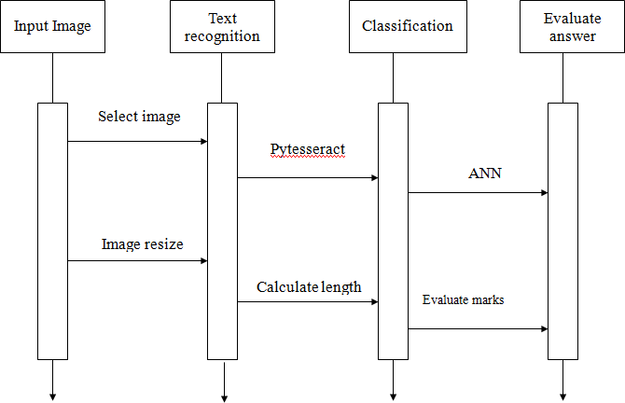

  - COMPONENT DIAGRAM:
Relationships are Graphically, a component diagram is a collection of vertices and arcs and commonly contain components, interfaces and dependency, aggregation, constraint, generalization, association, and realization relationships.

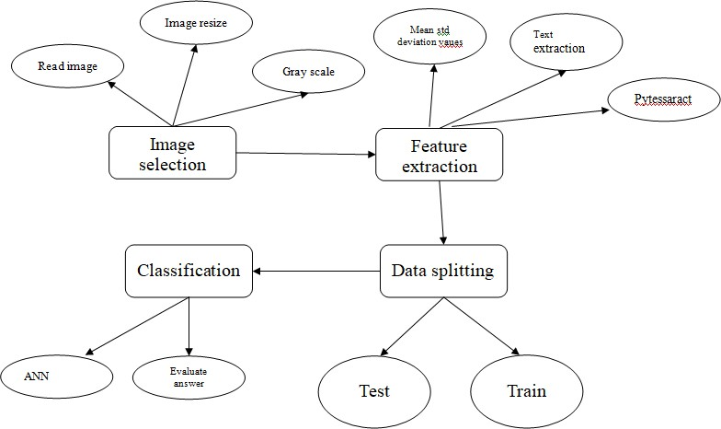

  - SYSTEM ARCHITECTURE :

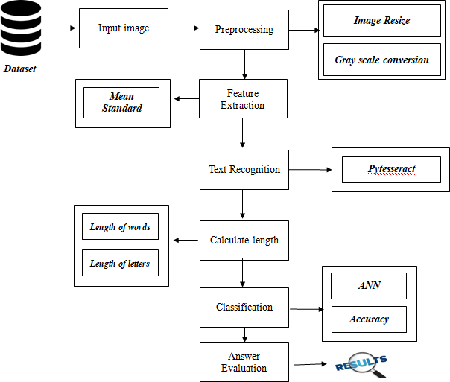

CHAPTER 7 CODING

SOFTWARE DESCRIPTION:

    - Python

Python is one of those rare languages which can claim to be both simple and powerful. You will find yourself pleasantly surprised to see how easy it is to concentrate on the solution to the problem rather than the syntax and structure of the language you are programming in. The official introduction to Python is Python is an easy to learn, powerful programming language. It has efficient high-level data structures and a simple but effective approach to object-oriented programming. Python's elegant syntax and dynamic typing, together with its interpreted nature, make it an ideal language for scripting and rapid application development in many areas on most platforms.I will discuss most of these features in more detail in the next section.

Features of Python
- Simple

Python is a simple and minimalistic language. Reading a good Python program feels almost like reading English, although very strict English! This pseudo-code nature of Python is one of its greatest strengths. It allows you to concentrate on the solution to the problem rather than the language itself.

Easy to Learn

As you will see, Python is extremely easy to get started with. Python has an extraordinarily simple syntax, as already mentioned.

Free and Open Source

Python is an example of a FLOSS (Free/Libré and Open Source Software). In simple terms, you can freely distribute copies of this software, read its source code, make changes to it, and use pieces of it in new free programs. FLOSS is based on the concept of a community which shares knowledge. This is one of the reasons why Python is so good - it has been created and is constantly improved by a community who just want to see a better Python.

High-level Language

When you write programs in Python, you never need to bother about the low-level details such as managing the memory used by your program, etc.

Portable

Due to its open-source nature, Python has been ported to (i.e. changed to make it work on) many platforms. All your Python programs can work on any of these platforms without requiring any changes at all if you are careful enough to avoid any system- dependent features.

You can use Python on GNU/Linux, Windows, FreeBSD, Macintosh, Solaris, OS/2, Amiga, AROS, AS/400, BeOS, OS/390, z/OS, Palm OS, QNX, VMS, Psion, Acorn RISC OS, VxWorks, PlayStation, Sharp Zaurus, Windows CE and PocketPC!

You can even use a platform like Kivy to create games for your computer and for iPhone, iPad, and Android.

Interpreted

This requires a bit of explanation.

A program written in a compiled language like C or C++ is converted from the source language i.e. C or C++ into a language that is spoken by your computer (binary code i.e. 0s and 1s) using a compiler with various flags and options. When you run the program, the linker/loader software copies the program from hard disk to memory and starts running it.

Python, on the other hand, does not need compilation to binary. You just run the program directly from the source code. Internally, Python converts the source code into an intermediate form called bytecodes and then translates this into the native language of your computer and then runs it. All this, actually, makes using Python much easier since you don't have to worry about compiling the program, making sure that the proper libraries are linked and loaded, etc. This also makes your Python programs much more portable, since you can just copy your Python program onto another computer and it just works!

Object Oriented

Python supports procedure-oriented programming as well as object-oriented programming. In procedure-oriented languages, the program is built around procedures or functions which are nothing but reusable pieces of programs. In object-oriented languages, the program is built around objects which combine data and functionality. Python has a very powerful but simplistic way of doing OOP, especially when compared to big languages like C++ or Java.

Extensible

If you need a critical piece of code to run very fast or want to have some piece of algorithm not to be open, you can code that part of your program in C or C++ and then use it from your Python program.

Embeddable

You can embed Python within your C/C++ programs to give scripting capabilities for your program's users.

Extensive Libraries

The Python Standard Library is huge indeed. It can help you do various things involving regular expressions, documentation generation, unit testing, threading, databases, web browsers, CGI, FTP, email, XML, XML-RPC, HTML, WAV files, cryptography, GUI (graphical user interfaces), and other system-dependent stuff. Remember, all this is always available wherever Python is installed. This is called the Batteries Included philosophy of Python.

Besides the standard library, there are various other high-quality libraries which you can find at the Python Package Index.

SAMPLE CODE
fromtkinter.filedialog import askopenfilename import pandas as pd
importmatplotlib.pyplot as plt from skimage.io import imread
fromskimage.transform import resize importnumpy as np

importpytesseract import re
fromsklearn.model_selection import train_test_split importos
import cv2
fromkeras.models import Sequential fromkeras.layers import Dense fromkeras.utils import to_categorical filename = askopenfilename()
img = imread(filename) print()
print("***********************************************") print()
print(" Original Image ") print()
print("***********************************************") plt.imshow(img)
plt.title('ORIGINAL IMAGE') plt.axis("off")
plt.show()
resized_image = resize(img, (150, 200)) print()
print("***********************************************") print()
print(" Resized Image ") print()
print("***********************************************")

fig = plt.figure() plt.title('RESIZED IMAGE') plt.imshow(resized_image) plt.axis("off")
plt.show()
r, g, b = resized_image[:,:,0], resized_image[:,:,1], resized_image[:,:,2] gray = 0.2989 * r + 0.5870 * g + 0.1140 * b
print()Print(" Gray scale Image ") print()
print("***********************************************") plt.imshow(gray)
plt.title('GRAY IMAGE') plt.axis("off")
plt.show()
mean_val = np.mean(gray) median_val = np.median(gray) var_val = np.var(gray)
Test_features = [mean_val,median_val,var_val] print(" Test Features ")
print() print("************************************") print()
print(Test_features)
pytesseract.pytesseract.tesseract_cmd = r'C:\Program Files (x86)\Tesseract- OCR\tesseract.exe'
text = pytesseract.image_to_string(img,lang = 'eng') print()

print("***********************************************") print()
print(" Text Extraction ") #=== No.of.words === num_of_words=len(text.split())
print("*******************************************") print()
print(" Number of words in extracted text ") print()
print("*******************************************") print()
print("The number of words:",num_of_words) num_of_letters=len(text)
print(" Number of letters in extracted text ") print()
print("*******************************************") print()
print("The number of words:",num_of_letters) df = pd.Series(text)
cleanup_re = re.compile('[^a-z]+') defcleanup(sentence):
sentence = str(sentence) sentence = sentence.lower()
sentence = cleanup_re.sub(' ', sentence).strip() return sentence
df[0] = df.apply(cleanup) ifnum_of_letters> 250:

marks=10
elifnum_of_letters>230 and num_of_letters<250: marks=9
elifnum_of_letters> 200 and num_of_letters<230: marks=8
elifnum_of_letters>180 and num_of_letters< 200: marks=7
elifnum_of_letters> 160 and num_of_letters< 180: marks=6
elifnum_of_letters> 140 and num_of_letters< 160: marks=5
elifnum_of_letters>110 and num_of_letters<140: marks=4
elifnum_of_letters> 80 and num_of_letters<110: marks=3
elifnum_of_letters>40 and num_of_letters<80: marks=2
else:
marks=1 ifnum_of_words>=15:
m=5
elifnum_of_words>=13 and num_of_words<15: m=4
elifnum_of_words>=10 and num_of_words<13: m=3
elifnum_of_words>=5 and num_of_words<10: m=2

elifnum_of_words>1 and num_of_words<5: m=1
else:
m=0
total_marks=(marks+m)/2
test_data = os.listdir('./dataset/test/') train_data = os.listdir('./dataset/train/') dot= []
labels = []
forimg in train_data: try:
img_1 = plt.imread('./dataset/train/' + "/" + img) img_resize = cv2.resize(img_1,((50, 50))) dot.append(np.array(img_resize[:,:,0])) labels.append(1)
except:
None
forimg in test_data: try:
img_2 = plt.imread('./dataset/test/'+ "/" + img) img_resize = cv2.resize(img_2,(50, 50)) dot.append(np.array(img_resize[:,:,0])) labels.append(0) x_train1=np.zeros((len(x_train),50,50))
fori in range(0,len(x_train)): x_train1[i,:,:]=x_train[i]
x_test1=np.zeros((len(x_test),50,50))

fori in range(0,len(x_test)): x_test1[i,:,:]=x_test[i] y_train1=np.array(y_train)
train_Y_one_hot = to_categorical(y_train1) test_Y_one_hot = to_categorical(y_test) print()
#initialize the model classifier = Sequential() #defining the layers
classifier.add(Dense(activation = "relu", input_dim = 50, units = 9, kernel_initializer = "uniform"))
classifier.add(Dense(activation = "relu", units = 14,kernel_initializer = "uniform")) classifier.add(Dense(activation = "sigmoid", units = 1,kernel_initializer = "uniform")) #compile the model
classifier.compile(optimizer = 'adam' , loss = 'mae', metrics = ['accuracy'] ) #fitting the model
classifier.fit(x_train1,train_Y_one_hot[:,0], batch_size = 2 ,epochs = 10 ) #predict the model
y_pred = classifier.predict(x_train1) y_pred = (y_pred> 0.5)
accuracy = classifier.evaluate(x_test1, test_Y_one_hot[:,0], verbose=1) print("*******************************************")
print(" PERFORMANCE ANALYSIS ")
print()

CHAPTER 8 TESTING

.TESTING PRODUCTS:

System testing is the stage of implementation, which aimed at ensuring that system works accurately and efficiently before the live operation commence. Testing is the process of executing a program with the intent of finding an error. A good test case is one that has a high probability of finding an error. A successful test is one that answer says discovered error.
Testing is vitalto the success of the system. System testing makes a logical assumption that if all parts of the system are correct, the goal will be successfully achieved. A series of tests are performed before the system is ready for the user acceptance testing. Any engineered product can be tested in one of the following ways. Knowing the specified function that a product has been designed to from, test can be conducted to demonstrate each function is fully operational. Knowing the internal working of a product, tests can be conducted to ensure that “algears mesh”, that is the internal operation of the product performs according to the specification and all internal components have been adequately exercised.

UNITTESTING:
Unit testing is the testing of each module and the integration of the overall system is done. Unit testing becomes verification efforts on the smallest unit of software design in the module. This is also known as ‘module testing’

INTEGRATION TESTING:
Data can be lost across an interface, one module can have an adverse effect on the other sub function, when combined, may not produce the desired major function. Integrated testing issystematic testing that can be done with sample data. The need for the integrated test is to find the overall system performance. There are two types of integration testing. They are:
- Top-down integration testing.
- Bottom-up integration testing.
.

TESTING TECHNIQUES/STRATEGIES:

- WHITEBOXTESTING:
White Box testing is a test case design method that uses the control structure of the procedure design to drive cases. Using the white box testing methods, we Derived test cases that guarantee that all in dependent paths with in a module have been exercised atleast once.

BLACKBOXTESTING:

  - Black box testing is done to find incorrect or missing function

  - Inter face error

  - Error in external data base access

  - Performance errors.

  - Initialization and termination errors

In functional testing’ ,is per for me to validate an application conform to its specifications of correctly performs all its required functions. So this testing is also called ‘black box testing’. It tests the external behaviour of the system. Here, the engineered product can be tested knowing the specified function that a product has been designed to perform, tests can be conducted to demonstrate that each function is fully operational.

CHAPTER 9 RESULTS

- Data selection:
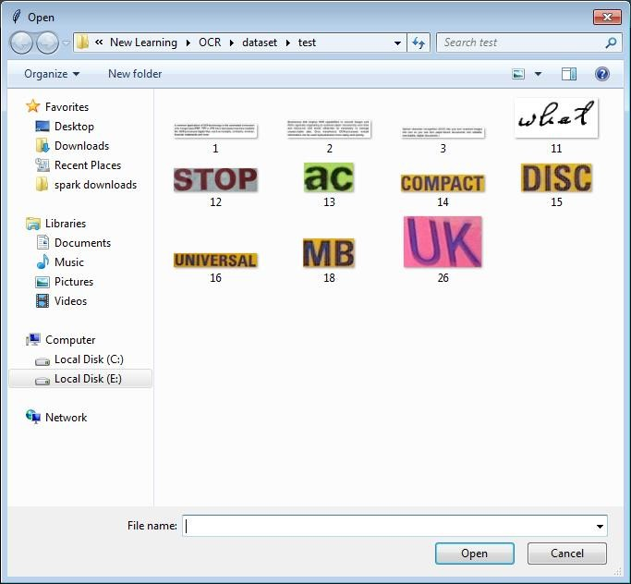
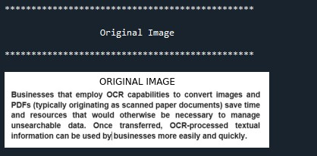

- Preprocessing:
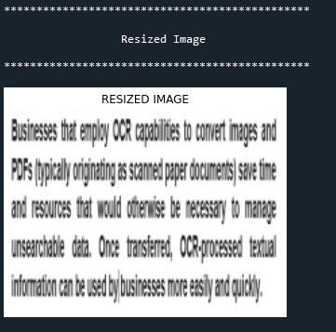
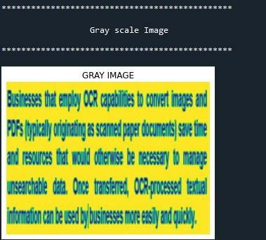

- Feature extraction:
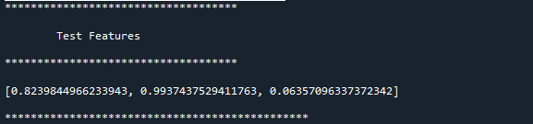

- Text extraction:

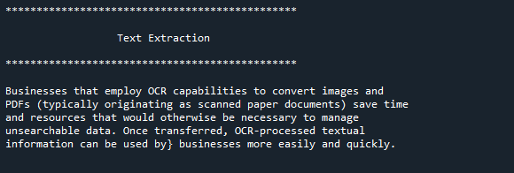

- Calculate length:
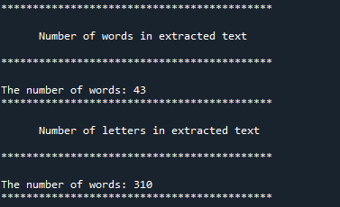

- Evaluate Marks:
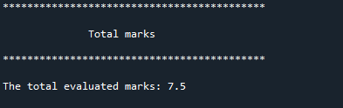

- ANN:
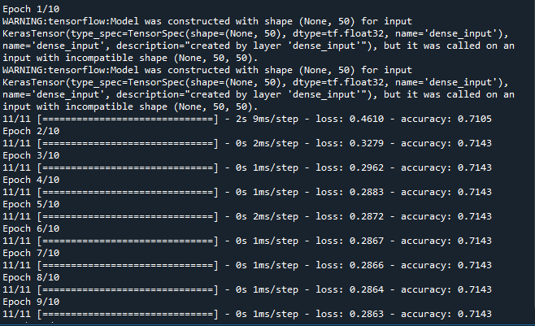

- Performance metrics:
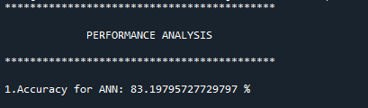

CHAPTER 10
CONCLUSION
We conclude that, the image dataset was taken from dataset repository. We are implemented the NLP techniques and classification algorithms (i.e.) deep learning algorithm. Then, deep learning algorithms such as artificial neural network (ANN). Finally, the result shows that the accuracy for above mentioned algorithm and evaluate the answer and put marks from 0 to 10 based on length of letters and length of words.

CHAPTER 11

FUTURE ENHANCEMENT
In the future, we should like to hybrid the two different machine learning. In future, it is possible to provide extensions or modifications to the proposed classification algorithms to achieve further increased performance. Apart from the experimented combination of data mining techniques machine algorithms can be used to improve the detection accuracy. Finally, the sentiment analysis detection system can be extended as a prevention system to enhance the performance of the system.

CHAPTER 12 REFERENCES
- Prince Sinha, SharadBharadia and AyushKaul, “Answer Evaluation Using Machine Learning”, March 2018. Available: https://www.researchgate.net/ publication/333856264\_Answer\_Evaluation\_Using\_ Machine\_Learning [Accessed: September 19, 2020]
- Honey Mehta, Sanjay Singla and Aarti Mahajan, "Optical Character Recognition (OCR) System for Roman Script & English Language using Artificial Neural Network (ANN) Classifier", in International Conference on Research Advances in Integrated Navigation System (RAINS - 2016), April 06
- 07, 2016.

[3]B.Vani and M. ShyniBeaulah, "High accuracy Optical Character Recognition algorithms using learning array of ANN", in International Conference on Circuit, Power and Computing Technologies [ICCPCT] 2014, pp. 1474 - 1479.
- SameekshaBarve, "Optical Character Recognition Using Artificial Neural Network", in International Journal of Advanced Research in Computer Engineering \& Technology, Volume 1, Issue 4, June 2012, pp. 131-133.
- J. Pradeep, E. Srinivasan and S. Himavathi, "Neural Network-based Handwritten Character Recognition system without feature extraction", in International Conference on Computer, Communication and Electrical Technology (ICCCET) 2011, 18th \& 19th March, 2011, pp. 40-44.
- Sk Asif Akram, MousumiSaha and Tamasree Biswas, "Evaluation of descriptive answer sheet using machine learning", in International Journal of

Engineering Sciences \& Research Technology (IJESRT), April 2019, pp. 184- 186.
- V. Lakshmi and Dr V. Ramesh, "Evaluating students descriptive answer using natural language processing and artificial neural networks", in International Journal of Creative Research Thoughts (IJCRT), Volume 5, Issue 4, December 2017, pp. 3168-3173.
- S. Impedovo, L. Ottaviano and S.Occhinegro, “Optical character recognition”, International Journal Pattern Recognition and Artificial Intelligence, Vol. 5(1-2), pp. 1- 24, 1991
- Sheeba Praveen, “An Approach to Evaluate Subjective Questions for Online Examination System”, Assistant Professor, Dept. CSE,Integral University, Lucknow ,U.P, India.
- J.Pradeep ,E.Srinivasan and S.Himavathi, “Diagonal Based Feature Extraction For Handwritten Alphabets Recognition System Using Neural Networks”, International Journal of Computer Science & Information Technology (IJCSIT), Vol 3, No 1, Feb 2011.
- B vanni, M. shyni, and R. Deepalakshmi, ”High accuracy optical character recognition algorithms using learning array of ANN” in Proc. 2014 IEEE International Conference on Circuit, Power and Computing Technologies (ICCPCT), 2014 International Conference.
- Baoguang Shi, Xiang Bai and Cong Yao, “An End-to-End Trainable Neural Network for Image-based Sequence Recognition and Its Application to Scene Text Recognition”, arXiv: 1507.05717v1 [cs.CV] 21 Jul 2015.
- YusufPerwej, Ashish Chaturvedi, “Neural Networks for Handwritten English Alphabet Recognition”, International Journal of Computer Applications (0975 – 8887) Volume 20– No.7, April 2011.

- George Nagy, Stephen V. Rice, and Thomas A. Nartker, “Optical Character Recognition: An Illustrated Guide to the Frontier (The Springer International Series in Engineering and Computer Science)”
- BatuhanBalci, Dan Saadati, Dan Shiferaw, “Handwritten Text Recognition using Deep Learning”, CS231n: Convolutional Neural Networks for Visual Recognition Spring 2017 project report.

CHAPTER 13 PUBLICATION

13. PUBLICATION

Journal Name | : | DOGO RANGSANG RESEARCH JOURNAL
Type | : | UGC Group-1
ISSN NO | : | 2347-7180
Impact Factor | : | 7.12
Volume | : | 09
Issue | : | 01
List Serial No | : | 28
Page No | : | 220-229
Paper Link | : | https://journal-dogorangsang.in/no_1_Online_22.html

We published a paper entitled with “AUTOMATIC ANSWER EVALUATION USING MACHINE LEARNING” in “Dogo Rangsang Research” with Volume 10, ISSUE 09 under the guidance of “S. Nahida” (Associate Professor) at “NRI INSTITUTE OF TECHNOLOGY” in COMPUTER SCIENCE ENGINEERING Department. The paper where we published is a UGC Group-1 Journal with an Impact Factor of 7.12.

