

**Final Project.**

**Subject : CSE307 (INTERNETWORKING ESSENTIALS)**

Name: J Tirumala Reddy

Section: K23CH-(G-2)

Roll No.: 36

Reg.No.: 12311047

Submitted To:

**Gagandeep Kaur**

1. **Physical scenario:**

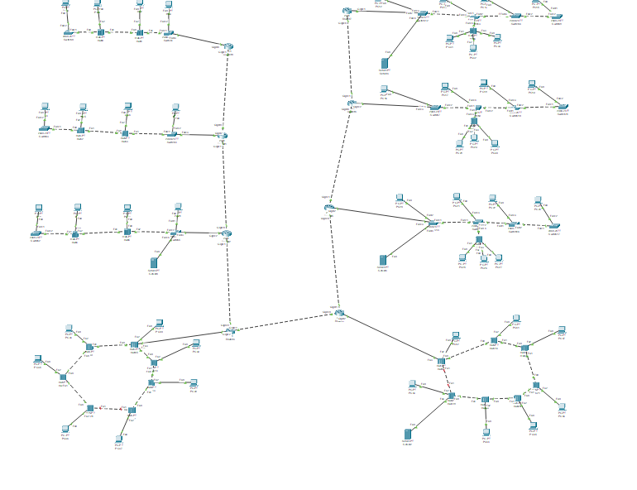

I have created network for a University campus consisting of different departments:

* Floors 1–3 have 4 computers each. **(use of Bus Topology with switch and hub)**
* Floors 4–6 have 5 computers each. **(use of Hybrid Topology with switch)**
* Floors 7–8 have 7 computers each. **(use of Mesh Topology with Hub)**

1. **IP VALUES and Servers:**

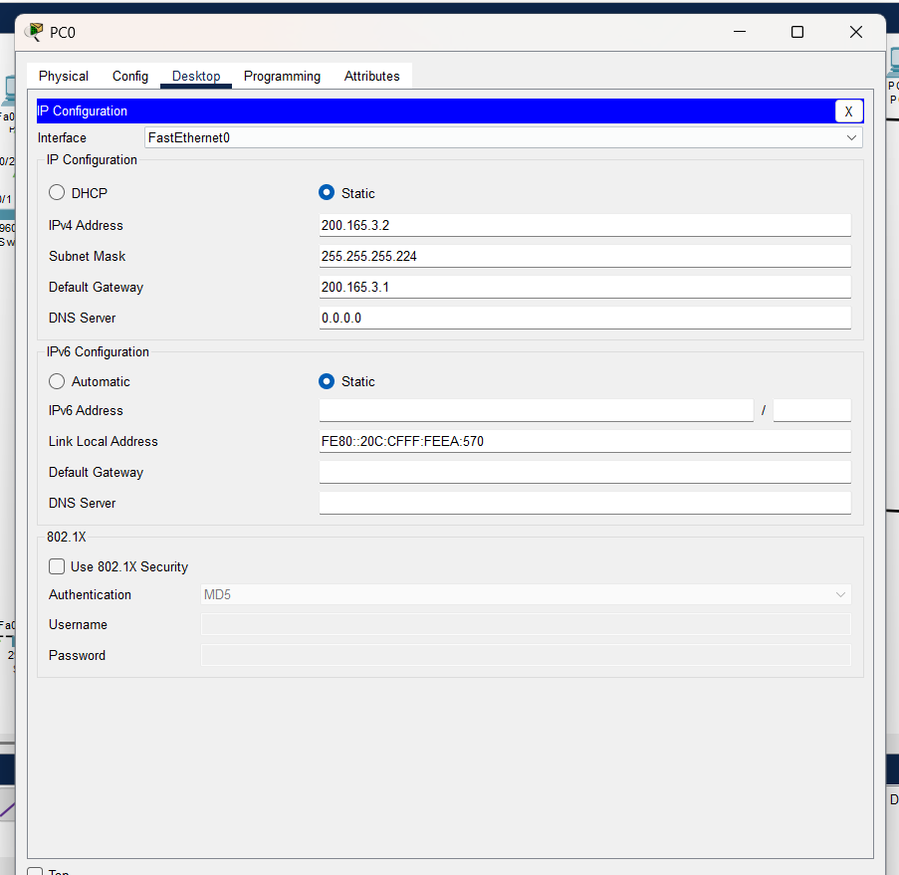

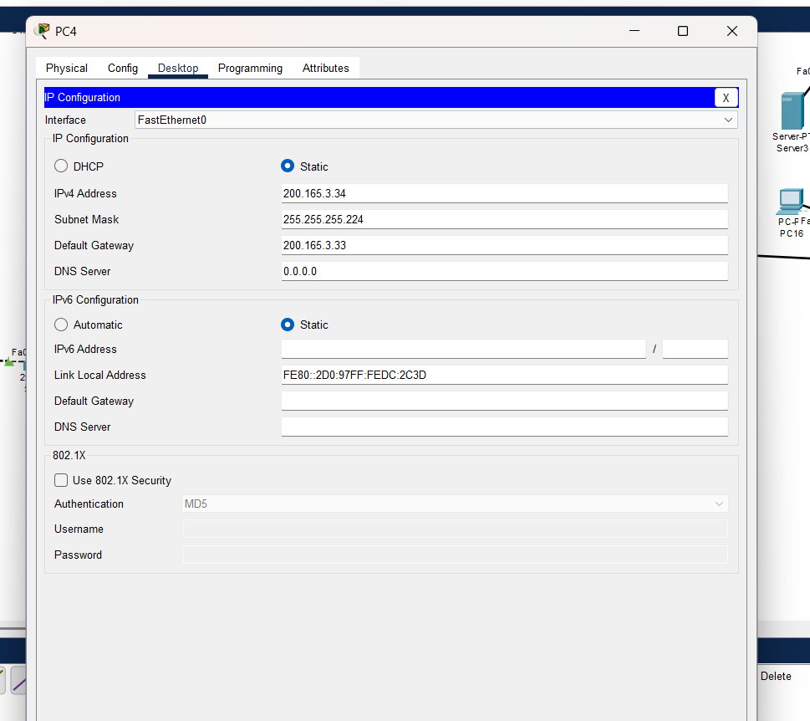

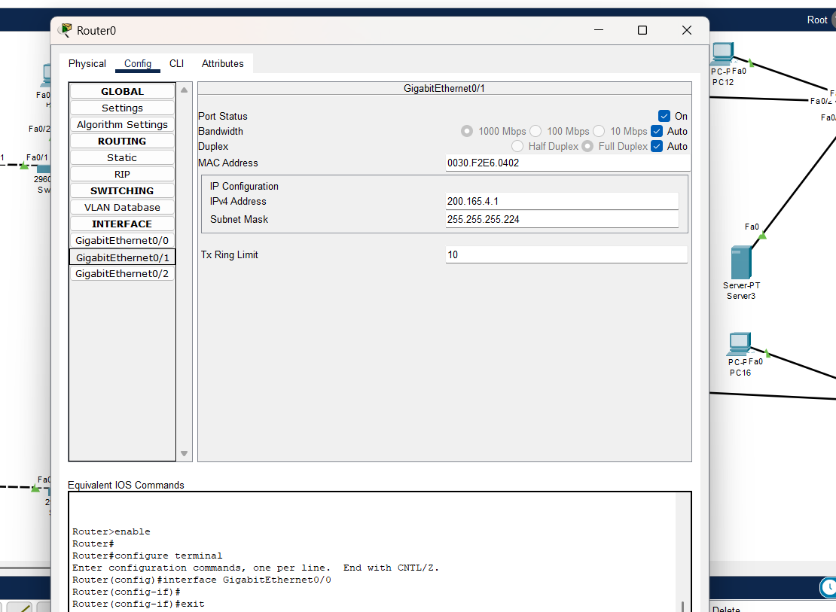

using **FLSM**, with the **network address** **200.163.3.0**

FLSM : Fixed Length Subnet Mask.

I have total subnets are 8. So using FLSM I have created new subnet mask and subnet address.

In FLSM, subnet mask is same for all networks .

2n >= 8

23 >= 8 (n = 3)

8 = 8

Given class was C:

In class C we have 32 and 8 network and host. So we have to add 3 to network and subtract 3 from host. So the new network and host are 35 and 5.

From this , we can easily find subnet mask.

--------.--------.--------.--------

8 8 8 3 128+64+32= 224.

So , The new subnet mask is **255.255.224.0 256-224 = 32**

**Now** we have to find Range : Difference is 32

200.163.3.0 to 200.163.3.31

200.163.3.32 to 200.163.3.63

200.163.3.64 to 200.163.3.95

200.163.3.96 to 200.163.3.127

200.163.3.128 to 200.163.3.159

200.163.3.160 to 200.163.3.191

200.163.3.192 to 200.163.3.223

200.163.3.224 to 200.163.3.255

**DHCP & DNS SERVER:**

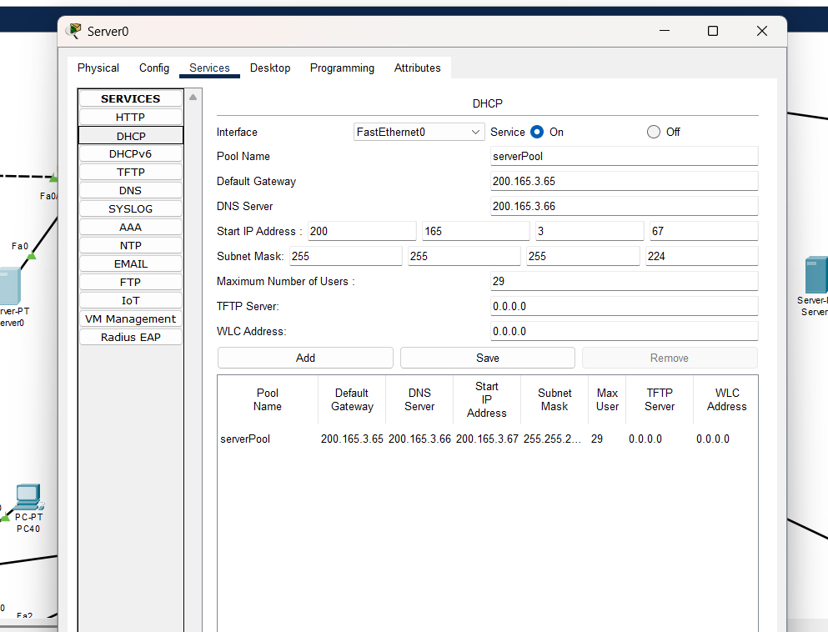

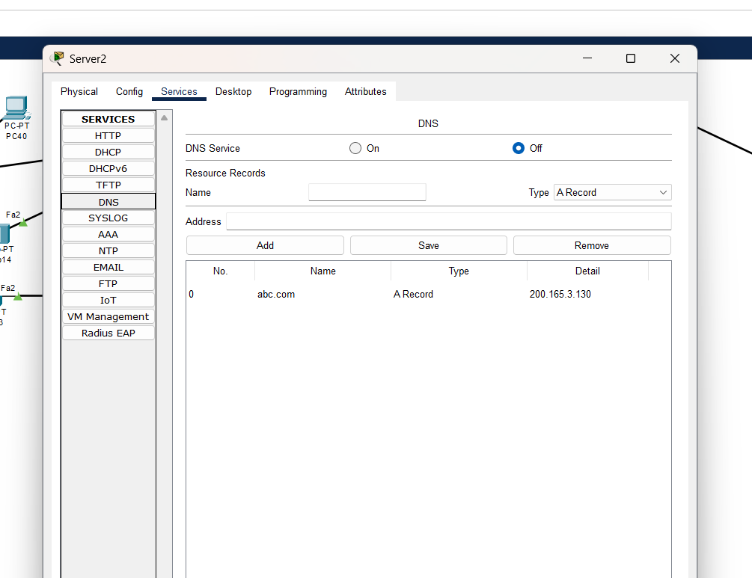

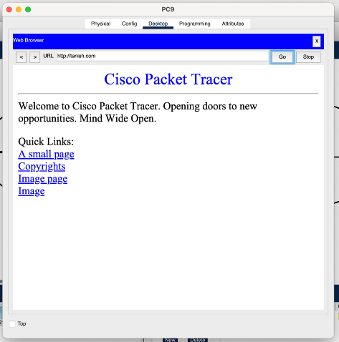

**EMAIL:**

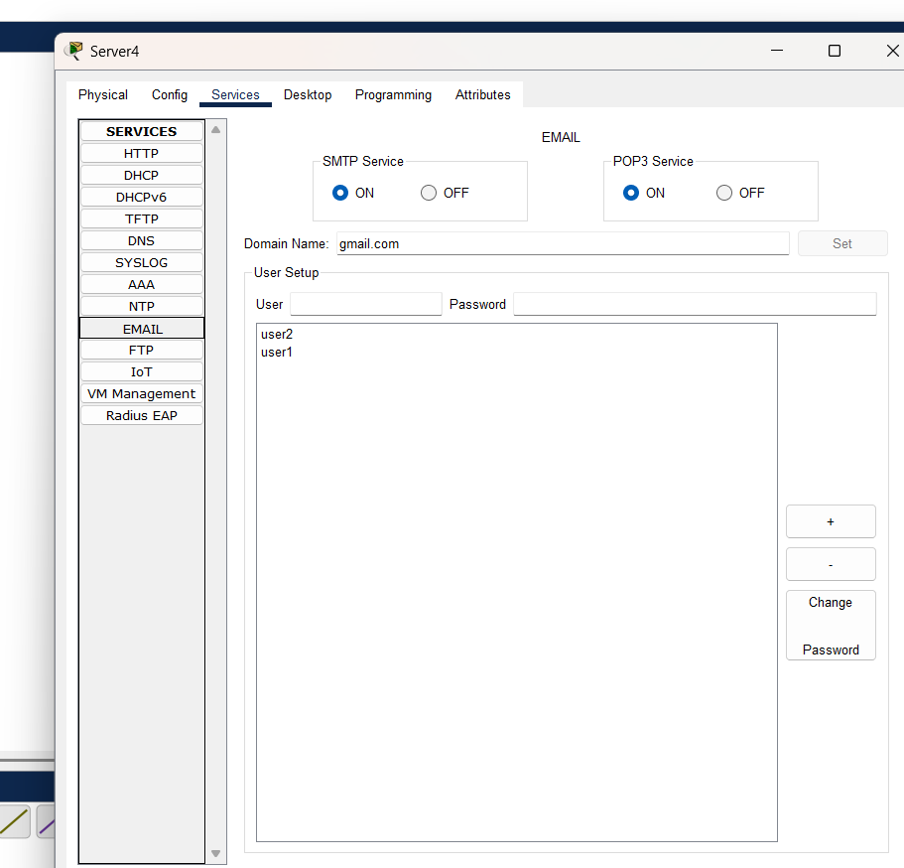

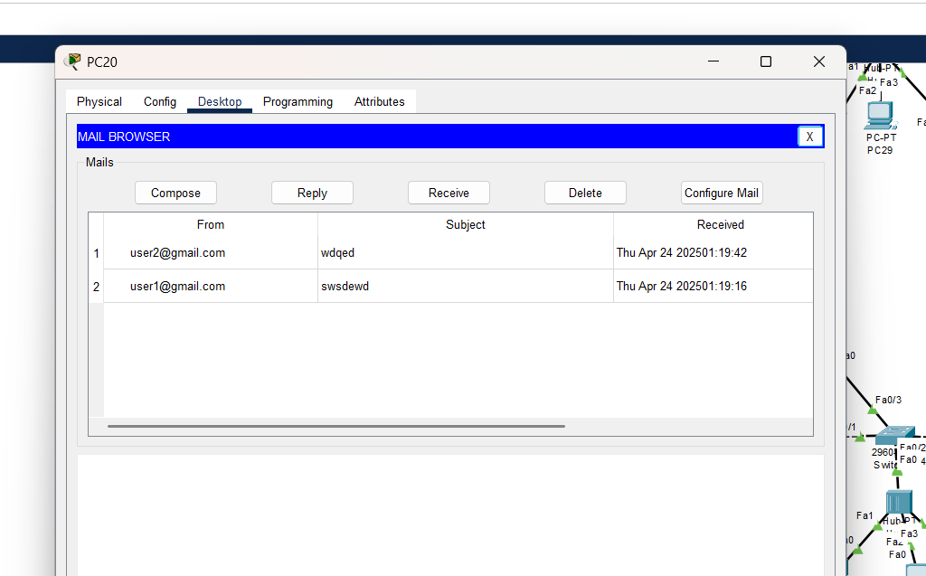

**FTP:**

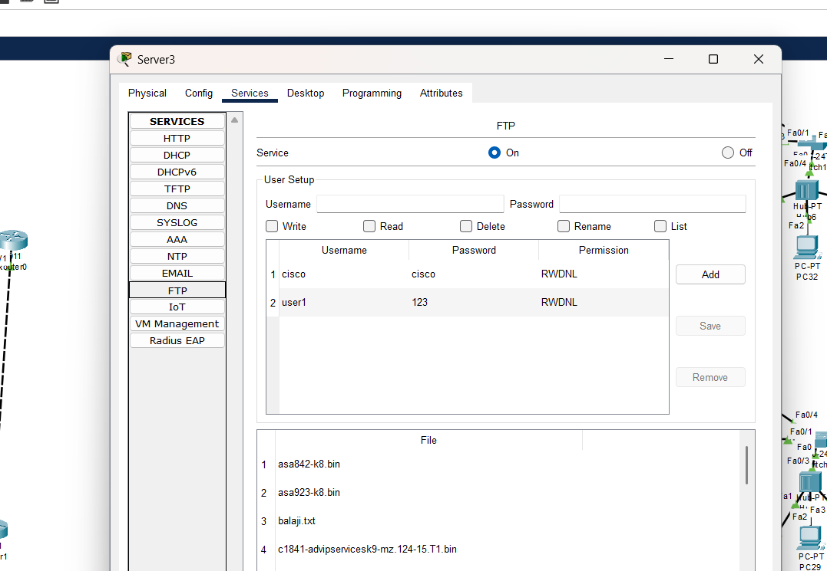

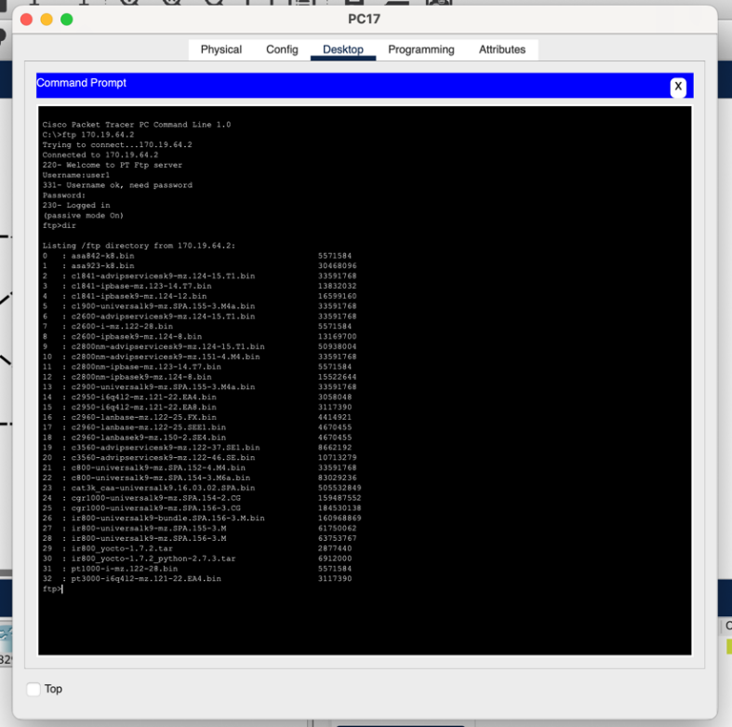

1. **Routing:**

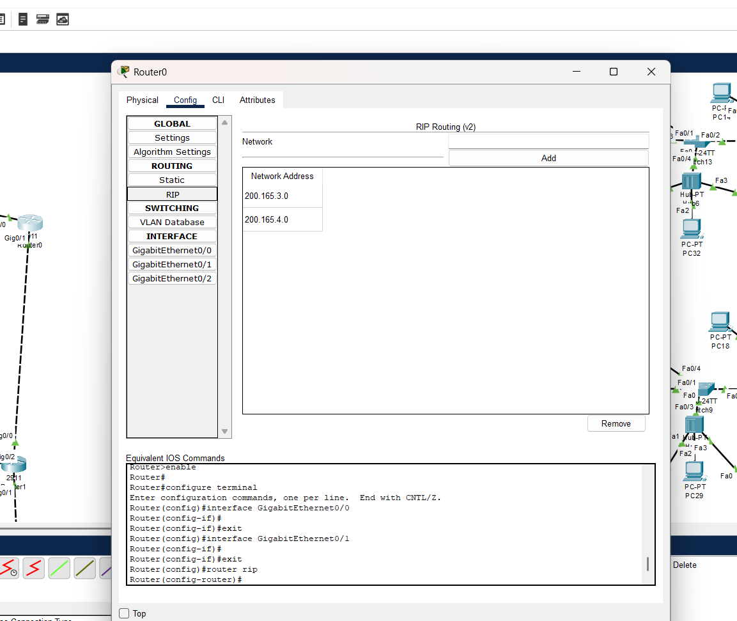

Static Routing was used here:

Commands for static routing : #ip route _unknown network_ _subnet mask_ _net hope_

**4. Communication between pc:**

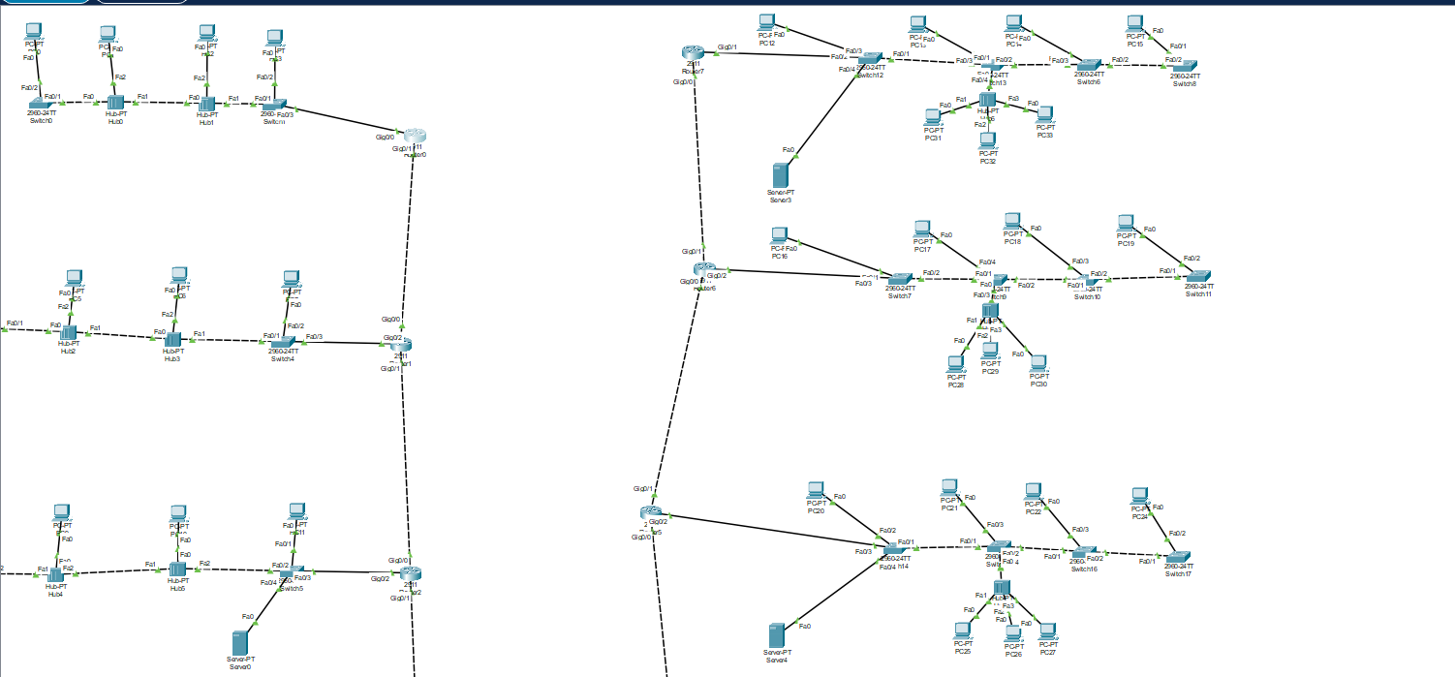

After Routing :

You can see in above pic that all the message sent from one pc to another became successful.

Example: PC8 TO PC63:

(You can clearly see that PC8 is attached to Router 4 and PC63 is attached to Router 3. So you can confirm that message is pass through R4 TO R3 )

Finally , we can send message pc to any pc .

**GIT-HUB link:** [**https://github.com/Tirumalareedy/CiscoPacketTracer**](https://github.com/Tirumalareedy/CiscoPacketTracer)

**\*THANK YOU\***