**ELECTRIC VEHICLE (EV) MARKET SEGMENTATION AND STRATEGY REPORT**

Tiruveedula Ajay

19/02/2025

**PROBLEM STATEMENT**

This report analyses the EV manufacturing landscape in India to identify key state-wise and city-wise segments. The goal is to provide insights for developing market strategies and understanding regional EV production hubs, supporting the growth of the electric vehicle ecosystem in India.

**1. INTRODUCTION**

This report presents an analysis of India's Electric Vehicle (EV) market using two datasets:

1. EV Maker by Place – Analyzing geographical distribution and major manufacturers.
2. State-wise EV Market Segmentation – Exploring vehicle class, category, and adoption trends.

The goal is to identify key trends, market clusters, and strategic insights that can support the growth of India's EV ecosystem.

**2. EV MANUFACTURER ANALYSIS**

**2.1 Key States for EV Manufacturing**

The **top states** leading in EV manufacturing include:

* **Maharashtra (10 manufacturers)** – Tata Motors, Bajaj, Mahindra.
* **Tamil Nadu (9 manufacturers)** – TVS, Ather Energy, Renault India.
* **Karnataka (7 manufacturers)** – Ather, Ola Electric, Bosch India.

These states have strong industrial ecosystems supporting EV production.

**2.2 City-wise EV Manufacturing Clusters**

* **Pune, Chennai, Bengaluru** are the top cities for EV production.
* **Established hubs** focus on four-wheelers (e.g., Tata Motors, Hyundai).
* **Emerging hubs** focus on two-wheelers and electric mobility startups (e.g., Ather Energy, Ola Electric).

**2.3 Market Segmentation by Manufacturer Type**

* **Four-Wheeler Segment:** Tata Motors, Hyundai, MG Motor.
* **Two-Wheeler Segment:** Hero Electric, TVS, Ather Energy.
* **Three-Wheeler Segment:** Mahindra Electric, Kinetic Green, Bajaj Auto.

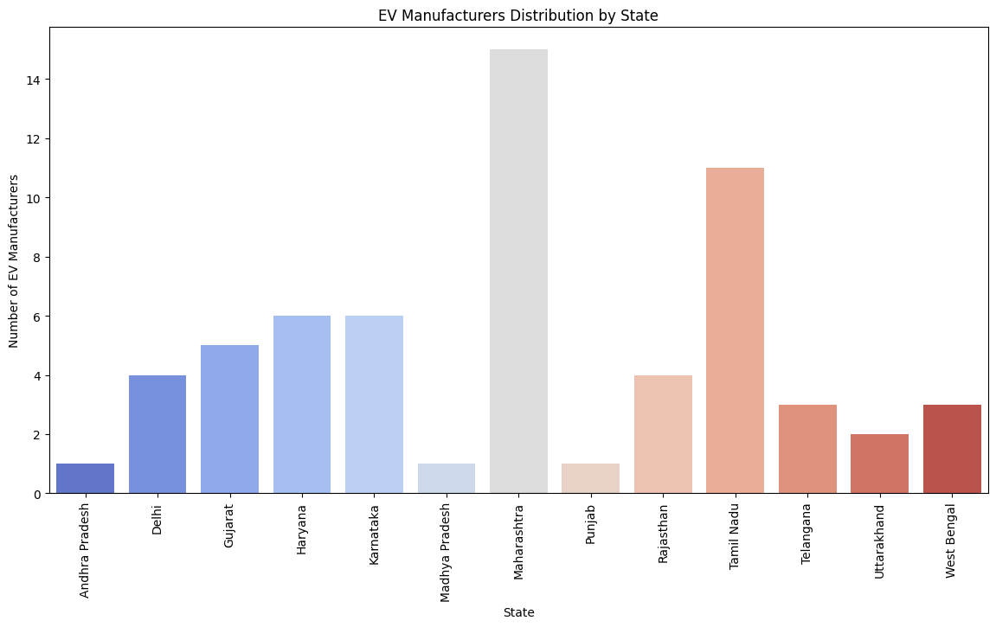

**3. STATE-WISE EV MARKET SEGMENTATION**

**3.1 EV Adoption Trends by State**

* State-wise analysis of total EV registrations reveals:
* **High Adoption States**: Maharashtra, Karnataka, and Tamil Nadu.
* **Moderate Growth**: Gujarat, Delhi, and Rajasthan.
* **Emerging Markets**: Telangana, Andhra Pradesh, and West Bengal.

**3.2 VEHICLE CLASS & CATEGORY ANALYSIS**

* Two-wheelers dominate the EV market, followed by four-wheelers and three-wheelers.
* Commercial EVs (three-wheelers & electric buses) are expanding due to government incentives and urban mobility solutions.
* Personal EVs (cars & two-wheelers) are gaining popularity with consumer subsidies and infrastructure growth.

**3.3 EV Sales and Market Expansion Segmentation**

* **Highest Sales Regions**: Maharashtra, Karnataka, Delhi.
* **Policy-driven growth areas**: Tamil Nadu, Gujarat, Telangana.
* **Emerging Demand Areas**: Andhra Pradesh, Punjab, Uttar Pradesh.

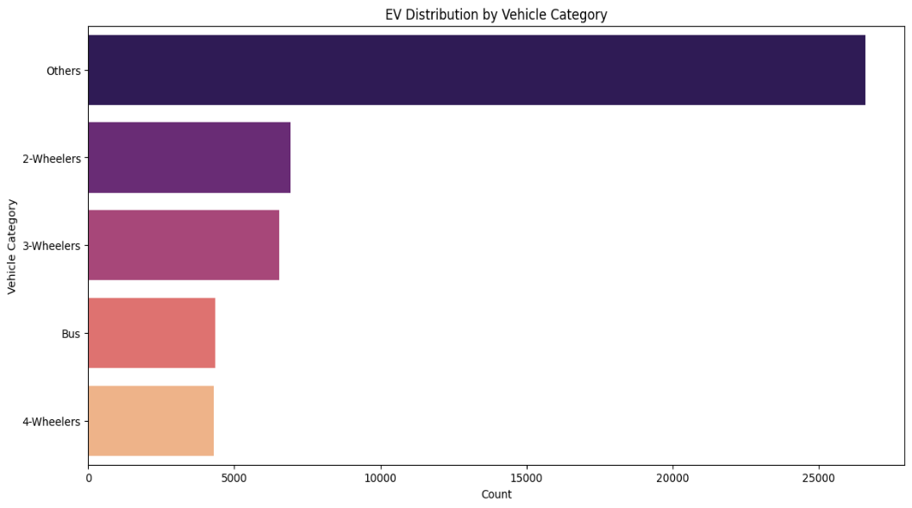

**4. Machine Learning Model Used**

To perform market segmentation, we used K-Means Clustering, an unsupervised machine learning algorithm that groups states based on EV adoption patterns. By normalizing the data and applying clustering techniques, we identified distinct market segments that help in understanding state-wise EV growth potential.

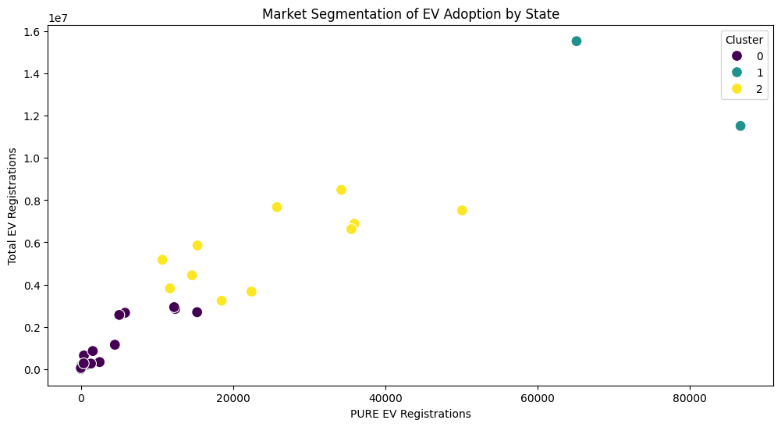

**5. KEY INSIGHTS & CONCLUSION**

* **Maharashtra, Tamil Nadu, and Karnataka** lead in both EV manufacturing and adoption.
* **Two-wheelers dominate** the market, followed by four-wheelers and three-wheelers.
* **Strategic focus on policy initiatives, infrastructure investments, and R&D** can accelerate EV adoption.
* **Emerging markets like Telangana, Punjab, and Rajasthan** present opportunities for future growth.

**6. ENHANCEMENTS FOR FUTURE ANALYSIS**

Given additional **time and budget**, we can enhance this project by:

* **Expanding Dataset Scope:** Including consumer preference surveys, charging station availability, and regional subsidy data.
* **New ML Models:** Trying **Hierarchical Clustering, Decision Trees, and Random Forests** for more refined segmentation.
* **Feature Additions:** Collecting additional columns like **battery range, charging time, government incentives, and consumer preferences** to improve analysis accuracy.

**7. MARKET SIZE ESTIMATION**

The estimated market size for the Indian EV sector (non-segmented) is projected to reach **$206 billion by 2030**, driven by policy support, battery technology advancements, and increasing consumer adoption.

**8. KEY MARKET SEGMENTATION FEATURES**

The **top four variables** for optimal market segmentation are:

* **State-wise EV adoption rate**
* **Vehicle class (two-wheeler, four-wheeler, three-wheeler)**
* **Total sales per state**
* **Presence of EV manufacturers in each state**

These features help in building robust and accurate market segmentation models, assisting stakeholders in policy planning and market expansion.

With targeted policies, sustainable infrastructure development, and industry collaborations, India is well-positioned to accelerate its transition towards an electric mobility future. ⚡🚗