**Snipe-IT Installation on GCP VM (Ubuntu) - Step-by-Step Guide**

**Step 1: SSH into your GCP VM**

Connect to your GCP VM to begin setup.

**Step 2: Update the system & install core tools** sudo apt update && sudo apt upgrade -y

sudo apt install unzip curl git -y

Updates your system and installs necessary tools.

**Step 3: Install Apache** sudo sudo apt install apache2 -y

Apache is the web server used to serve Snipe-IT.

**Step 4: Install PHP 8.2 and required extensions**

sudo apt install software-properties-common -y

sudo add-apt-repository ppa:ondrej/php -y

sudo apt install -y apache2 php8.2 php8.2-cli php8.2-common php8.2-mysql php8.2-curl php8.2-mbstring php8.2-xml php8.2-bcmath php8.2-gd php8.2-zip php8.2-tokenizer unzip curl git

Installs PHP and all required extensions for Snipe-IT.

# Step 5: Install MySQL and setup database

sudo apt install mysql-server -y sudo mysql_secure_installation sudo mysql -u root -p

CREATE DATABASE snipeit;

CREATE USER 'snipeuser'@'localhost' IDENTIFIED BY 'StrongPassword123';

GRANT ALL PRIVILEGES ON snipeit.* TO 'snipeuser'@'localhost';

FLUSH PRIVILEGES;

EXIT;

Creates MySQL database and user for Snipe-IT.

# Step 6: Install Composer

curl -sS https://getcomposer.org/installer | php

sudo mv composer.phar /usr/local/bin/composer

Composer installs PHP dependencies for Laravel.(anywhere we can run 🡪 like system path variables)

**Step 7: Download Snipe-IT via Git**

cd /var/www

sudo git clone https://github.com/snipe/snipe-it.git sudo chown -R $USER:www-data snipe-it

cd snipe-it

Clones the Snipe-IT codebase from GitHub.

**Step 8: Configure environment** cp .env.example .env

nano .env

Edit DB and APP_URL values in .env file.(during run time it needs to connect with db)

# Step 9: Install dependencies via Composer

composer install --no-dev --prefer-source

Installs all required Laravel dependencies.(in json file)

# Step 10: Generate App Key

php artisan key:generate

Generates Laravel application encryption key.(which helps to app secure from🡪 Session hijack, URL tampering, Token forgery etc)

# Step 11: Run database migrations

php artisan migrate

Creates all necessary tables in your MySQL DB.

(inside /database/migrations/ These files contain **PHP code that defines table structures**, like users, assets, locations, etc.)

**Step 12: Set permissions**

sudo chown -R www-data:www-data /var/www/snipe-it

sudo chmod -R 755 /var/www/snipe-it

Allows Apache to access the required files.

# Step 13: Configure Apache site

sudo nano /etc/apache2/sites-available/snipeit.conf Add Apache VirtualHost config pointing to /public.  
  
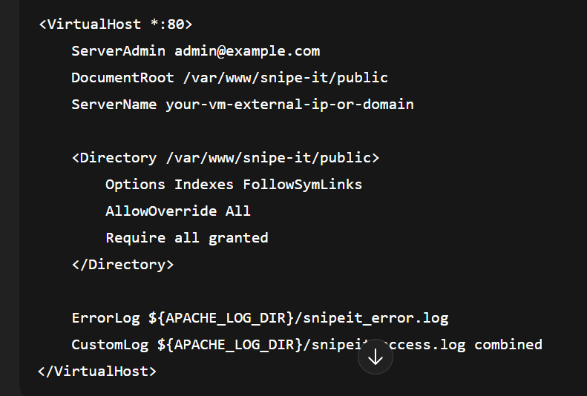

sudo a2ensite snipeit.conf sudo a2enmod rewrite

sudo systemctl restart apache2

Sets up Apache to serve Snipe-IT app.

# Step 14: Open in browser to finish setup

Visit http://<your-vm-ip> and complete the setup wizard.

Finish setting up your admin account and settings.

