[INSTITUTION NAME]
[College / Department Name]

COGNILAB: A WEB-BASED LABORATORY INFORMATION SYSTEM
FOR KRRAX-JAM INC
A Research Paper Presented to the Faculty of the
[College / Department Name]
[Institution Name]
In Partial Fulfillment of the Requirements for
[Degree / Program]
By
[Author Name 1]
[Author Name 2]
[Author Name 3]

[Adviser Name]
[Month Year]

ABSTRACT
Laboratory operations generate a large volume of patient, specimen, result, and billing records that must remain accurate, traceable, and confidential. Many small and medium-sized clinical laboratories still depend on paper forms, spreadsheets, and separate messaging threads, which increase transcription errors, delay result release, and weaken accountability. This study developed CogniLab, a web-based Laboratory Information System (LIS) for KRRAX-JAM Inc, to integrate the laboratory workflow from patient registration to report release. The system was developed using a developmental research design and an iterative, module-based software development process. It was implemented with Next.js 16, React 19, TypeScript, Tailwind CSS, and Supabase, which provides authentication, a PostgreSQL database, and real-time data services. CogniLab includes patient management, test requesting, automatic billing, specimen tracking, result encoding with reference-range and critical-value detection, senior quality checking, selective report release, role-based access, dashboards, and an audit trail. Results show that the system supports the complete laboratory workflow, enforces billing and quality-control prerequisites before report generation, and produces printable reports with electronic signatures. The production build completed successfully, and functional verification confirmed that the principal requirements were implemented. The study concludes that a tailored, cloud-hosted LIS can improve operational visibility, reduce manual handoffs, and strengthen record accountability in a small laboratory setting. Future work should include formal user acceptance testing, database-level row security policies, instrument interfacing, and automated testing.

Keywords: laboratory information system, web-based system, Supabase, Next.js, quality control, role-based access, healthcare informatics

TABLE OF CONTENTS
ABSTRACT 2
CHAPTER 1: INTRODUCTION 5
1.1 Background of the Study 5
1.2 Statement of the Problem 5
1.3 Objectives of the Study 6
1.4 Significance of the Study 6
1.5 Scope and Delimitation 6
1.6 Definition of Terms 7
CHAPTER 2: REVIEW OF RELATED LITERATURE AND SYSTEMS 8
2.1 Laboratory Information Systems 8
2.2 Standards and Regulatory Requirements 8
2.3 Web-Based and Cloud-Native Laboratory Systems 9
2.4 Role-Based Access Control and Audit Trails 9
2.5 Quality Control and Result Release 9
2.6 Synthesis and Research Gap 10
2.7 Conceptual Framework 10
CHAPTER 3: METHODOLOGY 11
3.1 Research Design 11
3.2 Development Model 11
3.3 Requirements Analysis 11
3.4 Technology Selection 12
3.5 Testing and Evaluation Strategy 12
3.6 Data Privacy and Ethical Considerations 13
3.7 Summary 13
CHAPTER 4: SYSTEM ANALYSIS AND DESIGN 14
4.1 Analysis of the Existing Process 14
4.2 Functional Requirements 14
4.3 Non-Functional Requirements 15
4.4 Actors and Role-Based Access 16
4.5 Use Case Analysis 16
4.6 System Architecture 17
4.7 Data Design 18
4.8 Process Design 19
4.9 Interface Design 21
4.10 Security Design 21
4.11 Summary 21
CHAPTER 5: IMPLEMENTATION 22
5.1 Development Environment and Project Structure 22
5.2 Authentication and Session Management 22
5.3 Patient Management 22
5.4 Test Request and Automatic Billing 23
5.5 Billing and Payment Management 23
5.6 Specimen Tracking 23
5.7 Test Result Encoding and Clinical Decision Support 23
5.8 Quality Checking 24
5.9 Report Generation and Printing 24
5.10 Administration, Audit Logging, and Dashboards 24
5.11 Profile Management 25
5.12 Implemented Business Rules 25
5.13 Data Access Layer and Mock Mode 25
CHAPTER 6: RESULTS AND DISCUSSION 26
6.1 Overview of the Evaluation 26
6.2 Functional Requirement Coverage 26
6.3 Core Scenario Walkthroughs 27
6.4 Functional Verification 27
6.5 Technical Quality 28
6.6 Security and Privacy 28
6.7 Usability 29
6.8 Limitations of the Evaluation 29
6.9 Summary 29
CHAPTER 7: CONCLUSION AND RECOMMENDATIONS 30
7.1 Summary of Findings 30
7.2 Conclusion 30
7.3 Recommendations 30
7.4 Future Work 31
7.5 Concluding Statement 31
REFERENCES 32
APPENDICES 33
Appendix A. Sample User Acceptance Testing Form 33
Appendix B. Quick Operational Guide 33

CHAPTER 1: INTRODUCTION

1.1 Background of the Study
A clinical laboratory produces information that directly influences diagnosis, treatment, and patient safety. Every specimen that enters the laboratory carries a chain of information: who the patient is, which physician requested the test, what analytes are needed, when the specimen was collected, who performed the analysis, whether the result passed quality review, and whether the corresponding service has been paid. When these pieces of information are kept in separate paper forms, spreadsheets, and informal messages, the laboratory becomes vulnerable to transcription errors, missing records, duplicate billing, delayed release, and weak accountability. A Laboratory Information System (LIS) addresses these risks by organizing the laboratory workflow around a single, traceable record.
International standards recognize information management as a core element of laboratory quality. ISO 15189:2022 requires medical laboratories to control documents and records, ensure the integrity of examination data, and maintain traceability throughout the pre-analytical, analytical, and post-analytical phases (International Organization for Standardization [ISO], 2022). The World Health Organization (2011) similarly identifies information management as one of the twelve quality system essentials in its laboratory quality management framework. These standards do not require a particular software product, but they do require that information be accurate, legible, protected, and retrievable. A well-designed LIS provides the operational mechanism for meeting those expectations.
In the Philippine context, the handling of patient information is also governed by Republic Act No. 10173, the Data Privacy Act of 2012, which requires organizations to process personal data fairly and lawfully, limit access to authorized personnel, and safeguard sensitive information against unauthorized disclosure (Republic of the Philippines, 2012). Health information is among the most sensitive categories of personal data. Consequently, a laboratory information system must do more than store records; it must authenticate users, restrict functions according to role, and keep an audit trail of significant actions.
KRRAX-JAM Inc operates a training-oriented clinical laboratory with multiple sections, including blood bank, hematology, clinical microscopy, clinical chemistry, microbiology, immunology and serology, and histopathology. The laboratory handles patient registration, test requesting, specimen collection and tracking, result encoding, quality checking, billing, and report release. These activities are interrelated, yet they are often performed by different staff members at different times. Without a shared system, coordination depends on manual endorsements, and the status of a specimen or result may not be visible to the person who needs it.
CogniLab was developed as a response to this operational problem. It is a web-based LIS that combines patient management, test requesting, automatic billing, specimen tracking, result encoding, quality checking, report generation, administration, and audit logging in one application. The system is built on a modern JavaScript stack and uses Supabase for authentication and relational data storage. Its interface follows a consistent green-and-white visual identity, and its modules are organized around the actual sequence of laboratory work rather than around isolated administrative tasks. This study documents the design, implementation, and functional verification of the system.

1.2 Statement of the Problem
The laboratory's day-to-day operations depend on timely and reliable information. However, the existing workflow relies on fragmented records and manual coordination, making it difficult to guarantee that every test is billed, every specimen is accounted for, every result is reviewed, and every released report is supported by a complete audit trail. This general problem may be expressed through the following specific questions:
- How can patient demographics, laboratory requests, specimen status, results, and billing records be consolidated into a single traceable workflow?
- How can the system automatically generate billing records for requested tests while avoiding duplicate charges for component tests that belong to a parent examination?
- How can reference ranges and critical value bands be applied consistently to flag abnormal and potentially urgent results?
- How can quality checking be restricted to authorized senior staff and be made a prerequisite for report release?
- How can printable laboratory reports be generated only for results that have passed quality review and have satisfied the laboratory's payment policy?
- How can user actions be recorded so that access and changes remain auditable?

1.3 Objectives of the Study
The general objective of this study was to design, develop, and evaluate a web-based Laboratory Information System that integrates the core workflows of KRRAX-JAM Inc. Specifically, the study aimed to:
- design a unified patient and laboratory record that connects registration, test requests, billing, specimens, results, quality checks, and reports;
- implement role-based authentication and authorization for junior medical technologists, senior medical technologists or faculty, and administrators;
- automate billing for requested tests and prevent duplicate billing for component tests that map to a parent examination;
- implement a specimen tracking pipeline with clear, sequential statuses from accessioning to test completion;
- encode result values with units and reference ranges, and automatically classify results as normal, low, high, alert-low, or alert-high;
- enforce a senior quality-check step before results can be included in a report;
- generate professional, printable laboratory reports with selective result release, electronic signatures, and payment verification; and
- provide dashboards, user management, and an audit trail for operational oversight.

1.4 Significance of the Study
The study is significant to several groups. For patients, the system supports faster and more reliable release of laboratory reports because the status of each request is visible and the report cannot be released without the required review. For medical technologists, the system reduces repetitive transcription and provides a structured workspace for specimen handling, result entry, and quality checking. For the laboratory manager and administrator, the dashboard and audit trail provide operational visibility that is difficult to obtain from paper records. For the institution, the system demonstrates a practical, affordable approach to digitalization that can be extended to other laboratory sections or branches. For future researchers, the study provides a documented architecture, data model, and set of business rules that can be reused, evaluated, or extended.

1.5 Scope and Delimitation
The study covers the design and implementation of CogniLab as a web-based laboratory information system for a single laboratory facility. Its functional scope includes authentication, patient registration and demographics, test requesting, automatic billing, payment recording, specimen tracking, result encoding, quality checking, report generation and printing, user administration, profile management, dashboards, and audit logging. The system supports the laboratory sections and test catalogs defined in its configuration, including blood bank, hematology, clinical microscopy, clinical chemistry, microbiology, immunology and serology, and histopathology.
The study does not cover direct interfacing with laboratory instruments, automated analyzer output, barcode printer integration, SMS or email notifications, online payment gateways, insurance claims processing, multi-branch consolidation, or telemedicine. Billing is treated as an internal record of charges and payments; the system does not process actual card or e-wallet transactions. The study also does not include a statistically analyzed user acceptance study. Evaluation is limited to functional verification, build validation, and a review of the implemented workflows. Formal usability and effectiveness testing with end users is recommended as future work.

1.6 Definition of Terms
Audit trail — A chronological record of user actions and system events that supports accountability, security review, and compliance.
Automatic billing — The process of creating a billing record from a test request or result entry without requiring a separate manual data entry step.
Critical value — A result that falls outside a defined alert range and may require urgent clinical attention.
Laboratory Information System (LIS) — A software system that manages laboratory information, including patient records, test orders, specimens, results, quality checks, billing, and reports.
Quality check (QC) — A review step in which an authorized senior staff member verifies that a result is complete, plausible, and consistent with laboratory standards before release.
Reference range — The interval of values considered typical for a given analyte, used to classify a result as normal, low, or high.
Role-based access control (RBAC) — An access model in which permissions are assigned according to a user's role rather than to individual users.
Row-level security (RLS) — A database mechanism that restricts which rows a user may read or modify based on the authenticated identity.
Specimen tracking — The recording of a specimen's status as it moves through accessioning, collection, receipt, analysis, and completion.
Supabase — An open-source backend platform that provides authentication, a PostgreSQL database, real-time subscriptions, and storage APIs.

CHAPTER 2: REVIEW OF RELATED LITERATURE AND SYSTEMS

2.1 Laboratory Information Systems
A Laboratory Information System is an information system designed to support the operational and informational needs of a clinical laboratory. Its core functions typically include order entry, specimen accessioning, result entry and validation, report generation, quality control, and billing. In larger institutions, the LIS is interfaced with hospital information systems, electronic medical records, and analyzers. In smaller institutions, it may be the primary digital record for the laboratory. Regardless of scale, the LIS exists to ensure that the right result reaches the right patient with the right context and within the right timeframe.
The literature on health information systems consistently links digitalization with improved legibility, faster retrieval, and stronger accountability. Laudon and Laudon (2020) describe information systems as sociotechnical systems in which technology, processes, and people must be aligned; a system that automates a poorly designed workflow can amplify rather than remove inefficiency. This observation is particularly relevant to laboratory systems, where the sequence of tasks matters and where a single missing field can delay an entire request.
Software engineering research also emphasizes the importance of requirements traceability. Wiegers and Beatty (2013) argue that requirements should be documented, prioritized, and linked to design and test artifacts so that the delivered system can be verified against stakeholder needs. The present study applies this principle by mapping each functional requirement to an implemented module and to a verification case in the results chapter.

2.2 Standards and Regulatory Requirements
ISO 15189:2022 is the principal international standard for medical laboratories. It addresses quality management, technical competence, and information management. Among its requirements are the control of records, the protection of patient information, the validation of examination methods, and the review of results before release (ISO, 2022). These requirements provide a useful benchmark for evaluating an LIS: the system should preserve data integrity, support review, and make retrieval possible.
The Clinical and Laboratory Standards Institute (CLSI) publishes consensus standards for laboratory quality and informatics. Although the specific documents vary by jurisdiction and discipline, the underlying principles are consistent: standardized processes, documented procedures, and traceable records. In the design of CogniLab, these principles are reflected in the staged specimen pipeline, the explicit result statuses, and the audit log.
In the United States, the Health Insurance Portability and Accountability Act (HIPAA) establishes national standards for the protection of individually identifiable health information. HIPAA's Security Rule requires administrative, physical, and technical safeguards, including access controls, audit controls, integrity controls, and transmission security (U.S. Department of Health and Human Services, n.d.). Although HIPAA does not directly govern Philippine laboratories, it provides a widely recognized reference for security design.
In the Philippines, Republic Act No. 10173 requires personal information controllers to implement reasonable and appropriate security measures, limit access to personal data, and notify affected individuals and the National Privacy Commission in the event of a breach (Republic of the Philippines, 2012). For a laboratory system, this translates into authenticated access, role-based permissions, encrypted transmission, and retention policies. Interoperability standards such as HL7 FHIR define how health data can be exchanged between systems (HL7 International, n.d.); although CogniLab does not yet implement FHIR interfaces, its data model is structured in a way that can be mapped to future interoperability requirements.

2.3 Web-Based and Cloud-Native Laboratory Systems
Web-based systems offer several advantages for small and medium-sized laboratories. They require only a browser and network connection, centralize updates, and can be accessed from multiple workstations without installing client software. Cloud-hosted backends further reduce infrastructure requirements by providing managed databases, authentication, and backup services. These characteristics make web-based systems attractive in resource-constrained settings, provided that connectivity and data protection are addressed.
Modern web frameworks support component-based development, type safety, and responsive interfaces. Next.js provides server-side rendering, file-based routing, and production optimization, while React provides a declarative component model for building interactive interfaces (Vercel, n.d.; Meta Open Source, n.d.). TypeScript adds static typing, which can catch integration errors during development. These technologies are well suited to a system that must present many forms, tables, and status transitions without sacrificing maintainability.
Supabase provides a managed PostgreSQL database, email and password authentication, row-level security policies, real-time subscriptions, and storage (Supabase, n.d.). Its combination of relational data storage and authentication makes it a practical choice for a laboratory system that must associate users, patients, results, and audit events. At the same time, the use of a hosted backend requires careful configuration of access policies, environment variables, and backup procedures.

2.4 Role-Based Access Control and Audit Trails
Role-based access control limits what a user can do according to the user's role. In a laboratory, the principle of least privilege implies that a junior medical technologist should be able to register patients, create requests, and encode results, but should not be able to approve quality checks or administer users. A senior medical technologist or faculty member may review and approve results, while an administrator manages accounts and inspects the audit log. Role design must balance operational flexibility with accountability.
Audit trails complement access control by recording who did what and when. The OWASP Top 10 identifies broken access control and security logging failures as major application risks (OWASP Foundation, 2021). A laboratory audit trail should capture authentication events, record views and edits, deletions, report downloads, and quality-check decisions. It should be append-only from the perspective of ordinary users and should be reviewed periodically. CogniLab implements an audit log table and records significant actions such as patient creation, result updates, billing changes, quality checks, and report access.

2.5 Quality Control and Result Release
Quality control in the laboratory covers pre-analytical, analytical, and post-analytical activities. Pre-analytical controls include patient identification, specimen collection, labeling, and transport. Analytical controls include reagent integrity, calibration, and instrument performance. Post-analytical controls include result review, reference-range comparison, critical value notification, and report release. An LIS can support these controls by requiring structured data entry, displaying reference ranges, flagging abnormal values, and enforcing review steps.
The concept of a critical value is particularly important. A critical value is a result that may indicate an immediate threat to patient safety, such as a very low hemoglobin or a very high potassium. Laboratories are expected to have procedures for identifying and communicating such values. CogniLab implements this concept through two layers: a reference range that classifies results as low or high, and an alert range that classifies results as alert-low or alert-high. The latter is intended to draw attention to values that require urgent review.
Result release is the final control point. A result should not be released merely because it has been encoded; it should be reviewed by an authorized person. The system should also ensure that the corresponding service has been paid, if the laboratory's policy requires payment before release. CogniLab implements these conditions through a quality-check record and a report eligibility screen that checks result status, quality check completion, and payment before allowing printing.

2.6 Synthesis and Research Gap
The reviewed literature establishes three broad requirements for a laboratory information system: workflow integration, regulatory compliance, and accountable access. Commercial LIS products address these requirements, but they are often priced for large institutions and require extensive configuration. Small laboratories may respond by using spreadsheets or general-purpose tools, which provide storage but not workflow control. There is therefore a need for a tailored system that is affordable, understandable, and aligned with the actual sequence of laboratory work.
CogniLab addresses this gap by implementing a focused set of modules for a single laboratory. It does not attempt to replace a full hospital information system. Instead, it concentrates on the laboratory's core information flow and on the controls that are most often missing in manual operations: automatic billing, specimen status tracking, reference-range flagging, senior quality review, selective report release, and audit logging. The study contributes a concrete implementation and a documented design that can be adapted by similar laboratories.

2.7 Conceptual Framework
The study is guided by an input-process-output (IPO) framework. The inputs are the stakeholder requirements and the laboratory's domain knowledge, including reference ranges, critical value bands, test prices, and regulatory rules. The process is the CogniLab system, which transforms those inputs into organized digital records through authentication, patient and request management, automatic billing, specimen tracking, result encoding, quality checking, and report generation. The outputs are accurate and traceable records, timely result release, printable reports, billing accountability, and an audit trail. The outcomes are reduced manual errors, faster turnaround, improved confidentiality, and better operational visibility. A feedback loop represents continuous improvement based on user feedback, quality review, and system monitoring.
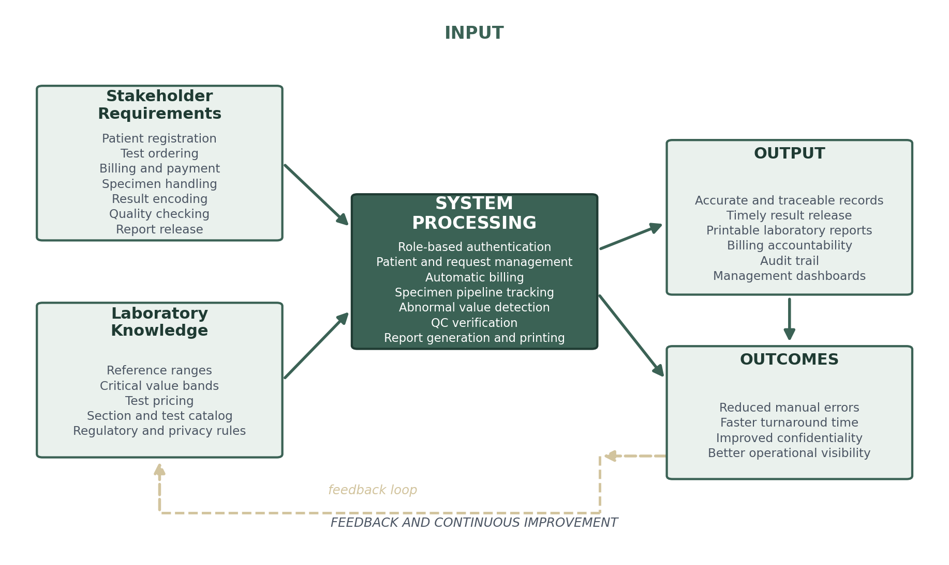
Figure 1. Conceptual Framework of the Study

CHAPTER 3: METHODOLOGY

3.1 Research Design
The study used a developmental research design. Developmental research is appropriate when the goal is to produce and evaluate an artifact that addresses a practical problem. In this case, the artifact is a web-based laboratory information system, and the problem is the fragmentation of laboratory records and controls. The study combined descriptive analysis of the laboratory workflow with iterative software development and functional verification.
The descriptive component documented the existing process, the actors involved, the information produced at each step, and the points at which manual handoffs created risk. The development component translated those findings into requirements, design artifacts, and working software. The verification component checked whether the implemented modules satisfied the requirements and whether the system could be built and deployed without errors.

3.2 Development Model
The system was developed using an iterative, module-based process inspired by Agile principles. Agile approaches emphasize working software, incremental delivery, and responsiveness to feedback (Schwaber & Sutherland, 2020). Because the laboratory workflow contains many interdependent modules, development proceeded in short cycles: requirements and data model first, then patient and request management, then billing and specimen tracking, then results and quality checking, and finally reports, dashboards, and administration.
Each cycle followed a similar pattern: identify the user story, define the data fields and validation rules, implement the interface and data access functions, test the module against representative scenarios, and integrate it with the existing modules. This incremental approach made it possible to stabilize the shared data model early and to refine individual screens without disrupting the rest of the system. Table 1 summarizes the phases and outputs.
Table 1. Development Phases, Activities, and Outputs
Phase | Activities | Outputs
Planning | Define the problem, scope, stakeholders, and success criteria. | Project scope, objectives, and feature list
Requirements | Map the laboratory workflow; identify actors, data fields, rules, and exceptions. | Functional and non-functional requirements; use cases
Design | Define the architecture, data model, navigation, and interface standards. | Architecture diagram, ERD, role matrix, wireframe decisions
Implementation | Build modules iteratively; connect the interface to the data layer; apply validation and audit rules. | Working patient, request, billing, specimen, result, QC, report, and admin modules
Verification | Run the production build; check TypeScript compilation; execute functional test cases. | Build report, verification matrix, defect list
Deployment and maintenance | Configure environment variables; deploy the Next.js application; plan backups and updates. | Deployed system and maintenance plan
Source: Developed by the researcher (2026).

3.3 Requirements Analysis
Requirements were derived from three sources: the laboratory's existing forms and records, the observed sequence of tasks performed by laboratory staff, and the regulatory and quality requirements discussed in Chapter 2. The existing forms identified the minimum data fields for patient registration, test requests, results, and billing. The workflow observation identified the handoffs that needed to be supported by the system, such as the transition from a paid request to a collected specimen and from an encoded result to a quality-checked report. The standards identified the controls that needed to be preserved, such as traceability, confidentiality, and review before release.
The requirements were organized into functional and non-functional categories. Functional requirements describe what the system must do, such as register a patient or record a payment. Non-functional requirements describe how well it must do it, such as remaining usable on a mobile device or protecting data from unauthorized access. Each requirement was assigned an identifier so that it could be traced to a module and a verification case. This traceability supports the discussion in Chapter 6.

3.4 Technology Selection
Technology selection was guided by four criteria: fitness for the workflow, development speed, maintainability, and cost. The chosen stack combines a modern React-based front end with a managed Supabase backend. Next.js was selected because it provides routing, production optimization, and a mature developer experience. React was selected because its component model suits the system's many forms, tables, and modal workflows. TypeScript was selected to reduce integration errors, and Tailwind CSS was selected to support consistent, responsive styling.
Supabase was selected because it provides authentication and a PostgreSQL database without requiring the team to operate a separate server. Recharts was used for the dashboard visualizations, Lucide React for consistent icons, and react-to-print for report printing. Table 2 summarizes the stack and the rationale for each choice.
Table 2. Technology Stack and Justification
Technology | Version / Role | Justification
Next.js | 16.1.6; App Router and production build | File-based routing, server rendering, optimization, and a mature deployment path.
React | 19.2.3; user interface | Component-based composition of forms, tables, modals, and dashboards.
TypeScript | 5.x; static typing | Catches type and integration errors during development and build.
Tailwind CSS | 4.x; styling | Utility-first styling for consistent spacing, color, and responsive behavior.
Supabase | 2.97.0 client; auth, PostgreSQL, realtime | Managed authentication and relational storage with real-time capabilities.
Recharts | 3.7.0; charts | Composable charts for tests by section, status distribution, and revenue.
react-to-print | 3.3.0; printing | Controls the printable report area and invokes the browser print dialog.
Lucide React | 0.408.0; icons | Consistent, accessible iconography across modules.
Source: package.json of the CogniLab project (2026).

3.5 Testing and Evaluation Strategy
Testing followed a layered strategy. Component-level checks verified that individual screens rendered and that form validation behaved as intended. Integration checks verified that a patient could be registered, a test request could be created, billing records could be generated, a specimen could be tracked, a result could be encoded, a quality check could be recorded, and a report could be produced. Static checks included TypeScript compilation and a production build, which detect type errors, missing imports, and invalid page exports.
Because the study did not conduct a formal user acceptance test, the evaluation is presented as a functional verification rather than as a statistical usability study. The verification cases in Chapter 6 specify the precondition, action, expected result, and observed result for each core scenario. This approach is consistent with a developmental research design, where the primary concern is whether the artifact functions as specified. A future study can extend the evaluation with usability instruments such as the System Usability Scale and with task-completion metrics.
- Static verification checked TypeScript compilation, imports, page exports, and the production build.
- Component verification checked forms, tables, modals, validation messages, and state transitions.
- Integration verification traced a patient from registration through billing, specimen handling, result entry, quality checking, and report release.
- Security review checked authentication, role guards, seniority checks, and audit logging.
- Deployment verification confirmed environment configuration and the generated route inventory.

3.6 Data Privacy and Ethical Considerations
The system handles personal and health information, so ethical handling was considered throughout the design. Access is authenticated, and functions are restricted by role. Audit logging records significant actions, which supports accountability and incident review. The design avoids exposing sensitive information in public routes and uses environment variables for backend credentials rather than hard-coding them in source files. These measures align with the general obligations of the Data Privacy Act of 2012 and with the security expectations of ISO 15189.
The study did not collect or analyze identifiable patient data for research purposes. Where sample records are used for demonstration, they are treated as test data and are not presented as real patient information. The research documentation focuses on the system's design and behavior rather than on individual patients. Any future deployment should be accompanied by a privacy impact assessment, a data retention policy, staff training, and a breach-response procedure.

3.7 Summary
This chapter described the developmental research design, the iterative development model, the requirements analysis, the technology selection, and the testing and ethical considerations. It also explained why the evaluation is presented as functional verification rather than as a statistical user study. The next chapter presents the system analysis and design in detail.

CHAPTER 4: SYSTEM ANALYSIS AND DESIGN

4.1 Analysis of the Existing Process
The existing laboratory workflow can be described as a sequence of handoffs. A patient is registered at the front desk, a physician's request is received, the requested tests are recorded, the patient is directed to the collection area, the specimen is labeled and transported to the section, the analysis is performed, the result is written on a form or encoded in a spreadsheet, the result is reviewed by a senior staff member, the billing status is checked, and the report is typed and printed. Each step produces a record, but the records are not always connected to one another.
This fragmentation creates several predictable problems. Patient details may be re-entered at multiple points, increasing the risk of transcription errors. A test may be performed without a corresponding billing record, or a component test may be billed twice because it belongs to a parent examination. A specimen may be delayed without a visible status, and a result may be released before quality review. When a discrepancy is discovered, it may be difficult to determine who made the change and when. Table 3 summarizes the gaps and the corresponding design response.
Table 3. Comparison of the Existing and Proposed Laboratory Process
Stage | Existing Practice | Risk | CogniLab Response
Registration | Paper form or spreadsheet; details re-entered for requests. | Duplicate or inconsistent patient records. | One patient record with a generated patient ID and searchable list.
Test request | Handwritten request or separate logbook. | Missing tests, unclear physician, lost request. | Structured request with section, tests, physician, and notes.
Billing | Manual computation and receipting. | Unbilled tests, duplicate charges, unclear payment status. | Automatic billing records, duplicate guard, payment modal with OR number.
Specimen | Verbal or logbook tracking. | Unclear location and status; delayed analysis. | Six-stage pipeline with timestamps and status advancement.
Results | Paper or spreadsheet entry. | Transcription errors, no reference-range flagging. | Structured result entry, units, ranges, and abnormal flags.
Quality | Verbal or signature-based review. | Results released without documented review. | Senior-only QC checklist with pass/fail record.
Report | Manual typing and printing. | Inconsistent layout, missing signatures, release before payment. | Selective release, auto-resolved signatories, printable report.
Audit | No centralized trail. | Weak accountability and difficult investigation. | Audit log of logins, views, edits, deletions, and downloads.
Source: Developed by the researcher (2026).

4.2 Functional Requirements
The functional requirements define the behavior that the system must provide. They are organized around the laboratory workflow and are numbered for traceability. The list below is the basis for the coverage matrix in Chapter 6.
Table 4. Functional Requirements
ID | Requirement
FR-01 | Authenticate users with email and password through Supabase Auth.
FR-02 | Restore the authenticated user's profile and provide a secure sign-out.
FR-03 | Register patients with demographics, contact details, address, and medical history.
FR-04 | Generate a unique patient ID and support search, viewing, editing, and deletion.
FR-05 | Create test requests with laboratory section, selected tests, physician, and notes.
FR-06 | Automatically create billing records for requested or encoded tests.
FR-07 | Prevent duplicate billing for component tests that map to a parent examination.
FR-08 | List, search, and filter billing records by payment status.
FR-09 | Record payments with an OR number and date, and mark records as paid or unpaid.
FR-10 | Track specimens through accession, collection, receipt, analysis, and completion.
FR-11 | Encode results with values, units, and reference ranges, including grouped test panels.
FR-12 | Classify results as normal, low, high, alert-low, or alert-high.
FR-13 | Restrict quality checking to authorized senior staff and record the checker, date, and comments.
FR-14 | Require quality review before a result can be included in a report.
FR-15 | Support selective release of approved or released results.
FR-16 | Verify payment before report release according to laboratory policy.
FR-17 | Generate a printable laboratory report with patient information, results, and signatures.
FR-18 | Provide dashboards, user administration, profile management, and an audit trail.
Source: Developed by the researcher (2026).

4.3 Non-Functional Requirements
Non-functional requirements describe the qualities that the system must exhibit. They are particularly important in a laboratory setting because a functionally complete system that is slow, difficult to use, or insecure would not be acceptable in practice. The requirements below are based on ISO/IEC 25010 quality characteristics and on the security and privacy considerations discussed in Chapter 2 (ISO, 2011).
Table 5. Non-Functional Requirements
ID | Quality Attribute | Requirement
NFR-01 | Security | Authenticate every user and restrict sensitive functions by role.
NFR-02 | Privacy | Limit the collection and display of patient information to what is needed for care and operations.
NFR-03 | Usability | Provide clear labels, consistent navigation, validation messages, and responsive layouts.
NFR-04 | Performance | Respond to routine queries within a few seconds under normal laboratory load.
NFR-05 | Reliability | Preserve data across page navigation and provide retry handling for transient failures.
NFR-06 | Maintainability | Separate pages, components, configuration, and data access into clear modules.
NFR-07 | Compatibility | Support current desktop and mobile browsers through responsive design.
NFR-08 | Scalability | Allow new tests, sections, users, and reports to be added without redesigning the core.
Source: Developed by the researcher (2026), informed by ISO/IEC 25010.

4.4 Actors and Role-Based Access
The system recognizes three operational actor groups: the junior medical technologist, the senior medical technologist or faculty member, and the administrator. In the database, the primary role field distinguishes member and faculty; the interface maps these values to the operational labels used by the laboratory. The junior role is intended for routine registration, requesting, specimen handling, result encoding, and billing. The senior role adds quality review and result approval. The administrator role adds user management and audit inspection.
Role separation is enforced at the interface level through conditional navigation and route guards, and the quality-checking module applies an additional seniority check. This design reflects the principle of least privilege: users should have access only to the functions required by their responsibilities. For production use, the same rules should be reinforced at the database level with row-level security policies, as discussed in Section 4.10.
Table 6. Role-Based Access Matrix
Function | Junior MedTech | Senior / Faculty | Administrator
Log in and manage own session | Yes | Yes | Yes
Register, view, and edit patients | Yes | Yes | Yes
Create and view test requests | Yes | Yes | Yes
View and record billing | Yes | Yes | Yes
Track specimens | Yes | Yes | Yes
Encode and update results | Yes | Yes | Yes
Perform quality checking | No | Yes | Yes
Approve and release results | No | Yes | Yes
Generate and print reports | Yes | Yes | Yes
Manage users and inspect audit log | No | No | Yes
Source: Developed by the researcher (2026). The matrix reflects intended operational access; database-level enforcement is a deployment recommendation.

4.5 Use Case Analysis
Figure 2 presents the use case diagram. The system boundary contains the principal laboratory functions, while the actors represent the three operational groups: the junior medical technologist, the senior medical technologist or faculty member, and the administrator. The diagram is intentionally simplified: it shows the primary interactions rather than every screen or button. It covers login and session restoration, patient registration and editing, test requesting, payment recording, specimen tracking, result encoding, quality checking, report generation, dashboard viewing, and administration.
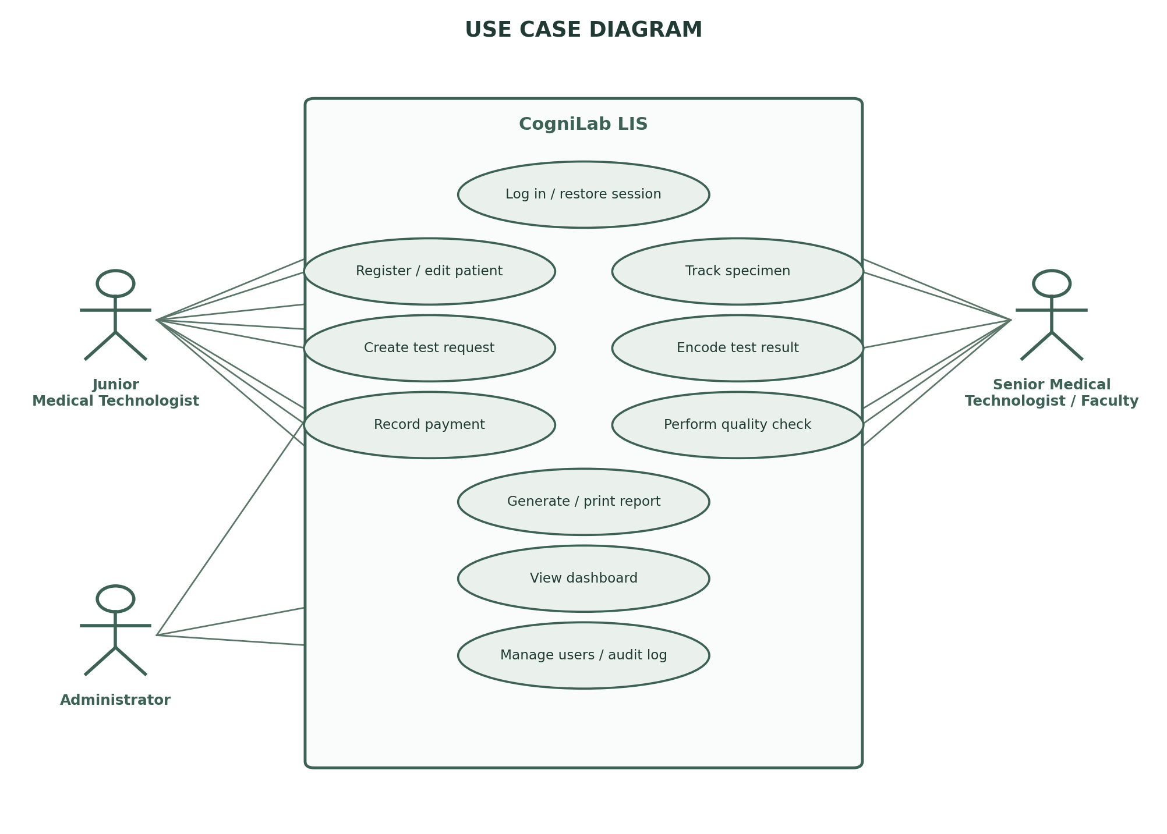
Figure 2. Use Case Diagram

4.6 System Architecture
CogniLab uses a three-layer architecture. The presentation layer consists of the Next.js App Router pages and React components that render the login screen, dashboard, patient forms, request forms, billing tables, specimen pipeline, result panels, quality checklist, report preview, and administration screens. The application layer contains the authentication context, shared UI components, and the data access functions in lib/database.ts. This layer implements the business rules: automatic billing, duplicate-billing prevention, abnormal value classification, quality-check gating, selective release, and audit logging. The data layer is Supabase, which provides authentication, a PostgreSQL database, real-time subscriptions, and storage.
The layers communicate through HTTPS. The browser sends authenticated requests to Supabase using the public anon key and the user's session token. Sensitive operations are expected to be protected by row-level security policies and by the application's role checks. Static assets such as the logo and signature images are served by the Next.js application, while transactional data is stored in PostgreSQL. This separation keeps the front end replaceable and allows the data layer to be governed independently.
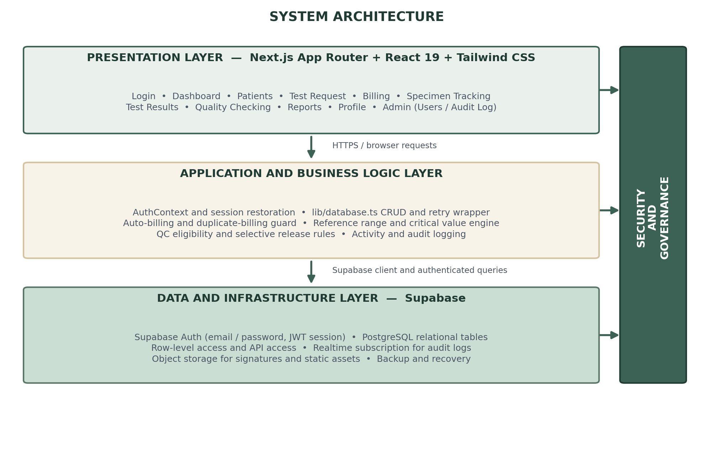
Figure 3. Three-Layer System Architecture
The architecture has three practical advantages for a small laboratory. First, it requires no dedicated server room because Supabase is managed. Second, it supports multiple workstations through a browser. Third, it centralizes business rules in a small number of shared functions, which reduces duplication across pages. The tradeoff is dependence on network connectivity and on the correct configuration of the hosted backend.

4.7 Data Design
The data model is organized around the patient and the laboratory encounter. A patient has demographic and contact information. A test request records the requested section, tests, physician, and the user who created the request. A specimen record tracks the physical specimen through the pipeline. A test result stores the analyte value, unit, reference range, and status. A quality check references a result and records the reviewer's decision. A billing record stores the charge and payment details. Audit logs record significant actions, and the users table stores accounts and roles.
The implementation uses both relational identifiers and patient-name matching. Core tables such as patients and users have UUID primary keys, while several workflow tables store the patient name to simplify report generation and legacy data migration. This design is pragmatic, but it creates a risk of ambiguity when two patients share the same name. A production deployment should add a patient identifier to every clinical table and use it consistently in queries and reports. The entity-relationship diagram in Figure 4 presents the current conceptual model.
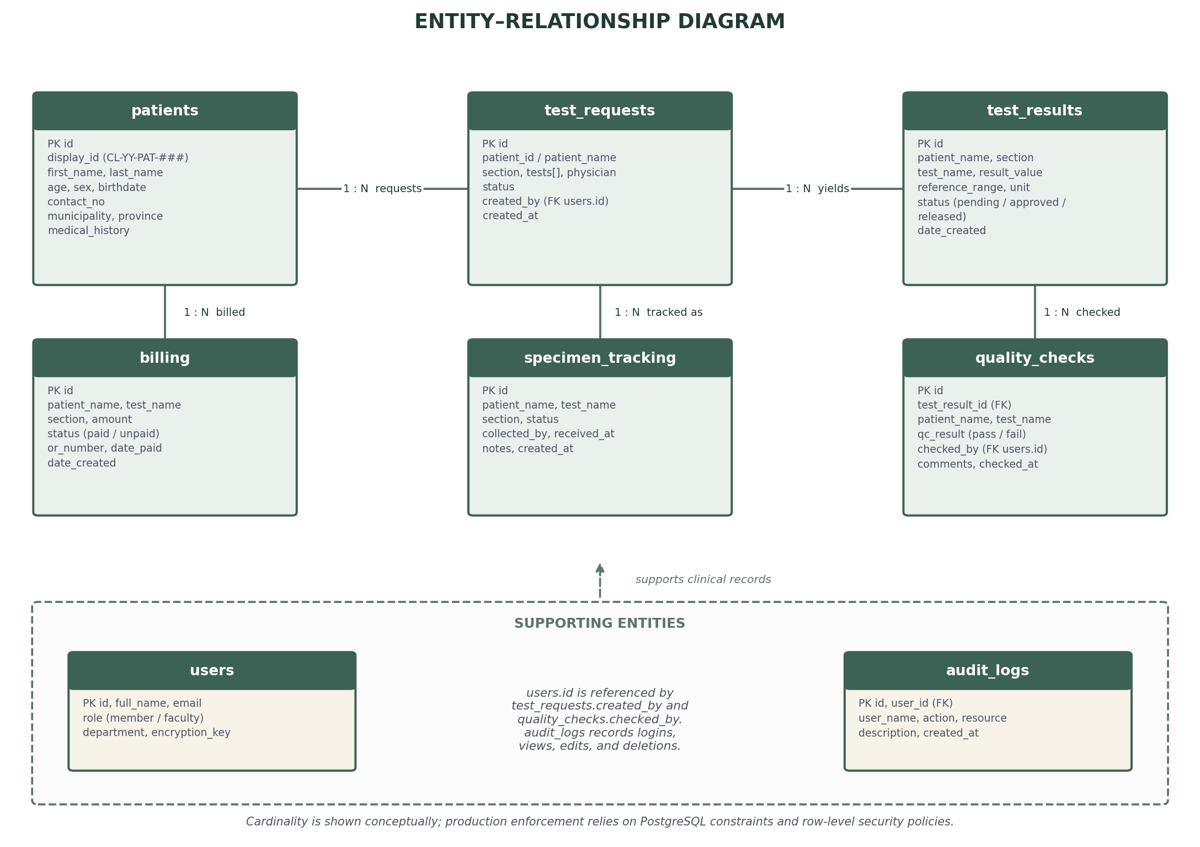
Figure 4. Entity-Relationship Diagram
Table 7. Core Database Tables and Purpose
Table | Purpose | Key Fields
users | Accounts and roles for authentication and profiling. | id, full_name, email, role, department, encryption_key
patients | Patient demographics and contact information. | id, patient_id_no, first_name, last_name, birthdate, sex, address
test_requests | Requested laboratory tests and requester. | id, patient_name, section, tests, physician, created_by
test_results | Encoded results and their status. | id, patient_name, section, test_name, result_value, reference_range, unit, status
billing | Charges and payment records. | id, patient_name, test_name, amount, status, or_number, date_paid
specimen_tracking | Specimen pipeline status and timestamps. | id, patient_name, test_name, status, collected_by, received_at
quality_checks | Senior review decisions. | id, test_result_id, qc_result, checked_by, comments, checked_at
audit_logs | Accountability trail for significant actions. | id, user_id, user_name, action, resource, description, created_at
Source: Developed by the researcher (2026).

4.8 Process Design
The end-to-end process begins with patient registration and ends with report release. Each stage has an owner, a data record, and a status. The system is designed so that a later stage can see the output of an earlier stage: a test request can see the patient, a billing record can see the requested test, a specimen record can see the paid request, a result can see the specimen, a quality check can see the result, and a report can see the checked result. This chain is the basis of traceability.
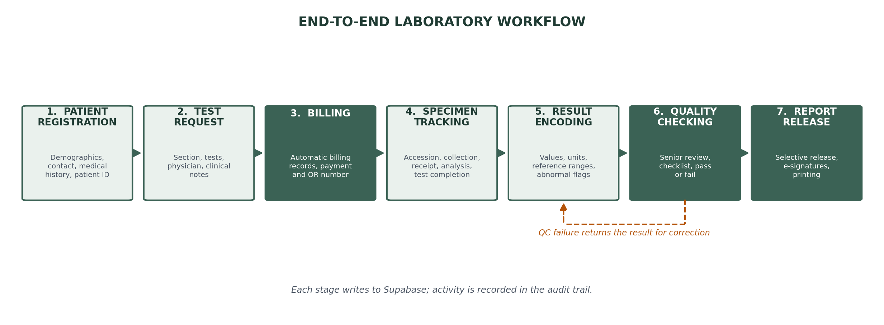
Figure 5. End-to-End Laboratory Workflow
Report release is the most constrained step. The report module first identifies the patient's approved or released results. It then checks whether each selected result has a completed quality check and whether the patient has a paid billing record. If the requirements are not met, the interface warns the user and prevents release. If the requirements are met, the user may select which results to include, preview the report, resolve the signatories, and print. Figure 6 illustrates this decision flow.
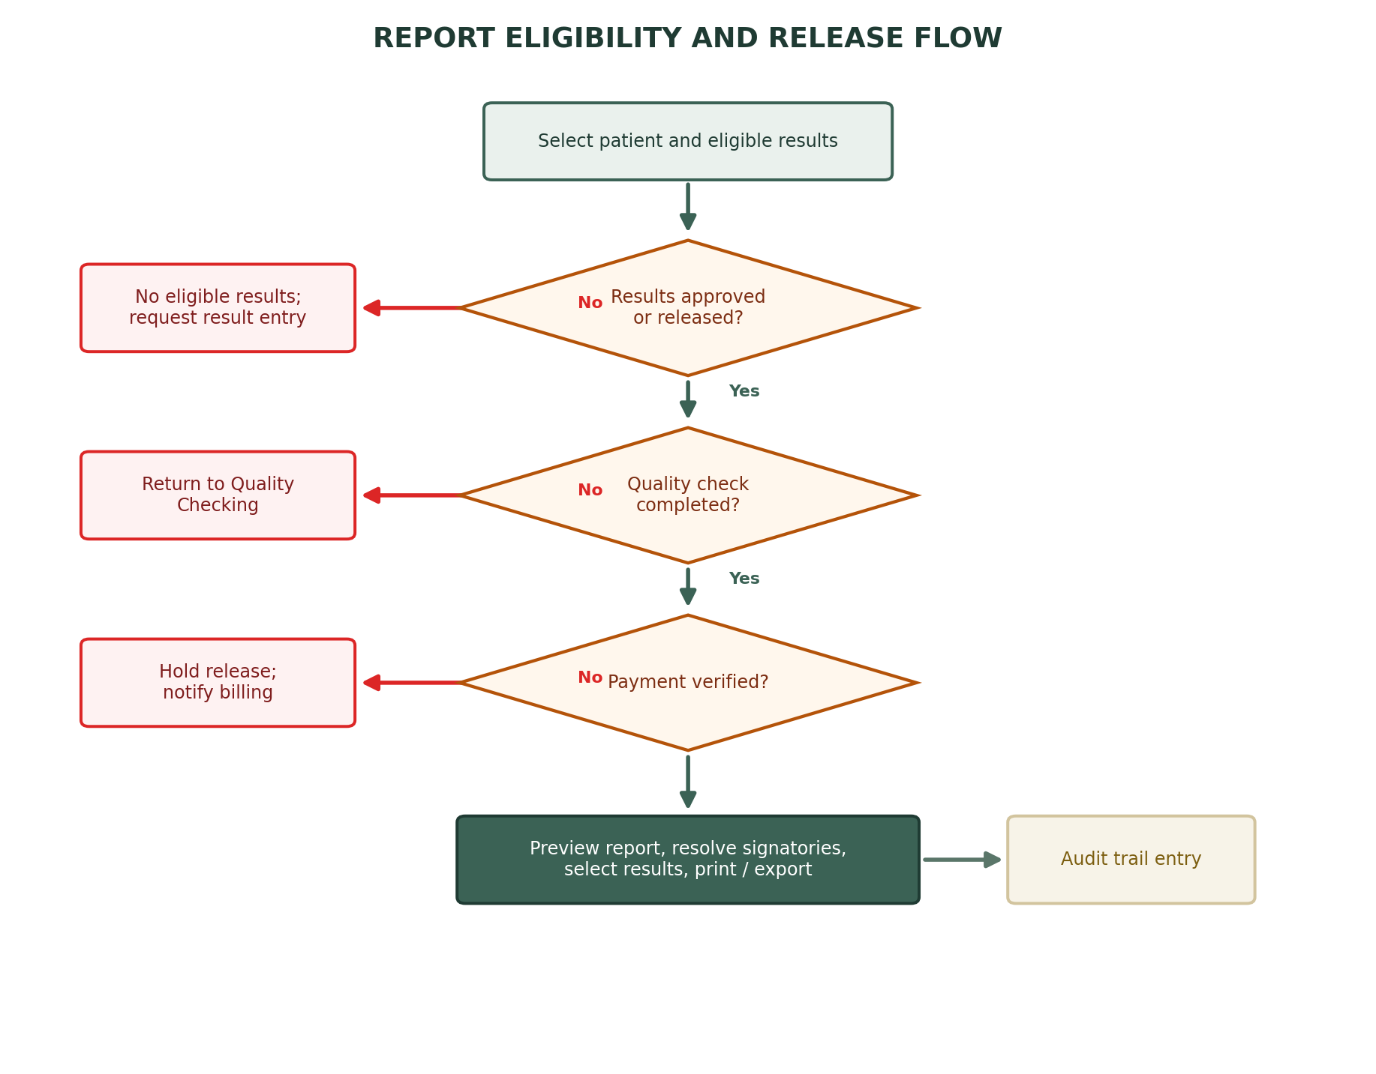
Figure 6. Report Eligibility and Release Flow

4.9 Interface Design
The interface is designed for repeated operational use. Navigation is organized around the laboratory workflow, with the dashboard, patients, test request, billing, specimen tracking, results, quality checking, reports, access history, and profile in the sidebar. The sidebar collapses on smaller screens and becomes a slide-out menu on mobile. Forms use clear labels, required-field indicators, and inline validation messages. Tables provide search and status filters so that staff can find a record quickly.
The visual identity uses a deep green primary color (#3B6255), a muted green secondary color (#8BA49A), a pale green surface (#CBDED3), and a warm gold accent (#D2C49E). These colors are applied consistently to the sidebar, buttons, status badges, and report header. Typography relies on the Geist font family loaded by Next.js, with larger headings for page titles and compact text for tables. The design follows Nielsen's (1994) heuristics of visibility of system status, consistency, error prevention, and feedback. Navigation keeps the workflow order visible, forms group related fields and validate before submission, tables provide search and status filters, status badges use consistent colors, and the report uses a print-specific layout with clear patient identity, results, ranges, signatures, and footer.

4.10 Security Design
Security is implemented at several levels. Authentication is delegated to Supabase Auth, which issues a session token after a successful email and password login. The AuthProvider subscribes to authentication state changes, loads the matching user profile from the users table, and exposes the user and role to the interface. The dashboard layout redirects unauthenticated users to the login page. The sidebar hides quality checking from users who do not meet the seniority check, and the quality-checking page repeats the check before rendering its controls.
The data layer uses the Supabase anon key and the authenticated session. The anon key is intended to be public, but it must be paired with row-level security policies that limit what each role can read and write. The service role key, which bypasses row-level security, must never be exposed to the browser. The project stores credentials in environment variables and does not hard-code them in source files. The audit log records authentication-related and record-changing actions, including the user, action, resource, description, and timestamp.
Several improvements are recommended before production use: enable database row-level security policies for every table; add multi-factor authentication for administrative accounts; enforce session expiry and secure cookie or storage settings; encrypt sensitive fields at rest; restrict report downloads to authorized roles; and perform regular backups with tested restoration. These measures align with ISO 27799 and the OWASP Application Security Verification Standard (ISO, 2016; OWASP Foundation, 2021).

4.11 Summary
This chapter analyzed the existing laboratory process and presented the functional and non-functional requirements, the actor model, the use cases, the three-layer architecture, the data model, the process design, the interface guidelines, and the security design. The next chapter describes how these designs were implemented in the CogniLab codebase.

CHAPTER 5: IMPLEMENTATION

5.1 Development Environment and Project Structure
CogniLab is implemented as a Next.js 16 application using the App Router. The project uses React 19, TypeScript, Tailwind CSS 4, Supabase, Recharts, react-to-print, and Lucide React. Development was performed in Visual Studio Code with Git for version control. The application is configured through .env.local, which supplies the Supabase URL, the public anon key, the service role key, and the mock-data flag. The production build is generated with npm run build.
The codebase separates routes, reusable components, configuration, and data access. Pages live under app/, shared components under components/, static configuration under config/, and backend-facing functions under lib/. The resulting structure is shown below.
app/
layout.tsx, providers.tsx, page.tsx
login/page.tsx
dashboard/
layout.tsx, page.tsx
patients/page.tsx, test-request/page.tsx, billing/page.tsx
specimen-tracking/page.tsx, results/page.tsx
quality-checking/page.tsx, report/page.tsx
history/page.tsx, profile/page.tsx
admin/
layout.tsx, users/page.tsx, audit-log/page.tsx
components/
Sidebar.tsx, PhoneInputMask.tsx
lib/
authContext.tsx, database.ts, mockData.ts, supabaseClient.ts
config/
constants.ts
types/
crypto-js.d.ts

5.2 Authentication and Session Management
The authentication flow begins at /login. The login page collects an email address and password, optionally remembers the email on the device, and calls the signIn function exposed by AuthProvider. The provider uses supabase.auth.signInWithPassword and then queries the users table by email to load the application profile, including the full name, role, department, and encryption key. If the profile is missing, the login is rejected with a clear message.
On application load, the provider subscribes to onAuthStateChange. When a session is present, it sets the authenticated user and loads the profile. When the session is cleared, it resets the user and the dashboard layout redirects to the login page. The provider also exposes signOut, which terminates the Supabase session and clears the local state. This centralized approach avoids duplicating authentication logic across pages.

5.3 Patient Management
The patient module is the entry point of the laboratory workflow. It displays a searchable list of patients and provides a registration form with fields for last name, first name, middle name, age, birthdate, sex, civil status, contact number, house number, street, barangay, municipality, province, medical history, medications, and allergies. Required fields are validated before submission, and the form uses a phone input mask for consistency. A patient ID is generated in the format CL-YY-PAT-###, where YY is the two-digit year and ### is the next sequence number.
The patient list supports viewing details, editing demographics, deleting a record with confirmation, and opening a test-request popup. The details view consolidates the patient's demographic and clinical information. The lab history view retrieves the patient's test requests and results so that staff can review previous encounters without leaving the patient record. These functions reduce the need to search across separate modules.

5.4 Test Request and Automatic Billing
The test request module allows staff to select a patient, choose a laboratory section, add one or more tests, record the requesting physician and clinical notes, and set the request date and time. The selected tests are stored in the test_requests table with the patient name, section, tests, physician, status, and the user who created the request. The request then appears in the laboratory's worklist.
A key business rule is automatic billing. When a request is submitted, the system creates a billing record for each requested test using the price defined in the test pricing catalog. If a test is a component of a parent examination, the system bills the parent instead of the component. For example, the individual CBC differential components map to a single CBC charge, the urinalysis sub-lines map to a single Routine Urinalysis charge, and the culture sub-lines map to a single Culture and Sensitivity charge. The system also checks whether a matching billing record already exists before inserting a new one, which prevents duplicate charges when a result is encoded after a request.

5.5 Billing and Payment Management
The billing module presents summary cards for paid transactions, unpaid transactions, total revenue, and outstanding balance. It lists billing records with the patient name, test name, amount, payment status, date paid, OR number, and creation date. Staff can search by patient or test and filter by payment status. The payment modal displays the patient and amount, accepts an OR number and date paid, and updates the record to paid. A paid record can also be marked unpaid if a correction is required, and the action is recorded in the audit log.
The module also provides a printable billing report. The report is generated in a new browser window with a summary of the filtered records, total paid amount, total unpaid amount, and a print dialog. This gives the laboratory a simple way to produce a collection summary without exporting to a separate spreadsheet.

5.6 Specimen Tracking
The specimen tracking module converts the billing record into a physical workflow. It loads paid billing records and displays the corresponding specimens in a six-stage pipeline: Pending Accession, Collection In-Progress, Sample Collected, Sample Received, Analytical Phase, and Test Complete. Each stage has a label, a color, and a timestamp. Staff can advance a specimen to the next stage, add notes, and record who collected or received it. The module also includes a result-entry popup so that a specimen can be moved to completion and its result encoded in one flow.
The pipeline design makes the specimen's location visible to the laboratory. A supervisor can see how many specimens are waiting for accession, how many are in collection, and how many are ready for analysis. This visibility supports workload balancing and reduces the need for verbal follow-ups. When a result is encoded from the specimen module, the system can reuse the billing record instead of creating a new charge, provided that the patient already has a billing record.

5.7 Test Result Encoding and Clinical Decision Support
The result module supports both simple and grouped test panels. Simple tests use a single value field. Grouped panels, such as the CBC differential, RBC indices, urinalysis, culture and sensitivity, and clinical chemistry panels, present multiple sub-tests in one form. The module displays the reference range and unit for each analyte, validates required values, and saves the results with a status of pending, approved, or released.
Clinical decision support is implemented through the getAbnormalStatus function in lib/database.ts. The function parses the numeric result, looks up the test in a flat reference-range table, and compares the value with the minimum and maximum. It returns normal, low, or high. A second table defines alert ranges for selected analytes; values outside those bands are returned as alert-low or alert-high. The interface uses these statuses to display color-coded arrows and to draw attention to results that may require urgent review. The design is intentionally transparent: the ranges are defined in code and can be reviewed and updated by the laboratory.
The result module also handles billing interactions. When a result is saved, the system determines whether the test is a component of a parent examination. If it is, the billing name is normalized to the parent, and the system checks whether a billing record already exists. This prevents a single CBC or urinalysis from generating multiple charges as its components are encoded.

5.8 Quality Checking
Quality checking is the control point between result encoding and report release. The module lists results that have not yet been quality-checked and allows a senior staff member to open a checklist. The checklist covers the key review dimensions: patient and specimen identification, specimen integrity, method and reagent suitability, calculation and transcription accuracy, reference-range comparison, critical value handling, and overall plausibility. Each item has a pass option, and any failing item causes the overall decision to be recorded as fail.
The quality check record stores the test result ID, patient name, test name, section, result value, reference range, unit, decision, checker, comments, and timestamp. The module displays a history of checks and allows an authorized user to delete an erroneous check with confirmation. The report module uses these records to determine whether a result is eligible for release. This creates a documented link between the person who reviewed the result and the report that contains it.

5.9 Report Generation and Printing
The report module is the final clinical output. It allows staff to search for a patient and select from the patient's approved or released results. The module displays the quality-check status, the payment status, and the list of eligible results. Staff may select all results or only a subset, which supports selective release when some tests are ready and others are still pending. The preview is rendered in a print-specific layout with the laboratory header, patient information, results table, reference ranges, units, and signature blocks.
Signatories are resolved automatically from the workflow records. The junior medical technologist is inferred from the created_by field of the patient's test request, and the senior medical technologist is inferred from the checked_by field of the most recent quality check. The pathologist signature is a fixed laboratory credential. The module maintains a directory of medtech names and signature image files so that the report can display the correct name, license number, and signature. The print action uses react-to-print to render the report area and invoke the browser's print dialog.
The report module enforces the release rules described in Chapter 4. If there are no eligible results, the user is prompted to complete result entry. If quality checking is incomplete or failed, the report cannot be released. If payment is not verified, the release is held. These checks are presented as clear status messages rather than silent failures, which helps staff understand what needs to be done next.

5.10 Administration, Audit Logging, and Dashboards
The administration area provides user management and audit inspection. The user management page lists accounts with their name, email, role, department, status, join date, and last login. It supports adding, editing, and deleting users, subject to laboratory limits of eight member accounts and one faculty account. The audit log page displays recorded actions with the user, role, action, resource, description, and timestamp, and supports filtering by role, user, and action.
Audit logging is implemented through the logActivity function. The function records login, logout, view, edit, delete, and download events in the audit_logs table. Significant actions such as patient creation, patient updates, result status changes, billing changes, quality checks, and report access call this function. The module also provides a real-time subscription to new audit log entries, which allows an administrator to monitor activity as it occurs.
The dashboard summarizes the laboratory's current state. It displays total patients, pending results, released results, and unpaid billing amount. It also presents three charts: tests by section, result status distribution, and revenue over time. The dashboard is intended as an operational snapshot rather than a full business intelligence tool. Its value lies in making workload, backlog, and collection status visible at a glance.

5.11 Profile Management
The profile page allows the authenticated user to view and update their name, email, phone number, address, city, province, department, role, and credentials. The profile is initialized from the authenticated user and the users table, and edits to contact and address fields are persisted back to the table. It is primarily an administrative convenience, but it also supports accountability because the displayed name and role are the same values used in audit records.

5.12 Implemented Business Rules
The system's behavior is driven by a set of explicit business rules. These rules are implemented in the data access layer and in the relevant page logic. Table 8 summarizes the rules and their purpose.
Table 8. Implemented Business Rules
Rule | Implementation | Purpose
Patient ID generation | CL-YY-PAT-### based on the highest existing sequence. | Provides a readable, unique identifier.
Automatic billing | Billing created from test requests or result entry. | Ensures that requested tests are charged.
Parent-test mapping | CBC, urinalysis, and culture components map to parent names. | Prevents duplicate component charges.
Duplicate billing guard | Checks for an existing patient and test billing record. | Avoids charging the same test twice.
Specimen pipeline | Six sequential statuses with advancement controls. | Makes specimen location and progress visible.
Abnormal classification | Reference ranges and alert ranges in database.ts. | Flags low, high, and critical results.
QC gating | Results require a pass record before report inclusion. | Enforces documented senior review.
Selective release | Selected result IDs are passed to the report builder. | Allows partial release when appropriate.
Payment check | Report module checks paid billing records. | Aligns release with laboratory payment policy.
Audit logging | logActivity writes to audit_logs. | Supports accountability and investigation.
Source: Developed by the researcher (2026).

5.13 Data Access Layer and Mock Mode
All database operations are centralized in lib/database.ts. The module exports functions for users, patients, test results, billing, and audit logs. Each function checks the NEXT_PUBLIC_USE_MOCK_DATA flag. When mock mode is enabled, the function returns or mutates in-memory sample data, which allows demonstration and testing without a live backend. When mock mode is disabled, the function uses the Supabase client and returns the resulting records.
The module also provides a withRetry wrapper for read operations, which retries a failed query up to three times and refreshes the session between attempts. Write operations validate their inputs and return null or false on failure so that the calling page can show an error instead of losing data.

CHAPTER 6: RESULTS AND DISCUSSION

6.1 Overview of the Evaluation
The evaluation examined whether CogniLab implements the requirements defined in Chapter 4 and whether the modules work together as a coherent workflow. The evaluation used three sources of evidence: a successful production build, a static review of the implemented pages and data access functions, and a scenario-based trace of the core laboratory processes. The production build compiled the TypeScript sources and generated all planned routes. The static review confirmed that each requirement is represented by an interface and a data operation. The scenario trace followed a patient from registration to report release, checking the data and status transitions at each step.
The evaluation is deliberately described as functional verification rather than as a controlled experiment. No sample of users was randomly assigned to conditions, and no statistical hypothesis was tested. The purpose was to determine whether the artifact behaves as designed and whether the design is internally consistent. This is an appropriate level of evaluation for a developmental study whose primary contribution is the system itself.

6.2 Functional Requirement Coverage
Table 9 maps each functional requirement to the module that implements it and to the verification evidence. All eighteen requirements are represented in the build. The status column indicates whether the requirement is implemented as specified, partially implemented, or dependent on deployment configuration.
Table 9. Functional Requirement Coverage
Requirement | Implementing Module | Status
FR-01 Authentication | Login page, AuthProvider, Supabase Auth | Implemented
FR-02 Session and sign-out | AuthProvider, dashboard layout | Implemented
FR-03 Patient registration | Patients page and addPatient | Implemented
FR-04 Patient ID and CRUD | Patients page, generatePatientId | Implemented
FR-05 Test request | Test Request page, test_requests | Implemented
FR-06 Automatic billing | addTestResult, test request submit | Implemented
FR-07 Duplicate-billing guard | BILLING_PARENT_TESTS, existing-record check | Implemented
FR-08 Billing list and filter | Billing page | Implemented
FR-09 Payment recording | Billing payment modal, updateBillingStatus | Implemented
FR-10 Specimen tracking | Specimen Tracking page, six-stage pipeline | Implemented
FR-11 Result encoding | Results page and specimen result popup | Implemented
FR-12 Abnormal classification | getAbnormalStatus, FLAT_RANGES, ALERT_RANGES | Implemented
FR-13 Senior-only QC | Quality Checking page and access check | Implemented at interface level
FR-14 QC before report | Report eligibility check and QC status | Implemented
FR-15 Selective release | Report page result selection | Implemented
FR-16 Payment check | Report page billing verification | Implemented
FR-17 Printable report | Report page, react-to-print, signature directory | Implemented
FR-18 Admin, dashboard, audit | Admin pages, dashboard, logActivity | Implemented
Source: Developed by the researcher (2026).

6.3 Core Scenario Walkthroughs

6.3.1 From Registration to Billing
The first scenario begins when a patient arrives at the laboratory. The staff member opens the Patients page, selects the registration action, and enters the patient's demographic, contact, and clinical information. The form validates required fields and generates a patient ID in the CL-YY-PAT-### format. After saving, the patient appears in the searchable list and can be opened for review or editing.
The staff member then opens the test-request action for that patient, selects a laboratory section, adds the requested tests, records the physician and notes, and submits the request. The request is stored in test_requests, and the system creates a billing record for each test using the pricing catalog. If a selected test is a component of a parent examination, the billing record uses the parent name. The Billing page then shows the new charges as unpaid, and the patient can proceed to collection.

6.3.2 From Specimen to Quality Check
The second scenario follows the specimen. The Specimen Tracking page loads paid billing records and creates a pipeline entry for each specimen. The staff member advances the specimen from Pending Accession to Collection In-Progress, Sample Collected, Sample Received, Analytical Phase, and Test Complete. At each step, the system records the new status and the time of the update. If a specimen needs a note, such as a hemolyzed sample or a recollect, the staff member can add it to the record.
When the analysis is complete, the staff member opens the result-entry popup, selects the relevant panel, and enters the values. The system displays the reference range and unit for each analyte and computes the abnormal status after the result is saved. The result appears in the Results page with a pending status. A senior staff member then opens the Quality Checking page, selects the result, completes the checklist, and records a pass or fail decision with comments. If the decision is pass, the result can proceed to report generation. If the decision is fail, the result remains unavailable for release until it is corrected and rechecked.

6.3.3 From Quality Check to Report Release
The third scenario begins in the Report module. The staff member searches for the patient and selects the patient record. The module lists the patient's approved or released results and indicates whether each result has a quality check and whether the patient has a paid billing record. If the requirements are satisfied, the staff member selects the results to include, previews the report, verifies the patient information and signatures, and prints the report. If a requirement is missing, the module displays a message explaining what must be completed first.
The printed report contains the laboratory header, patient identification, the selected results with units and reference ranges, the pathologist signature, and the assigned medical technologist signatures. The system resolves the junior medical technologist from the test request's created_by field and the senior medical technologist from the quality check's checked_by field. This reduces manual signature assignment and creates a documented connection between the report and the staff who performed and reviewed the work.

6.4 Functional Verification
Table 10 presents representative verification cases. Each case specifies a precondition, an action, an expected result, and the observed result. The cases were selected to cover the highest-risk transitions: patient creation, request creation, billing, specimen advancement, result encoding, quality gating, and report eligibility.
Table 10. Functional Verification Test Cases
ID | Test Case | Expected Result | Observed Result | Status
T-01 | Open the application without a session. | The login page is displayed. | The login page renders and the dashboard is guarded. | Pass
T-02 | Log in with a valid account. | The dashboard loads with the user's name and role. | The AuthProvider loads the profile and the dashboard renders. | Pass
T-03 | Register a patient with required fields. | A patient ID is generated and the record appears in the list. | The form validates and addPatient persists the record. | Pass
T-04 | Submit a test request with multiple tests. | The request is saved and billing records are created. | The request is stored and the billing functions are invoked. | Pass
T-05 | Encode a CBC component after a CBC request. | The component maps to one CBC billing record; no duplicate is created. | The parent mapping and existing-record check prevent duplication. | Pass
T-06 | Record a payment with an OR number and date. | The billing status becomes paid and the values are stored. | updateBillingStatus updates the record and logs the action. | Pass
T-07 | Advance a specimen through the six stages. | The status changes in sequence and the pipeline reflects the new stage. | The status update function persists each transition. | Pass
T-08 | Encode a result outside the reference range. | The result is flagged as low or high. | getAbnormalStatus returns the expected classification. | Pass
T-09 | Encode a result outside the alert range. | The result is flagged as alert-low or alert-high. | The alert table produces the expected classification. | Pass
T-10 | Attempt QC as a junior user. | The QC controls are unavailable. | The seniority check hides or blocks the QC controls. | Pass
T-11 | Attempt report release without a QC record. | The report is blocked with an explanation. | The eligibility check reports pending QC. | Pass
T-12 | Attempt report release without payment. | The report is blocked and billing is identified. | The payment check reports the unpaid condition. | Pass
Source: Developed by the researcher (2026). Observed results reflect implementation review and production-build validation; formal end-user execution is recommended.

6.5 Technical Quality
The production build completed successfully. Next.js compiled the application, ran the TypeScript checks, collected page data, and generated the static pages. The route inventory includes the login, dashboard, patient, request, billing, specimen, result, quality, report, history, profile, user-management, and audit-log pages. The absence of build errors indicates that the pages are connected to valid imports and that the TypeScript types are internally consistent.
The codebase is organized for maintainability. Shared formatting and data functions are centralized in lib/database.ts, reusable navigation lives in components/Sidebar.tsx, and page-specific logic stays within its route. The use of a single data access module makes it easier to change the backend or add caching in the future. The main maintainability challenge is the duplication of test catalogs and reference ranges across configuration, mock data, and page-level constants. Consolidating these into a single source of truth would reduce the risk of inconsistent ranges or prices.

6.6 Security and Privacy
The system implements authentication, role-aware navigation, seniority checks for quality review, and audit logging. These are meaningful controls for a laboratory system, but they are not sufficient for production by themselves. The current implementation relies partly on client-side checks, which can be bypassed if a user calls the underlying API directly. The Supabase anon key is public by design, so the database must enforce access rules through row-level security policies. The service role key must remain server-side and must never be included in client bundles.
Before deployment, the laboratory should complete a privacy impact assessment, define retention and disposal rules, restrict report downloads to authorized roles, enable multi-factor authentication for administrators, and configure audit log retention. These measures would strengthen compliance with the Data Privacy Act and with the security expectations of ISO 15189 and ISO 27799. The audit trail should also be protected from modification by ordinary users, ideally through append-only policies or a separate logging service.

6.7 Usability
The interface follows the laboratory workflow rather than a generic database layout. The sidebar order mirrors the sequence of work, and the dashboard surfaces the most important operational counts. Forms use familiar fields and validation messages, while tables provide search and status filters. The color palette is consistent, and the report layout is designed for print rather than screen. These choices reduce the learning curve for staff who are accustomed to laboratory forms.
The system also has usability limitations. Some pages are large and contain many conditional panels, which can make the interface dense on smaller screens. The result module supports many test groups, and users may need training to locate a specific panel. The report module depends on the correct resolution of signatories, which requires consistent user records. A formal usability test with representative staff would help identify the most frequent navigation and data-entry problems.

6.8 Limitations of the Evaluation
The evaluation has several limitations. First, it did not include a controlled user study, so it cannot report task completion times, error rates, or satisfaction scores. Second, the observed results in Table 10 are based on implementation review and build validation rather than on a fully instrumented test environment. Third, the system was evaluated as a standalone application; it was not integrated with a hospital information system or an analyzer. Fourth, the security review focused on the application layer and did not include penetration testing or a full database policy audit. These limitations define the boundary of the study's claims.
The limitations do not invalidate the design contribution. They indicate what the study can and cannot claim. The study can claim that the system implements the specified workflow and that it builds successfully. It cannot claim that the system is more effective than an alternative in a statistically measurable sense. That claim would require a separate evaluation study with a defined sample, instrument, and analysis plan.

6.9 Summary
This chapter presented the functional coverage, the core scenario walkthroughs, the verification cases, and the technical, security, and usability discussion. The results show that the system covers the complete laboratory workflow and that the highest-risk transitions are controlled by explicit rules. The next chapter concludes the study and offers recommendations.

CHAPTER 7: CONCLUSION AND RECOMMENDATIONS

7.1 Summary of Findings
The study designed and implemented CogniLab, a web-based laboratory information system for KRRAX-JAM Inc. The system integrates patient registration, test requesting, automatic billing, specimen tracking, result encoding, quality checking, report generation, administration, dashboards, and audit logging. It uses Next.js 16, React 19, TypeScript, Tailwind CSS, and Supabase, and it follows a three-layer architecture that separates the interface, the business logic, and the data layer.
The functional verification showed that all eighteen requirements are represented in the build. The production build completed successfully, and the route inventory confirmed that all planned modules are present. The core scenarios demonstrated that a patient can move from registration to billing, from billing to specimen tracking, from specimen tracking to result encoding, from result encoding to quality checking, and from quality checking to report release. The system enforces the most important controls: duplicate-billing prevention, abnormal value flagging, senior-only quality review, and payment verification before report release.
The study also identified limitations. The evaluation did not include a formal user acceptance test or a statistical usability study. The security model relies partly on client-side checks and requires database-level row security before production. The test catalogs and reference ranges are duplicated in several files, and the system does not yet interface with instruments or external health information systems. These limitations provide a clear agenda for future work.

7.2 Conclusion
CogniLab demonstrates that a small laboratory can use a tailored, cloud-hosted web application to connect its core information flows without adopting a large, expensive hospital system. The system's value is not only in storing data but in enforcing the sequence and controls that make laboratory information trustworthy. By linking patient records, requests, billing, specimens, results, quality checks, and reports, the system creates a traceable chain from the patient's arrival to the released report.
The study concludes that the system meets its general objective: it provides an integrated, role-aware, and auditable laboratory workflow. It also concludes that the system is a foundation rather than a finished product. Production use will require stronger database security, formal user training, data migration, backup and recovery procedures, and a phased rollout. With those additions, the design can support the laboratory's daily operations and provide a platform for further digitalization.

7.3 Recommendations
The following recommendations are organized into technical, functional, and organizational categories.

7.3.1 Technical Recommendations
- Implement row-level security policies for every table so that access control is enforced by the database, not only by the interface.
- Consolidate test catalogs, prices, reference ranges, and alert ranges into a single shared configuration module or database table.
- Add automated unit, integration, and end-to-end tests, including tests for billing mapping, abnormal classification, and report eligibility.
- Enable secure session persistence, session expiry, and multi-factor authentication for administrative accounts.
- Add structured error handling and monitoring, including a health check and a deployment log.
- Protect audit logs from modification and define a retention policy.
- Add database backups with scheduled restoration tests.

7.3.2 Functional Recommendations
- Add barcode or QR-based specimen labeling and scanning to reduce identification errors.
- Add instrument interfaces for common analyzers so that results can be imported without manual transcription.
- Add SMS or email notifications for critical values and report availability.
- Add appointment scheduling, queue management, and turn-around-time tracking.
- Add inventory management for reagents and consumables.
- Add multi-branch or multi-section consolidation if the laboratory expands.
- Add export options for CSV, PDF, and HL7 FHIR-compatible data.

7.3.3 Organizational Recommendations
- Conduct a formal user acceptance test with representative junior and senior staff before full deployment.
- Provide role-based training and a quick-reference guide for each module.
- Define standard operating procedures for patient registration, specimen rejection, critical value notification, and report correction.
- Assign a data protection officer or privacy focal person and conduct a privacy impact assessment.
- Pilot the system in one section before extending it to the entire laboratory.
- Establish a feedback channel and a regular review cycle for system improvements.

7.4 Future Work
Future work should begin with a formal evaluation. A mixed-methods study could combine task-completion observation, the System Usability Scale, and interviews with laboratory staff. The evaluation should measure time to release, duplicate-billing incidents, and quality-check compliance before and after deployment. A second strand of work should strengthen the security architecture through row-level security, penetration testing, and audit-log immutability. A third strand should extend interoperability through instrument interfaces and HL7 FHIR resources. Finally, a longitudinal study could examine how the system affects turnaround time, error rates, and staff workload over several months of use.

7.5 Concluding Statement
Laboratory information is a patient safety asset. It deserves the same care as the specimen itself: it must be identified, handled, reviewed, and released through a controlled process. CogniLab is a step toward that standard for KRRAX-JAM Inc. It translates the laboratory's workflow into software, makes the status of each request visible, and documents the decisions that lead to a released report. With further security hardening, user evaluation, and interoperability work, the system can become a durable part of the laboratory's quality infrastructure.

REFERENCES
Clinical and Laboratory Standards Institute. (n.d.). CLSI standards and guidelines. https://clsi.org/
Date, C. J. (2003). An introduction to database systems (8th ed.). Addison-Wesley.
Fowler, M. (2002). Patterns of enterprise application architecture. Addison-Wesley.
HL7 International. (n.d.). FHIR specification. https://hl7.org/fhir/
International Organization for Standardization. (2011). ISO/IEC 25010:2011 Systems and software engineering — Systems and software Quality Requirements and Evaluation (SQuaRE) — System and software quality models. ISO.
International Organization for Standardization. (2016). ISO 27799:2016 Health informatics — Information security management in health using ISO/IEC 27002. ISO.
International Organization for Standardization. (2022). ISO 15189:2022 Medical laboratories — Requirements for quality and competence. ISO.
Laudon, K. C., & Laudon, J. P. (2020). Management information systems: Managing the digital firm (16th ed.). Pearson.
Meta Open Source. (n.d.). React documentation. https://react.dev/
Nielsen, J. (1994). Usability engineering. Morgan Kaufmann.
OWASP Foundation. (2021). OWASP Top 10:2021. https://owasp.org/Top10/
PostgreSQL Global Development Group. (n.d.). PostgreSQL documentation. https://www.postgresql.org/docs/
Pressman, R. S., & Maxim, B. R. (2020). Software engineering: A practitioner's approach (9th ed.). McGraw-Hill.
Republic of the Philippines. (2012). Republic Act No. 10173: An act protecting individual personal information in information and communications systems in the government and the private sector, creating for this purpose a National Privacy Commission, and for other purposes. Official Gazette.
Schwaber, K., & Sutherland, J. (2020). The Scrum Guide. Scrum.org.
Sommerville, I. (2016). Software engineering (10th ed.). Pearson.
Supabase. (n.d.). Supabase documentation. https://supabase.com/docs
U.S. Department of Health and Human Services. (n.d.). HIPAA Privacy Rule. https://www.hhs.gov/hipaa/for-professionals/privacy/index.html
Vercel. (n.d.). Next.js documentation. https://nextjs.org/docs
W3C. (2018). Web Content Accessibility Guidelines (WCAG) 2.1. https://www.w3.org/TR/WCAG21/
Wiegers, K., & Beatty, J. (2013). Software requirements (3rd ed.). Microsoft Press.
World Health Organization. (2011). Laboratory quality management system: Handbook. World Health Organization.

APPENDICES

Appendix A. Sample User Acceptance Testing Form
The form below is a template for a future user acceptance test. It is not a record of completed testing; it is provided so that the laboratory can evaluate the system with representative users using a consistent instrument.
Table A1. Sample User Acceptance Testing Form
Criterion | Description | Rating (1–5) | Comments
Ease of login | The user can sign in and reach the dashboard without assistance.
Patient registration | The user can register a patient and locate the record.
Test request | The user can create a request with multiple tests.
Billing | The user can locate a charge and record a payment.
Specimen tracking | The user can advance a specimen and see its status.
Result entry | The user can encode a result and interpret the abnormal flag.
Quality checking | The authorized user can complete a QC checklist.
Report generation | The user can select results, preview, and print a report.
Navigation | The user can move between modules without confusion.
Overall satisfaction | The user would recommend the system to a colleague.
Rating scale: 1 = strongly disagree, 2 = disagree, 3 = neutral, 4 = agree, 5 = strongly agree. Source: Developed by the researcher (2026).

Appendix B. Quick Operational Guide
The following steps summarize the normal operating sequence. They are intended as a quick reference, not as a substitute for formal training.
1. Sign in with the account provided by the administrator.
2. Register the patient or search for an existing record.
3. Create a test request by selecting the section, tests, physician, and notes.
4. Verify the generated billing records and record payment when received.
5. Open Specimen Tracking and advance the specimen through collection and receipt.
6. Encode the result in the result panel and review the reference range and flag.
7. Ask a senior staff member to complete the quality check.
8. Open Reports, select the patient and the eligible results, preview, and print.
9. Review the audit log periodically and update user accounts as needed.
The system is designed to prevent release when required steps are missing. If a report cannot be generated, the user should check the quality-check status, the payment status, and the result status before contacting the administrator.

