Implementation and Integration of the Deception Mesh (The Mash)

# Key Innovation: Autonomous Deception Mesh (The Mash)

The Deception Mesh is a cybersecurity innovation designed to create a dynamic and intelligent defense layer within industrial and enterprise networks. It deploys deceptive assets (honeypots, honeytokens, fake credentials, etc.) to mislead, detect, and delay attackers while gathering intelligence about their methods.

# Connection with Other Key Innovations

1. AI Anomaly Detection:  
 - Learns from interactions within the deception mesh to identify abnormal patterns and improve real-time detection.

2. Digital Twin:  
 - Cross-verifies real-world system behavior against the twin to help validate alerts triggered by the deception mesh.

3. SOAR (Security Orchestration, Automation, and Response):  
 - Responds immediately to threats identified by the deception mesh, such as isolating compromised systems.

4. Federated Learning:  
 - Aggregates threat intelligence from the mesh and shares insights across decentralized systems without compromising privacy.

5. Backup & Recovery:  
 - Triggers just-in-time backups in response to ransomware indicators identified through the deception layer.

# Step-by-Step Implementation of the Deception Mesh

## Phase 1: Strategy and Planning

1. Define objectives and scope (e.g., lure ransomware, monitor APTs).

2. Map the network and identify optimal placement of decoys.

3. Choose tools (e.g., Conpot, Modern Honey Network, or commercial platforms).

## Phase 2: Build Deception Assets

4. Develop honeypots mimicking OT/IoT devices and credentials.

5. Program behavior for believability and diversity.

## Phase 3: Integration with Platform

6. Connect the mesh with edge nodes.

7. Integrate with the AI detection engine and SOAR.

8. Ensure logging to SIEM platforms.

## Phase 4: Testing and Optimization

9. Pen-test with red team simulations.

10. Refine deception strategy based on attacker behavior.

## Phase 5: Maintenance

11. Refresh and update deception assets.

12. Retrain AI models with deception-collected data.

# Visual Workflow Diagram

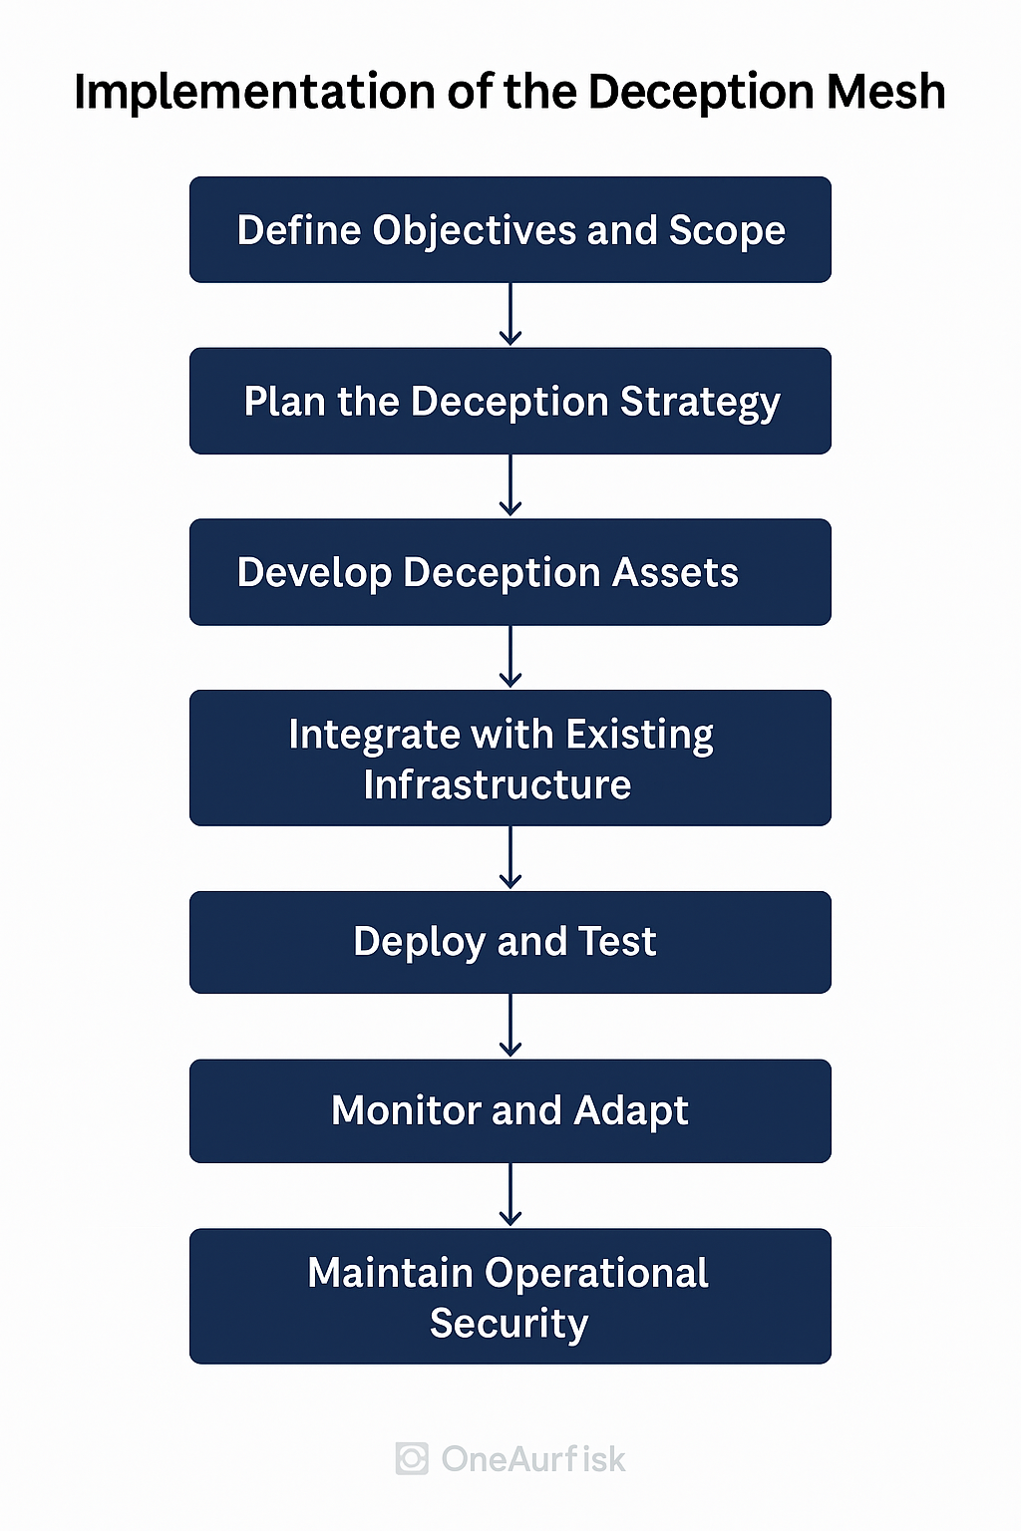

# Summary

The Mash not only serves as a deceptive barrier but also enhances the efficacy of the broader cybersecurity ecosystem within your platform. Its integration with AI, SOAR, federated learning, and backup mechanisms ensures a proactive, adaptive, and intelligent defense posture.