Create an E-Mail editor like Yahoo.

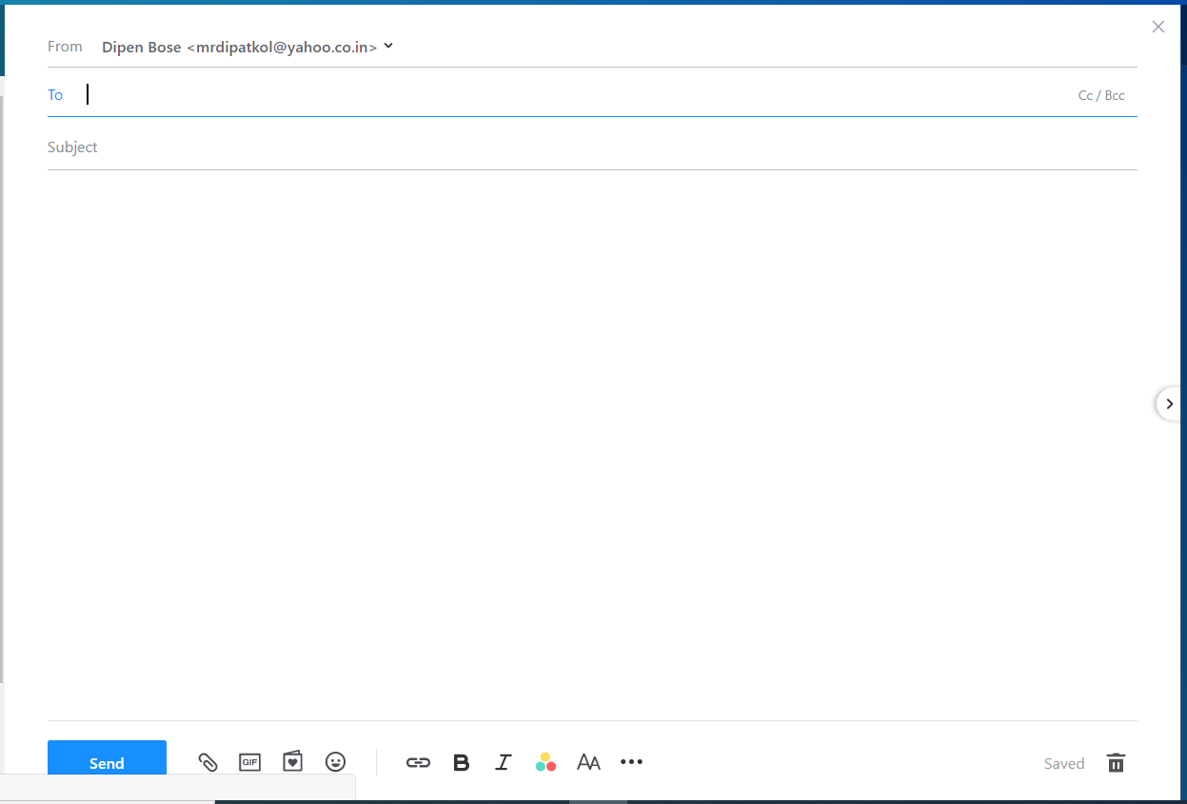

**[Elements]**

* Use CSS, **No Plugins Allowed**
* Get started today! (Plain text)
* Inputs
  + From (Should contain senders email – by default)
  + To
  + Subject
  + CC/BCC (Clickable Text)
* Send (Button)
* Attachment (Clickable Text)
* **B** & ***I*** must work
* Other Icons (Image)

**[Minimum requirements]**

* Implement the following validations for input:
* Email - Must be a valid email ID
* CC, BCC must appear after clicking on “cc/bcc”
* To, CC, BCC must automatically separate email ids with “;” on hitting space or tab.
* Onclick of send it must check if Subject line is empty and must popup appropriate message
* Onclick of Attachment “File Dialog” should appear.

**You are required to use pure javascript (No slider plugins allowed)**