

Synopsis

On

Mini Project:

**ELECTRICITY BILL CALCULATION**

Submitted in partial fulfillment of the requirement of the

degree of

**“B.Tech In Computer Science & Engineering”**

Submitted By:

TISHA ARORA (2100640100108) (B.Tech III SEM CS)

Under the supervision

Of

Mr. YASH SIR

Department of Computer Science & Engineering 2021-2025

# **ABSTRACT**

The purpose of electricity billing system is to automate the existing manual system by the help of computerized equipment and full fledged computer software fulfilling their requirements so that their valuable data can be stored for a longer period with easy accessing and manipulation of the same the required Software and Hardware are easily available and easy to work with.

Electricity billing system as described above can lead to error free secure reliable and fast management system it can assist the user to concentrate on the other activities rather to concentrate on the record keeping does it will help organization in better utilization of resources for organization can maintain computerized records without redundant entries that means that one need not be distracted by information that is not relevant, while being able to reach the information.

The aim is to automate its existing manual system by the help of computerized equipment and full fledged computer software fulfilling their requirements so that their valuable data can be stored for a longer period with easy accessing and manipulation of the same physically the project describe how to manage for good performance and better services for the clients.

# **INTRODUCTION**

The electricity billing system has been developed to override the problems prevailing in the practicing manual system this software is supported to eliminate and in some cases reduce the hardships faced by this existing system moreover this system is designed for the particular needs of the company to carry out operations in a smooth and effective manner

Application is reduced as much as possible to avoid errors while entering the data it also provides error message while entering invalid data no formal knowledge is needed for the user to use the system does why it is all it provide prove it is user-friendly electricity billing system as described above can lead to error free secure reliable and fast management system it can assist the user to concentrate on the other activities rather to concentrate on the Record Keeping that it will help your organization in the better utilization of resources

# **Scope of the Project**

It may help collecting perfect management in details in a very short time the collection will be obvious simple and sensible it will help awesome to know the management of fast dear perfectly and vividly it also helps in current all works relative to Electricity billing system it will also be reduced the cost of collecting the management and collection procedure will go on smoothly

Our project aims and business process automation that is we have tried to computerized various processes of electricity billing system

* To assist the staff and capturing the effort spent on their respective working areas
* To utilize resources in an efficient manner by increasing the productivity through automation
* It satisfies the user requirement
* Be easy to understand by the user and operator

# **HardwareRequirements:**

|  |  |  |
| --- | --- | --- |
| Properties | Minimum Requirements | Recommended Requirements |
| RAM | 128 MB | 16 GB |
| KEYBORD | 122 KEYS | 122 KEYS |
| CPU | PENTIUM III 6.30 GHz | Intel Core i7 2.4 GHz |
| Storage | 20 GB | 50 B or higher |

# **Software Requirements Specification**

# The software requirement specification is produced at the culmination of the analysis of the function and performance allocated to software as part of system engineering and Defined by the establishment of computer information description a detailed functional and behavioral description and indication of performance requirements and design constraints appropriate validation criteria and other data pertinent to requirement

* Windows 7, Linux
* Java Runtime Environment (JRE)
* Any Browser like (Chrome, MSedge )
* Java JDK 1.7

**DATA FLOW DIAGRAM**

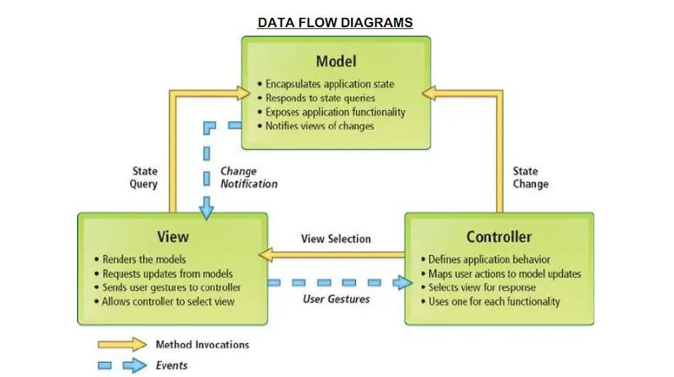

# **Conclusion**

Our project is only humble venture to satisfy the needs to manage their project work several user-friendly coding have also adopted this package shall prove to be a powerful package in that is find all the requirement of the school the objective of software planning is to provide a Framework that enables the manager to make reasonable estimate made within a limited time frame at the beginning of the software project and should be updated regularly as a Project progress

**At the end it is concluded that we have made effort on following points**

* A description of the background and context of the project and its relation to work already done in the area
* Made a statement of the aims and objective of the project
* The description of purpose scope and applicability
* We define the problem on which we are working in this project
* We describe the requirement specifications of the system and the actions that can be done on this thing
* We understand the problem domain and produce a model of the system which describes operations that can be performed in the system
* We included features and operation in detail including screen layout
* We designed user interface and security issues related to system
* Finally the system is implemented and tested according to test cases