**Drop-off Rate by Opportunity Category**

**Insights: Drop-off Rate by Opportunity Category**

* **Internships & Courses**: Highest drop-off (~1.09%) due to high time commitment, difficulty, or misaligned expectations.
* **Engagement Opportunities**: 0% drop-off, likely due to flexibility and immediate value.
* **Competitions & Events**: Low drop-off (~0.2% - 0.36%), possibly due to short duration and rewards.

**Recommendations to Reduce Drop-offs**

* **For Internships & Courses:** Set clear expectations before enrolment, Provide mentorship & peer support, and Introduce progress tracking & rewards.
* **Leverage Engagement Strategies:** Identify what makes engagement opportunities successful, and Add gamification, interactive sessions & community engagement.
* **Survey Dropouts to Identify Issues:** Conduct exit surveys to find reasons for drop-offs and Use insights to improve course & internship structures.
* **Flexible Completion Options:**  
   Offer modular learning & flexible deadlines, and Allow learners to pause & resume instead of dropping out.

**Age Group-wise Drop-off Rate**

**Insights: Age Group-Wise Drop-Off Rate Analysis**

* **Teenagers (≤19) & Mid 20s (25-29) → Highest Drop-Off Rates (1.14% & 1.145%)** 
  + Likely due to course complexity or engagement issues.
* **Early 20s (20-24) → Moderate Drop-Off Rate (0.91%)** 
  + High drop-off count but spread across a large participant base.
* **Drop-Offs Decline in Older Groups (30s+)** 
  + Stronger commitment & alignment with professional goals.
  + 50+ group: 0.00% drop-off rate → Highest retention.

**Recommendations**

* **Support Teenagers & Mid-20s:** Provide structured onboarding, interactive learning, and mentorship.
* **Simplify Course Design for Younger Learners:** Use modular content, gamification, and engaging formats.
* **Boost Retention for Early 20s:** Introduce flexible pacing, peer learning communities, and check-ins.
* **Leverage High Retention in Older Groups:** Expand leadership-oriented programs & networking opportunities.
* **Improve Expectation-Setting:** Clearly define course workload, use trial modules, and pre-course assessments.

**Drop of relation with other columns**

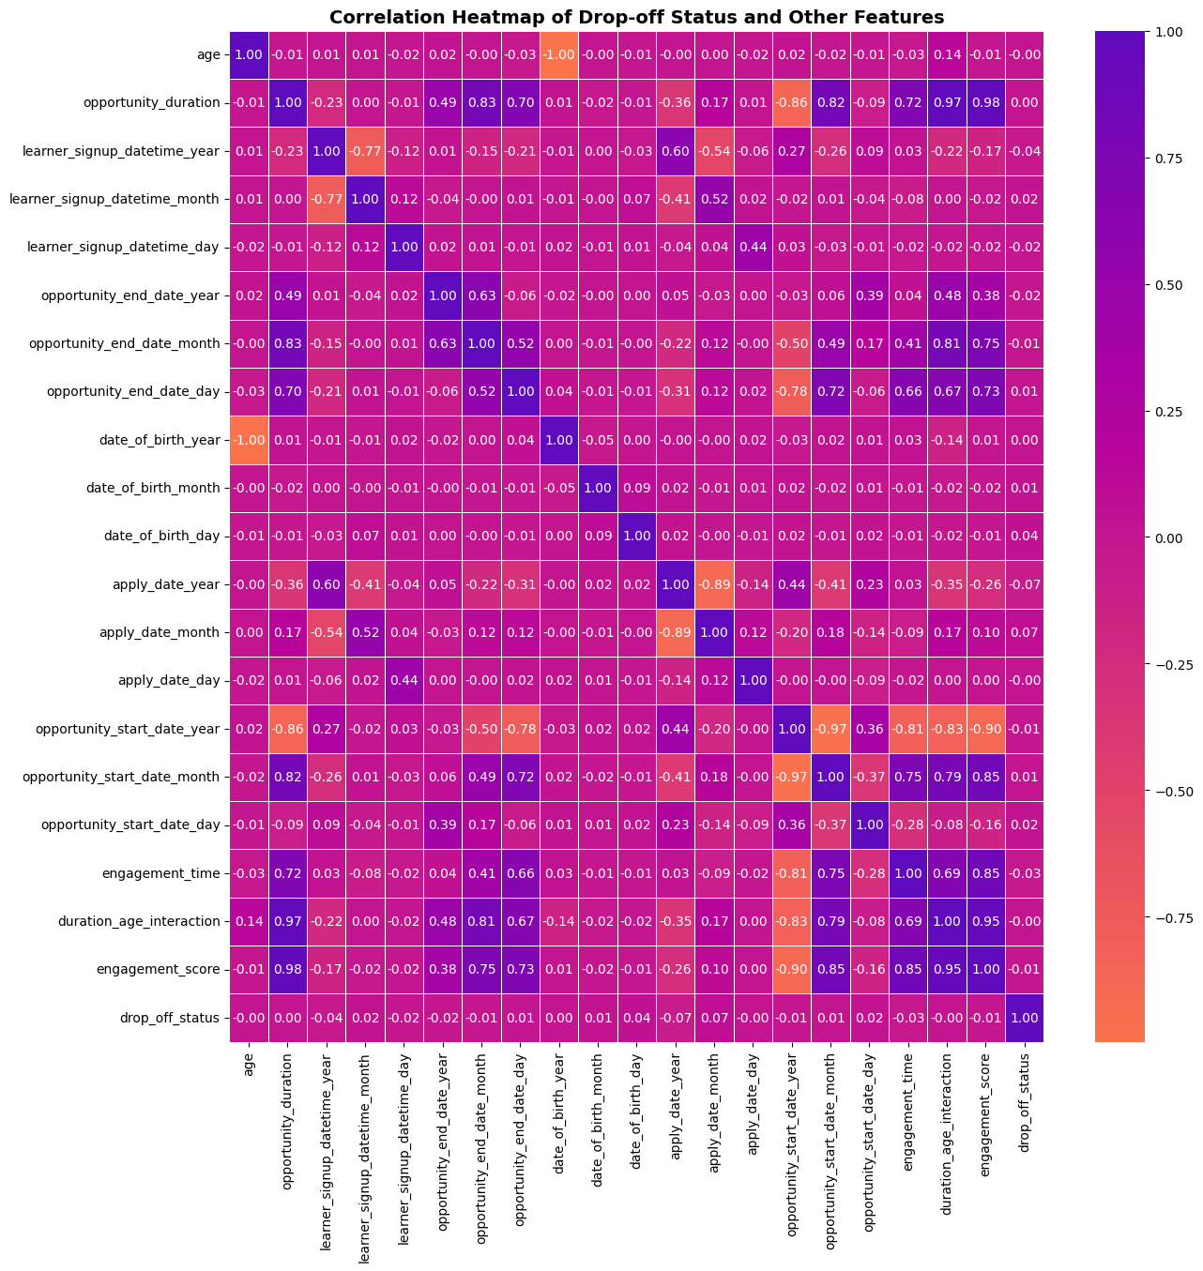

**Insights: Correlation of Features with Drop-Off Status**

**Weak Positive Correlations (Slight Drop-Off Influence)**:

* **Apply Date Month (0.068)** → Timing of application may impact drop-offs.
* **DOB Day (0.044), Signup Month (0.024), Start Date Day (0.016), DOB Month (0.010)** → Minor seasonal effects.

**Near-Zero Influence**:

* **Opportunity Duration (0.002), End Date Day (0.007), DOB Year (0.002)** → No strong link to drop-offs.

**Negative Correlations (Better Retention)**:

* **Age (-0.002), Engagement Score (-0.006), Engagement Time (-0.026)** → Older learners & active participants drop off less.
* **Apply Date Year (-0.075)** → Recent applicants retain better.

**Recommendations**

* **Enhance Support During High Drop-Off Periods** → Strengthen onboarding & early engagement in risky months.
* **Use Engagement Metrics for Retention** → Track low-engagement learners & send personalized nudges.
* **Improve Support for Younger Learners** → Provide mentorship & structured onboarding.
* **Refine Start Dates & Durations** → Optimize timing & ensure strong pre-start engagement.
* **Continue Improving Onboarding** → Build on recent success by refining learner support strategies.

**Drop-off trend by Opportunity start date**

**Insights: Drop-Off Trends by Start Date**

* **Highest Drop-Offs**: **March 2023 (1.47%)**, **Nov 2022 (1.26%)**, **April 2024 (1.09%)** → Likely due to schedule conflicts & weak onboarding.
* **Lower Drop-Offs in 2024**: **Jan (0.99%), Feb (0.63%), Mar (0.55%)** → Improved engagement & retention strategies.
* **Zero Drop-Offs**: **June 2023, Aug 2023, May 2024** → Stronger commitment & onboarding success.

**Recommendations**

* **Boost Engagement for High Drop-Off Periods**: Pre-start reminders, orientation webinars, mentorship, expectation-setting.
* **Leverage Low Drop-Off Months' Strategies**: Scale successful onboarding to high-risk months.
* **Optimize Start Dates**: Launch key programs in historically low drop-off months; offer rolling start dates.
* **Refine 2024 Strategies**: Continuously track trends, adjust outreach, and gather feedback for better retention.

**Gender-Opportunity Name-Drop-off Count**

**Insights: Gender-Wise Drop-Offs**

* **Higher Male Drop-Offs**: **Career Essentials (12), Data Visualization (8), Health Care Management (10), Project Management (3)** → Need better engagement.
* **Female Drop-Offs**: **Health Care Management (9), Project Management (7), Career Essentials (4)** → Spread across multiple programs.
* **Low Drop-Offs in "Other" & "Don't Want to Specify"** → Possible higher engagement or smaller group size.
* **Strong Retention in "Startup Mastery Workshop" & "UrbanRenew Challenge"** → Gender-neutral success.

**Recommendations**

* **For Males**: Hands-on projects, mentorship, pre-engagement materials in career & skill-based programs.
* **For Females**: Support networks, discussion forums, career guidance in health & business courses.
* **Analyze Low Drop-Off Groups**: Identify commitment drivers & apply to high-drop-off groups.
* **Leverage Successful Programs**: Use engagement models from low-drop-off programs in high-churn ones.

**Major-Opportunity Name-Drop Off Count**

**Insights: Drop-Offs by Major & Opportunity**

* **Computer Science:** Highest drop-offs (20 total) across various opportunities, indicating coursework pressure or relevance issues.
* **Health Majors:** High drop-offs in Health Care Management, suggesting misalignment with expectations.
* **Career Essentials:** Drop-offs across multiple majors, possibly due to redundancy.
* **Data & Information Systems:** Drop-offs in Data Visualization & Project Management, needing more hands-on content.
* **Engineering Majors:** Drop-offs in business/soft skills courses, indicating low interest in non-technical subjects.

**Recommendations**

* **For Computer Science:** Industry-focused content, coding projects, AI applications, and mentorship.
* **For Health Majors:** Real-world case studies, guest lectures, better content alignment.
* **For Career Essentials:** Major-specific pathways, mock interviews, interactive career planning.
* **For Data & Info Systems:** Hands-on projects, real-world applications in tech careers.
* **For Engineering Students:** Hybrid courses linking business & technical concepts, case studies of engineers in leadership roles.