**1.** What are the variables that affect hotel reservation better?

**2.**How can we make hotel reservations cancellations better?

**3.**How will hotels be assisted in making pricing and promotional decisions?

**HYPOTHESIS**

**1.**More cancellations occur when prices are higher.

**2.**When there is a longer list, customers tend to cancel more frequently

**3.** The majority of clients are coming from offline travel agents to make their reservations.

**ANALYSIS & FINDINGS**

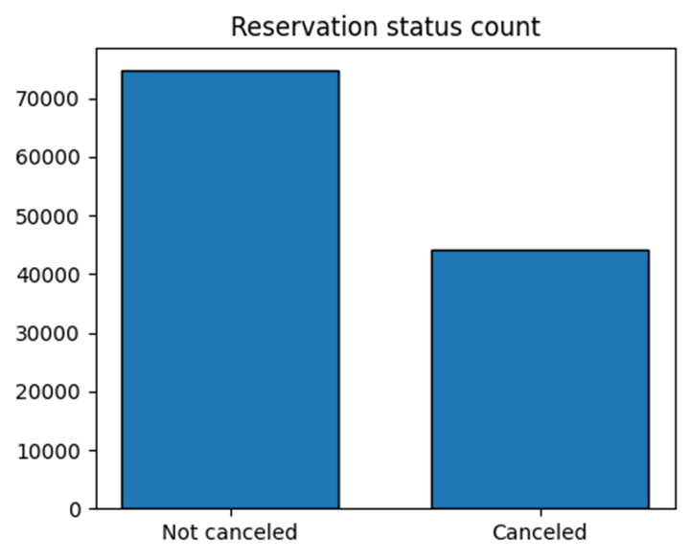

The accompanying bar graph shows the percentage of reservations that are cancelled and those that are not. It is obvious that there are still a significant number of reservations that have not been cancelled. There are still 37% of clients who cancelled their reservations, which has significant impact on the hotel’s earnings.

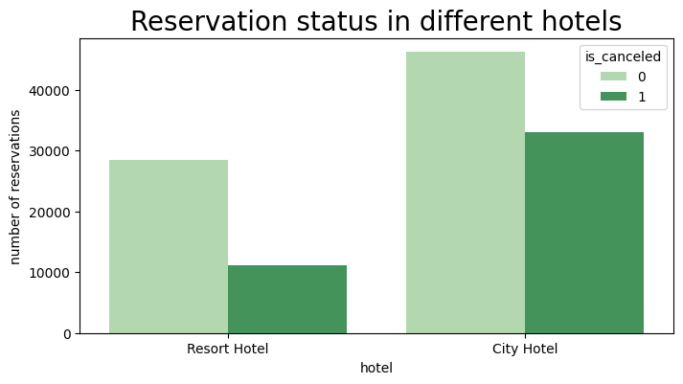

In comparison to resort hotels, city hotels have more bookings. It’s possible that resort hotels are more expensive than those in cities.

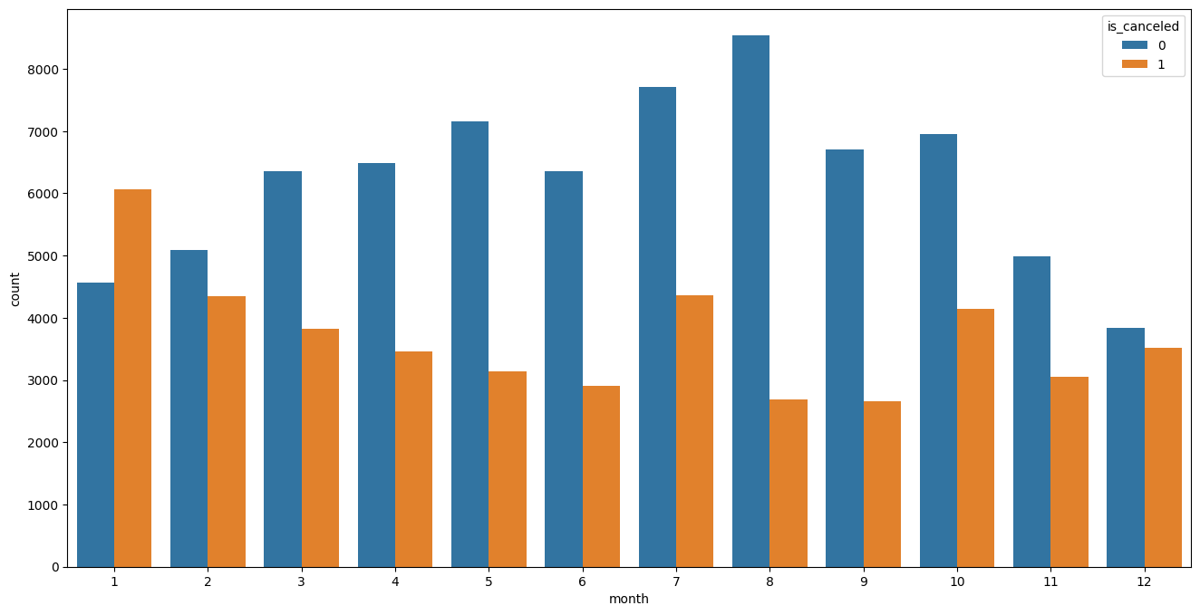We have developed the grouped bar graph to analyze the months with the highest and lowest reservations levels according to reservation status. As can be seen, both the number of confirmed reservations and the number of cancelled reservations are largest in the month of august. Whereas January is the month with most cancelled reservations.

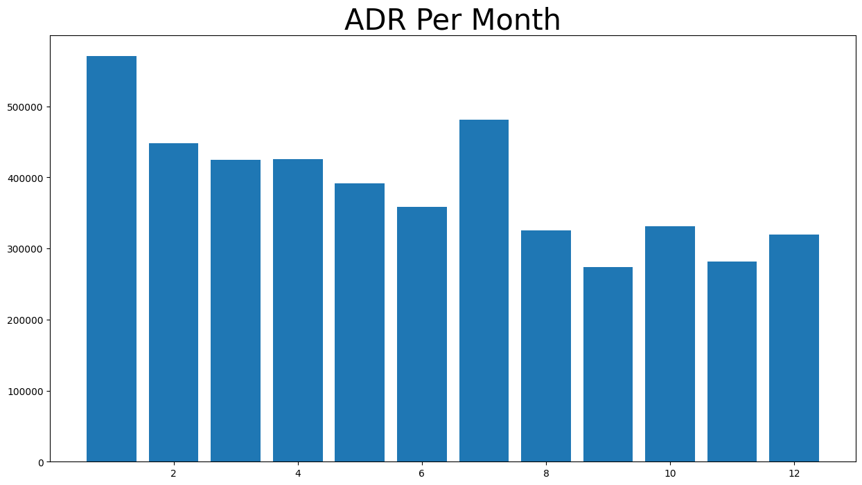This bar graph demonstrates that cancellations are most common when prices are greatest and are least when they are lowest. Therefore, the cost of the accommodation is solely responsible for the cancellation.

Now, let’s see which country has the highest reservation cancelled. The top country is Portugal with the highest number of cancellations.

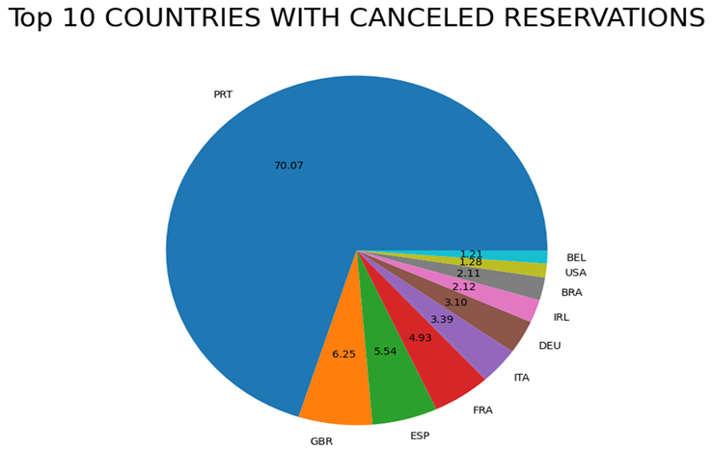

Let’s check the area from where guests are visiting the hotels and making reservations. Is it coming from direct or groups, online or offline Travel agents? Around 46% of the clients come from online travel agencies, where 27% come from groups. Only 4% of client’s hotels directly by visiting them and making reservations.

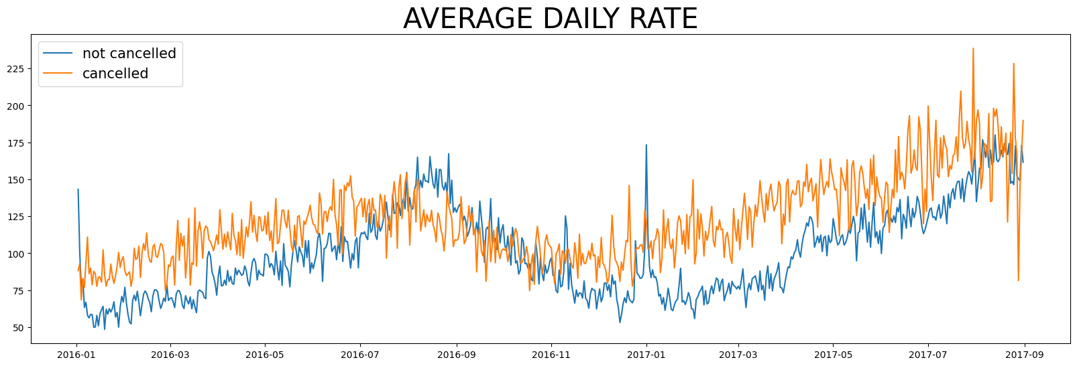

As seen in the graph, reservations are cancelled when the avg. daily rate is higher than when it is not cancelled. It clearly proves all the above analysis, that the higher price leads to higher cancellation.

**SUGGESTIONS:**

**1.**Cancellations rates rise as the price does. In order to prevent cancellations of reservations, hotels could work on their pricing strategies and try to lower the rates for specific hotels based on locations. They can also provide some discounts to consumers.

**2.** As the ratio of the cancellation and not cancellation of the resort hotel is higher in the resort hotels. So the hotels should provide a reasonable discount on the room prices on weekends or on holidays.

**3.**In the month of January, hotels can start campaigns or marketing with a reasonable amount to increase their revenue as the cancellation is the highest in this month.