ATTENDANCE TRACKING SYSTEM
A Mini Project Report
Submitted in partial fulfilment of the requirements for
B.Tech in Artificial Intelligence and Data Science
Second Year
Domain: Python | MySQL | Tkinter GUI

1. Abstract
Manual attendance tracking using paper registers is time-consuming, error-prone, and makes it difficult to calculate attendance percentages or generate reports quickly. This project, the Attendance Tracking System, is a desktop application that digitizes the process of recording and managing student attendance for an academic class or section.
The system is built using Python as the core programming language, Tkinter for the graphical user interface, and MySQL as the backend database for permanent data storage. It allows a teacher or class coordinator to add student records, mark daily attendance as Present or Absent, search and view historical records, and automatically generate attendance reports along with attendance percentage calculations for every student.
The project demonstrates the practical application of database connectivity, GUI design, and modular programming concepts learned during the second year of the B.Tech (AI & DS) curriculum, and is scoped to be realistic and achievable without relying on advanced enterprise-level frameworks.

2. Objective
- To design and develop a simple, functional desktop application for tracking student attendance.
- To replace manual, paper-based attendance registers with a digital, searchable system.
- To apply core programming concepts: GUI design, database connectivity, and modular code organization.
- To automatically calculate attendance percentage for each student without manual computation.
- To generate exportable attendance reports for record-keeping.
- To gain hands-on experience integrating Python with a relational database (MySQL).

3. Software Requirements

3.1 Hardware Requirements
- Processor: Intel i3 or above
- RAM: 4 GB minimum (8 GB recommended)
- Storage: 500 MB free disk space

3.2 Software Requirements
- Operating System: Windows 10/11, Linux, or macOS
- Programming Language: Python 3.8 or above
- GUI Library: Tkinter (included with standard Python installation)
- Database: MySQL Server 8.0 or above
- Database Connector: mysql-connector-python library
- IDE / Editor: VS Code, PyCharm, or any text editor

4. System Design

4.1 System Architecture
The system follows a simple 3-layer architecture commonly used in small desktop applications:
- Presentation Layer (gui.py): Handles all user interaction using Tkinter widgets such as buttons, entry fields, dropdowns, and tables (Treeview).
- Logic Layer (attendance_logic.py): Contains all business rules — adding students, marking attendance, searching records, calculating percentages, and generating reports.
- Data Layer (db_connection.py + MySQL): Handles the actual storage and retrieval of data using SQL queries executed against a MySQL database.
This separation of concerns (also called modular design) makes the codebase easier to understand, test, and extend — a practice encouraged even in introductory software engineering courses.

4.2 Database Design (ER Overview)
The database 'attendance_db' consists of two related tables:
Table | Key Columns | Relationship | Purpose
students | student_id (PK), roll_no (unique) | One-to-many with attendance | Stores student profile details
attendance | attendance_id (PK), student_id (FK) | Many attendance rows per student | Stores daily Present/Absent status

A UNIQUE constraint on (student_id, attendance_date) in the attendance table ensures a student cannot be marked twice on the same day — the system updates the existing record instead.

4.3 Workflow
- 1. Admin launches the application (gui.py).
- 2. Admin adds student details through the 'Add Student' tab → stored in the students table.
- 3. Admin marks daily attendance through the 'Mark Attendance' tab → stored/updated in the attendance table.
- 4. Admin views or searches records via the 'View / Search' tab, which queries both tables using a SQL JOIN.
- 5. Admin generates a report via the 'Reports' tab, which calculates attendance percentage per student and can export it to a text file.

5. Modules

5.1 Student Management Module
Allows adding new students with roll number, name, branch, and year. Roll numbers are enforced as unique at the database level to prevent duplicate entries.

5.2 Attendance Marking Module
Allows marking a selected student as Present or Absent for a given date. If attendance for that date already exists, it is updated rather than duplicated.

5.3 View & Search Module
Displays all attendance records in a tabular format (using Tkinter's Treeview widget) and allows searching by roll number or student name using SQL's LIKE operator for partial matches.

5.4 Report Generation Module
Aggregates attendance data for every student — total days, days present, days absent — and calculates the attendance percentage using the formula:
Attendance % = (Days Present / Total Days Marked) × 100
The report can be viewed inside the application and exported as a plain text (.txt) file for printing or sharing.

6. Results
The application was tested locally with sample student data and attendance entries across multiple dates. All core features — adding students, marking attendance, searching, viewing, and report generation — worked as expected. Below are representative screenshots of each module.
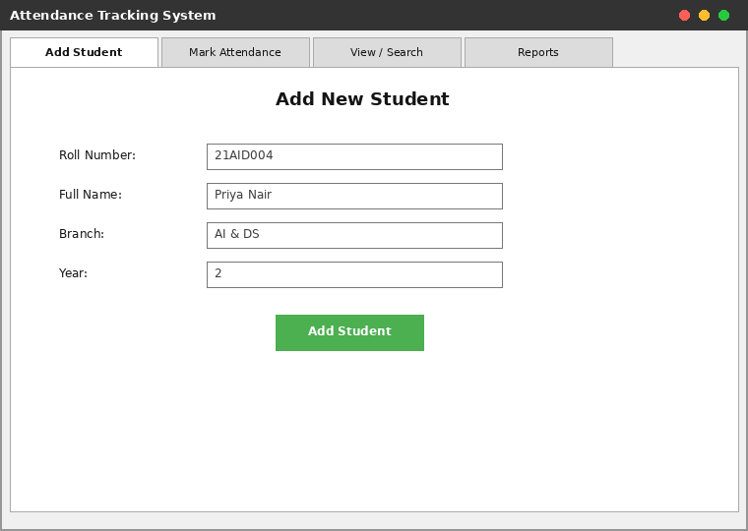
Fig 6.1 – Add Student tab, used to register new students into the database.
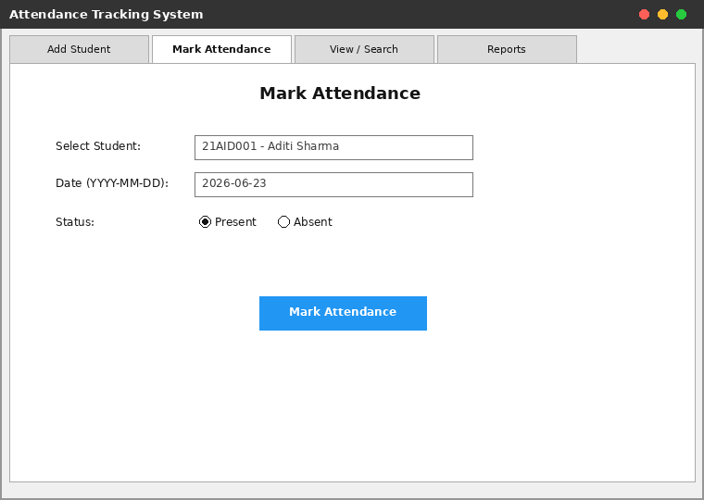
Fig 6.2 – Mark Attendance tab, used to mark a selected student Present or Absent for a chosen date.
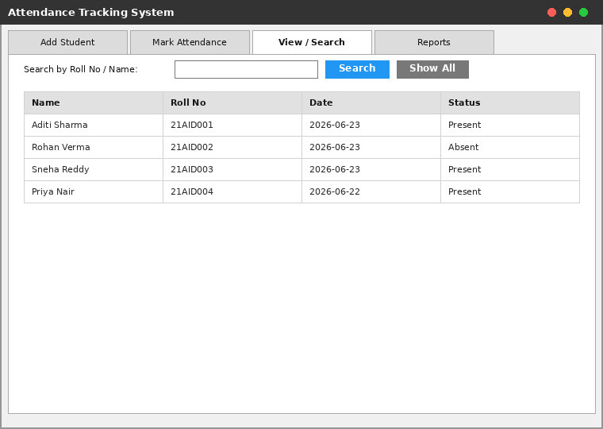
Fig 6.3 – View / Search tab, displaying all attendance records with search-by-roll-number/name capability.
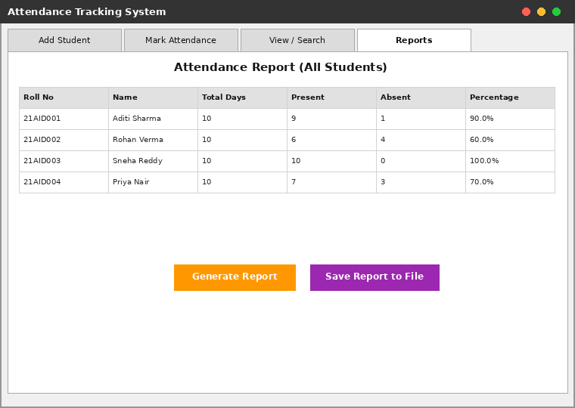
Fig 6.4 – Reports tab, showing automatically calculated attendance percentage for every student.
Note: The screenshots above are illustrative mockups of the application's layout used for documentation purposes; the actual running Tkinter window (produced when gui.py is executed on a machine with MySQL configured) follows the same layout and behaviour.

7. Future Enhancements
- Add a login/authentication system for teachers and administrators.
- Export attendance reports to PDF or Excel formats instead of plain text.
- Add subject-wise and month-wise attendance tracking instead of a single overall record.
- Add graphical charts (bar/pie charts) to visualize attendance trends using a library like Matplotlib.
- Send automatic email/SMS alerts to students or parents when attendance falls below a set threshold.
- Migrate the desktop GUI to a web-based interface for wider accessibility.

8. Conclusion
The Attendance Tracking System successfully demonstrates how core Python programming, GUI development with Tkinter, and database management with MySQL can be combined to build a practical, real-world application. The project reinforces fundamental software engineering practices such as modular design and separation of concerns, while remaining within the scope of a second-year B.Tech curriculum.

