Java – Full stack Assignment

* Module 1 – Overview of IT Industry

1)What is a Program?

Ans:- The program is a set of instruction.

2) Write a simple "Hello World" program in two different programming languages of your choice. Compare the structure and syntax.

Ans:- hello world in c

#include<stdio.h>

Int main(){

printf(“Hello world”);

return0;

}

Hello world in python

print (“Hello world”)

🡪Compare the structure and syntax.

1)c used the //symbol for comment.

Python uses the # symbol.

2)c uses the printf function to print output.

Python uses the print function.

3) Explain in your own words what a program

is and how it functions.

Ans:-

🡪a program is a set of instructions that a computer follows to perform a specific task or set of task.

🡪its like a recipe for your computer , telling it exactly what to do , step by step.

🡪program functions.

1)input

2)processing

3)storage

4)output

5)control

4)What is Programming?

Ans:- it means to create a program.

5) What are the key steps involved in the

programming process?

Ans:-

🡪planning

🡪designing

🡪coding

🡪testing

🡪debugging

🡪maintenance

6) Types of Programming Languages.

Ans:- There are main four types of programming

language.

1. Procedural programming language.
2. Object oriented programming language.
3. Logical programming language.
4. Functional programming language.

7) What are the main differences between high-

level and low-level programming languages?

Ans:-low-level language is a harder to read and

Write.(low level is machine dependent

Language)(0 or 1).

High-level language is a simply write and

Readable language.

8) World Wide Web & How Internet Works.

Ans:-WWW

The world wide web is a system of hypertext

Document that can be accessed via the Internet.

🡪HTML , HTTP they are main key components of

www.

🡪 INTERNET WORKING

🡪 A server is where website are stored, and

It works a lot like your computers hand drive.

🡪Once the request arrives, the server retrieves the

website and sends the correct data back to your

Computer.

🡪One of the best features of the internet is the

Ability to communicate almost instantly with anyone in the world.

9)Research and create a diagram of how data is

transmitted from a client to a server over the

internet.

%2 Ans:-

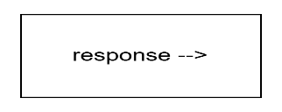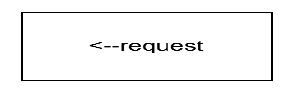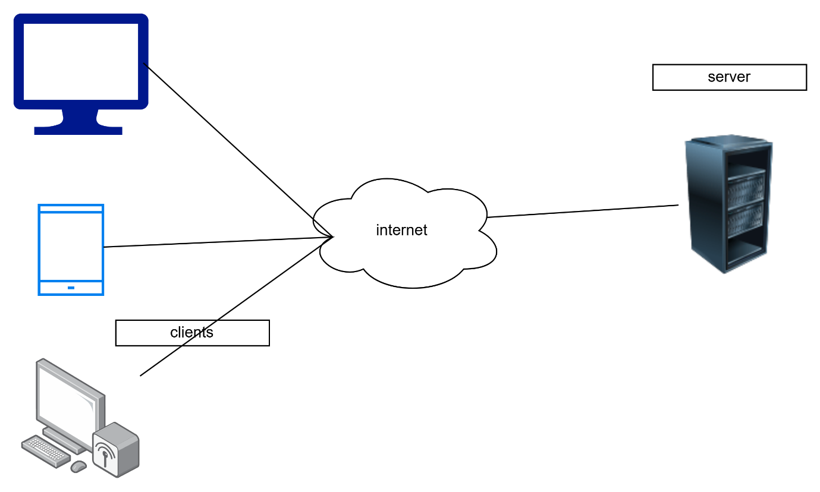

10) Describe the roles of the client and server in

web communication.

Ans:- Client

1)request:- the clint send the request to the

Server for a specific resource, such

As a web page, image, or data.

2)send data:- the client sends the data to the

Server, such as from data, login

Credentials, or search queries.

3)receives responses:- the client receives

Responses from the server

Including the request

Resources, error message,

Or other data.

🡪Server

1)receives request:- The server receives requests

From clients and processes

Them according.

2)processes requests:- The server processes the

Client’s request.

3)sends responses:-The server sends the

Responses back to the client

Including the requested

Resources, error messages,

Or other data.

11) Network Layers on Client and Server.

Ans:-There are many types of network layers.

1)Application layer

2)Transport layer

3)Network layer

4)Data link layer

5)Physical layer

12) Design a simple HTTP client-server

communication.

Ans:-

🡪SERVER SIDE

🡪create an HTTP server that listens on a specific port. define a route for handling incoming HTTP requests. When a request is received , send a response back to the client with a status code and message.

🡪CLIENT SIDE

🡪create an HTTP client that can send request to the server. Define a method for sending an HTTP request to the server. Handle the response received from the server and print the status code and message.

13)Explain the function of the TCP/IP model and its

layers.

Ans:-

🡪 The TCP/IP(transmission control protocol/

Internet protocol)model is a conceptual

Framework that describes the communication

Process over the internet.

🡪It’s a simplified version of the

OSI (open systems interconnection) model.

🡪TCP/IP model layer

1)application layer

2)transport layer

3)internet layer

4)network access layer.

14) Explain Client Server Communication.

Ans:-

🡪client – server communication process

1)client request : the client sends a request to

the server for a specific service or resources.

2)server request: the server receives the

Client’s request and processes it.

Back to the client, which may include the

Requested resource or an error message.

4)client receipt: the client receives the server’s

Response and uses the provided resource or

An error message.

15) Types of Internet Connections.

Ans:-

Here are the main types of internet

Connection:

1. Cabel internet
2. Wi-fi
3. Mobile hotspot

4)satellite internet

5)wireless broadband

16) : Research different types of internet connections (e.g., broadband, fiber, satellite)and list their pros and cons.

Ans:-

🡪1) Broadband Connection

A broadband connection is a high-speed internet connection that is always on and faster than traditional dial-up access.

🡪Pros:

- Faster speeds compared to dial-up connections

- Always-on connection, no need to dial in

- Can be used for multiple devices simultaneously

🡪Cons:

- May have data caps or throttling

- Can be affected by physical obstructions and

distance from the provider.

2) Fiber Optic Connection

A fiber optic connection uses light to transmit data through fiber optic cables.

🡪Pros:

- Extremely fast speeds, up to 10 Gbps

- Reliable and less prone to outages

- Can handle multiple devices and high-bandwidth

Applications.

🡪Cons:

- Limited availability, especially in rural areas

- Can be more expensive than other types of

Connections.

3) Satellite Connection

A satellite connection uses a satellite dish to connect to the internet.

🡪Pros:

- Available in areas where other connections are not

available

- Can be used for multiple devices simultaneously

🡪Cons:

- Slower speeds compared to other types of connections

- Can be affected by weather conditions and physical obstructions

- May have higher latency and data caps.

17) : How does broadband differ from fiber-optic internet

Ans:-

Broadband and fiber optics internet are both high speed internet connection , but they differ in their underlying technology :

Broadband internet

1. Uses existing infrastructure :

Broadband internet uses existing copper telephone lines (DSL) or coaxial cables (cable internet) to deliver internet.

1. Slower speed :

Broadband speeds typically range from 1 Mbps to 1,000 Mbps(1Gbps).

1. Distance limitations:

Broadband speed decrease with distance from the provider’s central office.

1. Shared bandwidth :

Broadband connection often share bandwidth with other users, which can lead to soler speeds during peak hours.

Fiber optics internet

1)Uses light to transmit data :

Fiber optics internet uses light to transmit data

through fiber-optics cables.

2)Faster speeds:

Fiber optics speeds typically range from 100 Mbps

to 10,000 Mbps (10 Gbps.)

3)Longer distance capabilities :

Fiber optics cables can transmit data over much

longer distances without signal degradation.

4)Dedication bandwidth :

Fiber optics connection typically provide dedication

bandwidth, ensuring consistent speeds even during

peak hours.

18) : Simulate HTTP and FTP requests using command line tools (e.g., curl).

Ans:-

🡪 HTTP Requests

1. GET Request

2. POST Request

3. PUT Request

4. DELETE Request

FTP Requests

1. Login to FTP Server
2. Upload File to FTP Server
3. Download File from FTP Server
4. List Files on FTP Server

19) What are the differences between HTTP and HTTPS protocols?

Ans:-

HTTP :

1)HTTP send data in plain text.

2)data is not encrypted, allowing interceptors to read or modify the data.

3)HTTP uses port 80 by default.

4)HTTP does not provide authentication or verification

Of the server’s identity.

HTTPS:

1)HTTPS sends data in encrypted from.

2)data is encrypted using a secure protocol such as TLS

(Transport layer security), SSL(secure sockets layer).

3)HTTPS uses port 443 by default.

4)HTTPS provide authentication or verification of the

Server’s identity through digital certificates.

20) Application Security

Ans:-

🡪 Application Security refers to the practices, measures, and controls designed to protect software applications from unauthorized access, use, disclosure, disruption, modification, or destruction.

21) Identify and explain three common application

security vulnerabilities. Suggest possible solutions.

Ans:-

🡪 1) SQL Injection Vulnerability

SQL injection occurs when an attacker injects malicious SQL code into a web application's database in order to access, modify, or delete sensitive data.

Possible solution: - Use prepared statements with parameterized queries to separate user input from the SQL code.

2) Cross-Site Scripting (XSS) Vulnerability

XSS occurs when an attacker injects malicious JavaScript code into a web application, which is then executed by the user's browser.

Possible solution:- Implement input validation and sanitization to ensure that user input conforms to expected formats and does not contain malicious characters.

3) Authentication and Session Management Vulnerability

Authentication and session management vulnerabilities occur when an attacker is able to bypass or manipulate the authentication and session management mechanisms of a web application.

Possible solution:- Implement strong password policies and multi-factor authentication to prevent weak passwords and unauthorized access.

22) What is the role of encryption in securing applications?

Ans:-

🡪Encryption plays a crucial role in securing application

By protecting sensitive data from unauthorized

access.

🡪Here are some ways encryption help secure

Application.

🡪1)confidentiality

2)data integrity

3)authentication

4)non-repudiation

23)Software Applications and Its Types.

Ans:-

🡪SOFTWARE APPLICATION

🡪a software application, also known as a program or

App, is a set of instructions that tell a computer what

To do.

🡪software application can perform a wide range of

Tasks, from simple calculations to complex

Simulation.

🡪TYPES OF SOFTWARE

🡪1)productivity software

2)graphics and design software

3)gaming software

4)educational software

5)mobile app

6)web application

24) Identify and classify 5 applications you use daily as either system software or application software.

Ans:-

🡪here are 5 application classified as either system

Software or application software.

🡪GOOGLE CHROME

Classification:-application software reason:

Google chrome is a web browser that provides

A plateform for users to access and view website

, making it an application software

🡪MICROSOFT WORD

Classification:-application software reason:

Microsoft office word is a word processing application

that application that allows users to creat , edit , print

document , making it an application software.

🡪SPOTIFY MUSIC PLAYER

Classification:-application software reason:

Spotify music player is a music streaming application

That allows users to listen to music , making it an

Application software.

🡪ANTIVIRUS SOFTWARE

Classification:-system software reason:

Antivirus software is a type of system software that

Protects that computer system from malware and

other security threats.

🡪MICROSOFT WINDOWS 10

Classification:-system software reason:

Microsoft windows 10 is an operating system that

Manages computer hardware resources and provides

A plateform for running application software.

25): What is the difference between system software

and application software?

Ans:-

🡪SYSTEM SOFTWARE

1)System software manages computer hardware and

Provides a plateform for application.

2)system software operates at a lower level of

Abstraction , interacting directly with computer

Hardware.

3)system software typically does not provide a user

Interface.

🡪APPLICATION SOFTWARE

1)application software performs specific tasks and

Provides a user interface.

2)application software operates at a higher level of

abstraction .

3)application software provides a user interface to

Interact with the user.

26)Software Architecture

Ans:-

🡪software architecture refers to the high level

structure and organization of a software system ,

including the relationships between different

components and the principles that guide their

design and evolution.

🡪1)modularity:-breaking down the system into smaller

Independent modules that can be developed ,

Tested , and maintained separately.

2)reusability:-designing components that can be

reuse across different parts of the system or even

in other systems.

3)scalability:- designing the system to scale

Horizontally or vertically as needed.

4)flexibility:- designing the system to be adaptable

To charging requirements or new technology.

5)maintainability:-designing the system to be easy

To understand , modify , and repair.

27)Design a basic three-tier software architecture

diagram for a web application

Ans:-

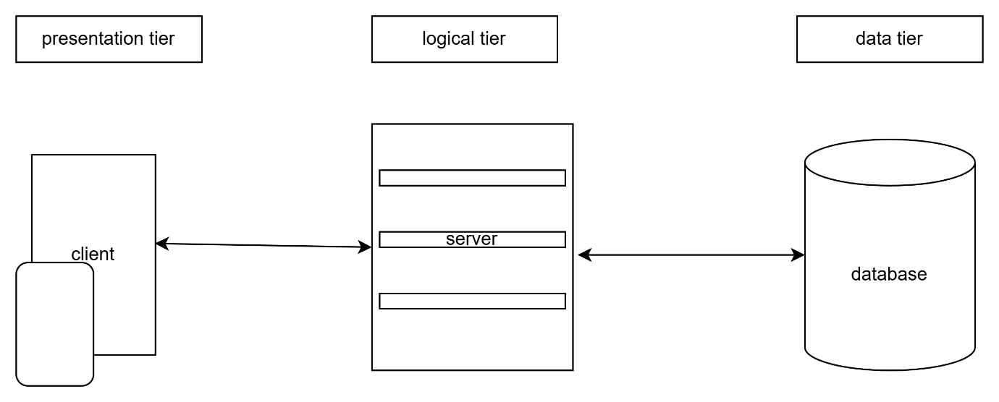

28)What is the significance of modularity in software

architecture?

Ans:-

🡪modular is a fundamental concept in software architecture that plays a crucial role in the design , development , and maintenance of software system.

29)Layers in Software Architecture

Ans:-

1. Presentation layer
2. Application layer
3. Infrastructure layer
4. Data access layer
5. Additional layer

30)Create a case study on the functionality of the

presentation, business logic, and data access layers

of a given software system.

Ans:-

CASE STUDY:-online shopping cart system.

🡪the online shopping cart system is a web-based

Application that allows customers to browse

product , add them to their shopping cart , and

checkout.

🡪the system consist of three main layers.

🡪PRESENTATION LAYER:-

The presentation layer is responsible for handling user interactions and displaying data to the user.

1)web page(html , css , js )

2)web server

3)web framework(react)

🡪BUSINESS LOGIC LAYER

The business logic layer is responsible for processing user input , performing calculations , and enforcing business rules.

1)application server (node.js)

2)business logic components(js)

🡪DATA ACCESS LAYER

The data access layer is responsible for storing

And retrieving data from the database.

1)database management system(my sql)

2)database schema(tables , relationship)

3)data access components(sql)

31)Why are layers important in software architecture?

Ans:-

🡪to provide a complete set of manage communication and power the software architecture.

32) Software Environments

Ans:-

A software environment refers to the combination of hardware , software , and network resources that a software system relies on to operate.

33) : Explore different types of software environments (development, testing, production).Set up a basic environment in a virtual machine.

Ans:-

🡪different types of software environment .

1)development environment:-this is the environment

Where software developers build , test , and debug.

2)testing:-this environment is used to verify the

software’s functionality and performance.

3)production:- this is the live environment where the

Software is deployed and used by end-users.

🡪SET UP A BASIC ENVIRONMENT IN A VIRTUAL

MATCHINE

1)step 1:-create a new virtual machine

2)step 2:-install the operating system

3)step 3:-install development tool

4)step 4:-test the environment.

34) Explain the importance of a development

environment in software production.

Ans:-

🡪the most important uses of developers to ensure various function of the application work as intended before it is released to user.

35) Source Code.

Ans:-

🡪source code is the human readable instruction

That a programmer writes to create a software program , application , or system.

36) : Write and upload your first source code file to

Github .

Ans:-

🡪 Step 1: Create a GitHub Account.

🡪 Step 2: Install Git.

🡪 Step 3: Create a New Repository.

🡪 Step 4: Create a New File.

🡪 Step 5: Initialize Git and Add the File.

🡪 Step 6: Commit the File.

🡪 Step 7: Link the Repository to GitHub.

🡪 Step 8: Push the File to GitHub.

37) : What is the difference between source code and

machine code?

Ans:-

🡪SOURCE CODE

1)source code is a human readable .

2)source code is written in a high-level language ,

such as , java , c++ , python.

3)source code can be run on different machine with the same operating system and programming language.

🡪MACHINE CODE

1)machine code is a machine readable binary code.

2)machine code is written in a low-level language .

3)machine code is specific to a particular computer architecture and operating system.

38) Github and Introductions.

Ans:-

🡪gitHub is a web-based plateform for version control

And collaboration on software development projects.

🡪introduction

🡪initialize git on a folder , making it a repository

🡪github now create a hidden folder to keep track of

Changes in that folder.

🡪you select the modified files you want to stage.

🡪guthub allows you to see the full history of every commit.

39) Create a Github repository and document how to commit and push code changes.

Ans:-

🡪 Creating a GitHub Repository

1. Log in to your GitHub account.

2. Click the "+" button in the top-right corner of the dashboard.

3. Select "New repository" from the dropdown menu.

4. Fill in the required information:

- Repository name

- Description (optional)

- Public or private repository

- Initialize repository with a README file (optional)

5. Click the "Create repository" button.

🡪Committing and Pushing Code Changes

🡪Step 1: Create a Local Repository

🡪Step 2: Link Your Local Repository to GitHub

🡪 Step 3: Commit Code Changes

🡪 Step 4: Push Code Changes to GitHub

40) Why is version control important in software development?

Ans:-

🡪the version control system helps manage the source code for the software twam by keeping track of all the code modifications.

41) : Create a student account on Github and collaborate on a small project with a classmate.

Ans:-

🡪Step 1: Create a Student Account on GitHub.

🡪Step 2: Create a New Repository.

🡪Step 3: Invite a Classmate to Collaborate.

🡪Step 4: Collaborate on the Project.

🡪Step 5: Merge Changes and Resolve Conflicts.

42) What are the benefits of using Github for students?

Ans:-

🡪 GitHub provides students with a platform to develop, showcase, and collaborate on projects, enhancing their coding skills, and career opportunities.

43) Types of Software

Ans:-

🡪there are main types of software.

1)system software

2)application software

3)programming software

44) Create a list of software you use regularly and classify them into the following categories: system, application, and utility software.

Ans:-

🡪System Software:

1. Operating System: Windows 10

2. Device Drivers: Graphics driver, Sound driver, Network driver

🡪Application Software:

1.Web Browser: Google Chrome

2.Email Client: Microsoft Outlook

🡪Utility Software:

1. Antivirus: Norton Antivirus

2. Disk Cleanup: CCleaner

45) : What are the differences between open-source and proprietary software?

Ans:-

🡪OPEN SOURCE

1)open-source software is often free.

2)open-source software can be customized.

3)open-source software is often developed and maintained by a community of volunteers.

🡪PROPRIETATY SOFTWARE

1)proprietaty software requires a license fee.

2) proprietaty software has limited customization options.

3) proprietaty software is developed and maintained

By a commercial company.

46) GIT and GITHUB Training

Ans:-

🡪 GIT and GITHUB training provides hands-on instruction on using GIT for version control and GITHUB for collaborative development, repository management, and project workflow.

47) Follow a GIT tutorial to practice cloning, branching,

and merging repositories.

Ans:-

🡪CLONING

Cloning repository using ‘git clone’. Navigation into

The cloned repository using cd your-repo- name.

🡪NEW BRANCHING

Create a new branch using git branch feature/new-

Feature. create a new file called new-feature.txt.

🡪MERGING BRANCHES

Merging branches switch back to the master branch

Using git checkout master. merge the feature branch

into master using git merge feature/new feature.

Verify the merge using git log – graph --oneline.

48) How does GIT improve collaboration in a software

development team?

Ans:-

🡪git is a powerful tool that improves collaboration in a software development team in several ways.

🡪git allows multipal developers to work on the same

Codebase simultaneously ,without conflicts.

🡪improved communication and collaboration among

Team members.

🡪faster issue resolution and conflict management.

🡪better code quality and maintainability.

49) Application Software.

Ans:-

🡪application software enable users to create and

manage document , spreadsheet , and presentations

🡪application software allow users to create and edit

visual content , such as images , video , and 3D

models.

🡪application software provide entertainment and

engagement for users.

50) Write a report on the various types of application

software and how they improve productivity

Ans:-

🡪PRODUCTIVITY SOFTWARE

Productivity software enable users to create and

Manage document , presentation.

Productivity:-enhancing document collaboration and

Sharing.

🡪GRAPHIC AND DESIGN SOFTWARE

Graphic design software allow users to create and edit visual content , such as image , video.

Productivity:-providing advanced editing and

Manipulation tools.

🡪EDUCATION SOFTWARE

Education software supports learning and technique ,

Covering subjects such as language learning math and

science .

productivity:-providing interactive and engaging

learning experience.

🡪BUSINESS SOFTWARE

Business software supports various business function

Such as accounting , customer relationship

Management and enterprise resource planning.

Productivity:-automating routing tasks and processes

Provide real time insights and analytics.

51) : What is the role of application software in

businesses?

Ans:-

🡪application software plays acritical role in business by providing specialized tools and features that enable organization to manage their operation more efficiently , improve customer relationship , and make data-driven decisions.

52) Software Development Process.

Ans:-

🡪the software development process , also know as the software development life cycle(SDLC).

🡪SOFTWAREW DEVLOPMENT PROCESS

1)planning/requirement gathering (what):-

Define project scope , goals , timeline , budget ,

And resources.

2)analysis(how):-

Collect and document software requirements.

3)designing(DFD , flowchart , use case):-

Create architechture design , and database design.

4)implementation /coding (h/w & s/w requirments):-

Write code .

5)testing(QA):-

Verify software quality , functionality , and performance through various testing technique.

6)maintenance:-

Monitor software performance , and update software

To meet changing requirments.

53) : Create a flowchart representing the Software Development Life Cycle (SDLC).

Ans:-

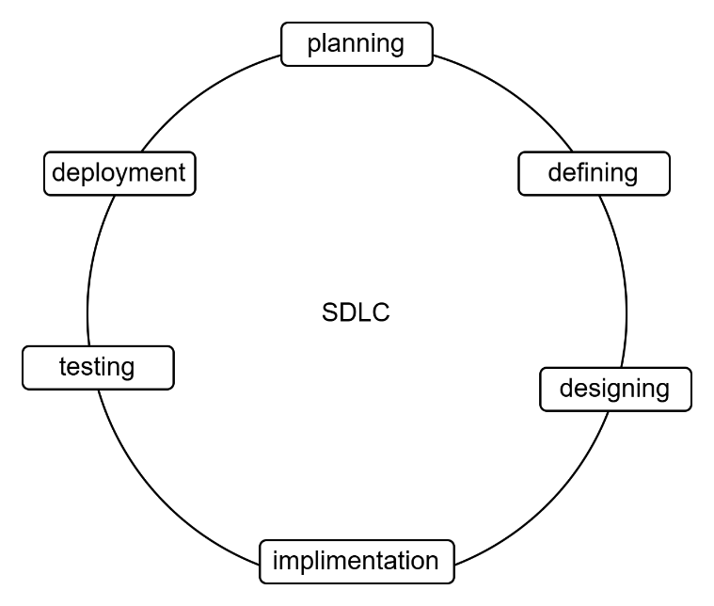

54) : What are the main stages of the software development process?

Ans:-

🡪planning

🡪requirement gathering

🡪design

🡪implimentation

🡪testing

🡪deployment

🡪maintenance

55) Software Requirement.

Ans:-

🡪software requirments are the specification of what

A software system should do , how it should behave

And what constraints it should satisfy.

🡪types of software requirments:-

1)functional requirement

2)interface requirments

3)performance requirments

4)security requirments

56) : Write a requirement specification for a simple library management system.

Ans:-

🡪the system shall allow librarians to add, edit , and

Delete book records.

🡪the system shall provide a search function to find books by title , author or category.

🡪the system shall require librarians to log in with a username and password.

🡪ability to check out and return books.

🡪ability to display a list of all books in the library.

57) Why is the requirement analysis phase critical in software development?

Ans:-

🡪this phase helps identified the right solution.

🡪gathering the information on what the stakeholders

Need helps software engineers come up with the right software solution.

🡪it helps them create software that meets the needs of the users.

58) Software Analysis.

Ans:-

🡪software analysis is basically a requirement analysis

That aims to determine the tasks that are needed to

get fully functional software.

59) : Perform a functional analysis for an online shopping system.

Ans:-

🡪user management:-the system shall allow new user to register and create an account.

🡪the system shall allow user to view and edit their

Profile information.

🡪the system shall display a catalog of available products , including product description , prices , and images.

🡪the system shall provide a search function to help users find specific products.

🡪the system shall allow users to add products to a shopping cart.

🡪the system shall integrate with a payment gateway

To process transaction securely.

🡪the system shall provide users with order tracking

Information , including , order status and shipping details.

🡪it maintain a record of users past orders.

It shall allow users to cancel order before they are shipped.

60) What is the role of software analysis in the development process?

Ans:-

🡪software analysis and design is a process of understanding the requirments of a software system and then designing a system that meets those requirments.

61) System Design.

Ans:-

🡪system design is the processes of defining and specifying the architecture , components , and interfaces of a system to meet the requirements and

Needs of its users.

62) Design a basic system architecture for a food delivery app.

Ans:-

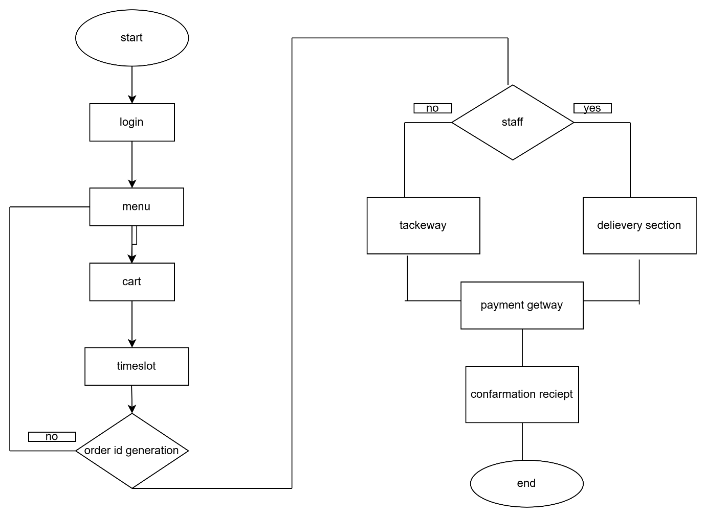

63) What are the key elements of system design?

Ans:-

🡪the key element of the system design include understanding the problem or need , creating prototypes or models , testing and refining the design ,

And finally implementing the system design.

64) Software Testing.

Ans:-

🡪software testing is the process of evaluating and verifying that a software application or system meets the required specifications , works as expected , and is free from defects.

🡪it involves executing a set of test cases to validate the software functionality , performance , security and

Usability.

65) Develop test cases for a simple calculator program.

Ans:-

🡪 Here are some test cases for a simple calculator

program:

🡪Test Case 1: Addition

- Input: 2 + 2

- Expected Output: 4

- Test Description: Test the addition functionality with

two positive numbers.

🡪Test Case 2: Subtraction

- Input: 5 - 3

- Expected Output: 2

- Test Description: Test the subtraction functionality

with two positive numbers.

🡪 Test Case 3: Multiplication

- Input: 4 \* 5

- Expected Output: 20

- Test Description: Test the multiplication functionality

with two positive numbers.

🡪Test Case 4: Division

- Input: 10 / 2

- Expected Output: 5

- Test Description: Test the division functionality with

two positive numbers.

🡪 Test Case 5: Decimal Numbers

- Input: 2.5 + 1.8

- Expected Output: 4.3

- Test Description: Test the calculator's handling of

decimal numbers.

🡪Test Case 8: Negative Numbers

- Input: -2 + (-3)

- Expected Output: -5

- Test Description: Test the calculator's handling of

negative numbers

66) : Why is software testing important?

Ans:-

🡪software testing is important because it ensures the delivery of high-quality , reliable , and error-free software products that meet user expectations and requirments.

67) : Document a real-world case where a software application required critical maintenance.

Ans:-

🡪 Case Study: Heartbleed Bug in OpenSSL

In April 2014, a critical vulnerability known as the Heartbleed bug was discovered in the OpenSSL encryption library.

🡪 Problem Statement:

The Heartbleed bug allowed attackers to access sensitive information, such as encryption keys, passwords, and credit card numbers, by exploiting a buffer overflow vulnerability in OpenSSL.

🡪 Critical Maintenance Requirements:

1. Patch the vulnerability: Update OpenSSL to a

version that fixed the Heartbleed bug.

1. Revoke and reissue certificates: Revoke existing

SSL/TLS certificates and reissue new ones to prevent attackers from using stolen certificates.

🡪 Maintenance Process

1. Assessment: Identify systems and applications that

used OpenSSL and were vulnerable to the Heartbleed bug.

1. Patch deployment: Deploy patches to update

OpenSSL to a fixed version.

68) : What types of software maintenance are there?

Ans:-

1)corrective maintenance

2)adaptive maintenance

3)preventive maintenance  
4)perfective maintenance

69)development.

Ans:-

🡪 Development is the systematic process of designing, building, testing, and deploying software applications, systems, or products to meet specific requirements or needs.

70) : What are the key differences between web and desktop applications?

Ans:-

🡪WEB APPLICATION

1)web application run on web browser.

2)web application can be accessed from anywhere with

An internet connection , using various devices. (desktops , laptops)

3)web application do not require installation , users

Can access them directly through a web browser.

4)web application can be update centrally , without

Requiring users to install updates on their devices.

🡪DESKTOP APPLICATION

1)desktop application run directly on the operating system.

2) desktop application can only be accessed from the computer on which they are installed.

3) desktop application requires installation on the user’s computer , which can be time-consuming and may require administratore .

4) desktop application require users to install updates manually , which can be time-consuming and may cause compatibility issues.

71) Web Application.

Ans:-

🡪a web application is a software application that runs

On a web server , is accessed through a web browser

Or mobile devices , and provides interactive and dynamic content to users.

72) What are the advantages of using web applications over desktop applications?

Ans:-

🡪WEB APPLICATION

1)it can be accessed from anywhere with an internet

Connection.

2)no need to installed software on the user’s device.

3)update are applied centrally , without requiring

User intervention.

4)reduce software development and maintenance costs.

🡪DESKTOP APPLICATION

1)it can be accessed from various devices .

2)reduce storage requirments and saves disk space.

3)ensures all users have access to the latest version.

4)eliminates the need for expensive hardware

upgrades.

73) . Designing.

Ans:-

🡪designing is the process of creating and planning the visual , funcational , and user experience aspects of a

Product , system , or space to meet specific goals and

Requirements.

74) : What role does UI/UX design play in application development?

Ans:-

🡪UI/UX design plays a crucial role in application development by creating intuitive , engaging , and user-centered interfaces that enhances that enhance the overall user experience and support business goals.

75) Mobile Application.

Ans:-

🡪a mobile application is a software application designed to run on mobile devices such as smartphone , tablets , and smartwatches.

76) What are the differences between native and hybrid mobile apps?

Ans:-

🡪NATIVE

1)native apps are built for a specific mobile plateform

, such as ios or android.

2)native apps use plateform specific programming language , such as swift for ios or java for android.

3)native app have directly access to device hardware

, such as cameras , gps , and accelerometers.

4)native apps typically have fast performance and responsive user interface.

🡪HYBRID

1)hybrid apps are built using cross-plateform framework , such as react native or flutter.

2) hybrid apps use web technologies , such as HTML

Css , and javascript , to build the user interface.

3)hybrid apps are wrapped in a native container ,

Which provides accesses to device hardware.

4)hybrid apps can have slower performance compared

to native app , due to the overhead of the cross-

plateform framework.

77) DFD (Data Flow Diagram)

Ans:-

🡪a data flow diagram is a graphical representation

Of the flow of data through a system , highlight the

Inputs , processing , output , and storage of data.

78) Create a DFD for a hospital management system.

Ans:-

🡪

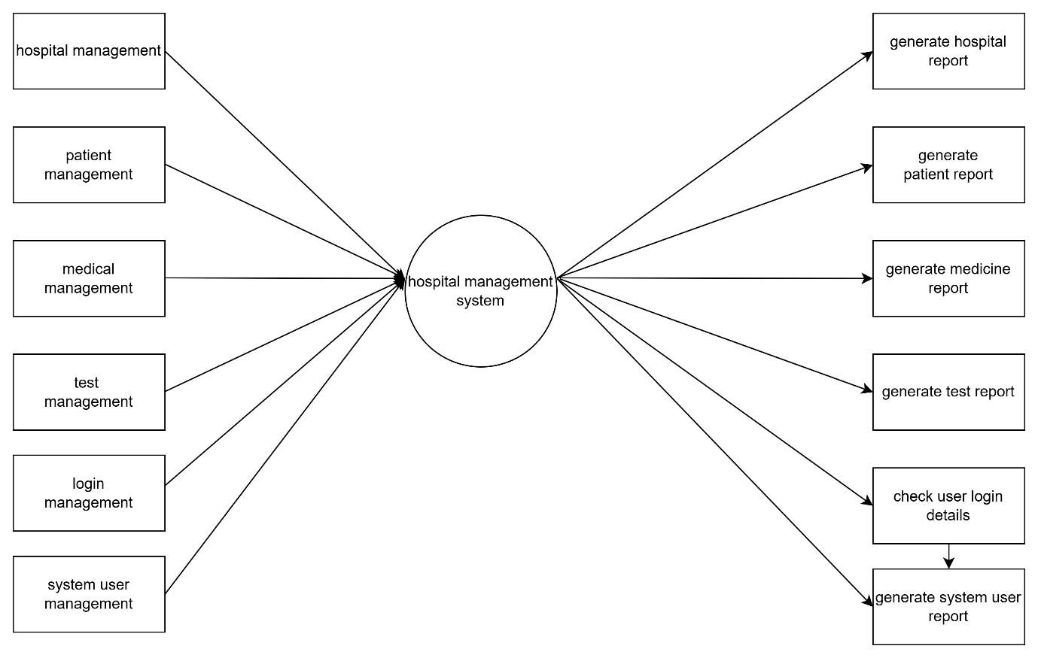

79) What is the significance of DFDs in system analysis?

Ans:-

🡪the signification Of DFD system analysis is that provides the clear , concise , and visual representation of a system’s data flow , processes , and relationships , facilitating effective system analysis and desig

80) . Desktop Application.

Ans:-

🡪a desktop application is a software program that runs on a computer’s desktop, providing a user interface and functionality for tasks such as productivity , gaming , or entertainment.

81) Build a simple desktop calculator application using a GUI library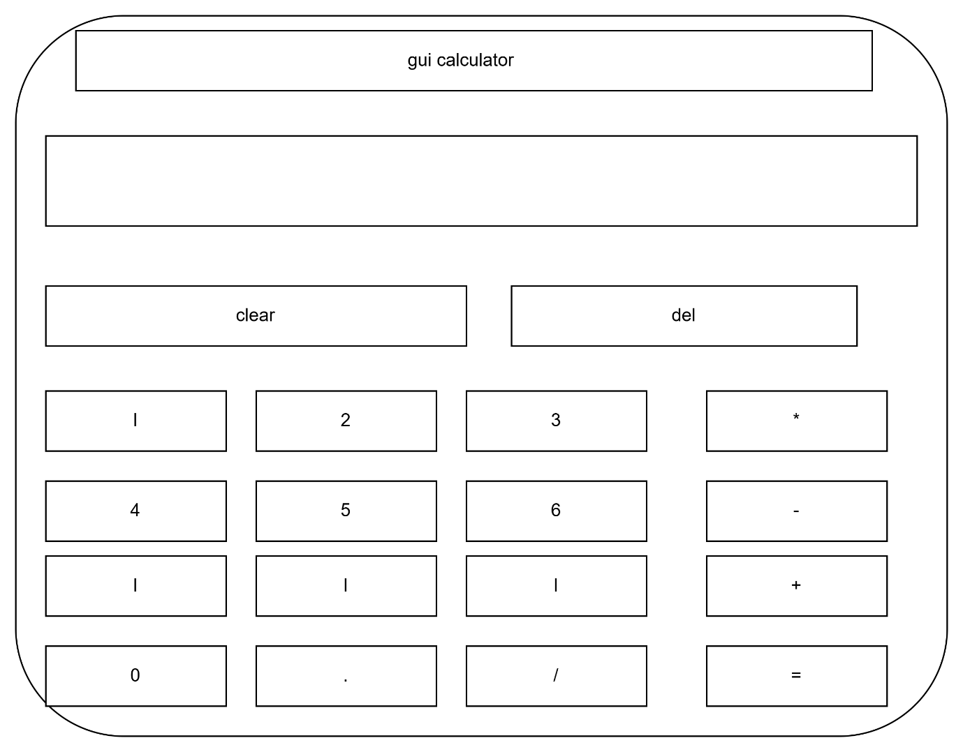82) What are the pros and cons of desktop applications compared to web applications.

Ans:-

🡪 Desktop Applications:

Pros:

1. Faster Performance: Desktop applications can utilize local machine resources, resulting in faster performance.

2. Offline Access: Desktop applications can function without an internet connection.

3. Security: Desktop applications are less vulnerable to online threats and data breaches.

4. Customization: Desktop applications can be tailored to meet specific user needs.

Cons:

1. Platform Dependence: Desktop applications are platform-specific (e.g., Windows, macOS, Linux).

2. Installation and Updates: Desktop applications require manual installation and updates.

3. Storage Requirements: Desktop applications require local storage space.

4. Limited Accessibility: Desktop applications can only be accessed from the installed machine.

Web Applications:

Pros:

1. Cross-Platform Compatibility: Web applications can run on any device with a web browser.

2. Easy Updates and Maintenance: Web applications can be updated and maintained centrally.

3. Accessibility: Web applications can be accessed from anywhere with an internet connection.

4. Scalability: Web applications can scale to meet growing user demands.

Cons:

1. Dependence on Internet Connection: Web applications require a stable internet connection to function.

2. Security Risks: Web applications are more vulnerable to online threats and data breaches.

3. Performance Issues: Web applications can be affected by network latency, bandwidth, and server performance.

4. Limited Customization: Web applications can have limited customization options due to browser and device constraints.

83) Flow Chart.

Ans:-

🡪a flowchart is a graphical representation of a process or algorithm , using symbols , arrows , and text to illustrate the sequence of steps , decision , and actions.

84) : Draw a flowchart representing the logic of a basic online registration system.

Ans:-

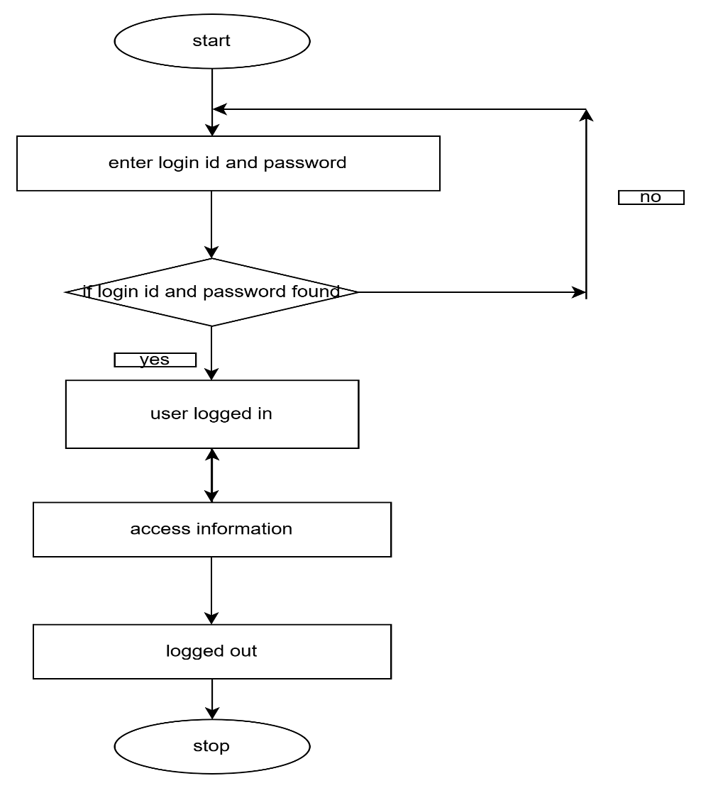

85) : How do flowcharts help in programming and system design?

Ans:-

🡪flowcharts help in programming and system design by providing a visual representation of program logic and system behaviour , facilitating analysis , problem-solving , and communication.

Thank you