1.破冰游戏

在这个环节中，你将在培训师的引导下，与其他学员进行一场破冰游戏。

An **icebreaker** is a [facilitation](https://en.wikipedia.org/wiki/Facilitation_(business)) exercise intended to help a group to begin the process of [forming](https://en.wikipedia.org/wiki/Forming-storming-norming-performing) themselves into a [team](https://en.wikipedia.org/wiki/Team). Icebreakers are commonly presented as a game to "warm up" the group by helping the members to get to know each other. They often focus on sharing personal information such as names, [hobbies](https://en.wikipedia.org/wiki/Hobby), etc.[1]

“破冰”是一项旨在帮助团队开始形成自己的团队的便利练习。破冰者通常被认为是一种通过帮助成员互相认识来“热身”的游戏。他们经常专注于分享个人信息，比如姓名、爱好等等。[1]

 [1]Dennick, Reg.Small Group Teaching: Tutorials, Seminars and Beyond. p. 20.

破冰游戏可以使团体更加融洽，鼓励害羞的人更多地参与，活跃团队的气氛，使完全陌生的人群建立起凝聚力。[2]

[2]. 鞠慧, 破冰游戏在国际汉语课堂教学中的运用. 国际汉语教育研究, 2015(00): 第128页.

2.Mem入学引导课——顾学雍

在这门课上，你将收获到顾学雍老师讲解的计算思维，**Computational thinking** is the thought processes involved in formulating a problem and expressing its solution(s) in such a way that a computer—human or machine—can effectively carry out.[3]

计算思维是一种思维过程，它涉及到制定一个问题，并以一种计算机人或机器能够有效执行的方式表达它的解决方案。

 [3]Wing, Jeannette (2014).[*"Computational Thinking Benefits Society"*](http://socialissues.cs.toronto.edu/index.html%3Fp=279.html).40th Anniversary Blog of Social Issues in Computing.

Computational Thinking is an iterative process based on three stages (captured by the figure to the right):

1. Problem formulation (abstraction);
2. Solution expression (automation);
3. Solution execution and evaluation (analyses).[4]

计算性思维是一个基于三个阶段的迭代过程

1.问题公式化(抽象);

2.解表达式(自动化);

3.解决方案执行和评估(分析)[4]

[4]https://en.wikipedia.org/wiki/Computational_thinking

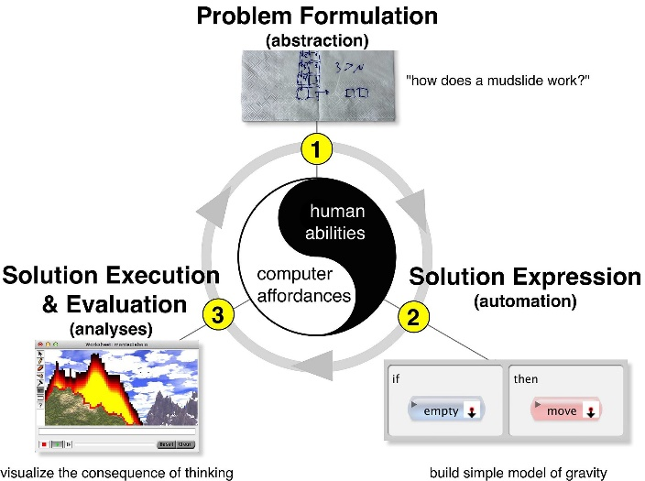[5]

[5]Fig. 1 A. Repenning, A. Basawapatna, and N. Escherle, "Computational Thinking Tools," to appear at the IEEE Symposium on Visual Languages and Human-Centric Computing, Cambridge, UK, 2016.

3.探究清华——卢达溶

在这门课上，你将在卢达溶老师的引导下，学习“自强不息、厚德载物”的校训和“行胜于言”的校风， “中西融汇、古今贯通、文理渗透”的办学风格和“又红又专、全面发展”的培养特色，弘扬“爱国奉献、追求卓越”传统和“人文日新”精神[6]

[6]<http://www.tsinghua.edu.cn/publish/newthu/newthu_cnt/about/about-2.html>

插图：6张（清华园、清华学堂、古月堂、主楼、六教、大礼堂）



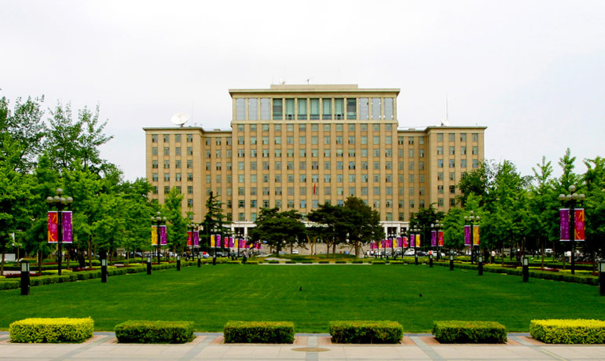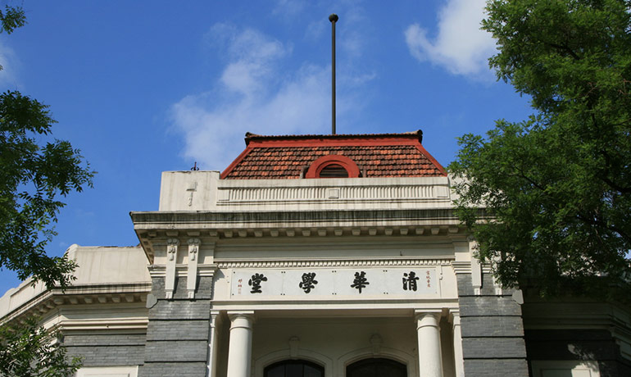



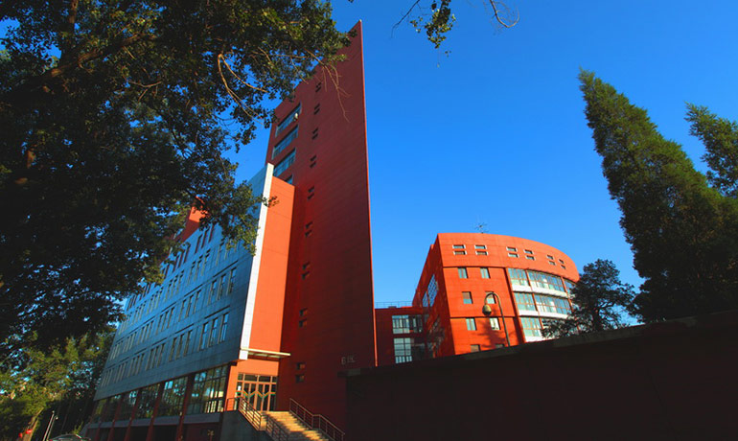

[6]

<http://www.tsinghua.edu.cn/publish/newthu/newthu_cnt/about/about-2.html>

参考文献

[1]Dennick, Reg. Small Group Teaching: Tutorials, Seminars and Beyond. p. 20.

[2]鞠慧, 破冰游戏在国际汉语课堂教学中的运用. 国际汉语教育研究, 2015(00): 第128页.

[3]Wing, Jeannette (2014). ["Computational Thinking Benefits Society"](http://socialissues.cs.toronto.edu/index.html%3Fp=279.html).40th Anniversary Blog of Social Issues in Computing.

[4]<https://en.wikipedia.org/wiki/Computational_thinking>

[5]Fig. 1 A. Repenning, A. Basawapatna, and N. Escherle,"Computational Thinking Tools", to appear at the IEEE Symposium on Visual Languages and Human-Centric Computing, Cambridge, UK, 2016.

[6].<http://www.tsinghua.edu.cn/publish/newthu/newthu_cnt/about/about-2.html>