Steps on how to setup the system
- Install git application in your computer using this website
https://git-scm.com/install/windows
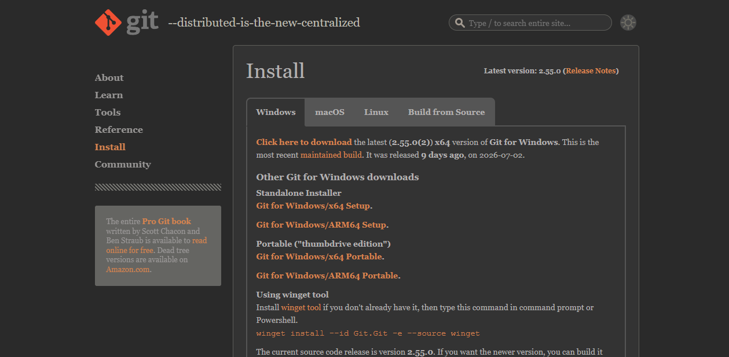
- Click the Git for Windows/x64 Setup
- Click on the Git for Windows/x64 Setup select where you want to save the installer. Then Click save.
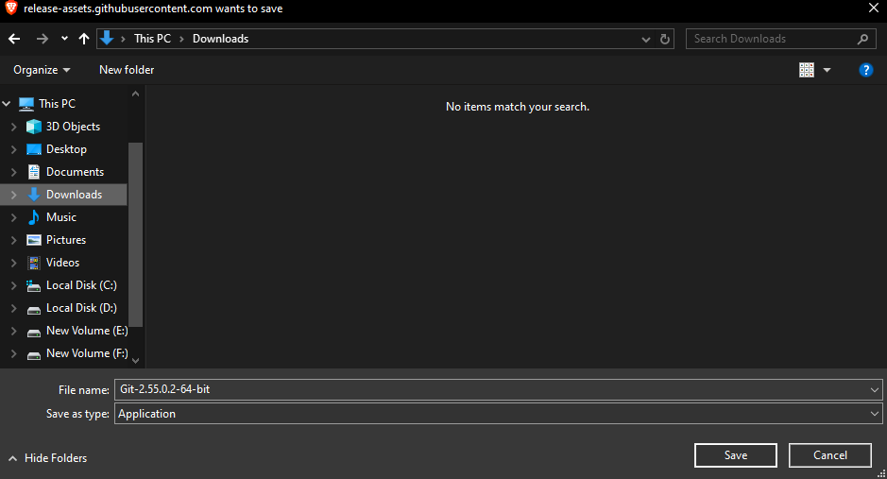
- Save the installer click it and install the software
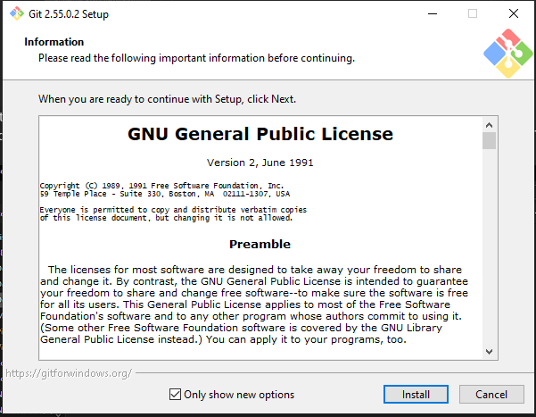
- After installing the software search for the git cmd and open the application. 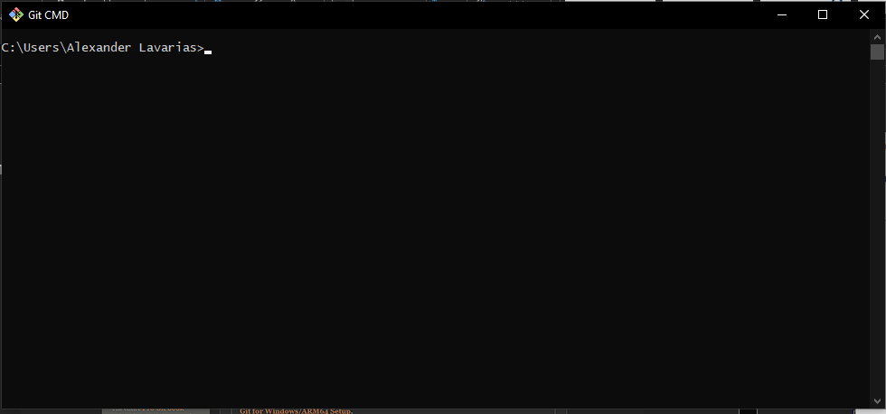

- Let the git open for a while and download XAMPP in this website: https://www.apachefriends.org/

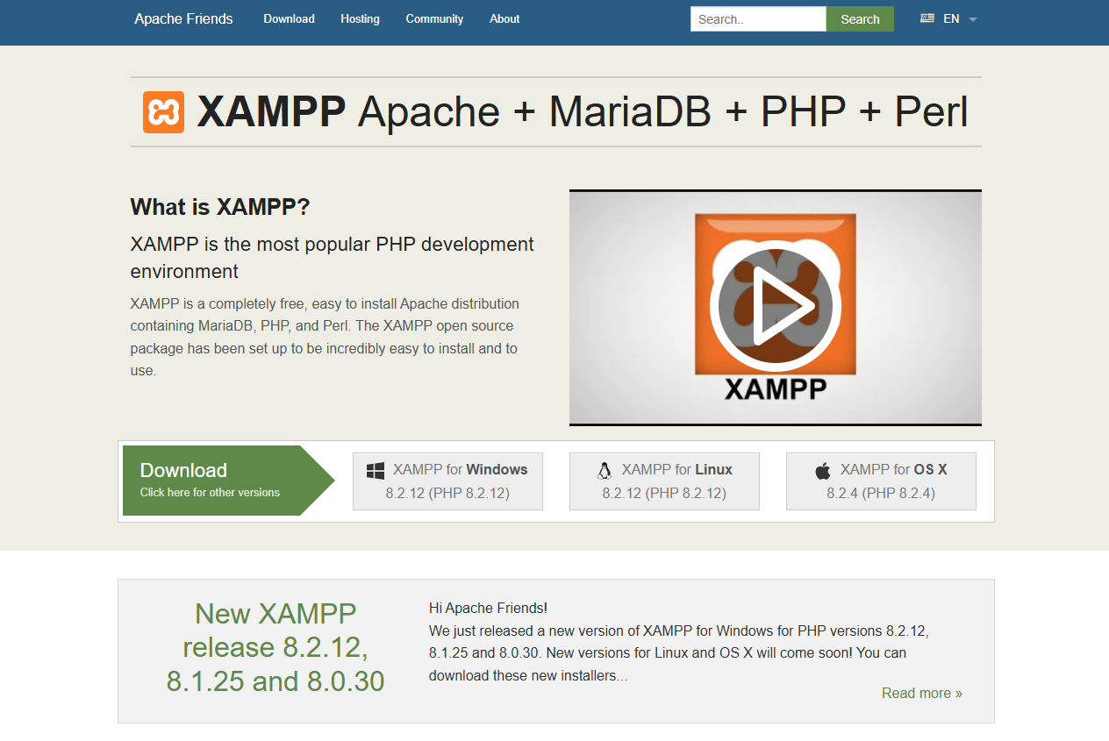
- Select where you want to save and start downloading the app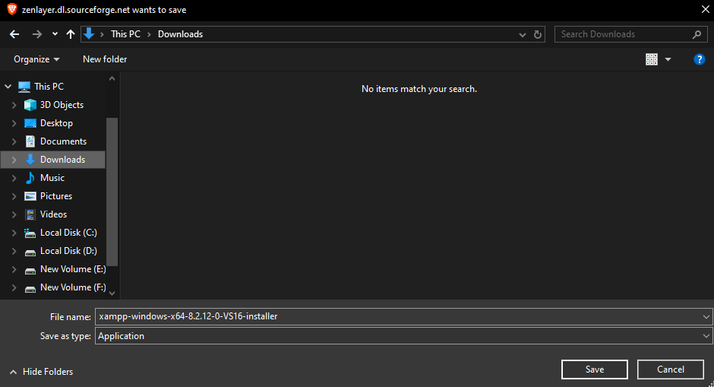
- After downloading the app install it

- Open the XAMPP control panel and start the apache and MySQL start button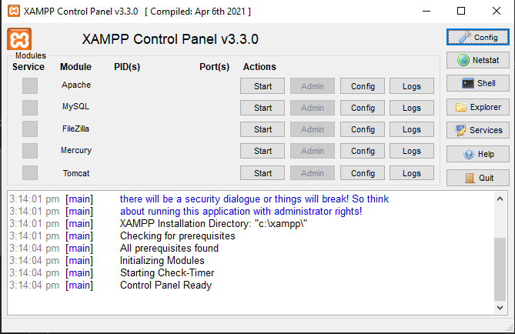
- Go back to the GIT cmd and type these command
cd ../../
cd xampp/htdocs
git clone https://github.com/TissueRole/capstone22.git
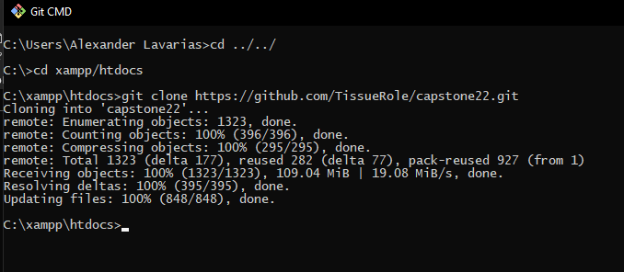
Wait until the updating files is done
- Next is go the location of the file or system
- First go the local disk C drive and look for the xampp file and double click it 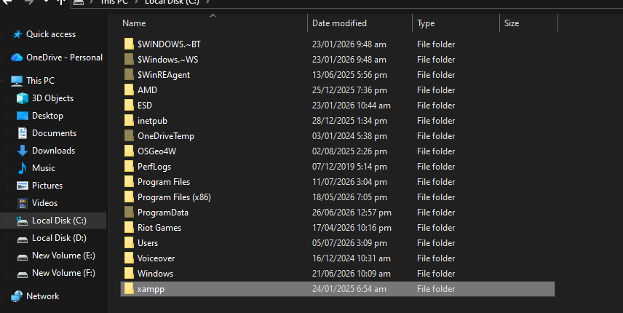
- Second: go the htdocs file
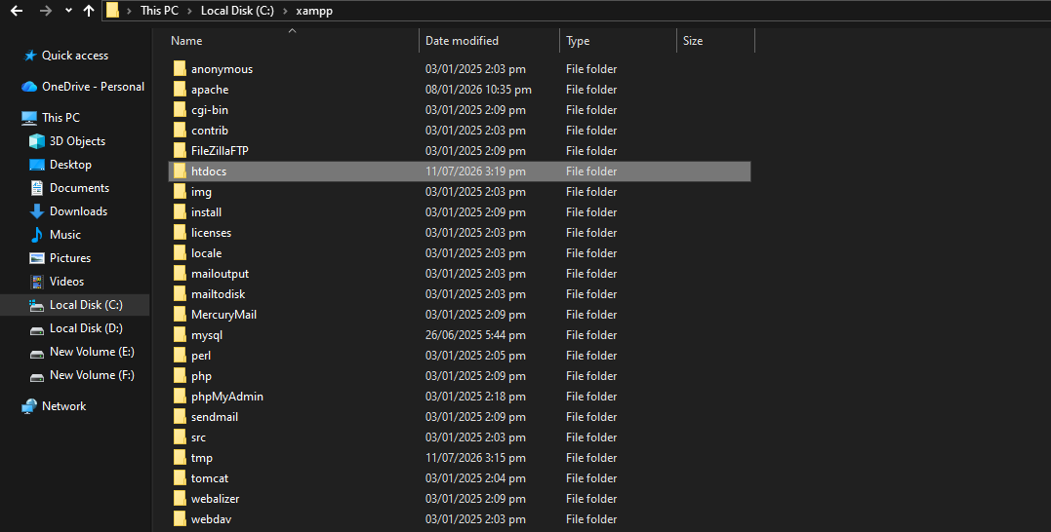
- Third: Go to the capstone22 folder (can change the folder name)
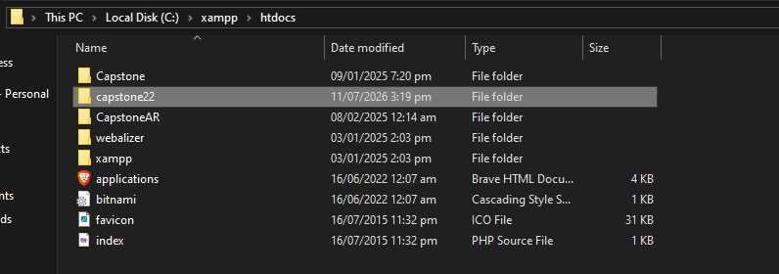
- Click on the file named capstone(19-06) for the database
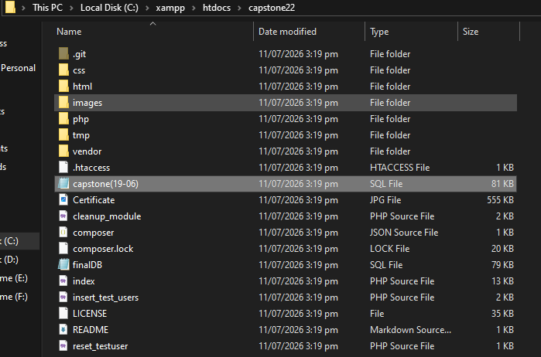
- After clicking the file copy all the contents
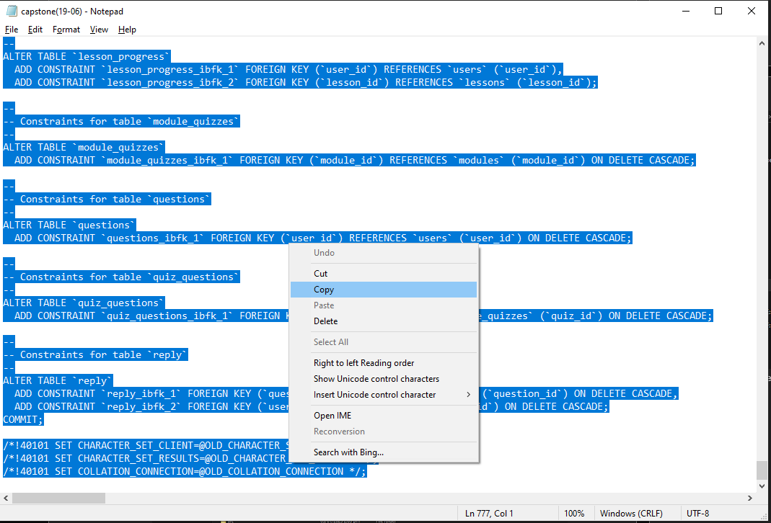
- Go to the XAMPP Control panel and click the admin button and it will redirect to the admin page
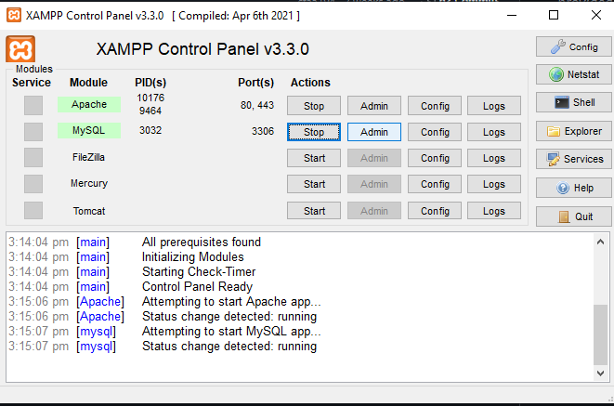
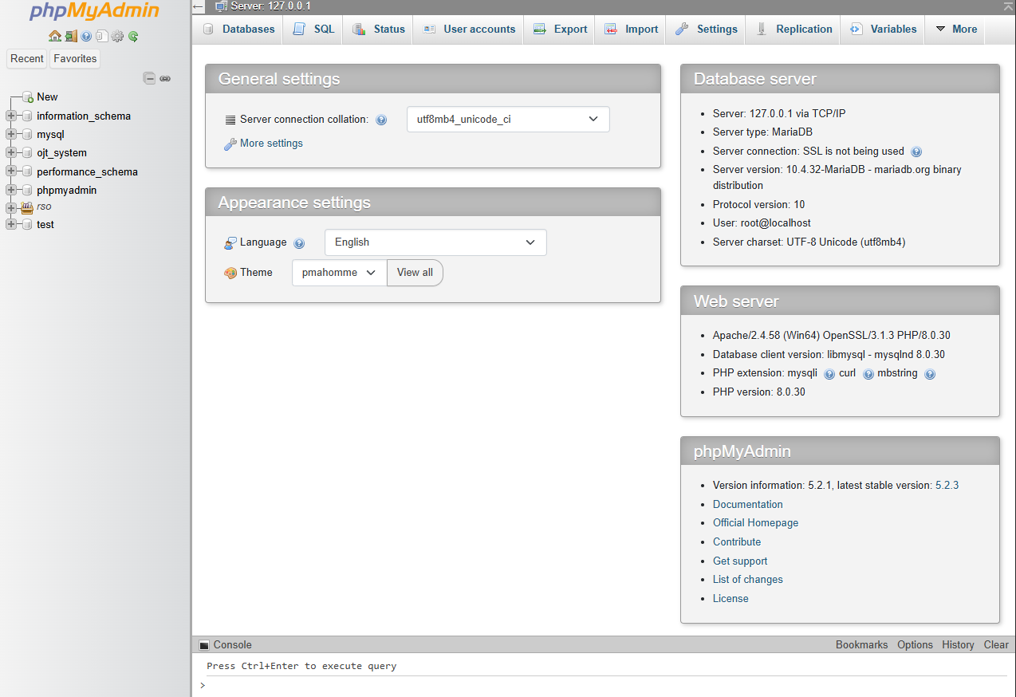
Click the Databases tab to add the database of the system. Add the name called “capstone” and click create
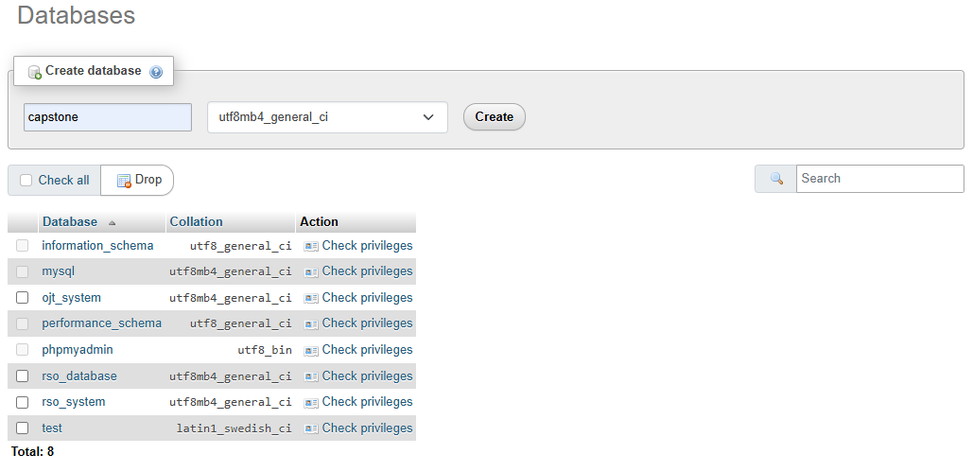
After creating the database name it will redirect the page to this area
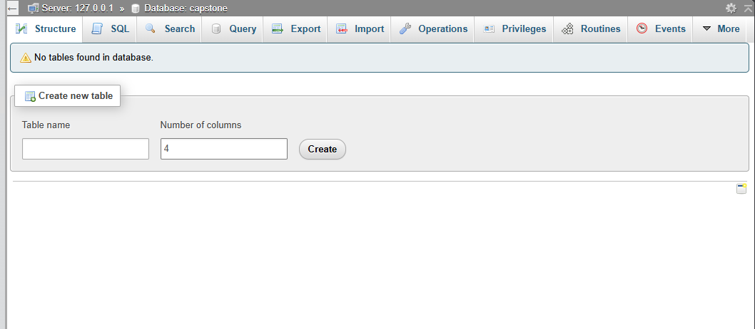
Click the SQL tab and paste the content of the database and click the Go button
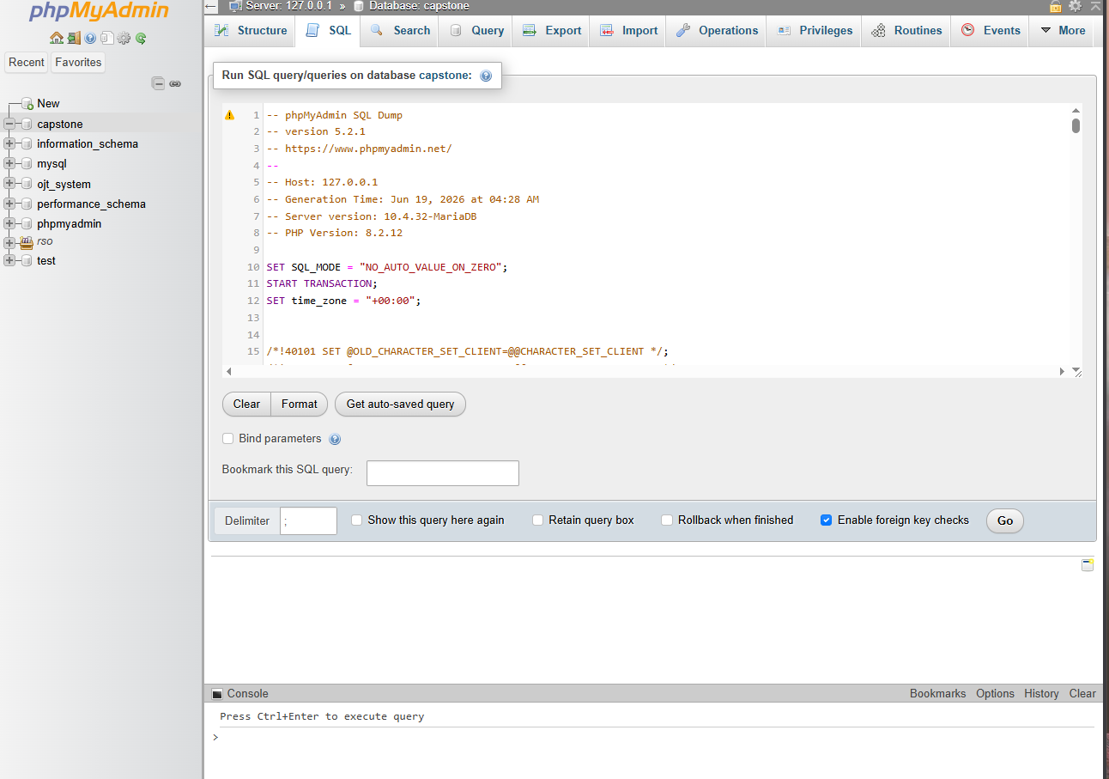

- After setting app the database and the files, open your browser and type “localhost/capstone22/” or localhost/(foldername) if folder name is changed

