Blood Bank Platform
  - Project problem and objectives Literature review Requirement priorities
The project aims to develop a platform connecting blood banks and hospitals. It organizes the donation journey from donor registration to component preparation and laboratory release, then supports stock matching, hospital requests, and planning for future demand.

1. Project problem
The project addresses the need to organize interconnected information and activities within blood banks and between banks and hospitals. Managing a donation requires linking the donor profile to the donation attempt, eligibility decision, collection outcome, processed components, and laboratory screening result. Tracking these stages requires connected records and clear responsibilities so authorized staff can retrieve information and follow the state of donations and inventory.
For hospital requests, knowing that a blood group is available is not sufficient. The platform must check the requested component, exact ABO/Rh group, and complete quantity at a single bank, then identify the nearest qualifying bank. Related needs include monitoring component expiry, documenting physical disposal, and using historical records to support demand planning. The project therefore brings donation, inventory, and request workflows together, while accounting for the freshness of synchronized stock when searching across banks.

2. Project objectives
The overall objective is to build a shared platform for blood bank operations and hospital requests, supporting traceability of donations and components and an organized response to requests. Its specific objectives are to:
1. Register blood banks, hospitals, and staff accounts, and control access according to each user’s role and organization.
2. Maintain donor profiles and donation attempts, recording eligibility or deferral, collection outcomes, collected volumes, and reasons for unsuccessful collection.
3. Record individual processed components, their volumes and acceptance or rejection, and allow authorized staff to finalize laboratory screening.
4. Enable hospital staff to submit patient-linked requests and view the nearest bank supplying the complete exact-match quantity, or a no-match result; allow inventory staff to accept pending requests.
5. Monitor expired components, notify the responsible inventory staff, and document physical disposal, the responsible person, and the disposal time.
6. Support demand planning by generating forecasts by component and ABO/Rh group and retrieving saved forecasts, according to the priorities of the current phase.

3. Proposed solution
The proposed platform connects blood banks and hospitals through a shared client interface and a modular backend. It links donor records and donation processing to component inventory, hospital requests, and demand forecasting. The following diagrams describe the system structure and the hospital request workflow.

3.1. System block diagram
The backend is deployed as one modular monolithic application with seven functional modules: Organizations, Accounts, Donors, Donations, Requests, Analytics & AI, and Inventory. Each module separates request handling, business logic, and data access. The client sends requests to the server, and the modules access a shared database. Responses return along the same paths; cross-module interactions are omitted from the diagram for clarity.
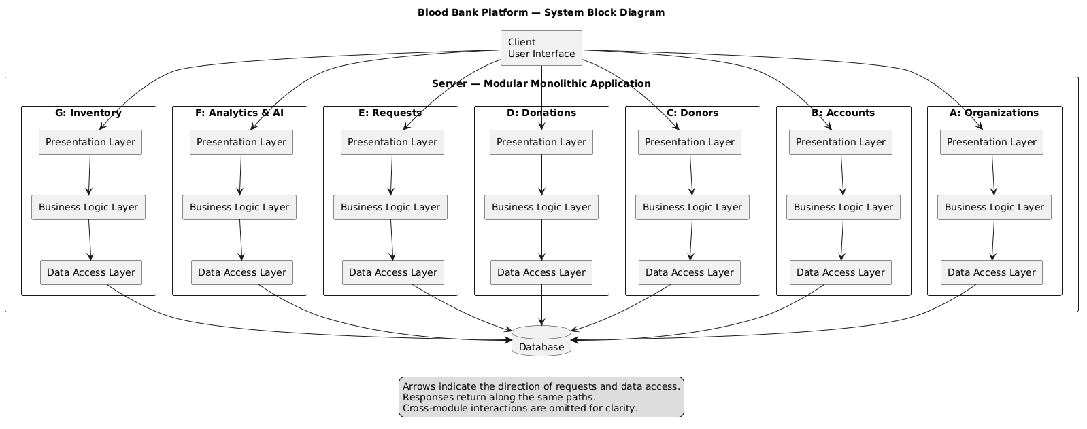
Figure 1. System block diagram of the Blood Bank Platform.

3.2. Hospital request flowchart
Hospital staff enter the mandatory request details, review the nearest qualifying bank, and confirm submission. Inventory staff review the request and accept or deny it. Acceptance requires a fresh availability check before reserving the components. Delivery follows reservation as a physical operation.
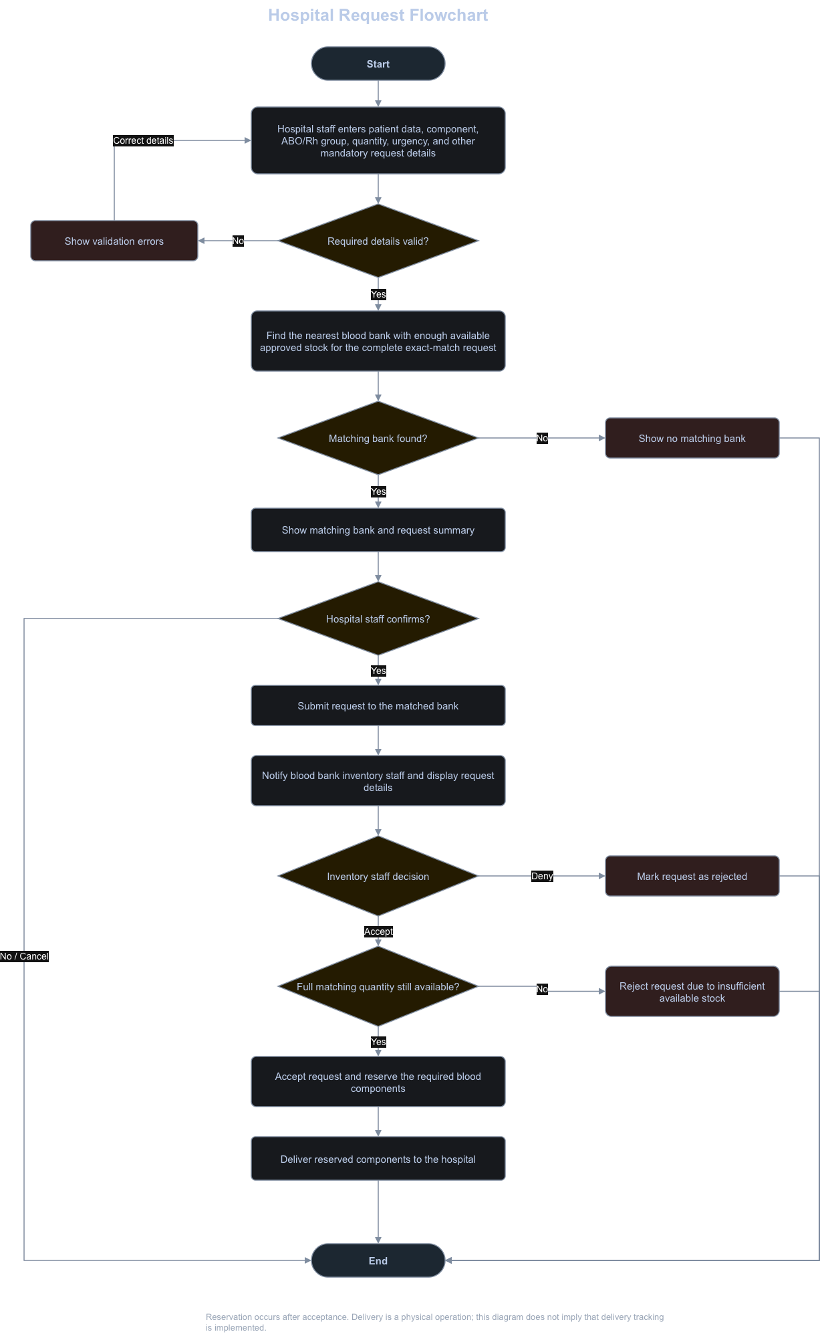
Figure 2. Hospital request workflow including validation, matching, acceptance, reservation, and delivery.

4 .Theoretical background and literature review
The review examines four research papers and three existing systems related to donation, blood bank operations, component inventory, hospital requests, and demand forecasting. Each work is considered through its strengths, limitations, and relevance to the proposed platform, followed by a comparison of documented features.

4 1 Research studies

Study 1 Rajawat et al. (2025) [1]
Rajawat et al. bring donor registration, donation tracking, screening results, component inventory, hospital requests, expiry alerts, and reports into one proposed workflow. This makes the paper a useful model for describing how records pass from one bank activity to the next. The paper mainly presents a design and expected benefits rather than measured results from a deployed system. It places demand forecasting and multi-branch support in future work. It does not explain local work during a network outage or later synchronization. Its integrated workflow is the closest reference for the core bank operations in this project. The proposed system keeps that scope small, adds explicit roles and request rules, and treats demand forecasting and offline recording as planned current-phase features rather than future ideas.

Study 2 Shah et al. (2022) [2]
Shah et al. propose a database linking donor details, blood bags, storage, discards, donation camps, requests, distribution, and staff records. The work shows the value of a shared data model: changes to donations, stock, and requests can be recorded consistently. The paper focuses on database organization and broad system functions. It does not demonstrate a detailed staff-by-staff screening and collection flow, bank-level demand prediction, offline synchronization, or a rule that selects one nearest bank with enough exact-match stock for a whole request. The database relationships help define the proposed system’s donor, donation attempt, component, disposal, and hospital request records. The graduation scope then assigns each update to a specific actor and testable action.

Study 3 Kwon et al. (2024) [3]
Kwon et al. used 247,537 transfusion records from one hospital, together with national public data, to predict demand for red cells, fresh frozen plasma, and platelets in four Rh-positive ABO groups. They compared XGBoost, LightGBM, CatBoost, and a combined model. This gives a concrete example of forecasting by component and blood group. The source data come from one hospital and use actual transfusions as demand observations. The proposed platform initially has bank requests and donation data, which are different measures and may be much smaller. The published models therefore cannot be assumed to work equally well for every bank or for Rh-negative groups. The project can use the paper to guide a modest forecast feature: choose a bank, component, ABO/Rh group, and period; compare a simple baseline with a learned model; save the result; and report its error when enough history exists. Forecasts support planning and do not decide whether a request is accepted.

Study 4 Anirudh, Dhanush Kumar, and Ramya (2025) [4]
Blood Net describes donor registration, blood and plasma donation appointments, alerts, and searches using blood group and location. Its hospital-facing search addresses the practical problem of finding a potential donor near a patient. Its main match is between hospitals and donors, not between a hospital request and prepared, approved component stock. The paper does not specify full-quantity fulfilment from one bank, a local offline workflow, or demand forecasting. It helps distinguish donor discovery from the proposed request match. In this project, a hospital submits a patient-linked request; the system returns the nearest qualifying bank that has the complete exact component and ABO/Rh quantity, or “No match.”

4 2 Existing systems

e-RaktKosh Centralized Blood Bank System [5]
India’s e-RaktKosh connects donor management, blood grouping, infection screening, component preparation, stock across many blood banks, disposal records, alerts, and reports. Its public search lets users look for available blood by location, blood group, and component. This is the broadest operational system in the review. Its national scope includes many functions and identity links beyond this project’s small first phase. The public availability search helps users inspect stock, but the cited material does not establish an automatic rule that returns one nearest bank able to satisfy the complete exact-match quantity. Its description also does not define how staff continue local work and reconcile records after a connection outage. It provides a real example of connected bank operations and component-level stock visibility. The proposed system adopts a narrower set of bank and hospital actions, with a specific full-quantity matching rule and an explicit offline-first design.

BloodNet Ordering and Inventory System [6]
Australia’s BloodNet lets authorized facilities order blood products, record receipt, manage stock movements, report inventory, and record what happens to units, including discard. It also supports an interface with facility laboratory systems to exchange near real-time inventory data. BloodNet is centered on the ordering facility and product supplier. Its published scope does not cover donor intake, collection, or the earlier laboratory screening path inside a blood bank. Its documented downtime procedure is a fallback process, not a description of local-first records that later synchronize. Its order, inventory, and discard records are useful examples for the hospital and stock side of the proposed platform. The project adds the donor-to-component path and a match across candidate banks before an inventory staff member accepts a request.

American Red Cross Blood Donor App [7]
The Blood Donor App helps donors find nearby drives, schedule or change appointments, view donation history and mini-health results, and follow a donation’s journey toward a hospital. These features make donor participation easier and give donors clear feedback after donation. It is a donor-facing service. Its published features do not describe bank staff recording screening decisions, managing approved component stock, or handling hospital component requests. Its nearby search locates donation sites rather than matching a hospital to a supplying bank. The app supports the value of clear donor records and history. The current project keeps intake with reception staff and concentrates on internal bank operations and hospital requests rather than donor appointment or engagement tools.

4 3 Synthesis and position of the proposed platform
The reviewed works cover different parts of the service chain: bank operations and shared records, facility ordering and inventory, donor participation, and forecasting. The proposed system connects the donor-to-component workflow with hospital requests and explicitly selects the nearest bank with the complete quantity of the exact component and ABO/Rh group. These are planned features, not evaluated evidence of superiority.
The literature review also proposes permitted local recording during outages and later synchronization. Cross-bank availability depends on current synchronized stock; disconnected banks cannot be presented as certainly available. Forecasting uses bank request history as a practical demand signal and donation history as supply context. Its usefulness must be assessed against actual local data rather than assumed from transfusion-based research.

4 4 Comparative analysis
Yes indicates a feature included in the described work. No indicates a feature outside its stated scope or deferred to future work. Not Stated means the source does not provide enough information to decide. The proposed-system row presents planned Graduation Project 1 features, not verified implementation or evaluation results.
System or study | Donor registration | Staff donation and lab flow | Component stock | Hospital component request | Find nearby matching donors | Nearest bank with full exact match | Demand forecast | Offline work and sync
Rajawat et al. [1] | Yes | Yes | Yes | Yes | No | Not Stated | No | Not Stated
Shah et al. [2] | Yes | No | Yes | Yes | No | Not Stated | No | Not Stated
Kwon et al. [3] | No | No | No | No | No | No | Yes | No
Blood Net [4] | Yes | No | Not Stated | No | Yes | No | No | Not Stated
e-RaktKosh [5] | Yes | Yes | Yes | Not Stated | No | Not Stated | Not Stated | Not Stated
BloodNet [6] | No | No | Yes | Yes | No | No | No | No
Red Cross Donor App [7] | Yes | No | No | No | No | No | No | Not Stated
Proposed system  Graduation 1 | Yes | Yes | Yes | Yes | No | Yes | Yes | Yes
Source: Literature_Review.docx, Section 4. Forecasting and synchronization in the proposed-system row reflect the literature review scope. The functional requirements assign the forecasting priorities shown below.

5 Requirement priorities using MoSCoW
The functional requirements specify 24 requirements for Senior Project 1. The table preserves their identifiers and assigned priorities: Must for essential requirements, Should for important requirements, and Could for optional requirements. Items outside this release are described under Won’t for this phase, rather than treated as permanently excluded.
There are 20 Must requirements, two Should requirements, and two Could requirements. The visit ticket is optional: screening and collection staff can open donation attempts from their queues without a ticket.
ID | Functional requirement | Priority
FR-01 | Administrators register blood banks for organizational oversight and system access. | Must
FR-02 | Administrators register hospitals to enable specific patient-linked component requests. | Must
FR-03 | Administrators can view registered staff accounts. | Must
FR-04 | Administrators update existing staff account details, roles, and organization assignments. | Must
FR-05 | Blood bank HRM and administrators can register staff member accounts with their blood bank. | Must
FR-06 | Registered users can log in. | Must
FR-07 | Blood bank HRM and administrators can remove assigned staff members from their blood bank. | Must
FR-08 | Receptionists search existing donor profiles before new registration or updates. | Must
FR-09 | Receptionists register new donor profiles with identifying and contact information. | Must
FR-10 | Receptionists update existing donor profiles to maintain accurate personal records. | Should
FR-11 | Receptionists create a donation attempt for the identified donor and place it in the screening queue. | Must
FR-12 | Receptionists can print a ticket with the unique donation-attempt barcode. Screening and collection staff can scan it to open the attempt. | Could
FR-13 | Screeners review assessments and record whether the donor is eligible or deferred, including the deferral reason. | Must
FR-14 | Collection staff record blood collection start for eligible donation attempts. | Must
FR-15 | Collection staff record successful or unsuccessful blood collection, with volume and reason if unsuccessful. | Must
FR-16 | Technicians record each processed component container, its individual volume, and its acceptance or rejection. | Must
FR-17 | Authorized technicians record screening results and finalize the donation’s laboratory screening outcome. | Must
FR-18 | Hospital staff submit patient-linked requests for specific blood components. | Must
FR-19 | Hospital staff view the nearest bank fulfilling the complete exact-match quantity, or no match. | Must
FR-20 | Inventory staff accept pending hospital requests for available approved components. | Must
FR-21 | Bank administrators forecast demand by component and ABO/Rh blood group. | Should
FR-22 | Bank administrators retrieve and view previously generated component demand forecasts. | Could
FR-23 | Inventory staff receive disposal notifications identifying specific expired bank components. | Must
FR-24 | Inventory staff record physical disposal, responsible person, and disposal time. | Must

5 1 Outside the current release
Won’t in this phase covers blood-smear image analysis and automatic integration with hospital records or laboratory instruments, following the scope stated in the functional requirements. Donors are recorded in the platform but do not use a donor portal during this phase. These are scope boundaries, not additional FR identifiers.
Offline recording and later synchronization are proposed in the literature review but are not assigned a MoSCoW priority among the 24 functional requirements. No new priority is assigned to them here.

6 References

Research papers and existing systems
[1] Rajawat, A. S., Gupta, H. K., Rashid, A., Hussain, S., & Pagar, N. (2025). Blood Bank Management System. International Journal of Progressive Research in Engineering Management and Science, 5(11), 972–980. https://www.ijprems.com/uploadedfiles/paper/issue_11_november_2025/44808/final/fin_ijprems1763535970.pdf
[2] Shah, A., Shah, D., Shah, D., Chordiya, D., Doshi, N., & Dwivedi, R. (2022). Blood Bank Management and Inventory Control Database Management System. Procedia Computer Science, 198, 404–409. https://doi.org/10.1016/j.procs.2021.12.261
[3] Kwon, H. J., Park, S., Park, Y. H., Baik, S. M., & Park, D. J. (2024). Development of blood demand prediction model using artificial intelligence based on national public big data. Digital Health, 10. https://doi.org/10.1177/20552076231224245
[4] Anirudh, N., Dhanush Kumar, R., & Ramya, M. (2025). Blood Net: Linking Hospital with Donors. ICRDICCT, 840–849. https://doi.org/10.5220/0013921600004919
[5] e-RaktKosh. (n.d.). About e-RaktKosh and blood availability search. https://eraktkosh.mohfw.gov.in/BLDAHIMS/bloodbank/about.cnt ; https://eraktkosh.mohfw.gov.in/
[6] National Blood Authority. (n.d.). BloodNet for blood products from Lifeblood; BloodNet user tips and support materials. https://www.blood.gov.au/blood-products/access-and-ordering/bloodnet-blood-products-lifeblood ; https://www.blood.gov.au/bloodnet-user-tips-and-support-materials
[7] American Red Cross. (n.d.). Blood Donor App. https://www.redcrossblood.org/blood-donor-app.html

Project documents and earlier graduation report
BloodBank_Functional_Requirements.docx. Project scope, actor responsibilities, and functional requirements.
Literature_Review.docx. Related work, synthesis, comparative analysis, and references.
Seminar_1_Presentation_Plan.md. Project objective section.
Sheikh Ali, Hazar; Hassan Agha, Nabigha; and Al-Halabi, Mohammad Fayez. Medical Facility Management System: Blood Bank and Donation Center Management System. Graduation Project 2, Syrian Private University, Faculty of Engineering, Department of Informatics Engineering. Supervised by Dr. Fadi Ibrahim, September 2024. Chapter 1, printed pages 18–19. Used as a reference for framing the problem and objectives.
System-Architecture.docx. Client-server architecture, modular backend structure, layered module responsibilities, and system block diagram.
Hospital Request Flowchart. Supplied diagram hospital-request-flowchart.drawio.png, illustrating the hospital request process.

