Blood Bank Platform

System Architecture
The Blood Bank Platform combines three complementary architectural styles: Client–Server Architecture to organize communication between the user interface and the server, Modular Monolithic Architecture to divide the backend into functional modules, and Layered Architecture to separate responsibilities within each module.

1 Client Server Architecture
The system consists of two main parts: a client that presents information and enables users to interact with the platform, and a server that processes requests, enforces business rules, and manages data. The client sends requests to the server and receives results to present to the user.
Reasons for adoption
- Separates user interface responsibilities from business processing and data management.
- Allows the client and server to evolve relatively independently.
- Centralizes the enforcement of business rules and access permissions.

2 Modular Monolithic Architecture
The backend is organized into seven functional modules: Organizations, Accounts, Donors, Donations, Requests, Analytics & AI, and Inventory. Each module is responsible for a specific business area of the platform.
Each module has clear responsibilities and boundaries and collaborates with other modules through defined interfaces. All modules operate within a single application that is deployed as one unit.
Reasons for adoption
- Organizes the system around its main business functions.
- Reduces overlap between the responsibilities of different modules.
- Supports maintenance and further development through clear module boundaries.
- Keeps deployment and operation manageable for the project’s scope.

3 Layered Architecture Within Modules
Each module is organized into three logical layers:
- Presentation Layer: Handles interaction with the client by receiving requests and returning the results of processing.
- Business Logic Layer: Applies business rules and performs the operations associated with the module.
- Data Access Layer: Retrieves, stores, and updates data.
These layers collaborate through defined relationships, maintaining a separation between request handling, business rules, and data access. The backend’s presentation layer provides the interface to the client, while the frontend handles the visual user interface.
Reasons for adoption
- Clarifies the internal responsibilities of each module.
- Makes business operations easier to test and errors easier to locate.
- Helps limit the impact of changes by separating concerns.
- Improves maintainability and supports the reuse of business logic.

Integration of the Architectural Styles
The three architectural styles describe different aspects of the system. Client–Server Architecture defines the relationship between the user interface and the server. Modular Monolithic Architecture defines how the backend is divided into functional areas. Layered Architecture defines how responsibilities are organized within each module.
Together, these choices provide a clear structure that supports maintenance and future development while keeping the system’s operational complexity appropriate to the project’s scope.

System Block Diagram
The diagram shows the client–server relationship, the seven modules within a single backend application, and the three logical layers inside each module.
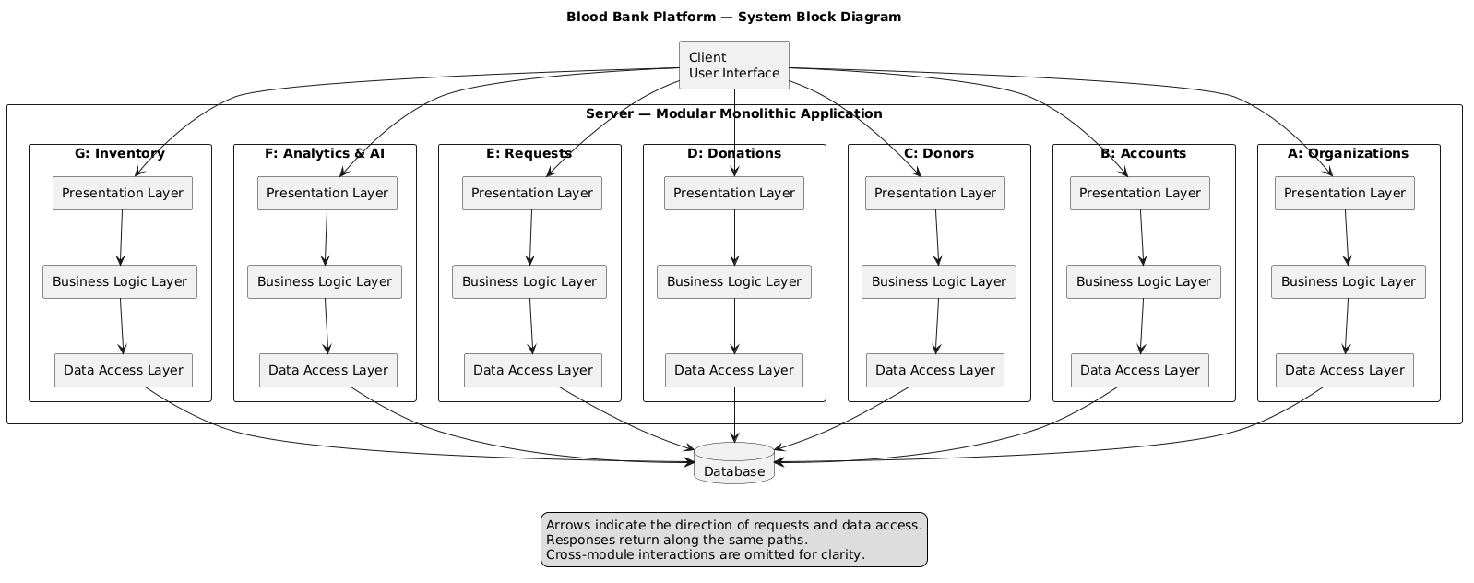
Figure 1. System block diagram of the Blood Bank Platform.
Arrows indicate the direction of requests and data access. Responses return along the same paths. Cross-module interactions are omitted for clarity.

