**Name:**

**Toby Nanthaphone Sriratanakoul**

**Student id:**

**11485513**

**Subject Code:**

**ITC322**

**Assessment 3**

Contents

Documentation 1

# Documentation

The file submitted is a zip folder that contains all the files given for the task plus A3Graph.java which extends to Graph.java and a TestA3Graph.java file. Please run the TestA3Graph.java which contains the main.

The files for the friend.txt and index.txt must be in the root folder where the IDE is installed. i.e. D:\Eclipse\ITC322

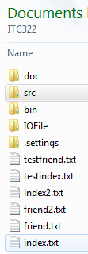

The program will close if the wrong input is entered, such as an Alphabet when choose a task from the menu.

