**MEDIA**

Montana mining map: <http://www.montanamining.org/images/mine_map_lg.jpg>

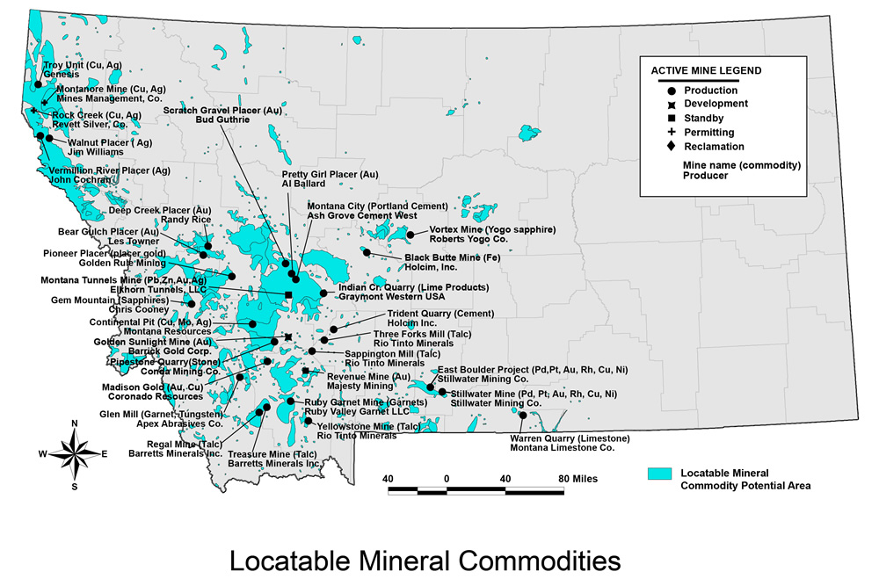

Montana mining facts: <http://meic.org/issues/mining-in-montana/>

California Mining maps: <https://thediggings.com/usa/california>

-California has 319,870 records of mining claims on public land managed by the Bureau of Land Management and 35,787 records of mineral deposits listed by the United States Geological Survey (USGS).

-24,610 active mining claims.

-San Bernadino, Inyo, and Plumas are the most active counties in California.

-The top commodities in California deposits are gold, silver, copper, chromium, and tungsten.

-San Bernardino, El Dorado, and Calaveras are the counties in California with the most deposits.

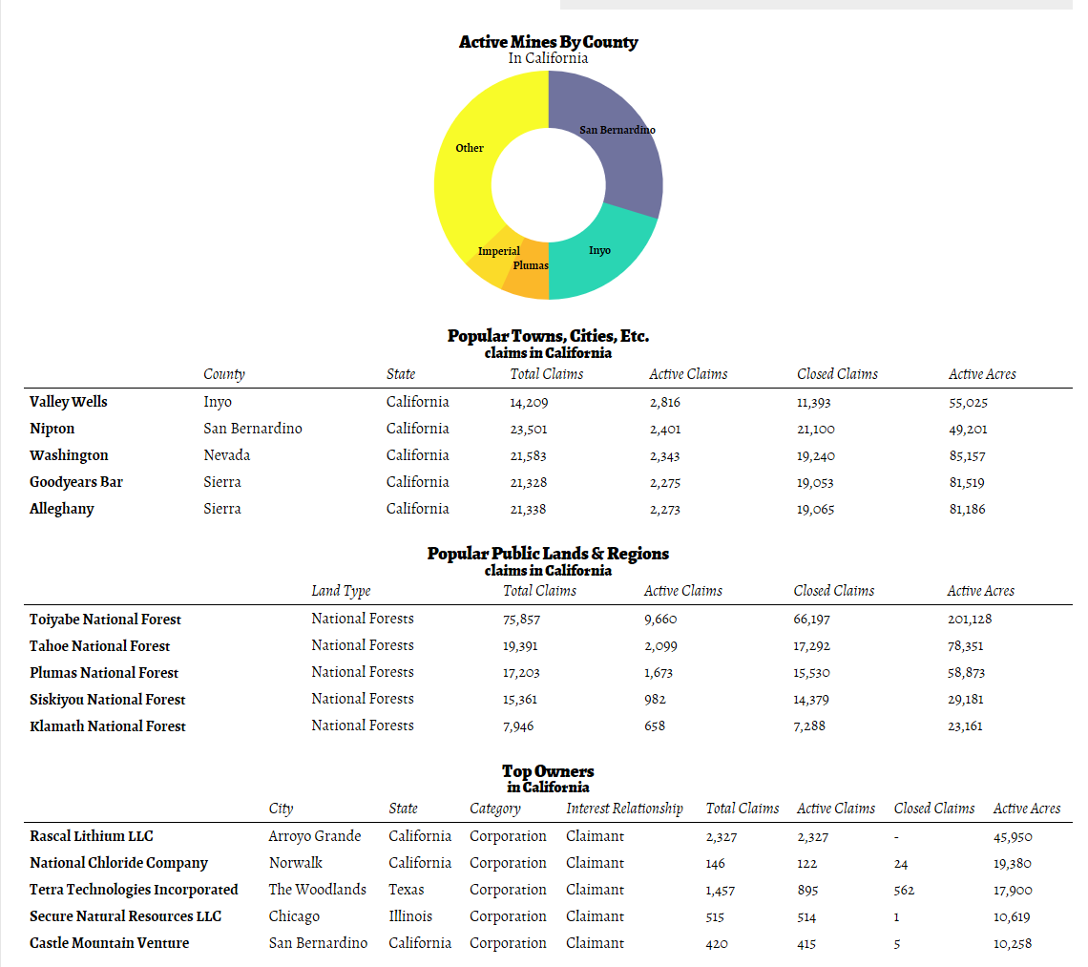

**could make these facts into our own data tables on the California web page.

US mining facts: <https://nma.org/facts-stats-and-data/>

-On average, every American uses approximately 3.4 tons of coal and nearly 40,000 pounds of newly mined materials each year.

-50% of all US electricity is generated from coal and uranium, and nearly every manufactured good contains some mineral component

-<https://nma.org/wp-content/uploads/2019/04/most_requested_coal_statistics_2018_prelim.pdf> (create link to this fact sheet?)

<https://files.dnr.state.mn.us/education_safety/education/teachers/activities/soudan_mine/miningfacts.pdf>

**Mining Facts**:

-Mining has touched less than one-quarter of one percent of all the land in the US

-About 320,000 people work directly in mining throughout the US and employment in industries that support mining (including manufacturing) accounts for another

-Processed materials of mineral origins account for 5 percent of US gross domestic product

-Minerals account for US exports of as much as $6 billion per year

-The US is the world’s second largest producer of copper and gold

-The US has the world’s largest reserve of coal

-Investment in technology, training and equipment has made the U.S. mining industry the safest in the world. Source: National Mining Association

-A newborn infant will need a lifetime supply of:

• 800 pounds of lead • 750 pounds of zinc • 1,500 pounds of copper • 3,593 pounds of aluminum • 32,700 pounds of iron • 26,550 pounds of clays • 28,213 pounds of salt • and 1,238,101 pounds of stone, sand, gravel and cement Source National Mining Association