Letter Test

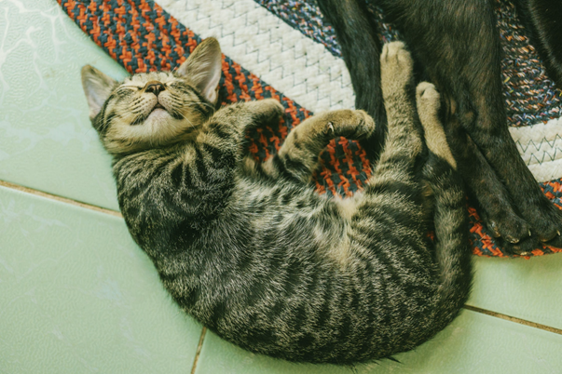

**{{ letter.properties.client }}**

# **The Letter**

{{ letter.description.xml }}

## Contacts

{% set table = letter.contacts.table %}

|  |  |  |
| --- | --- | --- |
| {%tc for col in table.headers %} | {{r col }} | {%tc endfor %} |
| {%tr for row in table.data %} | | |
| {%tc for col in row %} | {{r col }} | {%tc endfor %} |
| {%tr endfor %} | | |

## Friends

{% for table in letter.friends.tables %}

|  |  |  |
| --- | --- | --- |
| {%tc for col in table.headers %} | {{r col }} | {%tc endfor %} |
| {%tr for row in table.data %} | | |
| {%tc for col in row %} | {{r col }} | {%tc endfor %} |
| {%tr endfor %} | | |

{% endfor %}

## Website

{{ letter.website.xml }}

# Content

## Synthesis

{{ letter.synthesis.xml }}

# Parts

{% for name, part in parts.items() %}

## {{ part.properties.name }}

|  |  |  |
| --- | --- | --- |
| {{ part.properties.id }} | **{{ part.properties.name }}** | {{ part.properties.subclass}} |
| Description | {{ parts[name].description.xml }} | |
| Synthesis | {{ parts[name].synthesis.xml }} | |
| Tips | {{ part.tips.xml }} | |

{% endfor %}