酒店管理系统

HMS (Hotel Management System)

体系结构设计模型

V2.0

钛4+小组 (Titanium Quartet)

蒋文荟 李佩瑶 李珍鸿 李一然

2016/10/11

目录

更新历史 3

一、软件体系结构逻辑设计方案 4

二、开发包设计 5

三、开发包图 8

3.1 酒店管理系统客户端开发包图 8

3.2 酒店管理系统服务器开发包图 9

3.3 酒店管理系统用户界面跳转示意图 10

# 更新历史

|  |  |  |  |
| --- | --- | --- | --- |
| 修改人员 | 日期 | 变更原因 | 版本号 |
| 李一然 | 2016/10/10 | 编写逻辑模型示意图和客户端及服务器包图 | V1.0 |
| 李珍鸿 | 2016/10/10 | 编写开发包设计表格 | V1.1 |
| 李佩瑶 | 2016/10/10 | 编写界面跳转示意图 | V1.2 |
| 李一然 | 2016/10/11 | 合并各个部分，修改界面跳转示意图以及包图 | V2.0 |

# 一、软件体系结构逻辑设计方案

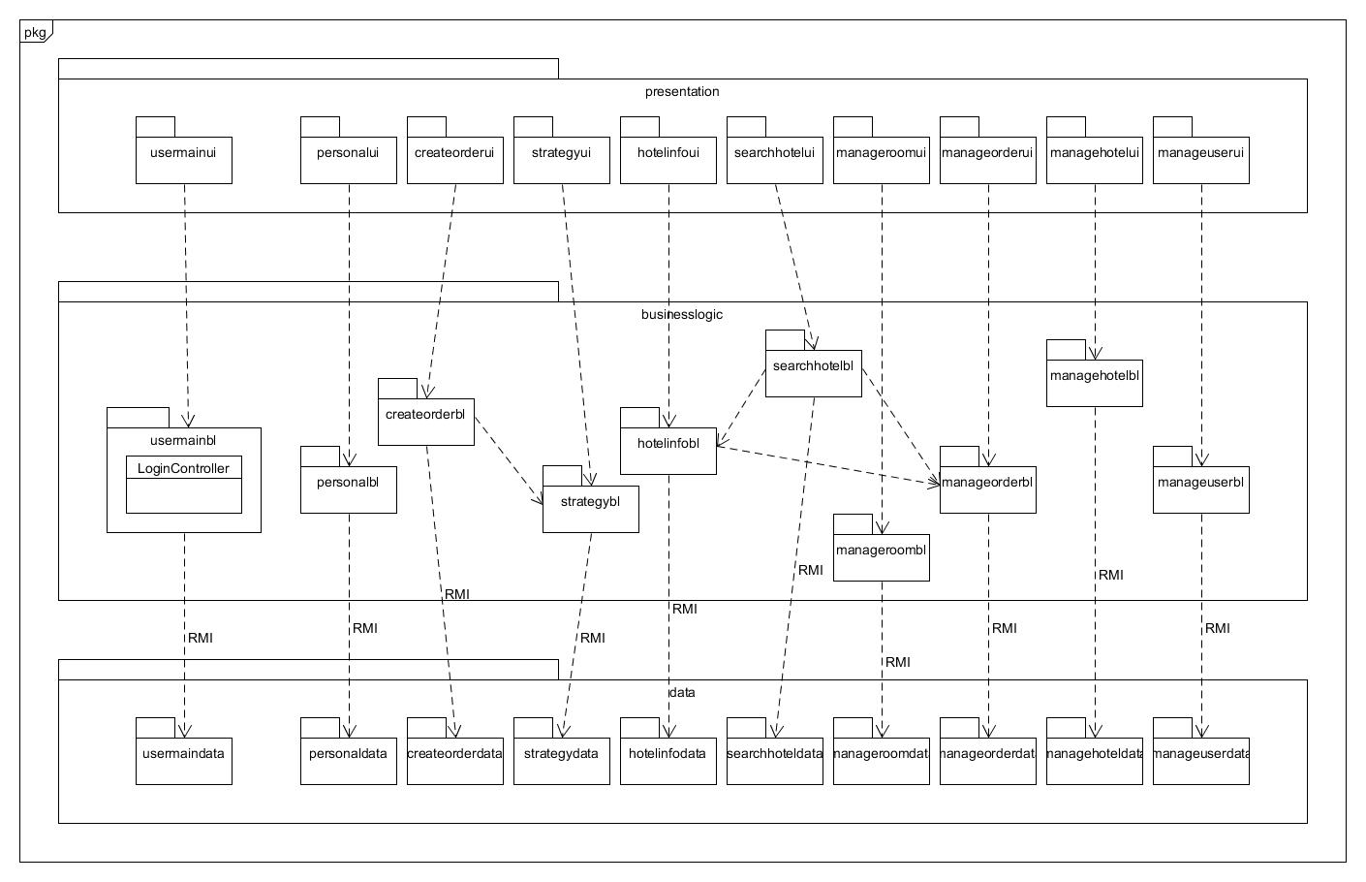

# 二、开发包设计

|  |  |
| --- | --- |
| 开发包 | 依赖的其他开发包 |
| mainui | usermainui, personalui, createorderui, strategyui, hotelinfoui, searchhotelui, manageroomui, manageorderui, managehotelui, manageuserui |
| usermainui | usermainblservice ,VO, |
| personalui | personalblservice, VO |
| createorderui | createorderblservice, VO |
| strategyui | strategyblservice, VO |
| hotelinfoui | hotelinfoblservice, VO |
| searchhetelui | searchhetelblservice, VO |
| manageroomui | manageroomblservice, VO |
| manageorderui | manageorderblservice, VO |
| managehotelui | managehotelblservice, VO |
| manageuserui | manageuserblservice, VO |
| usermainblservice |  |
| usermainbl | userdataservice,PO |
| personalblservice |  |
| personalbl | userdataservice, creditdataservice, PO |
| createorderblservice |  |
| createorderbl | orderdataservice, roomdataservice, creditdataservice, strategydataservice, PO |
| Strategyblservice |  |
| strategybl | mainuserbl, strategydataservice, locationdataservice, PO |
| Hotelinfoblservice |  |
| hotelinfobl | manageorderbl , roomdataservice, strategydataservice, hotelinfodataservice, reviewdataservice, PO |
| searchhotelblservice |  |
| searchhotelbl | manageorderbl, roomdataservice, reviewdataservice, locationdataservice, hotelinfodataservice, PO |
| manageroomblservice |  |
| manageroombl | mainuserbl, orderdataservice, roomdataservice, PO |
| manageorderblservice |  |
| manageorderbl | mainuserbl, orderdataservice, roomdataservice, creditdataservice, PO |
| managehotelblservice |  |
| managehotelbl | mainuserbl, userdataservice, hotelinfodataservice, PO |
| manageuserblservice |  |
| mangeuserbl | creditdataservice, userdataservice |
| orderdataservice | Java RMI,PO |
| orderdata | databaseutility, PO |
| roomdataservice | Java RMI,PO |
| roomdata | databaseutility, PO |
| userdataservice | Java RMI,PO |
| userdata | databaseutility, PO |
| creditdataservice | Java RMI,PO |
| creditdata | databaseutility, PO |
| strategydataservice | Java RMI,PO |
| strategydata | databaseutility, PO |
| hotelinfodataservice | Java RMI,PO |
| hoteldatainfo | databaseity, PO |
| reviewdataservice | Java RMI,PO |
| reviewdata | databaseutility, PO |
| Locationdataservice | Java RMI,PO |
| locationdata | databaseutility, PO |
| PO |  |
| VO |  |
| databaseutility |  |

# 三、开发包图

## 3.1 酒店管理系统客户端开发包图

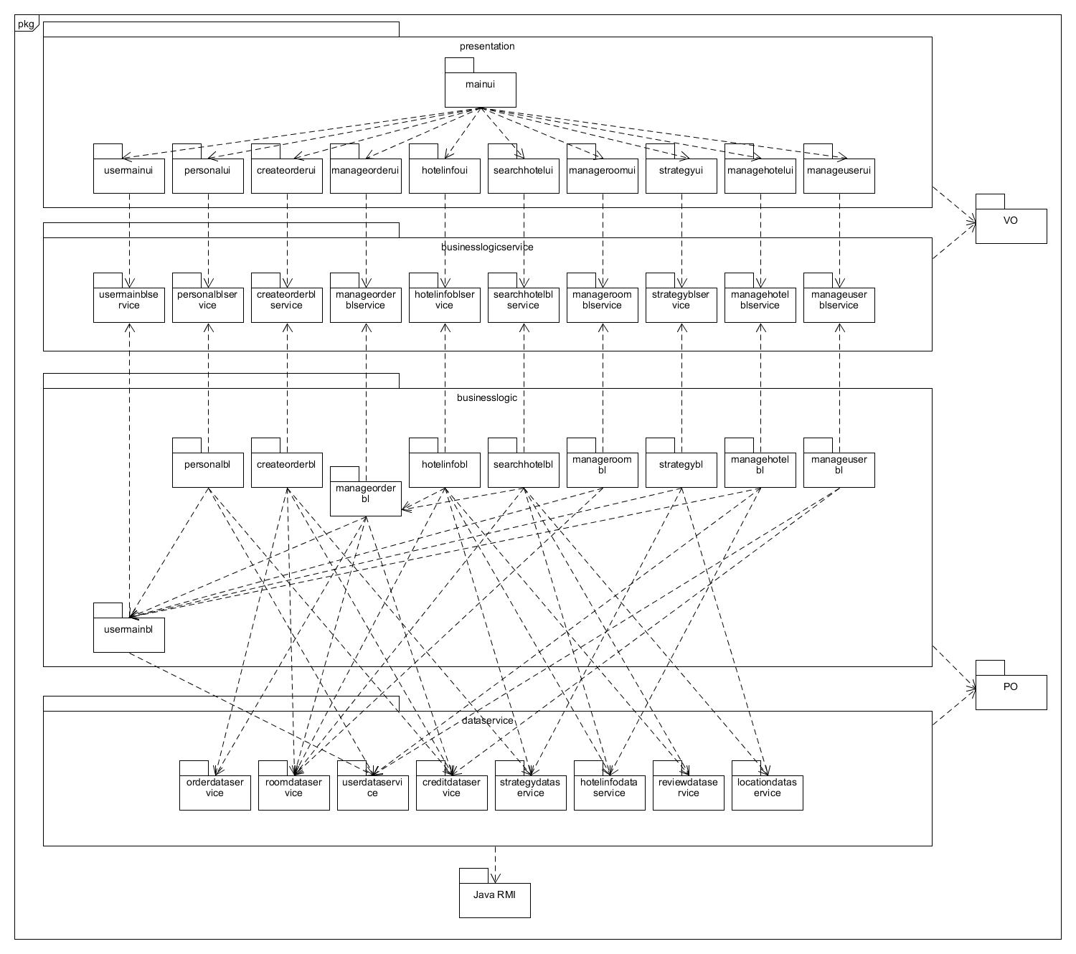

## 3.2 酒店管理系统服务器开发包图

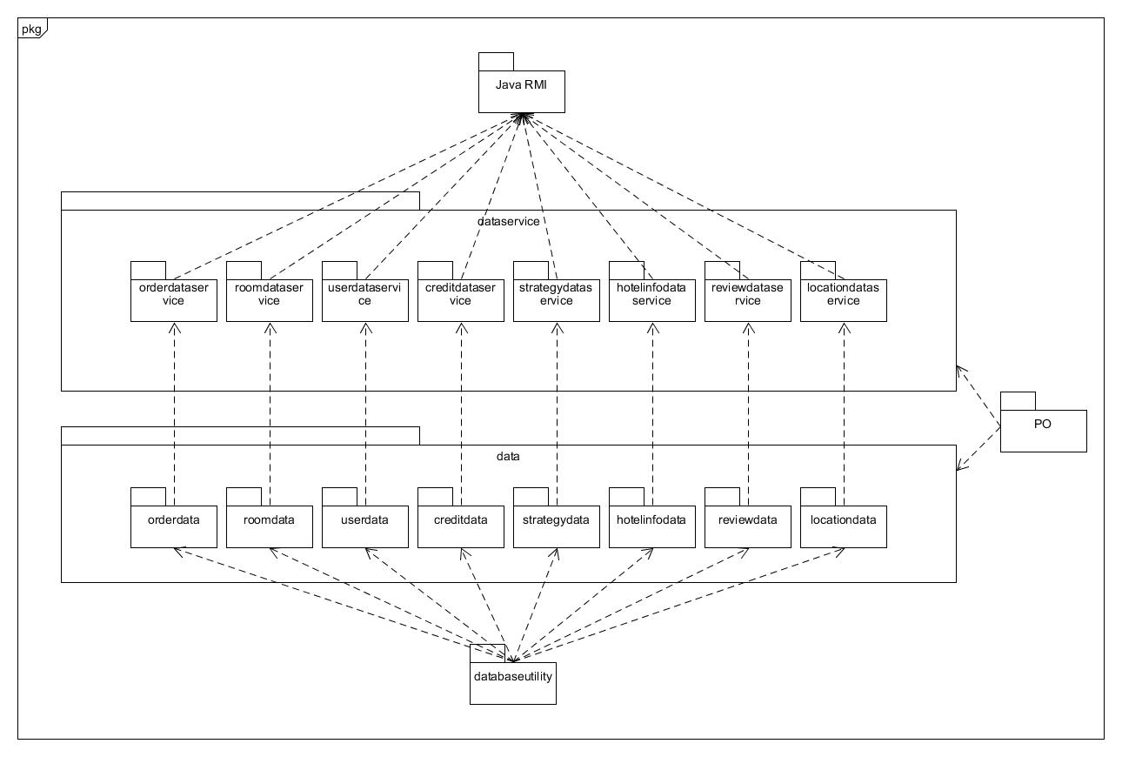

## 3.3 酒店管理系统用户界面跳转示意图

