**Dharmsinh Desai University, Nadiad**

**Department of Information Technology**

**Subject Name: Design Patterns and Application Frameworks**

**Lab Work**

**B.Tech. IT, Sem: VI**

**Submitted By:**

Roll No.: IT069

Name: Maniya Arjun B.

Batch: H4

ID: 19ITUOS121

**Index**

1. Implement programming solution that uses

Abstract class, interface, Object composition, and

Inheritance…………………………………………………………………………………………….. 3

1. Implement programming solutions that use

following design pattern ………………………………………………………………………… 6

a. Singleton

b. AbstractFactory

c. Prototype

3. Implement programming solutions that use

following design pattern ………………………………………………………………………… 24

a. Composite

b. Decorator

c. Facade

4. Solving programming problems using Java-8

functional programming. ………………………………………………………………………… 41

5. Designing and implementing web

interface using JavaScript, and CSS …………………………………………………………… 47

6. Designing and implementing web interface

using Bootstrap and customizing CSS ……………………………………………………….. 57

7. Designing and implementing a single

page web interface using Angular JS …………………………………………………………. 61

8. Designing and implementing interactive web

interface using AJAX …………………………………………………………………………………. 68

9. Implement data access using Hibernate …………………………………………………….. 82

10. Implement relational data access using Hibernate ……………………………………. 87

11. Implement form handling with data

binding using SpringMVC ………………………………………………………………………… 94

12. Implement form handling with form

validation using SpringMVC …………………………………………………………………….. 100

# Experiment-1

**Aim :**  Implement programming solution that uses Abstract class, interface, Object

composition, and inheritance.

* In this I have used my father Company which is running in surat .

**File Structure :-**

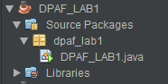

**Code :-**

package dpaf_lab1;

interface cmpName {

    void Cname();

}

interface cmpType {

    void type();

}

interface cmpLoc {

    void loc();

}

class Nameimpl extends Locimpl implements cmpName, cmpType {

    public void Cname() {

        System.out.println("Aspire Meditech.");

    }

    public void type() {

        System.out.println("Private-lim.");

    }

}

abstract class Locimpl implements cmpLoc {

    public void loc() {

        System.out.println("Surat");

    }

}

public class DPAF_LAB1 {

    public static void main(String[] args) {

        Nameimpl d = new Nameimpl();

        d.Cname();

        d.type();

        d.loc();

    }

}

**Output : -**

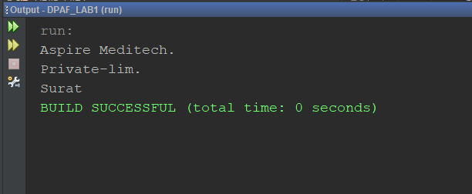

# Experiment-2

**Aim :** Implement programming solutions that use following design pattern

a. Singleton

b. AbstractFactory

c. Prototype

1. **Singleton :-** 
   * Here I have take very simple and useful example of making database connection one instance at a time .

**File Structure :-**

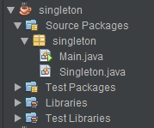

**Code :-**

**Singleton.java :-**

package singleton;

import java.sql.Connection;

import java.sql.DriverManager;

public class Singleton {

    private static Connection conn = null;

    public static Connection getConnection() {

        if (conn == null) {

            try {

                Class.forName("org.postgresql.Driver");

                conn = DriverManager.getConnection("jdbc:postgresql://localhost:5432/postgres", "postgres", "shree9592");

                System.out.println("connection done");

            } catch (Exception e) {

                e.printStackTrace();

            }

        }

        return conn;

    }

}

**Main :-**

package singleton;

import java.sql.Connection;

*/\*\**

*\**

*\* @author IT069 arjun*

*\*/*

public class Main {

    public static void main(String[] args) {

        try {

            Connection conn = Singleton.getConnection();

            System.out.println("Connection Succesful");

        } catch (Exception e) {

        }

    }

}

**Input/Output :-**

**Input :-**

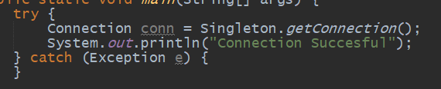

**Output :-**

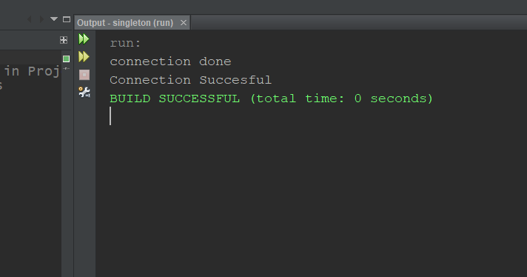

1. **Abstract Factory :-**
   * Here I have use furniture shop example .

**File Structure :-**

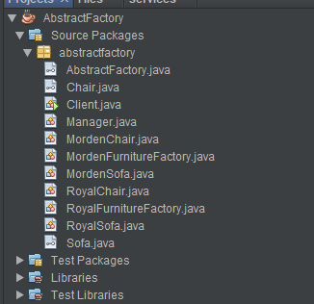

**Code :-**

**AbstractFactory.java :-**

package abstractfactory;

public interface AbstractFactory {

   public Chair getChair();

   public Sofa getSofa();

}

**MordenFurnitureFactory.java :-**

package abstractfactory;

*/\*\**

*\**

*\* @author IT069 arjun*

*\*/*

public class MordenFurnitureFactory implements AbstractFactory{

    @Override

    public Chair getChair() {

        return new MordenChair();

    }

    @Override

    public Sofa getSofa() {

        return new MordenSofa();

    }

}

**RoyalFurnitureFactory.java :-**

*/\**

*\* To change this license header, choose License Headers in Project Properties.*

*\* To change this template file, choose Tools | Templates*

*\* and open the template in the editor.*

*\*/*

package abstractfactory;

*/\*\**

*\**

*\* @author IT069 arjun*

*\*/*

public class RoyalFurnitureFactory implements AbstractFactory{

    @Override

    public Chair getChair() {

        return new RoyalChair();

    }

    @Override

    public Sofa getSofa() {

        return new RoyalSofa();

    }

}

**Chair.java :-**

*/\**

*\* To change this license header, choose License Headers in Project Properties.*

*\* To change this template file, choose Tools | Templates*

*\* and open the template in the editor.*

*\*/*

package abstractfactory;

*/\*\**

*\**

*\* @author IT069 arjun*

*\*/*

public interface Chair {

    void createChair();

}

**MordenChair.java :-**

*/\**

*\* To change this license header, choose License Headers in Project Properties.*

*\* To change this template file, choose Tools | Templates*

*\* and open the template in the editor.*

*\*/*

package abstractfactory;

*/\*\**

*\**

*\* @author IT069 arjun*

*\*/*

public class MordenChair implements Chair{

    @Override

    public void createChair() {

        System.out.println("Morden chair created");

    }

}

**RoyalChair.java :-**

package abstractfactory;

*/\*\**

*\**

*\* @author IT069 arjun*

*\*/*

public class RoyalChair implements Chair{

    @Override

    public void createChair() {

        System.out.println("Royal chair has created");

    }

}

**Sofa.java :-**

*/\**

*\* To change this license header, choose License Headers in Project Properties.*

*\* To change this template file, choose Tools | Templates*

*\* and open the template in the editor.*

*\*/*

package abstractfactory;

*/\*\**

*\**

*\* @author admin*

*\*/*

public interface Sofa {

    void createSofa();

}

**MordenSofa.java :-**

*/\**

*\* To change this license header, choose License Headers in Project Properties.*

*\* To change this template file, choose Tools | Templates*

*\* and open the template in the editor.*

*\*/*

package abstractfactory;

*/\*\**

*\**

*\* @author IT069 arjun*

*\*/*

public class MordenSofa implements Sofa{

    @Override

    public void createSofa() {

        System.out.println("Mordern sofa created");

    }

}

**RoyalSofa.java :-**

*/\**

*\* To change this license header, choose License Headers in Project Properties.*

*\* To change this template file, choose Tools | Templates*

*\* and open the template in the editor.*

*\*/*

package abstractfactory;

*/\*\**

*\**

*\* @author IT069 arjun*

*\*/*

public class RoyalSofa implements Sofa{

    @Override

    public void createSofa() {

        System.out.println("Royal sofa created ");

    }

}

**Client.java:-**

*/\**

*\* To change this license header, choose License Headers in Project Properties.*

*\* To change this template file, choose Tools | Templates*

*\* and open the template in the editor.*

*\*/*

package abstractfactory;

import java.util.Scanner;

*/\*\**

*\**

*\* @author IT069 arjun*

*\*/*

public class Client {

    public static void main(String[] args) {

        AbstractFactory fur_type = null;

        Scanner sc = new Scanner(System.in);

        System.out.println("Tell Furniture you want for your home \n1.Mordern\n2.Royal"+"\nEnter choice :- ");

        int choice = Integer.parseInt(sc.nextLine());

       switch(choice){

           case 1:

               fur_type = new MordenFurnitureFactory();

               break;

           case 2:

               fur_type = new RoyalFurnitureFactory();

               break;

           default:

               System.out.println("not valid choice");

               break;

       }

       Manager furniture = new Manager(fur_type);

       furniture.getFurniture();

    }

}

**Input/Output :-**

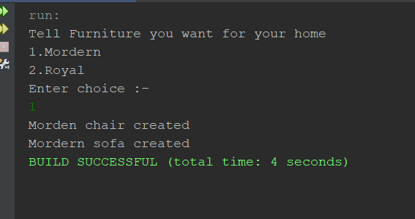

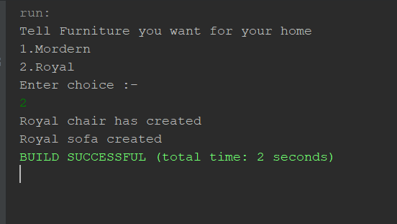

1. **Prototype :-**
   * Here I have use mobile shop example;

**File Structure :-**

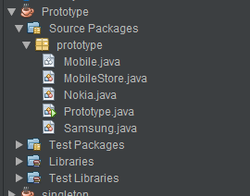

**Code :-**

**Mobile.java :-**

*/\**

*\* To change this license header, choose License Headers in Project Properties.*

*\* To change this template file, choose Tools | Templates*

*\* and open the template in the editor.*

*\*/*

package prototype;

*/\*\**

*\**

*\* @author IT069 arjun*

*\*/*

public abstract class Mobile implements Cloneable{

    protected String comp_name = null;

    abstract void production();

    @Override

    protected Object clone() throws CloneNotSupportedException {

        return super.clone();

    }

}

**MobileStore.java :-**

*/\**

*\* To change this license header, choose License Headers in Project Properties.*

*\* To change this template file, choose Tools | Templates*

*\* and open the template in the editor.*

*\*/*

package prototype;

import java.util.HashMap;

import java.util.Map;

*/\*\**

*\**

*\* @author IT069 arjun*

*\*/*

public class MobileStore {

    private static Map<String,Mobile> mobileMap = new HashMap<>();

    static{

        mobileMap.put("samsung", new Samsung());

        mobileMap.put("Nokia", new Nokia());

    }

    public static Mobile getMobile(String mobile_name) throws CloneNotSupportedException {

        return (Mobile) mobileMap.get(mobile_name).clone();

    }

}

**Nokia.java :-**

*/\**

*\* To change this license header, choose License Headers in Project Properties.*

*\* To change this template file, choose Tools | Templates*

*\* and open the template in the editor.*

*\*/*

package prototype;

*/\*\**

*\**

*\* @author IT069 arjun*

*\*/*

public class Nokia extends Mobile{

    public Nokia() {

        comp_name = "Nokia";

    }

    @Override

    void production() {

        System.out.println("Nokia phone has been maded and sold ");

    }

}

**Prototype.java :-**

*/\**

*\* To change this license header, choose License Headers in Project Properties.*

*\* To change this template file, choose Tools | Templates*

*\* and open the template in the editor.*

*\*/*

package prototype;

*/\*\**

*\**

*\* @author IT069 arjun*

*\*/*

public class Prototype {

    public static void main(String[] args) throws CloneNotSupportedException {

        MobileStore.getMobile("samsung").production();

        MobileStore.getMobile("Nokia").production();

    }

}

**Samsung.java :-**

*/\**

*\* To change this license header, choose License Headers in Project Properties.*

*\* To change this template file, choose Tools | Templates*

*\* and open the template in the editor.*

*\*/*

package prototype;

*/\*\**

*\**

*\* @author IT069 arjun*

*\*/*

public class Samsung extends Mobile {

    public Samsung() {

        comp_name = "samsung";

    }

    @Override

    void production() {

        System.out.println("samsung phone has maded and sold");

    }

}

**Input / Output :-**

**Input :-**

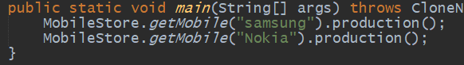

**Output :-**

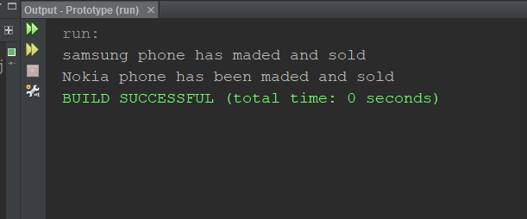

# Experiment-3

**Aim :** Implement programming solutions that use following design pattern

a. Composite

b. Decorator

c. Façade

1. Composite :-
   * Here I have take one Company Hierarchal tree ;

File Structure :-

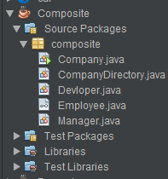

Code :-

Company.java :-

*/\**

*\* To change this license header, choose License Headers in Project Properties.*

*\* To change this template file, choose Tools | Templates*

*\* and open the template in the editor.*

*\*/*

package composite;

*/\*\**

*\**

*\* @author IT069 arjun*

*\*/*

public class Company

{

    public static void main (String[] args)

    {

        Devloper dev1 = new Devloper(100, "Vatsal Malaviya", "Pro Developer");

        Devloper dev2 = new Devloper(101, "Tarang Mavani", "Developer");

        CompanyDirectory engDirectory = new CompanyDirectory();

        engDirectory.addEmployee(dev1);

        engDirectory.addEmployee(dev2);

        Manager man1 = new Manager(200, "Arjun Maniya", "SEO Manager");

        Manager man2 = new Manager(201, "Kevla Merja", "Arjun's Manager");

        CompanyDirectory accDirectory = new CompanyDirectory();

        accDirectory.addEmployee(man1);

        accDirectory.addEmployee(man2);

        CompanyDirectory directory = new CompanyDirectory();

        directory.addEmployee(engDirectory);

        directory.addEmployee(accDirectory);

        directory.showEmployeeDetail();

    }

}

CompanyDirectory.java :

*/\**

*\* To change this license header, choose License Headers in Project Properties.*

*\* To change this template file, choose Tools | Templates*

*\* and open the template in the editor.*

*\*/*

package composite;

*/\*\**

*\**

*\* @author IT069 arjun*

*\*/*

import java.util.ArrayList;

import java.util.List;

public class CompanyDirectory implements Employee {

    private List<Employee> employeeList = new ArrayList<Employee>();

    @Override

    public void showEmployeeDetail() {

        for (Employee emp : employeeList) {

            emp.showEmployeeDetail();

        }

    }

    public void addEmployee(Employee emp) {

        employeeList.add(emp);

    }

    public void removeEmployee(Employee emp) {

        employeeList.remove(emp);

    }

}

Devplore.java :-

*/\**

*\* To change this license header, choose License Headers in Project Properties.*

*\* To change this template file, choose Tools | Templates*

*\* and open the template in the editor.*

*\*/*

package composite;

*/\*\**

*\**

*\* @author IT069 arjun*

*\*/*

public class Devloper implements Employee {

    private String name;

    private long empId;

    private String position;

    public Devloper(long empId, String name, String position) {

        this.empId = empId;

        this.name = name;

        this.position = position;

    }

    @Override

    public void showEmployeeDetail() {

         System.out.println(empId + " " + name );

    }

}

Employee :-

*/\**

*\* To change this license header, choose License Headers in Project Properties.*

*\* To change this template file, choose Tools | Templates*

*\* and open the template in the editor.*

*\*/*

package composite;

*/\*\**

*\**

*\* @author IT069 arjun*

*\*/*

public interface Employee {

    void showEmployeeDetail();

}

Manager.java :-

*/\**

*\* To change this license header, choose License Headers in Project Properties.*

*\* To change this template file, choose Tools | Templates*

*\* and open the template in the editor.*

*\*/*

package composite;

*/\*\**

*\**

*\* @author IT069 arjun*

*\*/*

public class Manager implements Employee {

    private String name;

    private long empId;

    private String position;

    public Manager(long empId, String name, String position) {

        this.empId = empId;

        this.name = name;

        this.position = position;

    }

    @Override

    public void showEmployeeDetail() {

        System.out.println(empId + " " + name);

    }

}

**Input/Output :-**

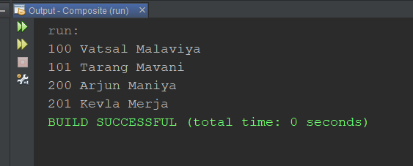

1. **Decoretor :-**
   * **Here I have use shape decorator as example :-**

**File Structure :-**

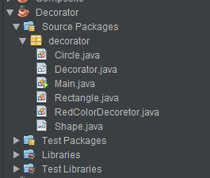

**Code:-**

**Circle.java :-**

*/\**

*\* Click nbfs://nbhost/SystemFileSystem/Templates/Licenses/license-default.txt to change this license*

*\* Click nbfs://nbhost/SystemFileSystem/Templates/Classes/Class.java to edit this template*

*\*/*

package decorator;

*/\*\**

*\**

*\* @author admin*

*\*/*

public class Circle implements Shape {

    @Override

    public void draw() {

        System.out.print("\ncircle");

    }

}

**Decoretor.java :-**

*/\**

*\* Click nbfs://nbhost/SystemFileSystem/Templates/Licenses/license-default.txt to change this license*

*\* Click nbfs://nbhost/SystemFileSystem/Templates/Classes/Class.java to edit this template*

*\*/*

package decorator;

*/\*\**

*\**

*\* @author admin*

*\*/*

public abstract class Decorator implements Shape{

    protected Shape decoShape;

    public Decorator(Shape decoShape){

        this.decoShape = decoShape;

    }

    @Override

    public void draw() {

        decoShape.draw();

    }

}

**Main.java :-**

*/\**

*\* Click nbfs://nbhost/SystemFileSystem/Templates/Licenses/license-default.txt to change this license*

*\* Click nbfs://nbhost/SystemFileSystem/Templates/Classes/Main.java to edit this template*

*\*/*

package decorator;

*/\*\**

*\**

*\* @author admin*

*\*/*

public class Main {

*/\*\**

*\* @param args the command line arguments*

*\*/*

    public static void main(String[] args) {

*// TODO code application logic here*

       Shape redCircle = new RedColorDecoretor(new Circle());

       Shape redRec = new RedColorDecoretor(new Rectangle());

       redCircle.draw();

       redRec.draw();

    }

}

**Rectangle.java :-**

*/\**

*\* Click nbfs://nbhost/SystemFileSystem/Templates/Licenses/license-default.txt to change this license*

*\* Click nbfs://nbhost/SystemFileSystem/Templates/Classes/Class.java to edit this template*

*\*/*

package decorator;

*/\*\**

*\**

*\* @author admin*

*\*/*

public class Rectangle implements Shape {

    @Override

    public void draw() {

            System.out.print("\nRectangle");

    }

}

**RedColorDecoretor.java :-**

*/\**

*\* Click nbfs://nbhost/SystemFileSystem/Templates/Licenses/license-default.txt to change this license*

*\* Click nbfs://nbhost/SystemFileSystem/Templates/Classes/Class.java to edit this template*

*\*/*

package decorator;

*/\*\**

*\**

*\* @author admin*

*\*/*

public class RedColorDecoretor extends Decorator {

    public RedColorDecoretor(Shape decoShape)

    {

        super(decoShape);

    }

    @Override

    public void draw() {

        decoShape.draw();

        setColor(decoShape);

    }

    public void setColor(Shape decoShape) {

        System.out.println(" set red color");

    }

}

**Shape.java :-**

package decorator;

*/\*\**

*\**

*\* @author admin*

*\*/*

public interface Shape {

    void draw();

}

**Input / Output :-**

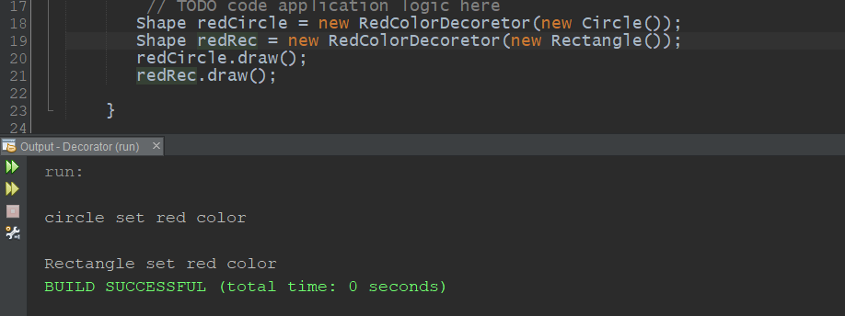

1. **Façade :-**

Here I have take VLC example that can open media file as per user command (wish).

**File Structure :-**

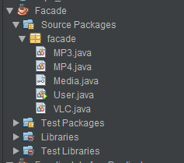

**Code :-**

**Media.java :-**

package facade;

*/\*\**

*\**

*\* @author admin*

*\*/*

public interface Media {

    void play();

}

**MP3.java :-**

package facade;

*/\*\**

*\**

*\* @author IT069 arjun*

*\*/*

public class MP3 implements Media{

    @Override

    public void play() {

        System.out.println("Media is open in MP3");

    }

}

**MP4.java :-**

package facade;

*/\*\**

*\**

*\* @author IT069 arjun*

*\*/*

public class MP4 implements Media{

    @Override

    public void play() {

        System.out.println("Media is open in MP4");

    }

}

**User.java :-**

*/\**

*\* To change this license header, choose License Headers in Project Properties.*

*\* To change this template file, choose Tools | Templates*

*\* and open the template in the editor.*

*\*/*

package facade;

*/\*\**

*\**

*\* @author admin*

*\*/*

public class User {

*/\*\**

*\* @param args the command line arguments*

*\*/*

    public static void main(String[] args) {

*// TODO code application logic here*

        VLC vlc = new VLC();

        vlc.playMP4();

        vlc.playMP3();

    }

}

**VLC.java :-**

*/\**

*\* To change this license header, choose License Headers in Project Properties.*

*\* To change this template file, choose Tools | Templates*

*\* and open the template in the editor.*

*\*/*

package facade;

*/\*\**

*\**

*\* @author IT069 arjun*

*\*/*

public class VLC {

    private Media mp4, mp3;

    public VLC() {

        mp4 = new MP4();

        mp3 = new MP3();

    }

    public void playMP3() {

        mp3.play();

    }

    public void playMP4() {

        mp4.play();

    }

}

**Input/Output :-**

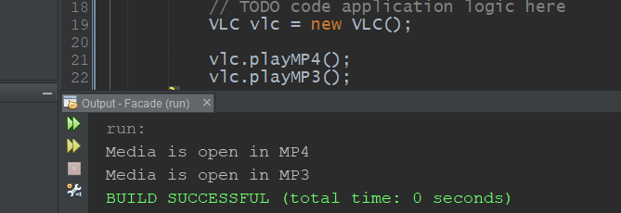

# **Experiment-4**

**Aim :** Solving programming problems using Java-8 functional programming**.**

**File Structure :-**

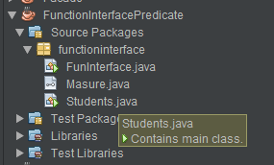

**Code :-**

**Functional Interface Example :-**

**Mesure.java:-**

*/\**

*\* Click nbfs://nbhost/SystemFileSystem/Templates/Licenses/license-default.txt to change this license*

*\* Click nbfs://nbhost/SystemFileSystem/Templates/Classes/Class.java to edit this template*

*\*/*

package functioninterface;

*/\*\**

*\**

*\* @author admin*

*\*/*

@FunctionalInterface

interface Mesure{

    int calucate(int x);

}

**FunInterface.java :-**

*/\**

*\* Click nbfs://nbhost/SystemFileSystem/Templates/Licenses/license-default.txt to change this license*

*\* Click nbfs://nbhost/SystemFileSystem/Templates/Classes/Main.java to edit this template*

*\*/*

package functioninterface;

*/\*\**

*\**

*\* @author admin*

*\*/*

public class FunInterface {

*/\*\**

*\* @param args the command line arguments*

*\*/*

    public static void main(String[] args) {

*// TODO code application logic here*

        int x = 5;

        Masure area = (int a) -> x * x;

        Masure vol = (int a) -> x * x * x;

        int squareArea = area.calucate(x);

        System.out.println(squareArea);

        int volCube = vol.calucate(x);

        System.out.println(volCube);

    }

}

**Input/Output :-**

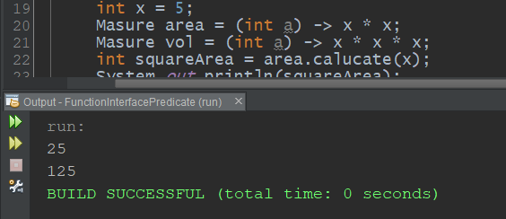

**Predicate Example :-**

**Students.java :-**

* + **Here I have make one filter to sort out student by marks (ex. Name of students that have more than 90 marks)**

*/\**

*\* To change this license header, choose License Headers in Project Properties.*

*\* To change this template file, choose Tools | Templates*

*\* and open the template in the editor.*

*\*/*

package functioninterface;

import java.util.ArrayList;

import java.util.List;

import java.util.function.Predicate;

*/\*\**

*\**

*\* @author admin*

*\*/*

public class Students {

    String name;

    int marks;

    public Students() {

    }

    public Students(String name, int marks) {

        this.name = name;

        this.marks = marks;

    }

    public String getName() {

        return name;

    }

    public int getMarks() {

        return marks;

    }

    @Override

    public String toString() {

        return " Name --> "+getName()+" Marks --> "+ getMarks(); *//To change body of generated methods, choose Tools | Templates.*

    }

    public static void main(String[] args) {

*// TODO code application logic here*

        List<Students> students = new ArrayList<>();

        students.add(new Students("Arjun", 99));

        students.add(new Students("xyz", 50));

        List<Students> filterStudents = filterByMarks(students,(Students s) -> s.getMarks() > 90);

    }

    public static List<Students> filterByMarks(List<Students> students, Predicate<Students> predicate)

    {

        List<Students> result = new ArrayList<>();

        for(Students s : students)

        {

            if(predicate.test(s))

            {

                result.add(s);

                System.out.println(s.toString());

            }

        }

        return result;

    }

}

**Input/Output :-**

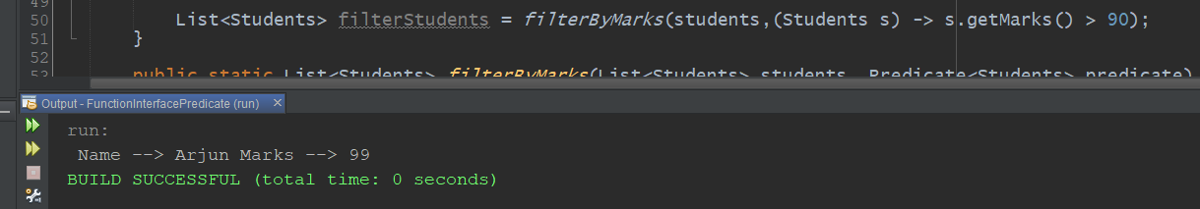

# Experiment-5

**Aim :- : Designing and implementing web interface using JavaScript, and CSS**

* **Here I have made simple calc using javascript and css .**

**File Structure :-**

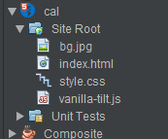

**Code :-**

**Index.html :-**

<!DOCTYPE html>

<html lang="en">

    <head>

        <meta charset="UTF-8">

        <meta name="viewport" content="width=device-width, initial-scale=1.0">

        <link rel="stylesheet" href="style.css">

        <title>Online Cal</title>

    </head>

    <body>

         <div id="overlay"></div>

        <div class="container">

            <form action="post" class="cal" name="calc">

                <input type="text" readonly class="value" name="txt" />

                <span class="num clear" onclick="calc.txt.value = ''">c</span>

                <span class="num" onclick="document.calc.txt.value += '/'">/</span>

                <span class="num" onclick="document.calc.txt.value += '*'">*</span>

                <span class="num" onclick="document.calc.txt.value += '7'">7</span>

                <span class="num" onclick="document.calc.txt.value += '8'">8</span>

                <span class="num" onclick="document.calc.txt.value += '9'">9</span>

                <span class="num" onclick="document.calc.txt.value += '-'">-</span>

                <span class="num" onclick="document.calc.txt.value += '4'">4</span>

                <span class="num" onclick="document.calc.txt.value += '5'">5</span>

                <span class="num" onclick="document.calc.txt.value += '6'">6</span>

                <span class="num pluse" onclick="document.calc.txt.value += '+'">+</span>

                <span class="num" onclick="document.calc.txt.value += '1'">1</span>

                <span class="num" onclick="document.calc.txt.value += '2'">2</span>

                <span class="num" onclick="document.calc.txt.value += '3'">3</span>

                <span class="num" onclick="document.calc.txt.value += '0'">0</span>

                <span class="num" onclick="document.calc.txt.value += '00'">00</span>

                <span class="num" onclick="document.calc.txt.value += '.'">.</span>

                <span class="num equal" onclick="document.calc.txt.value = eval(calc.txt.value)">=</span>

            </form>

        </div>

    </body>

</html>

**Style.css :-**

*/\**

*To change this license header, choose License Headers in Project Properties.*

*To change this template file, choose Tools | Templates*

*and open the template in the editor.*

*\*/*

*/\**

*Created on : 28 Mar, 2022, 9:30:13 PM*

*Author     : admin*

*\*/*

*{

    margin: 0;

    padding: 0;

    box-sizing: border-box;

}

body{

    display: flex;

    justify-content: center;

    align-items: center;

    min-height: 100vh;

    background-image:url("bg.jpg");

    background-position: center;

    background-size: cover;

}

.container{

    position: absolute;

    background: rgba(255, 255, 255, 0.05);

    border-radius: 6px;

    overflow: hidden;

    z-index: 100;

    backdrop-filter: blur(15px);

    border-top: 1px solid rgba(255, 255, 255, 0.2);

    border-left: 1px solid rgba(255, 255, 255, 0.2);

    box-shadow: 5px 5px 30px rgba(0, 0, 0, 0.2);

}

.container .cal{

    position: relative;

    display: grid;

}

.container .cal .value{

    padding: 10px;

    grid-column: span 4;

    height: 140px;

    width: 300px;

    text-align: right;

    border: none;

    outline: none;

    font-size: 30px ;

    background: transparent;

    color:#fff;

    border-bottom: 1px solid rgba(255, 255, 255, 0.05);

    border-right: 1px solid rgba(255, 255, 255, 0.05);

}

.container .cal span{

    display: grid;

    place-items: center;

    width: 75px;

    height: 75px;

    color: white;

    font-size: 20px;

    font-weight: 400;

    cursor: pointer;

    user-select: none;

    border-bottom: 1px solid rgba(255, 255, 255, 0.05);

    border-right: 1px solid rgba(255, 255, 255, 0.05);

}

.container .cal span:hover{

    transition: 0s;

    background: rgba(255, 255, 255, 0.05);

}

.container .cal span:active{

    background: rgba(20, 20, 20, 0.74);

    font-size: 25px;

    font-weight: 500;

}

.container .cal .clear{

    grid-column: span 2;

    width: 150px;

}

.container .cal .pluse{

    grid-row: span 2;

    height: 150px;

}

#overlay {

    position: fixed;

    display: none;

    width: 100%;

    height: 100%;

    top: 0;

    left: 0;

    right: 0;

    bottom: 0;

    background-color: rgba(0,0,0,0.5);

    z-index: 1;

    cursor: pointer;

}

**Input/Output :-**

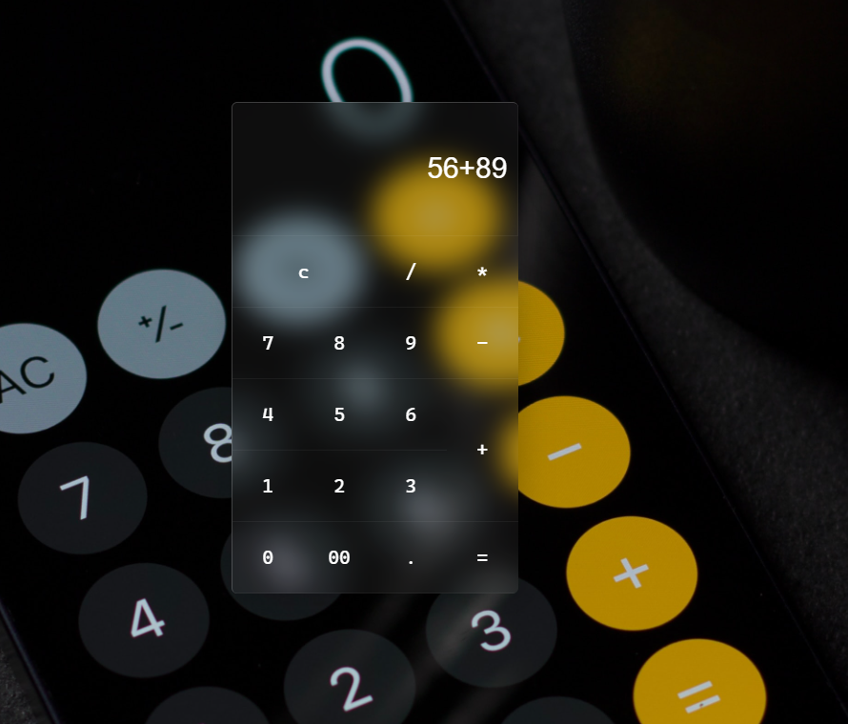

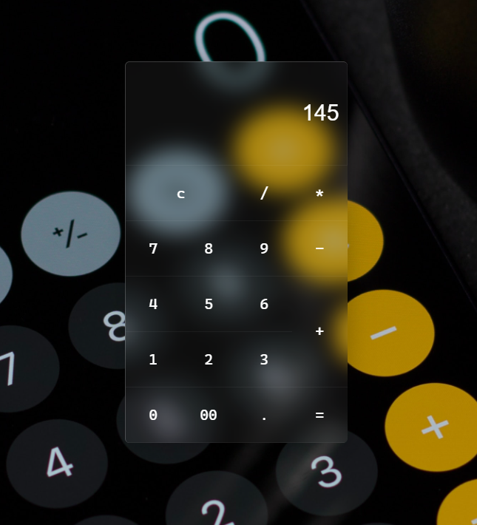

# Experiment-6

**Aim : Designing and implementing web interface using Bootstrap and customizing CSS**

**File structure :-**

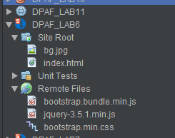

**Code :-**

**index.html:-**

<!DOCTYPE html>

<html>

    <head>

*<!-- jQuery cdn link -->*

        <link href="https://cdn.jsdelivr.net/npm/bootstrap@5.1.3/dist/css/bootstrap.min.css" rel="stylesheet" integrity="sha384-1BmE4kWBq78iYhFldvKuhfTAU6auU8tT94WrHftjDbrCEXSU1oBoqyl2QvZ6jIW3" crossorigin="anonymous">

        <script src="https://cdn.jsdelivr.net/npm/bootstrap@5.1.3/dist/js/bootstrap.bundle.min.js" integrity="sha384-ka7Sk0Gln4gmtz2MlQnikT1wXgYsOg+OMhuP+IlRH9sENBO0LRn5q+8nbTov4+1p" crossorigin="anonymous"></script>

        <script src="https://code.jquery.com/jquery-3.5.1.min.js">

        </script>

        <style type="text/css">

            .content {

                position: absolute;

                top: 50%;

                left: 50%;

                transform: translate(-50%, -50%);

                width: 500px;

                height: 200px;

                text-align: center;

                background-color: #e8eae6;

                box-sizing: border-box;

                padding: 10px;

                z-index: 100;

                display: none;

*/*to hide popup initially*/*

            }

            .close-btn {

                position: absolute;

                right: 20px;

                top: 15px;

                background-color: white;

                color: black;

                border-radius: 50%;

                padding: 4px;

            }

            .form-signin{

                padding: 10px;

                background: #000000;

            }

        </style>

    </head>

    <body>

        <header class="p-3 bg-dark text-white">

            <div class="container">

                <div class="d-flex flex-wrap align-items-center justify-content-center justify-content-lg-start">

                    <a href="/" class="d-flex align-items-center mb-2 mb-lg-0 text-white text-decoration-none">

                        <h2 style="padding : 0px 10px;">Maniya</h2>

                    </a>

                    <ul class="nav col-12 col-lg-auto me-lg-auto mb-2 justify-content-center mb-md-0">

                        <li><a href="#" class="nav-link px-2 text-secondary">Home</a></li>

                        <li><a href="#" class="nav-link px-2 text-white">Features</a></li>

                        <li><a href="#" class="nav-link px-2 text-white">Pricing</a></li>

                        <li><a href="#" class="nav-link px-2 text-white">FAQs</a></li>

                        <li><a href="#" class="nav-link px-2 text-white">About</a></li>

                    </ul>

                    <form class="col-12 col-lg-auto mb-3 mb-lg-0 me-lg-3">

                        <input type="search" class="form-control form-control-dark" placeholder="Search..." aria-label="Search">

                    </form>

                    <div class="text-end">

                        <button type="button" class="btn btn-outline-light me-2" onclick="togglePopup()">Login</button>

                        <button type="button" class="btn btn-warning" >Sign-up</button>

                    </div>

                </div>

            </div>

        </header>

        <div class="container col-xxl-8 px-4 py-5">

            <div class="row flex-lg-row-reverse align-items-center g-5 py-5">

                <div class="col-10 col-sm-8 col-lg-6">

                    <img src="bg.jpg" class="d-block mx-lg-auto img-fluid" alt="Bootstrap Themes" width="700" height="500" loading="lazy">

                </div>

                <div class="col-lg-6">

                    <h1 class="display-5 fw-bold lh-1 mb-3">Responsive left-aligned hero with image</h1>

                    <p class="lead">Quickly design and customize responsive mobile-first sites with Bootstrap, the world’s most popular front-end open source toolkit, featuring Sass variables and mixins, responsive grid system, extensive prebuilt components, and powerful JavaScript plugins.</p>

                    <div class="d-grid gap-2 d-md-flex justify-content-md-start">

                        <button type="button" class="btn btn-primary btn-lg px-4 me-md-2" onclick="togglePopup()">Login</button>

                        <button type="button" class="btn btn-outline-secondary btn-lg px-4">Sign-up</button>

                    </div>

                </div>

            </div>

        </div>

*<!-- div containing the popup -->*

        <div class="content">

            <div onclick="togglePopup()" class="close-btn">

                X

            </div>

            <main class="form-signin">

                <form>

                    <h2>Maniya</h2>

                    <h3 class="h3 mb-3 fw-normal">Please sign in</h3>

                    <div class="form-floating">

                        <input type="email" class="form-control" id="floatingInput" placeholder="name@example.com">

                        <label for="floatingInput">Email address</label>

                    </div>

                    <div class="form-floating">

                        <input type="password" class="form-control" id="floatingPassword" placeholder="Password">

                        <label for="floatingPassword">Password</label>

                    </div>

                    <div class="checkbox mb-3">

                        <label>

                            <input type="checkbox" value="remember-me"> Remember me

                        </label>

                    </div>

                    <button class="w-100 btn btn-lg btn-primary" type="submit">Sign in</button>

                    <p class="mt-5 mb-3 text-muted">@ 2021-2022</p>

                </form>

            </main>

        </div>

        <script type="text/javascript">

*// Function to show and hide the popup*

            function togglePopup() {

                $(".content").toggle();

            }

        </script>

</html>

**Input / output :-**

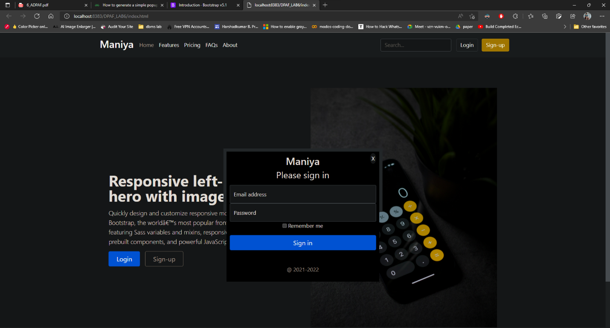

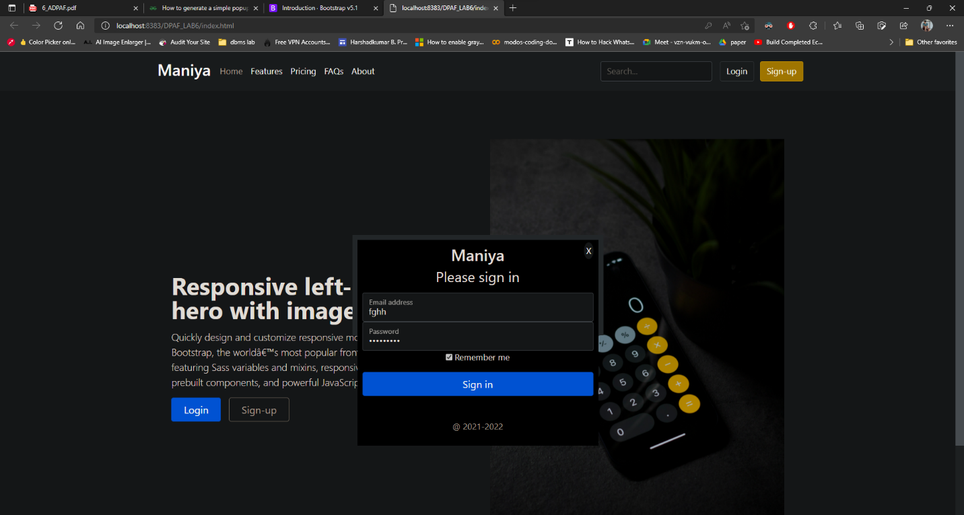

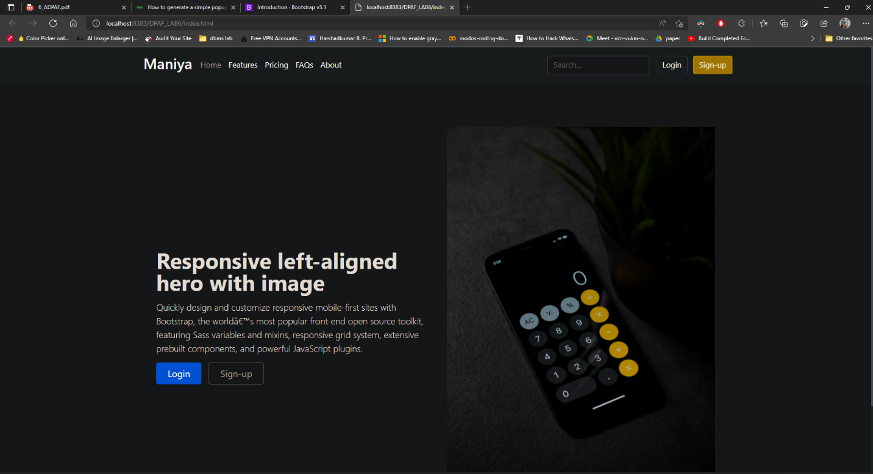

# Experiment-7

**Aim : Designing and implementing a single page web interface using Angular JS**

**File Structure :-**

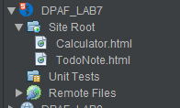

**Code :-**

**Basic Calculator :-**

**Cal.html :-**

<!DOCTYPE html>

*<!--*

*To change this license header, choose License Headers in Project Properties.*

*To change this template file, choose Tools | Templates*

*and open the template in the editor.*

*-->*

<html>

<head>

    <title>LAB7</title>

     <script data-require="angular.js@1.0.7" data-semver="1.0.7" src="https://ajax.googleapis.com/ajax/libs/angularjs/1.0.7/angular.js"></script>

</head>

<body>

    <div ng-app="CalculatorApp" ng-controller="CalculatorController">

        <p><input type="number" ng-model="a"></p>

        <p><input type="number" ng-model="b"></p>

        <p><select ng-model="operator">

                <option>+</option>

                <option>*</option>

                <option>-</option>

                <option>/</option>

            </select></p>

        <p>{{ result()}}</p>

    </div>

    <script>angular.module('CalculatorApp', [])

    .controller('CalculatorController', function($scope) {

        $scope.result = function() {

            if ($scope.operator == '+') {

                return $scope.a + $scope.b;

            }

            if ($scope.operator == '-') {

                return $scope.a - $scope.b;

            }

            if ($scope.operator == '*') {

                return $scope.a * $scope.b;

            }

            if ($scope.operator == '/') {

                return $scope.a / $scope.b;

            }

        };

    });</script>

</body>

</html>

**Input / Output :-**

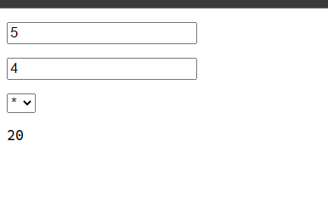

**TODO Note Example :-**

**TodoNote.html :-**

<!DOCTYPE html>

<html>

    <script src="https://ajax.googleapis.com/ajax/libs/angularjs/1.6.9/angular.min.js"></script>

    <link rel="stylesheet" href="https://www.w3schools.com/w3css/4/w3.css"> *<!--  same as bootstrap -->*

    <body>

        <script>

            var app = angular.module("myTodoList", []);

            app.controller("myCtrl", function ($scope) {

                $scope.notes = ["DPAF submission", "Created by IT069", "Hacker Rank Contest"];

                $scope.addNote = function () {

                    $scope.errorMessage = "";

                    if (!$scope.addMe) {

                        return;

                    }

                    if ($scope.notes.indexOf($scope.addMe) == -1)

                    {

                        $scope.notes.push($scope.addMe);

                        $scope.addMe = "";

                    } else {

                        $scope.errorMessage = "This item is already in list";

                    }

                }

                $scope.removeNote = function (x) {

                    $scope.notes.splice(x, 1);

                }

            });

        </script>

        <div class="w3-content" style="max-width:700px">

            <div ng-app="myTodoList" ng-controller="myCtrl" class="w3-card-2 w3-margin w3-center" style="max-width:700px;">

                <header class="w3-container w3-light-grey w3-padding-16"><h1>My TODO List</h1></header>

                <ul class="w3-ul">

                    <li ng-repeat="x in notes" class="w3-padding-16">{{x}}<span ng-click="removeNote($index)" style="cursor:pointer;" class="w3-right w3-margin-right">&times;</span></li>

                </ul>

                <div class="w3-container w3-light-grey w3-padding-16">

                    <div class="w3-row w3-margin-top">

                        <div class="w3-col s10">

                            <input placeholder="Add shopping items here" ng-model="addMe" class="w3-input w3-border w3-padding">

                        </div>

                        <div class="w3-col s2">

                            <button ng-click="addNote()" class="w3-btn w3-padding w3-green">Add Note</button>

                        </div>

                    </div>

                    <p class="w3-text-red">{{errorMessage}}</p>

                </div>

            </div>

        </div>

    </body>

</html>

**Input / Output :-**

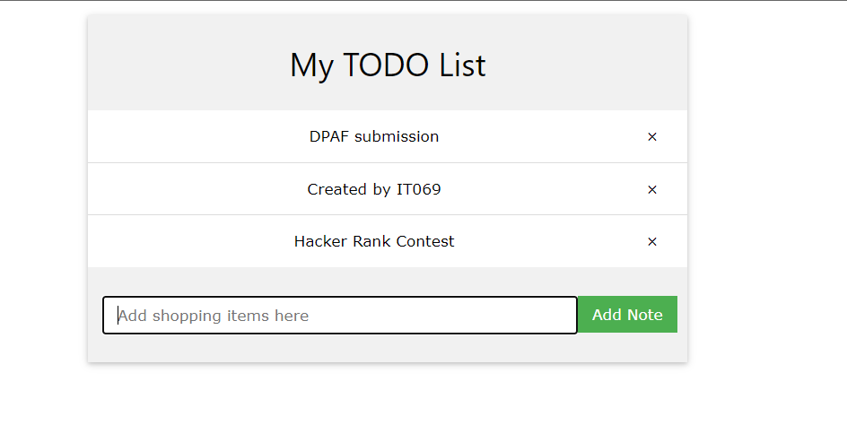

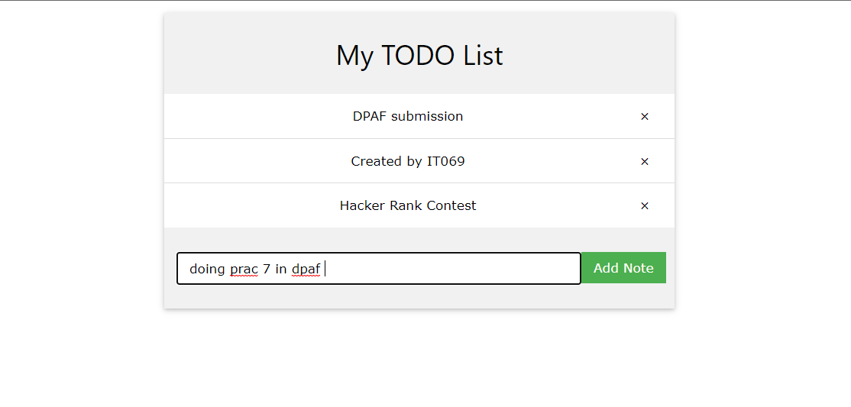

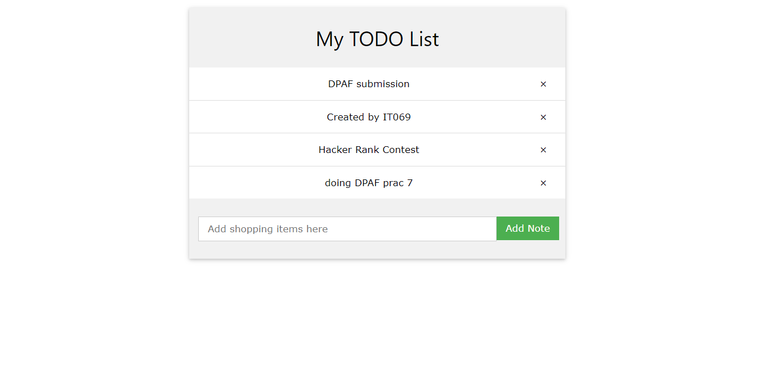

# Experiment-8

**Aim : Designing and implementing interactive web interface using AJAX**

**File Structure :-**

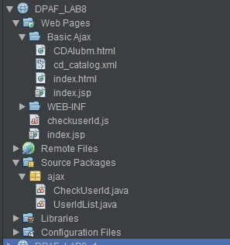

**Code :-**

1. **Basic Ajax Examples :-**

**CDAlbum.html :-**

**This will sawing all song albums list in xml files.**

<!DOCTYPE html>

<html>

    <link rel="stylesheet" href="https://www.w3schools.com/w3css/4/w3.css">

    <body>

        <div class="w3-content w3-border w3-center w3-form">

            <p>Click on a Row to display album information.</p>

            <p id='showCD'></p>

            <input type="button" onclick="previous()" value="<<">

            <input type="button" onclick="next()" value=">>">

        </div>

        <table id="demo" class="w3-table w3-bordered w3-striped w3-border w3-content w3-margin-top" style=" max-width: 700px;"></table>

        <script>

            var x, xmlhttp, xmlDoc

            xmlhttp = new XMLHttpRequest();

            xmlhttp.open("GET", "cd_catalog.xml", false);

            xmlhttp.send();

            xmlDoc = xmlhttp.responseXML;

            x = xmlDoc.getElementsByTagName("CD");

            table = "<tr><th>Artist</th><th>Title</th></tr>";

            for (i = 0; i < x.length; i++) {

                table += "<tr onclick='displayCD(" + i + ")'><td>";

                table += x[i].getElementsByTagName("ARTIST")[0].childNodes[0].nodeValue;

                table += "</td><td>";

                table += x[i].getElementsByTagName("TITLE")[0].childNodes[0].nodeValue;

                table += "</td></tr>";

            }

            document.getElementById("demo").innerHTML = table;

            function displayCD(i) {

                document.getElementById("showCD").innerHTML =

                        "Artist: " +

                        x[i].getElementsByTagName("ARTIST")[0].childNodes[0].nodeValue +

                        "<br>Title: " +

                        x[i].getElementsByTagName("TITLE")[0].childNodes[0].nodeValue +

                        "<br>Year: " +

                        x[i].getElementsByTagName("YEAR")[0].childNodes[0].nodeValue;

            }

            function next() {

                if (i < x.length - 1) {

                    i++;

                    displayCD(i);

                }

            }

            function previous() {

                if (i > 0) {

                    i--;

                    displayCD(i);

                }

            }

        </script>

    </body>

</html>

**Input / Output :-**

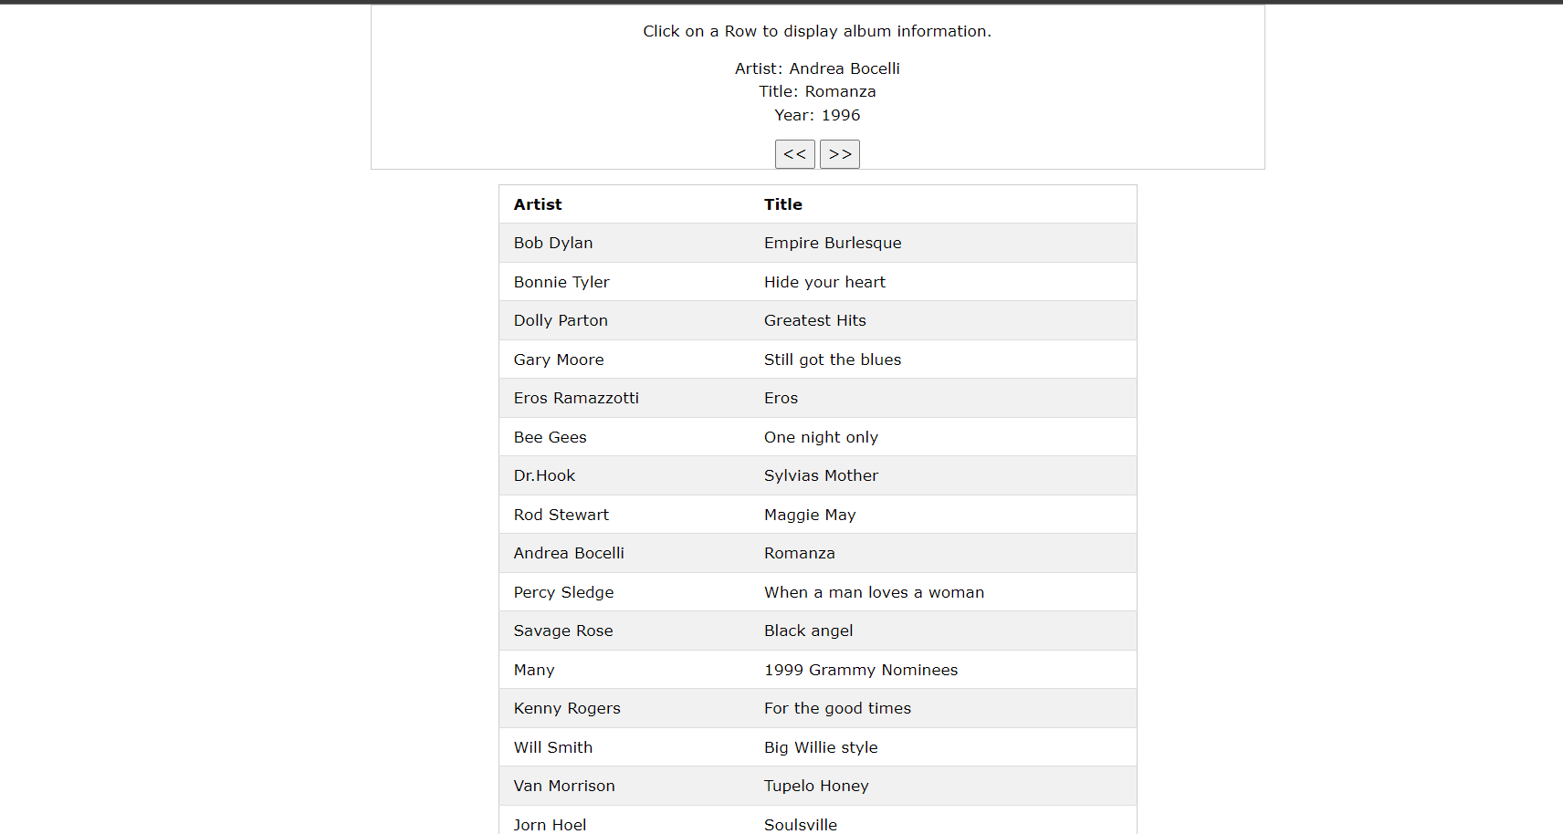

**Math table (Dynamic) :-**

**table.html :-**

<html>

    <head>

        <link rel="stylesheet" href="https://www.w3schools.com/w3css/4/w3.css">

        <script>

            var request;

            function sendInfo()

            {

                var v = document.vinform.t1.value;

                var url = "index.jsp?val=" + v;

                if (window.XMLHttpRequest) {

                    request = new XMLHttpRequest();

                } else if (window.ActiveXObject) {

                    request = new ActiveXObject("Microsoft.XMLHTTP");

                }

                try

                {

                    request.onreadystatechange = getInfo;

                    request.open("GET", url, true);

                    request.send();

                } catch (e)

                {

                    alert("Unable to connect to server");

                }

            }

            function getInfo() {

                if (request.readyState == 4) {

                    var val = request.responseText;

                    document.getElementById('res').innerHTML = val;

                }

            }

        </script>

    </head>

    <body>

    <marquee><h1>This is an example of ajax</h1></marquee>

    <form name="form" >

        <input type="text" name="t1">

        <input type="button" class="w3-button w3-round-xlarge w3-black" value="ShowTable" onClick="sendInfo()">

    </form>

    <span id="res"> </span>

</body>

</html>

**Index.jsp :-**

<%--

    Document   : index

    Created on : 29 Mar, 2022, 2:26:56 PM

    Author     : admin

--%>

<%

    int n = Integer.parseInt(request.getParameter("val"));

    for (int i = 1; i <= 10; i++) {

        out.print(i * n + "<br>");

    }

%>

**Input / Output :-**

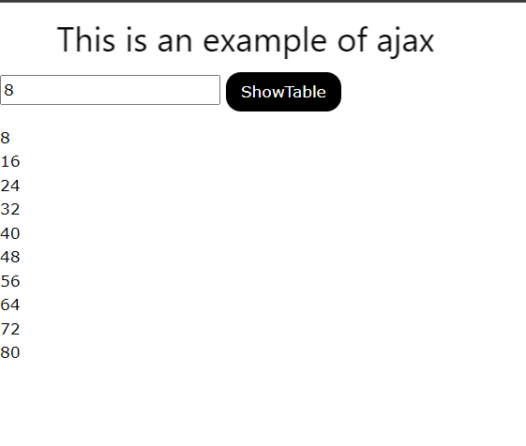

1. **Check userId is unique or not (Ajax + jQuery + javascript + Bootstrap + java + servlet )**

**Index.html :-**

<%@page contentType="text/html" pageEncoding="UTF-8"%>

<!DOCTYPE html>

<head>

    <script type="text/javascript" src="checkuserId.js"></script>

    <meta http-equiv="Content-Type" content="text/html; charset=UTF-8">

    <title>UniqueUser</title>

    <link rel="stylesheet" href="https://maxcdn.bootstrapcdn.com/bootstrap/4.5.2/css/bootstrap.min.css">

</head>

<body onload="init()">

    <br><br><br>

    <div class="row">

        <div class="col-3"></div>

        <div class="col-6 bg-light">

            <h1>Kindly Fill up the Form</h1>

            <hr><hr>

            <form name="registrationForm" action="register">

                <table border="0" cellpadding="5">

                    <tr>

                        <td>User Id:</td>

                        <td><input type="textfield" name="userid" id="userid" onchange="doChecking();"/></td>

                        <td><div id="status"></div></td>

                    </tr>

                    <tr>

                        <td>Name:</td>

                        <td><input type="textfield" name="name"/></td>

                        <td></td>

                    </tr>

                    <tr>

                        <td>Semester:</td>

                        <td><input type="textfield" name="name"/></td>

                        <td></td>

                    </tr>

                    <tr>

                        <td></td>

                        <td><input type="submit"/></td>

                        <td></td>

                    </tr>

                </table>

            </form>

        </div>

        <div class="col-3"></div>

    </div>

</body>

</html>

**checkedUserId.js :-**

*/\**

*\* To change this license header, choose License Headers in Project Properties.*

*\* To change this template file, choose Tools | Templates*

*\* and open the template in the editor.*

*\*/*

var xhr;

var useridField;

var statusField;

function init() {

    useridField = document.getElementById("userid");

    statusField = document.getElementById("status");

}

function doChecking() {

    var url = "CheckUserId?userid=" + escape(useridField.value);

    xhr = createXHRObject();

    xhr.open("GET", url, true);

    xhr.onreadystatechange = callback;

    xhr.send(null);

}

function createXHRObject() {

    var xhrObject;

    try {

*// Opera 8.0+, Firefox, Safari*

        xhrObject = new XMLHttpRequest();

    } catch (e) {

*// Internet Explorer Browsers*

        try {

            xhrObject = new ActiveXObject("Msxml2.XMLHTTP");

        } catch (e) {

            try {

                xhrObject = new ActiveXObject("Microsoft.XMLHTTP");

            } catch (e) {

*// Something went wrong*

                alert("Your browser broke!");

                return false;

            }

        }

    }

    return xhrObject;

}

function callback() {

    if (xhr.readyState == 4) {

        if (xhr.status == 200) {

            setMessaage(xhr.responseXML);

        }

    }

}

function setMessaage(responseXML) {

    var statusElement = responseXML.getElementsByTagName("status")[0];

    var status = statusElement.childNodes[0].nodeValue;

    if (status == "NotAvailable") {

        statusField.innerHTML = "<font color=red>This User Id is already exist. Please try with different.</font>";

    } else {

        statusField.innerHTML = "<font color=green>This is valid UserID.</font>";

    }

}

**CheckUserId.java : -**

package ajax;

import java.io.IOException;

import javax.servlet.ServletConfig;

import javax.servlet.ServletContext;

import javax.servlet.ServletException;

import javax.servlet.http.HttpServlet;

import javax.servlet.http.HttpServletRequest;

import javax.servlet.http.HttpServletResponse;

public class CheckUserId extends HttpServlet {

    private UserIdList userIdList = new UserIdList();

    private ServletContext context;

    @Override

    public void init(ServletConfig config) throws ServletException {

        this.context = config.getServletContext();

    }

    protected void processRequest(HttpServletRequest request, HttpServletResponse response) throws

            ServletException, IOException {

        String submittedUserId = request.getParameter("userid");

        StringBuffer sBuff = new StringBuffer();

        if (submittedUserId != null) {

            submittedUserId = submittedUserId.trim().toLowerCase();

        } else {

            context.getRequestDispatcher("/error.jsp").forward(request,

                    response);

        }

        if (userIdList.isPresent(submittedUserId)) {

            sBuff.append("<status>");

            sBuff.append("NotAvailable");

            sBuff.append("</status>");

        } else {

            sBuff.append("<status>");

            sBuff.append("Available");

            sBuff.append("</status>");

        }

        response.setContentType("text/xml");

        response.getWriter().write(sBuff.toString());

    }

    @Override

    protected void doGet(HttpServletRequest request,

            HttpServletResponse response)

            throws ServletException, IOException {

        processRequest(request, response);

    }

    @Override

    protected void doPost(HttpServletRequest request,

            HttpServletResponse response)

            throws ServletException, IOException {

        processRequest(request, response);

    }

}

**UserIdList.java :-**

package ajax;

import java.util.ArrayList;

public class UserIdList {

    private final ArrayList<String> userIdList = new ArrayList<>();

    public ArrayList<String> getList() {

        return userIdList;

    }

    public UserIdList() {

        userIdList.add("arjun@gmail.com");

        userIdList.add("kevla@gmail.com");

        userIdList.add("tarang");

        userIdList.add("rohit");

    }

    public void addId(String userId) {

        userIdList.add(userId);

    }

    public boolean isPresent(String userId) {

        boolean status = false;

        for (String id : userIdList) {

            if (id.compareTo(userId) == 0) {

                status = true;

                break;

            }

        }

        return status;

    }

}

**Input / Output :-**

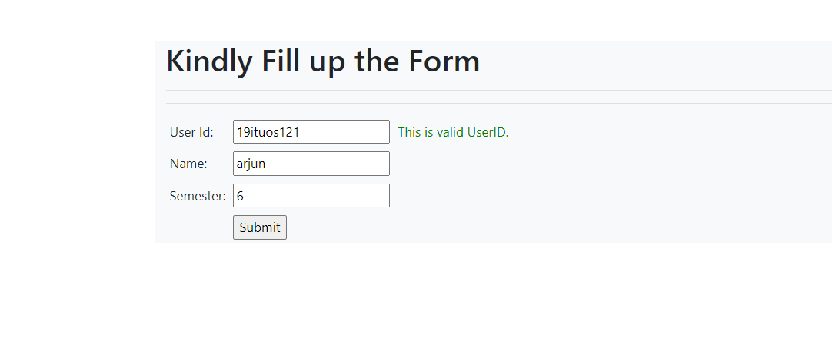

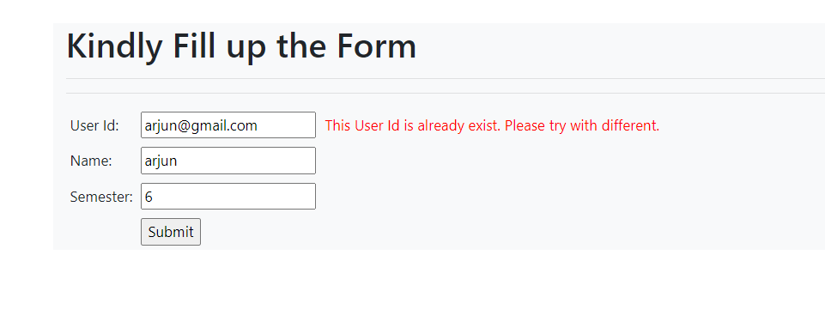

# Experiment-9

**Aim : Implement data access using Hibernate**

**File Structure :-**

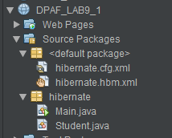

**Code :-**

**Main.java :-**

package hibernate;

*/\**

*\* To change this license header, choose License Headers in Project Properties.*

*\* To change this template file, choose Tools | Templates*

*\* and open the template in the editor.*

*\*/*

*/\*\**

*\**

*\* @author IT069 arjun*

*\*/*

import org.hibernate.Session;

import org.hibernate.SessionFactory;

import org.hibernate.Transaction;

import org.hibernate.cfg.Configuration;

public class Main {

    public static void main(String[] args) {

        Student st = new Student("arjun", "maniya", 6);

        SessionFactory sessionFactory =new Configuration().configure().buildSessionFactory();

        Session session = sessionFactory.openSession();

        Transaction tx = session.beginTransaction();

        session.save(st);

        tx.commit();

        session.close();

        sessionFactory.close();

    }

}

**Student.java :-**

package hibernate;

*/\**

*\* To change this license header, choose License Headers in Project Properties.*

*\* To change this template file, choose Tools | Templates*

*\* and open the template in the editor.*

*\*/*

*/\*\**

*\**

*\* @author IT069 arjun*

*\*/*

public class Student {

    int id;

    String fname;

    String lname;

    int sem;

    public Student() {

    }

    public int getId() {

        return id;

    }

    public void setId(int id) {

        this.id = id;

    }

    public Student(String fname, String lname, int sem) {

        this.fname = fname;

        this.lname = lname;

        this.sem = sem;

    }

    public String getFname() {

        return fname;

    }

    public void setFname(String fname) {

        this.fname = fname;

    }

    public String getLname() {

        return lname;

    }

    public void setLname(String lname) {

        this.lname = lname;

    }

    public int getSem() {

        return sem;

    }

    public void setSem(int sem) {

        this.sem = sem;

    }

    @Override

    public String toString() {

        return "student{" + "fname=" + fname + ", lname=" + lname + ", sem=" + sem + '}';

    }

}

**Hibernate.cfg.xml :-**

<?xml version="1.0" encoding="UTF-8"?>

<!DOCTYPE hibernate-configuration PUBLIC "-//Hibernate/Hibernate Configuration DTD 3.0//EN" "http://hibernate.sourceforge.net/hibernate-configuration-3.0.dtd">

<hibernate-configuration>

  <session-factory>

    <mapping resource="hibernate.hbm.xml"/>

  </session-factory>

</hibernate-configuration>

**Hibernate.hbm.xml :-**

<?xml version="1.0" encoding="UTF-8"?>

<!DOCTYPE hibernate-mapping PUBLIC "-//Hibernate/Hibernate Mapping DTD 3.0//EN" "http://hibernate.sourceforge.net/hibernate-mapping-3.0.dtd">

<hibernate-mapping>

    <class name="hibernate.Student" table="student">

        <id name="id" type="int" column="id">

            <generator class="native"/>

        </id>

        <property name="fname" column="first_name" type="string"/>

        <property name="lname" column="last_name" type="string"/>

        <property name="sem" column="semester" type="int"/>

    </class>

</hibernate-mapping>

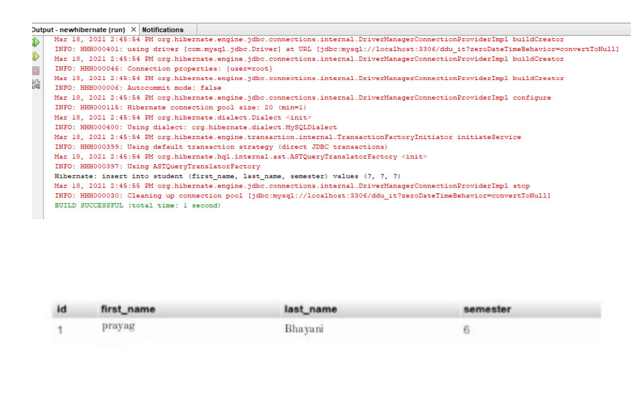

# Experiment 10

**Aim : : Implement relational data access using Hibernate.**

**File Structure :-**

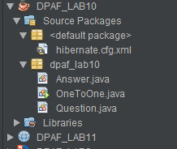

**Code :-**

**Answer.java :-**

*/\**

*\* To change this license header, choose License Headers in Project Properties.*

*\* To change this template file, choose Tools | Templates*

*\* and open the template in the editor.*

*\*/*

package dpaf_lab10;

*/\*\**

*\**

*\* @author IT069 arjun*

*\*/*

import javax.persistence.Column;

import javax.persistence.Entity;

import javax.persistence.Id;

import javax.persistence.Table;

@Entity

@Table(name = "answer")

public class Answer {

    @Id

    @Column(name = "answer_id")

    private int answerId;

    private String answer;

    public Answer(int answerId, String answer) {

        this.answerId = answerId;

        this.answer = answer;

    }

    public Answer() {

    }

    public int getAnswerId() {

        return answerId;

    }

    public void setAnswerId(int answerId) {

        this.answerId = answerId;

    }

    public String getAnswer() {

        return answer;

    }

    public void setAnswer(String answer) {

        this.answer = answer;

    }

}

**OneToOne.java :-**

*/\**

*\* To change this license header, choose License Headers in Project Properties.*

*\* To change this template file, choose Tools | Templates*

*\* and open the template in the editor.*

*\*/*

package dpaf_lab10;

*/\*\**

*\**

*\* @author IT069 arjun*

*\*/*

import org.hibernate.Session;

import org.hibernate.SessionFactory;

import org.hibernate.Transaction;

import org.hibernate.cfg.Configuration;

public class OneToOne {

    public static void main(String[] args) {

        Answer answer1 = new Answer(25, "Java is Programming Language");

        Question q1 = new Question(1, "What is Java?", answer1);

        Answer answer2 = new Answer(27, "API work with object in java");

        Question q2 = new Question(2, "What is Collection Framework?", answer2);

        SessionFactory sessionFactory = new Configuration().configure().buildSessionFactory();

        Session session = sessionFactory.openSession();

        Transaction tx = session.beginTransaction();

        session.save(q1);

        session.save(q2);

        session.save(answer1);

        session.save(answer2);

        tx.commit();

        session.close();

        sessionFactory.close();

    }

}

**Qustions.java :-**

*/\**

*\* To change this license header, choose License Headers in Project Properties.*

*\* To change this template file, choose Tools | Templates*

*\* and open the template in the editor.*

*\*/*

package dpaf_lab10;

*/\*\**

*\**

*\* @author IT069 arjun*

*\*/*

import javax.persistence.Column;

import javax.persistence.Entity;

import javax.persistence.Id;

import javax.persistence.OneToOne;

@Entity

public class Question {

    @Id

    @Column(name = "question_id")

    private int questionId;

    private String question;

    @OneToOne

    private Answer answer;

    public Question() {

    }

    public Question(int questionId, String question, Answer answer) {

        this.questionId = questionId;

        this.question = question;

        this.answer = answer;

    }

    public int getQuestionId() {

        return questionId;

    }

    public void setQuestionId(int questionId) {

        this.questionId = questionId;

    }

    public String getQuestion() {

        return question;

    }

    public void setQuestion(String question) {

        this.question = question;

    }

    public Answer getAnswer() {

        return answer;

    }

    public void setAnswer(Answer answer) {

        this.answer = answer;

    }

}

**Hibernet.cfg.xml :-**

<?xml version="1.0" encoding="UTF-8"?>

<!DOCTYPE hibernate-configuration PUBLIC "-//Hibernate/Hibernate Configuration DTD 3.0//EN" "http://hibernate.sourceforge.net/hibernate-configuration-3.0.dtd">

<hibernate-configuration>

    <session-factory>

        <property name="hibernate.dialect">org.hibernate.dialect.PostgreSQLDialect</property>

        <property name="hibernate.connection.driver_class">org.postgresql.Driver</property>

        <property name="hibernate.connection.url">jdbc:postgresql://localhost:5432/postgres</property>

        <property name="hibernate.connection.username">postgres</property>

        <property name="hibernate.connection.password">shree9592</property>

        <property name="hibernate.hbm2ddl.auto">create</property>

        <property name="hibernate.show_sql">true</property>

        <mapping class="dpaf_lab10.Answer"/>

        <mapping class="dpaf_lab10.Question"/>

    </session-factory>

</hibernate-configuration>

**Input / Output :-**

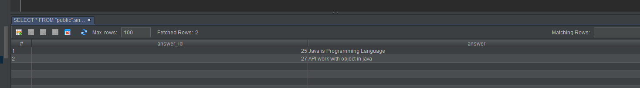

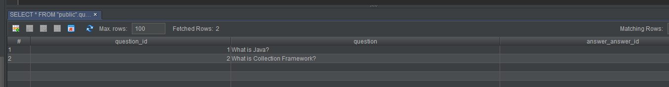

# Experiment-11

**Aim : Implement form handling with data binding using**

**Code :-**

Student.java

public class Student {

private Integer age;

private String name;

private Integer id;

public void setAge(Integer age) {

this.age = age;

}

public Integer getAge() {

return age;

}

public void setName(String name) {

this.name = name;

}

public String getName() {

return name;

}

public void setId(Integer id) {

this.id = id;

}

public Integer getId() {

return id;

}

}

StudentController.java

import org.springframework.stereotype.Controller;

import org.springframework.web.bind.annotation.ModelAttribute;

import org.springframework.web.bind.annotation.RequestMapping;

import org.springframework.web.bind.annotation.RequestMethod;

import org.springframework.web.servlet.ModelAndView;

import org.springframework.ui.ModelMap;

@Controller

public class StudentController {

@RequestMapping(value = "/student", method = RequestMethod.GET)

public ModelAndView student() {

return new ModelAndView("student", "command", new Student());

}

@RequestMapping(value = "/addStudent", method = RequestMethod.POST)

public String addStudent(@ModelAttribute("SpringWeb")Student student,

ModelMap model) {

model.addAttribute("name", student.getName());

model.addAttribute("age", student.getAge());

model.addAttribute("id", student.getId());

return "result";

}

}

Student.jsp

<%@taglib uri="http://www.springframework.org/tags/form" prefix="form"%>

<html>

<head>

<title>Spring MVC Form Handling</title>

</head>

<body>

<h2>Student Information</h2>

<form:form method="POST" action="/HelloWeb/addStudent">

<table>

<tr>

<td><form:label path="name">Name</form:label></td>

<td><form:input path="name" /></td>

</tr>

<tr>

<td><form:label path="age">Age</form:label></td>

<td><form:input path="age" /></td>

</tr>

<tr>

<td><form:label path="id">id</form:label></td>

<td><form:input path="id" /></td>

</tr>

<tr>

<td colspan="2">

<input type="submit" value="Submit"/>

</td>

</tr>

</table>

</form:form>

</body>

</html>

result.jsp

<%@taglib uri="http://www.springframework.org/tags/form" prefix="form"%>

<html>

<head>

<title>Spring MVC Form Handling</title>

</head>

<body>

<h2>Submitted Student Information</h2>

<table>

<tr>

<td>Name</td>

<td>${name}</td>

</tr>

<tr>

<td>Age</td>

<td>${age}</td>

</tr>

<tr>

<td>ID</td>

<td>${id}</td>

</tr>

</table>

</body>

</html>

**Input / output :-**

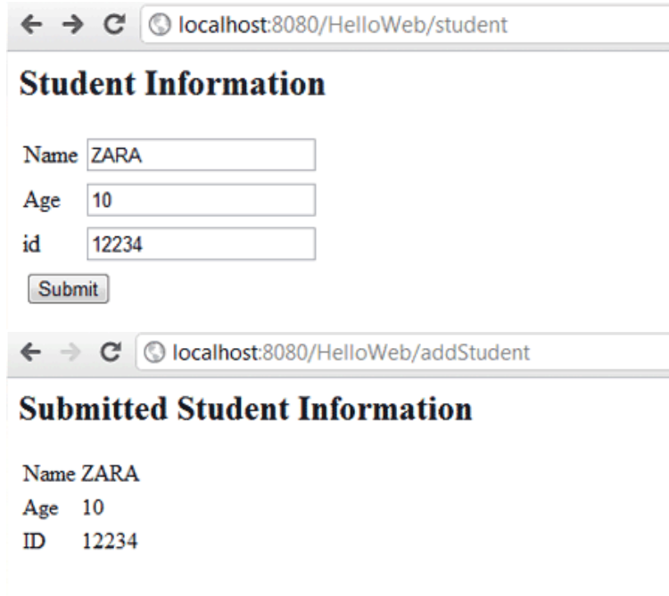

# Experiment-12

**Aim : Implement form handling with form validation using SpringMVC**

**File Structure :-**

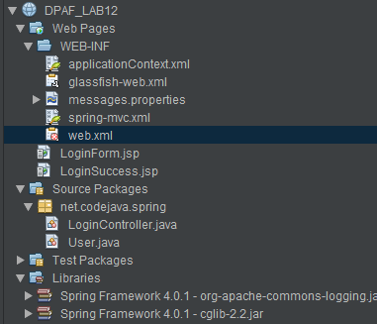

**Code :-**

**LoginController.java :-**

package net.codejava.spring;

import java.util.Map;

import javax.validation.Valid;

import org.springframework.stereotype.Controller;

import org.springframework.validation.BindingResult;

import org.springframework.web.bind.annotation.ModelAttribute;

import org.springframework.web.bind.annotation.RequestMapping;

import org.springframework.web.bind.annotation.RequestMethod;

*/\*\**

*\**

*\* @author www.codejava.net*

*\**

*\*/*

@Controller

public class LoginController {

    @RequestMapping(value = "/login", method = RequestMethod.GET)

    public String viewLogin(Map<String, Object> model) {

        User user = new User();

        model.put("userForm", user);

        return "LoginForm";

    }

    @RequestMapping(value = "/login", method = RequestMethod.POST)

    public String doLogin(@Valid @ModelAttribute("userForm") User userForm,

            BindingResult result, Map<String, Object> model) {

        if (result.hasErrors()) {

            return "LoginForm";

        }

        return "LoginSuccess";

    }

}

**User.java :-**

package net.codejava.spring;

import javax.validation.constraints.Size;

import org.hibernate.validator.constraints.Email;

import org.hibernate.validator.constraints.NotEmpty;

*/\*\**

*\**

*\* @author www.codejava.net*

*\**

*\*/*

public class User {

    @NotEmpty

    @Email

    private String email;

    @NotEmpty(message = "Please enter your password.")

    @Size(min = 6, max = 15, message = "Your password must between 6 and 15 characters")

    private String password;

    public String getEmail() {

        return email;

    }

    public void setEmail(String email) {

        this.email = email;

    }

    public String getPassword() {

        return password;

    }

    public void setPassword(String password) {

        this.password = password;

    }

}

**LoginForm.jsp :-**

<%@ page language="java" contentType="text/html; charset=UTF-8"

    pageEncoding="UTF-8"%>

<%@ taglib prefix="form" uri="http://www.springframework.org/tags/form"%>

<!DOCTYPE html PUBLIC "-//W3C//DTD HTML 4.01 Transitional//EN"

    "http://www.w3.org/TR/html4/loose.dtd">

<html>

<head>

<meta http-equiv="Content-Type" content="text/html; charset=UTF-8">

<title>Login</title>

<style>

    .error {

        color: red; font-weight: bold;

    }

</style>

</head>

<body>

    <div align="center">

        <h2>Spring MVC Form Validation Demo - Login Form</h2>

        <table border="0" width="90%">

        <form:form action="login" commandName="userForm">

                <tr>

                    <td align="left" width="20%">Email: </td>

                    <td align="left" width="40%"><form:input path="email" size="30"/></td>

                    <td align="left"><form:errors path="email" cssClass="error"/></td>

                </tr>

                <tr>

                    <td>Password: </td>

                    <td><form:password path="password" size="30"/></td>

                    <td><form:errors path="password" cssClass="error"/></td>

                </tr>

                <tr>

                    <td></td>

                    <td align="center"><input type="submit" value="Login"/></td>

                    <td></td>

                </tr>

        </form:form>

        </table>

    </div>

</body>

</html>

**LoginSuccess.jsp :-**

<%@ page language="java" contentType="text/html; charset=UTF-8"

    pageEncoding="UTF-8"%>

<!DOCTYPE html PUBLIC "-//W3C//DTD HTML 4.01 Transitional//EN"

    "http://www.w3.org/TR/html4/loose.dtd">

<html>

<head>

<meta http-equiv="Content-Type" content="text/html; charset=UTF-8">

<title>Welcome</title>

</head>

<body>

    <div align="center">

        <h2>Welcome ${userForm.email}! You have logged in successfully.</h2>

    </div>

</body>

</html>

**Input/ output :-**



