SENSORS AND USES :

FLEX SENSOR:
Detects the bending movement of the fingers/hand. Used to convert hand gestures into control commands for the robot.
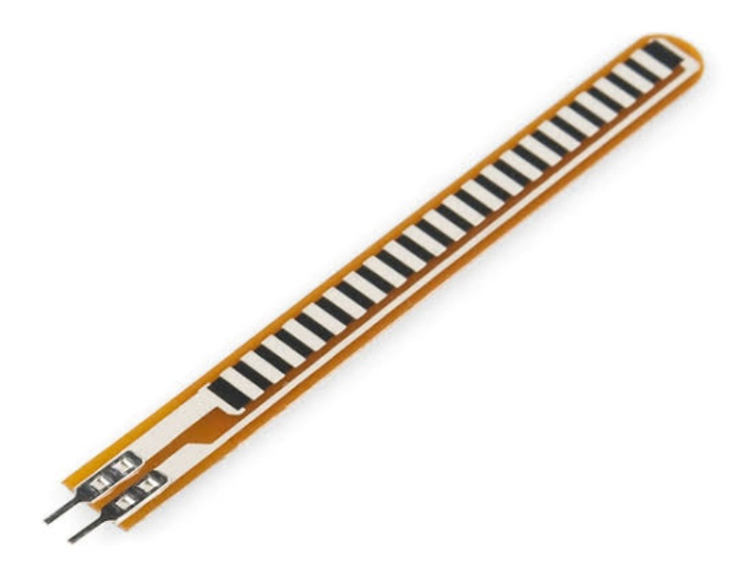

MPU6050 :
Measures hand movement and orientation using a 3-axis accelerometer and 3-axis gyroscope. Used to detect gestures such as forward, backward, left, and right.
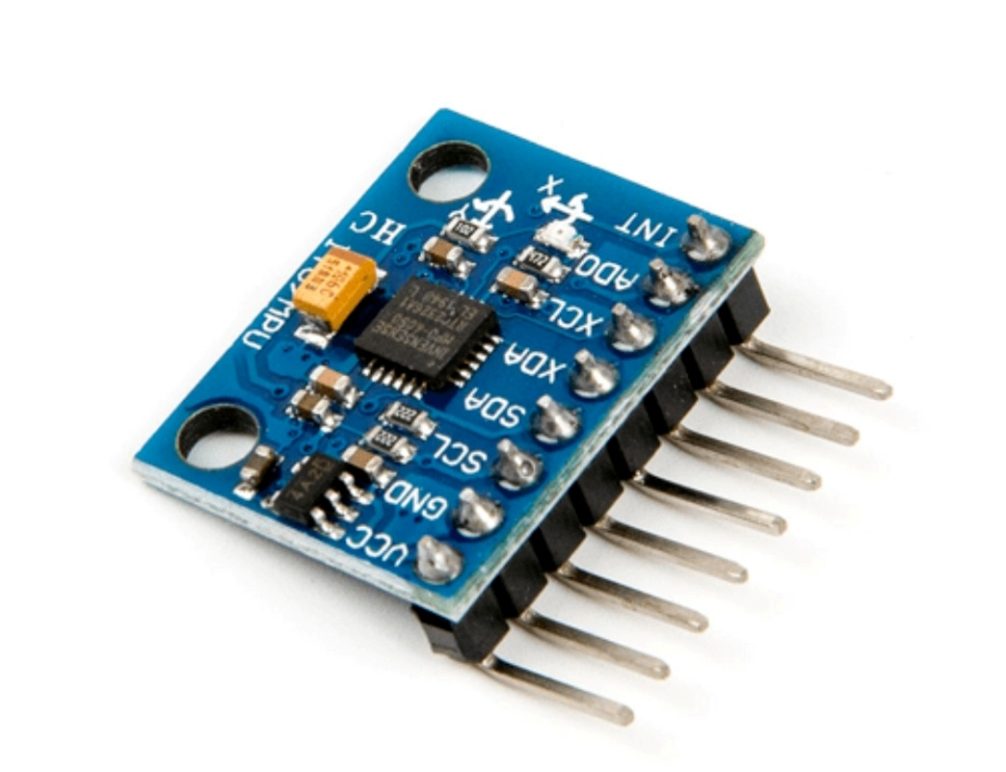

Arduino Nano
Processes sensor data and controls the system. Acts as the main controller of the transmitter/glove. Reads flex sensor and MPU6050 data, processes the gestures, and sends control commands.
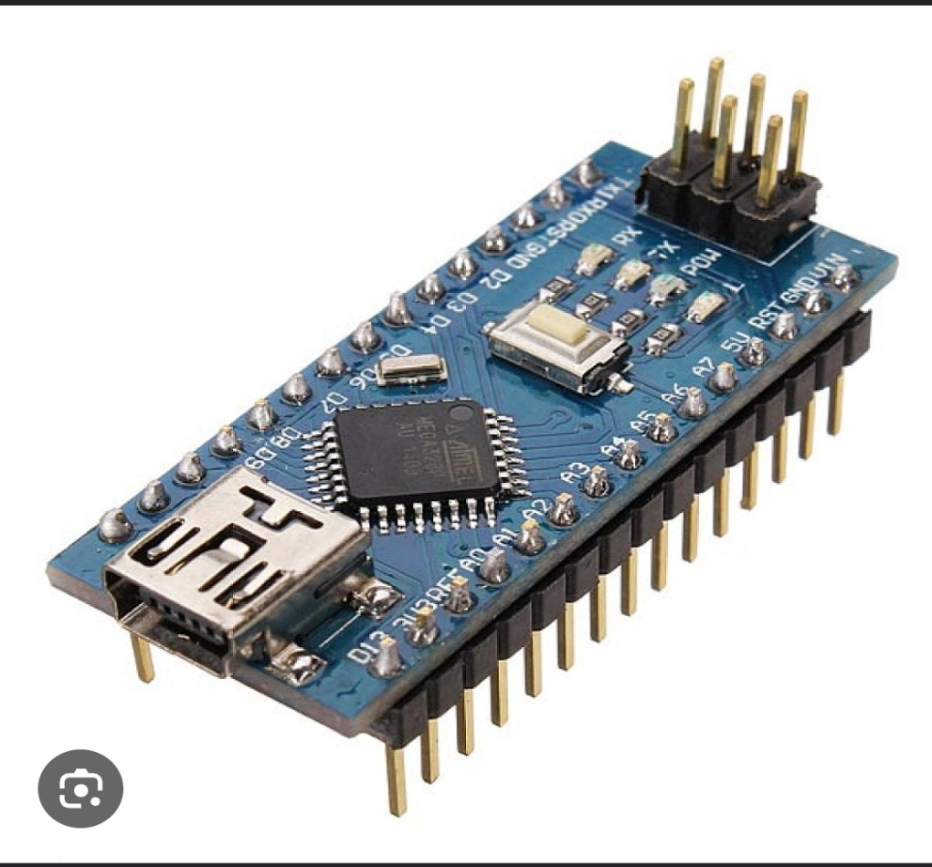

NRF24L01
Provides wireless communication between the hand/glove controller and the firefighting robot.
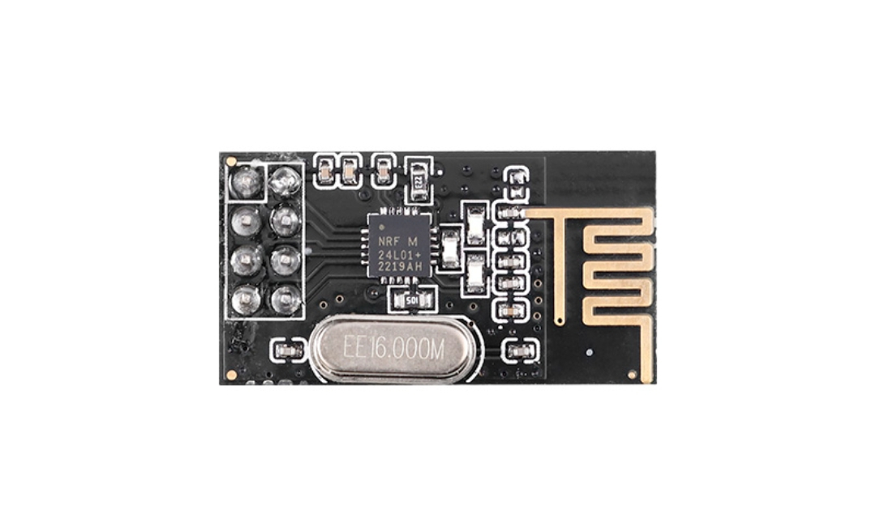
5. Mist Maker
Produces a fine water mist for firefighting. The mist helps suppress flames while reducing water consumption

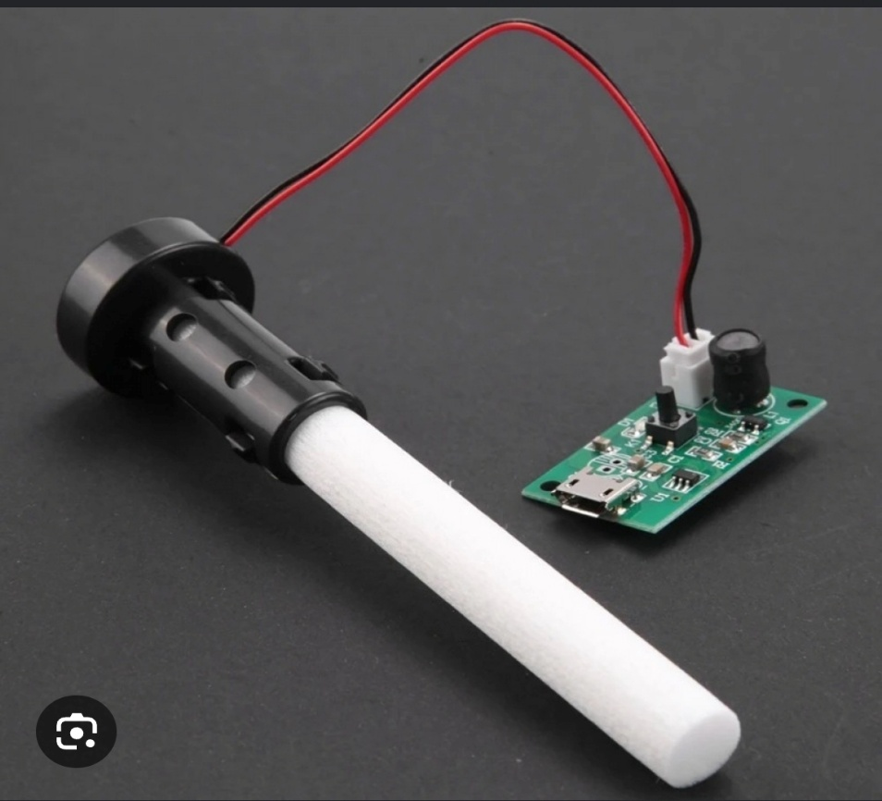

6. IR Sensor
Detects the presence/proximity of an object or flame source depending on the type of IR sensor used. It can help the robot detect obstacles or identify the fire direction.
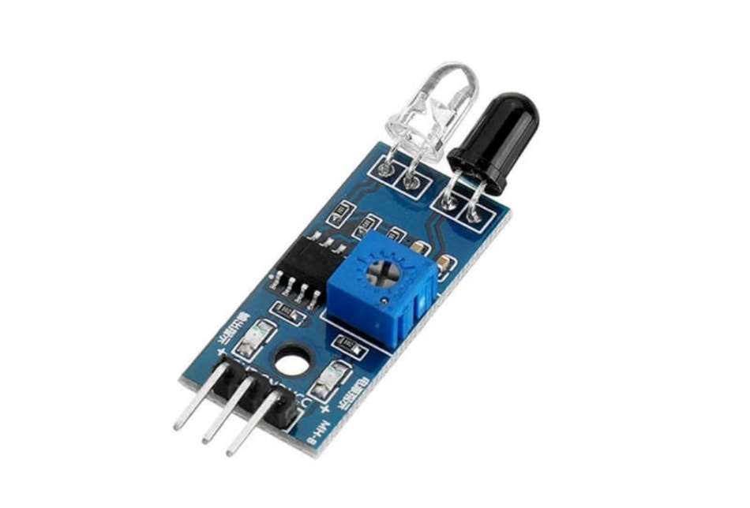
7. L298N Motor Driver
Controls the speed and direction of the DC motors. It allows the Arduino to drive the robot's motors for forward, backward, left, and right movement.

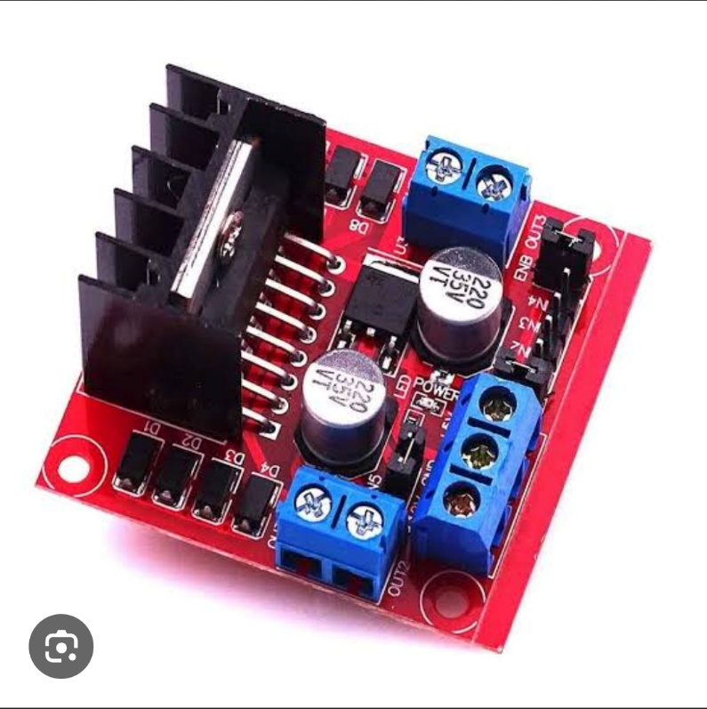

8. Relay Module
Acts as an electrical switch controlled by the Arduino. Used to turn the mist maker/pump or other high-power load ON/OFF safely.
