**Member : Jian Chen , Xutao Wang**

**Assignment_1**

Firstly, we set up a network with 10 nodes, from 1 to 10, it is like below:

10

1

5

6

7

8

9

3

2

4

Every node can only directly communicate with others which are connected. And the Network topology is like below:

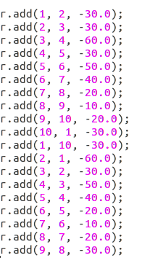

Every node periodically broadcast a “request” packet to the neighbors. We do this by using the below code:



Using the AMSend.send function and the first parameter is set the AM_BROADCAST_ADDR. It means send the packet to all the neighbors. And at the same time we record the current time by using the “call LocalTime.get()”.

When we received the message. First we need to get the source of the message.



And random a time 



After the random time response the message



And we defined a new function called Time1.fired(). its use is to response the message and send back to the source of the message.

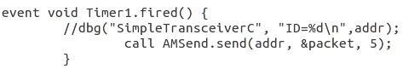

Here, we also use AMSend.send function but the first parameter we set the source of the message, and the third parameter (length of the message) we set 5 to make a different with the first send message.

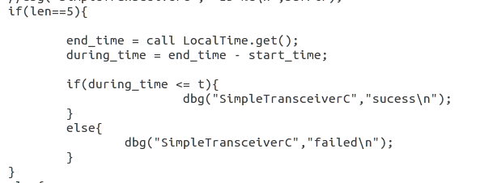

If the node receive the message length is 5, it means that it is the response of the receiver or it is the first time to get the message. When it sender get the response of the receiver, it calculate the during time by end time - start time. If the during time less than the given time t, it print success or it print failed.

When we set periodical interval 2500 and the t = 15 and then we got the results as followed.

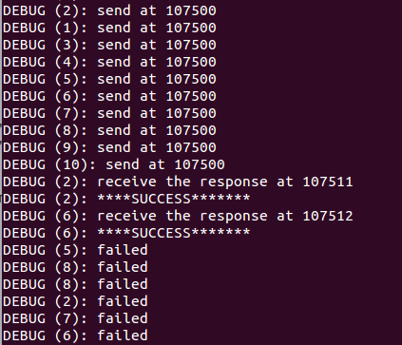

We change the t to 500. and remake the program again and got the results as followed.

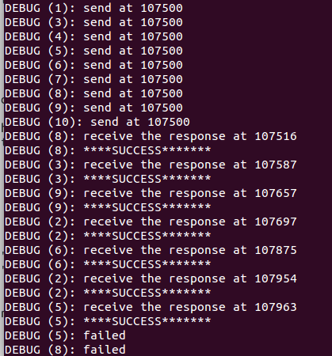

In conclusion, the main reason of failure are these two:

1. Boardcasting is not 100% success.
2. If t(the waiting time) gets bigger, the possibility of success gets higher.