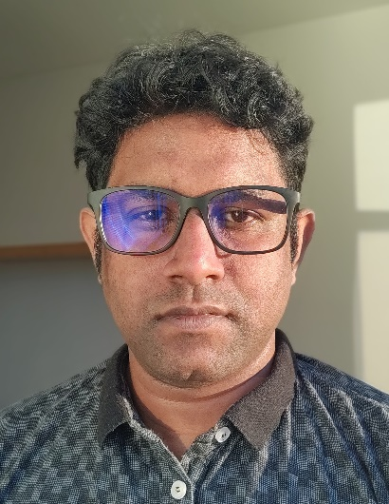**Titash Roy Choudhury**

International Data Consultant @ [Ataccama](https://www.ataccama.com/)

U Stírky, 182 00

Prague 8, Czech Republic

[titash@live.in](mailto:titash@live.in)

live:titash (**Skype**)

+420 702271464 (**Phone**)

JOB STATUS – Looking for **relevant work opportunities** across the **EU**, currently based in Prague, Czech Republic.

VISA STATUS – **EU BLUE CARD (CZECH)**

DATE OF AVAILABILITY – **01/05/2020**

**SUMMARY**

I have **7+** **years** of **industrial work experience** in **developing**, designing and maintaining **Enterprise Data Warehouses**​ for ​**E-gaming​**, ​**Finance** ​and ​**Insurance** ​domains.

* I **profile**, **map** and **catalog data** sources before proposing effective, resilient and industry acknowledged **ETL Design Patterns.**
* I develop **ETL/​ELT**​​ **data pipelines**​ for **data ingestion** and **integration**​ from ​diverse sources​ (**​MongoDB​**, ​RDBMS​, delimited flat files, **​XML**​, **​JSON**​ etc.)
* Using ​**SQL Server (2012 onwards)** and **​SSIS** (Data Tools) ​, I have developed **SCD Type2** with **Inferred Members** data load support.
* I have experience with implementation of ​**DWH** ​modelled using ​**Inmon**​, **Kimball**​ and ​Anchor **​data models**
* **DQ Rules** in **Python** & **SQL** that can be exposed as **WEB API** across organization​.
* Complete ​**SDLC** experience​ with **Agile** (**​Scrum​** and **​Kanban**​) and version control using ​**GIT** and ​**TFS**.

I also build financial **dashboards** and **reports** in **Power BI**, **SSRS** after educating and **training business users** to utilize **self-service BI**.

I have limited experience in configuration management and maintenance of **SQL Server** database **and Power BI Report (On Premise)** servers.

Key skills include:

SQL | Python | SSIS | XML | JavaScript | Shell | Git | Pandas | SQL Alchemy | Power BI | Azure | SQL Server | DWH | MDS | DQ | FLASK | DOCKER

**WORK EXPERIENCE**

[Ataccama s.r.o​](https://www.ataccama.com/), *Prague, Czech Republic as* ***International Data Consultant*** *from* **11/2019**

I work primarily in Data Quality and Master Data Management for different client projects at Ataccama. I have undertaken activities including but not limited to client training, product demos, proof of concepts, setting up development and production environment, project coordination, and component development initiatives.

* Google API integration in the Ataccama One IDE as an address validation component to improve data quality and governance metrics.
* Data Masking Endeavour in SQL Server tables to provide selective access to Personal Identifiable Data.
* POC demo of Fuzzy similarity match that was as Python Function exposed as an API deployed over FLASK.

[SEB Life International​](https://www.linkedin.com/company/seb-life-international/), Kuala Lumpur, Malaysia as **ETL Developer** from ***05/2018*** *to* ***11/2019***

Lead the SSIS(SQL Server) **ETL implementation** of **Enterprise Data Warehouse** based on ​[IBM Insurance Information Warehouse](https://www.ibm.com/my-en/marketplace/insurance-information-warehouse) model for​ **SEB Life International** with [GDPR compliance](https://azurepartnerportal.blob.core.windows.net/media/Resources/SQL%20Server%20GDPR%20Guidance%20Paper.pdf), for reports like​ [Solvency II](https://eiopa.europa.eu/regulation-supervision/insurance/solvency-ii) and [Asset Under Management](https://en.wikipedia.org/wiki/Assets_under_management)​ by consuming data from diverse legacy sources including but not limited to SQL Server, Oracle, WEB APIs (XML) and Postgres. Designed **dashboards and reports** in **Power BI** for Internal AUM, Asset Analysis, Sustainability data of financial assets. Worked on datasets extract for the backend team to consume and display on Customer E-life Web Access Portal.

[Aon India Services Ltd](https://www.aon.com/india/default.jsp), *Noida, India as* ***Software Engineer II (Business Intelligence)*** *from* ***04/2016*** to ***04/2018***

Worked primarily as an **ETL application owner** from onshore for **Aon’s Global Time Tracking systems** that aided decisions in charging clients based on the work hours logged by Aon Employee in over 12 different countries where Aon operated.

[Aditi Technologies Ltd](https://www.linkedin.com/company/aditi-technologies/about/), *Bangalore, India as* ***Solutions Engineer (Business Intelligence)*** *from* ***04/2013*** to ***03/2016***

End to End **Data Warehouse ownership** for Ladbrokes UK, in both SQL Server and Oracle BI eco-systems.

**EDUCATION**

**Bachelors in Engineering (Information Technology)**, 2012 – Rajiv Gandhi Technical University, Bhopal, India