# Quiz Chapter 2

## ITE Y3 G5

1. Suppose two nodes start to transmit at the same time a packet of length L over a broadcast channel of rate R. Denote the propagation delay between the two nodes as dprop. Will there be a collision if dprop < L/R? Why or why not?
2. How big is the MAC address space? The IPv4 address space? The IPv6 address space?
3. Why is an ARP query sent within a broadcast frame? Why is an ARP response sent within a frame with a specific destination MAC address?
4. Suppose that *N* switches supporting *K* VLAN groups are to be connected via a trunking protocol. How many ports are needed to connect the switches? Justify your answer.
5. Consider three LANs interconnected by two routers, as shown in Figure 5.33.
   1. Assign IP addresses to all of the interfaces. For Subnet 1 use addresses of the form 192.168.1.xxx; for Subnet 2 uses addresses of the form 192.168.2.xxx; and for Subnet 3 use addresses of the form 192.168.3.xxx.
   2. Assign MAC addresses to all of the adapters.
   3. Consider sending an IP datagram from Host E to Host B. Suppose all of the ARP tables are up to date. Enumerate all the steps, as done for the single-router example in Section 5.4.1. (of book Network Computing: a top down approach)
   4. Repeat (c), now assuming that the ARP table in the sending host is empty (and the other tables are up to date).

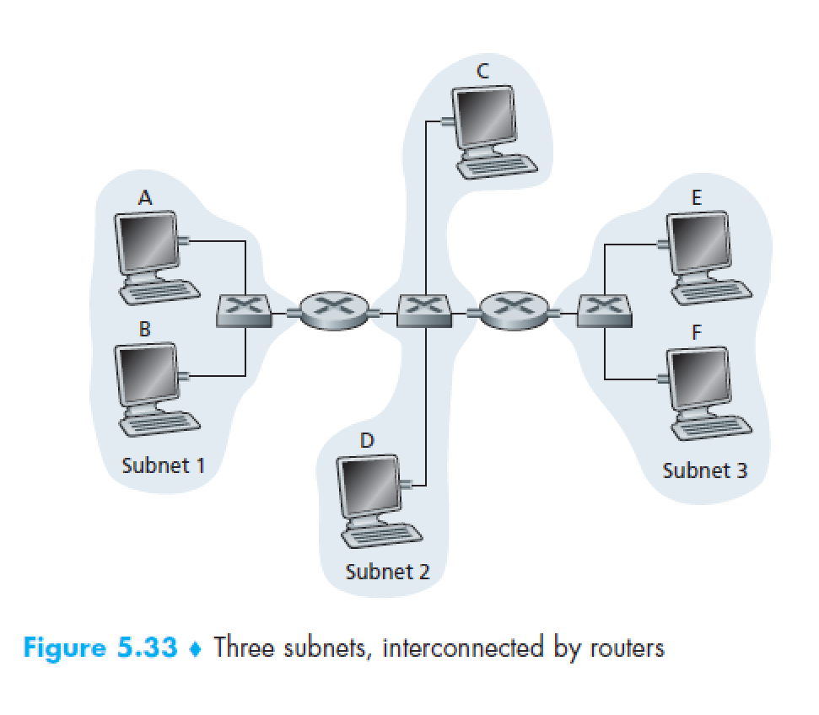

1. Describe the role of the beacon frames in 802.11.
2. True or false: Before an 802.11 station transmits a data frame, it must first send an RTS frame and receive a corresponding CTS frame.
3. Why are acknowledgments used in 802.11 but not in wired Ethernet?
4. True or false: Ethernet and 802.11 use the same frame structure.