Name : Dyly Tithsambath
Class : ITE-M-Year3

Homework 02

1. Review of Unix/Linux general purpose utility command :
man : display the user manual of any command that we can run on the terminal.
Who : displays a list of users who are currently logged into the computer.
Cat : allows us to create single or multiple files, view contain of file, concatenate files and redirect output in terminal or files.
Cd : used to change the current working directory in Linux.
cp : used to copy files or group of files or directory.
Ps : used to list the currently running processes.
Ls : used to list all file and directory in current working directory
mv : is a command line utility that moves files or directories from one place to another.
Rm : used to remove files or directories
mkdir : used to create directory
rmdir : used remove empty directories from the file system in Linux.
Echo : used to display line of text/string that are passed as an argument.
More : used to view the text files in the command prompt, displaying one screen at a time in case the file is large. (Ex : more +30 sample.txt)
date : used to display the system date and time.
Time : used to determine how long a given command takes to run.
Kill : used to terminate processes manually.
History : used to show you all of the last commands that have been recently used.
Chmod : used to change the access mode of a file and directory.
Chown : used to changing the owner of a given file or folder.
Pwd : used to current print working directory.
Cal : is a calendar command in Linux which is used to see the calendar of a specific month or a whole year.
Logout : to log out of the terminal.
Shutdown command : used to turn off a computer.
2. Login to the system and do the following :
a. Use the appropriate command to determine your login shell :
- To determine login shell use this command : $ echo $SHELL
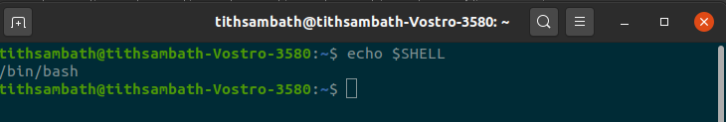

b. Use the /etc/passwd file to verify the result of previous step
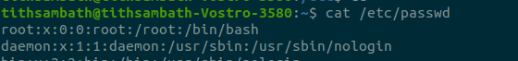
- To verify the result of previous step use this command : cat /etc/passwd

c. Use the who command and redirect the result to a file called your_name_mylab2a.
- To redirect the result to a file with who command use this ‘>’
e.g : who > Tithsambath_Dyly_mylab2a.txt
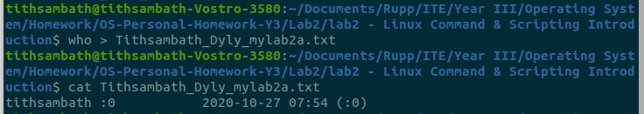

d. Use the date and who commands in sequence (in one line)
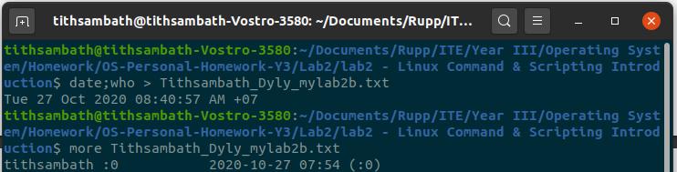

e. Write a sed command that deletes the first character in each line in a file
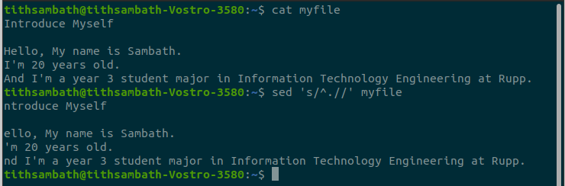
f. Write a sed command that deletes the character before the last character in each
line in a file

