SMART GRIEVANCE MANAGEMENT SYSTEM
Project Documentation

React + ASP.NET Core Web API + SQL Server + FastAPI

A centralized, AI-assisted platform for submitting, tracking, managing and analyzing public grievances.

Table of Contents
Use Word's References → Table of Contents → Update Table to generate the final page numbers automatically.
- Chapter 1: Introduction
- Chapter 2: Requirement Analysis
- Chapter 3: System Design
- Chapter 4: Database Design
- Chapter 5: Implementation (.NET)
- Chapter 6: Frontend (React)
- Chapter 7: AI Module
- Chapter 8: API Documentation
- Chapter 9: Testing
- Chapter 10: Deployment & Future Scope
- Appendix A: Screenshot Checklist
- Appendix B: Viva Preparation Notes

Abstract
The Smart Grievance Management System is a full-stack web application designed to provide a structured and transparent mechanism for citizens to submit grievances and for administrators to manage, prioritize and resolve them. The platform combines a React frontend, ASP.NET Core Web API backend, SQL Server database and a FastAPI-based artificial intelligence module.
The system supports secure authentication, grievance submission, automatic ticket generation, status tracking, administrative dashboards and AI-assisted classification. The AI module is designed to predict grievance categories and priorities and to identify similar complaints, helping reduce manual effort and duplicate handling. JWT-based authentication protects API resources, Entity Framework Core provides database access, and Swagger supports API exploration and testing.
This document presents the requirements, design, database structure, implementation, frontend workflow, AI module, APIs, testing approach, deployment strategy and future enhancements of the proposed system.

Chapter 1: Introduction

1.1 Project Overview
The Smart Grievance Management System provides a single digital platform through which users can register complaints, receive a unique ticket ID, track progress and view resolution updates. Administrators can review incoming grievances, assign or update their status, prioritize work and use AI recommendations to improve triage.

1.2 Problem Statement
Traditional grievance handling can involve fragmented communication, manual registers, delayed responses and limited visibility into complaint status. Duplicate complaints may also be difficult to identify, while administrators may spend significant time manually categorizing and prioritizing requests. The proposed system addresses these issues through centralized storage, workflow automation, role-based access and AI-assisted analysis.

1.3 Objectives
- Provide an easy-to-use grievance submission and tracking mechanism.
- Generate a unique ticket ID for every grievance.
- Allow administrators to view, filter, update and manage grievances.
- Use AI to predict grievance category and priority.
- Detect potentially similar or duplicate grievances.
- Provide secure authentication using JWT.
- Maintain grievance and user data in a structured SQL Server database.
- Expose documented APIs through ASP.NET Core and Swagger.
- Support containerized deployment using Docker.

1.4 Scope
The project covers citizen/user authentication, grievance creation, ticket generation, status tracking, administrative management, reporting, AI-based categorization and priority recommendation, similarity detection, REST API integration and database persistence. Future integrations may include email/SMS notifications, multilingual NLP, advanced analytics and integration with external government service portals.

1.5 Technology Stack
Layer | Technology
Frontend | React, JavaScript/TypeScript, CSS
Backend | ASP.NET Core Web API (.NET)
Database | Microsoft SQL Server
ORM | Entity Framework Core
Authentication | JWT (JSON Web Tokens)
API Documentation | Swagger / OpenAPI
AI Service | FastAPI, Python
Deployment | Docker / containerized services

Chapter 2: Requirement Analysis

2.1 Stakeholders / Users
User | Responsibilities
Citizen / User | Register/login, submit grievances, view ticket ID, track status and view updates.
Administrator | Authenticate, review grievances, change status, manage priorities/categories, view reports and use AI recommendations.
AI Service | Predict category/priority and identify similar grievance text.
System / Database | Persist users, grievances, statuses, predictions and related records.

2.2 Functional Requirements
- User registration and secure login.
- JWT token generation and protected API access.
- Grievance submission with relevant details.
- Automatic ticket ID generation.
- Grievance status tracking.
- Administrator dashboard for grievance management.
- Category and priority assignment.
- AI-assisted category prediction.
- AI-assisted priority prediction.
- Similarity/duplicate detection.
- Search, filtering and reporting.
- Swagger-based API documentation.

2.3 Non-Functional Requirements
- Security: authenticated and authorized access to protected resources.
- Performance: responsive API operations and efficient database queries.
- Usability: simple navigation and clear grievance status.
- Reliability: consistent persistence of grievance records.
- Scalability: modular services that can be independently scaled.
- Maintainability: separation of frontend, backend, database and AI service.
- Availability: deployment using containers for repeatable environments.

2.4 Feasibility Study
Feasibility | Assessment
Technical | Feasible using React, ASP.NET Core, SQL Server, FastAPI and Docker.
Economic | Uses widely available/open-source development frameworks; infrastructure cost depends on deployment environment.
Operational | Designed around familiar web workflows: login, submit, track and administer.
Schedule | Can be implemented incrementally by separating frontend, backend, database and AI modules.
Legal / Security | Requires appropriate handling of user information, authentication secrets and access permissions.

Chapter 3: System Design

3.1 Overall Architecture
The application follows a layered, service-oriented architecture. The React client communicates with the ASP.NET Core Web API. The API handles authentication, business logic and persistence through Entity Framework Core and SQL Server. For AI-assisted analysis, the backend communicates with a FastAPI service that exposes prediction endpoints.
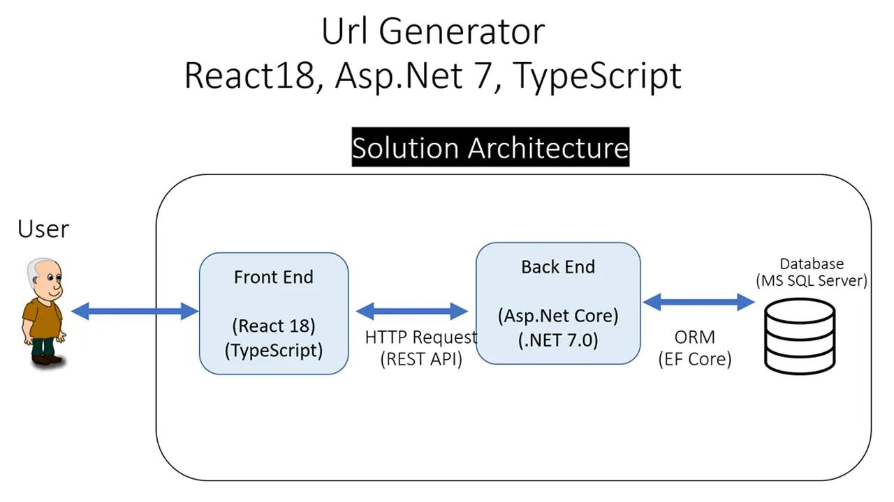

3.2 Use Case Diagram

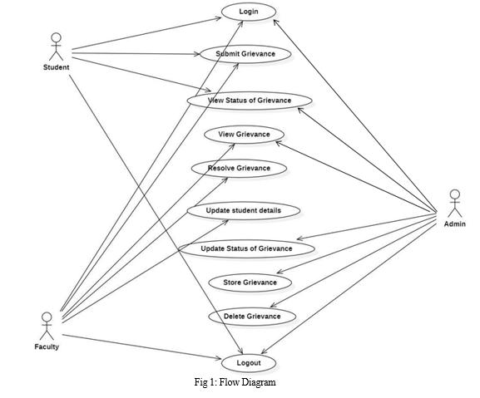

3.3 DFD Level 0
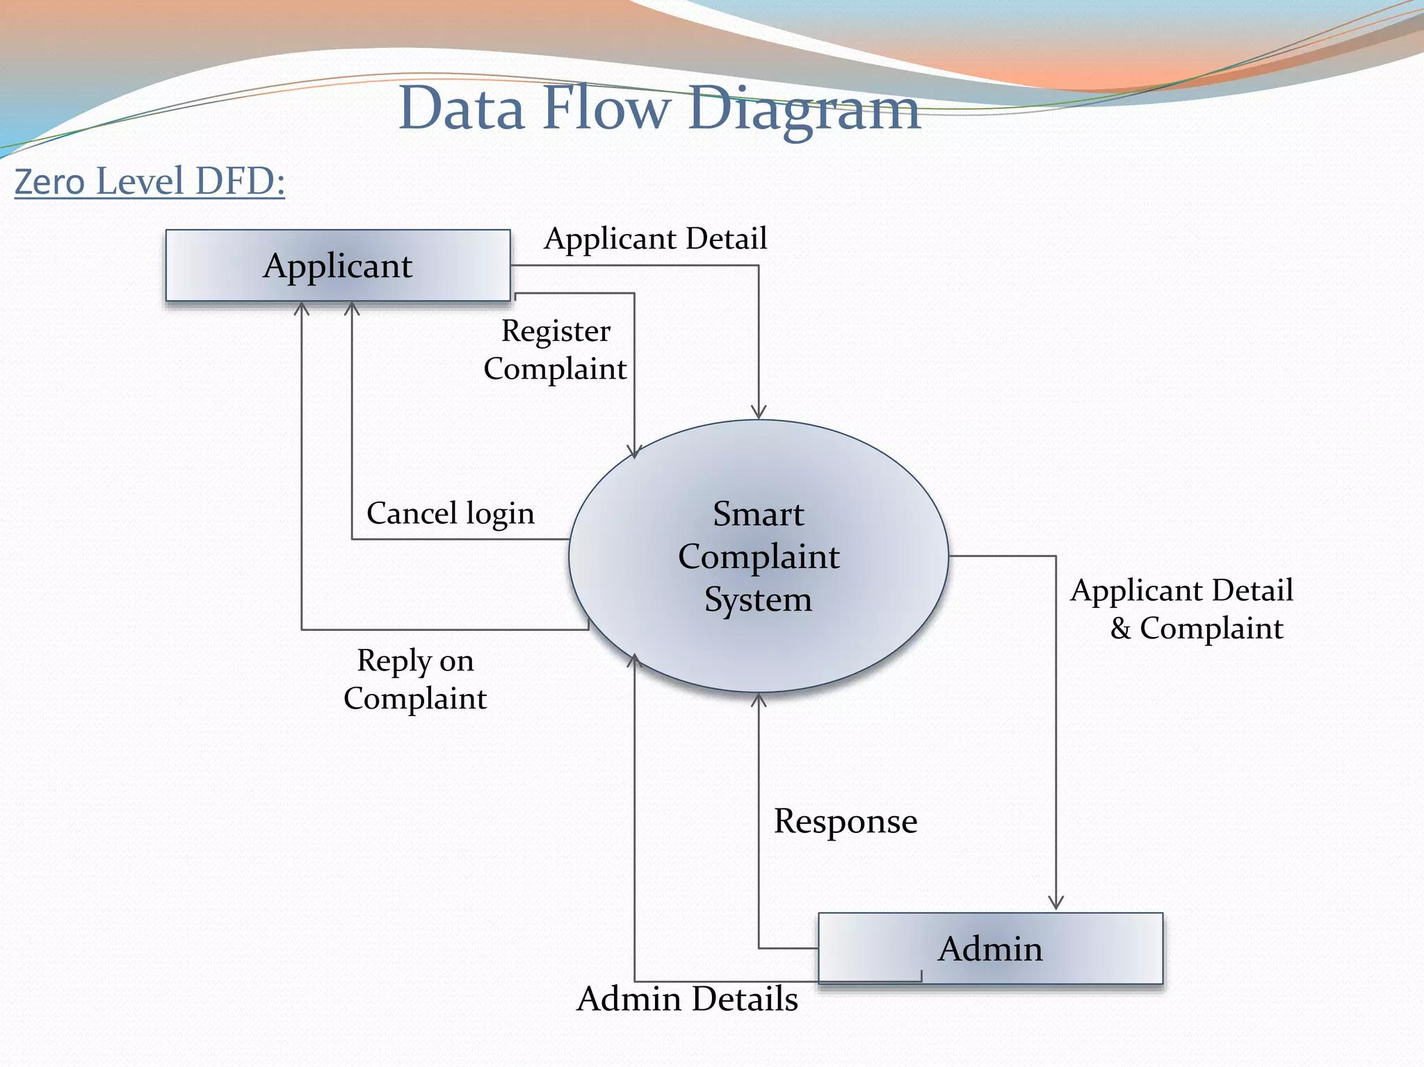

3.4 DFD Level 1
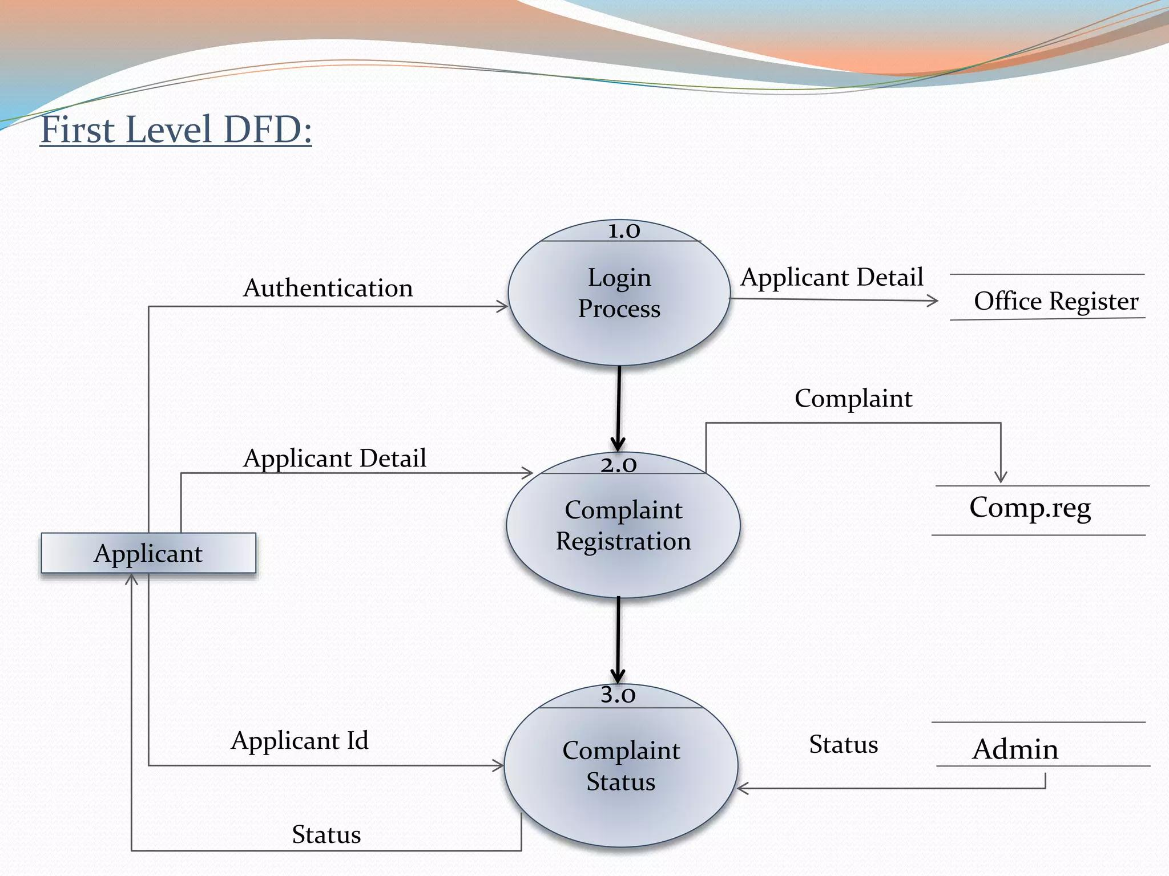

3.5 Activity Diagram

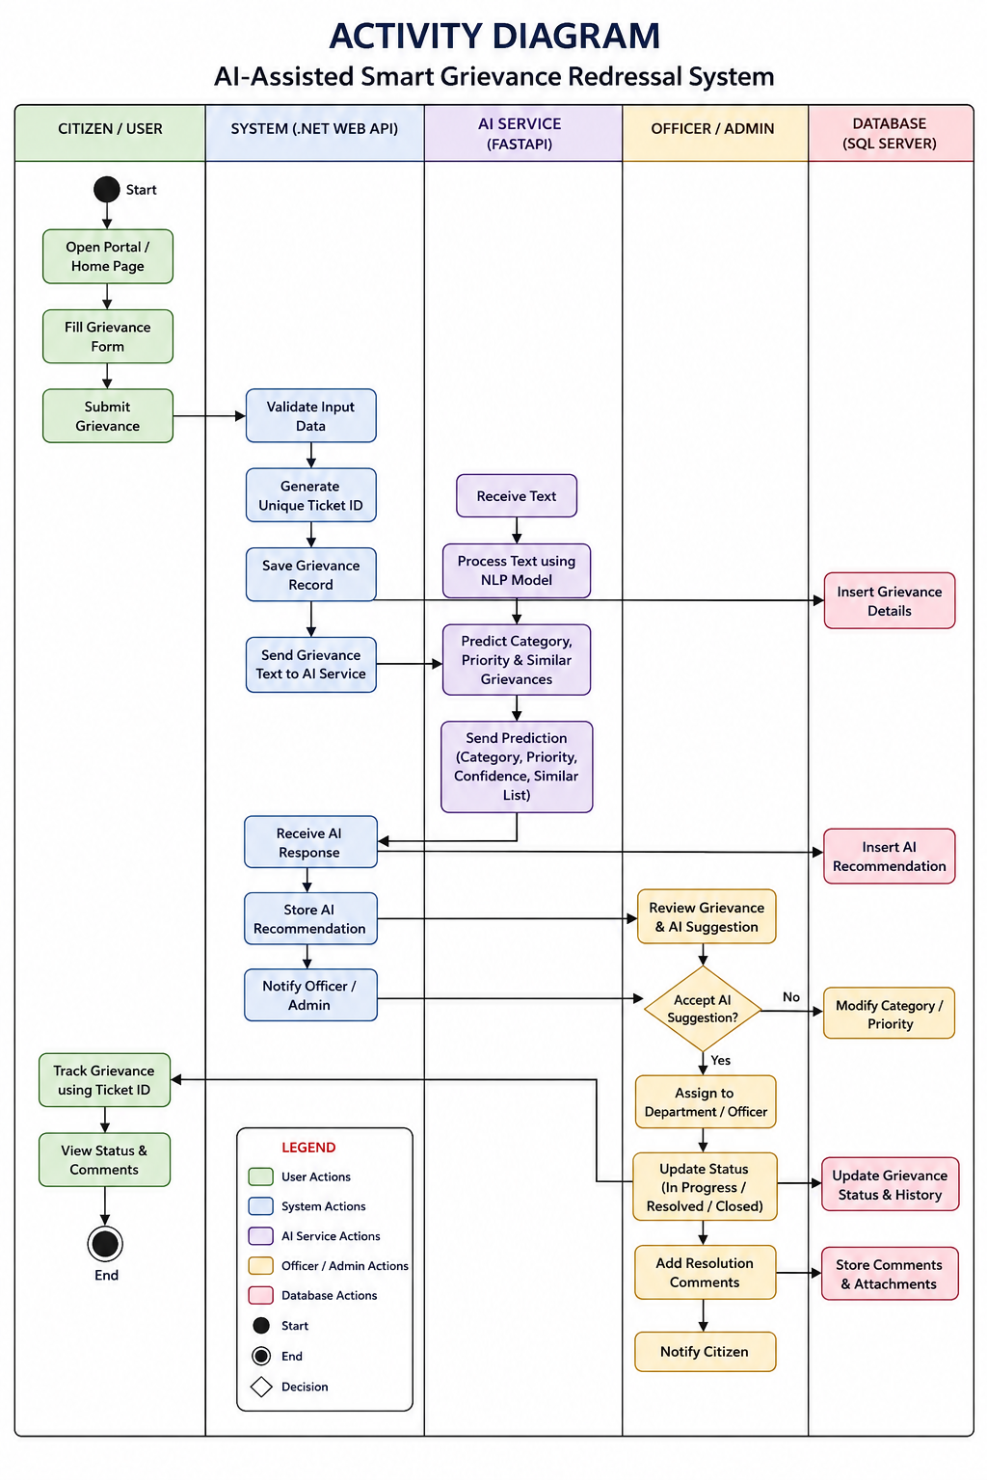

3.6 Sequence Diagram
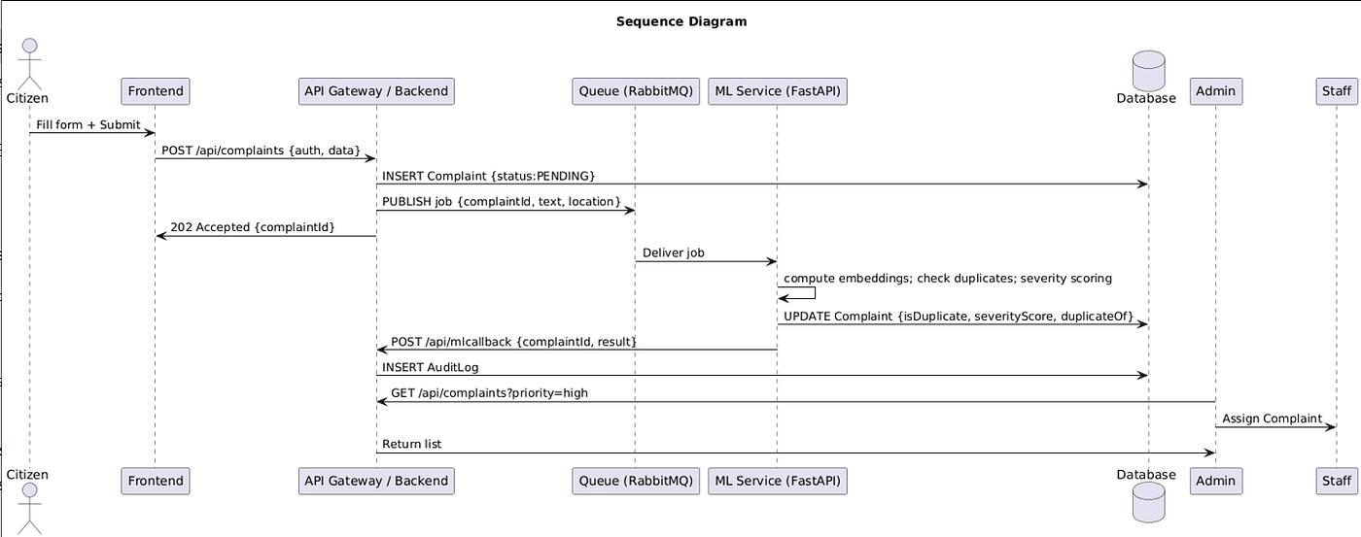

Chapter 4: Database Design

4.1 Database Overview
SQL Server is used as the relational database. Entity Framework Core maps application models to database tables and provides a consistent data-access layer. The database should preserve referential integrity between users, grievances, statuses, categories and AI analysis records.

4.2 ER Diagram

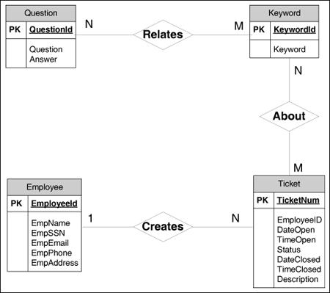

4.3 Proposed Schema
Table | Purpose | Key Fields
Users | Stores registered user/admin accounts. | UserId (PK), Name, Email, PasswordHash, Role
Grievances | Stores submitted complaints. | GrievanceId (PK), TicketId, UserId (FK), CategoryId (FK), Description, StatusId (FK), Priority, CreatedAt
Categories | Stores grievance categories. | CategoryId (PK), CategoryName
Statuses | Stores workflow statuses. | StatusId (PK), StatusName
AIAnalysis | Stores AI outputs for a grievance. | AnalysisId (PK), GrievanceId (FK), PredictedCategory, PredictedPriority, SimilarityScore, CreatedAt
Updates / History | Stores status or administrative updates. | UpdateId (PK), GrievanceId (FK), UpdatedBy, StatusId, Comment, UpdatedAt

4.4 Relationships
- One user can submit many grievances.
- Each grievance belongs to one submitting user.
- Each grievance can be associated with a category and status.
- A grievance can have multiple history/update records.
- A grievance can have one or more AI analysis records depending on implementation.
- Category and status records are reusable reference data.

Chapter 5: Implementation (.NET)

5.1 ASP.NET Core Web API
The backend is implemented as a RESTful ASP.NET Core Web API. Controllers receive HTTP requests, validate inputs, call application/data-access logic and return structured JSON responses. The API is designed to keep business responsibilities separate from the React presentation layer.

5.2 Controllers
- AuthController: registration and login.
- GrievanceController: create, retrieve, update and track grievances.
- AdminController: administrative operations and dashboard data.
- AIController or AI integration service: invokes the FastAPI service where required.
- ReportsController: reporting and summary endpoints, if implemented.

5.3 Models
Models represent database entities such as User, Grievance, Category, Status and AIAnalysis. Entity Framework Core uses these classes to map application objects to SQL Server tables.

5.4 DTOs
Data Transfer Objects prevent database entities from being exposed directly through the API. Request DTOs define accepted input, while response DTOs control the information returned to the client.

5.5 Entity Framework Core
Entity Framework Core provides database connectivity, object-relational mapping, migrations and LINQ-based queries. The DbContext coordinates entity sets and database operations.

5.6 JWT Authentication
After successful authentication, the server issues a signed JSON Web Token. The client sends the token in the Authorization header for protected requests. Backend authorization checks the token and, where applicable, the user's role before allowing administrative operations.

5.7 Swagger
Swagger/OpenAPI provides an interactive API specification. It helps developers inspect available endpoints, request parameters, response structures and authentication requirements.

Chapter 6: Frontend (React)

6.1 Pages
Page | Purpose
Login / Registration | Authenticate or create an account.
Home / Dashboard | Provide navigation and overview.
Grievance Submission | Collect grievance details and submit them.
Ticket Confirmation | Display the generated ticket ID.
Track Status | Search/view grievance progress using ticket information.
Admin Dashboard | List, filter and manage grievances.
AI Recommendation | Display category, priority and similarity recommendations.
Reports Dashboard | Display grievance statistics and trends.

6.2 Components
- Reusable navigation/header components.
- Form components for authentication and grievance submission.
- Cards/tables for grievance summaries.
- Status and priority badges.
- Protected route components.
- Admin dashboard widgets.
- Charts or report components where implemented.

6.3 Routing
React Router can be used to map URLs to pages and protect authenticated/admin-only routes. Authentication state can be maintained using a suitable state/context mechanism and the JWT can be attached to API requests through a centralized HTTP client.

6.4 UI Workflow
- User opens the application and logs in or registers.
- User completes the grievance form and submits it.
- Frontend sends the request to the ASP.NET Core API.
- API validates and stores the grievance and generates a ticket ID.
- AI service may return category, priority and similarity information.
- User receives the ticket ID and can later track its status.
- Admin reviews grievances from the dashboard and updates progress.

Chapter 7: AI Module

7.1 Overview
The AI module is implemented as a separate FastAPI service so that machine-learning/NLP functionality remains independent of the main .NET application. The service receives grievance text and returns structured prediction results.

7.2 Category Prediction
Category prediction classifies a grievance into an appropriate domain such as sanitation, roads, water supply, electricity, public safety or another project-defined category. The exact categories should match the trained dataset and application configuration.

7.3 Priority Prediction
Priority prediction estimates the urgency of a grievance. The prediction can be based on textual indicators, category, severity-related terms and other features available to the model. The application may map predictions to labels such as Low, Medium, High or Critical.

7.4 Similarity Detection
Similarity detection compares a new grievance against existing grievances to identify potentially duplicate or related complaints. A similarity score can be returned so that administrators can review possible matches rather than automatically merging records without confirmation.

7.5 FastAPI Integration
FastAPI exposes lightweight HTTP endpoints for inference. The ASP.NET Core backend can call the AI service, receive JSON results and store or display them. This separation allows the AI model to be updated without restructuring the React application.

7.6 AI Processing Flow
- Receive grievance text from the backend.
- Validate and preprocess the text.
- Generate category prediction.
- Generate priority prediction.
- Compare the grievance with existing/reference representations for similarity.
- Return structured JSON containing predictions and scores.
- Backend stores or presents the recommendation to the administrator.

Chapter 8: API Documentation

8.1 Authentication Endpoints
Method | Endpoint | Purpose
POST | /api/auth/register | Create a user account.
POST | /api/auth/login | Authenticate a user and return JWT.
GET | /api/auth/me | Return authenticated user information, if implemented.

8.2 Grievance Endpoints
Method | Endpoint | Purpose
POST | /api/grievances | Submit a new grievance.
GET | /api/grievances/{id} | Retrieve a grievance by ID.
GET | /api/grievances/ticket/{ticketId} | Track a grievance using ticket ID.
PUT | /api/grievances/{id} | Update grievance information/status where authorized.
GET | /api/grievances | List grievances, subject to authorization and filters.

8.3 AI Endpoints
Method | Endpoint | Purpose
POST | /predict/category | Predict grievance category.
POST | /predict/priority | Predict grievance priority.
POST | /predict/similarity | Return similarity/duplicate analysis.

8.4 Example Request
Example grievance submission payload:
{
"description": "Street light is not working near the main gate.",
"location": "Main Gate",
"category": "Electricity"
}

8.5 Example Response
{
"success": true,
"ticketId": "GRV-2026-0001",
"status": "Submitted"
}

8.6 AI Response Example
{
"predictedCategory": "Electricity",
"predictedPriority": "High",
"similarityScore": 0.87
}

Note: Endpoint names and JSON fields above are a documentation template. Replace them with the exact routes and DTO properties implemented in the final project.

Chapter 9: Testing

9.1 Testing Strategy
Testing should cover individual components, API integration, authentication/authorization, database operations, frontend workflows and AI-service integration. Both valid and invalid inputs should be tested.

9.2 Test Cases
ID | Test Case | Input / Action | Expected Result
TC-01 | Valid login | Correct email and password | JWT returned; user enters dashboard.
TC-02 | Invalid login | Wrong password | Authentication fails with appropriate error.
TC-03 | Submit grievance | Valid grievance details | Grievance saved and ticket ID generated.
TC-04 | Invalid grievance | Required field missing | Validation error returned; record not created.
TC-05 | Track ticket | Valid ticket ID | Current grievance status displayed.
TC-06 | Invalid ticket | Unknown ticket ID | Not-found response/message displayed.
TC-07 | Admin update | Authorized admin changes status | Status and history updated.
TC-08 | Unauthorized admin access | Normal user calls admin endpoint | Request denied.
TC-09 | AI category | Valid grievance text | Category prediction returned.
TC-10 | AI priority | Valid grievance text | Priority prediction returned.
TC-11 | Similarity | Grievance similar to existing text | Similarity result/score returned.
TC-12 | Swagger | Open API documentation | Endpoints and schemas visible.
TC-13 | Database | Create/read/update grievance | Data persists correctly.
TC-14 | UI navigation | Open protected page without login | User redirected/denied as configured.

Chapter 10: Deployment & Future Scope

10.1 Docker Deployment
Docker can package the frontend, ASP.NET Core API and FastAPI service into reproducible containers. SQL Server may run as a container for development or be hosted as a managed/database server in production. Environment variables should be used for connection strings, JWT secrets and service URLs rather than hard-coding credentials.

10.2 Suggested Deployment Architecture
- React frontend container serves the client application.
- ASP.NET Core container exposes the main REST API.
- FastAPI container exposes AI inference endpoints.
- SQL Server stores persistent application data.
- Reverse proxy/API gateway can route external traffic and provide HTTPS.
- Persistent volumes/backups should be configured for database data.

10.3 Security Considerations
- Hash passwords using a secure password hashing mechanism.
- Store JWT signing secrets securely.
- Validate and sanitize incoming data.
- Apply role-based authorization to administrator endpoints.
- Use HTTPS in production.
- Protect database credentials and AI service configuration.
- Log security-relevant events without exposing sensitive user information.

10.4 Future Scope
- Email/SMS/push notifications for status changes.
- Multilingual grievance submission and NLP.
- More advanced duplicate detection using semantic embeddings.
- Geographical heat maps of grievance concentration.
- Predictive analytics for recurring civic issues.
- Automatic assignment of grievances to departments.
- Citizen feedback and satisfaction scoring after resolution.
- Cloud-native deployment with monitoring and autoscaling.
- Model monitoring, retraining and explainability dashboards.

10.5 Conclusion
The Smart Grievance Management System combines a modern web frontend, secure .NET backend, relational database and independent AI service to create a practical platform for grievance handling. By centralizing complaint records, providing ticket-based tracking and supporting AI-assisted categorization, prioritization and similarity detection, the system can reduce manual effort and improve transparency. The modular architecture also provides a foundation for future enhancements such as notifications, multilingual support, analytics and scalable cloud deployment.

