E-COMMERCE CUSTOMER BEHAVIOUR ANALYSIS AND CUSTOMER SEGMENTATION
Author: Tithi Mandal
Research-oriented analytics report generated from the supplied customer-level dataset.

1. Executive Summary
This project analyzes 150 customer records to understand demographics, purchasing behaviour, recency, RFM value, and machine-learning segments. The source contains 16 fields and no missing or duplicate records. Standardized Age, PurchaseAmount, Frequency, and Recency features were evaluated with K-Means for K=2 through 8; K=4 was selected because it achieved the highest silhouette score (0.446) while remaining interpretable. The highest-spending cluster is High-Value Loyal Customers, and Clothing is the most represented category. These are descriptive findings, not causal claims.

2. Introduction
Customer analytics helps an e-commerce business prioritize retention, loyalty, and category decisions. This study uses a compact customer-level dataset to demonstrate a reproducible path from validation and exploration to RFM scoring and unsupervised segmentation.

3. Problem Statement
Customers differ in how recently and frequently they engage and how much they spend. Without a structured view of these differences, marketing resources may be applied uniformly. The project addresses this by profiling behaviour and grouping customers with similar standardized behavioural patterns.

4. Objectives
- Validate and clean the supplied customer data.
- Measure demographic, category, purchase, and recency KPIs.
- Explore relationships without confusing correlation with causation.
- Construct transparent quantile-based RFM scores.
- Evaluate K-Means cluster counts with inertia and silhouette diagnostics.
- Translate cluster profiles into cautious, actionable business recommendations.

5. Dataset Description
The analytical dataset has 150 rows and 16 columns. Age ranges from 20 to 55, PurchaseAmount from 900 to 7,300, Frequency from 2 to 18, and Recency from 2 to 84.
Feature | Description | Type
CustomerID | Unique customer identifier | Categorical
Age | Customer age | Numerical
Gender | Customer gender | Categorical
PurchaseAmount | Customer spending amount | Numerical
Frequency | Purchase frequency | Numerical
Recency | Days/units since activity as supplied | Numerical
Category | Product category | Categorical

6. Data Preprocessing
The CSV was parsed with pandas, required columns were checked, numeric behaviour fields were coerced to numeric, and complete duplicate rows and duplicate CustomerIDs were removed if present. In the supplied file, missing-value counts and duplicate counts were both zero. Observed values were non-negative and within plausible ranges. CustomerID was excluded from modelling; categorical fields were used for profiles rather than K-Means features. StandardScaler was applied to the four numerical behaviour features so that purchase amount did not dominate the distance calculation.

7. Exploratory Data Analysis
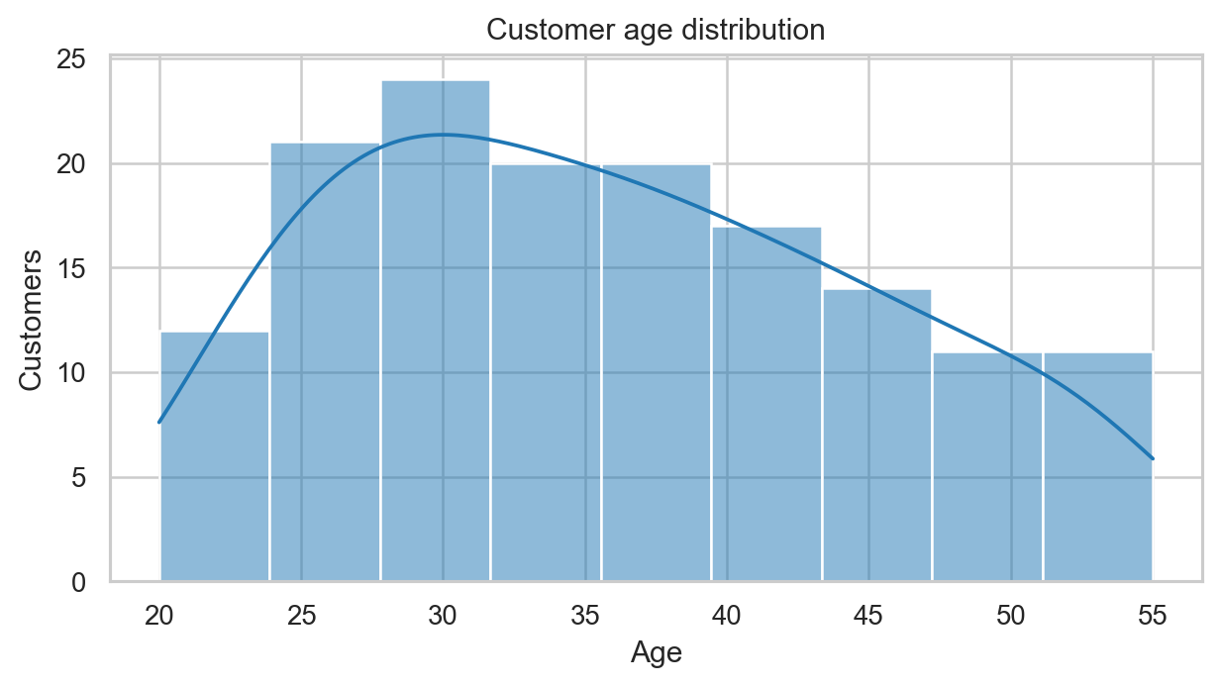
Figure 1. Customer age distribution
Interpretation: The histogram describes the spread of the 150 supplied ages.
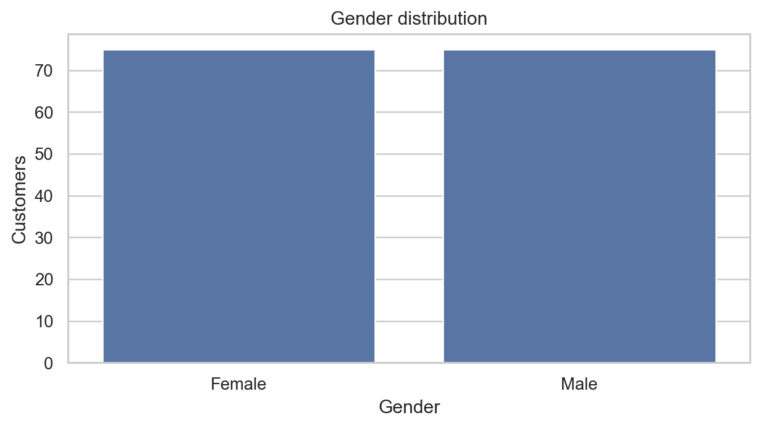
Figure 2. Gender distribution
Interpretation: The bar chart compares the two observed gender groups.
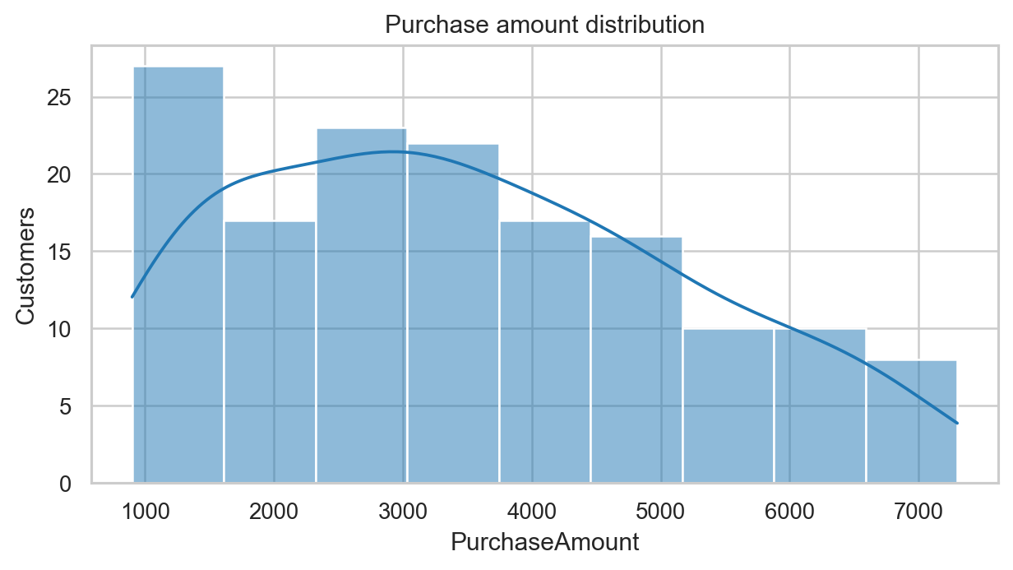
Figure 3. Purchase amount distribution
Interpretation: Spending varies across the customer base and is not treated as a causal outcome.
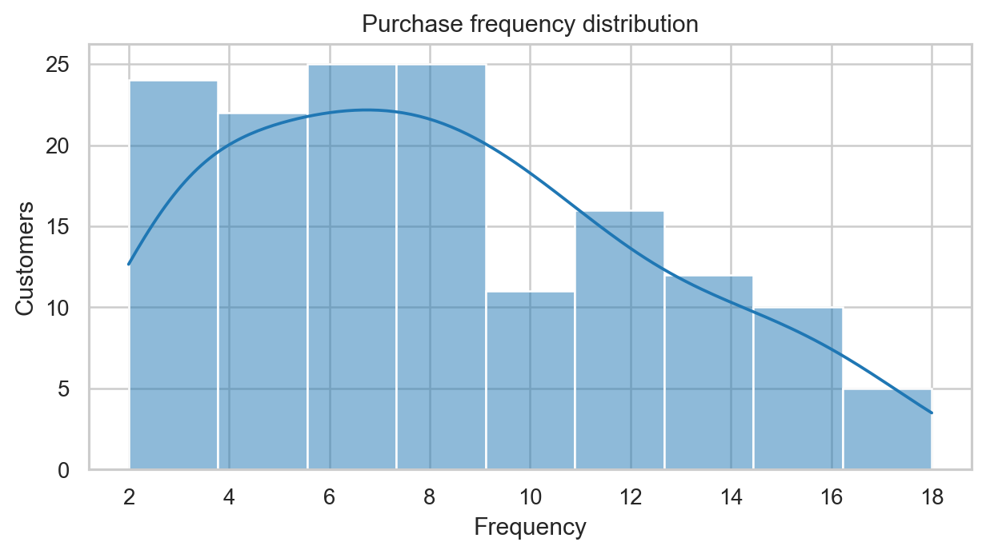
Figure 4. Purchase frequency distribution
Interpretation: Frequency is a supplied customer-level measure.
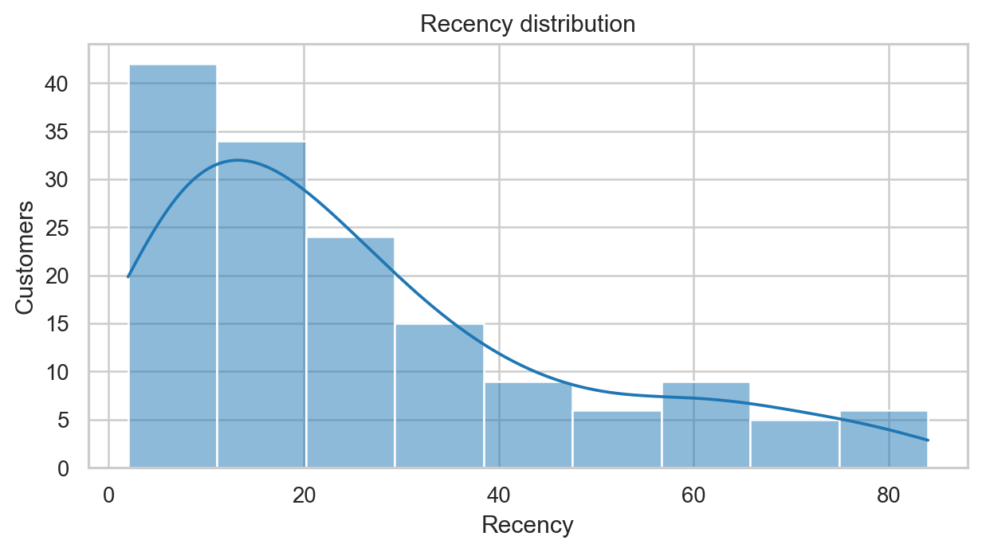
Figure 5. Recency distribution
Interpretation: Higher recency values indicate older activity under the dataset definition.
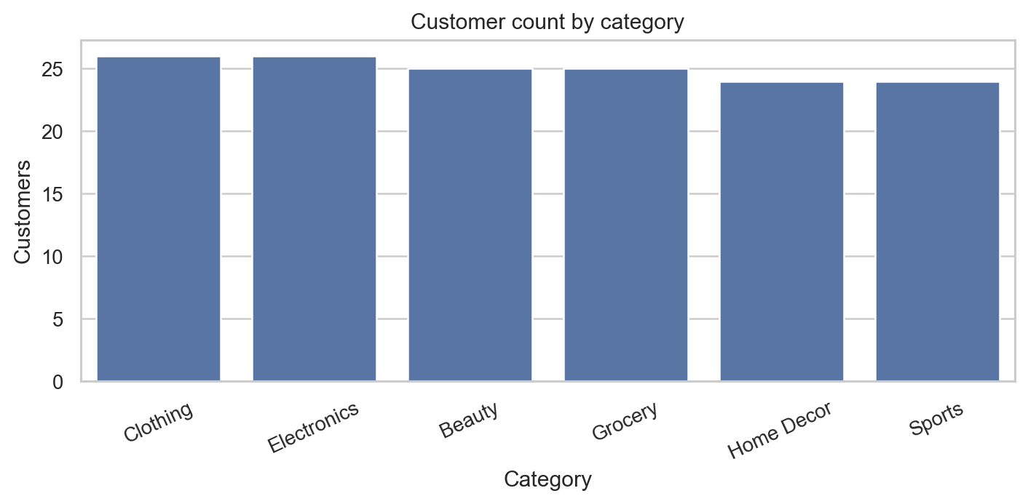
Figure 6. Category distribution
Interpretation: Clothing has the highest customer count in this dataset.
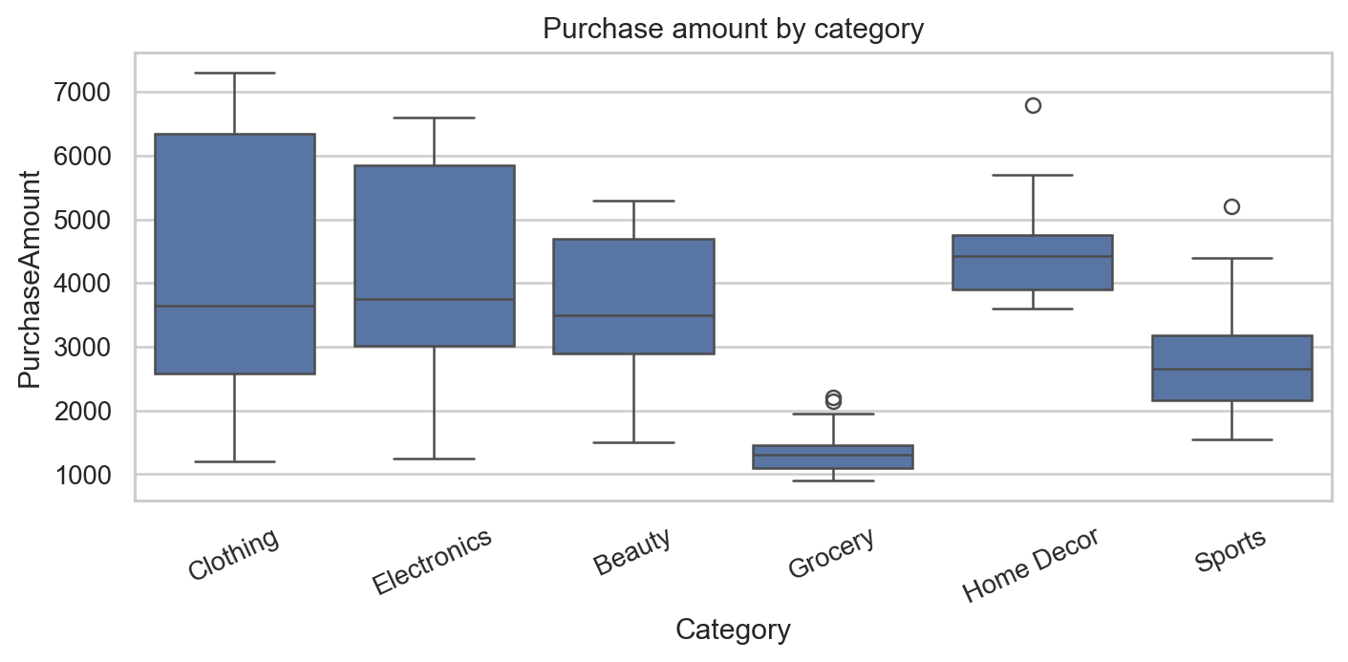
Figure 7. Purchase amount by category
Interpretation: The box plots compare spending distributions by category.
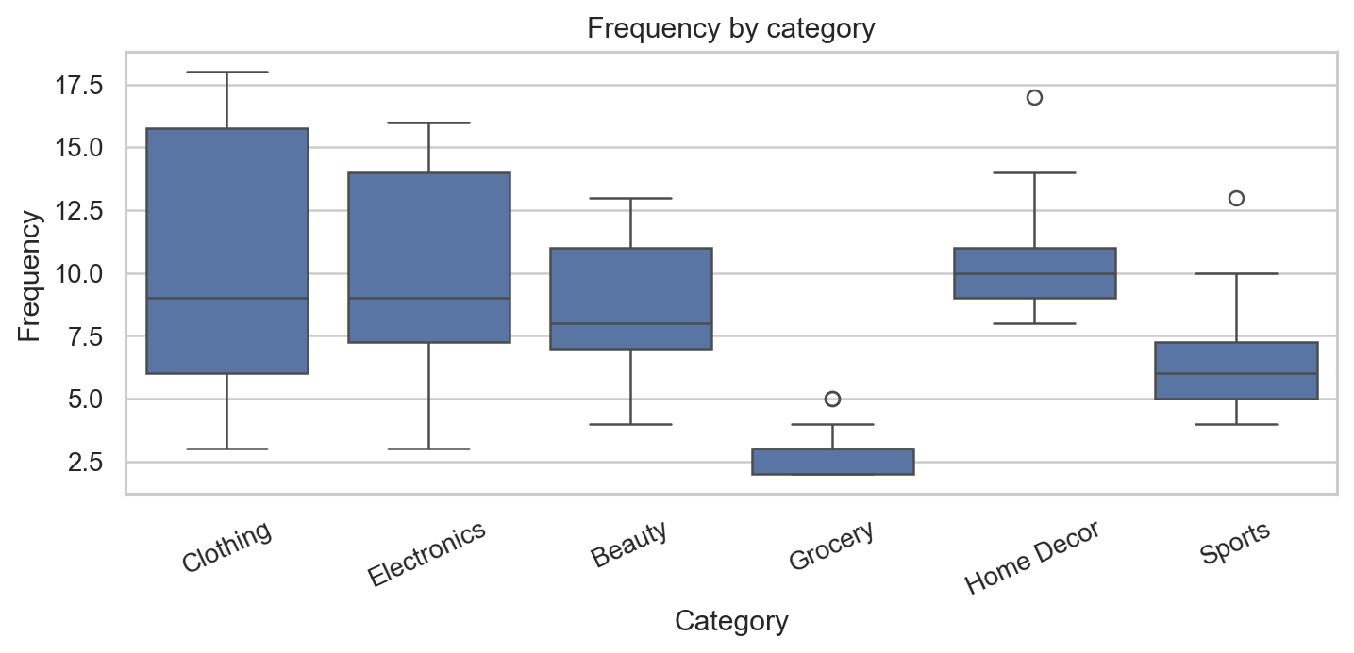
Figure 8. Frequency by category
Interpretation: Category-level frequency differences are descriptive.
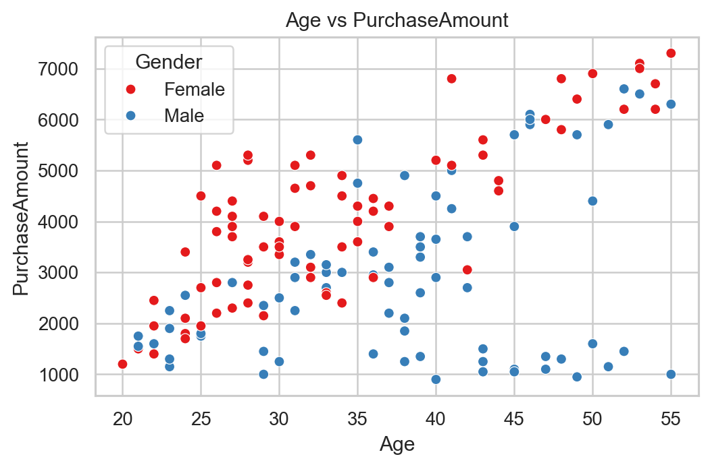
Figure 9. Age versus purchase amount
Interpretation: The scatter plot shows association only; it does not establish that age causes spending.
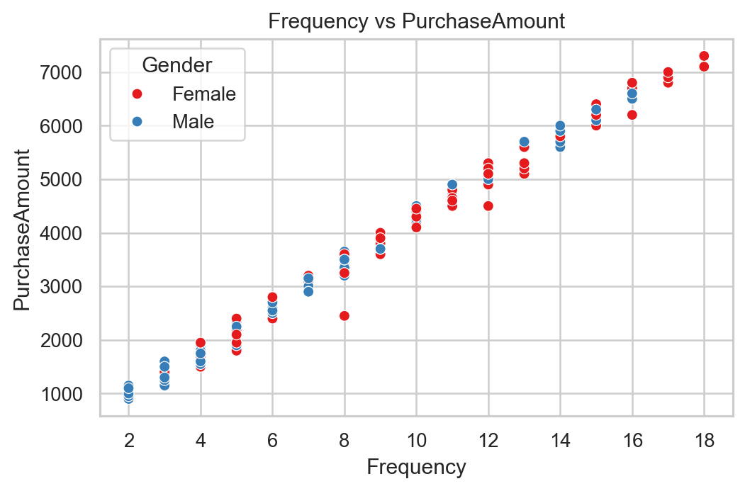
Figure 10. Frequency versus purchase amount
Interpretation: The plot helps inspect whether high-frequency customers also spend more.
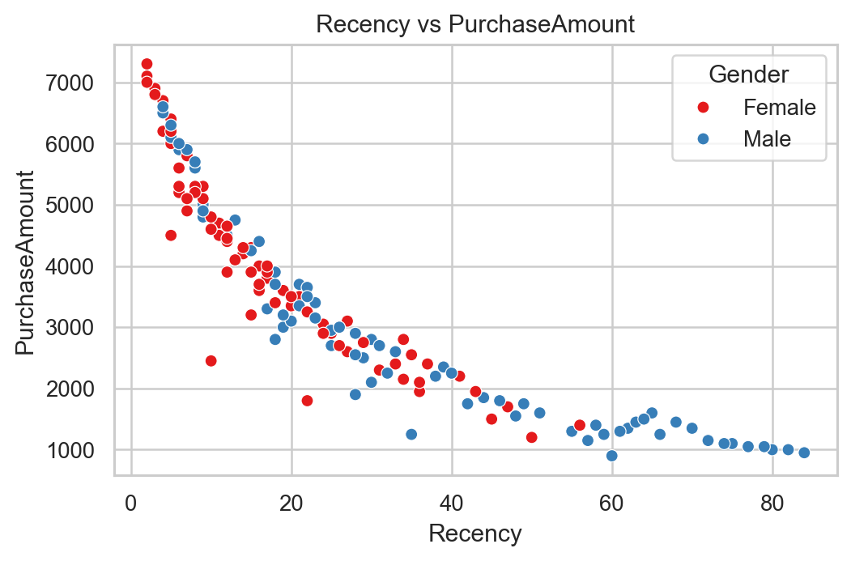
Figure 11. Recency versus purchase amount
Interpretation: The relationship between older activity and spending can be visually inspected.
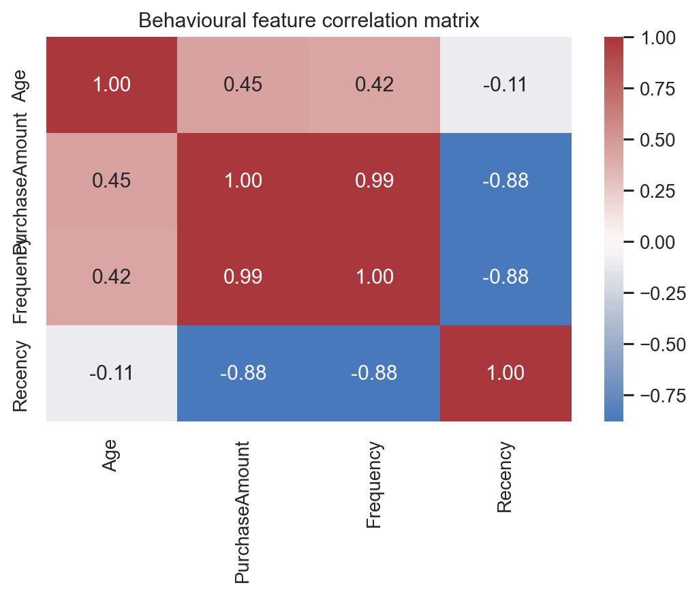
Figure 12. Correlation heatmap
Interpretation: Correlation summarizes linear association and should not be read as causation.

8. KPI Analysis
KPI | Value
Total customers | 150
Total purchase amount | 523,150
Average age | 35.98
Average purchase amount | 3,487.67
Maximum purchase amount | 7,300
Minimum purchase amount | 900
Average frequency | 8.23
Maximum frequency | 18
Average recency | 26.56
Most recent activity | 2
Male customers | 75
Female customers | 75
Most popular category | Clothing
High-value customer count | 38

9. RFM Analysis
R is Recency, F is Frequency, and M is PurchaseAmount as the available monetary proxy. Each variable was ranked into five equal-sized quantile groups. Recency was reversed for scoring, because lower recency indicates more recent activity. The combined score is the sum of the three component scores. Labels are rule-based summaries of these data-derived scores and are not churn predictions.
RFMSegment | Customers | AvgRecency | AvgFrequency | AvgPurchase
At-Risk Customers | 60 | 47.50 | 4.22 | 1866.67
High-Value Customers | 33 | 5.58 | 14.42 | 5942.42
Low-Engagement Customers | 27 | 20.70 | 7.56 | 3229.63
Loyal Customers | 25 | 12.84 | 10.28 | 4408.00
Potential Loyal Customers | 5 | 14.00 | 8.80 | 3530.00

10. Customer Segmentation Methodology
K-Means assigns each standardized observation to the nearest centroid and minimizes the within-cluster sum of squared distances: J = sum over clusters and observations of ||x_i - mu_k||^2. Standardization is necessary because the behavioural features have different units and scales. K-Means was fitted with random_state=42 and n_init=20.

11. Elbow Method and Silhouette Analysis
Inertia decreases as K grows, so the elbow is considered alongside separation quality. The silhouette score compares within-cluster cohesion with nearest-cluster separation; higher values are preferred. K was selected by the maximum silhouette score across K=2..8, then checked for profile interpretability.
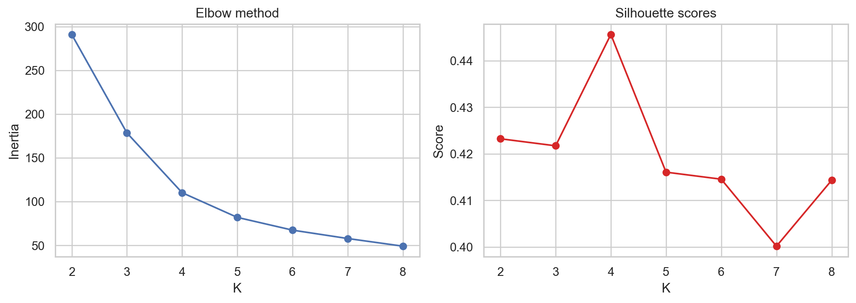
Figure 13. Elbow and silhouette diagnostics
Interpretation: K=4 produced the highest silhouette score among the evaluated candidates.

12. Customer Segmentation Results
Cluster ID | Avg Age | Avg Purchase | Avg Frequency | Avg Recency | Customers | Dominant Gender | Dominant Category | Segment Name
0 | 44.44 | 1208.33 | 2.50 | 69.44 | 18 | Male | Grocery | At-Risk Customers
1 | 47.38 | 5903.12 | 14.22 | 6.25 | 32 | Female | Clothing | High-Value Loyal Customers
2 | 33.09 | 3757.81 | 8.86 | 17.38 | 64 | Female | Home Decor | Regular Customers
3 | 26.75 | 2000.00 | 4.64 | 39.50 | 36 | Female | Sports | Regular Customers
Names are assigned from observed relative profiles: high purchase and at least median frequency produces High-Value Loyal Customers; high recency produces At-Risk Customers; high frequency produces Frequent Customers; remaining profiles are Regular Customers. Where a segment name is reused, it reflects the same rule and should be read with the numeric profile.
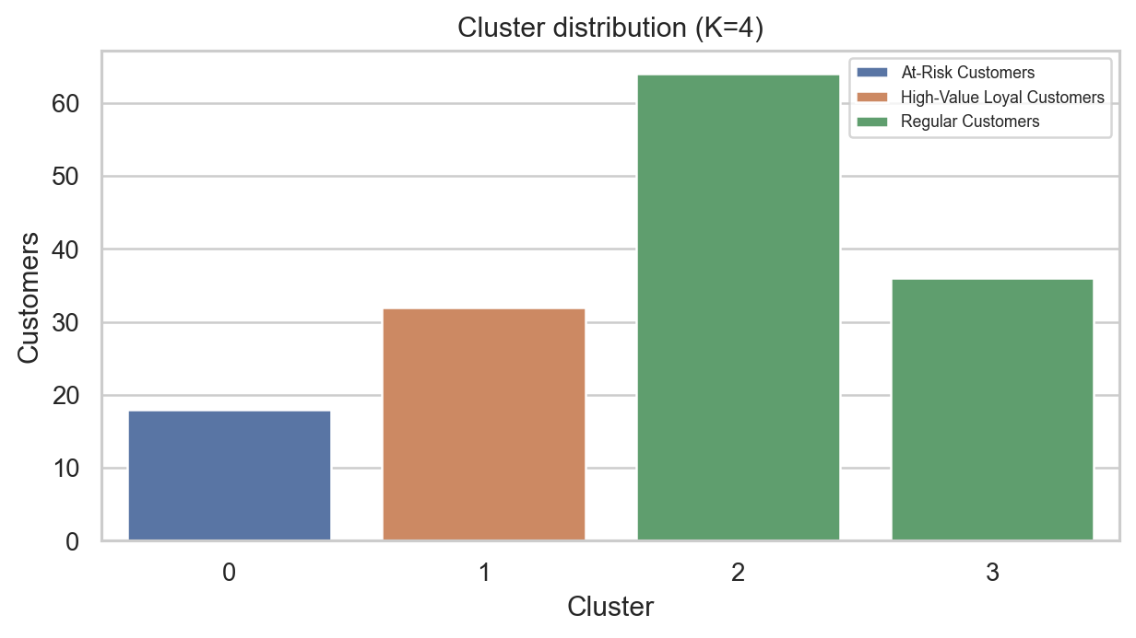
Figure 14. Cluster distribution
Interpretation: Cluster colours show relative group membership; PCA is a two-dimensional projection and does not preserve every original dimension.
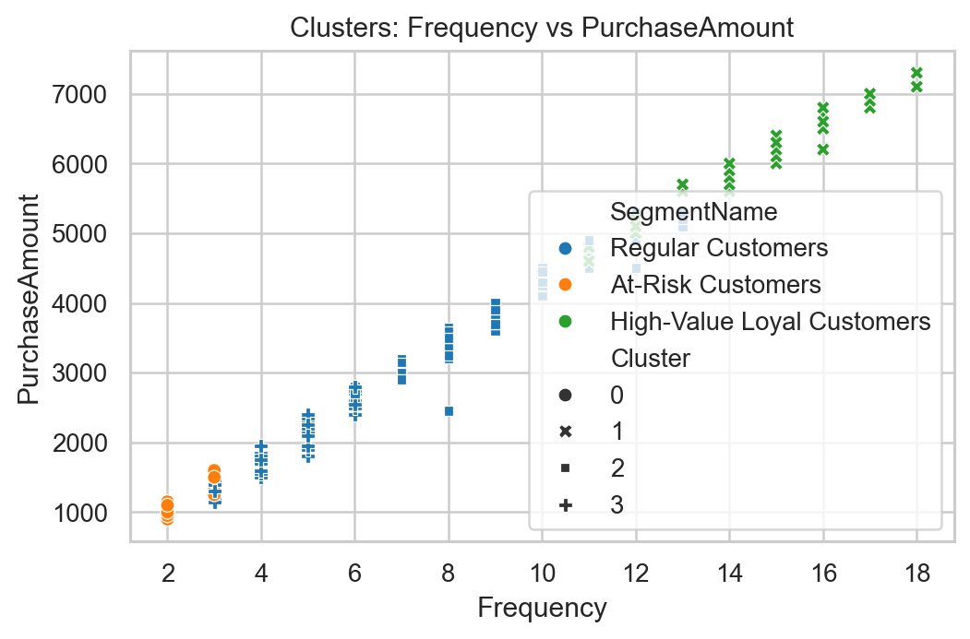
Figure 15. Cluster frequency and purchase amount
Interpretation: Cluster colours show relative group membership; PCA is a two-dimensional projection and does not preserve every original dimension.
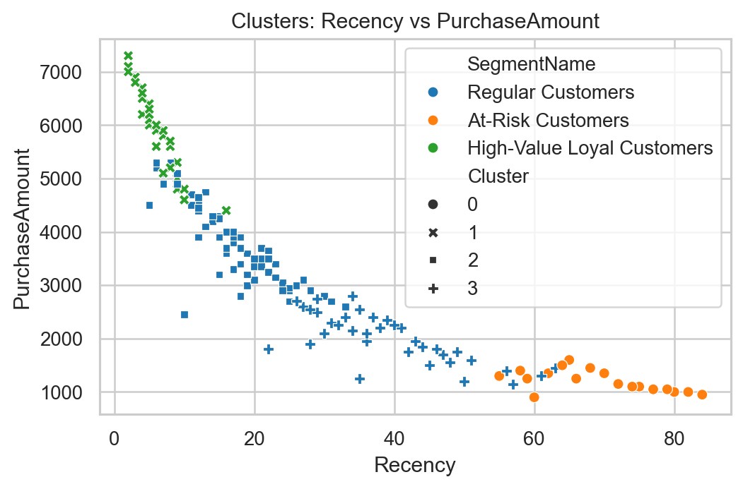
Figure 16. Cluster recency and purchase amount
Interpretation: Cluster colours show relative group membership; PCA is a two-dimensional projection and does not preserve every original dimension.
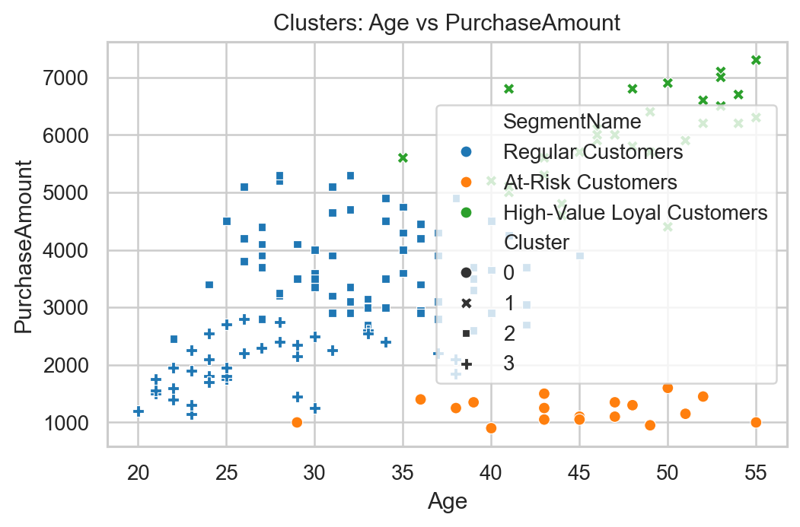
Figure 17. Cluster age and purchase amount
Interpretation: Cluster colours show relative group membership; PCA is a two-dimensional projection and does not preserve every original dimension.
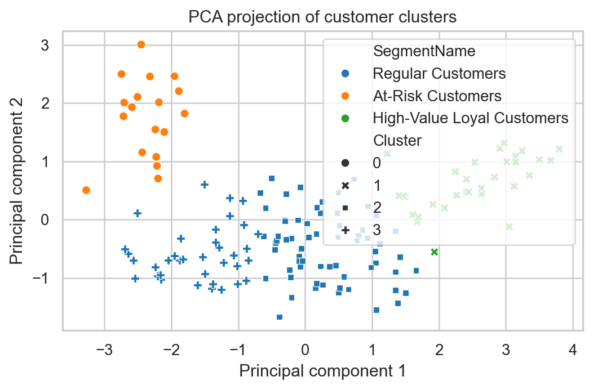
Figure 18. PCA cluster projection
Interpretation: Cluster colours show relative group membership; PCA is a two-dimensional projection and does not preserve every original dimension.
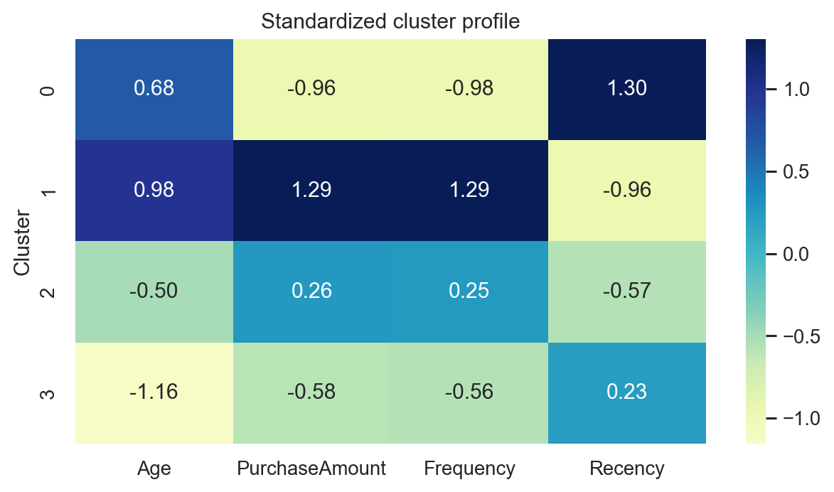
Figure 19. Standardized cluster profile
Interpretation: Cluster colours show relative group membership; PCA is a two-dimensional projection and does not preserve every original dimension.

13. Statistical Analysis
Research question | Method | Statistic | p-value | Interpretation
Purchase differs by gender | Welch t-test | -4.326 | 0.0000 | Reject H0
Purchase associated with frequency | Spearman correlation | 0.995 | 0.0000 | Significant at 0.05
Recency associated with spending | Spearman correlation | -0.974 | 0.0000 | Significant at 0.05
Spending differs by category | One-way ANOVA | 21.666 | 0.0000 | Significant at 0.05
For each test, H0 states that there is no group difference or association, while H1 states that a difference or association exists. A 0.05 threshold is used. Statistical significance is not evidence of causation.

14. Business Insights and Recommendations
- Prioritize High-Value Loyal Customers with retention rewards because this group has the highest average purchase amount (5,903).
- Use frequency-led loyalty campaigns for High-Value Loyal Customers, which has the highest average frequency (14.2).
- Develop category-specific merchandising for Clothing, the most represented category with 26 customers.
- Create a re-engagement audience from customers at or above the 75th percentile of recency (36); this is a behavioural flag, not a confirmed churn label.
- Use PCA and cluster charts for communication, but make campaign decisions from the original feature profiles rather than the two-dimensional projection.

15. Streamlit Dashboard
The app.py dashboard supports file upload and local fallback, executive KPIs, demographic and behaviour filters, RFM inspection, cluster diagnostics and profiles, customer-level exploration, business insights, and CSV downloads. Input validation gives users a helpful error for missing columns, malformed files, or invalid numeric values.

16. Limitations
This is a small customer-level dataset with no transaction timestamps, transaction lines, product attributes, explicit churn label, or customer lifetime value. Recency is a supplied numeric measure rather than a date-derived metric. K-Means results depend on the selected features, scaling, and this sample. Statistical tests are observational and should be confirmed with larger data.

17. Future Scope
Future work could add transaction-level CLV, churn prediction, recommendation systems, time-series purchase analysis, real-time segmentation, larger datasets, and personalized campaign automation.

18. Conclusion
The project turns the supplied 150-record dataset into a reproducible customer intelligence workflow. It combines transparent data checks, descriptive EDA, quantile-based RFM scoring, and silhouette-evaluated K-Means segmentation. The resulting profiles support differentiated retention, loyalty, category, and re-engagement strategies while respecting the dataset's limits and avoiding unsupported causal claims.

