**MODELS.py CODE**

import sqlite3

def init_db():

    conn = sqlite3.connect('database.db')

    cursor = conn.cursor()

    # Create the tables

    cursor.execute('''

    CREATE TABLE IF NOT EXISTS flavors (

        id INTEGER PRIMARY KEY,

        name TEXT NOT NULL,

        is_seasonal BOOLEAN NOT NULL

    )''')

    cursor.execute('''

    CREATE TABLE IF NOT EXISTS inventory (

        id INTEGER PRIMARY KEY,

        ingredient TEXT NOT NULL,

        quantity INTEGER NOT NULL

    )''')

    cursor.execute('''

    CREATE TABLE IF NOT EXISTS allergens (

        id INTEGER PRIMARY KEY,

        name TEXT NOT NULL

    )''')

    cursor.execute('''

    CREATE TABLE IF NOT EXISTS cart (

        id INTEGER PRIMARY KEY,

        flavor_id INTEGER NOT NULL,

        quantity INTEGER NOT NULL,

        FOREIGN KEY(flavor_id) REFERENCES flavors(id)

    )''')

    conn.commit()

    conn.close()

if __name__ == "__main__":

    init_db()

**app.py code**

from flask import Flask, request, jsonify

import sqlite3

app = Flask(__name__)

def connect_db():

    return sqlite3.connect('database.db')

@app.route('/flavors', methods=['GET', 'POST'])

def manage_flavors():

    conn = connect_db()

    cursor = conn.cursor()

    if request.method == 'POST':

        data = request.get_json()

        name = data.get('name')

        is_seasonal = data.get('is_seasonal', False)

        cursor.execute("INSERT INTO flavors (name, is_seasonal) VALUES (?, ?)", (name, is_seasonal))

        conn.commit()

        return jsonify({"message": "Flavor added successfully"}), 201

    elif request.method == 'GET':

        cursor.execute("SELECT * FROM flavors")

        flavors = cursor.fetchall()

        return jsonify(flavors)

@app.route('/cart', methods=['POST'])

def add_to_cart():

    conn = connect_db()

    cursor = conn.cursor()

    data = request.get_json()

    flavor_id = data.get('flavor_id')

    quantity = data.get('quantity')

    cursor.execute("INSERT INTO cart (flavor_id, quantity) VALUES (?, ?)", (flavor_id, quantity))

    conn.commit()

    return jsonify({"message": "Item added to cart"}), 201

@app.route('/allergens', methods=['POST'])

def add_allergen():

    conn = connect_db()

    cursor = conn.cursor()

    data = request.get_json()

    name = data.get('name')

    cursor.execute("INSERT INTO allergens (name) VALUES (?)", (name,))

    conn.commit()

    return jsonify({"message": "Allergen added successfully"}), 201

if __name__ == '__main__':

    app.run(debug=True)

**Dockerfile**

FROM python:3.9-slim

WORKDIR /app

COPY . .

RUN pip install flask

CMD ["python", "app.py"]

**COMMANDS**

1. Python models.py
2. Python app.py
3. Build and run container  
    docker build -t ice-cream-parlor .

    docker run -p 5000:5000 ice-cream-parlor

1. Test the application

Add a Flavor:  Invoke-RestMethod -Uri http://127.0.0.1:5000/flavors -Method Post -Headers @{ "Content-Type"     ="application/json" } -Body '{"name": "Vanilla", "is_seasonal": false}'

    View Flavors: curl http://127.0.0.1:5000/flavors

    Add to Cart: Invoke-RestMethod -Uri http://127.0.0.1:5000/cart -Method Post - Headers @{ "Content-Type" = "application/json" } -Body '{"flavor_id": 1, "quantity": 2}'

    Add an Allergen: Invoke-WebRequest -Uri http://127.0.0.1:5000/allergens -Method Post -Headers @{ "Content-Type" = "application/json" } -Body '{"name": "Peanuts"}'

**Screen Shot**

**Build and run container**

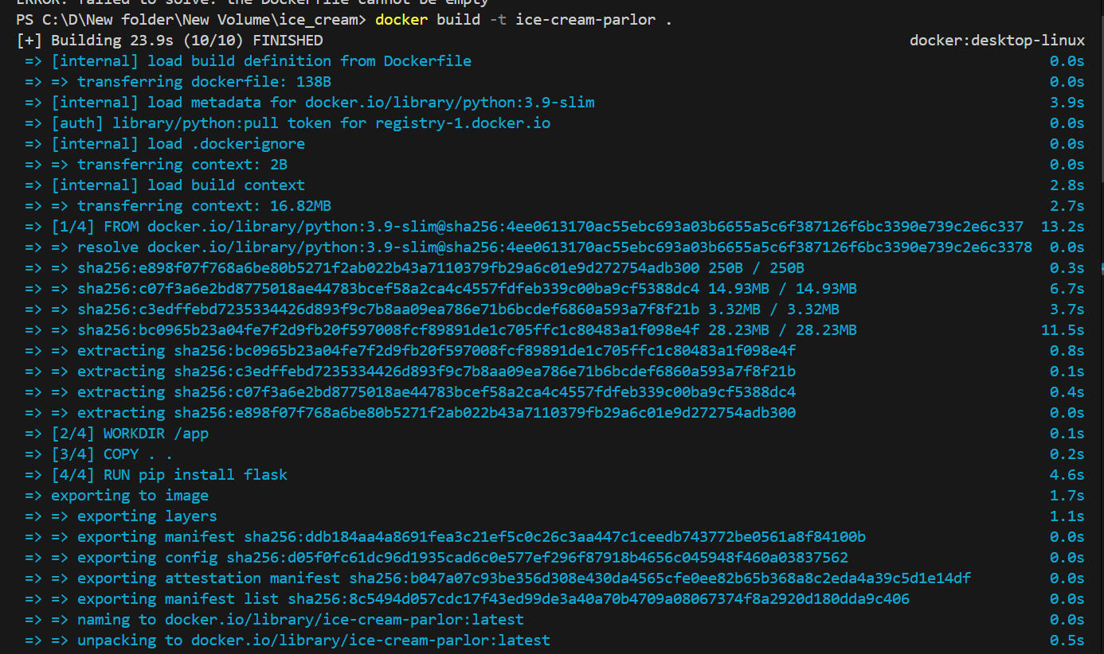

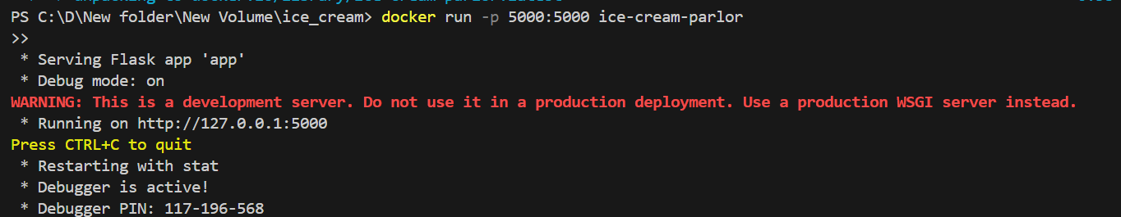

**Docker Setup**

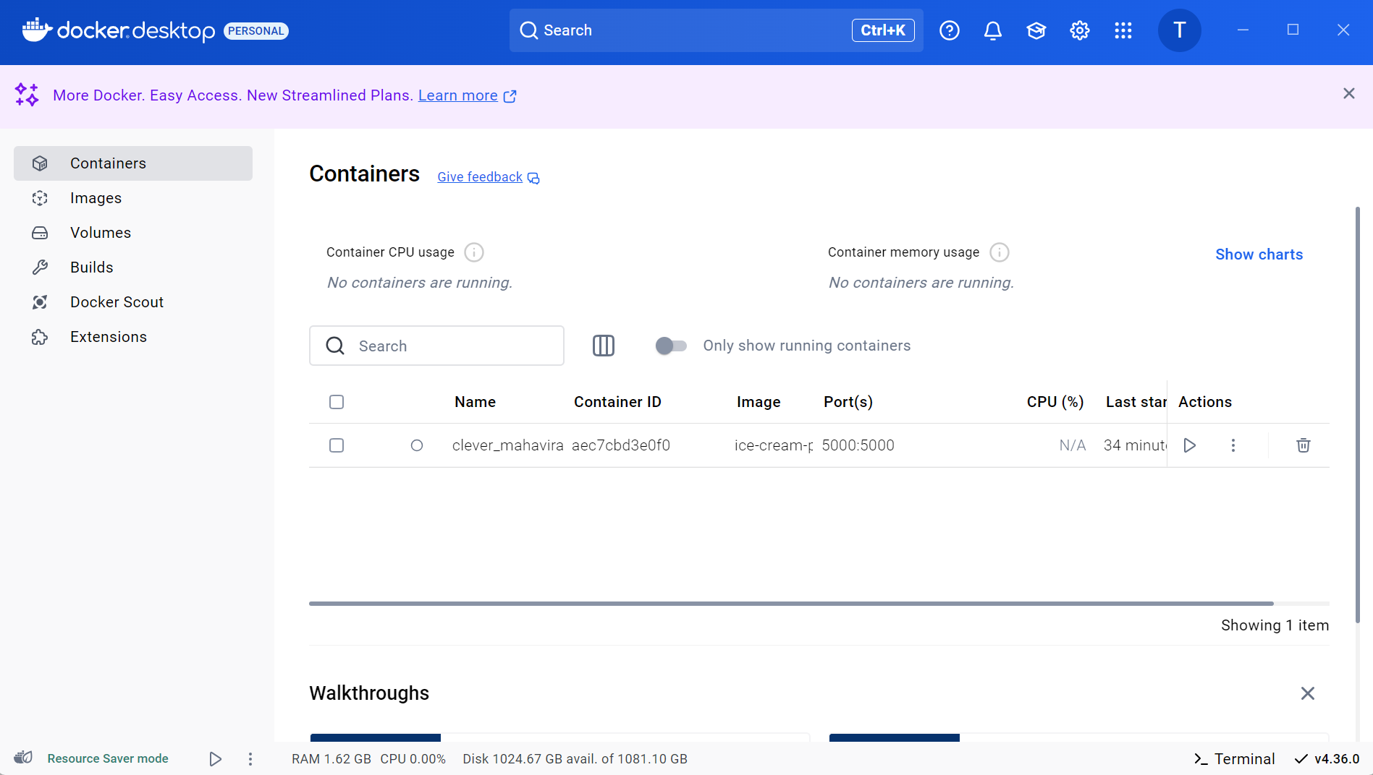

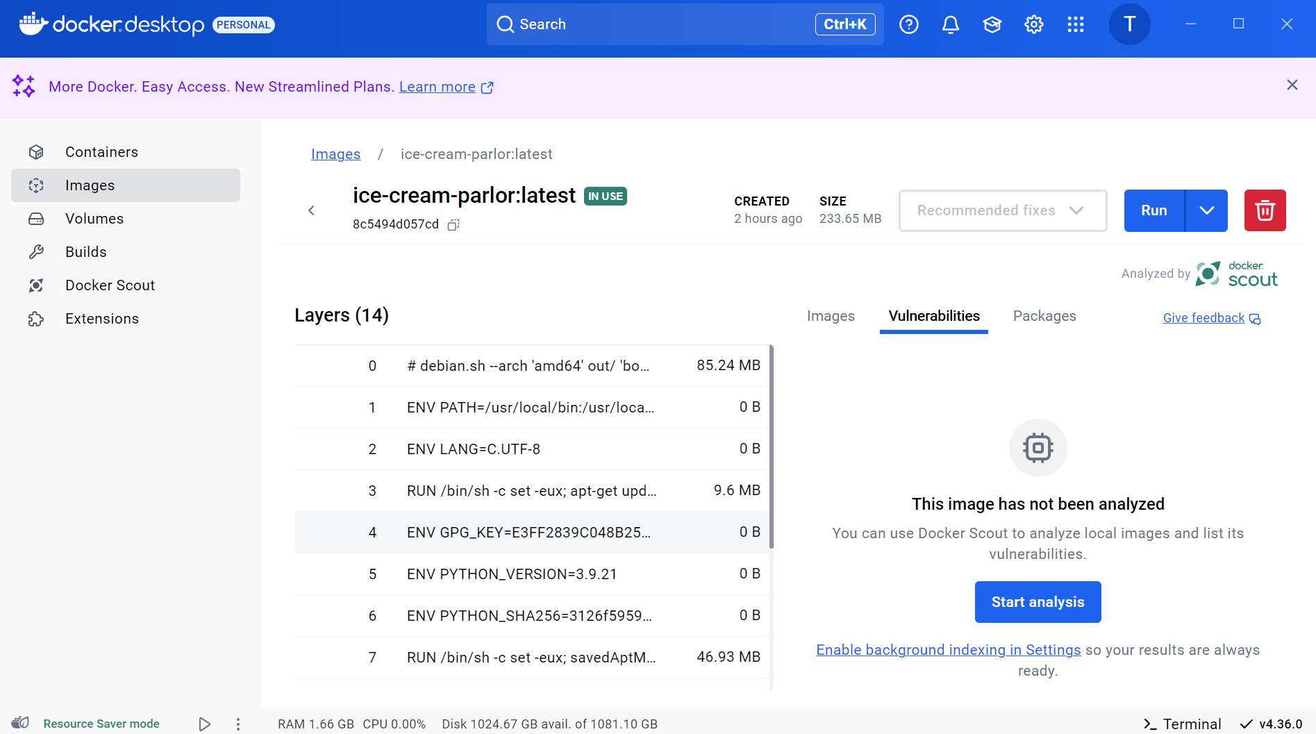

**Test the application**

